TIM FAQ
AI-Powered Knowledge Base FAQ Generator
Technical Documentation

1. Architecture Overview
Tim FAQ lets users upload documents (PDF, DOCX, TXT, MD) or ask free-form questions and automatically generates a direct answer plus a set of related FAQ pairs. It combines a Flask web app (user-facing client) with a FastAPI backend that runs a RAG (Retrieval-Augmented Generation) pipeline backed by ChromaDB and LLMs (Gemini, with Groq as fallback).
Request flow:
User Browser → Flask Client (client/) — http://127.0.0.1:5000
├── /login, /signup, Google OAuth → SQLite/Postgres
├── /chat → renders chat.html
│ │ JS fetch → Flask route → requests.post
│ ▼
│ FastAPI Backend (backend/) — http://127.0.0.1:8000
│ ├── /api/v1/faq/generate, /generate-all, /translate, /export/pdf
│ ├── RAG pipeline: embed → ChromaDB → retrieve → Gemini 2.5 Flash
│ └── returns { source, direct_answer, faq_pairs, total }
└── /admin → user/chat/FAQ stats dashboard
Two separate processes:
- FastAPI backend (backend/) — stateless RAG/AI service, port 8000.
- Flask client (client/) — user accounts, chat history, UI, port 5000. Talks to the backend over HTTP using requests.

2. Project Structure
tim/
├── .env # environment variables (secrets, API keys)
├── pyproject.toml # Poetry dependency manifest
├── backend/ # FastAPI service — RAG + FAQ generation
│ ├── main.py # FastAPI app entrypoint
│ ├── api/routes/faq.py # FAQ generation, translation, export, delete endpoints
│ ├── core/config.py # Settings (env vars) via pydantic-settings
│ └── rag/
│ ├── embedder.py # Embedding + ChromaDB vectorstore management
│ ├── retriever.py # Similarity search / chunk retrieval
│ ├── generator.py # LLM prompt construction + response parsing
│ └── pipeline.py # Orchestrates embed → retrieve → generate
├── client/ # Flask web app — UI, auth, chat history
│ ├── app/__init__.py # create_app() factory, blueprint registration
│ ├── models/user.py # User model (Flask-Login, bcrypt)
│ ├── models/chat.py # Chat, Message, FAQCollection, FAQPair, Document
│ ├── routes/auth.py # signup/login/logout
│ ├── routes/chat.py # chat CRUD, FAQ generation, rating/editing
│ ├── routes/admin.py # admin dashboard
│ ├── static/css/style.css # Neural Glitch theme
│ └── templates/ # base, signup, login, chat, admin, share HTML
└── tests/ # (empty — no tests yet)

3. Tech Stack
Layer | Technology
Backend API | FastAPI + Uvicorn
Frontend | Flask + Jinja2 templates
Frontend DB | SQLite (default) or Postgres via CLIENT_DATABASE_URL
Backend DB | Postgres via DATABASE_URL (SQLAlchemy, currently scaffolding)
Vector store | ChromaDB (persisted to ./chroma_db)
Embeddings | Nomic (nomic-embed-text-v1.5 via langchain-nomic)
LLMs | Gemini 2.5 Flash (primary), Groq Llama 3.3 70B (fallback)
Auth | Flask-Login + bcrypt; Google OAuth via Flask-Dance
File parsing | pypdf (PDF), python-docx (DOCX)
PDF export | ReportLab
Text splitting | LangChain RecursiveCharacterTextSplitter

4. Environment Variables (.env)
Variable | Used by | Notes
FASTAPI_HOST, FASTAPI_PORT | backend | default 127.0.0.1:8000
FLASK_HOST, FLASK_PORT | client | default 127.0.0.1:5000
FLASK_SECRET_KEY | client | required, used for sessions
DATABASE_URL | backend | Postgres connection string
CLIENT_DATABASE_URL | client | optional; falls back to SQLite client.db
GEMINI_API_KEY | backend | primary LLM
GROQ_API_KEY | backend | fallback LLM
NOMIC_API_KEY | backend | embeddings
CHROMA_DB_PATH | backend | default ./chroma_db
GOOGLE_CLIENT_ID, GOOGLE_CLIENT_SECRET | client | Google OAuth login

5. Running the Project
# 1. Activate the virtual environment
"C:\Users\TYSON\AppData\Local\pypoetry\Cache\virtualenvs\tim-rf3smOIg-py3.13\Scripts\activate.ps1"

# 2. Start the FastAPI backend (port 8000)
python -m backend.main

# 3. Start the Flask client (port 5000)
python -m client.run
Visit http://127.0.0.1:5000. The Flask app redirects to /login (unauthenticated) or /chat (authenticated).
⚠ The first user to register via Google OAuth is automatically promoted to admin.

6. Backend (FastAPI) — backend/

6.1 main.py
Creates the FastAPI app, adds CORS (allowing the Flask client at 127.0.0.1:5000), and mounts two routers under /api/v1: faq (tag: FAQ) and health (tag: Health).

6.2 Routes — api/routes/health.py
Method | Path | Description
GET | /api/v1/health | Returns {"status": "ok", "version": "1.0.0"}

6.3 Routes — api/routes/faq.py
Method | Path | Description
GET | /api/v1/faq/debug | Returns total chunks and distinct doc_ids in ChromaDB
POST | /api/v1/faq/generate | Generate FAQs from prompt and/or up to 10 uploaded files
POST | /api/v1/faq/generate-all | Generate FAQs across all uploaded files independently, then combine
POST | /api/v1/faq/translate | Translate a direct answer + FAQ pairs into a target language
POST | /api/v1/faq/export/pdf | Render a direct answer + FAQ pairs as a styled PDF
POST | /api/v1/faq/delete-doc | Delete all ChromaDB chunks for a given doc_id

File handling rules
- Max 10 files per request, 10 MB each.
- Supported extensions: .pdf, .docx/.doc, .txt, .md.
- PDF text extracted via pypdf; DOCX via python-docx; txt/md decoded as UTF-8.

/faq/generate logic
- Extract text from any uploaded files.
- If the prompt mentions a specific filename, isolate that file.
- Otherwise, if files were uploaded, use the last uploaded file only.
- If no prompt was given but a file is present, use default prompt.
- Calls run_pipeline(prompt, file_texts).

/faq/generate-all logic
- Requires at least one file.
- If the prompt names a specific file, redirects to single-file run_pipeline.
- Otherwise calls run_pipeline_all(file_texts, prompt) — each document processed independently, then merged.

6.4 Core — core/config.py
Settings (pydantic-settings) loads all environment variables from .env. extra = "ignore" allows unused vars without error.

6.5 Core — core/db.py
Sets up a SQLAlchemy engine, SessionLocal, and Base against DATABASE_URL (Postgres). Not currently wired into any FAQ route — scaffolding for future backend-side persistence.

6.6 Models — models/schemas.py
Model | Fields | Purpose
UnifiedFAQRequest | prompt, filename?, content? | (defined, not directly used by current routes)
FAQPair | question, answer | A single Q&A pair
FAQResponse | source, direct_answer, faq_pairs, total | Standard response shape for all generation endpoints

6.7 RAG — rag/embedder.py
- Initializes NomicEmbeddings (model nomic-embed-text-v1.5) and a Chroma vectorstore persisted at CHROMA_DB_PATH.
- embed_document(text, doc_id): deletes existing chunks, splits text into 500-char chunks with 50-char overlap, adds to Chroma.
- delete_document(doc_id): removes all chunks for a given doc_id.
⚠ doc_id is currently the filename — re-uploading a file with the same name overwrites its embeddings.

6.8 RAG — rag/retriever.py
- RELEVANCE_THRESHOLD = 0.75 — chunks above this distance score are discarded.
- retrieve_chunks(query, doc_ids=None, k=6): global or per-doc similarity search.
- retrieve_chunks_per_doc(query, doc_ids, k_per_doc=6): returns dict[doc_id -> list[chunks]], used by generate-all pipeline.

6.9 RAG — rag/generator.py
- invoke_llm(prompt_text): tries Gemini first; on any exception, falls back to Groq.
- generate_full_response_from_chunks(prompt, chunks): context-grounded prompt → ANSWER: + 5 Q/A pairs.
- generate_full_response_from_prompt(prompt): pure LLM knowledge, no document context.
- generate_full_response_from_all_docs(doc_chunks): per-document FAQ sets concatenated.
- translate_response(direct_answer, faq_pairs, target_language): re-translates existing answer/FAQs.
- parse_full_response(raw): parses LLM fixed-format output into (direct_answer, list[FAQPair]).

6.10 RAG — rag/pipeline.py
- run_pipeline: embed files → retrieve chunks → generate from chunks (or fallback to pure LLM if irrelevant).
- run_pipeline_all: embed all files → retrieve per-doc → generate combined answer.

7. Frontend (Flask) — client/

7.1 App factory — app/__init__.py
- Loads .env, configures SQLAlchemy (SQLite or Postgres).
- Registers blueprints: Google OAuth, auth, chat, admin.
- Calls db.create_all() on startup (auto-creates tables if missing).
- Root / redirects to /chat (logged in) or /login.

7.2 Models — app/models/

user.py — User
Field | Type | Notes
id | int, PK
username | string, unique
email | string, unique
password_hash | string | bcrypt hash; "google_oauth" placeholder for OAuth accounts
role | string | "user" or "admin"; first Google OAuth user becomes admin
created_at | datetime

chat.py
Model | Key Fields | Relationships
Chat | id, user_id, title, created_at, updated_at | has many Message, FAQCollection (cascade delete)
Message | id, chat_id, role (user/assistant), content, created_at | belongs to Chat
FAQCollection | id, chat_id, source, direct_answer, created_at | has many FAQPair (cascade delete)
FAQPair | id, collection_id, question, answer, rating (up/down/null) | belongs to FAQCollection
Document | id, user_id, filename, doc_id, chunk_count, uploaded_at | (defined; not currently populated)

7.3 Routes — app/routes/auth.py
Method | Path | Description
GET/POST | /signup | Create account (username, email, password); password hashed with bcrypt
GET/POST | /login | Email + password login via Flask-Login
GET | /logout | Logs out current user

7.4 Routes — app/routes/chat.py
Method | Path | Description
GET | /chat | Redirects to most recently updated chat, or creates a new one
GET | /chat/new | Creates a new Chat and redirects to it
GET | /chat/<chat_id> | Renders chat.html for a given chat
POST | /chat/<chat_id>/delete | Deletes a chat (cascades messages/collections)
POST | /chat/<chat_id>/generate | Forwards prompt+files to backend /faq/generate, saves result
POST | /chat/<chat_id>/generate-all | Forwards prompt+files to backend /faq/generate-all, saves result
POST | /chat/faq/<pair_id>/rate | Sets/toggles a FAQ pair rating (up/down)
POST | /chat/faq/<pair_id>/edit | Edits a FAQ pair question/answer text
GET | /share/<collection_id> | Public (no login) read-only view of an FAQCollection
POST | /chat/export/pdf | Proxies to backend /faq/export/pdf, streams PDF to browser
GET | /chat/<chat_id>/history | Returns full chat history as JSON

7.5 Routes — app/routes/admin.py
Protected by @login_required + custom @admin_required decorator.
Method | Path | Description
GET | /admin | Dashboard: stats grid + most-active user + user management
POST | /admin/delete/<user_id> | Delete a user (cannot delete self)
POST | /admin/promote/<user_id> | Promote user to admin
POST | /admin/demote/<user_id> | Demote admin to user (cannot demote self)

7.6 Templates
Template | Purpose
base.html | Shared layout: sidebar, navbar, animated star-field canvas, theme toggle
signup.html | Marketing landing page + signup form + Google OAuth
login.html | Login form + Google OAuth
chat.html | Main chat interface (file upload, FAQ generation, voice, translation)
admin.html | Stats grid + most-active-user + user management table
share.html | Public, unauthenticated view of a single FAQ collection

7.7 chat.html — Main Chat UI
Key client-side features (vanilla JS):
- History loading: fetches /chat/<id>/history and renders user/assistant message bubbles with FAQ cards.
- File attachments: drag/select up to 5 files (10 MB each). Reveals Generate FAQ and Overall FAQ buttons.
- FAQ rating: thumbs up/down buttons per FAQ pair → /chat/faq/<id>/rate.
- Inline editing: startEdit(pairId) swaps FAQ card into editable fields. saveEdit POSTs to /chat/faq/<id>/edit.
- Copy: copyToClipboard formats direct answer + Q/A pairs as plain text to clipboard.
- Export PDF: exportPDF POSTs to /chat/export/pdf, downloads returned PDF as faqs.pdf.
- Share: shareCollection copies a public share URL (/share/<collection_id>) to clipboard.
- Translation: language dropdown (Tamil, Hindi, Spanish, French, Arabic, German, Japanese, Chinese) calls /faq/translate.
- Text-to-speech: readAloud uses Web Speech API (SpeechSynthesisUtterance) as a toggle.
- Voice input: toggleMic uses SpeechRecognition. Live partial transcripts stream into the prompt textarea.
- Theme toggle: persisted dark/light theme via localStorage.

7.8 Styling — static/css/style.css
A custom dark "Neural Glitch" theme: deep void backgrounds, cyan and magenta neon accents, animated aurora gradients, scanline grid overlay, glassmorphism cards, and angular clip-path buttons/inputs. Includes a full light-theme override (body.light-theme) and responsive breakpoints down to mobile.

8. Visual Walkthrough — UI Screenshots

8.1 Landing Page
The homepage showcases Tim FAQ's key features with a dark "Neural Glitch" theme — cyan neon accents, animated aurora backgrounds, and feature cards highlighting multi-file upload, Gemini AI + Groq, vector search, export/share, multi-language support, and voice input.
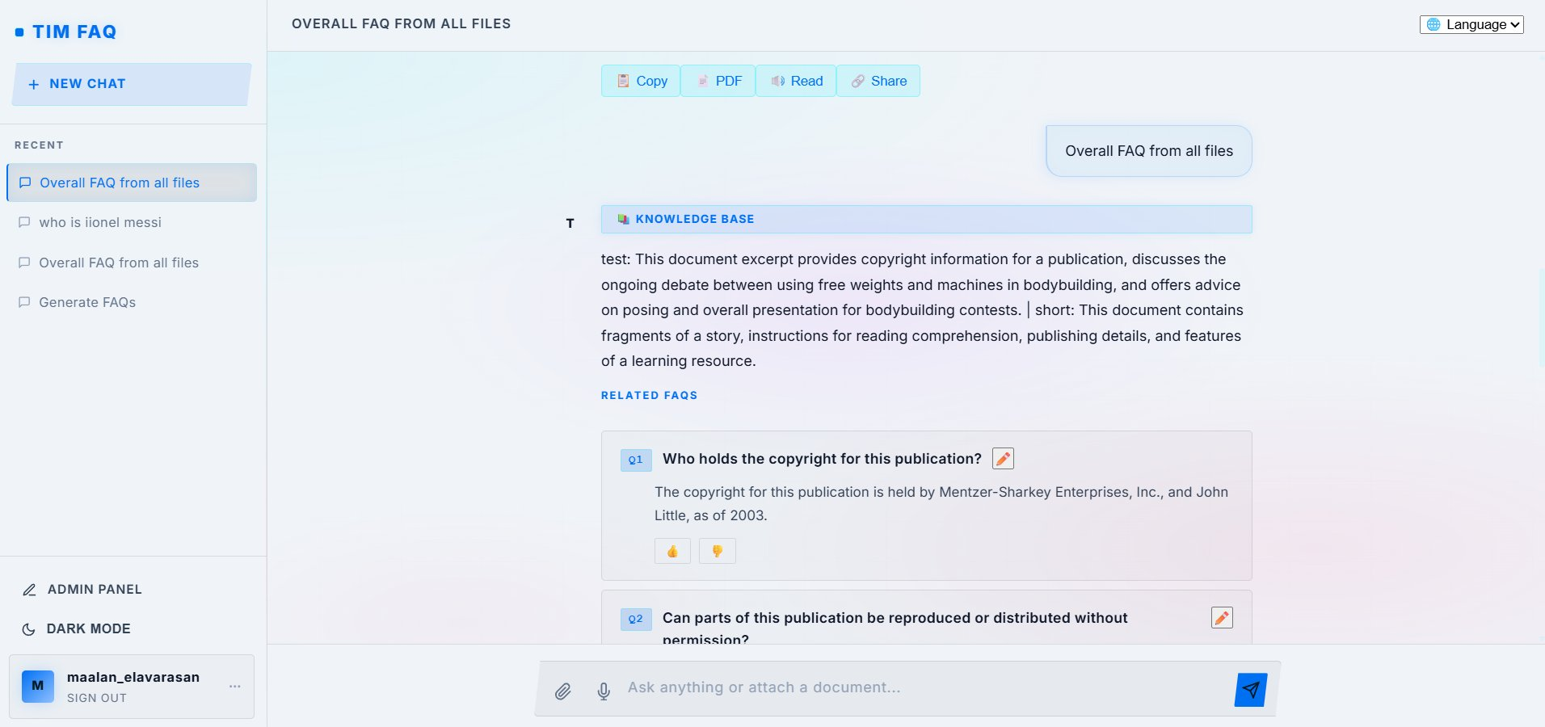
Figure 1: Tim FAQ Landing Page — Dark Theme

8.2 Login Page
Clean authentication screen with email + password fields and Google OAuth integration. Same neon cyberpunk aesthetic with a purple gradient login button.
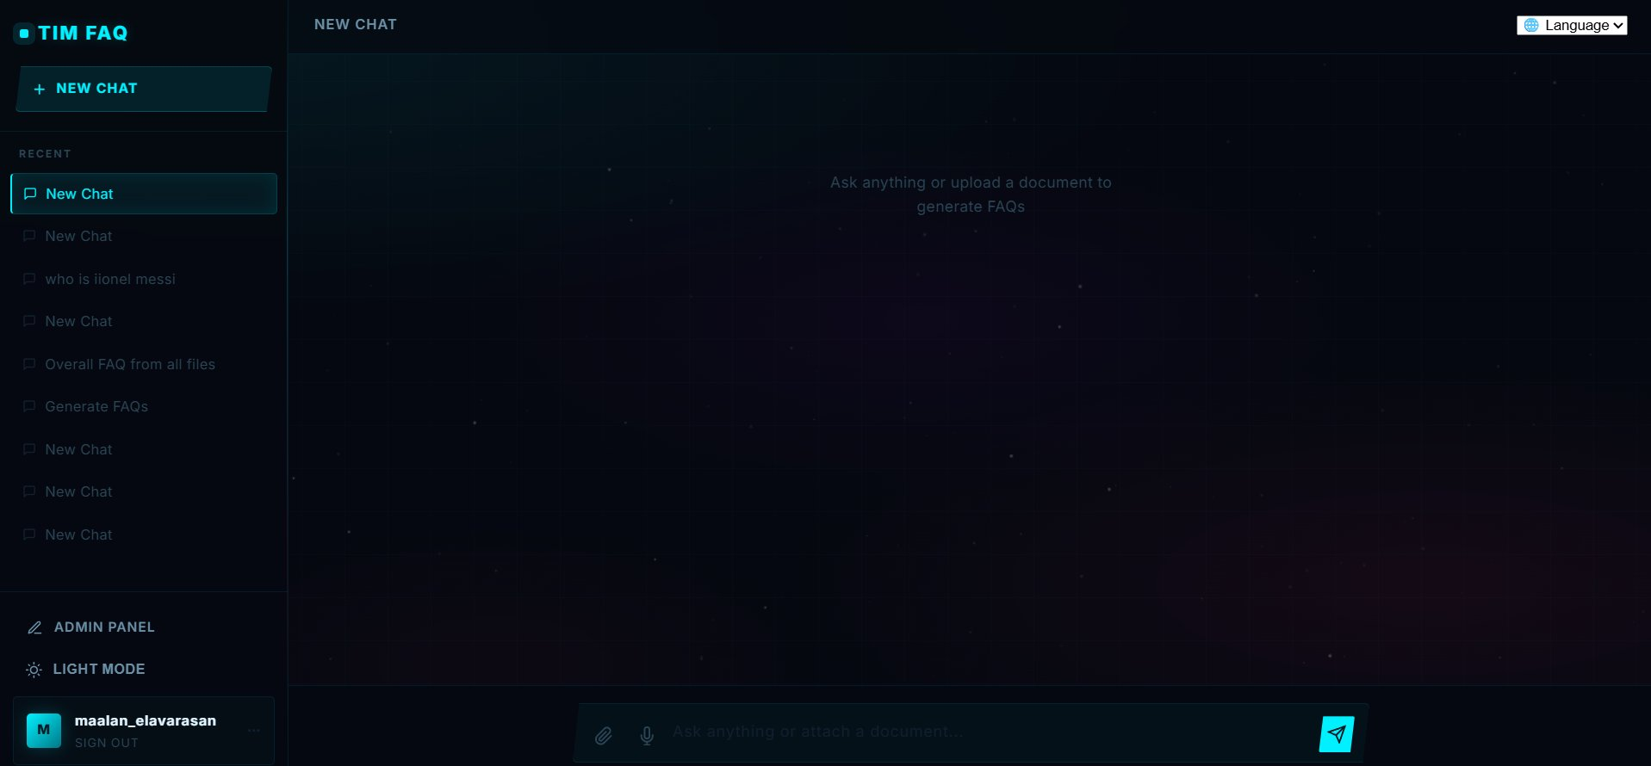
Figure 2: Login Page

8.3 Empty Chat (New Chat State)
Shows the main chat interface when no messages exist. Left sidebar displays chat history, theme toggle, admin panel link, and user info. Center pane prompts "Ask anything or upload a document to generate FAQs".
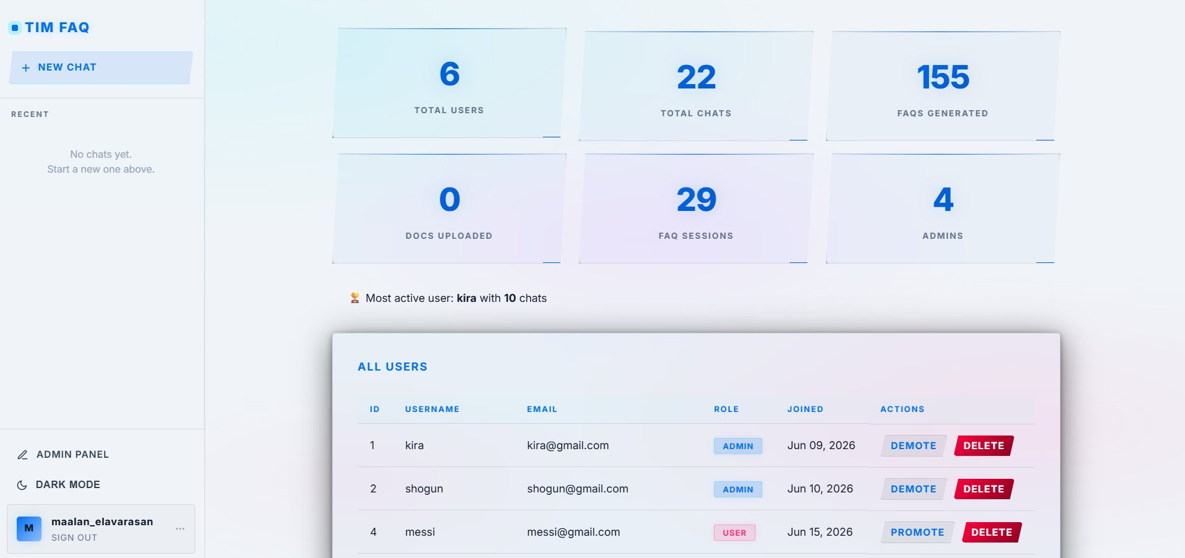
Figure 3: Empty Chat — Light Theme
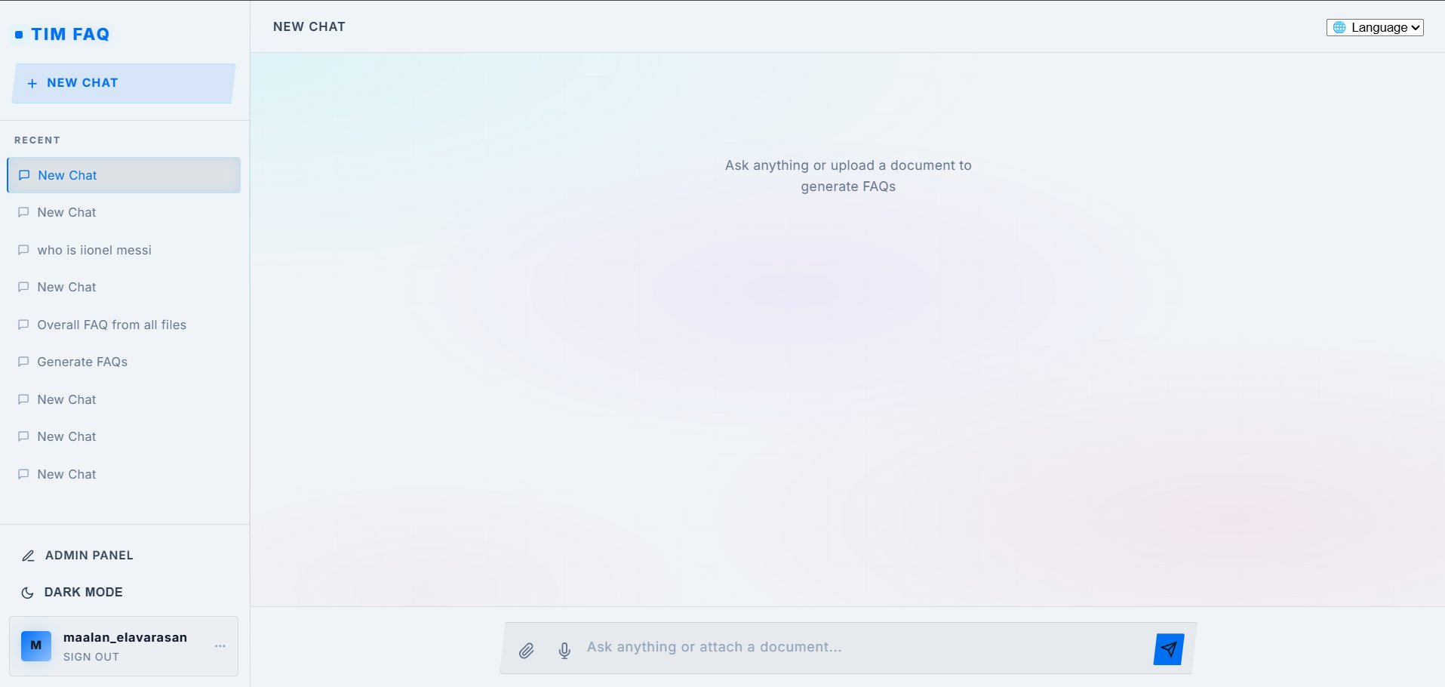
Figure 4: Empty Chat — Dark Theme

8.4 Chat with FAQ Generation Results
After uploading a document or asking a question, the AI returns a source badge, direct answer, and numbered Q/A pairs with edit and rating controls. Action buttons at the bottom allow Copy, PDF export, Read (text-to-speech), and Share.
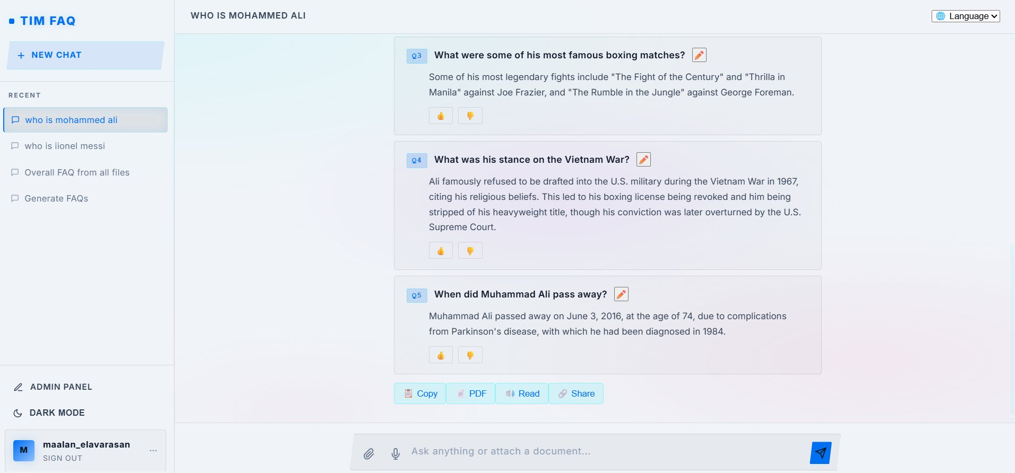
Figure 5: AI-Generated Response (Gemini AI source)
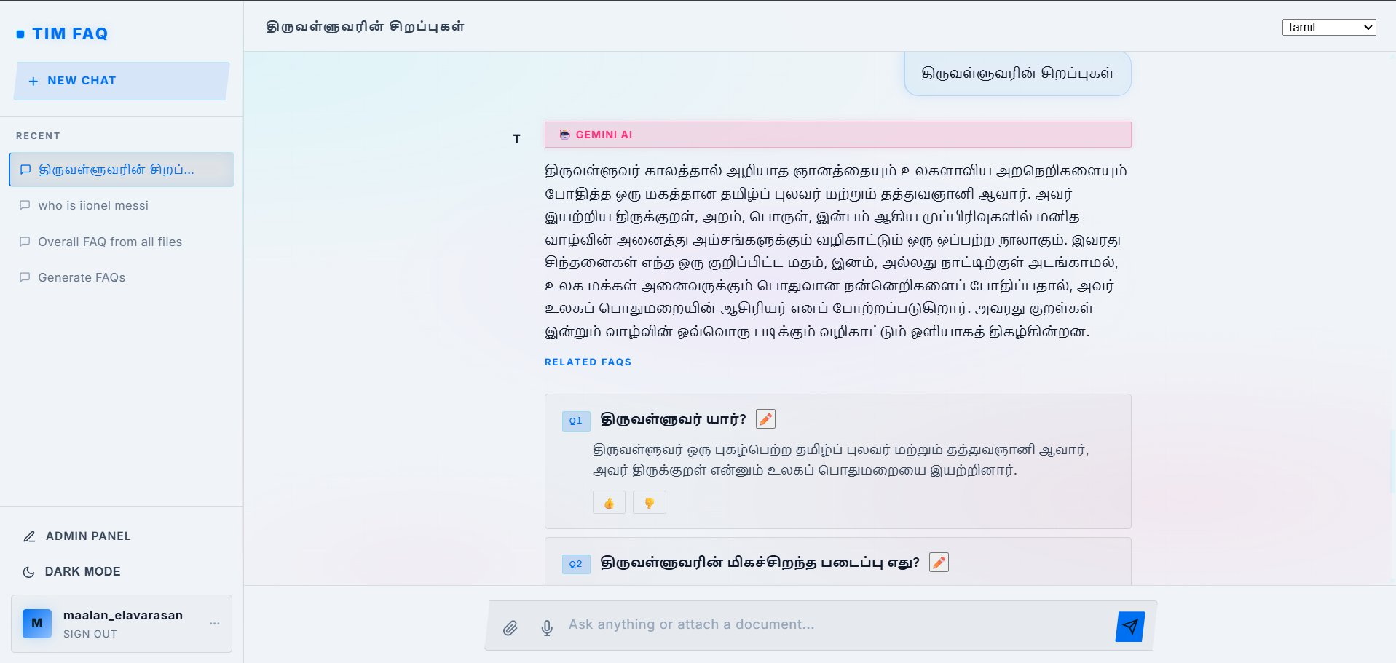
Figure 6: Additional FAQ Pairs scrolled into view

8.5 Translation & Multi-Language Support
Select a language from the dropdown (Tamil, Hindi, Spanish, French, Arabic, German, Japanese, Chinese). The UI re-renders the direct answer and all FAQ pairs in the chosen language in real time.
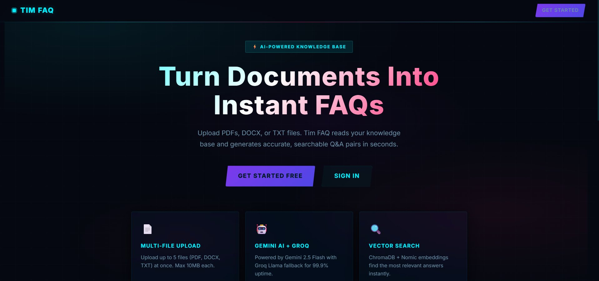
Figure 7: Tamil Language Translation

8.6 Admin Dashboard
Admins see a stats grid (Total Users, Total Chats, FAQs Generated, Docs Uploaded, FAQ Sessions, Admin Count) and a Most Active User highlight. Below is an All Users table with Promote/Demote/Delete actions.
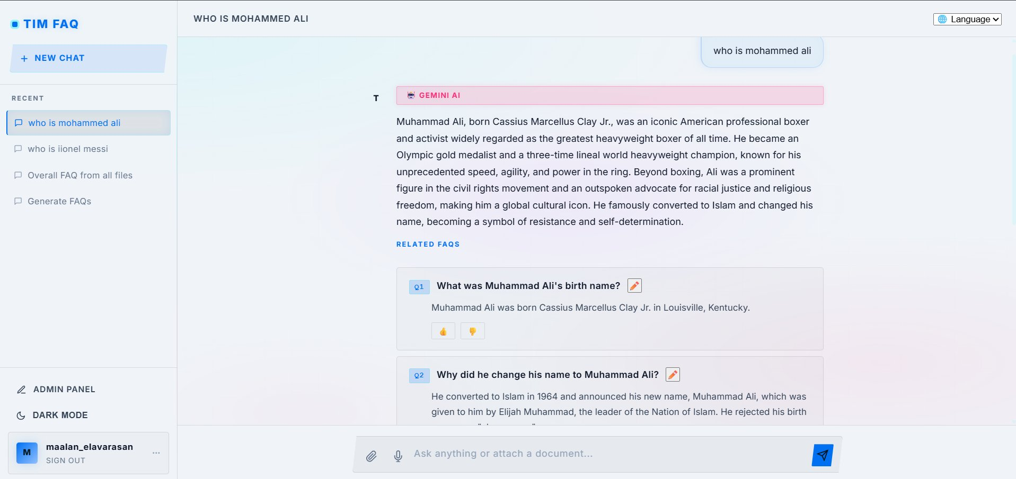
Figure 8: Admin Dashboard

8.7 Knowledge Base Response
When documents are uploaded, the system embeds them into ChromaDB and retrieves the most relevant chunks using vector similarity. The AI uses these chunks to ground its answer, marked with a "📚 KNOWLEDGE BASE" badge (cyan).
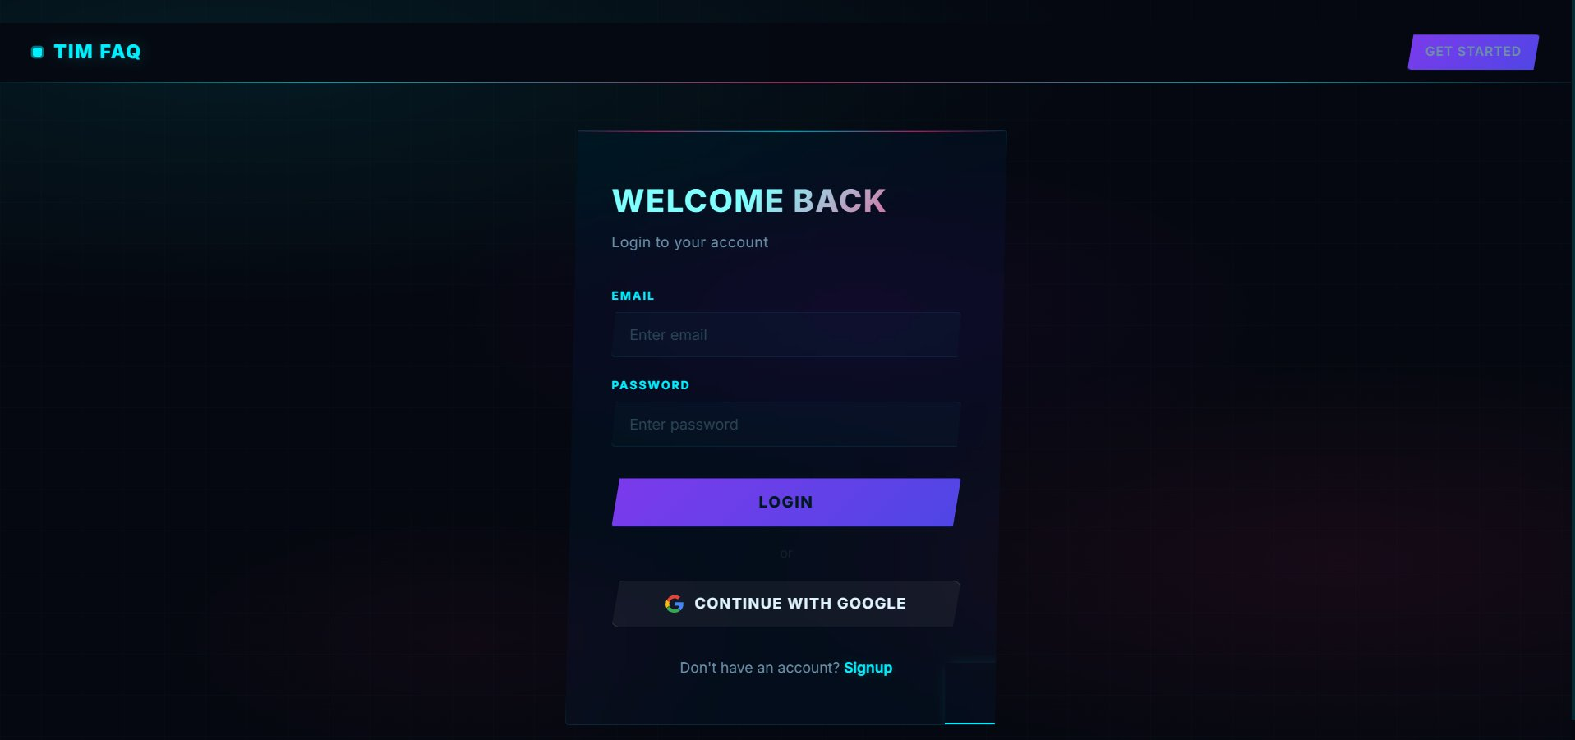
Figure 9: Knowledge Base Grounded Response

9. End-to-End Request Flow Example
Scenario: User uploads policy.pdf and asks "What is the refund window?"
- Browser → POST /chat/5/generate (Flask) with prompt + file.
- Flask _call_fastapi → POST http://127.0.0.1:8000/api/v1/faq/generate (multipart).
- FastAPI generate_faq: extracts text, isolates the file, calls run_pipeline(prompt, [("policy.pdf", text)]).
- run_pipeline: embed_document → retrieve_chunks → generate_full_response_from_chunks → Gemini returns ANSWER: + 5 Q/A pairs.
- Flask _save_response: stores Message (user + assistant), FAQCollection, and 5 FAQPair rows; returns JSON to browser.
- chat.html renders the assistant message, source badge, and FAQ cards with rate/edit controls.

10. Known Gaps / Notes
- backend/api/middleware/auth.py is currently empty — no backend-level auth is enforced; FastAPI is only protected by CORS.
- backend/core/db.py (Postgres) is configured but not used by any current route.
- client/app/static/js/ is empty — all chat JS is inline in chat.html.
- tests/ is empty — no automated tests yet.
- doc_id = filename means two users uploading files with the same name will overwrite each other's embeddings in ChromaDB — no per-user namespacing.
- requirements.txt and pyproject.toml list overlapping but slightly different dependency sets; Poetry (pyproject.toml) appears to be the source of truth.

