**First Draft**

**Defenders of Ragnar**

**A Game by Marc-Andre Michaud**

**Student, Gaming Experience Development Sr**

**PROG1189: Comprehensive Development Project**

**New Brunswick Community College**

**School of Information Technology and Natural Resources**

**April 14th, 2022**

**Made using the SFML Game Development game engine**

**Document Revision history:**

|  |  |  |  |
| --- | --- | --- | --- |
| Version | Date | Author(s) | Changes |
| 0.1 | January 16, 2022 | Marc-Andre Michaud | Document created |
| 0.2 | January 25, 2022 | Marc-Andre Michaud | First rough draft |
|  |  |  |  |

Table of Contents

1. Section I - Game Overview 5

1.1. Game Concept 5

1.2. Design History 5

1.3. Genre 5

1.4. Target Audience 5

1.5. Game Flow Summary 5

1.6. Look and Feel 5

1.7. Project Scope 6

1.7.1. Number of locations 6

1.7.2. Number of Enemies 6

1.7.3. Number of Towers 6

2. Section II - Gameplay and Mechanics 6

2.1. Gameplay 6

2.2. Mechanics 7

2.2.1. Tower Types 7

2.2.2. Warrior Towers 7

2.2.3. Wizard Towers 8

2.2.4. Prestige Towers 8

2.2.5. Tower Management 9

2.2.6. Buttons 9

2.2.7. Combat 10

2.2.8. Economy 10

2.3. Screen Flow 10

2.3.1. Screen Descriptions 10

2.4. Easter Eggs 10

3. Section III – Story, Setting, and Character 11

3.1. Story and Narrative 11

3.1.1. Back Story 11

3.1.2. Level Stories 11

4. Section IV – Levels 12

4.1. Forest Level 12

4.1.1. Enemies 12

4.2. Cemetery Level 12

4.2.1. Enemies 12

4.3. Beach Level 13

4.3.1. Enemies 13

4.4. Mountain Level 13

4.4.1. Enemies 13

5. Section V - Interface 14

5.1. Main Menu 14

5.2. Pause Menu 14

5.3. In-game Menu 14

5.4. Mouse Input 14

5.5. Keyboard Input 14

5.6. Music 14

5.7. Sound Effects 14

6. Section VI - Artificial Intelligence 14

7. Section VII – Technical 15

7.1. Target Hardware and operating system 15

7.2. Game Engine 15

8. Section VIII – Game Art 15

8.1. Concept Art 15

8.1.1. Protagonists 15

8.1.2. Antagonists 16

8.1.3. Forest Level 17

# Section I - Game Overview

## Game Concept

Defenders of Ragnar is a strategic Tower Defence game, roughly based on UO:Defender, which is itself based on Ultima Online.

The game uses a top-down isometric tile-based view with 2D animated sprites for towers and enemies. The mouse will be the primary input method, with a few keyboard shortcuts.

The game's main objective is placing "towers" that will attack enemies coming down a path to stop them from coming through. Success is achieved by strategically placing towers, and the game is lost by having too many enemies make it through the game area.

## Design History

Initial Version

## Genre

Tower Defence

Medieval Fantasy

Strategy

## Target Audience

Tower defence players. UO:Defender players.

## Game Flow Summary

The player starts at a menu screen that includes level selection. Clicking on a level option starts said level.  
  
Within the level, the player must make it through a set number of waves to win the level. A wave ends when all enemies are dead or walked off the game board.

Winning, losing, or quitting will return the player to the menu.

## Look and Feel

The game is 2D and isometric tile-based. The theme is medieval fantasy, and the art style is simplistic.

## Project Scope

A summary of the scope of the game.

### Number of locations

Forest level

Cemetery level

Beach level

Mountain level

### Number of Enemies

Roughly 40

### Number of Towers

Roughly 20

# Section II - Gameplay and Mechanics

## Gameplay

The player will progress through levels by clearing enemy waves, earning gold, and experience points.

Gold is used for purchasing additional towers and upgrading existing towers. Existing towers must have reached an experience threshold before upgrading.  
  
Once the player has upgraded a tower to grandmaster rank, a corresponding prestige class tower will be unlocked and available for purchase.

Clearing the last wave of a level wins said level.

## Mechanics

### Tower Types

The game has two base tower types: Club warriors and Novice wizards. The warriors can be upgraded to a weapon type, and wizards can be upgraded to an element type.

Once a weapon type or element is selected, a tower can rank up with that specific weapon or element.

Warrior type towers go from Club Warrior, to Warrior, to Master, to Grandmaster.

Wizard type towers go from Novice, to Apprentice, to Master, to Grandmaster.

Prestige class towers mix weapon types with element types.

Warrior and prestige towers have a range of 1 tile, while wizard towers can have a range of 2 or 3 tiles.

### Warrior Towers

#### Club

Clubs are only used by the base type warrior tower. They do moderate damage with moderate swing speed with no special features.

#### Sword

Swords are the raw DPS option. They do moderate damage, but with fast swing speed.

#### Axe

Axes do moderate area of effect damage with moderate swing speed. An axe warrior's attack will damage enemies near the target as well as the target.

#### Mace

Maces do moderate damage with moderate swing speed but will stun enemies on hit.

### Wizard Towers

#### Ice

Ice wizards have a range of 2 and will slow enemies down on hit.

#### Fire

Fire wizards have a range of 2 and do area of effect damage.

#### Energy

Energy wizards have a range of 3 and do high damage.

#### Poison

Poison wizards have a range of 2 and poison enemies, causing damage over time.

### Prestige Towers

#### Ice Sword

Ice sword towers have the properties of sword towers, and slow enemies down on hit.

#### Fire Axe

Fire axe towers behave like axe towers while dealing more damage

#### Energy Mace

Energy mace towers behave like mace towers while dealing more damage

### Tower Management

#### Inspecting Towers

Mousing over a tower will highlight the tiles within the tower's attack range.

#### Placing Towers

If the player has enough gold available, they can click on a base tower button or prestige tower button to begin the process of placing a tower.

Once the button is pressed, the game will begin giving the player special feedback when mousing over tiles. If the tile moused over cannot have a tower built on it, it will be highlighted in red. If the tile is buildable, a 3x3 or 5x5 square of tiles will be highlighted matching the desired tower's attack range if built in said tile.

Clicking on a valid tile at this stage will build the tile and deduct gold. Pressing the Escape key will abort the tower placement process.

#### Upgrading Towers

Once a tower has reached its experience threshold for its next upgrade, it will be highlighted to demonstrate that it is ready to upgrade.

Once clicked upon, a small menu will be displayed near the tower displaying upgrade options. Clicking on an option with enough gold will close the menu and upgrade the tower. Mousing away or hitting Escape will close the menu.

### Buttons

#### Tower Buttons

There are five tower selection buttons in total. Two for the basic tower types (Club warrior and Novice wizard), and three for the prestige towers (Ice Sword, Fire Axe, Energy Mace), which will only function once unlocked.

#### Wave Start Button

A button is available in between waves to start the next wave.

#### Volume buttons

Music and sound effect volume buttons are available for increasing or decreasing music and sound effect volume.

### Combat

Enemies in this game don't attack. They challenge the player through speed, numbers, and resilience. When able, a tower will attack whichever enemy within its range is further along the path. After attacking, a tower must wait a given period of time before being able to attack again.

### Economy

The player earns gold by killing enemies. Stronger enemies give more gold. Gold is spent on purchasing towers and upgrading towers.

## Screen Flow

### The screen stays in a fixed position at all times. The window size is big enough to encompass the entirety of the game board during play, and the menu is the size of the window.

### Screen Descriptions

#### Main Menu Screen

The main menu includes level selection, game quitting, and any future options.

#### Game Screen

The game screen has the game board in the center, with a small menu with buttons at the bottom.

#### Pause Screen

The pause screen is an overlay with text on top of the game screen. The game is paused while the pause screen is active.

## Easter Eggs

While the game has no actual hidden content, it has references to other video games.

The Timber wolf and Grey Wolf enemies are references to Ultima Online.

The "energy" element is also a reference to Ultima Online.

The Sea Dog enemy is a reference to a "salty sea dog" pub in Ultima, and also a pub of the same name that happens to be next to my house.

The medusa enemies are a reference to Castlevania's floating medusa head enemies.

# Section III – Story, Setting, and Character

## Story and Narrative

### Back Story

King Ragnar II has tasked you with defending his kingdom of Elion. You will travel the realm defending it from would-be invaders. The King's warriors and wizards will be at your disposal.

Each location will offer finite waves of invaders, which you must stop from crossing into the inner kingdom. Each enemy slain will earn you gold to hire and upgrade your towers (warriors and wizards.)

### Level Stories

Although the levels do not have a strictly formulated story, they do have a general theme that will be reflected in the graphics and gameplay.

#### Forest Level

The forest level begins with forest creatures but develops into an escalation conflict with an army of orcs, ending in a confrontation with the orc boss.

#### Cemetery Level

The cemetery level involves waves of undead enemies, culminating in an encounter with the lich king.

#### Beach Level

The beach level includes a mix of sea creatures, orcish pirates, and undead rising from the sea. The boss for the level is the ghost pirate captain.

#### Mountain Level

The mountain level begins with mountain-dwelling creatures and hobgoblins, then escalates into a volcanic theme, culminating with the magma king as the final boss.

# Section IV – Levels

## Forest Level

### Enemies

1. Dire Wolf
2. Forest Scorpion
3. Giant Scorpion
4. Grey Wolf
5. Ogre
6. Orc Boss
7. Orc Lumberjack
8. Orc Scout
9. Orc Soldier
10. Orc Warrior
11. Timber Wolf

## Cemetery Level

### Enemies

1. Ancient Zombie
2. Dire Ghost Wolf
3. Dire Zombie Dog
4. Ghost Dog
5. Ghost Wolf
6. Lich King
7. Lich Lord
8. Lich
9. Skeleton
10. Zombie Dog
11. Zombie

## Beach Level

### Enemies

1. Ancient Drowned
2. Deep Sea Scorpion
3. Drowned Bones
4. Drowned Lich
5. Drowned
6. Fishman Elite
7. Fishman
8. Ghost Pirate Captain
9. Ghost Pirate
10. Orc Pirate Captain
11. Orc Pirate
12. Sea Dog
13. Sea Scorpion
14. Zombie Pirate

## Mountain Level

### Enemies

1. Ancient Medusa
2. Charred Bones
3. Charred
4. Fire Giant
5. Fire Lich
6. Fire Medusa
7. Fire Scorpion
8. Hell Hound
9. Hobgoblin Heavy Infantry
10. Hobgoblin Scout
11. Hobgoblin Warrior
12. Magma King
13. Magma Scorpion
14. Medusa
15. Mountain Giant
16. Rock Scorpion

# Section V - Interface

## Main Menu

The main menu has level selection buttons with level image thumbnails and a game quit button.

## Pause Menu

The pause menu is an overlay over the game screen, which allows either unpausing the game or returning to the main menu.

## In-game Menu

During gameplay, there is a small menu at the bottom of the screen with clickable buttons for purchasing towers, sound volume control, and starting the next wave.

## Mouse Input

The mouse is the main method of input. The game is mostly played by clicking menu button and clicking on tiles to place or upgrade towers.

Mousing over tiles will highlight the tile. Mousing over a tower will highlight the tiles in the tower's range.

## Keyboard Input

The Escape button will cancel tower placement and tower upgrade. P will pause. M and S will toggle sound and music muting.

## Music

The game has menu music and in-game music.

## Sound Effects

Towers have sound effects that match their attacks

# Section VI - Artificial Intelligence

Enemies spawn down a given assigned path. With each update, they attempt to move down the path.

Towers attempt to attack when an enemy is within range, and the tower is not on cooldown. When a tower can attack, It will attack the enemy within range which is furthest along its path.

# Section VII – Technical

## Target Hardware and operating system

PCs running Windows 10

## Game Engine

This game was made using the GEX game engine using SFML. The GEX game engine is based on the SFML book.

# Section VIII – Game Art

## Concept Art

### Protagonists

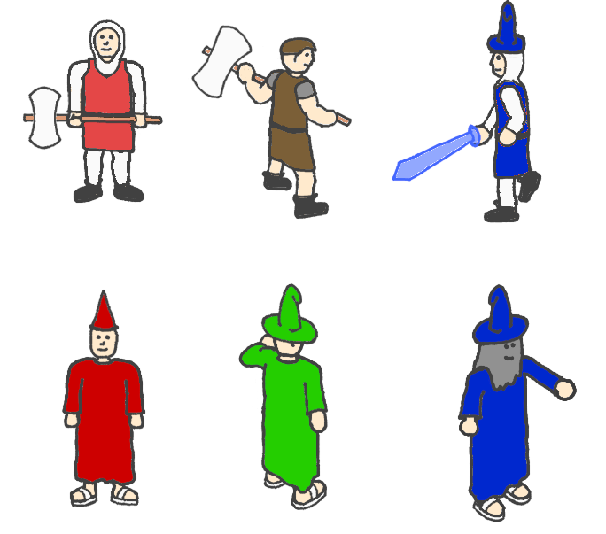

### Antagonists

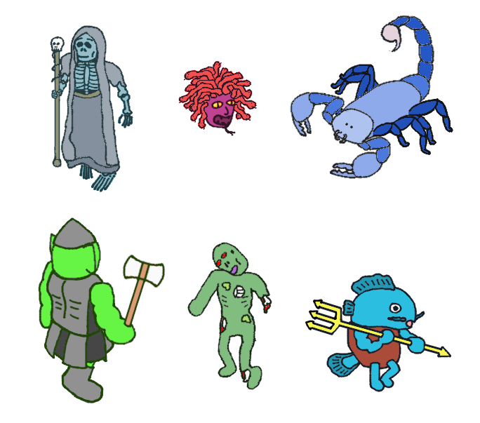

### Forest Level

