Spring REST using SpringBoot3

- Create a Spring Web Project using Maven

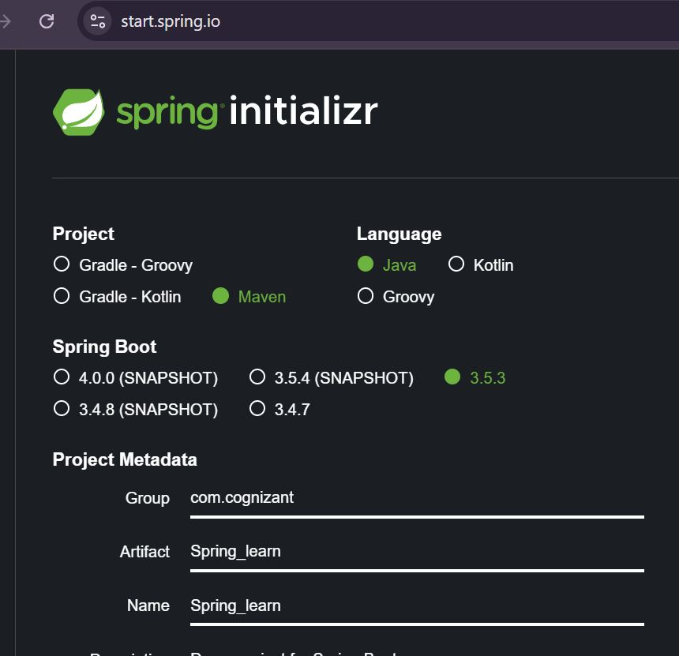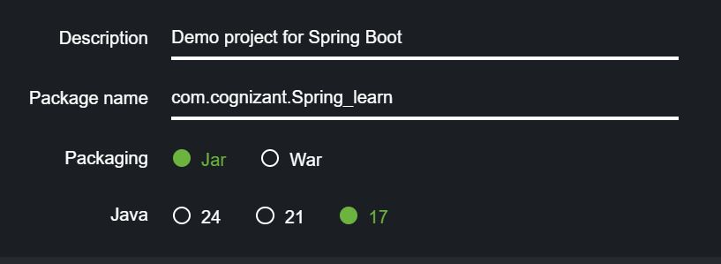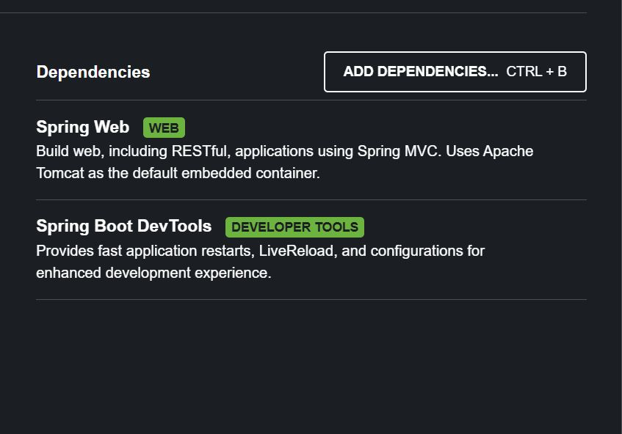

Downloading the packages via terminal
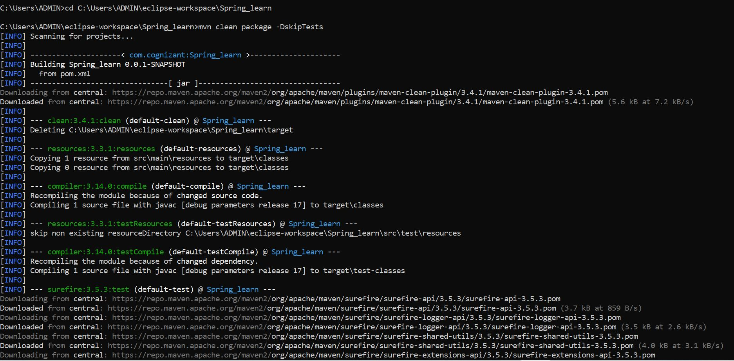
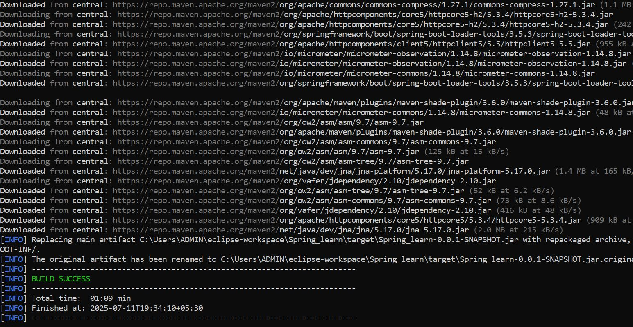

package com.cognizant.spring_learn;
import org.springframework.boot.SpringApplication;

@SpringBootApplication

public class SpringLearnApplication {
public static void main(String[] args) {
SpringApplication.run(SpringLearnApplication.class, args);
}
}

OUTPUT:
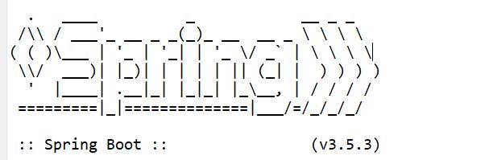
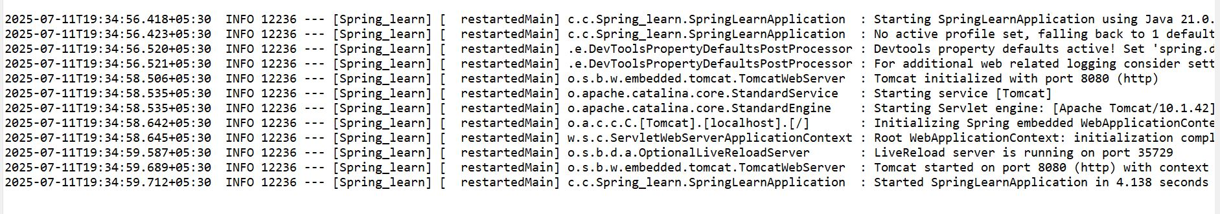

Exercise - 2: Spring Core – Load Country from Spring Configuration XML

package com.cognizant. Spring_learn;
import org.slf4j.Logger;
import org.slf4j.LoggerFactory;
public class Country
private static final Logger LOGGER = LoggerFactory.getLogger(Country.class);
private String code;
private String name;
public Country() {
}
LOGGER.debug("Inside Country Constructor");
public String getCode() {
LOGGER.debug("Getting code");
return code;
}

public void setCode(String code) {
LOGGER.debug("Setting code"); this.code = code;
}
public String getName() {
LOGGER.debug("Getting name"); return name;
}
public void setName(String name) { LOGGER.debug("Setting name"); this.name = name;
}
@Override
public String toString() {
return "Country [code=" + code + ", name=" + name + "]";
}
}

<?xml version="1.0" encoding="UTF-8"?>
<beans xmlns="http://www.springframework.org/schema/beans" xmlns:xsi="http://www.w3.org/2001/XMLSchema-instance" xsi:schemaLocation="http://www.springframework.org/schema/beans
http://www.springframework.org/schema/beans/spring-beans.xsd">
<bean id="country" class="com.cognizant. Spring_learn. Country"> <property name="code" value="IN"/>
<property name="name" value="India"/>
</bean>
</beans>

OUTPUT:
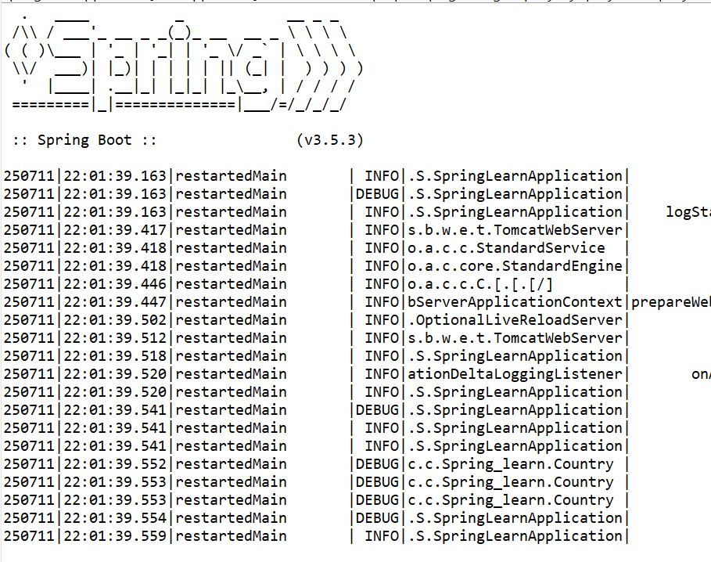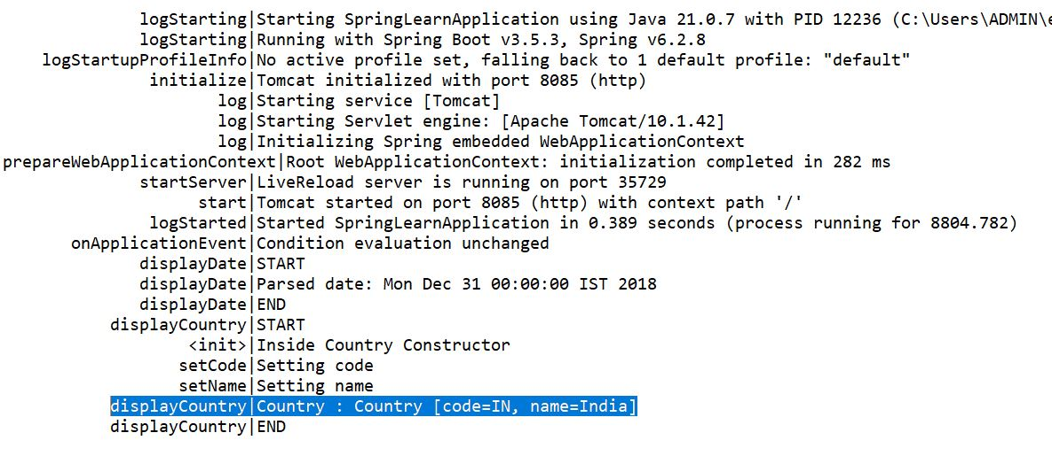

Exercise - 3: Hello World RESTful Web Service Hello World RESTful Web Service

package com.cognizant. Spring_learn.controller;
import org.slf4j.Logger;
import org.slf4j.LoggerFactory;
import org.springframework.web.bind.annotation.GetMapping;
import org.springframework.web.bind.annotation. RestController;
@RestController
public class HelloController {
private static final Logger LOGGER = LoggerFactory.getLogger (HelloController.class);
@GetMapping("/hello")
public string sayHello() {
LOGGER.info("START sayHello()");
String message = "Hello World!!";
LOGGER.info("END sayHello()");
return message;
}
}

package com.cognizant. Spring_learn;
import org.springframework.boot.SpringApplication;
import org.springframework.boot.autoconfigure. SpringBootApplication;
import org.springframework.context.annotation.ComponentScan;
@SpringBootApplication
@ComponentScan (basePackages = "com.cognizant.Spring_learn")
public class SpringLearnApplication {
public static void main(String[] args) {
SpringApplication.run(SpringLearnApplication.class, args);
}
}

OUTPUT:
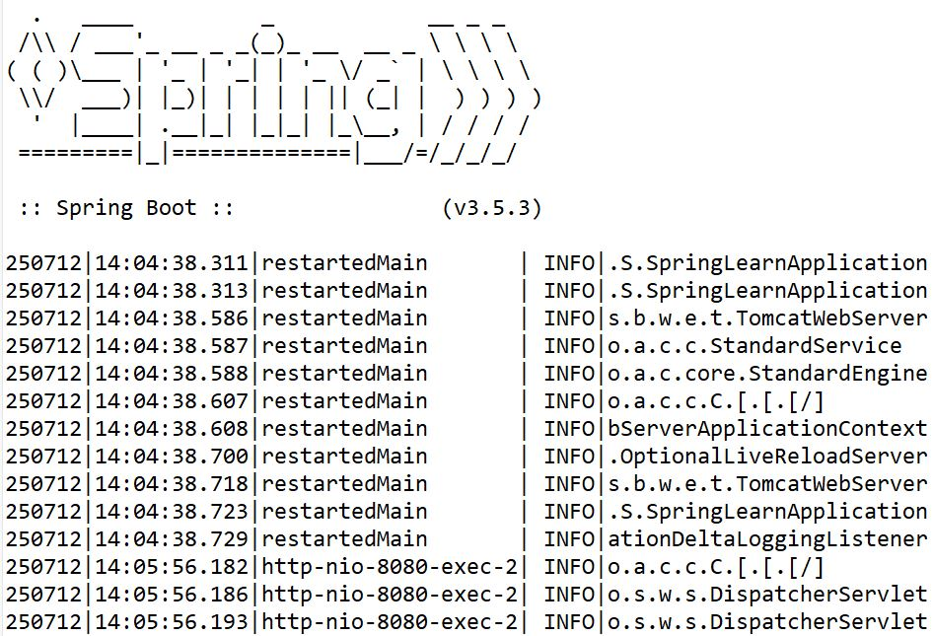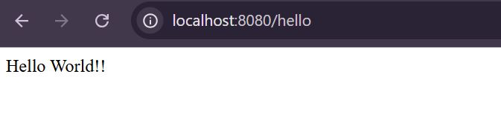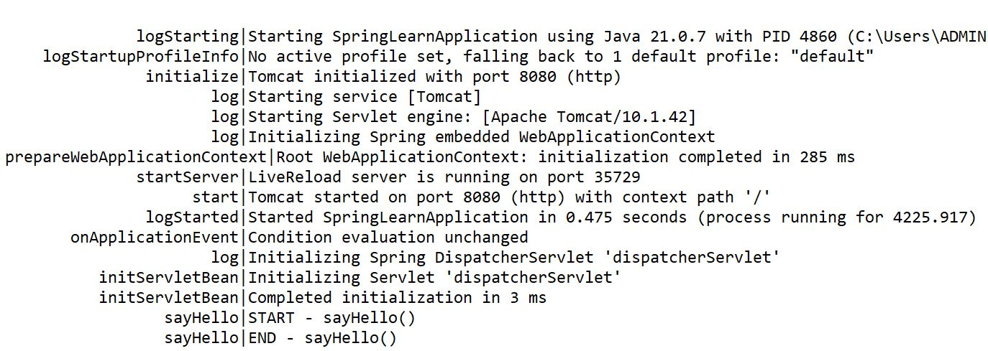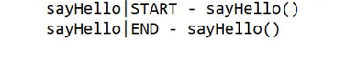

Exercise - 4: REST Country Web Service

package com.cognizant.Spring_learn;
public class Country {
private String code;
private String name;
public Country() {}
public String getCode() {
return code;
}
public void setCode(String code) {
this.code = code;
}
public String getName() {
return name;
}
public void setName(String name) {
this.name = name;
}
@Override
public String toString() {
return "Country [code=" + code + ", name=" + name + "]";
}
}

package com.cognizant.Spring_learn.controller;
import com.cognizant. Spring_learn.Country; import org.slf4j.Logger;
import org.slf4j.LoggerFactory;
import org.springframework.web.bind.annotation.GetMapping;
import org.springframework.web.bind.annotation. RestController;
@RestController
public class CountryController {
private static final Logger LOGGER = LoggerFactory.getLogger(CountryController.class);
@GetMapping("/country")
public Country getCountryIndia() { LOGGER.info("START - getCountryIndia()");
Country country = new Country();
country.setCode("IN");
country.setName("India");
LOGGER.info("END - getCountryIndia()");
return country;
}
}

OUTPUT

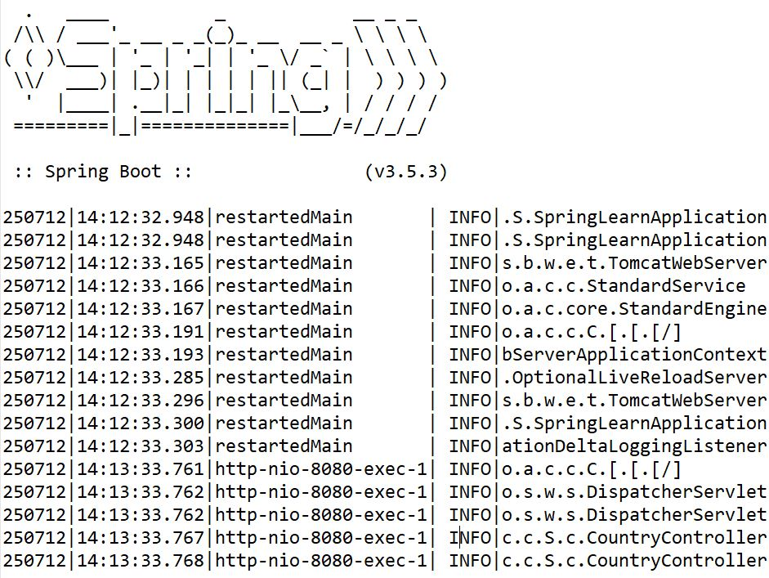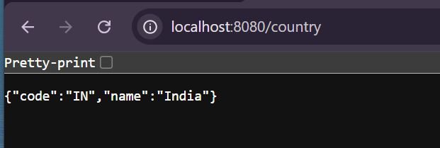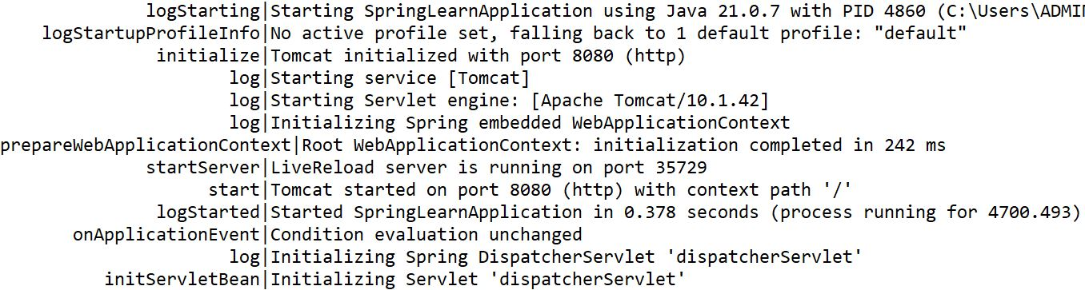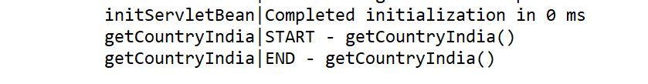

Exercise - 4: REST - Get country based on country code

http://www.springframework.org/schema/beans/spring-beans.xsd (xsi:schemaLocation) <?xml version="1.0" encoding="UTF-8"?>
<beans xmlns="http://www.springframework.org/schema/beans" xmlns:xsi="http://www.w3.org/2001/XMLSchema-instance" xsi:schemaLocation="http://www.springframework.org/schema/beans
http://www.springframework.org/schema/beans/spring-beans.xsd">
<bean id="in" class="com.cognizant.Spring_learn.Country">
<property name="code" value="IN"/>
<property name="name" value="India"/>
</bean>
<bean id="us" class="com.cognizant. Spring_learn. Country"> <property name="code" value="US"/>
<property name="name" value="United States"/>
</bean>
<bean id="cn" class="com.cognizant.Spring_learn. Country">
<property name="code" value="CN"/>
<property name="name" value="China"/>
</bean>
</beans>

package com.cognizant. Spring_learn.controller;
import com.cognizant.Spring_learn.Country;
import org.slf4j.Logger;
import org.slf4j.LoggerFactory;
import org.springframework.context.ApplicationContext;
import org.springframework.context.support.ClassPathXmlApplicationContext;
import org.springframework.web.bind.annotation.GetMapping;
import org.springframework.web.bind.annotation. PathVariable;
import org.springframework.web.bind.annotation. RestController;
@RestController
public class CountryController {
private static final Logger LOGGER = LoggerFactory.getLogger(CountryController.class);
@GetMapping("/country")
public Country getCountryIndia() {
LOGGER.info("START
getCountryIndia()");
Country country = new Country();
country.setCode("IN");
country.setName("India");
-
LOGGER.info("END getCountryIndia()");
return country;
}

@GetMapping("/countries/{code}")
public Country getCountry (@PathVariable String code) {
LOGGER.info("START - getCountry() for code: {}", code);
ApplicationContext context = new ClassPathXmlApplicationContext("country.xml"); Country country = (Country) context.getBean (code.toLowerCase());
LOGGER.info("END getCountry()");
return country;
}
}

OUTPUT:
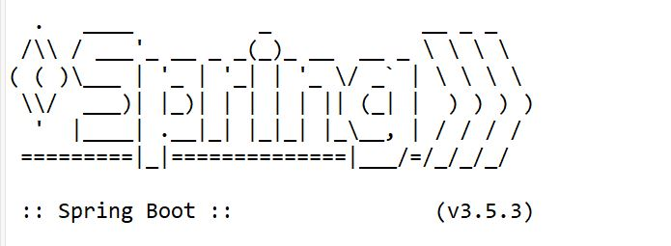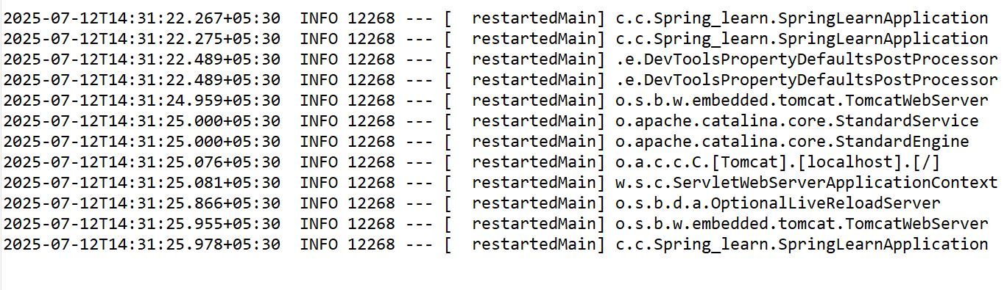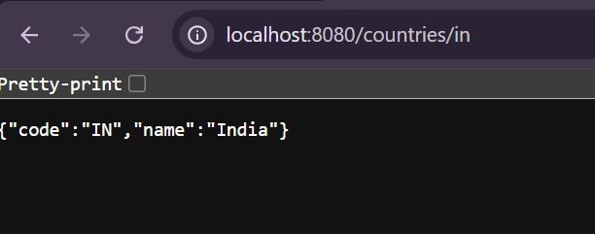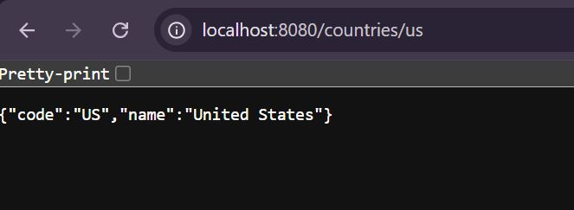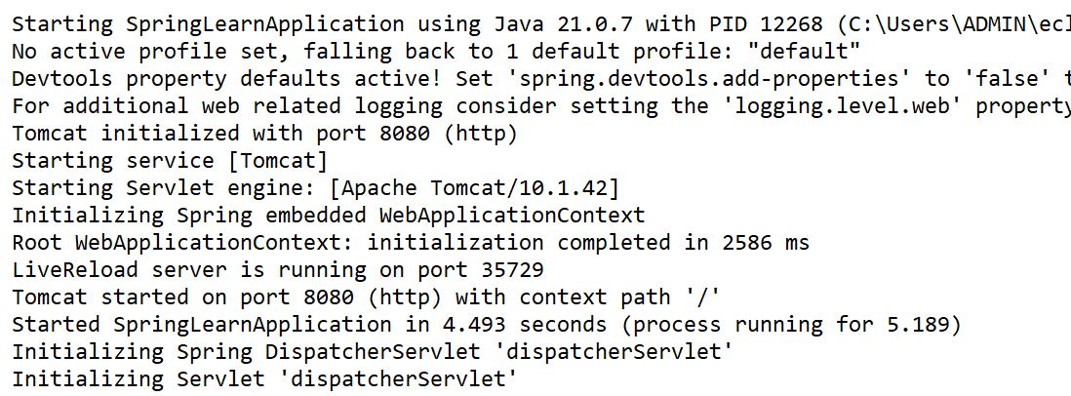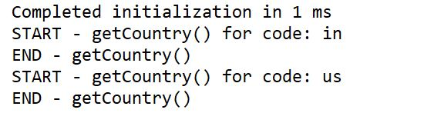

Exercise - 6: Create authentication service that returns JWT

import io.jsonwebtoken.Jwts;
import io.jsonwebtoken.SignatureAlgorithm;

import java.util.Date;
import java.util.HashMap;
import java.util.Map;

public class JwtAuthService {

private static final String SECRET_KEY = "mysecretkey123";

public static void main(String[] args) {
String username = "user1";
String token = generateToken(username);
System.out.println("Generated JWT Token: " + token);
}

public static String generateToken(String username) {
Map<String, Object> claims = new HashMap<>();
claims.put("sub", username);
claims.put("created", new Date());
return Jwts.builder()
.setClaims(claims)
.setExpiration(new Date(System.currentTimeMillis() + 1000 * 60 * 60))
.signWith(SignatureAlgorithm.HS512, SECRET_KEY.getBytes())
.compact();
}
}

OUTPUT
:

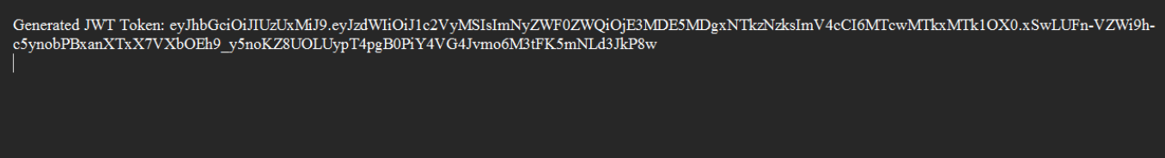

3 spring-rest-handson
(Additional)

Handson - 1: Display Employee List and Edit Employee form using RESTful Web Service

<?xml version="1.0" encoding="UTF-8"?>
<beans
xmlns="http://www.springframework.org/schema/beans" xmlns:xsi="http://www.w3.org/2001/XMLSchema-instance"
xsi:schemaLocation="
http://www.springframework.org/schema/beans
http://www.springframework.org/schema/beans/spring-beans.xsd">
<bean id="department1"
class="com.cognizant.Spring_learn.model.Department">
<property name="id" value="1" />
<property name="name" value="Human Resources" />
</bean>
<bean id="department2" class="com.cognizant.Spring_learn.model.Department">
<property name="id" value="2" />
<property name="name" value="Finance" />
</bean>
<bean id="skill1" class="com.cognizant.Spring_learn.model.Skill">
<property name="id" value="1" /> <property name="name" value="Java" />
</bean>
<bean id="skil12" class="com.cognizant.Spring_learn.model.Skill">
<property name="id" value="2" />
<property name="name" value="SQL" />
</bean>
<bean id="skil13" class="com.cognizant.Spring_learn.model.Skill">
<property name="id" value="3" />
<property name="name" value="Python" />
</bean>
<bean id="employee1" class="com.cognizant. Spring_learn.model. Employee"> <property name="id" value="1001" />
<property name="name" value="Ram" /> <property name="department" ref="department1" /> <property name="skills">
<list>
<ref bean="skill1" />
<ref bean="skill2" />
</list>
</property>
</bean>
<bean id="employee2" class="com.cognizant. Spring_learn.model.Employee"> <property name="id" value="1002" />
<property name="name" value="Kumar" /> <property name="department" ref="department2" /> <property name="skills">
<list>
<ref bean="skill2" /> <ref bean="skill3" />
</list>
</property>
</bean>
<bean id="employee3" class="com.cognizant. Spring_learn.model.Employee"> <property name="id" value="1002" />
<property name="name" value="Dinakar" /> <property name="department" ref="department2" /> <property name="skills">
<list>
<ref bean="skill3" />
</list>
</property>
</bean>
<bean id = "employeeList" class = "java.util.ArrayList">
<construstor-arg>
<list>
<ref bean = "employee1"/>
<ref bean = "employee2"/>
<ref bean = "employee3"/>
</list>
</constructor-arg>
</bean>
</beans>

package com.cognizant.Spring_learn.model;

public class Department{
private int id;
private String name;
public int getId() {
return id;
}

public Department() {}
public void setId(int id) {
this.id = id;
}
public String getName() {
return name;
}
public void setName(String name) {
this.name = name;
}
@Override
public String toString() {
return "Department [id=" + id + ", name=" + name + "]";
}

}

public com.cognizant.Spring_learn.model
public class Skill{
private int id;
private String name;
public Skill() {}
public int getId() {
return id;
}
public void setId(int id) {
this.id = id;
}
public String getName() {
return name;
}
public void setName(String name) {
this.name = name;
}
@Override
public String toString() {
return "Skill [id=" + id + ", name=" + name + "]";
}

}

package com.cognizant.orm_learn;

import java.util.List;

public class Employee{
private int id;
private String name;
private Department department;
private List<Skill> skills;

public Employee() {}

@Override
public String toString() {
return "Employee [id=" + id + ", name=" + name + ", department=" + department + ", skills=" + skills + "]";
}

public int getId() {
return id;
}

public void setId(int id) {
this.id = id;
}

public String getName() {
return name;
}

public void setName(String name) {
this.name = name;
}

public Department getDepartment() {
return department;
}

public void setDepartment(Department department) {
this.department = department;
}

public List<Skill> getSkills() {
return skills;
}

public void setSkills(List<Skill> skills) {
this.skills = skills;
}

}

package com.cognizant. Spring_learn.dao;
import com.cognizant. Spring_learn.model.Employee;
import org.springframework.context.ApplicationContext;
import org.springframework.context.support. ClassPathXmlApplicationContext; import org.springframework.stereotype. Repository;
import java.util.List;
@Repository
public class EmployeeDao {
public List<Employee> getAllEmployees () {
ApplicationContext context = new ClassPathXmlApplicationContext("employee.xml"); return context.getBean("employeeList", List.class);
}
}

package com.cognizant. Spring_learn.service;
import com.cognizant. Spring_learn.dao. EmployeeDao; import com.cognizant. Spring_learn.model.Employee;
import org.springframework.beans.factory.annotation.Autowired;
import org.springframework.stereotype.Service;
import java.util.List;
@Service
public class EmployeeService {
@Autowired
private EmployeeDao employeeDao;
public List<Employee> getAllEmployees () { return employeeDao.getAllEmployees();
}
}

package com.cognizant.Spring_learn.controller;
import com.cognizant.Spring_learn.model.Employee;
import com.cognizant. Spring_learn.service.EmployeeService;
import org.slf4j.Logger;
import org.slf4j.LoggerFactory;
import org.springframework.beans.factory.annotation.Autowired;
import org.springframework.web.bind.annotation. RestController;
import org.springframework.web.bind.annotation.GetMapping;

import java.util.List;

@RestController
public class EmployeeController {
private static final Logger LOGGER = LoggerFactory.getLogger (EmployeeController.class);
@Autowired
private EmployeeService employeeService;
@GetMapping("/employees")
public List<Employee> getAllEmployees () {
LOGGER.info("START - getAllEmployees ()");
List<Employee> employees = employeeService.getAllEmployees(); LOGGER.info("END - getAllEmployees()");
return employees;
}
OUTPUT

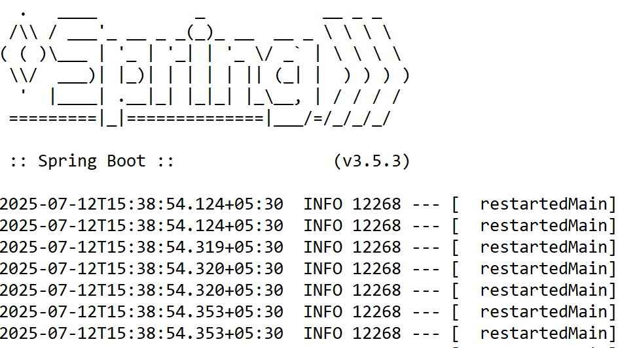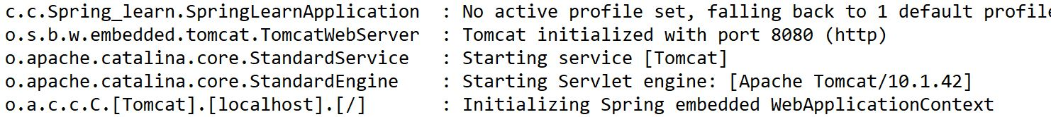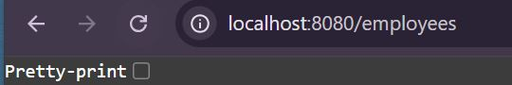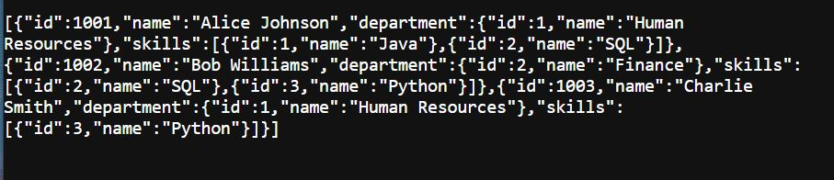

Handson - 2: Create static employee list data using spring xml configuration

package com.cognizant. Spring_learn.dao;
import com.cognizant. Spring_learn.model.Employee;
import org.springframework.context.ApplicationContext;
import org.springframework.context.support. ClassPathXmlApplicationContext; import org.springframework.stereotype. Repository;
import java.util.List;
@Repository
public class EmployeeDao {
public List<Employee> getAllEmployees () {
ApplicationContext context = new ClassPathXmlApplicationContext("employee.xml"); return context.getBean("employeeList", List.class);
for(Employee e: employeeList) {
if(e.getId() == id) return e;
}
return null;
}
}

<bean id = "employeeList" class = "java.util.ArrayList">
<construstor-arg>
<list>
<ref bean = "employee1"/>
<ref bean = "employee2"/>
<ref bean = "employee3"/>
</list>
</constructor-arg>
</bean>
</beans>

package com.cognizant. Spring_learn.service;
import com.cognizant. Spring_learn.dao. EmployeeDao; import com.cognizant. Spring_learn.model.Employee;
import org.springframework.beans.factory.annotation.Autowired;
import org.springframework.stereotype.Service;
import java.util.List;
@Service
public class EmployeeService {
@Autowired
private EmployeeDao employeeDao;
public List<Employee> getAllEmployees () { return employeeDao.getAllEmployees();
}
}

package com.cognizant.Spring_learn.controller;
import com.cognizant.Spring_learn.model.Employee;
import com.cognizant. Spring_learn.service.EmployeeService;
import org.slf4j.Logger;
import org.slf4j.LoggerFactory;
import org.springframework.beans.factory.annotation.Autowired;
import org.springframework.web.bind.annotation. RestController;
import org.springframework.web.bind.annotation.GetMapping;

import java.util.List;

@RestController
public class EmployeeController {
private static final Logger LOGGER = LoggerFactory.getLogger (EmployeeController.class);
@Autowired
private EmployeeService employeeService;
@GetMapping("/employees")
public List<Employee> getAllEmployees () {
LOGGER.info("START - getAllEmployees ()");
List<Employee> employees = employeeService.getAllEmployees(); LOGGER.info("END - getAllEmployees()");
return employees;
}
@GetMapping("/employees")
public List<Employee> getAllEmployees () {
}
LOGGER.info("START - getAllEmployees()");
List<Employee> employees = employeeService.getAllEmployees(); LOGGER.info("END getAllEmployees ()");
return employees;
-
@GetMapping("/employees/{id}")
public Employee getEmployeeById(@PathVariable int id) { LOGGER.info("START - getEmployeeById({})", id);
Employee employee = employeeService.getEmployeeById(id); LOGGER.info("END-getEmployeeById” );
return employee;
}
}

OUTPUT:
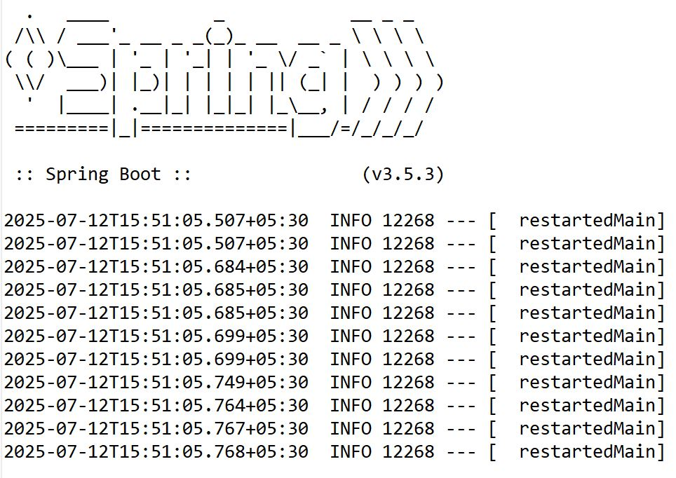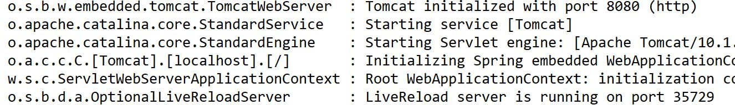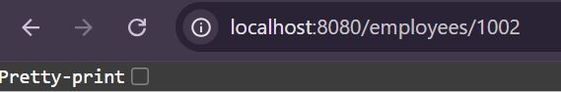

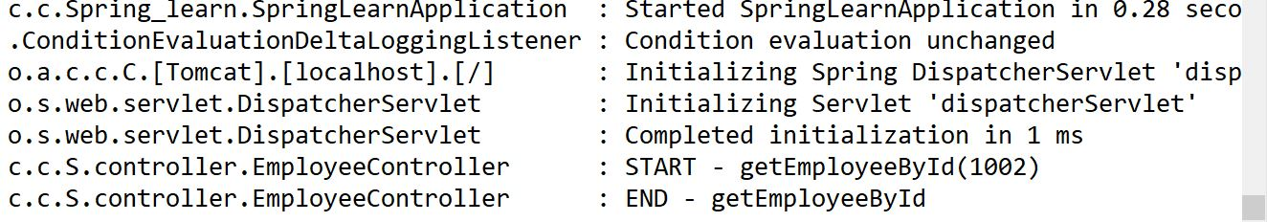
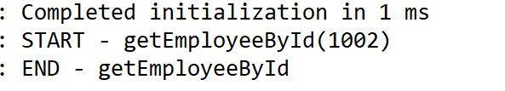

Handson - 3: Create REST service to gets all employees

package com.cognizant.Spring_learn.dao;
import com.cognizant. Spring_learn.model.Employee; import org.springframework.context.ApplicationContext;
import org.springframework.context.support.
ClassPathXmlApplicationContext;
import org.springframework. stereotype. Repository;
import java.util.List;
@Repository
public class EmployeeDao {
private static List<Employee> employeeList;
public List<Employee> getAllEmployees() {
if (employeeList == null) { ApplicationContext context = new
}
ClassPathXmlApplicationContext("employee.xml");
employeeList = context.getBean("employeeList", List.class);
return employeeList;
}
public Employee getEmployeeById(int id) {
List<Employee> list = getAllEmployees();
for(Employee e : list) {
if(e.getId() == id) return e;
}
return null;
}
}

package com.cognizant. Spring_learn.service;
import com.cognizant. Spring_learn.dao. EmployeeDao; import com.cognizant. Spring_learn.model.Employee;
import org.springframework.beans.factory.annotation.Autowired;
import org.springframework.stereotype.Service;
import java.util.List;
@Service
public class EmployeeService {
@Autowired
private EmployeeDao employeeDao;
public List<Employee> getAllEmployees () { return employeeDao.getAllEmployees();
}
}

package com.cognizant.Spring_learn.controller;
import com.cognizant.Spring_learn.model.Employee;
import com.cognizant. Spring_learn.service.EmployeeService;
import org.slf4j.Logger;
import org.slf4j.LoggerFactory;
import org.springframework.beans.factory.annotation.Autowired;
import org.springframework.web.bind.annotation. RestController;
import org.springframework.web.bind.annotation.GetMapping;

import java.util.List;

@RestController
public class EmployeeController {
private static final Logger LOGGER = LoggerFactory.getLogger (EmployeeController.class);
@Autowired
private EmployeeService employeeService;
@GetMapping("/employees")
public List<Employee> getAllEmployees () {
LOGGER.info("START - getAllEmployees ()");
List<Employee> employees = employeeService.getAllEmployees(); LOGGER.info("END - getAllEmployees()");
return employees;
}
@GetMapping("/employees")
public List<Employee> getAllEmployees () {
}
LOGGER.info("START - getAllEmployees()");
List<Employee> employees = employeeService.getAllEmployees(); LOGGER.info("END getAllEmployees ()");
return employees;
-
@GetMapping("/employees/{id}")
public Employee getEmployeeById(@PathVariable int id) { LOGGER.info("START - getEmployeeById({})", id);
Employee employee = employeeService.getEmployeeById(id); LOGGER.info("END-getEmployeeById” )
return employee;
}
}

OUTPUT:
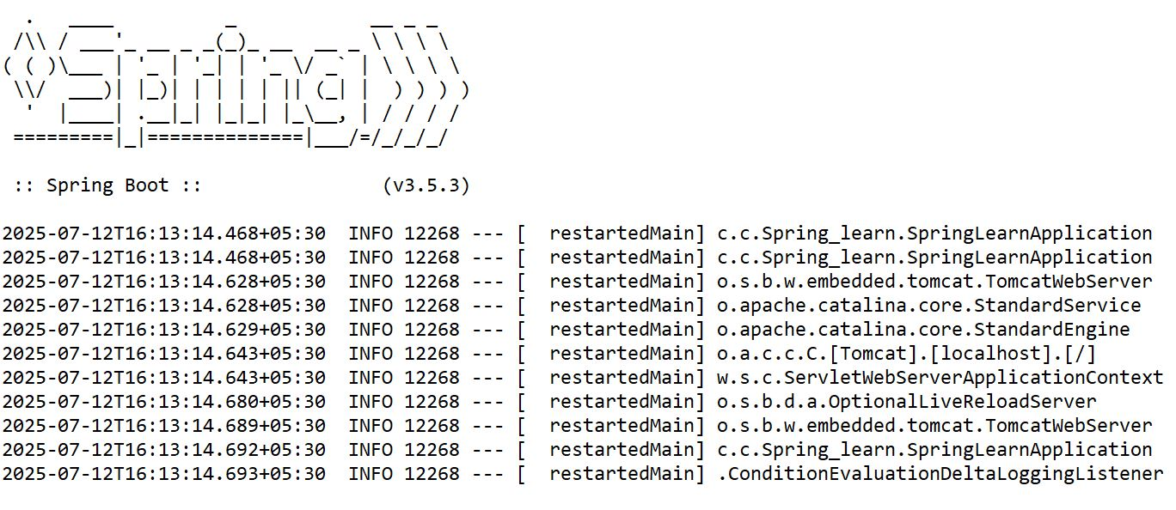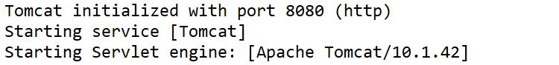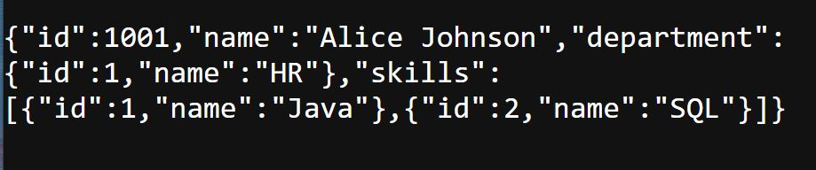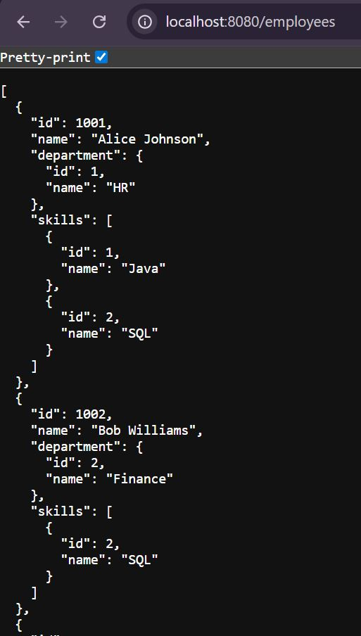

Exercise 3.2) REST - Add New Employee (POST)

package com.cognizant. Spring_learn.dao;
import com.cognizant.Spring_learn.model.Employee;
import org.springframework.context.ApplicationContext;
import org.springframework.context.support.ClassPathXmlApplicationContext;
import org.springframework.stereotype.Repository;
import java.util.List;
@Repository
public class EmployeeDao {
private static List<Employee> employeeList;
public List<Employee> getAllEmployees () {
if (employeeList == null) {
ApplicationContext context = new ClassPathXmlApplicationContext("employee.xml");
employeeList = context.getBean("employeeList", List.class);
}
return employeeList;
}
public Employee getEmployeeById(int id) {
List<Employee> list = getAllEmployees(); for (Employee e : list) {
if (e.getId()==id) {
return e;
}
}
return null;
}

public void addEmployee (Employee employee) {
getAllEmployees().add(employee);
}
}

package com.cognizant.Spring_learn.service;
import org.springframework.beans.factory.annotation.Autowired;
import org.springframework.stereotype.Service;

import com.cognizant.Spring_learn.dao.EmployeeDao;
@Service
public class EmployeeService {
@Autowired
private EmployeeDao employeeDao;
public List<Employee> getAllEmployees () {
return employeeDao.getAllEmployees();
}
public Employee getEmployeeById(int id) {
return employeeDao.getEmployeeById(id);
}
public void addEmployee (Employee employee) {
employeeDao.addEmployee (employee);
}
}

package com.cognizant.Spring_learn.controller;

import com.cognizant.Spring_learn.model.Employee;
import com.cognizant.Spring_learn.service.EmployeeService;
import org.slf4j.Logger;
import org.slf4j.LoggerFactory;
import org.springframework.beans.factory.annotation.Autowired;
import org.springframework.web.bind.annotation.GetMapping;
import org.springframework.web.bind.annotation.RestController;
import org.springframework.web.bind.annotation.PathVariable;
import org.springframework.web.bind.annotation.RequestBody;
import org.springframework.web.bind.annotation.PostMapping;
import java.util.List;

@RestController
public class EmployeeController{
private static final Logger logger = LoggerFactory.getLogger(EmployeeController.class);
@Autowired
private EmployeeService employeeService;
@GetMapping("/employees")
public List<Employee> getAllEmployees(){
logger.info("START - getAllEmployees()");
List<Employee> employeeList = employeeService.getAllEmployees();
logger.info("END - getAllEmployees()");
return employeeList;
}
@GetMapping("/employees/{id}")
public Employee getEmployeeById(@PathVariable int id) {
logger.info("START - getEmployeeById({})", id);
logger.info("END - getEmployeeById");
return employee;
}
@PostMapping("/employees")
public void addEmployee(@RequestBody Employee employee) {
logger.info("START - addEmployee()");
employeeService.addEmployee(employee);
logger.info("END - addEmployee()");
}
}

OUTPUT:
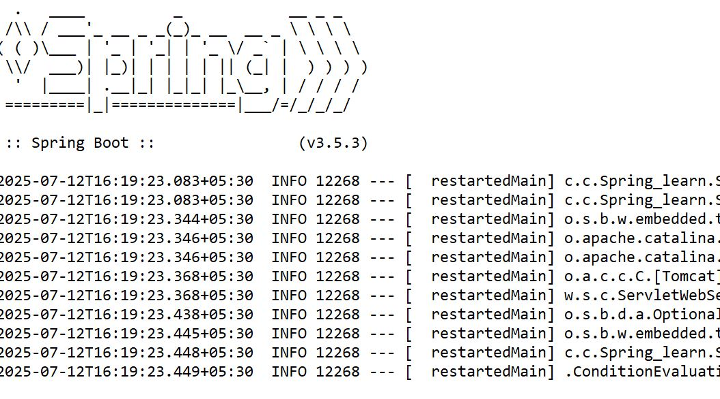
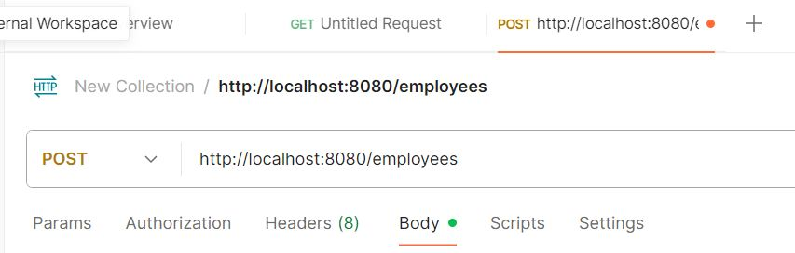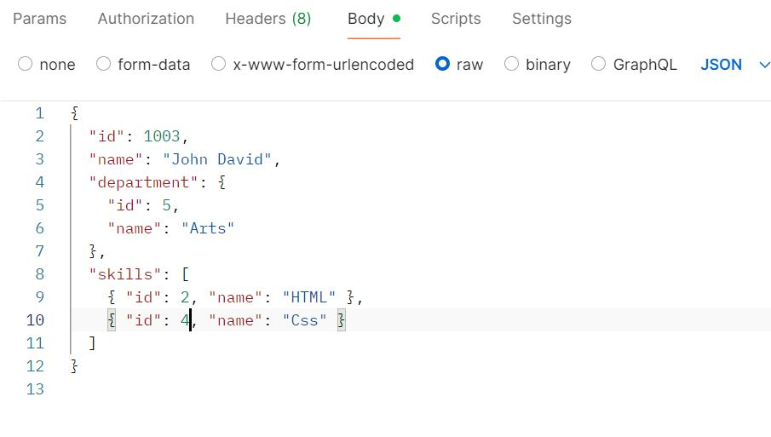
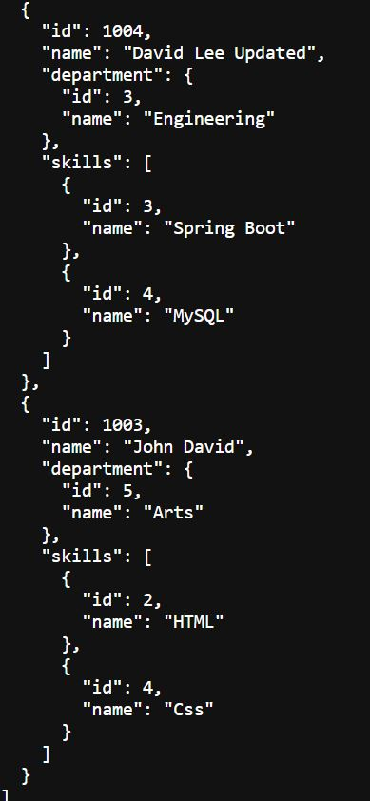
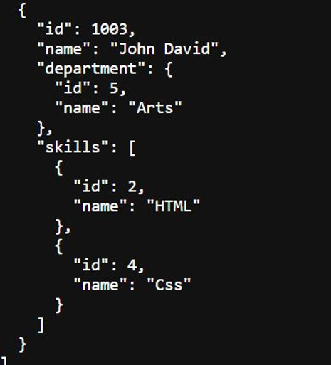
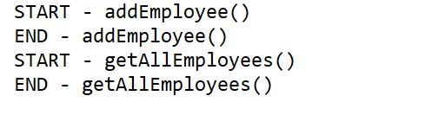

Exercise 3.3) PUT – Update existing employee

package com.cognizant. Spring_learn.controller;
import com.cognizant. Spring_learn.model.Employee;
@RestController
public class EmployeeController {
private static final Logger LOGGER = LoggerFactory. getLogger(EmployeeController.class);
@Autowired
private Employee Service employeeService;
@GetMapping("/employees")
public List<Employee> getAllEmployees () {
LOGGER.info("START - getAllEmployees ()");
List<Employee> employeeList = employeeService.getAllEmployees();
LOGGER.info("END - getAllEmployees ()");
return employeeList;
}
@GetMapping("/employees/{id}")
public Employee getEmployeeById(@PathVariable int id) {
LOGGER.info("START - get EmployeeById({})", id);
}
Employee employee = employeeService.getEmployeeById(id);
LOGGER.info("END getEmployeeById");
return employee;
-
@PostMapping("/employees")
public void add Employee (@RequestBody Employee employee) {
LOGGER.info("START - add Employee()");
employeeService.addEmployee (employee);
LOGGER.info("END - addEmployee()");
}
@PutMapping("/employees")
public void update Employee (@RequestBody Employee employee) {
LOGGER.info("START - updateEmployee()");
LOGGER.debug("Employee to update: {}", employee);
employeeService.updateEmployee (employee);
LOGGER.info("END - updateEmployee()");
}
}

package com.cognizant.Spring_learn.service;
import org.springframework.beans.factory.annotation.Autowired;
import org.springframework.stereotype.Service;

import com.cognizant.Spring_learn.dao.EmployeeDao;
@Service
public class EmployeeService {
@Autowired
private EmployeeDao employeeDao;
public List<Employee> getAllEmployees () {
return employeeDao.getAllEmployees();
}
public Employee getEmployeeById(int id) {
return employeeDao.getEmployeeById(id);
}
public void addEmployee (Employee employee) {
employeeDao.addEmployee (employee);
}
public void updateEmployee(Employee employee) {
Object employeeDao;
List<Employee> employees = employeeDao.getAllEmployees();
for(int i = 0; i < employees.size(); i++) {
if(employees.get(i).getId() == employee.getId()) {
employees.set(i, employee);
return;
}
}
}

OUTPUT:
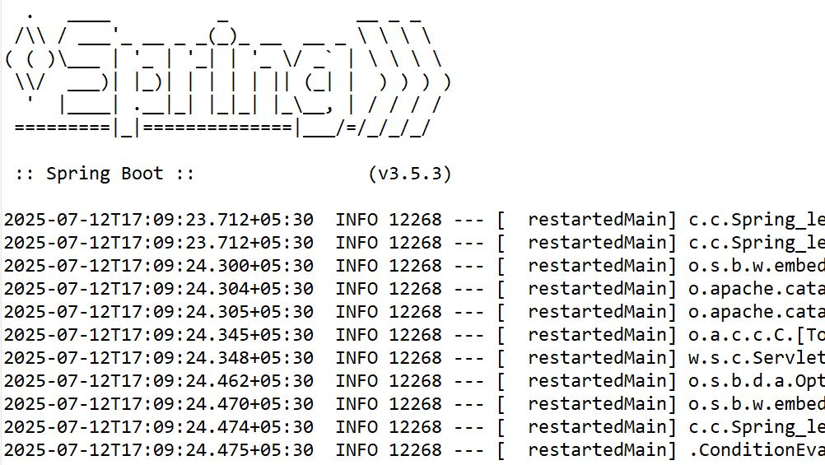
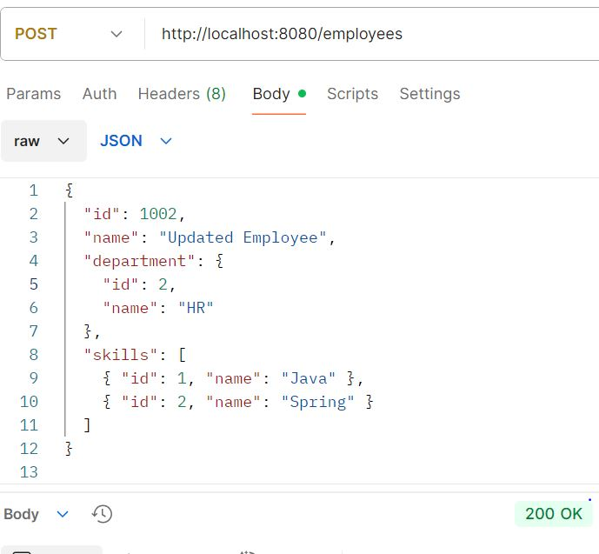
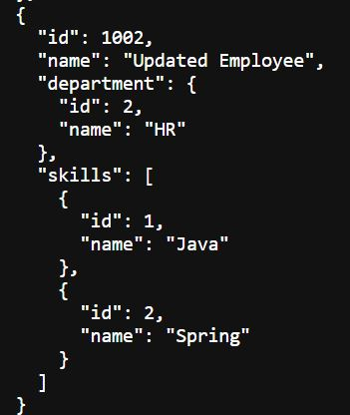
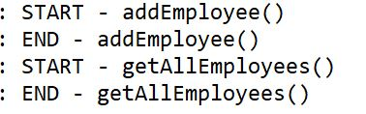

Handson 3.4) DELETE – Remove an Employee by ID

package com.cognizant. Spring_learn.controller;
import com.cognizant. Spring_learn.model.Employee;
@RestController
public class EmployeeController {
private static final Logger LOGGER = LoggerFactory. getLogger(EmployeeController.class);
@Autowired
private Employee Service employeeService;
@GetMapping("/employees")
public List<Employee> getAllEmployees () {
LOGGER.info("START - getAllEmployees ()");
List<Employee> employeeList = employeeService.getAllEmployees();
LOGGER.info("END - getAllEmployees ()");
return employeeList;
}
@GetMapping("/employees/{id}")
public Employee getEmployeeById(@PathVariable int id) {
LOGGER.info("START - get EmployeeById({})", id);
Employee employee = employeeService.getEmployeeById(id);
LOGGER.info("END getEmployeeById");
return employee;
}
@PostMapping("/employees")
public void add Employee (@RequestBody Employee employee) {
LOGGER.info("START - add Employee()");
employeeService.addEmployee (employee);
LOGGER.info("END - addEmployee()");
}
@PutMapping("/employees")
public void update Employee (@RequestBody Employee employee) {
LOGGER.info("START - updateEmployee()");
LOGGER.debug("Employee to update: {}", employee);
employeeService.updateEmployee (employee);
LOGGER.info("END - updateEmployee()");
}
@DeleteMapping("/employees/{id}")
public Employee deleteEmployeeById(@PathVariable int id) {
LOGGER.info("START - delete EmployeeById({})", id);
employeeService.deleteEmployeeById(id);
LOGGER.info("END deleteEmployeeById");
}

}

package com.cognizant.Spring_learn.service;
import org.springframework.beans.factory.annotation.Autowired;
import org.springframework.stereotype.Service;

import com.cognizant.Spring_learn.dao.EmployeeDao;
@Service
public class EmployeeService {
@Autowired
private EmployeeDao employeeDao;
public List<Employee> getAllEmployees () {
return employeeDao.getAllEmployees();
}
public Employee getEmployeeById(int id) {
return employeeDao.getEmployeeById(id);
}
public void addEmployee (Employee employee) {
employeeDao.addEmployee (employee);
}
public void updateEmployee(Employee employee) {
List<Employee> employees =
employeeDao.getAllEmployees();
for(int i = 0; i < employees.size(); i++) {
if(employees.get(i).getId() == employee.getId()) {
employees.set(i, employee);
return;
}
}
public void deleteEmployee(int id){
employeeDao.deleteEmployee (id);
}
}

package com.cognizant.Spring_learn.dao;
import com.cognizant. Spring_learn.model.Employee; import org.springframework.context.ApplicationContext;
import org.springframework.context.support.
ClassPathXmlApplicationContext;
import org.springframework. stereotype. Repository;
import java.util.List;
@Repository
public class EmployeeDao {
private static List<Employee> employeeList;
public List<Employee> getAllEmployees() {
if (employeeList == null) { ApplicationContext context = new
}
ClassPathXmlApplicationContext("employee.xml");
employeeList = context.getBean("employeeList", List.class);
return employeeList;
}
public Employee getEmployeeById(int id) {
List<Employee> list = getAllEmployees();
for(Employee e : list) {
if(e.getId() == id) return e;
}
return null;
}
public void addEmployee(Employee employee) {
getAllEmployees().add(employee);
}

public void deleteEmployee(int id) {
List<Employee> employees = getAllEmployees();
employees.removeIf(e -> e.getId() == id);
}

}

OUTPUT:
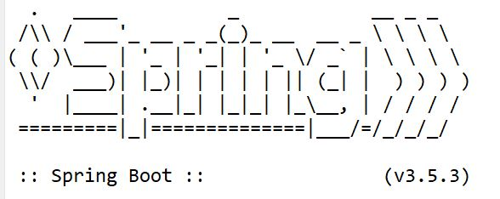
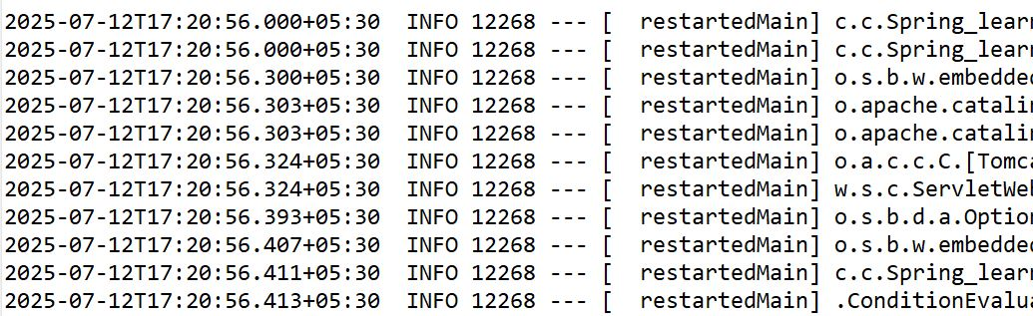
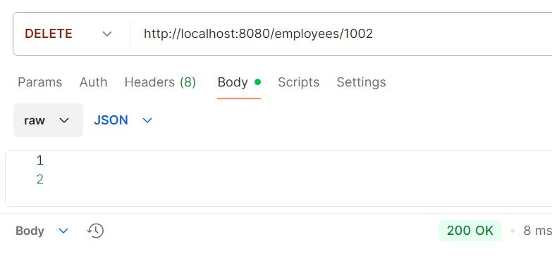
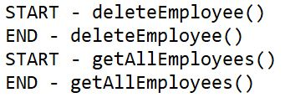

Handson - 5: Create REST service for department

<?xml version="1.0" encoding="UTF-8"?>
<beans xmlns="http://www.springframework.org/schema/beans"
xmlns:xsi="http://www.w3.org/2001/XMLSchema-instance"
xsi:schemaLocation="http://www.springframework.org/schema/beans
https://www.springframework.org/schema/beans/spring-beans.xsd">
<bean id="department List" class="java.util.ArrayList">
<constructor-arg>
<list>
<bean class="com.cognizant. Spring_learn.model. Department">
<property name="id" value="1"/>
<property name="name" value="HR"/>
</bean>
<bean class="com.cognizant. Spring_learn.model.Department">
<property name="id" value="2"/>
<property name="name" value="Finance"/>
</bean>
</list>
</constructor-arg>
</bean>
</beans>

package com.cognizant.Spring_learn.model;

public class Department{
private int id;
private String name;
public int getId() {
return id;
}

public Department() {}
public void setId(int id) {
this.id = id;
}
public String getName() {
return name;
}
public void setName(String name) {
this.name = name;
}
@Override
public String toString() {
return "Department [id=" + id + ", name=" + name + "]";
}

}

package com.cognizant. Spring_learn.service;
import java.util.List;
import org.springframework.beans.factory.annotation. Autowired;
import org.springframework. stereotype.Service;
import org.springframework.beans.factory.annotation.Qualifier;
import com.cognizant. Spring_learn.model.Department;
@Service
public class DepartmentService {
@Autowired
@Qualifier("departmentList")
private List<Department> departmentList;
public List<Department> getAllDepartments() {
return departmentList;
}
}

package com.cognizant. Spring_learn.controller;
import java.util.List;
import org.springframework.beans.factory.annotation.Autowired;
import org.springframework.web.bind.annotation.GetMapping;
import org.springframework.web.bind.annotation. RestController;
import com.cognizant.Spring_learn.model.Department;
import com.cognizant. Spring_learn.service.DepartmentService;
@RestController
public class DepartmentController {
@Autowired
private DepartmentService departmentService;
@GetMapping("/departments")
public List<Department> getAllDepartments() {
return departmentService.getAllDepartments();
}
}

OUTPUT:
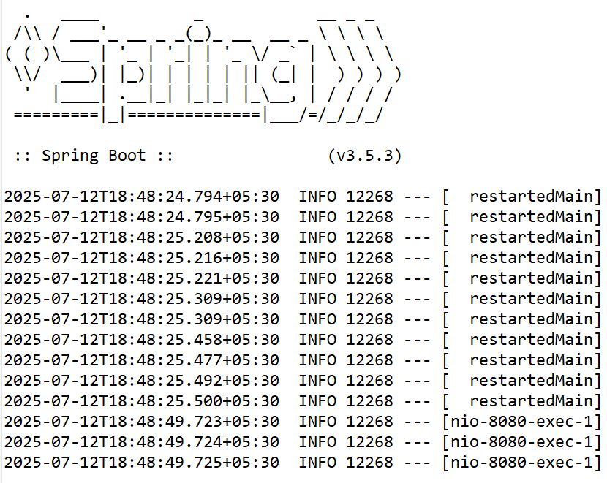
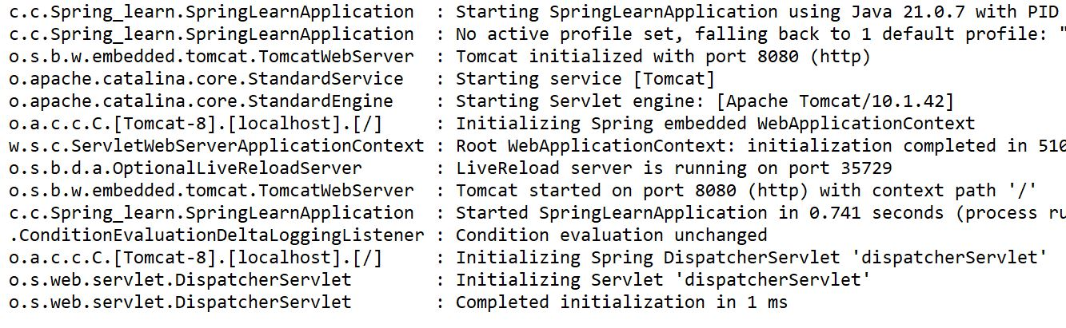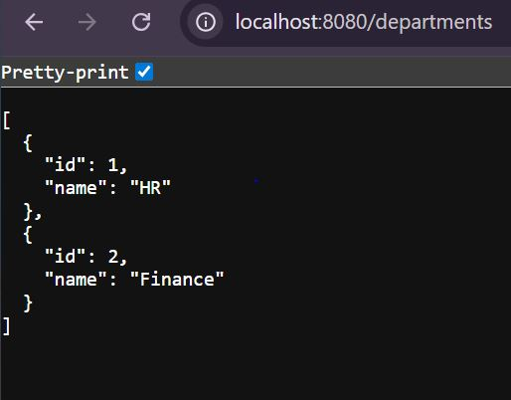
package com.cognizant.Spring_learn;
import org.springframework.boot.SpringApplication;
import org.springframework.boot.autoconfigure.SpringBootApplication;
import org.springframework.context.annotation.aspectj.ImportResource;

@SpringBootApplication
@ImportResource("classpath:department.xml")
public class SpringLearnApplication{
public static void main(String[] args) {
SpringApplication.run(SpringLearnApplication.class, args)
}
}

