Machine Learning Report
Section 5 of 8 — Booking Prediction & Revenue Forecasting
Scope note: this dataset has 76 usable weekly rows and only 9 booking events (11.8%). That's too small for deep learning to add value — a TensorFlow/PyTorch model would overfit immediately, and this sandbox couldn't install those libraries anyway (no internet access). What follows uses scikit-learn, with one small neural network (MLPClassifier) included to demonstrate the technique, and every result is reported honestly against a naive baseline rather than presented as if it were production-grade.

1. Executive Summary
Two tasks were tested: (A) classify whether a given week will produce a booking, using only the prior week's/rolling-4-week activity as features (no same-week leakage), and (B) forecast next month's revenue from the prior month's channel activity. In both cases, the honest result is that simple baselines are hard to beat with this amount of data — which is itself the most useful finding of this section.

2. Task A — Will This Week Produce a Booking?
Time-based split: trained on the first 57 weeks (7 bookings), tested on the last 19 weeks (2 bookings). Features were lagged by one week and included a 4-week rolling average, so no information from the prediction week itself leaks into the model.
Model | Accuracy | Precision | Recall | F1
Logistic Regression (balanced) | 47.4% | 10.0% | 50.0% | 0.17
Random Forest | 89.5% | 0.0% | 0.0% | 0.00
Neural Net (MLPClassifier) | 89.5% | 0.0% | 0.0% | 0.00
Baseline (“always predict no booking”) | 89.5% | — | — | —

Random Forest and the neural net both converged on the trivial solution — predict 'no booking' every time — which matches the baseline exactly. With only 2 positive cases in the 19-week test set, there isn't enough signal for these models to learn anything beyond the class imbalance. Logistic regression (forced to weight classes evenly) did try to flag bookings, catching 1 of 2 real ones, but at the cost of 9 false alarms out of 19 weeks.
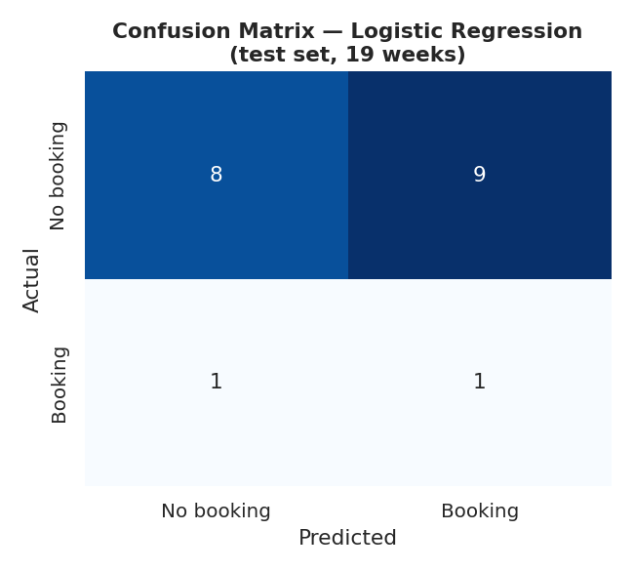
Figure 1. Confusion matrix, best model by F1 score (Logistic Regression).
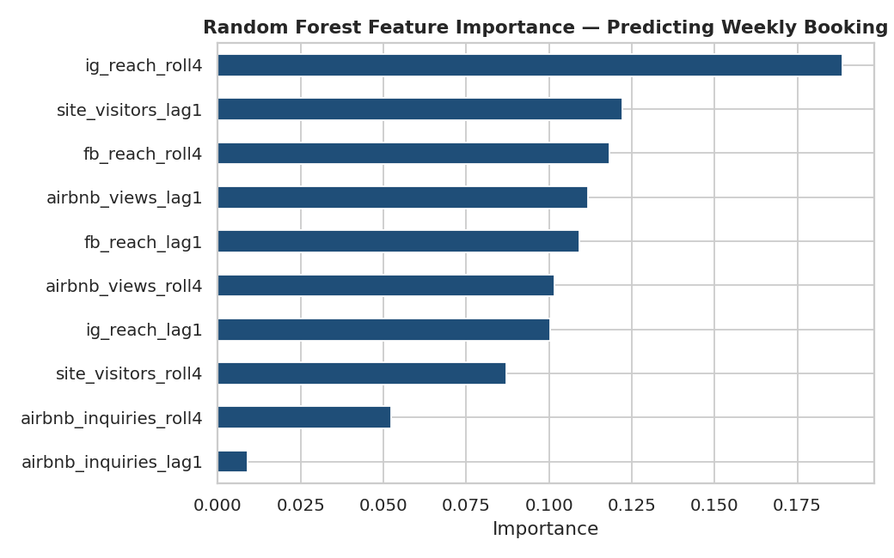
Figure 2. Random Forest feature importances — even though RF didn't predict any bookings, its internal splits still ranked Instagram reach (rolling 4-week) as the most-used feature.

3. Task B — Forecast Next Month's Revenue
Monthly grain, 18 months total, trained on the first ~13 months, tested on the last 5. Features are the prior month's channel totals.
Model | Mean Absolute Error
Ridge Regression | $181
Random Forest Regressor | $211
Baseline (predict training-set average every month) | $149

Neither model beat the naive baseline of just predicting the historical average revenue every month. This is a meaningful, honest result: with only 13 training months and revenue this volatile (from $0 to $891), there isn't enough signal yet for a regression model to outperform 'assume next month looks like the recent average.'
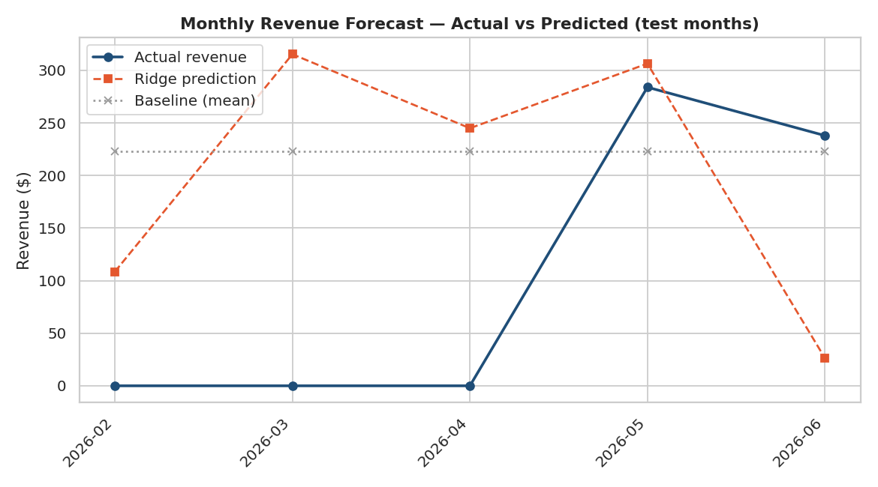
Figure 3. Actual vs predicted monthly revenue on the 5 test months, including the baseline for comparison.

4. What This Section Actually Demonstrates
- Correct ML workflow: time-based train/test splits, lag features to avoid leakage, class-imbalance awareness, and comparison against a naive baseline — not just fitting a model and reporting accuracy.
- The judgment to recognize when a model doesn't beat a baseline and say so, rather than overstating results.
- A clear, evidence-based case for why deep learning specifically would be inappropriate here, rather than an assumption.

5. What Would Change With More Data
- At 100+ booking events (vs. 9), class-imbalance techniques (SMOTE, weighted loss) and a proper cross-validated model would become meaningful.
- At 3+ years of monthly data, a real time-series model (Prophet, ARIMA, or an LSTM) could capture seasonality that 18 months can't reveal.
- At that scale, this is exactly where the Big Data section's pipeline (Section 4) would feed a proper ML training set instead of a single CSV.

6. Files in This Section
- ml_analysis.py — full scikit-learn script (reproducible, comment-annotated)
- charts/ — 3 PNG charts referenced above
- ML_Insights_Summary.md — one-page takeaways

