Python Analytics Report
Section 3 of 7 — Pandas EDA, Visualization & Correlation Analysis

1. Executive Summary
Using pandas for data wrangling and matplotlib/seaborn for visualization, this section merges all four weekly channels into a single dataframe and tests, statistically, what the Excel and SQL sections observed by eye: does social reach actually move bookings?
Answer: no. The correlation between weekly Facebook/Instagram reach and weekly bookings is effectively zero (r = -0.06 and -0.04). The only variables meaningfully correlated with bookings are further down the same funnel (inquiries, revenue) — not upstream traffic.

2. Method
- Loaded facebook_weekly.csv, instagram_weekly.csv, website_weekly.csv, airbnb_weekly.csv (exported from the SQL database in Section 2) into pandas DataFrames.
- Merged on week_date into one unified weekly dataframe (77-80 weeks).
- Aggregated to monthly for trend charts; kept weekly grain for correlation and rolling-average analysis.

3. Charts & Findings

3.1 Social Reach Trend
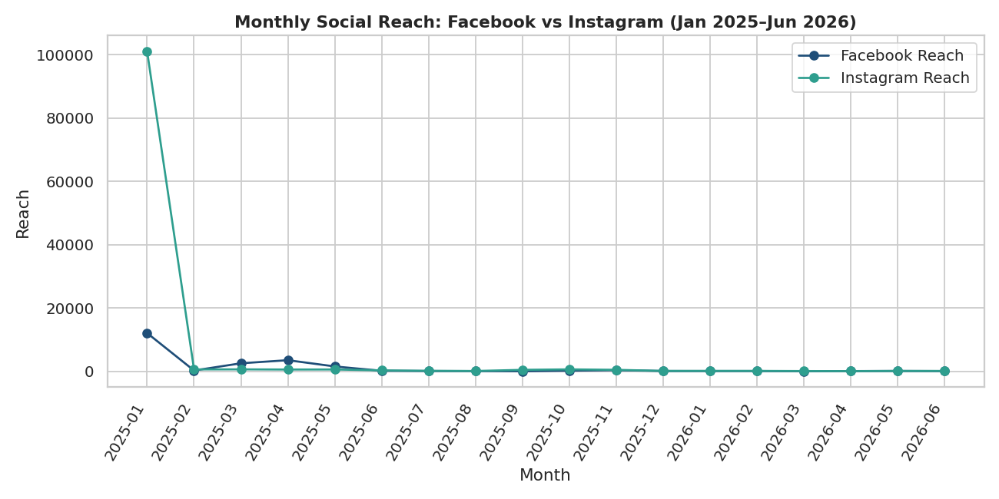
Figure 1. Facebook and Instagram reach by month, Jan 2025–Jun 2026.
Both channels spike in January 2025 (a single boosted post, per the raw data notes) then fall to a much lower steady state. Facebook never recovers; Instagram is noisier but sustains somewhat higher average reach.

3.2 Website Growth
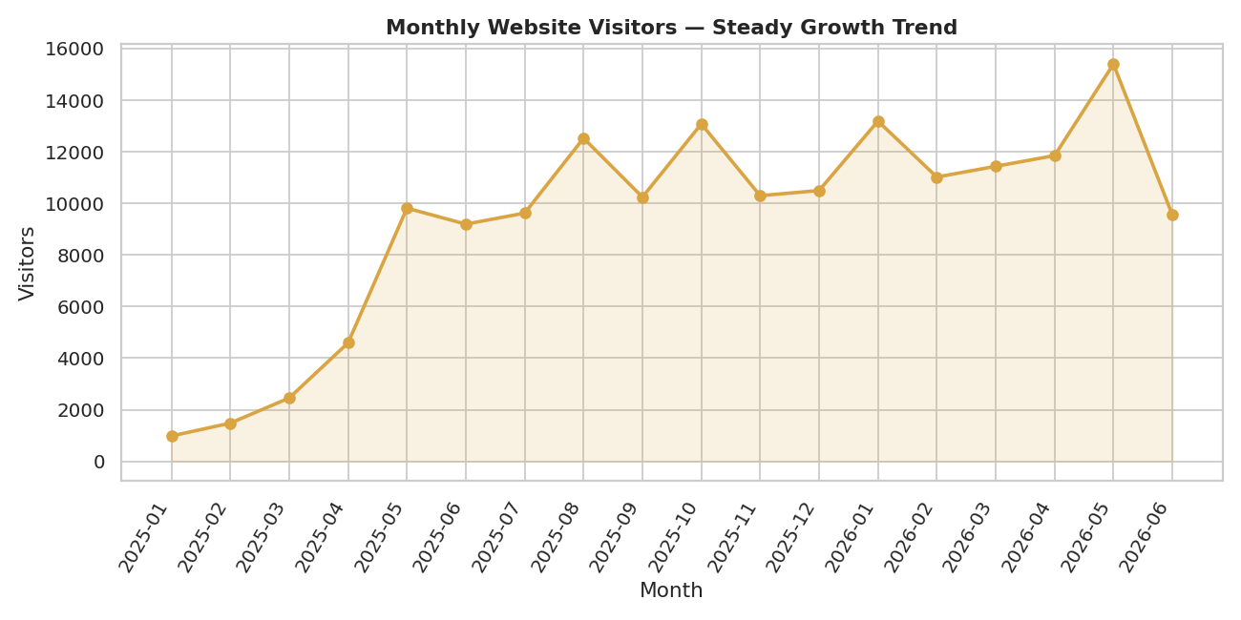
Figure 2. Website visitors by month — the one channel with a clear, sustained upward trend.

3.3 Booking Funnel
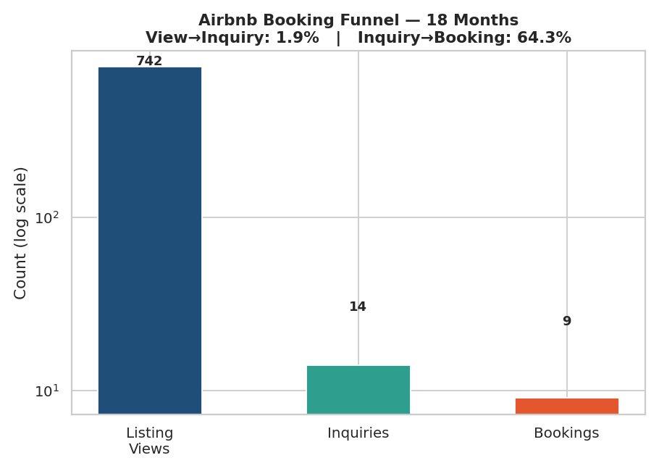
Figure 3. 742 listing views produced 14 inquiries (1.89%), which produced 9 bookings (64.29%). Log scale.
This chart makes the funnel shape immediately visible: the drop from views to inquiries dwarfs the drop from inquiries to bookings.

3.4 Monthly Revenue
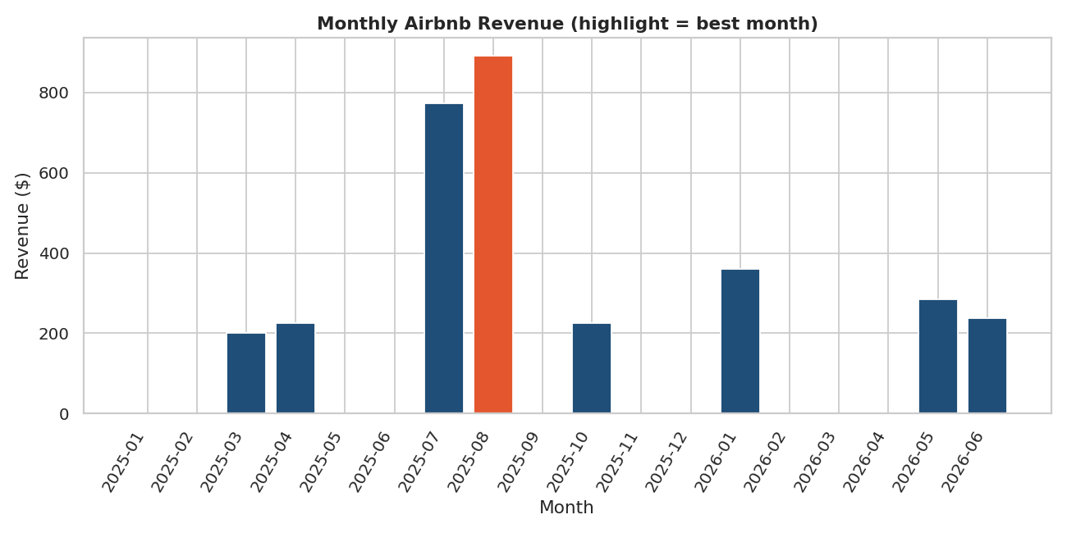
Figure 4. Monthly Airbnb revenue; August 2025 (highlighted) was the strongest month.

3.5 Cross-Channel Correlation
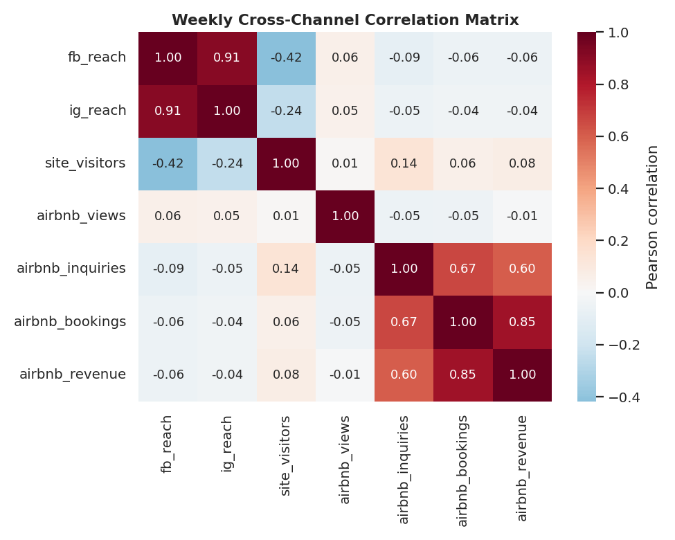
Figure 5. Pearson correlation matrix across all weekly metrics.
Metric | Correlation with Bookings
Airbnb revenue | +0.85
Airbnb inquiries | +0.67
Website visitors | +0.06 (negligible)
Instagram reach | −0.04 (negligible)
Airbnb views | −0.05 (negligible)
Facebook reach | −0.06 (negligible)

The only strong correlations with bookings are metrics that are structurally downstream of bookings already (revenue, inquiries). Every upstream traffic/reach metric is statistically unrelated to whether a given week produces a booking.

3.6 Facebook Reach — Smoothing the Noise
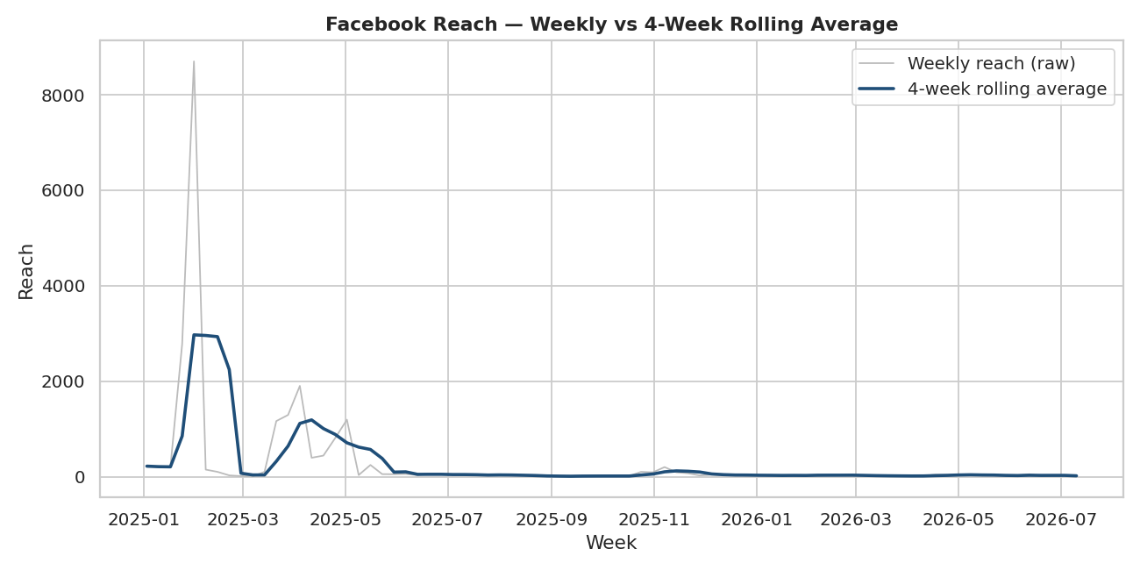
Figure 6. Raw weekly Facebook reach vs 4-week rolling average, confirming the Feb 2025 collapse is structural, not noise.

4. Recommendations
- Stop using social reach as a proxy for booking performance in reporting — statistically, in this dataset, it isn't one.
- Redirect analysis effort (and possibly ad spend) toward understanding what drives the 1.89% view-to-inquiry rate, since that's the step correlated with everything downstream.
- Use Aug/Jul 2025 as a case study: pull whatever changed in the listing, pricing, or guest messaging that month and test repeating it.

5. Files in This Section
- analysis.py — full pandas/matplotlib/seaborn script (reproducible, comment-annotated)
- facebook_weekly.csv, instagram_weekly.csv, website_weekly.csv, airbnb_weekly.csv — source data
- charts/ — 6 PNG charts referenced above
- Python_Insights_Summary.md — one-page takeaways

