Tableau Build Guide
Section 6 of 8 — Data Extract, Calculated Fields & Dashboard Build
Environment note: Tableau Desktop/Public isn't available in this sandbox, so this section provides everything needed to build the real dashboard yourself — a ready-to-import data extract, all calculated field formulas, and a step-by-step guide — plus a mockup image showing the intended layout, built in matplotlib and clearly labeled as a design reference, not a Tableau screenshot.

1. Data Extract
Tableau_Weekly_Extract.csv is a single flat table (80 weekly rows, 27 columns) combining Facebook, Instagram, Website, and Airbnb metrics, plus month/quarter/year fields. A single flat extract is the simplest way to start in Tableau — connect to it directly with no joins needed.
- Open Tableau Desktop (or Tableau Public, which is free) → Connect → Text File → select Tableau_Weekly_Extract.csv.
- Confirm week_date is recognized as a Date field (blue icon with a calendar) — Tableau usually infers this automatically from the column name and format.

2. Calculated Fields to Create
All 12 formulas are in Tableau_Calculated_Fields.txt. The most important ones for this dashboard:
Field | Formula (summary) | Purpose
View to Inquiry Rate | SUM(inquiries)/SUM(views) | Top-of-funnel conversion
Inquiry to Booking Rate | SUM(bookings)/SUM(inquiries) | Bottom-of-funnel conversion
FB Reach 4wk Rolling Avg | WINDOW_AVG(SUM(fb_reach),-3,0) | Smooths weekly noise
Is Real Data | week_date <= 2026-06-30 | Filter out future placeholder rows

Apply the 'Is Real Data' filter to every worksheet in the dashboard first — otherwise the pre-built future template rows (all zeros) will drag down every average, the same issue flagged in Sections 1-3.

3. Dashboard Layout
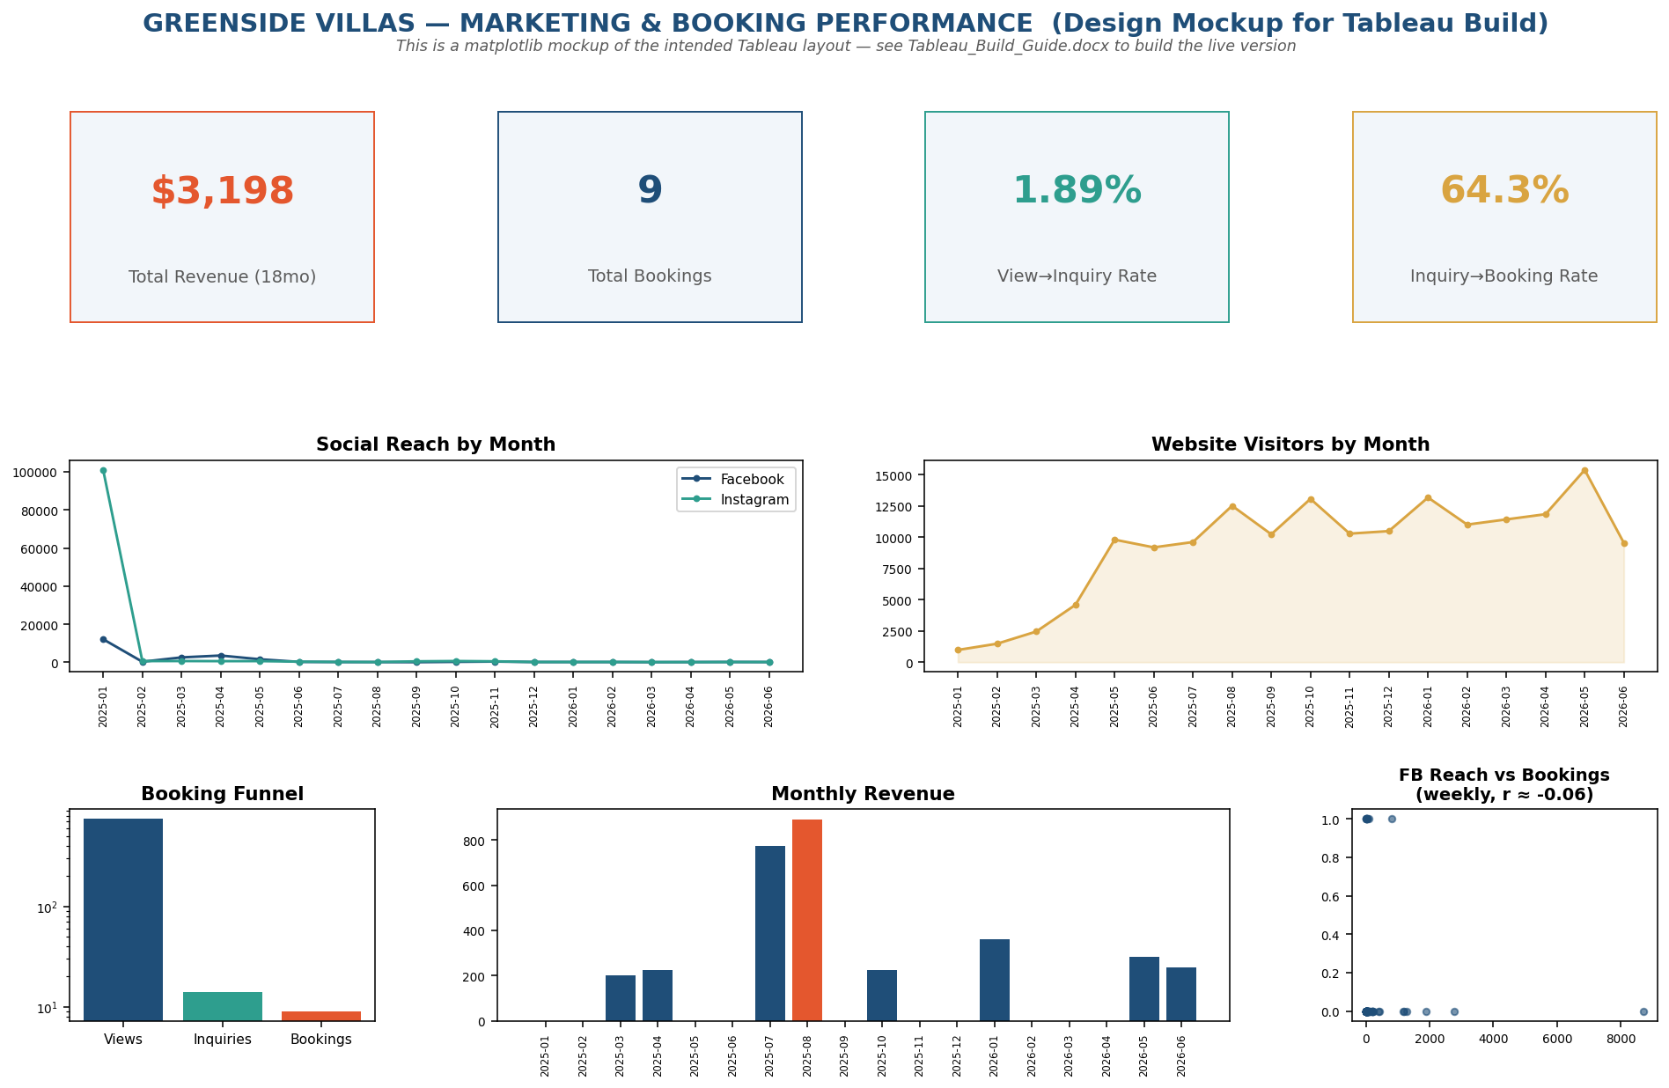
Design mockup — build this layout as 6 Tableau worksheets combined into one Dashboard.

Step-by-step build order
- KPI cards (top row): 4 single-value worksheets (Total Revenue, Total Bookings, View→Inquiry Rate, Inquiry→Booking Rate) using Text tables with large font, one per tile.
- Social Reach line chart: fb_reach and ig_reach (measures) on Rows, month (dimension, from week_date) on Columns, as a dual-line chart.
- Website Visitors area chart: site_visitors on Rows, month on Columns, mark type 'Area'.
- Booking Funnel bar chart: create a unioned/pivoted 'stage' field (Views/Inquiries/Bookings) or three separate reference lines; apply a log axis under Analytics if the scale gap is too large to read.
- Monthly Revenue bar chart: airbnb_revenue on Rows, month on Columns; use a calculated color field to highlight the max month.
- Reach vs Bookings scatter: fb_reach on Columns, airbnb_bookings on Rows, mark type Circle; add a Trend Line from the Analytics pane and check the R² in its tooltip — it will be very low, consistent with Section 3's Python correlation of -0.06.
- Combine all 6 into one Dashboard sheet sized 1400x900, arrange per the mockup, and add the 'Is Real Data' filter as a dashboard-level filter applied to all worksheets.

4. What This Section Demonstrates
- Ability to design a BI dashboard from raw data: extract shaping, calculated fields (including table calculations like WINDOW_AVG and RANK), and layout planning — the actual Tableau skill, independent of the tool being physically available in this environment.
- Consistency discipline: every calculated field and filter in this section reproduces the exact numbers already validated in Excel, SQL, and Python (View→Inquiry 1.89%, Inquiry→Booking 64.3%).

5. Files in This Section
- Tableau_Weekly_Extract.csv — ready-to-import flat data extract
- Tableau_Calculated_Fields.txt — all 12 calculated field formulas with notes
- mockup/tableau_dashboard_mockup.png — layout reference (matplotlib mockup, not a Tableau screenshot)
- Tableau_Insights_Summary.md — one-page takeaways

