SRI CHANDRASEKHARENDRA SARASWATHI VISWA MAHAVIDYALAYA
(UNIVERSITY ESTABLISHED under section 3 of UGC Act 1956) ENATHUR, KANCHIPURAM – 631 561



OBJECT ORIENTED PROGRAMMING LAB LABORATORY RECORD

Name : Mohammad Mabrur M

Reg. No : 112514009

Class : I Year B.Sc. (Cyber Security)

Subject : UCYF231P60 - Object Oriented Programming Lab

SRI CHANDRASEKHARENDRA SARASWATHI VISWA MAHAVIDYALAYA
(University Established under section 3 of UGC Act 1956)

BONAFIDE CERTIFICATE

This is to certify that this is the bonafide record of work done by
Mr.Ms.Mohammad Mabrur M, with Reg.No 112514009 of I Year B.Sc. (Cyber Security) in the Object Oriented Programming Lab during the year 2025.

Staff-in-charge Head of the Department

Submitted for the Practical Examination held on

Internal Examiner External Examiner.

1

INDEX

SNo. | Date | Title | Page | Sign
1 | 25-07-2025 | Classes & Objects | 3
2 | 30-07-2025 | Friend Function | 7
3 | 06-08-2025 | Inline Function | 9
4 | 08-08-2025 | Array Implementation | 11
5 | 20-08-2025 | Multiple Inheritance | 22
6 | 29-08-2025 | This Pointer | 24
7 | 10-09-2025 | Friend Class | 25
8 | 17-09-2025 | Function Overloading | 27
9 | 03-10-2025 | Operator Overloading | 30
10 | 10-10-2025 | String Manipulation | 32

2

1 | CLASSES AND OBJECTS | 25-07-2025

AIM :
Write a C++ Program to display Employee details Using Classes and Objects.

ALGORITHM :
Step 1: Start
Step 2: Declare variables:
num (integer) → to store number of employees
For each employee, store: empID (integer) name (string) department (string) salary (float)
Step 3: Display message — “Enter number of employees:”
Step 4: Read num
Step 5: i = 1
Step 6: Display message — “Enter details for employee i:” Input empID
Input name Input department Input salary
Step 7: i = i+1
Step 8: if i <= num goto Step 6, else continue
Step 9: j = 1
Step 10: Display message — “--- Employee Details ---” Display empID
Display name Display department Display salary
Step 11: j = j + 1
Step 12: if j <= num goto Step 10, else continue
Step 13: Stop

FLOWCHART :
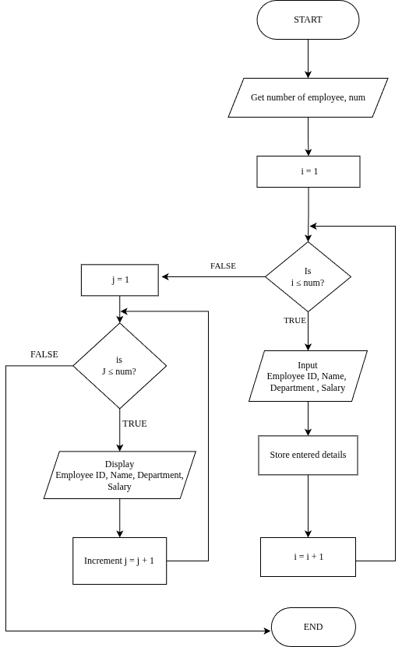
UML DIAGRAM :
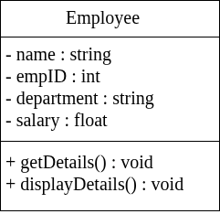 `

SOURCE CODE :

https://github.com/MABRUR-112514009/RECORD-CODE/blob/6978103009905af37b1feff91dad18d3dd90a6aa/EmpClass.cpp

OUTPUT :
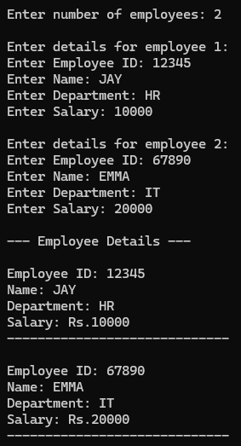

RESULT :
Thus the program is compiled and executed successfully with verified output.

2 | FRIEND FUNCTION | 30-07-2025

AIM :

Write a C++ Program to find the Mean Value Using Friend Function.

ALGORITHM :
Step 1: Start the program
Step 2: Read values num1, num2 Step 3: mean = num1 + num2 Step 4: Display mean
Step 5: Stop

FLOWCHART :
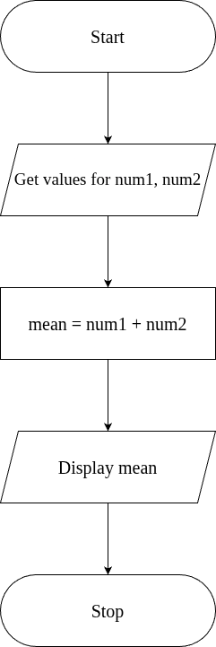
UML DIAGRAM :
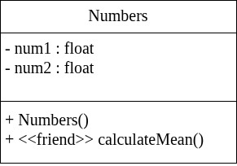

SOURCE CODE :

https://github.com/MABRUR-112514009/RECORD-CODE/blob/6978103009905af37b1feff91dad18d3dd90a6aa/FriendFnMean.cpp

OUTPUT :
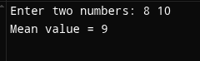

RESULT :
Thus the program is compiled and executed successfully with verified output.

3 | INLINE FUNCTION | 06-08-2025

AIM :
Write a C++ Program to Implement Inline Function.

ALGORITHM :
Step 1: Start
Step 2: Define an inline function square(int n) that returns n * n.
Step 3: In main(), declare an integer variable num.
Step 4: Read the value of num from the user.
Step 5: Call the inline function square(num) and store/print the result.
Step 6: Display the square of the given number.
Step 7: Stop

FLOWCHART :
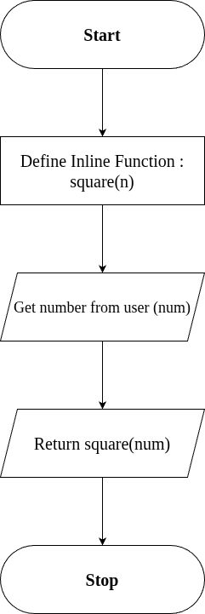
SOURCE CODE :

https://github.com/MABRUR-112514009/RECORD-CODE/blob/6978103009905af37b1feff91dad18d3dd90a6aa/InlineFn.cpp

OUTPUT :
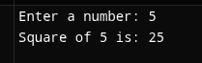

RESULT :
Thus the program is compiled and executed successfully with verified output.

4 | ARRAY IMPLEMENTATION | 08-08-2025

AIM :
Write a C++ Program to Implement Arrays.

ALGORITHM :
Step 1 : Start the Program
Step 2 : Create an Object "myArray" of Class "Array"
Step 3 : Display menu as below and get "choice"
- Insert
- Remove
- Search
- Display
- Exit
Step 4 : If (choice >= 6) go to step -, Else Continue
Step 5 : If (choice = 1)
Get value n from user set i = 0
Check for condition, i < n
On true; get Value for Insert (value) call myArray.insert(value) Increment i, i = i + 1
Else; break loop elseif (choice = 2)
get index to Remove (index) call myArray.remove(index)
elseif (choice = 3)
get value to search (value) call myArray.search (value)
elseif (choice = 4)
call myArray.display() elseif (choice = 5)
go to step 7
Step 6: Display "Invalid choice"
Step 7: Stop

ALGORITHM FOR INSERT FUNCTION :
Step 1: Start the program.
Step 2: Prompt the user to enter an element to insert into the array.
→ Input: element
Step 3: Check the current size of the array.
→ Condition: if size < 100
Step 4:
If the condition is TRUE (size < 100):
- Insert the element into the array at position arr[size].
- Increment the size of the array by 1.
→ size = size + 1
If the condition is FALSE (size >= 100):
- Display the message:
→ “Array is full. Cannot insert more elements.”
Step 5: Stop the program.

ALGORITHM FOR REMOVE FUNCTION :
Step 1: Start
Step 2: Get index from the user.
Step 3: Check the condition, (index < 0 || index >= size) On true; Go to Step 4
Else; Go to Step 5
Step 4: Print "Invalid index", then Go to Step 10
Step 5: Set i = index
Step 6: Check the condition, i < size - 1
On true; Go to Step 7 Else; Go to Step 8
Step 7: Shift the elements to the left by one position: arr[i] = arr[i + 1]
Repeat this step until all elements after the deleted index are shifted.
Step 8: Decrease the array size by one:
size = size - 1
Step 9: Print "Element deleted at index" followed by the value of index.
Step 10: Stop

ALGORITHM FOR SEARCH FUNCTION :
Step 1: Start
Step 2: Initialize i = 0
Step 3: Check the condition, i < size
On true; go to Step 4 Else; go to Step 8
Step 4: Check if the current array element matches the search key, arr[i] == key On true; go to Step 7
Else go to Step 5
Step 5: Increment i by 1, i = i + 1
Step 6: Go back to Step 3 (Repeat the checking process for the next element)
Step 7: Print "Element found at index" followed by the value of i Go to Step 9
Step 8: Print "Element not found
Step 9: Stop

ALGORITHM FOR DISPLAY FUNCTION :
Step 1: Start the program.
Step 2: Check if the array size is equal to 0, condition (size == 0) On true; Print "Array is empty".
Go to Step 8 (Stop).
Else; Continue to the next step.
Step 3: Print "Array elements:" to indicate that array elements will be displayed.
Step 4: Initialize a variable i = 0 (loop counter).
Step 5: Check the condition if (i < size).
On true; Print the element arr[i].
Increment i by 1 (i = i + 1).
Go back to Step 5 and repeat until i < size becomes False.
Else; Exit the loop.
Step 6: After printing all elements, end the loop.
Step 7: Stop the program.
FLOWCHART :
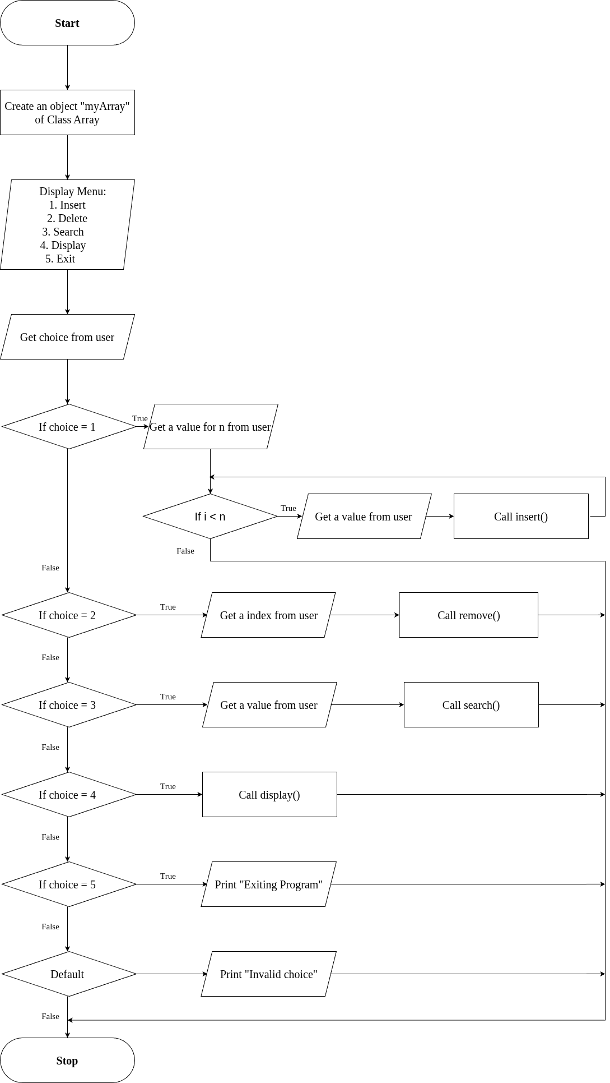
FLOWCHART FOR INSERT FUNCTION :
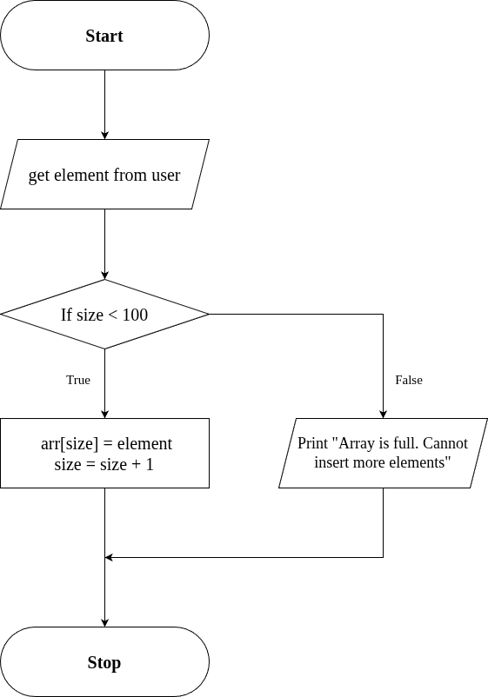
FLOWCHART FOR REMOVE FUNCTION :
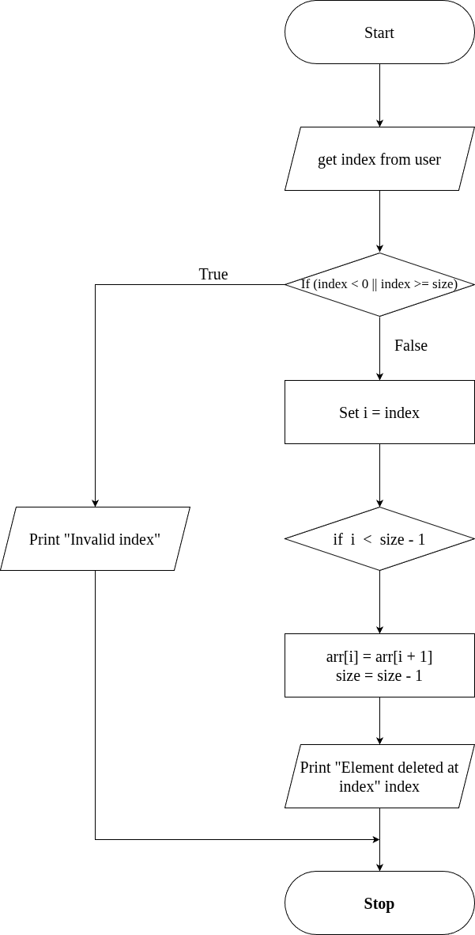
FLOWCHART FOR SEARCH FUNCTION :
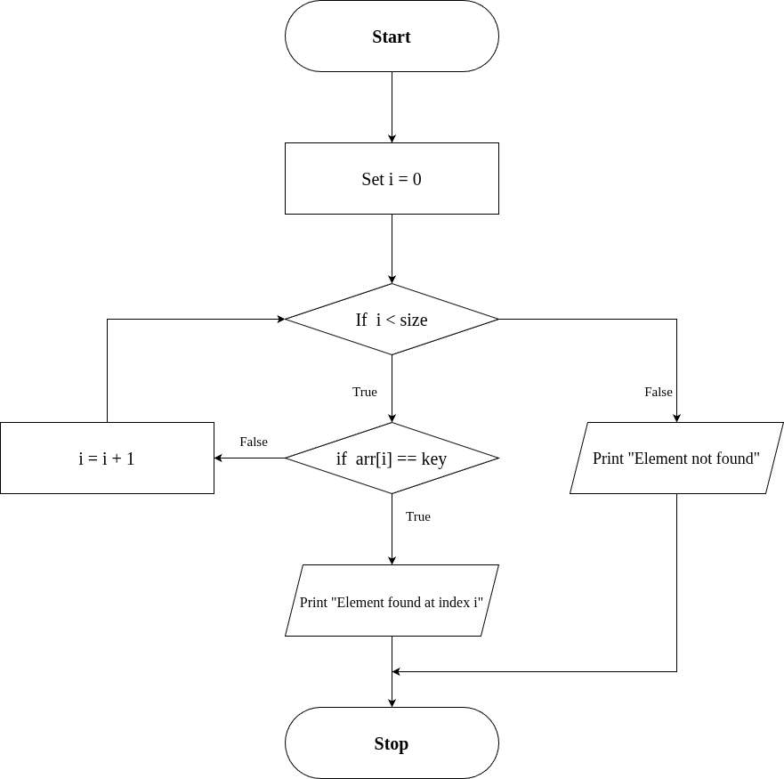
FLOWCHART FOR DISPLAY FUNCTION :
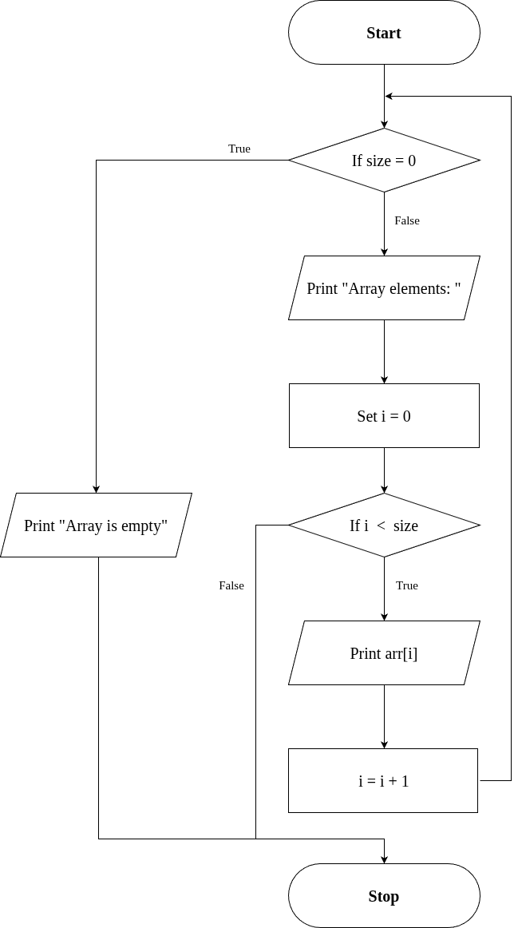
SOURCE CODE :
https://github.com/MABRUR-112514009/RECORD-CODE/blob/6978103009905af37b1feff91dad18d3dd90a6aa/ArrayImpl.cpp

OUTPUT :
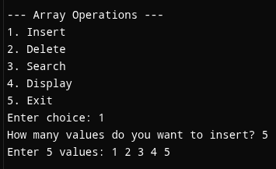
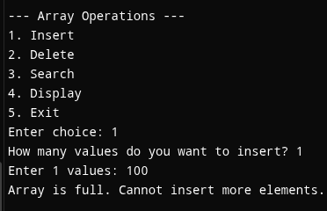
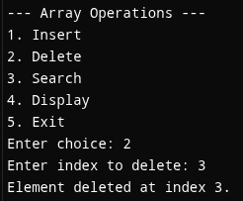

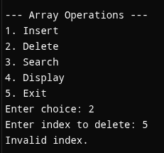
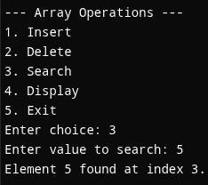
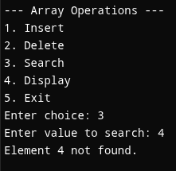
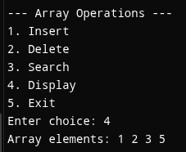

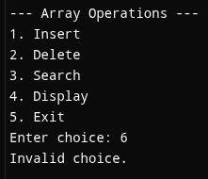
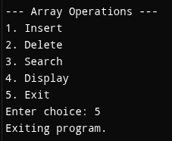

RESULT :
Thus the program is compiled and executed successfully with verified output.

5 | MULTIPLE INHERITANCE | 20-08-2025

AIM :
Write a C++ Program to implement Multiple Inheritance.

ALGORITHM :
Step 1: Start the program.
Step 2: Define the base class "Engine"
→ Declare a protected data member engineCC (integer).
→ Deﬁne a public member function getEngineInfo() that:
- Accepts user input for engineCC.
Step 3: Define the base class "Body"
→ Declare protected data members color and type (string).
→ Deﬁne a public member function getBodyInfo() that:
- Takes input for type (SUV/Sedan/Hatchback/etc)
Step 4: Define the derived class "Car" that inherits publicly from both "Engine" and "Body".
→ Deﬁne a public member function showDetails() that:
- Displays engineCC, color, and type.
Step 5: In the main() function:
  - Create an object obj of class Car.
  - Call obj.getEngineInfo() to input engine details.
  - Call obj.getBodyInfo() to input body details.
  - Call obj.showDetails() to display all vehicle details.
Step 6: End the program.

UML DIAGRAM :

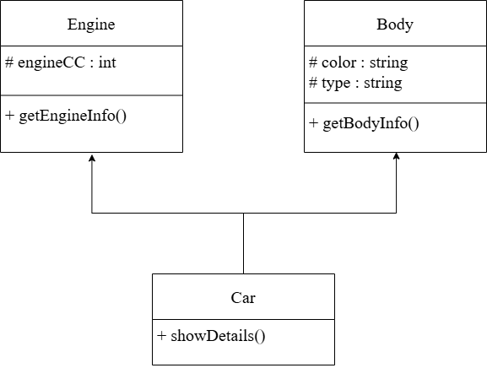
SOURCE CODE :
https://github.com/MABRUR-112514009/RECORD-CODE/blob/6978103009905af37b1feff91dad18d3dd90a6aa/MultipleInheritance.cpp

OUTPUT :
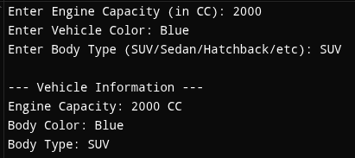

RESULT :
Thus the program is compiled and executed successfully with verified output.

6 | THIS POINTER | 29-08-2025

AIM :
Write a C++ Program To Implement This Pointer.

ALGORITHM :
Step 1: Start the program
Step 2: Create a class Sample with data members a and b
Step 3: Deﬁne setData(int a, int b) member function → Use this->a = a and this->b = b to assign values
Step 4: Define display() function to print the values of a and b
Step 5: In main(), create an object obj of class Sample
Step 6: Call obj.setData(10, 20)
Step 7: Call obj.display() to show stored values
Step 8: Stop the program

UML DIAGRAM :
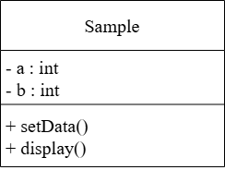

SOURCE CODE :
https://github.com/MABRUR-112514009/RECORD-CODE/blob/6978103009905af37b1feff91dad18d3dd90a6aa/ThisPointer.cpp

OUTPUT :
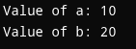
RESULT :
Thus the program is compiled and executed successfully with verified output

7 | FRIEND CLASS | DATE:  10-09-2025

AIM :
Write a C++ Program to Implement Friend class.

ALGORITHM :
Step 1: Start.
Step 2: Define class Auditor as a forward declaration so it can be referenced in class BankAccount.
Step 3: Define class BankAccount:
- Declare a private string variable (name) and double variable (balance).
- Define a constructor to initialize (name) and (balance).
- Implement deposit() and widthrawl() public functions.
- Declare Auditor as a friend class using the friend class keyword.
Step 4: Defines class Auditor:
- Implement a public member function showAccount that takes an object of class BankAccount as a parameter.
[Accesses and displays the private variables (name) and (balance) of BankAccount using the reference to the object.]
Step 5: Defines main function.
- Creates object (official) of class Auditor and object (acc) of class BankAccount.
- Call acc.deposit() and acc.widthrawl() to modify the balance.
- Call official.showAccount(acc) to display the account details( name and balance ) using the auditor object.
Step 6: End.

UML DIAGRAM :
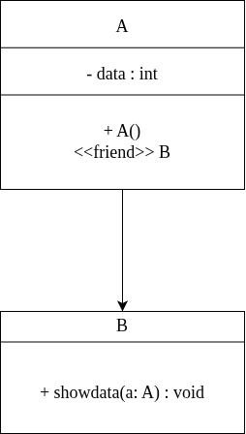

SOURCE CODE :
https://github.com/MABRUR-112514009/RECORD-CODE/blob/6978103009905af37b1feff91dad18d3dd90a6aa/FriendClass.cpp

OUTPUT :
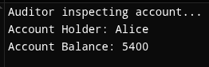

RESULT :
Thus the program is compiled and executed successfully with verified output.

8 | FUNCTION OVERLOADING | 17-09-2025

AIM :
Write a C++ Program to Implement Function overloading.

ALGORITHM :
Step 1: Start.
Step 2: Define a class named Calculator.
Step 3: Inside the class, define three overloaded functions named add:
- Function-1: int add(int a, int b)
-> Computes and returns the sum of two integers.
- Function-2: int add(int a, int b, int c)
-> Computes and returns the sum of three integers.
- Function-3: double add(double a, double b)
-> Computes and returns the sum of two double values.
Step 4: In the main() function:
- Create an object (calc) of class Calculator.
- Call and display the result of the overloaded functions: if parameters are of type int and only 2 parameters:
-> Call calc.add(int , int)
else if parameterrs are of type int and only 3 parameters:
-> Call calc.add(int , int , int) else if parameters are of type double:
-> Call calc.add(double , double) else:
Display: Input parameters are wrong.
Step 5: Display each result using cout.
Step 6: End.
FLOWCHART :
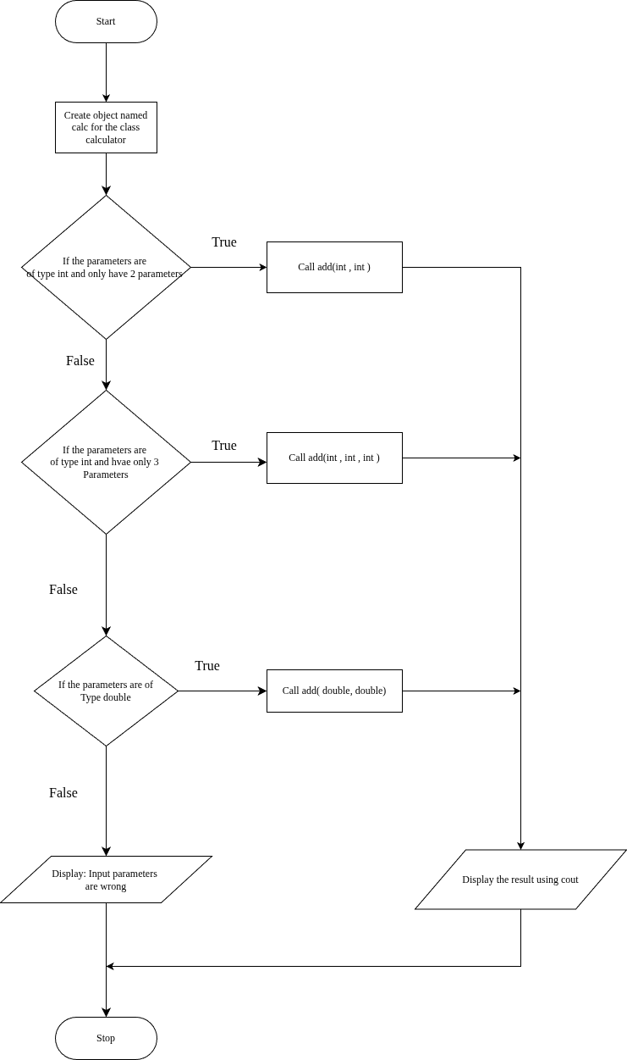
UML DIAGRAM :
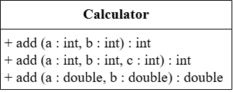

SOURCE CODE :
https://github.com/MABRUR-112514009/RECORD-CODE/blob/6978103009905af37b1feff91dad18d3dd90a6aa/FnOperloading.cpp

OUTPUT :
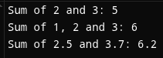

RESULT :

Thus the program is compiled and executed successfully with verified output.

9 | OPERATOR OVERLOADING | 03-10-2025

AIM :
Write a C++ Program to Implement Operator Overloading.

ALGORITHM :
Step 1: Start the program.
Step 2: Define a class named “Point”.
Step 3: Inside the classes, declare two private data members : ‘x’ and ‘y’. Step 4: Create a constructor Point(int a=0,int b =0)to initialize ‘x’ and ‘y’. Step 5: Define an overloaded + operator function :
- Take another object of type point as a parameter.
- Add the ‘x’ and ‘y’ values of both objects.
- Return a new Point object containing the sum.
Step 6: Define and display() function to print the ‘x’ and ‘y’ values.
Step 7: In main() function:
  - Create two objects of Class “Point”: p1(2,3) and p2(4,5).
  - Use the overloaded + operator to add the two objects: p3=p1+p2.
  - Display the result using p3.display().
Step 8: Stop the program.

UML DIAGRAM :
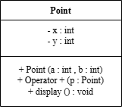

SOURCE CODE :

https://github.com/MABRUR-112514009/RECORD-CODE/blob/6978103009905af37b1feff91dad18d3dd90a6aa/OperOverloading.cpp

OUTPUT :
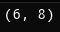

RESULT :
Thus the program is compiled and executed successfully with verified output.

10 | STRING MANIPULATION | 10-10-2025

AIM :
Write a C++ Program to Implement String Concepts.

ALGORITHM :
Step 1: Start
Step 2: Declare string variables (str1, str2, fullName, etc.)
Step 3: Initialize str1 = "Hello", str2 = "World"
Step 4: Concatenate str1 and str2 (using '+' operator)→ store in (combined)
Step 5: Display the combined string Step 6: Prompt user to enter full name Step 7: Read full name using getline() Step 8: Display the full name
Step 9: Find and display the length of the full name (using "length()" library function) Step 10: Extract and display the first 5 characters (using "substr()" library function) Step 11: Compare two strings ("Apple" and "Banana") (using "==" operator)
Step 12: Display comparison result
Step 13: Replace "C++" with "Python" in a sentence (using "replace()" library function)
Step 14: Display modified sentence
Step 15: Loop through and display each character of full name
Step 16: End

FLOWCHART :
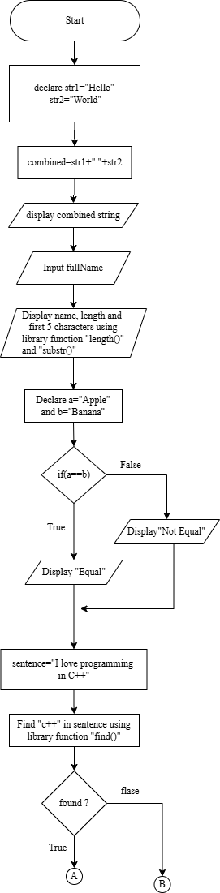
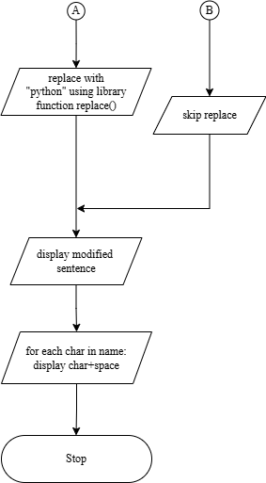

SOURCE CODE :

https://github.com/MABRUR-112514009/RECORD-CODE/blob/6978103009905af37b1feff91dad18d3dd90a6aa/StringManipulation.cpp

OUTPUT :
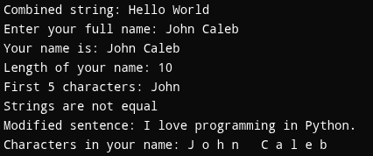

RESULT :
Thus the program is compiled and executed successfully with verified output.

