## Question 4: Use Webscraping to Extract GME Revenue Data

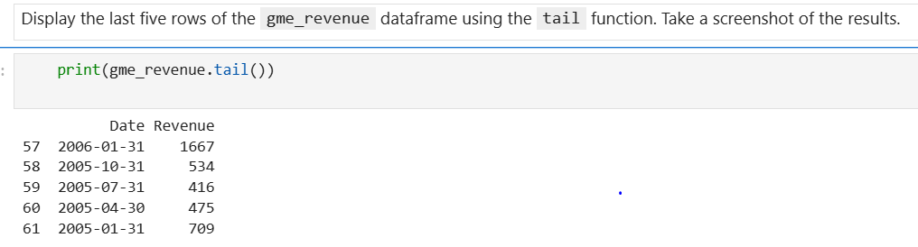

## Question 5: Plot Tesla Stock Graph

Use the make_graph function to graph the Tesla Stock Data, also provide a title for the graph. Note the graph will only show data upto June 2021.

