## Question 1: Use yfinance to Extract Stock Data

**Reset the index** using the reset_index(inplace=True) function on the tesla_data DataFrame and display the first five rows of the tesla_data dataframe using the head function. Take a screenshot of the results and code from the beginning of Question 1 to the results below.

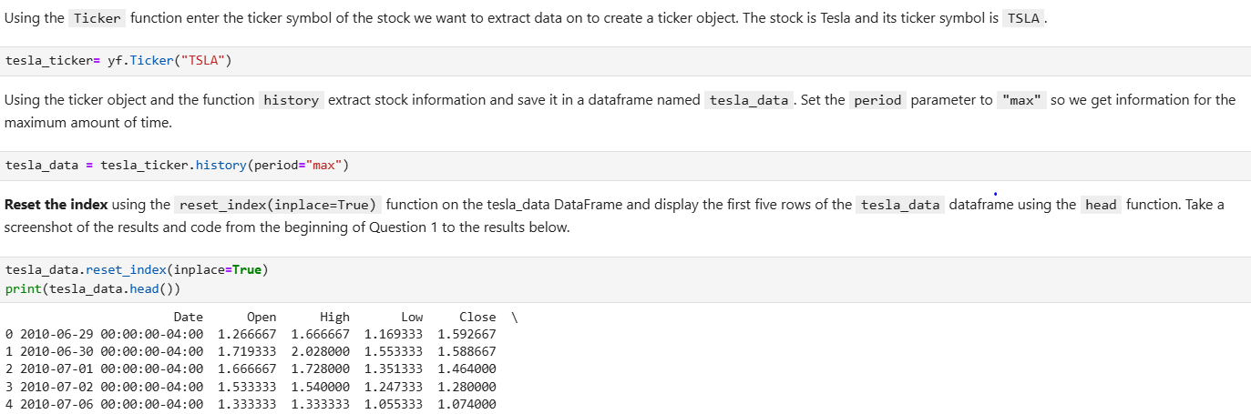

Question 2: Use Webscraping to Extract Tesla Revenue Data

Display the last 5 row of the tesla_revenue dataframe using the tail function. Take a screenshot of the results.

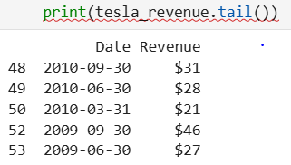

## Question 3: Use yfinance to Extract Stock Data

## **Reset the index** using the reset_index(inplace=True) function on the gme_data DataFrame and display the first five rows of the gme_data dataframe using the head function. Take a screenshot of the results and code from the beginning of Question 3 to the results below.

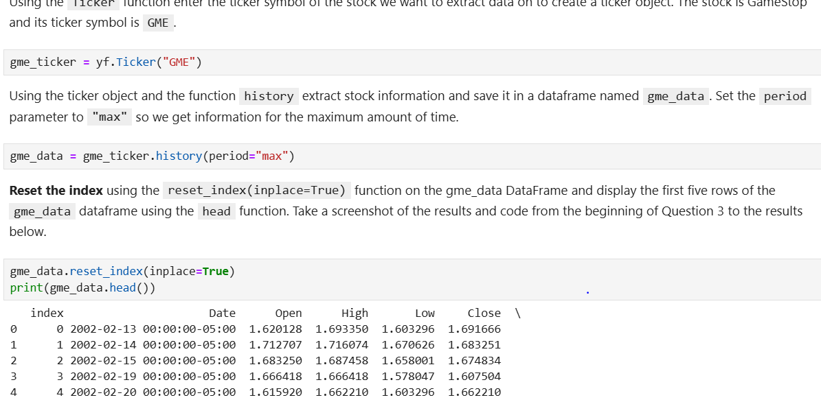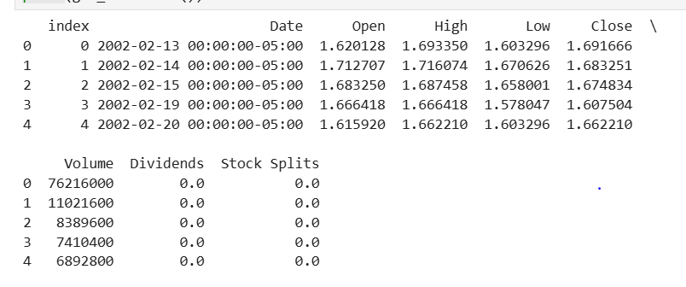

## Question 4: Use Webscraping to Extract GME Revenue Data

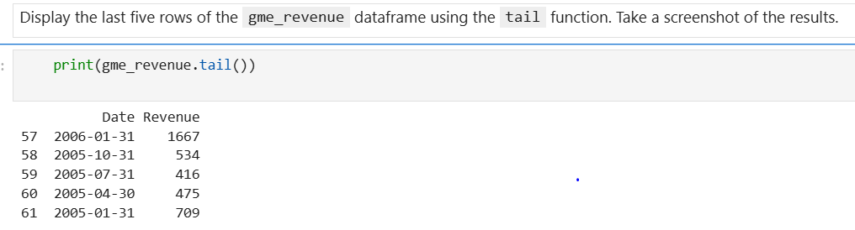

## Question 5: Plot Tesla Stock Graph

Use the make_graph function to graph the Tesla Stock Data, also provide a title for the graph. Note the graph will only show data upto June 2021.

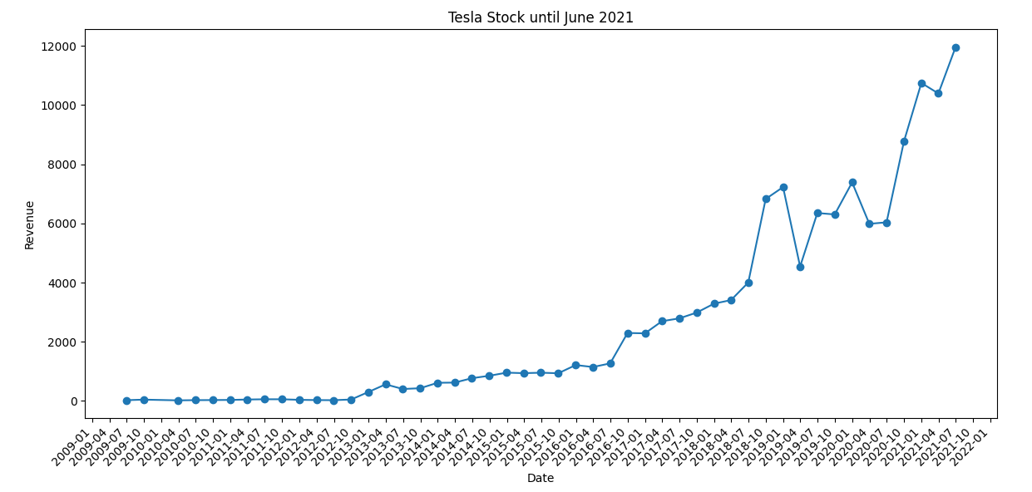

## Question 6: Plot GameStop Stock Graph

Use the make_graph function to graph the GameStop Stock Data, also provide a title for the graph. The structure to call the make_graph function is make_graph(gme_data, gme_revenue, 'GameStop'). Note the graph will only show data upto June 2021.