Eduard Pascale

SI4-RB01

Individual Project Proposal

# Introduction

I always end up buying a plant when it catches my eye in the store. Later, at home, I take good care of it, watering it, finding a good spot for it, and giving it the right nutrients. Despite all this effort, I still end up killing the plants. Sometimes when I am away from home for several days, I ask a friend to water my plant, but they either forget or don't water it consistently. I always ask myself whether I overwatered or underwatered the plant, or whether it received enough light or fresh air. Each time I face these uncertainties, I have to resort to online research for more information about the plant. However, this time around, I have come up with an idea that will help me avoid wasting my money, time, and energy.

# Project Goal

Whenever I’m buying a plant I would like to gather data about the plant and the environment, this may include moisture levels, light levels, air composition, temperature, humidity, water quantity, etc.

This works by attaching sensors next to the plant pot that will be running continuously. These sensors must be interconnected and send data simultaneously to a gateway. Since the sensors will be constantly running, there needs to be a reliable power source for them. Additionally, the sensors must be power-efficient and use protocols to send data to the cloud. By utilizing this data I can make better future decision and help save the plant life.

An Irrigation model could use the data from the humidity and moisture sensors to predict when the plant needs to be watered. By analyzing the humidity and moisture levels over time, you could identify patterns that indicate when the soil is getting dry and the plant needs to be watered.

Another model could use the data from the sensors to predict the overall health of the plant. By analyzing the trends and correlations between the different sensor readings, you could identify patterns that indicate whether the plant is thriving, struggling, or in danger of dying. This model could be useful for identifying problems early on, before they become severe.

# Context Diagram

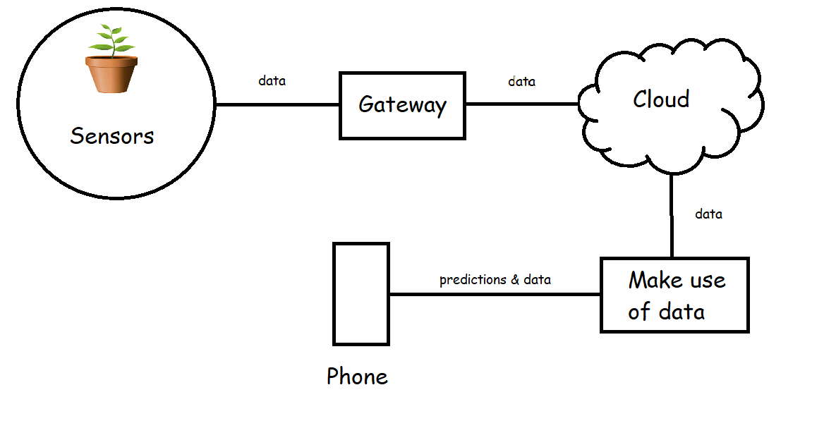

# Bibliography

**There are no sources in the current document.**