# CS 211 PA #1: PPM Images

This assignment is a continuation of lab 2. In this homework, you will create a program that will add simple effects to a PPM image.

## Prerequisites

Before beginning this assignment, you will need some sort of imaging software that can open PPM-based images. I recommend [Ifranview](http://www.irfanview.com/) for Windows as it's free and lightweight.

## PPM Image Format

The PPM image format is encoded in human-readable ASCII text. It might be helpful to read over the [formal PPM specification document](http://netpbm.sourceforge.net/doc/ppm.html). A PPM document has two pieces: the header and the body. The header is always the top three uncommented lines in the file:

|  |
| --- |
| P3  4 4  255 |

The first line specifies the type of image that is contained within the file. We will always use the "P3" specification. The second line specifies the number of columns and rows present in the image. In this example, we have a 4x4 image. The final number indicates the maximum value for each red, green, and blue element in the picture. Having a max value of 255 is quite common and is the value that we will always use. Below the header is the body of the PPM file. Each pixel has a red, green, and blue value. For example, the content of our 4x4 image might be:

|  |
| --- |
| 0 0 0 100 0 0 0 0 0 255 0 255  0 0 0 0 255 175 0 0 0 0 0 0  0 0 0 0 0 0 0 15 175 0 0 0  255 0 255 0 0 0 0 0 0 255 255 255 |

With these values, the pixel in the first column and row has a RGB value of (0,0,0) and the last column in the first row has an RGB value of (255,0,255). A blown-up image containing these values would look like:

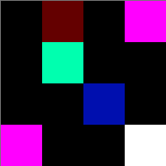

## Basic Tasks

Basic tasks require you to manipulate single pixels on a user specified image. Below is a reference value and the images that result from the image processing.

### Original Image

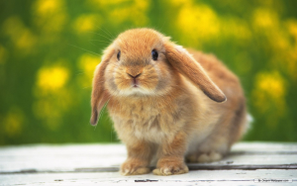

### Remove Red

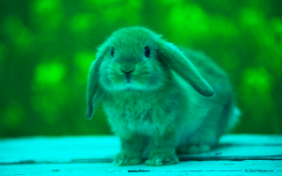

Will remove all red (i.e. set red to 0) pixels in the image

### Remove Green

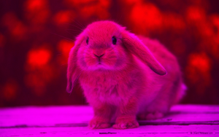

Will remove all green pixels in the image

### Remove Blue

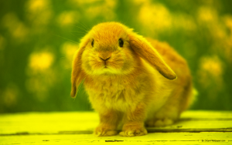

Will remove all blue pixels in the image

### Negate Red

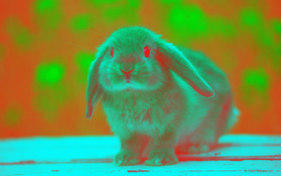

Will negate all red pixels in an image. To negate a color, simply subtract the current pixel's red color value from 255 (e.g. 255 – RED). Make this the new value for red.

### Negate Green

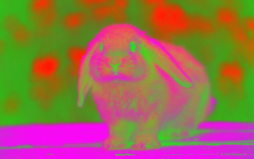

Will negate all green pixels in an image.

### Negate Blue

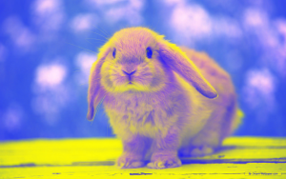

Will negate all blue pixels in an image.

### Add Random Noise

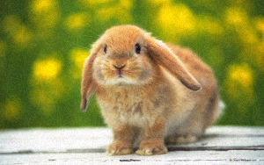

Will add random noise to the image by randomly selecting a value ranging from -10 to 10 and adding that value to the pixel's current value. If the addition causes the pixel value to be less than 0, then set to 0. Likewise, if the addition causes the pixel's value to be greater than 255, just set the pixel's value to 255. For example, we randomly generate the number -7. Next, we add -7 to each of the current pixel's red, green, and blue values.

### High Contrast

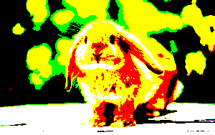

Examine each color in a pixel. If the color is greater than half of 255, then max the color out (i.e. set to 255). Otherwise, set the value to 0. For example, performing a high contrast operation on a pixel whose RGB values are 170, 50, 100 would result in an RGB value of 255, 0, 0.

### Grayscale

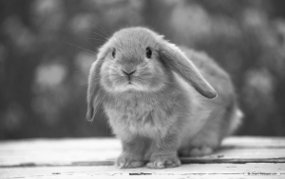

Converts the image to grayscale by setting the value of each color in a given pixel to the average of all three values. For example, if a pixel's RGB was 177, 15, 39, the resulting RGB value would be 77, 77, 77.

## Advanced Tasks

Advanced tasks require a bit more thought as they you to manipulate the several pixels at once. Below is the reference image for the advanced tasks:

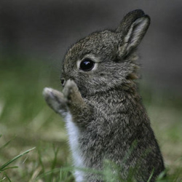

### Flip Horizontally

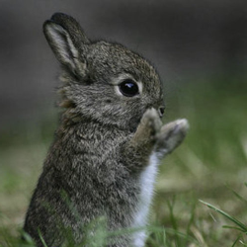

This will flip the supplied image horizontally. To accomplish, you will need to loop through your image and switch the order of every column. For example, if our picture had four columns numbered 0-3, you would need to swap columns 0 and 3, and columns 1 and 2.

### Flip Vertically

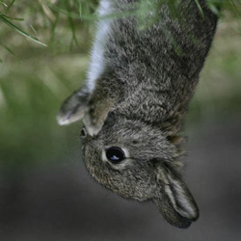

This will flip the supplied image vertically. To accomplish, you will need to loop through your image and swap the order of every row. For example, if our picture had four rows numbered 0-3, you would swap row 0 with row 3, and row 1 with row 2.

### Rotate 90 Degrees

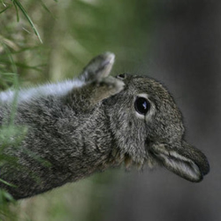

This one is probably the most conceptually difficult. Essentially, you will need to turn the first row into the last column, the 2nd row into the 2nd to last column, etc. until you turn the last row into the first column. Consider the following grid:

|  |  |  |  |
| --- | --- | --- | --- |
| 1 | 1 | 1 | 1 |
| 2 | 2 | 2 | 2 |
| 3 | 3 | 3 | 3 |

A 90 degree rotation would result in:

|  |  |  |
| --- | --- | --- |
| 3 | 2 | 1 |
| 3 | 2 | 1 |
| 3 | 2 | 1 |
| 3 | 2 | 1 |

NOTE: In order for this to properly work, you are going to have to alter the specified dimensions of your PPM file (2nd line).

### Blur

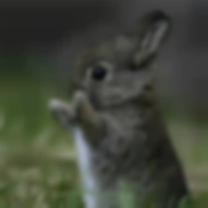

To perform a blur, you will need to do the following:

1. For each pixel in a given row, set the pixel's red value to the average of itself and its horizontally adjacent neighbors (i.e. i + 1, i - 1). For border cases, just take the average of the singular neighbor.
   1. Do the same procedure for the pixel's green and blue values
2. For each pixel in a given column, set the pixel's red value to be the average of itself and its vertically adjacent neighbors (i.e. j + 1, j - 1). For border cases, just take the average of the singular neighbor.
   1. Do the same procedure for the pixel's green and blue values.

Do this 10 times to get an extreme blur like the one depicted in my image.

### Pixelate

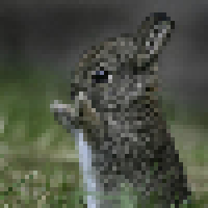

To pixelate an image, take a reference pixel P and a distance D and make all pixels adjacent to P in a DxD block the same as P. Then, skip over D pixels and repeat the process for a new P. For example, given a D of 2, here is how we would pixelate the following matrix:

|  |  |  |  |
| --- | --- | --- | --- |
| 1 | 2 | 3 | 4 |
| 5 | 6 | 7 | 8 |
| 9 | 10 | 11 | 12 |
| 13 | 14 | 15 | 16 |

|  |  |  |  |
| --- | --- | --- | --- |
| 1 | 1 | 3 | 3 |
| 1 | 1 | 3 | 3 |
| 9 | 9 | 11 | 11 |
| 9 | 9 | 11 | 11 |

Note that for the image above, I used a distance D of 5. Try playing around with different distance values.

## Chaining Effects Together

Note that manipulations may be chained together in order to create complex effects. Below is the image generated from performing a negate red, negate green, and negate blue operation.

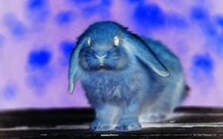

## Possible Strategy for Getting Started

* If you're feeling overwhelmed, try implementing one of the more simplistic image effects (e.g. remove red) inside of main. Once you get that working on a PPM file, put the necessary code into its own class and .h file.
* Use our labs as a template. Most of the ideas we covered in lab can be directly applied to the solving of this assignment.

## Header Comment, and Formatting

1. Be sure to modify the file header comment at the top of your program to indicate your name, student ID, completion time, and the names of any individuals that you collaborated with on the assignment.
2. Remember to follow the basic coding style guide. A basic list of rules is included with this document.

# Reflection Essay

In addition to the programming tasks listed above, your submission must include an essay that reflects on your experiences with this homework. This essay must be at least 350 words long. Note that the focus of this paper should be on your reflection, ***not*** on structure (e.g. introductory paragraph, conclusion, etc.). The essay is graded on content (i.e. it shows deep though) rather than syntax (e.g. spelling) and structure. Below are some prompts that can be used to get you thinking. Feel free to use these or to make up your own.

* Describe a particular struggle that you overcame when working on this programming assignment.
* Conversely, describe an issue with your assignment that you were unable to resolve.
* Provide advice to a future student on how he or she might succeed on this assignment.
* Describe the most fun aspect of the assignment.
* Describe the most challenging aspect of the assignment.
* Describe the most difficult aspect of the assignment to understand.
* Provide any suggestions for improving the assignment in the future.

# Required Program UI Components

While you are free to use any wording and style, your program must adhere to the following program flow:

1. The first keyboard input must obtain the name of the original PPM
2. The 2nd keyboard input must obtain the name of the output PPM
3. All subsequent keyboard inputs must obtain image effects from the user in the following order:
4. Remove red
5. Remove green
6. Remove blue
7. Negate red
8. Negate green
9. Negate blue
10. Add random noise
11. High contrast
12. Grayscale
13. Flip horizontally
14. Flip vertically
15. Rotate 90
16. Blur
17. Pixelate
18. Quit

Below I provide a sample UI:

|  |  |  |  |  |  |  |  |  |  |  |  |  |  |  |  |  |  |  |  |  |  |  |  |  |  |  |  |  |  |  |  |  |
| --- | --- | --- | --- | --- | --- | --- | --- | --- | --- | --- | --- | --- | --- | --- | --- | --- | --- | --- | --- | --- | --- | --- | --- | --- | --- | --- | --- | --- | --- | --- | --- | --- |
| PPM Image Manipulator Enter input file: **bunny.ppm**  Enter output file: **output.ppm**  Image Effects Menu   |  |  |  |  | | --- | --- | --- | --- | | 1. Remove Red | 2. Remove Green | 3. Remove Blue | 4. Negate Red | | 5. Negate Green | 6. Negate Blue | 7. Add Random Noise | 8. High Contrast | | 9. Grayscale | 10. Flip Horizontally | 11. Flip Vertically | 12. Rotate 90 | | 13. Blur | 14. Pixelate | 15. Exit Program |  |   Selection: **1**  Effect applied  Image Effects Menu   |  |  |  |  | | --- | --- | --- | --- | | 1. Remove Red | 2. Remove Green | 3. Remove Blue | 4. Negate Red | | 5. Negate Green | 6. Negate Blue | 7. Add Random Noise | 8. High Contrast | | 9. Grayscale | 10. Flip Horizontally | 11. Flip Vertically | 12. Rotate 90 | | 13. Blur | 14. Pixelate | 15. Exit Program |  |   Selection: **15**  Exiting program |

## Deliverables

You must upload your program and reflection as a ZIP file through Canvas no later than midnight on Monday, February 18, 2019.

### Checkin (10pts)

* During Lab 3, you must demonstrate to me your program. In order to receive full credit, you must have made sufficient progress on your assignment. I define significant progress as demonstrating an expenditure of meaningful effort on one large section of code. Your checkin should demonstrate that you are capable of completing the assignment by the due date.

### Reflection essay (10pts)

* Your reflection meets the minimum requirements as specified earlier in this document.

### Program UI Format (10pts)

* Your program's UI must exactly match my sample UI on the first page of this assignment. Your program should first prompt for state, cause, and year. Your program should then ask for another query. Your program **should not** contain any different prompts nor should they be in any different order.

### Basic Image Effects (40 pts)

* All of your basic image effects work properly

### Advanced Image Effects (30 pts)

* All of your advanced image effects work properly

## Grade Distribution

Your final grade for the assignment will be determined based on the number of points earned.

|  |  |
| --- | --- |
| Score (%) | Points Required |
| 100 | 90 |
| 90 | 85 |
| 80 | 75 |
| 70 | 60 |
| 60 | 45 |
| 50 | 30 |
| 40 | 25 |
| 25 | 20 |