## -----------------------Arduino------------------------

* What is an Arduino?

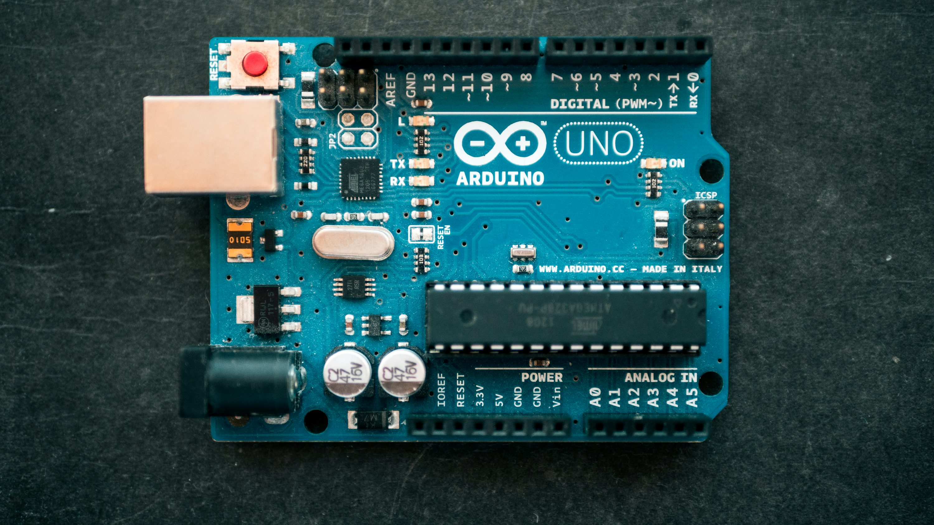

An **Arduino** is an open-source electronics platform

That consists of both hardware (a microcontroller board)

And software (the Arduino IDE). It is designed for easy

Use by beginners and professionals to build interactive

Projects, Automate tasks, and prototype devices.

### **Key Components of Arduino:**

1. **Microcontroller:** The "brain" of the board, typically an

ATmega series chip, which processes inputs and controls outputs.

1. **Digital & Analog I/O Pins:** Used to connect sensors, LEDs, motors, and other components.
2. **USB Port:** For programming and power.
3. **Power Pins:** Allow the board to be powered via USB, a battery, or an external power adapter.
4. **Clock & Voltage Regulators:** Ensure stable operation.

* Basic Information

Arduino is an open-source electronics platform based on easy-to-use hardware and software. It features microcontroller boards like the Arduino Uno, which allow users to create interactive projects by reading sensor inputs and controlling outputs like LEDs, motors, and displays. The Arduino IDE is used to write and upload code in C/C++. With built-in libraries and a vast community, Arduino is widely used in robotics, IoT, home automation, and education. Its affordability, versatility, and beginner-friendly nature make it ideal for both hobbyists and professionals in prototyping and automation projects. 🚀

* Types of Arduino

### Common Arduino Boards:

* **Arduino Uno:** The most popular board, great for beginners.
* **Arduino Mega:** More pins and memory for advanced projects.
* **Arduino Nano:** Small and compact for embedded applications.
* **Arduino Leonardo:** Supports USB emulation (e.g., acting as a keyboard/mouse).