[Student Name]’s Analysis
Data point | Gender
Data to be entered | Female
Input method | How many clicks/gestures? | How well does it help prevent errors? | How much guidance does it offer users? | Other comments?
Text box, with virtual keyboard.  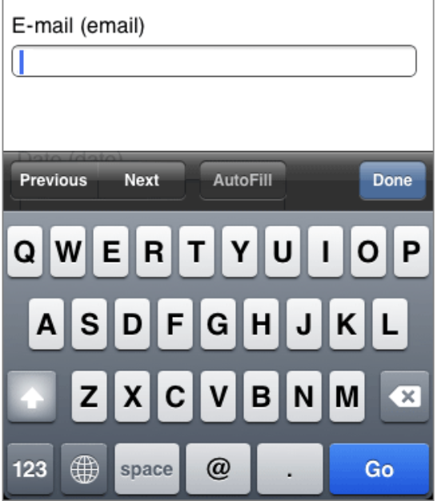 | 1 (tap in field)  6 (character strokes)  Total 7 gestures | It doesn't - users can type anything in the field | It doesn't, unless you add support text. | Supports any input, this including non-binary gender inputs.
Dropdown box, with spinner  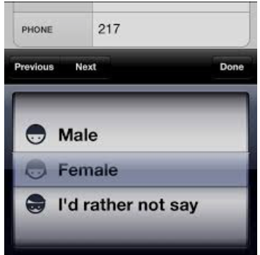 | 1 (tap in field)  1 (tap to select female)  Total 2 gestures | You can only pick one of the approved options | The text in the field before something is selected can offer guidance. | You must ensure all options are included in the list, or at least provide an 'other' option.
Radio buttons  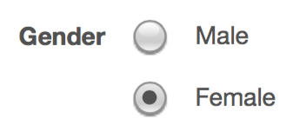 | 1 (tap on option)  Total 1 gesture | You can only pick one of the approved options.  BUT, you must have one selected by default, so users may accidentally skip the question and leave the wrong item selected. | All options are exposed, so users know what their choices are | You must ensure all options are included in the list, or at least provide an 'other' option.
Recommendation | Dropdown box

