Heuristic Evaluation

Student Name:

 | Severity
0 | Not a usability problem: The item identified follows the principles of visual and interaction design.
1 | Cosmetic problem only: This type of problem is usually a design-related issue of proximity and placement. For example, a problem that can be easily fixed and does not affect the usability of the site. Fixing this problem should be given low priority.
2 | Minor usability problem: This type of problem causes a minor disturbance for users. Users can still navigate through their task, but the response does not meet their original expectation. For example, the user needs to navigate through too many pages to complete the task, the user comes to a dead end but there are alternatives available, the language is difficult for the user to understand, or the user notices mismatches of terms and phrases. This type of problem is important to fix, so should be given priority.
3 | Major usability problem: This type of problem will deter users from using the site or is an issue in completing their tasks and missing the site’s and user’s goals. For example, the user cannot complete his/ her task, the user finds that the information is not clear, or there are broken links. This type of problem is imperative to fix.

App reviewed: The Weather Network
Feature: View weather at a new location

# | Matter (respect or violation) of a usability principle | Severity Rating | Description | Recommendation | Screenshot
1.0 | SAMPLE  Flexibility & efficiency of use  And  User control and freedom | 2 | SAMPLE  It’s a very inefficient way to add a city – it requires 5 screens, and multiple steps on each screen. Users are forced to ‘add’ a city to their list to simply see the weather. It doesn’t support just viewing it once. | SAMPLE  Allow users to see the weather before deciding to ‘save’ it to their list. | SAMPLE  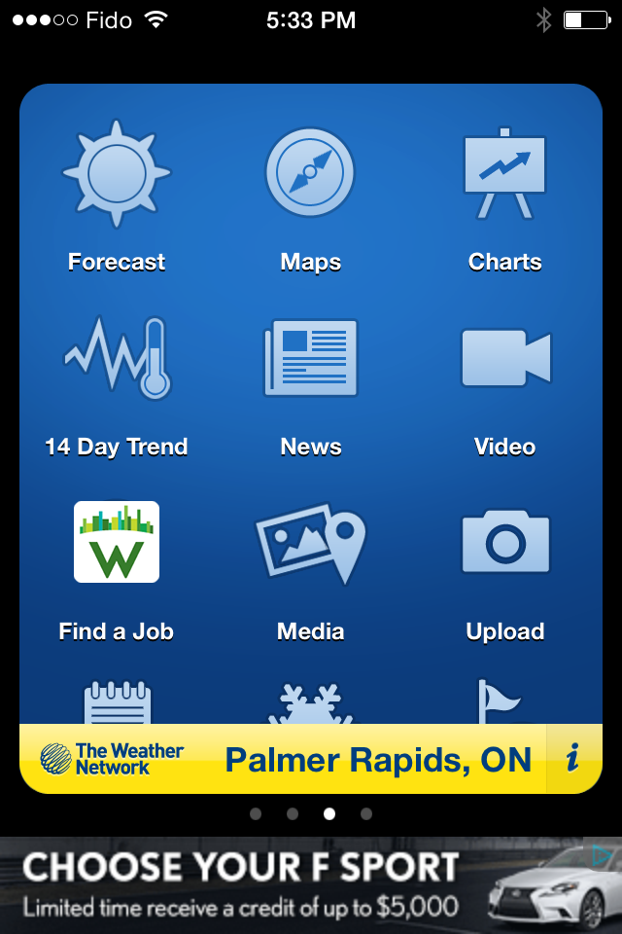
2.0 | Match between system and the real world. | 3 | The “Info” icon does not match the user’s expectations as a way to find a new city. It more likely suggests generic app info | Consider a more common approach – like a search icon. | 