Aim:

☛ Create a custom server using http module and explore the other modules of Node JS like OS, path, event.

Solution :

☛ Open Terminal or Command Prompt:

Open a terminal or command prompt in the directory where you saved your server.js file.

☛ Run the Server Script:

Execute the server script using the Node.js runtime. In the terminal, run:

node server.js

This will start the HTTP server, and you should see the message "Server running at http://127.0.0.1:3000/".

☛ Access the Server:

Open your web browser and navigate to http://127.0.0.1:3000/ or http://localhost:3000/. You should see the response "Hello, World!".

☛ Check OS Information:

In the same terminal where your server is running, you'll see information about your operating system (OS) type, platform, architecture, CPU cores, etc.

☛ Check Current Working Directory:

The current working directory of the script is printed in the terminal.

☛ Check Joined Path:

The joined path using the path module is printed in the terminal.

☛ Check Custom Event:

The script emits a custom event and listens for it. In the terminal, you should see the message "Custom Event Triggered: { message: 'Hello from custom event!' }".

☛ Stop the Server:

To stop the server, press Ctrl+C in the terminal where the server is running.

**server.js**

// Step 1: Import required modules

const http = require('http');

const os = require('os');

const path = require('path');

const { EventEmitter } = require('events');

// Step 2: Create an instance of EventEmitter

const eventEmitter = new EventEmitter();

// Step 3: Create a simple HTTP server

const server = http.createServer((req, res) => {

res.writeHead(200, { 'Content-Type':'text/plain' });

res.end('Hello, World!\n');

});

// Step 4: Define server port and hostname

constport = 3000;

consthostname = '127.0.0.1';

// Step 5: Listen for requests on the specified port and hostname

server.listen(port, hostname, () => {

console.log('Server running at http://${hostname}:${port}/');

});

// Step 6: Print OS information

console.log('OS Type:', os.type());

console.log('OS Platform:', os.platform());

console.log('OS Architecture:', os.arch());

console.log('CPU Cores:', os.cpus().length);

// Step 7: Print current working directory

console.log('Current Working Directory:', process.cwd());

// Step 8: Join paths using the path module

const joinedPath = path.join(__dirname, 'public', 'images');

console.log('Joined Path:', joinedPath);

// Step 9: Handle a custom event

eventEmitter.on('customEvent', (data) => {

console.log('Custom Event Triggered:', data);

});

// Step 10: Emit a custom event

eventEmitter.emit('customEvent', { message:'Hello from custom event!' });

## Output :

### In the Terminal:

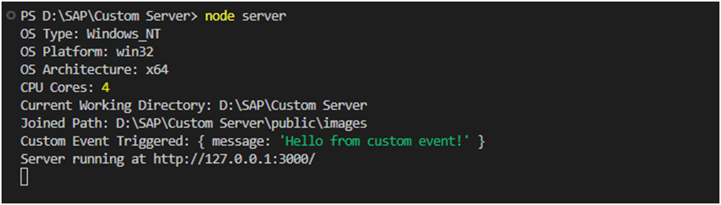

### In the Browser:

#### Link: http://127.0.0.1:3000/

