**Session -33 Task**

**Qn 1:**

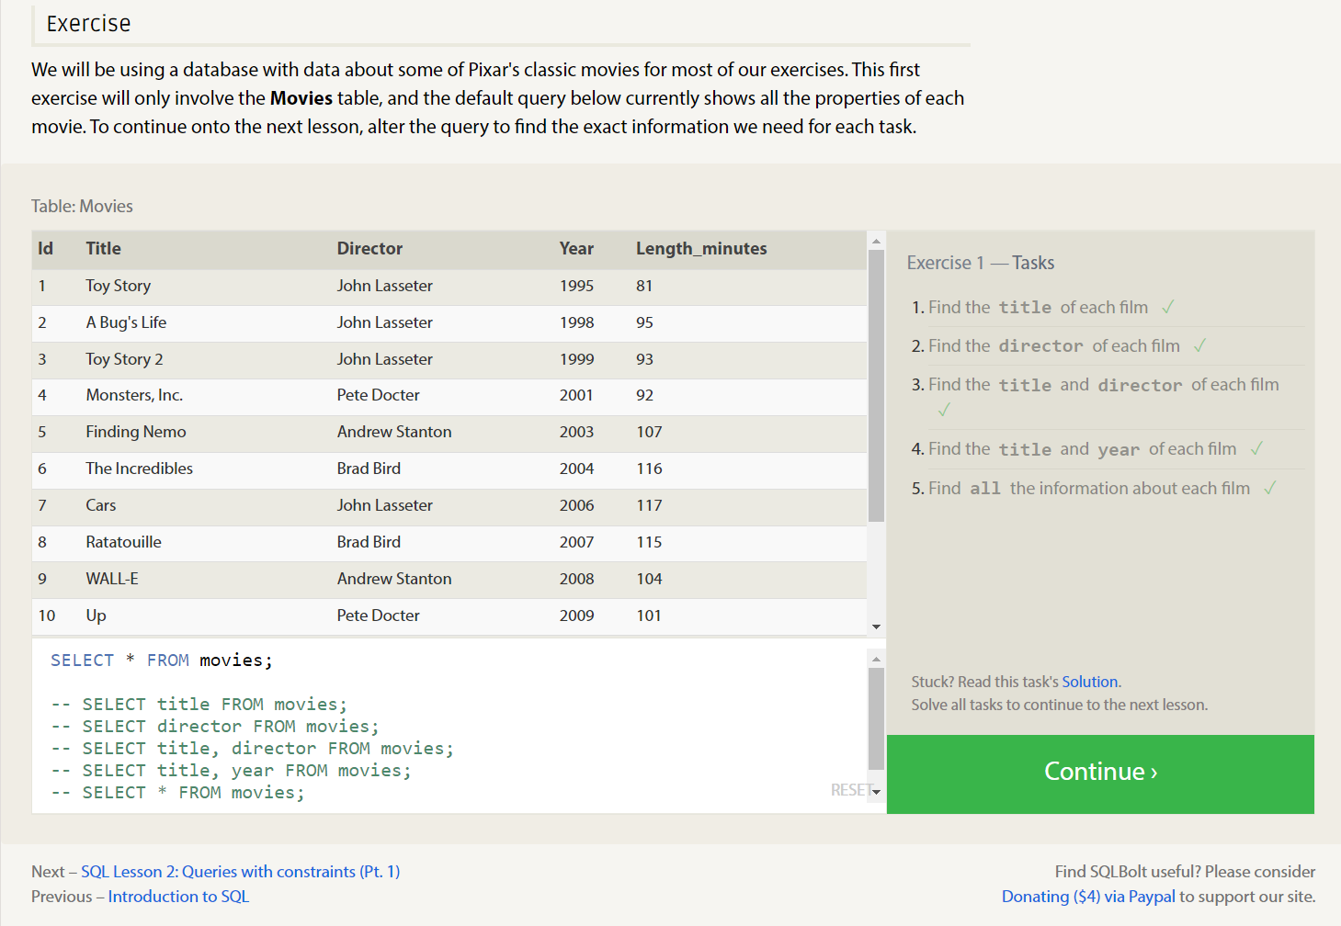

**Qn 2:**

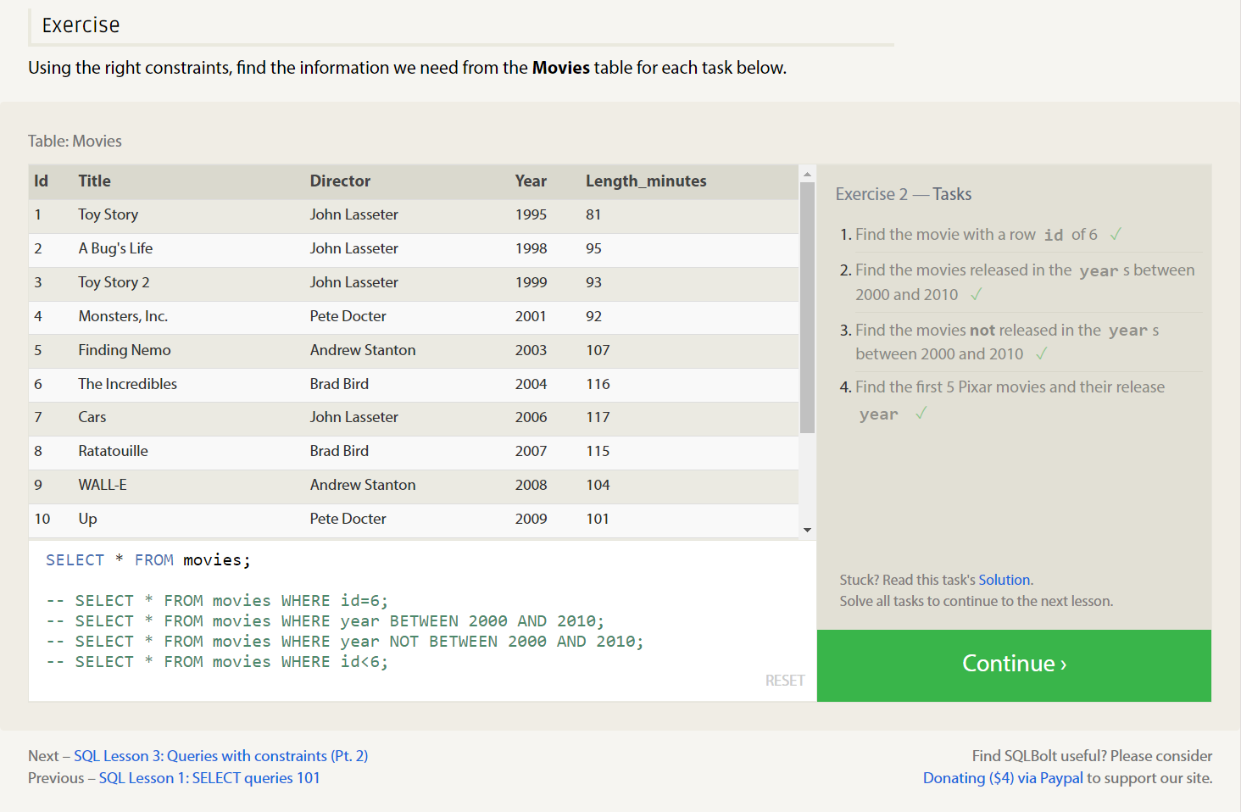

**Qn 3:**

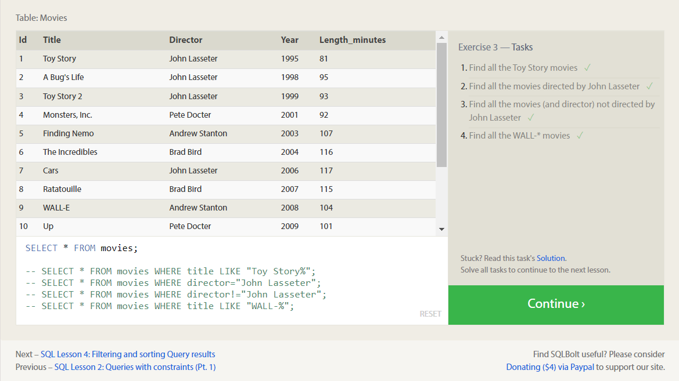

**Qn 4:**

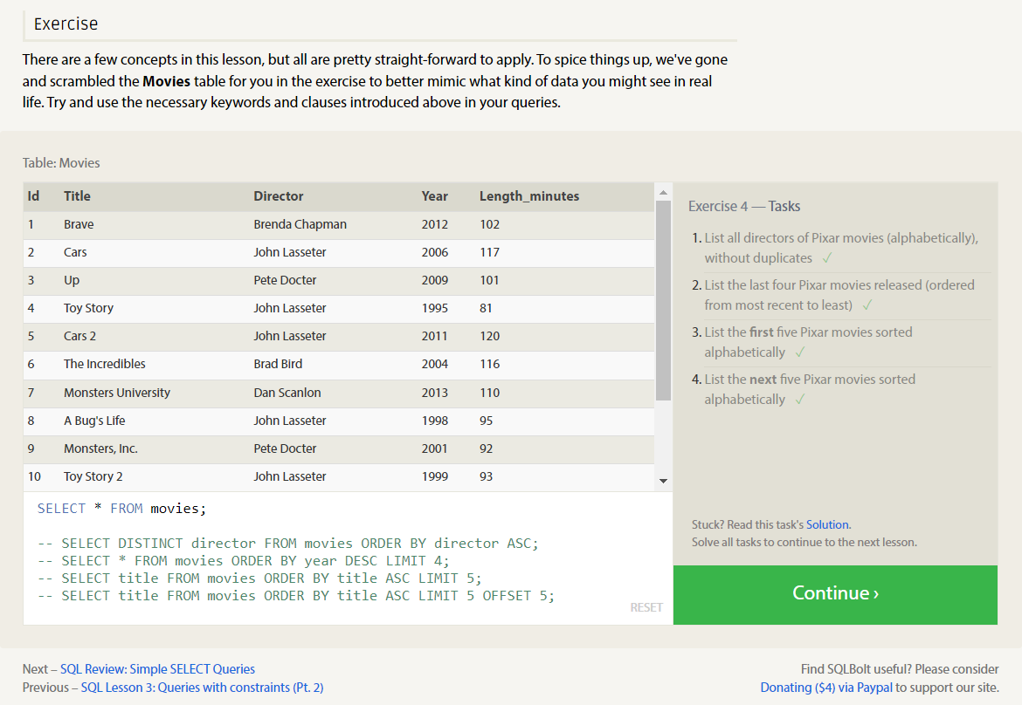

**Qn 5:**

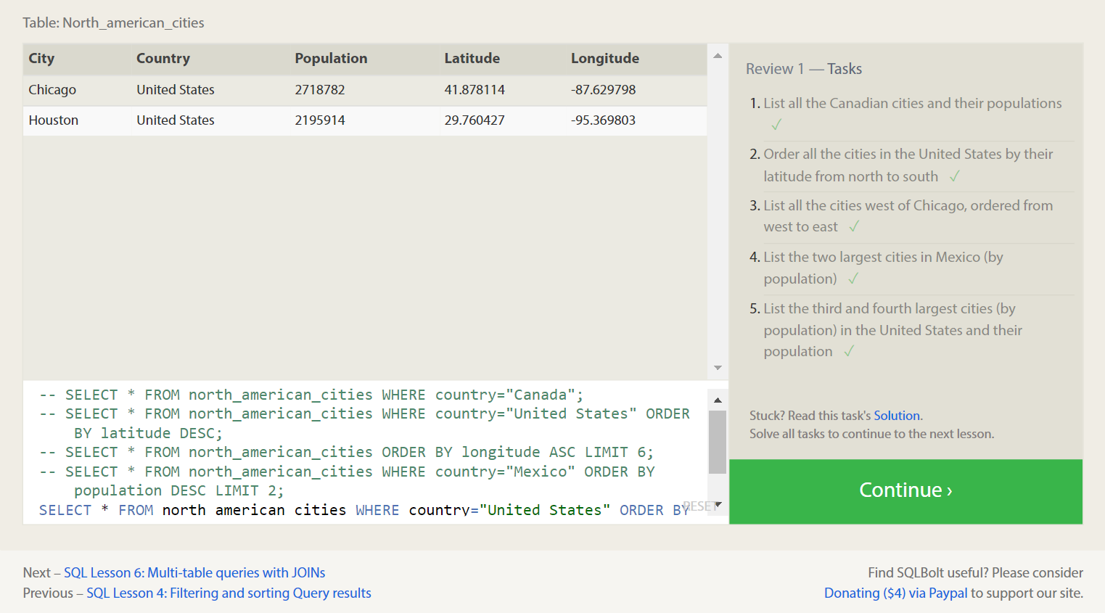

**Qn 6:**

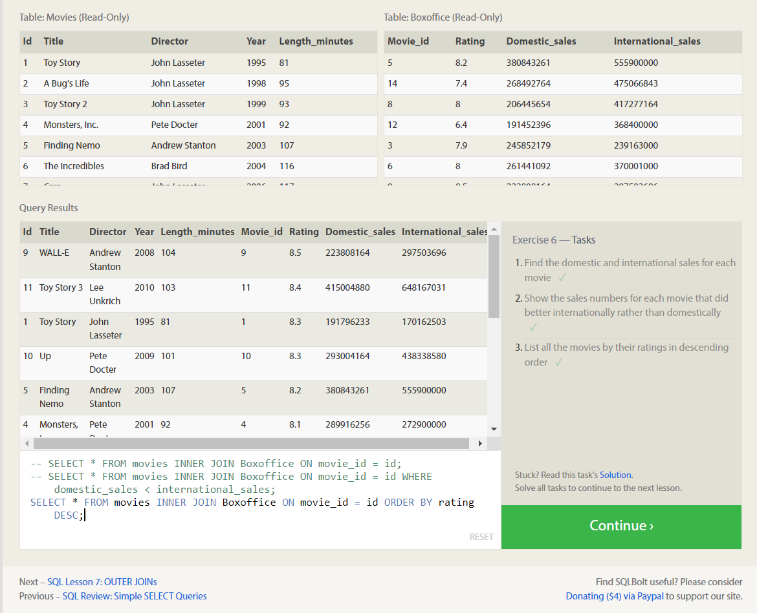

**Qn 7:**

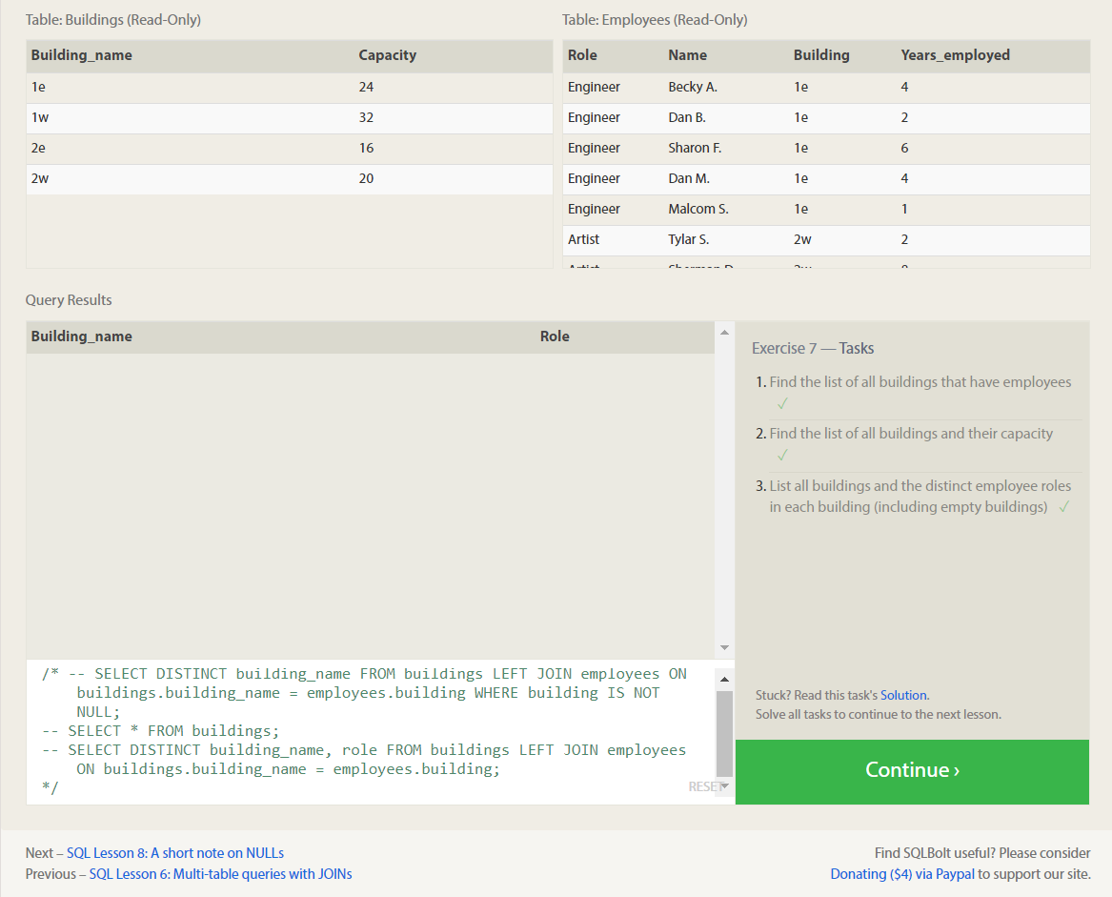

**Qn 8:**

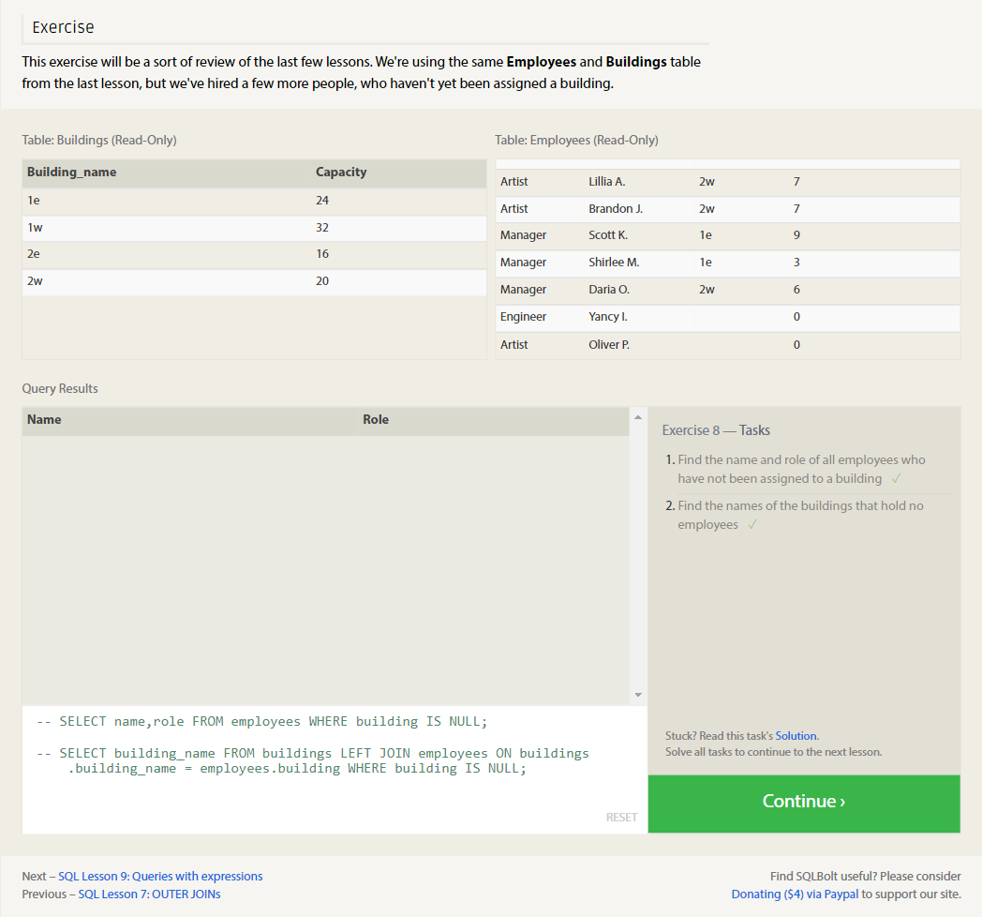

**Qn 9:**

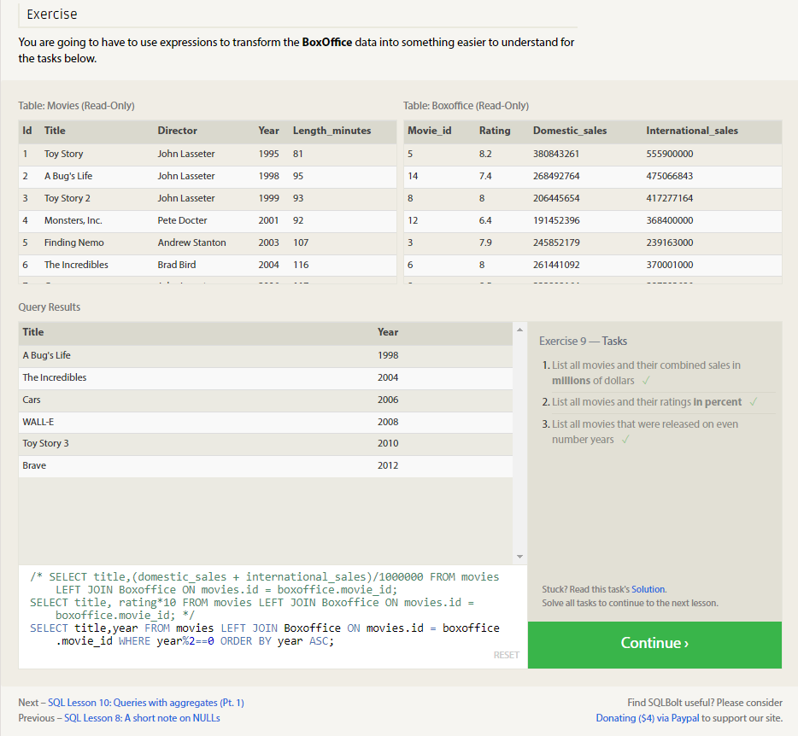

**Qn 10:**

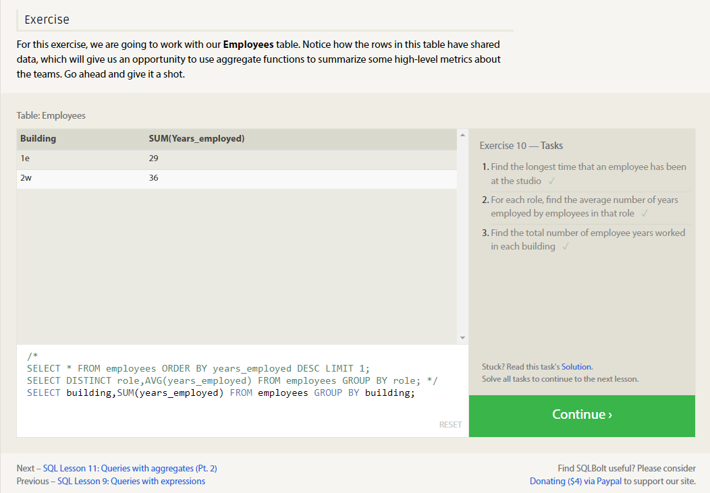

**Qn 11:**

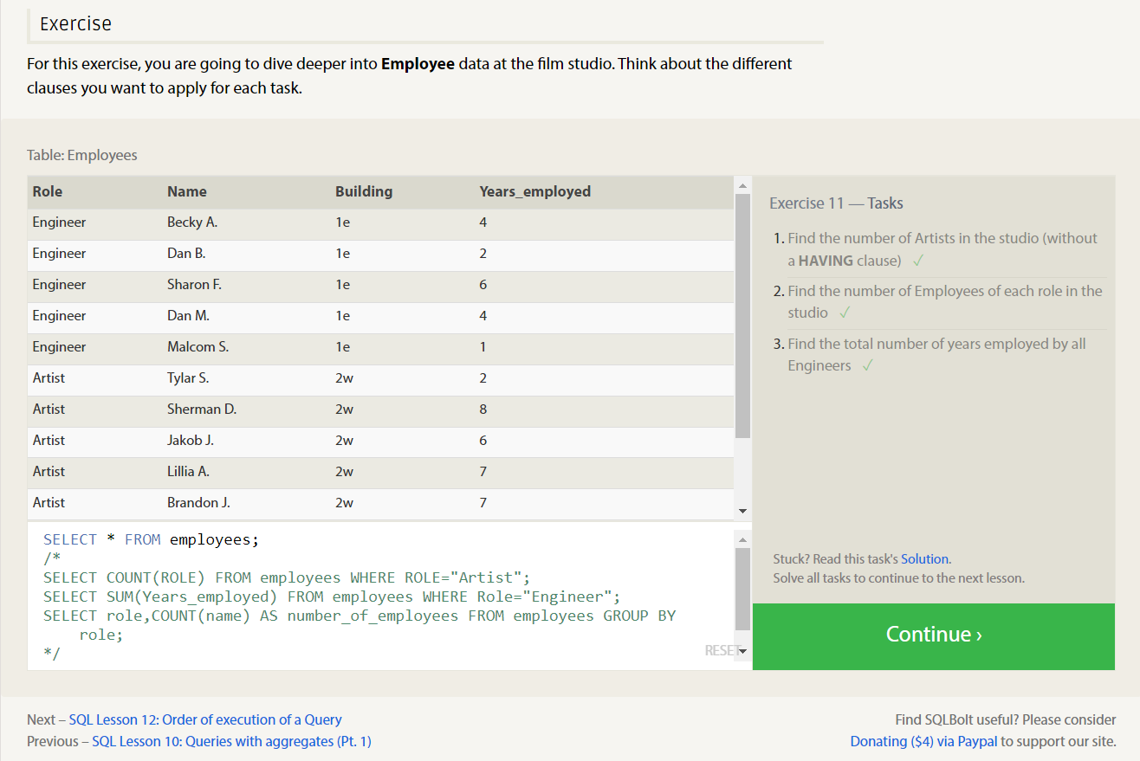

**Qn 12:**

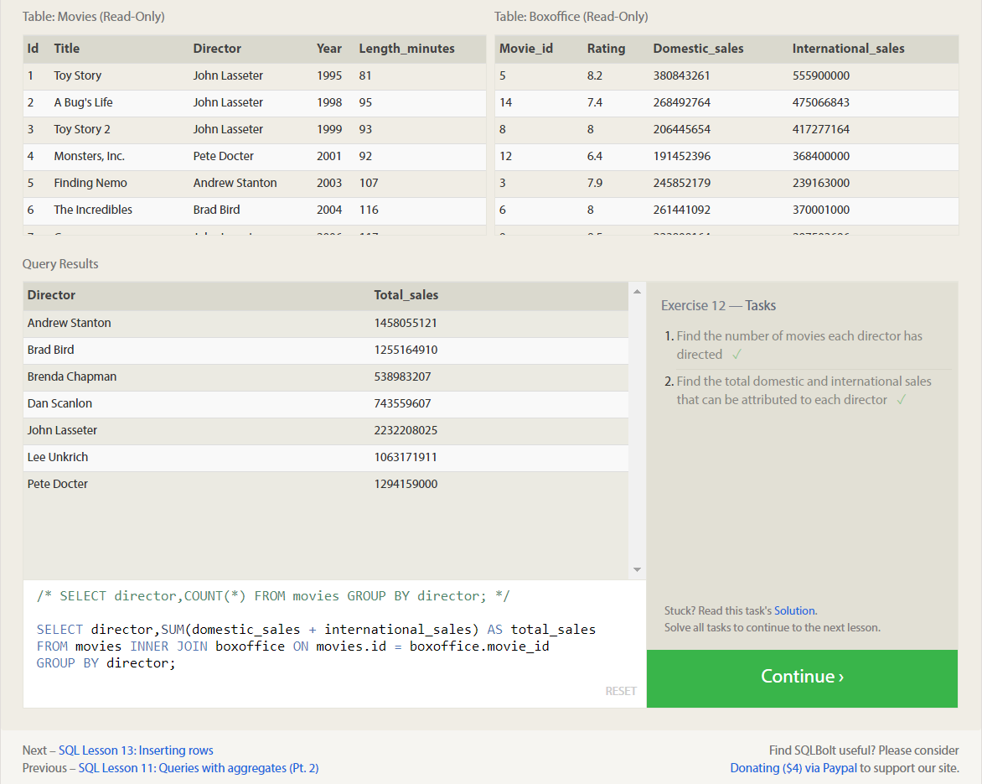

**Qn 13:**

**Qn 14:**

**Qn 15:**

**Qn 16:**

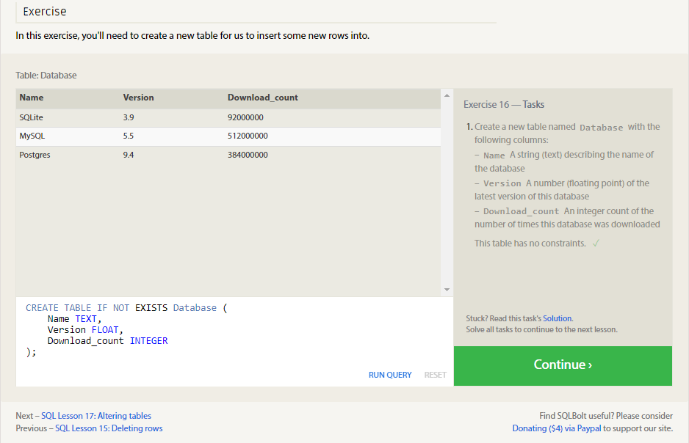

**Qn 17:**

**Qn 18:**

