**Frontend Overview:**

**React:**

Library Choice: The frontend is built using React, a declarative and efficient JavaScript library for building user interfaces. React allows for the creation of reusable UI components.

**Material-UI:**

UI Framework: Material-UI is used as the primary UI framework to implement the design language of Google's Material Design. It provides a set of React components following Material Design principles for a consistent and visually appealing user interface.

**Authentication Components:**

Login and Registration Forms: React components for user authentication, including login and registration forms. These components interact with the backend authentication API.

**User Profile Components:**

Profile Display: Components for displaying user information, including the user's profile picture, username, bio, and other relevant details.

Edit Profile Form: A form to edit and update the user's profile information.

**Feed Components:**

Post Feed: Components responsible for displaying posts in a user's feed, including images, captions, likes, and comments.

Create Post Form: A form for users to create and upload posts, including images.

**Friend Management Components:**

Friends List: Displays the user's list of friends with links to their profiles.

Add Friend Component: Allows users to send friend requests and manage their friends.

**Interactive Components:**

Like and Comment Buttons: Interactive components for liking posts and adding comments.

Notification Alerts: Components to display notifications for new friend requests, post likes, and comments.

**Routing:**

React Router: Implements client-side routing to navigate between different pages and components of the application without refreshing the entire page.

**State Management:**

React Context or Redux: Manages the state of the application, ensuring efficient data flow between components. State management is crucial for handling user authentication, post data, and friend lists.

**Responsive Design:**

Media Queries: Ensures a responsive design that adapts to various screen sizes and devices, providing a consistent user experience.

**Integration with Backend APIs:**

Axios or Fetch: Integration with backend APIs for user authentication, fetching posts, managing friends, and other interactions.

**Error Handling:**

Display Error Messages: Components for displaying error messages in case of failed operations, such as unsuccessful login attempts or failed post uploads.

Certainly! Let's delve into a more detailed backend overview, specifically focusing on API routes, controllers, and models for users, posts, and friend management:

**Backend Overview:**

**Node.js and Express.js:**

Node.js serves as the runtime, and Express.js is the web application framework for handling HTTP requests and responses.

**MongoDB and Mongoose:**

MongoDB is used as the NoSQL database to store data, while Mongoose serves as the ODM (Object Data Modeling) library to define schemas and interact with MongoDB.

**Models :**

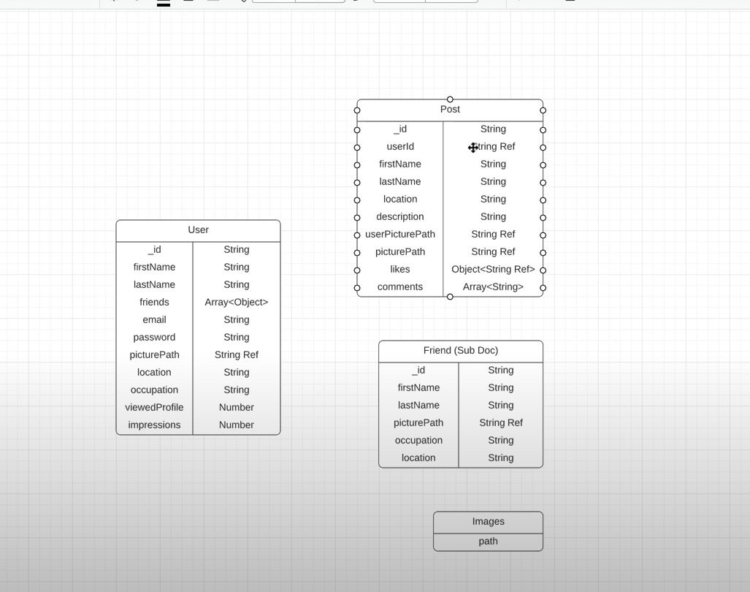

**User Model:**

**Schema Definition:**

Defines the structure of the User entity, including fields such as username, email, password (hashed), profilePicture, bio, etc.

**Mongoose Model:**

Represents the User entity in the application code.

Manages CRUD operations related to users.

**Post Model:**

**Schema Definition:**

Describes the structure of a post, including fields like userId (reference to the user who created the post), image, caption, likes, comments, createdAt, etc.

**Mongoose Model:**

Represents the Post entity in the application code.

Handles CRUD operations related to posts.

**Friend Model:**

**Schema Definition:**

Represents the relationship between users, including fields like userA, userB, status (pending, accepted, etc.).

**Mongoose Model:**

Manages friend-related operations, such as sending and accepting friend requests.

**User Authentication API:**

Endpoints:

/api/auth/register (POST): Allows users to register by providing a username, email, and password.

/api/auth/login (POST): Authenticates users using their credentials and returns a JWT upon successful login.

/api/auth/me (GET): Retrieves the user's profile information based on the JWT token.

**Post API:**

/api/posts (GET): Fetches a list of posts from the user's friends for the feed.

/api/posts/:postId (GET): Retrieves a specific post by ID.

/api/posts (POST): Creates a new post, allowing users to upload images and add captions.

/api/posts/:postId (PUT): Updates an existing post, e.g., editing captions.

/api/posts/:postId (DELETE): Deletes a post.

**Friend Management API:**

/api/friends/send-request (POST): Sends a friend request to another user.

/api/friends/accept-request (POST): Accepts a friend request from another user.

/api/friends/list (GET): Retrieves the list of friends for a user.

Authentication Middleware:

**JWT Verification:**

Middleware to verify and decode JWTs attached to protected routes.

Ensures that only authenticated users have access to certain endpoints.

Controllers:

**User Controller:**

Handles requests related to user registration, login, and profile information.

Post Controller:

Manages requests related to creating, updating, and deleting posts.

Friend Controller:

Handles friend-related requests, including sending and accepting friend requests.

Middleware for Request Handling: