ONLINE FRAUD DETECTION SYSTEM

Dokala.Jaya Deepika, a

Author Affiliations

1,2,3,4JNTU-GV COLLEGE OF ENGINEERING, VIZIANAGARAM

JAWAHARLAL NEHRU TECHNOLOGICAL UNIVERSITY- GURAJADA VIZIANAGARAM

DWARAPUDI, VIZIANAGARAM, ANDHRA PRADESH – 535003.

(A constituent college of JNTU-GV & Approved by AICTE ,New Delhi)(Recognised by UGC under section 2(f)&12(B) of UGC Act 1956)

Author Emails

jayadeepikadokala@gmail.coma

**Abstract:** Online fraud detection has become increasingly critical for organizations needing to secure transactions and safeguard customer trust efficiently and accurately. **FraudShield** is a next-generation fraud detection system developed to meet these needs by integrating advanced data science techniques and machine learning models, ensuring high accuracy across diverse transactional data and scenarios. The system leverages a combination of **Gradient Boosting Machines (GBM)** for powerful predictive modeling, **Neural Networks** for complex pattern recognition, and **anomaly detection techniques** like Isolation Forests for identifying rare fraudulent activities. Together, these components enable FraudShield to deliver robust fraud detection performance, adaptable to both structured and unstructured financial data. FraudShield’s architecture is built on a cloud-ready, microservices-based design, which allows for scalable, real-time processing of high data volumes. Data preprocessing and feature engineering techniques, such as normalization, outlier detection, and feature selection, further enhance detection accuracy by refining the quality of input data. The system also includes an intuitive user interface built with React.js, enabling seamless interaction and providing real-time alerts on suspicious activities.With applications across industries like finance, e-commerce, and healthcare, FraudShield automates the detection of fraudulent transactions, improving operational efficiency and reducing financial risks while minimizing false positives. In finance, for example, the system can rapidly identify suspicious transactions or account takeovers. In e-commerce, it can detect fraudulent purchases and safeguard customer data. Healthcare operations benefit from the detection of insurance fraud, enhancing compliance and data integrity. This document provides a detailed overview of the system’s design, functionality, and potential applications. Future improvements are also discussed, including mobile integration, extended anomaly detection capabilities, and expanded cloud infrastructure. FraudShield positions itself as a versatile, scalable solution for modern fraud prevention challenges, advancing the capabilities of fraud detection technology and supporting a wide range of industry applications.

1.**Introduction**: In recent years, online fraud detection has become a cornerstone for businesses and institutions aiming to secure digital transactions, protect sensitive data, and maintain customer trust. The rapid growth of online platforms in industries such as e-commerce, finance, healthcare, and logistics has led to an exponential increase in the volume of digital transactions. This surge has heightened the need for advanced fraud detection systems capable of identifying fraudulent activities in real-time with high accuracy. Traditional fraud detection methods, which often rely on rule-based systems, struggle to keep up with evolving fraud patterns and sophisticated attack strategies, leading to false positives and missed threats that compromise the security of digital operations. **FraudShield** was developed to address these challenges by leveraging state-of-the-art machine learning and data science techniques to enhance the accuracy, adaptability, and scalability of fraud detection systems. The system employs a hybrid approach, integrating **Gradient Boosting Machines (GBM)**, **Neural Networks**, and **anomaly detection models** to analyze transactional data and detect fraudulent activities. Gradient Boosting Machines offer robust predictive modeling capabilities, enabling FraudShield to accurately classify transactions as legitimate or fraudulent. Neural Networks enhance the system’s ability to identify complex patterns and behaviors associated with fraud, while anomaly detection methods, such as Isolation Forests, focus on uncovering rare and suspicious activities that deviate from normal transactional behavior.

Additionally, FraudShield features a comprehensive data preprocessing pipeline that includes techniques such as outlier detection, normalization, and feature selection to optimize data quality and improve model performance. These steps ensure the system can effectively handle noisy, high-dimensional, and imbalanced datasets, which are common in real-world fraud detection scenarios.

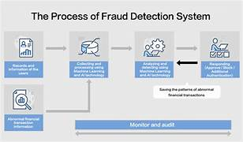

**3. System Architecture: FraudShield** is built on a modular system architecture that enables flexible integration and efficient processing. Key architectural components include:

**Machine Learning Foundation-**The architecture incorporates a robust machine learning pipeline with **Gradient Boosting Machines (GBM)** for predictive modeling, **Neural Networks** for detecting complex fraud patterns, and **anomaly detection models** like **Isolation Forests** for identifying unusual transactional behavior. This foundation ensures the system can detect fraudulent activities across various platforms and transaction types, enhancing accuracy and adaptability.

Core Technologies

* Programming Languages and Libraries: Python with libraries such as TensorFlow and PyTorch for model development.
* Web Technologies: React.js for frontend development and Node.js for backend, enabling responsive and user-friendly interfaces.
* Cloud Infrastructure: The deployment is designed to be cloud-ready, allowing for scalable processing and data storage.

**System Integration-** FraudShield employs a **microservices** design with a **RESTful API** for seamless communication between frontend and backend components. Each part of the architecture is optimized for scalability, ensuring the system can handle increasing transaction volumes while maintaining high speed and accuracy.

**4. Data Processing and Feature Engineering:** Effective data processing and feature engineering are critical to achieving high accuracy in fraud detection, particularly when working with diverse transaction data and user behaviors. **FraudShield** incorporates a sophisticated data preprocessing pipeline that optimizes raw input data, reduces noise, and extracts meaningful features for its machine learning models. This approach enhances fraud detection accuracy and enables the system to handle a wide range of transactional data, including online payments, credit card transactions, and account activities with varying complexities and patterns.

4.1 Data Collection and Preprocessing-

Data collection is the foundational step for any fraud detection system, as it determines the diversity and quality of the dataset used for model training and testing. In **FraudShield**, data is collected from multiple sources to cover a broad spectrum of transaction types, payment methods, and user behaviors. This includes high-volume transaction logs, low-frequency transactions, and datasets containing fraudulent activity patterns such as chargebacks and account takeovers.

Once the data is collected, it undergoes a series of preprocessing steps to ensure it is ready for feature extraction and model input. Key preprocessing steps include:

* **Data Normalization**: This step scales numerical values to ensure consistent ranges across features, helping machine learning models converge faster and perform better on diverse transaction data.
* **Noise Reduction**: Techniques such as smoothing and filtering are applied to transactional data to eliminate random noise or outliers that could skew model predictions. This is especially useful for datasets containing inconsistent or missing values.
* I**mbalanced Data Handling**: Fraud detection datasets are often imbalanced, with a small number of fraudulent transactions compared to legitimate ones. Techniques such as oversampling (e.g., SMOTE) or undersampling are used to balance the data and improve model performance..
  1. Advanced Feature Engineering-

Feature engineering involves extracting and refining features from the preprocessed data to improve model input quality. **FraudShield** employs several advanced techniques to capture the essential characteristics of fraudulent and legitimate transactions.

* **Time-Series Analysis**: By analyzing time-based patterns, FraudShield can detect anomalies in user behavior, such as sudden spikes in transaction amounts or frequency.
* **Feature Interaction**: New features are created by combining existing ones, such as transaction amount relative to account balance, to provide the model with more insightful data.
* **Behavioral Profiling**: This technique tracks user behavior over time, identifying deviations from their normal transaction patterns. Behavioral profiles help the system flag potentially fraudulent activities, even if they don’t match known fraud patterns.
  1. Enhancement Techniques for Low-Quality Images

Fraud detection systems often face challenges with incomplete or noisy data, which can hinder model performance. To address these issues, **FraudShield** includes several enhancement techniques tailored for such conditions:

* **Outlier Detection**: Statistical methods and machine learning models, such as Isolation Forests, identify and remove outliers that could distort the model’s learning process.
* **Data Imputation**: For missing data, imputation techniques such as mean, median, or model-based methods are used to fill in the gaps, ensuring a complete dataset for analysis.
* **Dynamic Thresholding**: Unlike fixed thresholds, dynamic thresholds adjust based on real-time data trends, improving the system's ability to detect anomalies under varying conditions.
  1. Feature Selection and Dimensionality Reduction

After feature extraction, **FraudShield** employs feature selection and dimensionality reduction techniques to optimize the input data further:

* **Principal Component Analysis (PCA)**: PCA reduces the dimensionality of the feature space while preserving the most informative features. This improves processing speed and reduces memory requirements, making the system more efficient and scalable.
* **Recursive Feature Elimination (RFE)**: RFE helps identify the most important features for fraud detection, enhancing model interpretability and performance.
* Stroke Width Transform: This technique measures the width of each stroke in handwritten text, helping the model differentiate between distinct characters that may be merged or overlapping.

**5. Model Development and Training:** The model architecture and training process are crucial to the performance of **FraudShield**, particularly for achieving high accuracy in detecting fraudulent activities across diverse transaction types and patterns. **FraudShield** employs a hybrid machine learning architecture that integrates Gradient Boosting Machines (GBMs) for robust predictive modeling, Neural Networks for capturing complex patterns, and anomaly detection techniques such as Isolation Forests to identify rare, suspicious behaviors. This combination enables the system to detect fraud with high precision, even in challenging scenarios such as low-frequency fraud, evolving fraud tactics, or complex transactional relationships.

* 1. **Neural Network Architecture**

The **FraudShield** model is designed with the following components:

* **Gradient Boosting Machines (GBM):** GBM layers provide strong predictive capabilities for binary classification tasks, effectively distinguishing between legitimate and fraudulent transactions. They capture intricate relationships between features and their impact on the classification outcome.
* **Neural Networks:** These layers are used to identify complex patterns and nonlinear relationships in transactional data. They enable the system to learn deep, abstract features that might indicate fraudulent behavior, such as subtle correlations between transaction time, location, and amount.
* **Anomaly Detection Models:** Isolation Forests are employed to identify rare and unusual transactions that deviate from the normal behavior of users. By isolating outliers, this component enhances the system’s ability to detect previously unseen fraud patterns.
* Together, these components enable **FraudShield** to achieve high performance in detecting diverse types of fraud, adapting to evolving patterns while minimizing false positives.

Together, these components allow InstantOCR to achieve robust and adaptable text recognition performance, handling documents with varying levels of complexity and quality. The **FraudShield** model is designed with the following components:

**5.2 Training Strategy**

The training strategy is structured to optimize model performance across diverse document types, ensuring accuracy and generalization. Key steps in the training pipeline include:

* **Data Batching**: The training data is organized into batches to facilitate efficient memory usage and stable learning. Mini-batch gradient descent is used to update the model parameters, reducing computational overhead while maintaining training stability.
* **Learning Rate Scheduling**: A dynamic learning rate schedule adjusts the learning rate as training progresses. Initially, a higher learning rate accelerates convergence, while a lower rate toward the end fine-tunes the model. This adaptive scheduling improves convergence and helps avoid local minima.
* **Data Augmentation**: Data augmentation techniques, such as rotation, scaling, and flipping, are applied to the training images to simulate real-world variations. This process expands the training dataset and enhances the model’s ability to generalize to unseen data.
* **Early Stopping and Model Checkpointing**: Early stopping is used to halt training once validation performance plateaus, preventing overfitting. Model checkpoints are saved periodically, allowing for retrieval of the best-performing model version based on validation accuracy.
  1. **Optimization Techniques**

To ensure optimal performance, **FraudShield** employs several optimization techniques:

* **Hyperparameter Tuning:** Critical parameters, such as learning rate, batch size, and tree depth for GBM, are optimized using grid search and random search. This step ensures that the model is fine-tuned for the best performance.
* **Regularization Methods:** Techniques like dropout in neural networks and L1/L2 regularization in GBM help prevent overfitting by discouraging overly complex models.
* **Gradient Clipping:** In the neural network layers, gradient clipping is applied to control exploding gradients, particularly when handling sequences or large feature spaces, ensuring stable and effective training.

.

**7. Use Cases and Applications:**

* **FinanceandBanking:**  
  Detecting fraudulent transactions in real-time, monitoring suspicious account activities, and preventing credit card fraud. The system can also be used for anti-money laundering (AML) by identifying unusual transaction patterns that deviate from customer profiles.

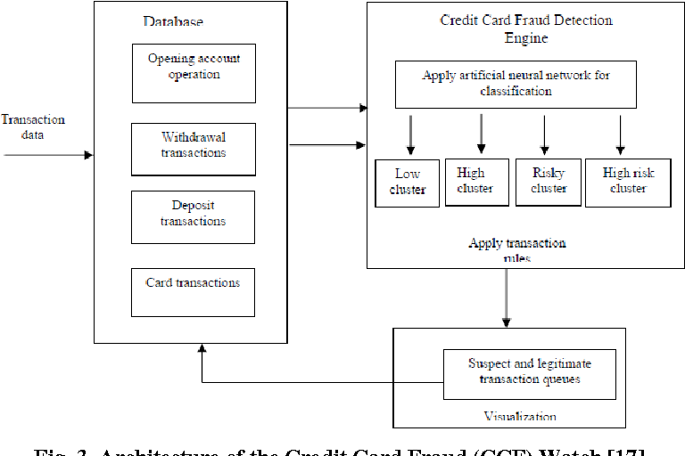

**8. Conclusion**

Online Fraud Detection represents a critical advancement in cybersecurity, offering high accuracy, scalability, and adaptability in detecting fraudulent activities across various platforms and industries. By leveraging sophisticated machine learning techniques, real-time transaction analysis, and behavior-based anomaly detection, the system can effectively identify and mitigate fraud in sectors such as banking, e-commerce, and digital payments. Future developments are focused on enhancing the system’s ability to adapt to emerging fraud tactics, improving the speed and accuracy of fraud detection, and expanding the system's capabilities for multi-layered protection. With continued advancements, online fraud detection systems will be increasingly essential in safeguarding digital transactions and maintaining trust in online services..