  - Prompt Engineering

Task 2: PROMPTING FOR CREATIVITY

Objective:

The objective of this task is to explore how prompt engineering techniques and prompt variations influence AI-generated creative outputs. This task focuses on few-shot prompting and tone-based response generation.

Tools Used:
- ChatGPT
- Microsoft Word
- Screenshot Tools

Main Prompt:
You are a creative social media expert.
Here are some examples:
Example 1:
Topic: Fitness
Caption:
Push harder today if you want a different tomorrow. 💪
Example 2:
Topic: Study Motivation
Caption:
Small progress every day adds up to big success. 📚✨
Example 3:
Topic: Internship Journey
Caption:
Every expert was once a beginner. Starting my internship journey today! 🚀
Now create 3 Instagram captions for:
Topic: First Internship Experience
Requirements:
- Motivational tone
- Use emojis
- Include hashtags
- Keep captions short and engaging

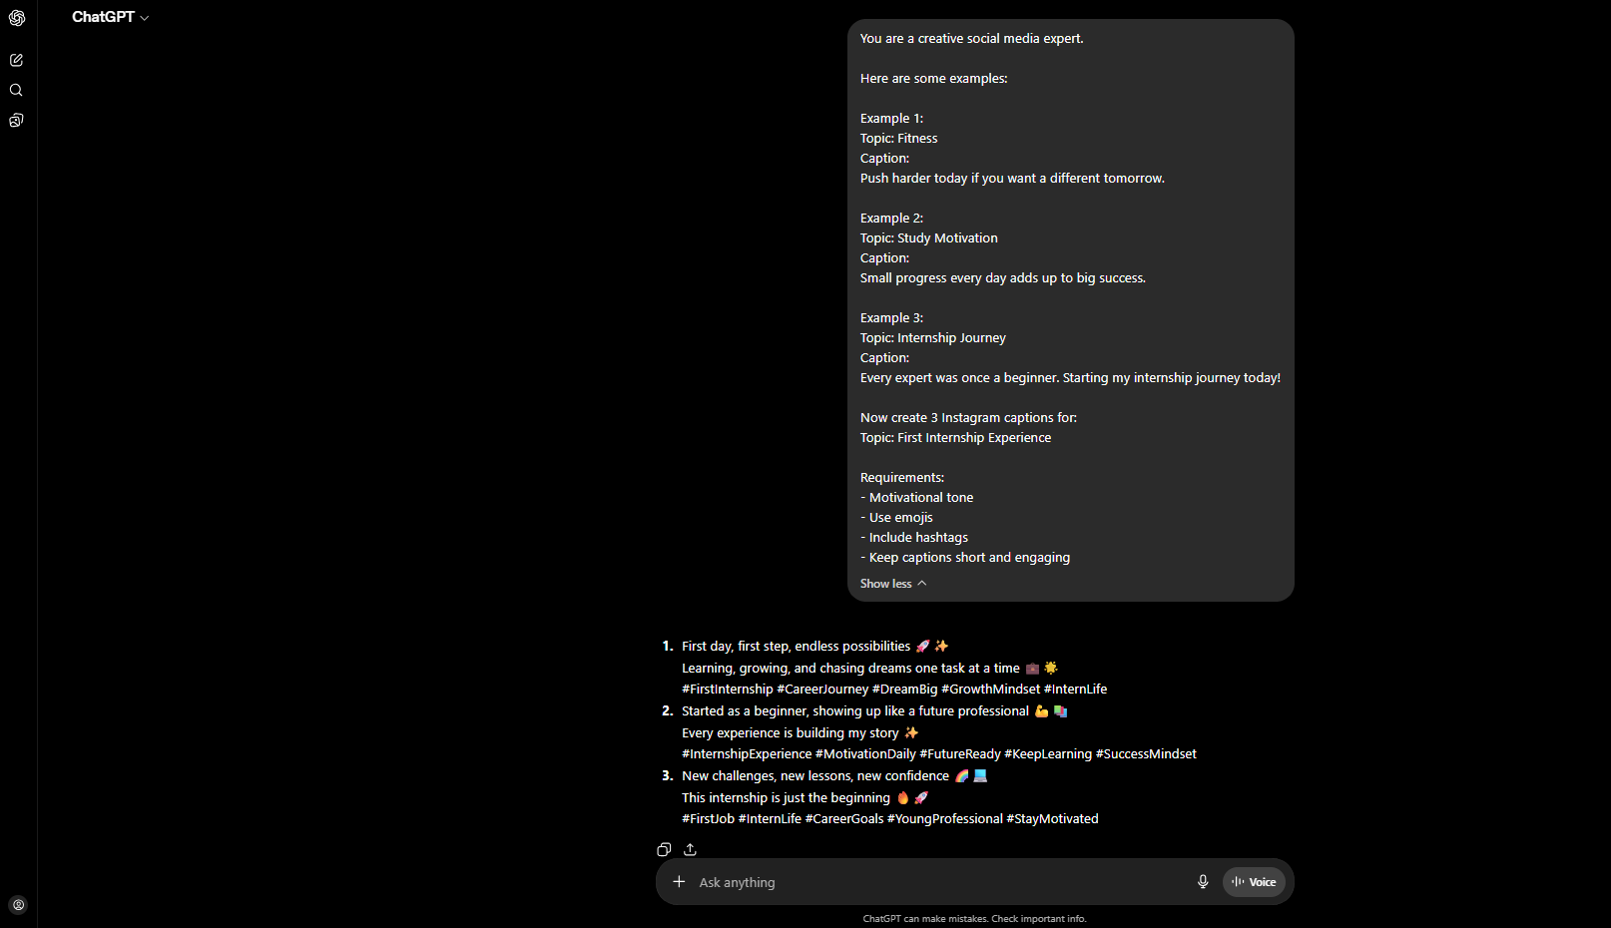

Variant 1 – Professional Tone
Prompt Used:
Create captions in a professional LinkedIn style.
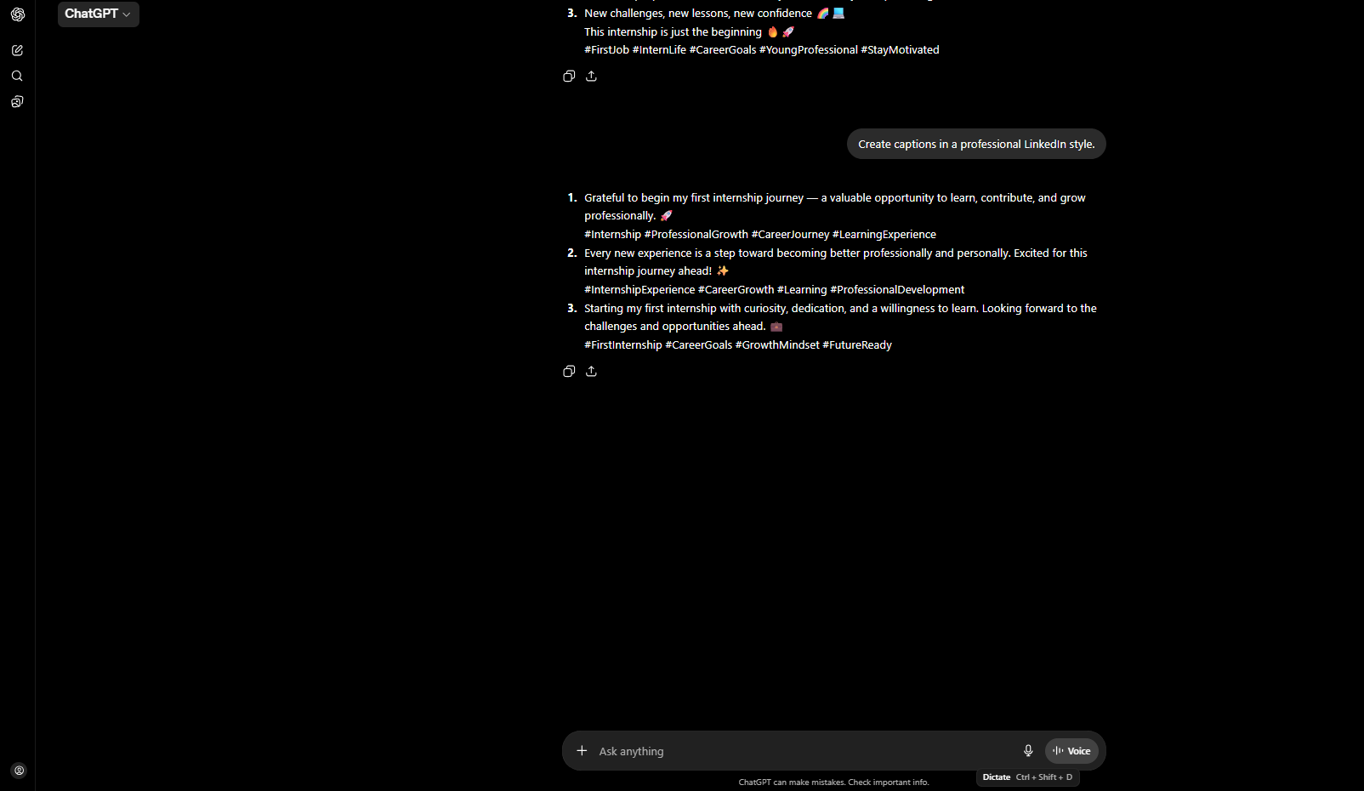
Analysis:
The professional tone generated formal and polished captions suitable for LinkedIn and career-related posts. The responses focused on growth, learning, and professionalism.

Variant 2 – Funny Tone
Prompt Used:
Create captions in a humorous and funny tone.
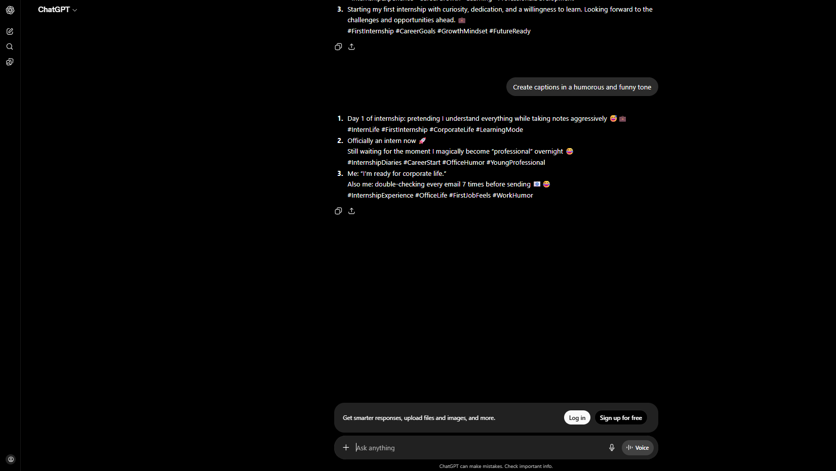

Analysis:
The funny tone generated light-hearted and entertaining captions with casual language and humor. The responses were more engaging and playful compared to the professional tone.
Variant 3 – Emotional Tone
Prompt Used:
Create captions in an emotional and inspiring tone.
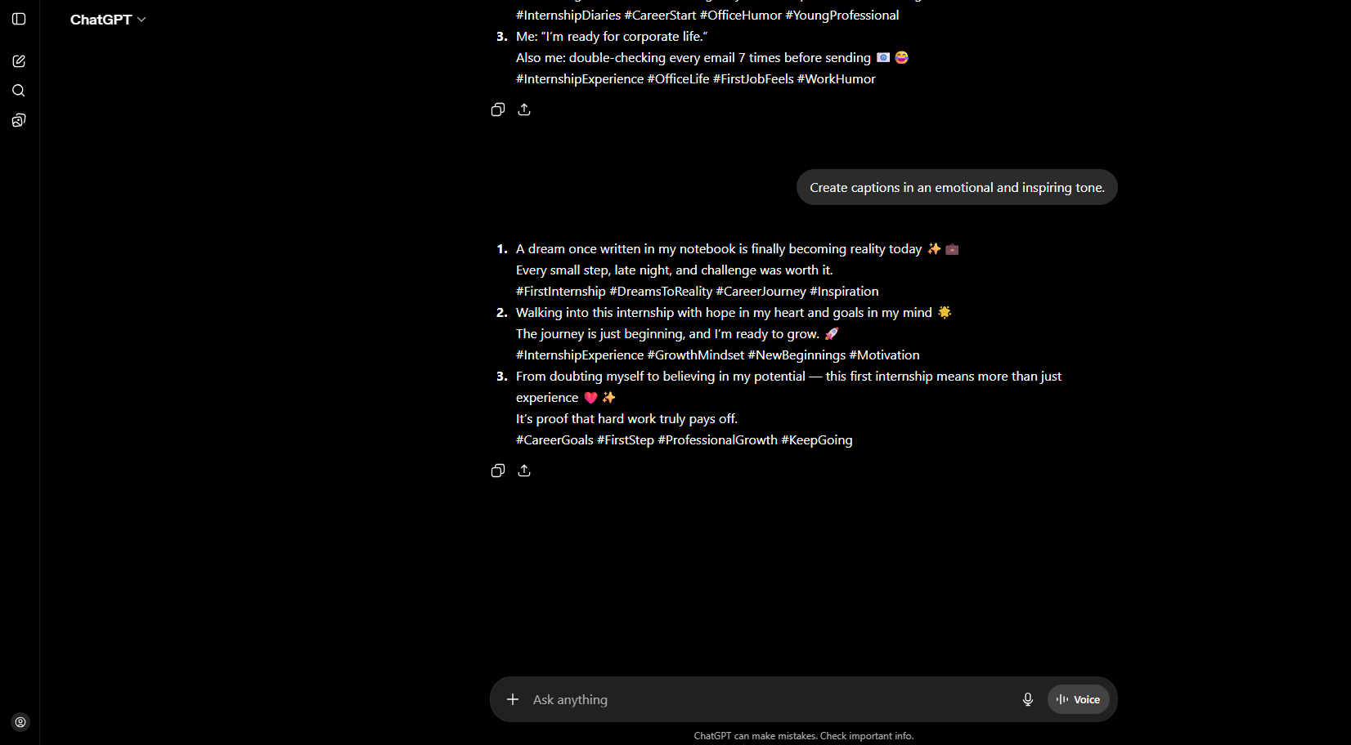

Analysis:
The emotional tone generated inspiring and heartfelt captions focused on personal growth, excitement, and motivation. The responses created a stronger emotional connection with the audience.

Conclusion:
Through this task, I gained practical experience in prompt engineering and understood how different prompt styles can influence AI-generated responses. By experimenting with professional, funny, and emotional tones, I observed how the same topic can produce completely different outputs depending on the wording and structure of the prompt.
This activity also helped me improve my creativity, communication, and understanding of few-shot prompting techniques. I learned that providing examples and clear instructions helps AI generate more accurate, engaging, and context-aware content.
Overall, this task was a valuable learning experience that showed me the importance of prompt design in generating high-quality AI responses for real-world creative applications such as social media content creation and digital communication.

