**The effect of Type 1 diabetes (T1D) on maternal contribution to the neonatal microbiome**

**Background:**

It has previously been reported that the neonates from Type1 diabetic mothers have altered microbiota at birth and in early childhood. However, distinguishing the relative impact of underlying maternal disease from confounding effects of glycemic control, medications, and mode of delivery is challenging. Neonatal microbiomes are primarily inoculated from their mothers, with secondary contributions from their surrounding environment, but the effect of T1D may influence maternal microbiome capacity to contribute to the inoculation and establishment of the neonatal microbiome. This study sought to investigate the impact of T1D on ability for maternal (sources) microbiomes to contribute to the inoculation and establishment of the neonatal (sinks) microbiomes, hypothesizing that when T1D glycemic index was properly controlled, the confounding effects of maternal disease would bear a greater influence on the maternal microbiomes ability to impact the offspring’s microbiome community assemblages when compared to the disease itself. To control for these and other covariates and co-morbidities common among women with T1D, we utilized maternal - neonatal dyad with T1D (n=92) paired with case controls (n=90), resulting in a total of 527 vaginal, rectum, and ear-skin swabs and stool samples.

**Methods:**

DNA extractions from all samples were sent for 16S V4 amplicon metagenomic sequencing (Illumina) followed by bioinformatics analyses (DADA2) and contribution estimates of the proportions of different maternal sources to a sample of a neonatal sink was obtained with sourcetracker2 by dyad pair.

**Results:**

Overall, results revealed that there was not a significant impact on the maternal microbiome’s ability to influence the neonatal microbiome. When stratified by source type and delivery method, we observed a significant effect of disease on maternal contribution from the maternal source microbiomes to the neonatal ear microbiome amongst vaginally delivery patients, but all other source contributions comparisons were deemed not significant, or a product of delivery method and not an effect of the impact of disease.

**Conclusion:** Although this study is limited with respect subject diversity, these findings by and large suggest that maternal contributions to the neonatal microbiome is not impacted by T1D in a manner independent of confounding variables. These data collectively suggest that confounding effects of maternal disease such as the extent of glycemic control, mode of delivery, or prophylactic antibiotic usage allows a greater impact on the emergent neonatal microbiome community assemblage and function.

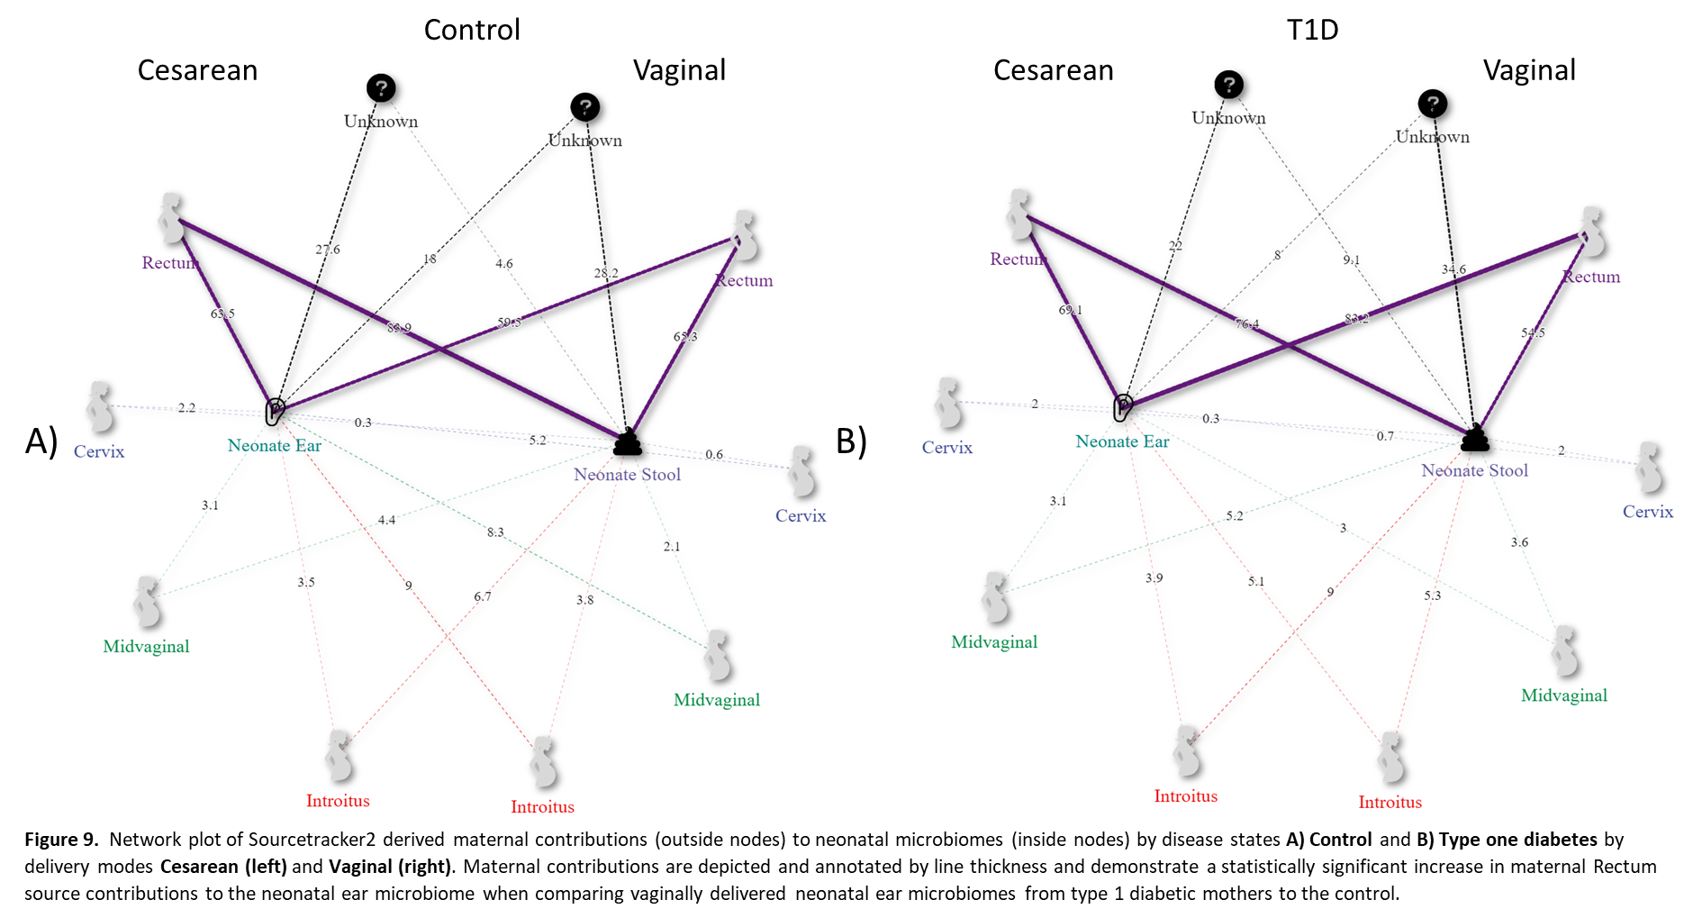

Figure 9. Network plot of Sourcetracker2 derived maternal contributions (outside nodes) to neonatal microbiomes (inside nodes) by disease states A) Control and B) Type one diabetes by delivery modes Cesarean (left) and Vaginal (right). Maternal contributions are depicted and annotated by line thickness and demonstrate a statistically significant increase in maternal Rectum source contributions to the neonatal ear microbiome when comparing vaginally delivered neonatal ear microbiomes from type 1 diabetic mothers to the control.

**Table 1.** Overview of maternal source mean contributions to newborn sinks by disease and delivery method.

|  |  |  |  |  |  |  |  |
| --- | --- | --- | --- | --- | --- | --- | --- |
|  |  |  | Source (mean ± std. error) | | | | |
| Delivery | Sink | Disease | Rectum | Cervix | Introitus | Unknown | Vagina |
| C-section | Ear | Control | 0.635 ± 0.31 | 0.022 ± 0.048 | 0.035 ± 0.043 | 0.276 ± 0.285 | 0.031 ± 0.051 |
| T1D | 0.691 ± 0.28 | 0.02 ± 0.03 | 0.039 ± 0.038 | 0.22 ± 0.25 | 0.031 ± 0.032 |
| Stool | Control | 0.839 ± 0.104 | 0.003 ± 0.003 | 0.067 ± 0.033 | 0.046 ± 0.111 | 0.044 ± 0.024 |
| T1D | 0.764 ± 0.252 | 0.003 ± 0.005 | 0.09 ± 0.091 | 0.091 ± 0.209 | 0.052 ± 0.069 |
| Vaginal | Ear | Control | 0.595 ± 0.311 | 0.052 ± 0.092 | 0.09 ± 0.096 | 0.18 ± 0.247 | 0.083 ± 0.105 |
| T1D | 0.832 ± 0.198 | 0.007 ± 0.011 | 0.051 ± 0.076 | 0.08 ± 0.174 | 0.03 ± 0.047 |
| Stool | Control | 0.653 ± 0.317 | 0.006 ± 0.006 | 0.038 ± 0.024 | 0.282 ± 0.331 | 0.021 ± 0.014 |
| T1D | 0.545 ± 0.336 | 0.02 ± 0.062 | 0.053 ± 0.053 | 0.346 ± 0.343 | 0.036 ± 0.042 |