**Impact of maternal T1D but not Cesarean delivery on the neonatal microbiome**

**Background:**

It has previously been reported that infants of Type1 DM gravidae have an altered microbiome. However, distinguishing the relative impact of underlying maternal T1D disease from confounding effects of glycemic control, medications, and mode of delivery is challenging. We hypothesized that a rigorous prospective study design collecting samples at birth would allow us to tease apart the impact of T1D vs other potential confounders and identify maternal sources contributing to her neonate’s microbiome. Our aim was to compare a rigorous study cohort of maternal - neonatal dyads with T1D (n=92) paired with case controls (n=90) and their n=527 vaginal, rectum, and ear-skin swabs and stool samples.

**Methods:**

DNA extractions from all samples were sent for 16S V4 amplicon metagenomic sequencing (Illumina) followed by bioinformatics analyses of microbial ASVs (DADA2) to ascribe the sourcetracker2 by dyad pair analyses.

**Results:**

Overall, the vast majority (>36%) of the neonate’s microbiota comprising its microbiome within 2 days of birth could be attributed to its maternal source (Fig. & Table). When stratified by source type and delivery method, we observed a significant effect of maternal T1D disease but not mode of delivery (Fig & Table). In both control and T1D dyad pairs, the greatest source contributor to the neonatal microbiome was traced to maternal stool source and vaginal vs stool vs cervix were not of significant difference in vaginal vs Cesarean born neonates.

**Conclusion:** Although this study is limited with respect subject diversity, these findings by and large suggest that maternal contributions to the neonatal microbiome are the principal sources, and there is variation by virtue of maternal T1D. Given that vaginally delivered & Cesarean born neonates are equally likely to have the majority of their microbiota tracked to maternal stool and vaginal sources, this reinforces the notion that intrauterine factors likely influence the infant microbiome.

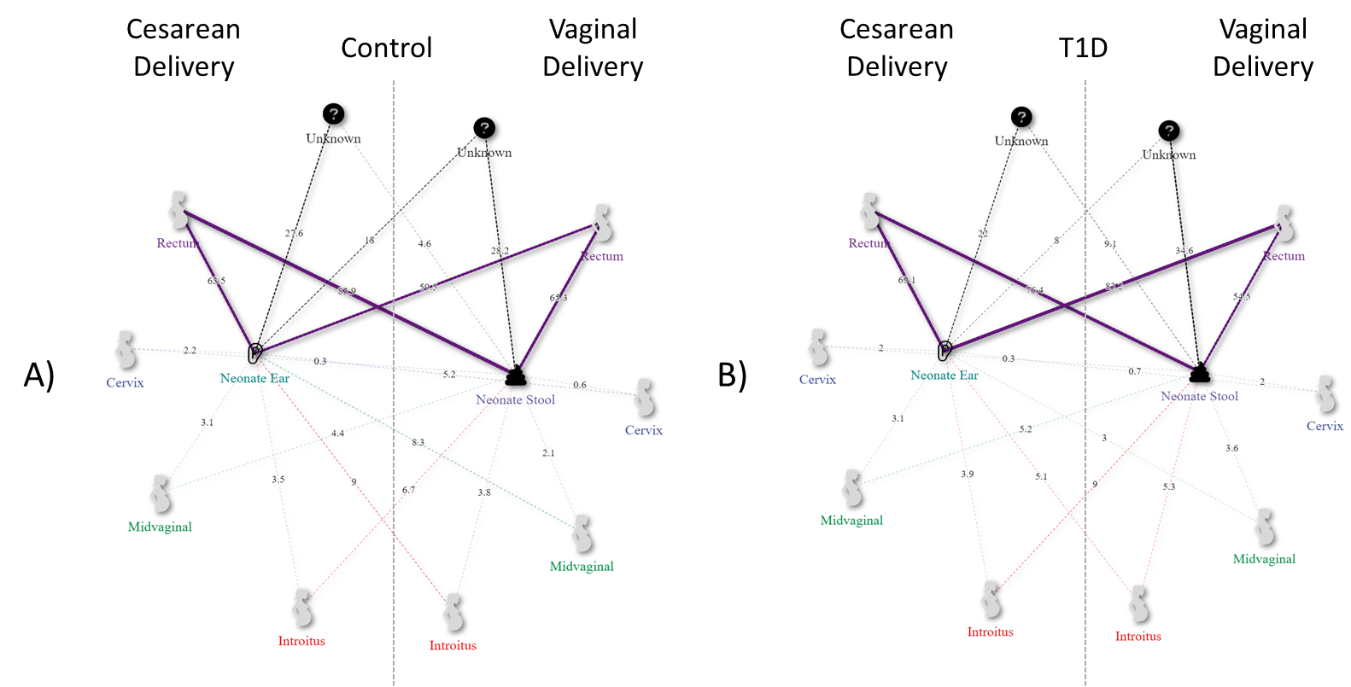

Figure 1. Network plot of Sourcetracker2 derived maternal contributions (outside nodes) to neonatal microbiomes (inside nodes) by disease states A) Control and B) T1DM, stratified by delivery mode (Cesarean (left) and Vaginal (right)). Maternal contributions are depicted and annotated by line thickness and demonstrate a statistically significant increase in maternal Rectum source contributions to the neonatal ear microbiome when comparing vaginally delivered neonatal ear microbiomes from T1D to the control.

**Table 1.** Overview of the proportion of maternal source contributions to newborn sinks by disease and delivery method.

|  |  |  |  |  |  |  |  |
| --- | --- | --- | --- | --- | --- | --- | --- |
|  |  |  | Source (mean proportion ± std. error) | | | | |
| Delivery | Sink | Disease | Rectum | Cervix | Introitus | Unknown | Vagina |
| C-section | Ear | Control | 0.635 ± 0.31 | 0.022 ± 0.048 | 0.035 ± 0.043 | 0.276 ± 0.285 | 0.031 ± 0.051 |
| T1D | 0.691 ± 0.28 | 0.02 ± 0.03 | 0.039 ± 0.038 | 0.22 ± 0.25 | 0.031 ± 0.032 |
| Stool | Control | 0.839 ± 0.104 | 0.003 ± 0.003 | 0.067 ± 0.033 | 0.046 ± 0.111 | 0.044 ± 0.024 |
| T1D | 0.764 ± 0.252 | 0.003 ± 0.005 | 0.09 ± 0.091 | 0.091 ± 0.209 | 0.052 ± 0.069 |
| Vaginal | Ear | Control | 0.595 ± 0.311 | 0.052 ± 0.092 | 0.09 ± 0.096 | 0.18 ± 0.247 | 0.083 ± 0.105 |
| T1D | 0.832 ± 0.198 | 0.007 ± 0.011 | 0.051 ± 0.076 | 0.08 ± 0.174 | 0.03 ± 0.047 |
| Stool | Control | 0.653 ± 0.317 | 0.006 ± 0.006 | 0.038 ± 0.024 | 0.282 ± 0.331 | 0.021 ± 0.014 |
| T1D | 0.545 ± 0.336 | 0.02 ± 0.062 | 0.053 ± 0.053 | 0.346 ± 0.343 | 0.036 ± 0.042 |