## Background:

For data collection in the field and ground-truthing sub-set of data generated through machine learning detection on historical maps, a customized digital field survey form is being developed using open-source Open Data Kit (ODK) software. ODK is a low-cost sustainable solution that allows offline data collection using mobile phones or tablets in resource-constrained environments. The collected data can be uploaded to a server when an internet connection is available. ODK uses XSLForms standard for developing survey questionnaires, this allows for easy authoring and collaboration on the questionnaire using Excel software. XSLForms are then converted to XML structure upon deployment on the server.

As per the requirements at hand, MAHSA survey forms are structured around multiple checks and constraints that allow minimizing the errors by navigating users through the form in a controlled way through using relevance logics. These logics are built on top of specific answers to a question e.g., choosing a yes or no response to a question can lead to a different group of following questions accordingly. ODK survey form also requires listing of possible choices for the questions, MAHSA team is working to document these choices which will also be imported to the Arches thesauri as concepts and allow homogeneity of the data.

Different steps and tools used in ODK data collection from the beginning of the process to data being imported into Arches can be seen in the diagram below:

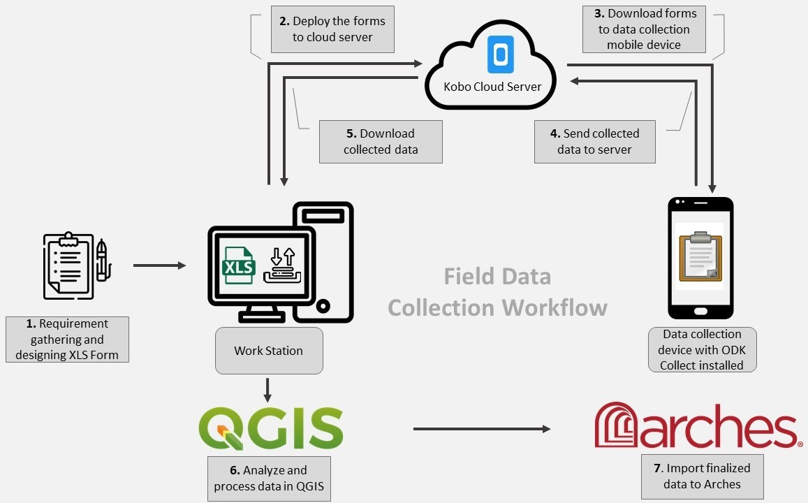Development of this ODK infrastructure for field data collection and ground-truthing goes hand-in-hand with the development for Arches database, as it will be used to access the on ground archaeological certainty for sites detected through machine learning algorithms and will also be used to collect new data in the areas where sites cannot be obtained from historical maps and legacy records.

## Instructions to install and configure ODK:

Kindly follow the steps below in mentioned order to complete signup, installation, and configuration for the ODK consultation session.

* Create an account here: <https://kf.kobotoolbox.org/accounts/register/#/>. As the account is created, kindly send me your username so that I can give you access to the ODK forms.
* Install ODK Collect on your android mobile device. Application can be searched and installed using Play Store or this URL: <https://play.google.com/store/apps/details?id=org.odk.collect.android>
* Once the application is installed, do the following configurations:
  + Open ODK Collect application on your mobile device
  + On the first screen click on 'Manually enter project details' and then enter the following details:
    - **URL:** [https://kc.kobotoolbox.org](https://kc.kobotoolbox.org/)
    - **Username:** Fill in the username used to create account in first step
    - **Password:** Fill in the password used to create account in first step

Form management:

To only see the latest version of form in Blank Forms category. Go to the project settings -> form management and then ‘check’ the box nest to ‘Hide old form versions.

## Basemaps:

ODK provides options to have different layers as basemaps for collecting location in field, you can see the available basemaps by following steps below:

* Tap the project option in top right and then select settings
* Click Maps and then select the required Source and relevant Map style.

### Loading pre-available site locations as offline tiles:

ODK also allows loading custom map tiles as a transparent layer on top of basemap, this option is very useful to see the location of preloaded data. A custom map layer would be created for each survey season and shared with the field team. This layer can be loaded in ODK as follows:

* You will need a cable to connect your device to PC
* Once device is connected to PC, custom map tiles file needs to be copied in the layer folder within ODK folder of the android device, here is an example of relative path for a device when connected to PC: This PC\Galaxy Note9\Phone\Android\data\org.odk.collect.android\files\layers
* Copy the file inside layers folder

It is highly recommended to interact (pan, zoom in and zoom out) the survey area location in ODK map when good internet connection is available so that ODK can cache the basemap tiles and it should then continue to work in case no internet is available in field.

## Location Accuracy:

The location accuracy of ODK keeps on varying and improving once the location recording question is selected in the form. ODK shows the location accuracy value on screen and the user can record location when acceptable location accuracy is reached.

It is recommended to be connected to mobile data where possible as it allows quick improvement of location accuracy.

## Geotagged Photos:

ODK uses main Camera application for collecting photos, so to capture geotagged photos kindly turn on the location/GPS tags in your main camera application, this option is available in the main camera settings if the device provides this functionality.

## View Collected Data:

To view the collected data log in to <https://kf.kobotoolbox.org/accounts/login>

* When logged in you will see the relevant project under deployed.
* Click on the project and you will be able to see the Data tab on top.
* Click data tab to see the collected data. It is not recommended to edit the collected data on KoboToolBox as it interacts with the form in slightly different way then android ODK collect.