THE MITRE CORPORATION

The MAEC™ Language Version 4.1 Specification

MAEC Bundle Version 4.1

Desiree Beck, Ivan Kirillov, Penny Chase, MITRE

June 12, 2014

Malware Attribute Enumeration and Characterization (MAEC™) is a standardized language for sharing structured information about malware based upon attributes such as behaviors, artifacts, and attack patterns.

By eliminating the ambiguity and inaccuracy that currently exists in malware descriptions and by reducing reliance on signatures, MAEC aims to improve human-to-human, human-to-tool, tool-to-tool, and tool-to-human communication about malware; reduce potential duplication of malware analysis efforts by researchers; and allow for the faster development of countermeasures by enabling the ability to leverage responses to previously observed malware instances.

**Acknowledgements**

The authors would like to thank the MAEC Community for its input and help in reviewing this document.

**Trademark Information**

MAEC, the MAEC logo, CybOX, STIX, and CVE are trademarks of The MITRE Corporation. All other trademarks are the property of their respective owners.

**Warnings**

MITRE PROVIDES MAEC "AS IS" AND MAKES NO WARRANTY, EXPRESS OR IMPLIED, AS TO THE ACCURACY, CAPABILITY, EFFICIENCY, MERCHANTABILITY, OR FUNCTIONING OF MAEC. IN NO EVENT WILL MITRE BE LIABLE FOR ANY GENERAL, CONSEQUENTIAL, INDIRECT, INCIDENTAL, EXEMPLARY, OR SPECIAL DAMAGES, RELATED TO MAEC OR ANY DERIVATIVE THEREOF, WHETHER SUCH CLAIM IS BASED ON WARRANTY, CONTRACT, OR TORT, EVEN IF MITRE HAS BEEN ADVISED OF THE POSSIBILITY OF SUCH DAMAGES.[1]

**Feedback**

The MAEC development team welcomes any feedback regarding the MAEC Language Bundle Specification. Please send any comments, questions, or suggestions maec@mitre.org.[2]

Table of Contents

1 Overview 1

1.1 Additional Documents and Information 2

1.2 Data Model Conventions 3

1.2.1 Data Model Fields and Types 3

1.2.2 XML Attributes and Elements 3

1.2.3 Non-MAEC Data Models 4

1.2.4 Primitive Data Types 4

1.3 Controlled Vocabularies 4

1.4 ID Formats 5

1.5 XML Implementation 7

1.6 Document Conventions 7

1.6.1 Key Words 7

1.6.2 Fonts 7

1.6.3 Namespaces 8

1.6.4 UML Diagrams 8

1.6.5 Property Table Notation 8

2 MAEC Bundle Data Model 12

2.1 MAEC Bundle 13

2.1.1 BundleType 13

2.1.2 BundleContentTypeEnum 15

2.2 Malware Instance Object Attributes 16

2.3 AV Classification 16

2.3.1 AVClassificationType 17

2.4 Process Tree 17

2.4.1 ProcessTreeType 17

2.4.2 ProcessTreeNodeType 18

2.5 Capability 19

2.5.1 CapabilityType 19

2.5.2 CapabilityPropertyType 21

2.5.3 CapabilityObjectiveType 22

2.5.4 CapabilityObjectiveRelationshipType 23

2.5.5 CapabilityRelationshipType 23

2.6 Behavior 24

2.6.1 BehaviorType 24

2.6.2 BehaviorPurposeType 25

2.6.3 BehavioralActionsType 26

2.6.4 BehavioralActionType 26

2.6.5 BehaviorRelationshipType 27

2.7 Action 27

2.7.1 MalwareActionType 27

2.7.2 ActionImplementationType 28

2.7.3 ActionImplementationTypeEnum 29

2.8 Object 29

2.9 Candidate Indicator 29

2.9.1 CandidateIndicatorType 30

2.9.2 CandidateIndicatorCompositionType 31

2.10 Collections 32

2.10.1 CollectionsType 32

2.10.2 BaseCollectionType 33

2.10.3 BehaviorCollectionType 33

2.10.4 ActionCollectionType 34

2.10.5 ObjectCollectionType 34

2.10.6 CandidateIndicatorCollectionType 34

2.11 Shared Types 35

2.11.1 APICallType 35

2.11.2 AssociatedCodeType 35

2.11.3 CVEVulnerabilityType 36

2.11.4 MalwareEntityType 36

2.11.5 ParameterType 36

2.11.6 VulnerabilityExploitType 37

2.12 Referential Types 37

2.12.1 BehavioralActionEquivalenceReferenceType 37

2.12.2 BehavioralActionReferenceType 38

2.12.3 BehaviorReferenceType 38

2.12.4 BundleReferenceType 39

2.12.5 CapabilityObjectiveReferenceType 39

2.12.6 CapabilityReferenceType 39

2.12.7 ObjectReferenceType 39

2.13 List Types 40

2.13.1 ActionCollectionListType 40

2.13.2 ActionListType 40

2.13.3 ActionReferenceListType 40

2.13.4 AVClassificationsType 40

2.13.5 BehaviorCollectionListType 41

2.13.6 BehaviorListType 41

2.13.7 BehaviorRelationshipListType 41

2.13.8 CandidateIndicatorCollectionListType 42

2.13.9 CandidateIndicatorListType 42

2.13.10 CapabilityListType 42

2.13.11 ObjectCollectionListType 43

2.13.12 ObjectListType 43

2.13.13 ObjectReferenceListType 43

2.13.14 ParameterListType 43

2.13.15 PlatformListType 44

Appendix – References 45

A.1 MAEC Documents 45

A.2 MAEC Web Pages 45

A.3 MAEC Schema 46

A.4 MAEC Development 46

A.5 Other References 47

# Overview

The Malware Attribute Enumeration and Characterization (MAEC) Language is defined by three data models and a set of default controlled vocabularies[3]. As illustrated in Figure 1‑1, “MAEC Bundle” is the (lowest) Tier 1 data model; “MAEC Package” is the (middle) Tier 2 data model; and “MAEC Container” is the (highest) Tier 3 data model. All three data models offer a stand-alone output format, so a lower level model can be used without the higher tier data model (although each model level encompasses and makes use of all lower tiers).

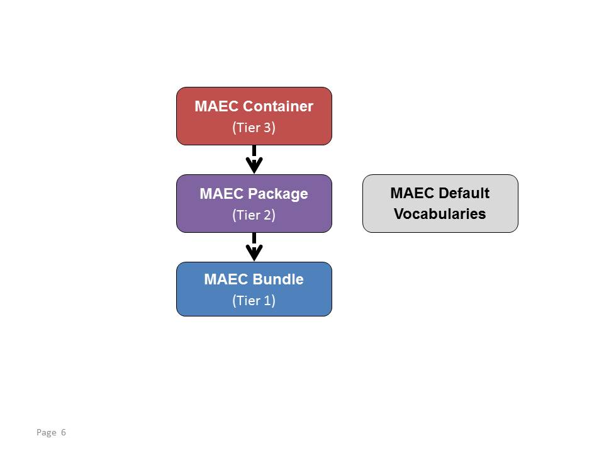

**Figure 1‑1**. MAEC data models

A complete discussion of the structure of the MAEC language can be found in the MAEC Overview [MAECO]. In brief:

* MAEC Bundle – provides the ability to capture and share data obtained from the analysis of a single malware instance. Its underlying structure is formed by Actions, Behaviors, and Capabilities.
* MAEC Package – enables a user to capture and share MAEC characterized data for one or more Malware Subjects; in most such cases, the Malware Subjects are related. A Malware Subject is MAEC’s representation of a malware instance and all of the known data associated with it, including data derived from analysis and metadata.
* MAEC Container – enables a user to share any collection of MAEC characterized data, including one or more Packages.

This document serves as the specification for the MAEC Bundle data model. Before we present the Bundle data model in Section 2, we provide relevant background information in Subsections 1.1 through 1.6.

## Additional Documents and Information

C:\Users\dbeck\AppData\Local\Microsoft\Windows\Temporary Internet Files\Content.IE5\WWA4NONN\MC900438059[1].pngC:\Users\dbeck\AppData\Local\Microsoft\Windows\Temporary Internet Files\Content.IE5\CVPZEYW4\MC900442132[1].pngNumerous overview, specification, and supporting documents are available for the MAEC Language. All documents are shown in Figure 1‑1 Icons are used to indicate whether the material is contained in an actual document ( ) or captured on a Web page ( ). This document is highlighted in yellow.

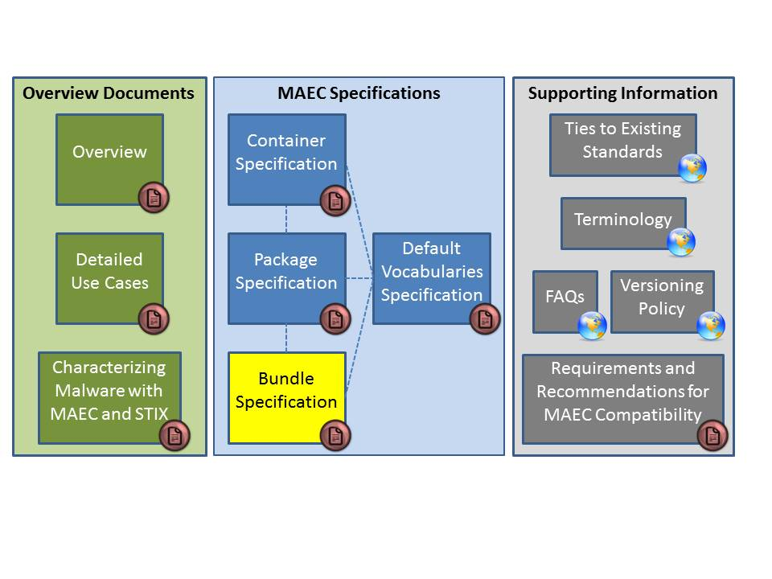

Figure 1‑1. MAEC Language v4.1 documents

All documents can be found on the MAEC Website [MAEC], and a summary and link to each is provided below:

* [Overview](http://maec.mitre.org/about/docs/MAEC_Overview.pdf): Introduces and motivates MAEC, provides an overview of the MAEC language, and presents a collection of high level use cases [MAECO].
* [Detailed Use Cases](https://maec.mitre.org/language/MAEC_Detailed_Examples_v4.0.1.pdf): Provides explicit examples to illustrate how MAEC can be used to capture malware information stemming from various forms of malware analysis [EXAMD].
* [Characterizing Malware with MAEC and STIX](https://maec.mitre.org/about/docs/Characterizing_Malware_MAEC_and_STIX_v1.0.pdf): Describes the use of MAEC and STIX in the context of malware characterization and malware metadata exchange [MAECS].
* [Container Specification](http://maec.mitre.org/language/version4.1/MAEC_Container_Spec_v2_1.pdf): Specification for the MAEC Container data model [SPECC].
* [Package Specification](http://maec.mitre.org/language/version4.1/MAEC_Package_Spec_v2_1.pdf): Specification for the MAEC Package data model [SPECP].
* [Bundle Specification](http://maec.mitre.org/language/version4.1/MAEC_Bundle_Spec_v4_1.pdf): Specification for the MAEC Bundle data model [MAECB]. (This document.)
* [Default Vocabulary Specification](http://maec.mitre.org/language/version4.1/MAEC_Vocabs_Spec_v1_1.pdf): Specification for the MAEC Default Vocabularies [SPECV].
* [Ties to Existing Standards](https://maec.mitre.org/about/standards.html): Provides an overview of how MAEC is related to MMDEF, CybOX, CPE, CVE, and STIX [TIES].
* [Terminology](https://maec.mitre.org/about/terminology.html): Contains terms associated with malware and malware analysis, as well as terminology that is specific to MAEC [TERM].
* [FAQs](https://maec.mitre.org/about/faqs.html): Frequently asked questions about MAEC including questions about the language, use, relationships to other efforts, and the MAEC community [FAQ].
* [Versioning Policy](https://maec.mitre.org/language/versioning_policy.html): Details the current methodology for determining whether a revision will require a major version change, a minor version change, or an update version change. Note that the MAEC schemas and default vocabularies are versioned independently of the MAEC Language, and their version numbers may or may not coincide with each other or with that of the MAEC Language [VER].
* [Requirements and Recommendations for MAEC Compatibility](https://maec.mitre.org/compatible/requirements.html): Specifies requirements for MAEC-compatible tools, services, and repositories [REQ].

## Data Model Conventions

The following information and conventions are used to define the MAEC data models, and may or may not apply to the particular MAEC data model documented in Section 2.

### Data Model Fields and Types

In Section 2, we define the types associated with the MAEC Bundle data model fields. It is important to understand that “fields” correspond to the malware-related properties captured in a MAEC document and “types” are used to define and express the underlying data model used in the fields.

### XML Attributes and Elements

Our methodology for representing a field as either an attribute or an element in the XML implementation[4] is based primarily on the determination of the complexity of the field. Generally, simple fields such as identifiers, data types, and timestamps are represented as attributes. Complex fields, for example, those that have multiplicity greater than one (such as lists), are represented as elements. However, in this specification we have attempted, as much as possible, to abstract away these XML-specific implementation details to provide a more general view of the MAEC Bundle data model.

### Non-MAEC Data Models

MAEC draws several components from the CybOX Language (see [MAECO]); consequently, the reader is referred to [CYBOX] for the definitions of these entities. In this specification, we do not define any types that are part of a non-MAEC data model. Instead we make note of the referenced data model’s specification and explicitly define only the extensions (i.e., new fields and types) that have been made as an extension of the base type.

### Primitive Data Types

The following primitive datatypes are used in the MAEC Language.

* binary – Data of this type conforms to the World Wide Web Consortium (W3C) Recommendation for hex-encoded binary data [W3C1].
* boolean – Data of this type conforms to the W3C Recommendation for boolean data [W3C2].
* double – Data of this type conforms to the W3C Recommendation for double data [W3C3].
* float – Data of this type conforms to the W3C Recommendation for float data [W3C4].
* int – Data of this type conforms to the W3C Recommendation for integer data [W3C5].
* QName – Data of this type conforms to the W3C Recommendation for an XML namespace-qualified name [W3C6].
* string – Data of this type conforms to the W3C Recommendation for string data [W3C7].
* unsigned int – Data of this type conforms to the W3C Recommendation for unsigned int data [W3C8].
* URI – Data of this type conforms to the W3C Recommendation for anyURI data [W3C9].
* dateTime – Data of this type represents a time value that conforms to the yyyy-mm-ddThh:mm:ss format.

## Controlled Vocabularies

Some of the fields defined in the MAEC schemas are of type cyboxCommon: ControlledVocabularyStringType. A field of this type is implemented through the xsi:type XML abstract type extension mechanism. The default vocabulary applicable to the particular type will be provided in the “Description” column of the property table. Default vocabularies are defined in the maec_default_vocabularies.xsd file available at [RELD]. Please see the MAEC Default Vocabularies Specification document [SPECV] for more information.

## ID Formats

In MAEC v4.1, all MAEC IDs are captured and formatted as XML QNames[5]. Each such ID includes both a namespace portion (optional) and an ID portion (required), separated by a colon (“:”). The recommended approach to creating a MAEC ID is to define a producer namespace and namespace prefix and then use the form:

[ns prefix]:[construct type]-[GUID]

The “ns prefix” SHOULD be a namespace prefix bound to a namespace owned/controlled by the producer of the content. For consistency across MAEC documents, the “construct type” SHOULD correspond to the labels provided in Table 1‑1 below (datatypes are defined in MAEC v4.1 unless otherwise indicated). Finally, the “GUID” SHOULD correspond to a globally unique ID. For example, a MAEC Bundle could have the following ID:

somecompany:bundle-2f44522e-8164-4050-8e13-e01f9a

In order to use this approach, the namespace and prefix MUST be defined in the head of the XML document, e.g., xmlns:somecompany=“http://company.example.com”.

This format provides high assurance that IDs will be both meaningful and unique. Meaning comes from the producer namespace, which denotes who is producing it, as well as the construct type, which denotes to what the ID pertains. Uniqueness is achieved when the meaningful portion is combined with a globally unique ID.

Table 1‑1. Recommended construct type labels

|  |  |  |
| --- | --- | --- |
| **Construct Name** | **Datatype (defining ID)** | **Construct Type (in ID)** |
| **BUNDLE IDs and IDREFs** |  |  |
| action_collection | ActionCollectionType | action_collection |
| action_implementation | ActionImplementationType | action_implementation |
| action_equivalence_reference | BehavioralAction  EquivalenceReferenceType | action_equivalence |
| action | cybox:ActionType | action |
| behavior | BehaviorType | behavior |
| behavior_collection | BehaviorCollectionType | behavior_collection |
| maec_bundle | BundleType | bundle |
| candidate_indicator_collection | CandidateIndicatorCollectionType | candidate_indicator_collection |
| candidate_indicator | CandidateIndicatorType | candidate_indicator |
| capability | CapabilityType | capability |
| malware_instance_object_attributes | cybox:ObjectType | object |
| strategic_objective | CapabilityObjectiveType | objective |
| tactical_objective | CapabilityObjectiveType | objective |
| object_collection | ObjectCollectionType | object_collection |
| process_tree_node | ProcessTreeNodeType | process_tree |
| object | cybox:ObjectType | object |
| **PACKAGE IDs and IDREFs** |  |  |
| action_equivalence | ActionEquivalenceType | action_equivalence |
| analysis | AnalysisType | analysis |
| malware_subject | MalwareSubjectType | malware_subject |
| object_equivalence | ObjectEquivalenceType | object_equivalence |
| maec_package | PackageType | package |
| malware_instance_object_attributes | cybox:ObjectType | object |
| **CONTAINER IDs** |  |  |
| maec_container | ContainerType | container |

## XML Implementation

The XML implementation of the MAEC Language data model is documented in a series of XML Schemas.[6] These schemas describe how the information presented in this Specification is formatted and represented as XML. Please refer to the appropriate Schema for more information about a specific XML implementation.

*MAEC Container Model*

<https://maec.mitre.org/language/version4.1/maec-container-schema.xsd>

*MAEC Package Model*

<https://maec.mitre.org/language/version4.1/maec-package-schema.xsd>

*MAEC Bundle Model*

<https://maec.mitre.org/language/version4.1/maec-bundle-schema.xsd>

*MAEC Default Vocabularies*

https://maec.mitre.org/language/version4.1/maec-default-vocabularies.xsd

The complete listing of XML representation resources can be found on the MAEC website [REL4].

## Document Conventions

The following conventions are used in this document.

### Key Words

The key words "MUST", "MUST NOT", "REQUIRED", "SHALL", "SHALL NOT", "SHOULD", "SHOULD NOT", "RECOMMENDED", "MAY", and "OPTIONAL" in this document are to be interpreted as described in *RFC 2119* [RFC2119].

### Fonts

The following font and font style conventions are used in the document:

* Capitalization is used for MAEC high level concepts, which are defined as basic components in the MAEC Overview document [MAECO] (see Section 2 in [MAECO]).

Examples: Bundle, Strategic Objective, Malware Subject

* The Courier New font is used for writing constructs in the MAEC Language Data Model (and related data models).

Examples: CandidateIndicatorType, Malware_Subject

Note that all high level concepts have a corresponding data model construct (e.g., Malware Subject 🡪 Malware_Subject).

* The ‘*italic, with single quotes*’ font is used for noting values for MAEC Language properties.

Examples: ‘*2.1’, ‘MAEC Default Device Driver Action Names’*

### Namespaces

This document uses the concept of namespaces[7] to logically group MAEC constructs throughout the Data Model section of the document, as well as other parts of the specification. The format of these namespaces is prefix:namespace, where the prefix is the namespace component, and the namespace is the actual namespace URI. Table 1‑2 on page 10 provides a listing of the default namespaces used in MAEC to help provide context as to the particular source data model or vocabulary used in a field. Table 1‑2 also lists the relevant version of each of the data models. These namespaces are compatible with XML Namespaces [W3C0], though the MAEC language is not restricted to XML serialization.

### UML Diagrams

The Data Model makes use of Unified Modeling Language (UML) diagrams where appropriate, to visually depict relationships for the MAEC Language constructs. Diagrams are included for any construct that inherits from other constructs or has a compositional relationship.

### Property Table Notation

Throughout the data model, tables are used to describe each data type and its properties. Each property table will consist of a column of field names to identify the property, a type column to reflect the datatype of the property, a multiplicity column to reflect the allowed number of occurrences of the property, and a description column that will describe the property. In addition:

* Fields that are part of a “choice” relationship (e.g., Field1 OR Field2 is used but not both) will be denoted by a unique letter subscript (e.g., API_CallA, CodeB) and single logic expression in the Multiplicity column. For example, if there is a choice of field API_CallA and CodeB, the expression “A(1)|B(0..1)” will indicate that the API_Call field can be chosen with multiplicity 1 or the Code property can be chosen with multiplicity 0..1.

Values in the type column are either primitive datatypes or other types defined in this document. These values will be cross referenced to the base definition of their types.

Table 1‑2. Namespace prefixes used by MAEC

|  |  |  |  |
| --- | --- | --- | --- |
| **Data Model / Vocab** | **Namespace Prefix** | **Description** | **Example** |
| MAEC Bundle  v4.1 | maecBundle | The MAEC Bundle data model captures the constructs used in a MAEC Bundle. | maecBundle:ActionType |
| MAEC Package  v2.1 | maecPackage | The MAEC Package data model captures the constructs used in a MAEC Package. | maecPackage:MalwareSubjectType |
| MAEC Container  v2.1 | maecContainer | The MAEC Container data model captures all MAEC characterized data. | maecContainer:PackageListType |
| MAEC Default Vocabularies  v1.1 | maecVocabs | The MAEC default vocabularies define types for default controlled vocabularies used within MAEC. | maecVocabs:FileActionNameVocab |
| Malware Metadata Exchange Format (MMDEF) v1.2 | metadata | The MMDEF data model captures some constructs used in exchanging malware sample data. | metadata:fieldDataEntry |
| CybOX Core  v2.1 | cybox | The CybOX core data model captures all the core constructs used in CybOX. | cybox:ObjectType |
| CybOX Common  v2.1 | cyboxCommon | The CybOX common data model captures common constructs used across CybOX objects and other types. | cyboxCommon:MeasureSourceType |
| CybOX Default Vocabularies  v2.1 | cyboxVocabs | The CybOX default vocabularies define types for default controlled vocabularies used within CybOX. | cyboxVocabs:HashNameVocab |
| Code Object  v2.1 | CodeObj | The CybOX Code Object data model is intended to characterize a body of computer code. | CodeObj:CodeObjectType |
| System Object  v2.1 | SystemObj | The CybOX System Object data model is intended to characterize computer systems (as a combination of both software and hardware). | SystemObj:SystemObjectType |
| Process Object  v2.1 | ProcessObj | The CybOX Process Object data model is intended to characterize system processes. | ProcessObj:ProcessObjectType |

# MAEC Bundle Data Model

The root of the MAEC Bundle v4.1 data model is the MAEC_Bundle field of type BundleType. The BundleType and other types are defined below. Definitions have been organized by functional group (MAEC_Bundle, Process_Tree, Capability, Behavior, Action, Object, Candidate_Indicator, and Collections). Types shared by multiple functional groups appear in Section 2.11, “referential” types appear in Section 2.12, and “list” types appear in Section 2.13. All types originate from the MAEC Bundle schema, unless otherwise noted with a namespace prefix, e.g., “cybox” for the CybOX Core schema[8].

MAEC is designed to be very flexible, which means that a MAEC_Bundle containing analysis data can be created in a variety of ways. However, there are practices that best take advantage of MAEC’s features; for example, to conserve space in a MAEC document, one may place all objects under the Objects root field (of type ObjectListType), all actions under the Actions root field (of type ActionListType), etc. The Object and Action fields, etc. can then be referenced as needed throughout the MAEC_Bundle via their ID attribute using the IDREF field on the corresponding reference structure, e.g., the ObjectReferenceType. In addition to reducing the amount of space that would be required if each object or action were defined multiple times in a MAEC_Bundle, the practice of having all entities of the same type defined in one location is advantageous from an organizational perspective.

Alternatively, in some situations, Objects, Actions, Behaviors, and Candidate_Indicators might be best grouped according to categories by leveraging the Collections field (Object_Collections, Action_Collections, etc.) For example, an analyst may find it easiest to define all IP addresses objects associated with a malware instance in one Object_Collection field and all URL objects in a second Object_Collection field. However, if there will be duplication between the collections, it might still be preferable to characterize the objects under the Objects field and then reference the relevant Object fields from each of the collections via their ID attribute. As MAEC is used more operationally, more information on best practices will be available on the MAEC Web site [MAEC].

## MAEC Bundle

The root field of the MAEC Bundle schema is the MAEC_Bundle field of type BundleType. The MAEC_Bundle field represents the characterization of a single malware instance, whose identity is characterized in the top-level Malware_Instance_Object_Attributes field, via the CybOX ObjectType.

### BundleType

The BundleType serves as the high-level construct that encapsulates all MAEC_Bundle fields and represents some characterized analysis data (from any arbitrary set of analyses) for a single malware instance in terms of its MAEC components (e.g., Capabilities, Behaviors, Actions, Objects, etc.).

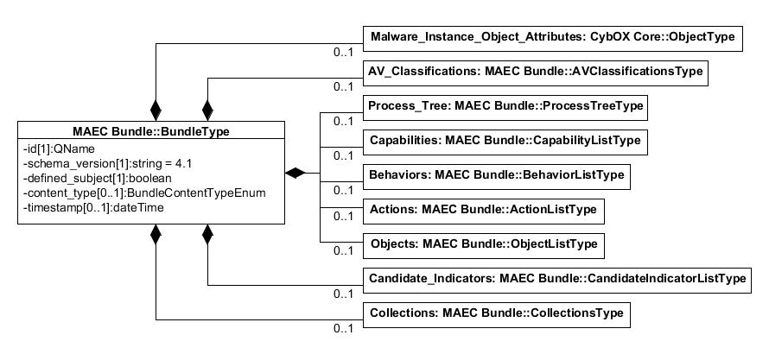

|  |  |  |  |
| --- | --- | --- | --- |
| **Field** | **Type** | **Multiplicity** | **Description** |
| **id** | QName | 1 | Specifies a unique ID for the MAEC_Bundle. The ID SHOULD follow the pattern defined in Section 1.4. |
| **schema_version** | string | 1 | Specifies the version of the MAEC Bundle schema that the document has been written in and that SHOULD be used for validation. The fixed value is ‘*4.1*.’ |
| **defined_subject** | boolean | 1 | Specifies whether the fields that describe the properties of the malware instance characterized by the MAEC_Bundle are included inside this MAEC_Bundle (via the Malware_Instance_Object_Attributes field) or elsewhere (such as a Malware_Subject in a MAEC_Package). |
| **content_type** | BundleContentType  Enum | 0..1 | Specifies the general type of content contained in the MAEC_Bundle, e.g., ‘*static analysis tool output*,’ ‘*dynamic analysis tool output*,’ etc. |
| **timestamp** | dateTime | 0..1 | Specifies the date/time that the MAEC_Bundle was generated. |
| **Malware_Instance_Object_Attributes** | cybox:ObjectType | 0..1 | Characterizes the properties of the malware instance (e.g., its MD5 hash) whose capabilities, behaviors, actions, objects, process tree, and candidate indicators are characterized in this MAEC_Bundle. This is equivalent to the Malware_Instance_Object_Attributes field inside of a Malware_Subject in the MAEC_Package, and it is therefore only REQUIRED if this MAEC_Bundle is to be used in a stand-alone fashion, i.e., without an accompanying MAEC_Package and with the defined_subject field set to '*true*'. |
| **AV_Classifications** | AVClassifications  Type | 0..1 | Contains 1-n AVClassificationType fields, which capture any Anti-Virus scanner tool classifications of the malware instance. |
| **Process_Tree** | ProcessTreeType | 0..1 | Specifies the observed process tree of execution for the malware instance, along with references to any corresponding actions performed by each process, if applicable. |
| **Capabilities** | CapabilityListType | 0..1 | Contains 1-n fields of CapabilityType, which function as the MAEC representation for any capabilities that were observed for the malware instance. |
| **Behaviors** | BehaviorListType | 0..1 | Contains 1-n fields of BehaviorType, which function as the MAEC representation for any behaviors that were observed for the malware instance. |
| **Actions** | ActionListType | 0..1 | Contains 1-n fields of ActionType, which function as the MAEC representation for any lower-level actions that were observed for the malware instance. |
| **Objects** | ObjectListType | 0..1 | Contains 1-n fields of ObjectType, which function as the MAEC representation for any objects associated with the malware instance. |
| **Candidate_Indicators** | CandidateIndicatorListType | 0..1 | Contains 1-n fields of CandidateIndicatorType, which function as the MAEC representation of any candidate indicators associated with the malware instance. |
| **Collections** | CollectionsType | 0..1 | Contains the Collection fields for behaviors, actions, objects, and candidate indicators. |

### BundleContentTypeEnum

The BundleContentTypeEnum is a non-exhaustive enumeration of the general types of content that a MAEC_Bundle can contain.

|  |  |
| --- | --- |
| **Enumeration Value** | **Description** |
| **dynamic analysis tool output** | Specifies that the MAEC_Bundle primarily captures some form of dynamic analysis tool output, such as from a sandbox. |
| **static analysis tool output** | Specifies that the MAEC_Bundle primarily captures some form of static analysis tool output, such as from a packer detection tool. |
| **manual analysis output** | Specifies that the MAEC_Bundle primarily captures some form of manual analysis output, which may or may not involve the use of tools. |
| **extracted from subject** | Specifies that the MAEC_Bundle primarily captures some data that extracted from the malware instance, such as some PE Header fields. |
| **mixed** | Specifies that the MAEC_Bundle captures some mixed forms of analysis or tool output for the malware instance, such as both dynamic and static analysis tool output. |
| **other** | Specifies that the MAEC_Bundle captures some other form of analysis or tool output that is not represented by the other enumeration values. |

## Malware Instance Object Attributes

The Malware_Instance_Object_Attributes field characterizes the properties (e.g., a file name and MD5 hash) and thus identity of the malware instance for which capabilities, behaviors, actions, objects, the process tree, and candidate indicators are characterized in the MAEC_Bundle. This field is equivalent to the Malware_Instance_Object_Attributes field inside of a Malware_Subject in the MAEC_Package, and it is therefore only REQUIRED if this MAEC_Bundle is to be used in a stand-alone fashion, i.e., without an accompanying MAEC_Package. In this case, the defined_subject field on the MAEC_Bundle MUST be set to ‘*true*’ and the Malware_Instance_Object_Attributes field in the MAEC_Bundle SHOULD be used to characterize the fields of the object that represents the malware instance. Please see Section 2.2.2 in [SPECP] for discussion on how the Malware_Instance_Object_Attributes field can be used in a MAEC_Package.

The Malware_Instance_Object_Attributes field is of type cybox:ObjectType, which will not be defined here (see [CYBOX]). While the id and idref fields of the CybOX ObjectType are OPTIONAL and have no required syntax, when the ObjectType is used in MAEC, the id field SHOULD always be used. The recommended format for the id field is given in Section 1.4.

## AV Classification

The AV_Classification field of type AVClassificationType captures information relating to anti-virus (AV) scanner classifications for a malware instance captured in the MAEC_Bundle or MAEC_Package.

### AVClassificationType

The AVClassificationType characterizes AV-classification related data and extends the CybOX Common ToolInformationType. The extended fields are listed below.

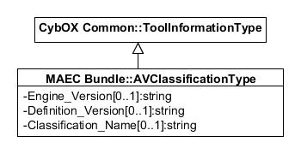

|  |  |  |  |
| --- | --- | --- | --- |
| **Field** | **Type** | **Multiplicity** | **Description** |
| **Engine_Version** | string | 0..1 | Captures the version of the AV engine used by the AV scanner tool that assigned the classification to the malware instance. |
| **Defintion_Version** | string | 0..1 | Captures the version of the AV definitions used by the AV scanner tool that assigned the classification to the malware instance. |
| **Classification_Name** | string | 0..1 | Captures the classification assigned to the malware instance by the AV scanner tool characterized in the CybOX Vendor and (Product) Name fields. |

## Process Tree

The Process_Tree field of type ProcessTreeType specifies the observed process tree of execution for the malware instance, along with references to any corresponding Action entities, if applicable.

### ProcessTreeType

The ProcessTreeType captures the process tree for the malware instance, including the parent process and processes spawned by it, along with any actions initiated by each process.

|  |  |  |  |
| --- | --- | --- | --- |
| **Field** | **Type** | **Multiplicity** | **Description** |
| **Root_Process** | ProcessTreeNodeType | 1 | Captures the root process in the process tree. |

### ProcessTreeNodeType

The ProcessTreeNodeType captures a single process, or node, in the process tree. It extends the CybOX ProcessObj:ProcessObjectType. The extended fields are listed below.

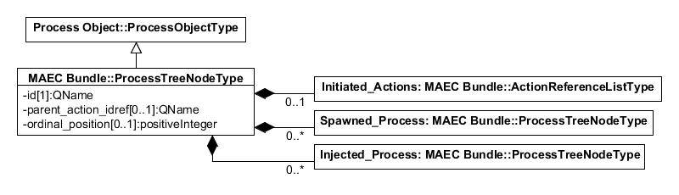

|  |  |  |  |
| --- | --- | --- | --- |
| **Field** | **Type** | **Multiplicity** | **Description** |
| **id** | QName | 1 | Specifies a unique ID for the process node. The ID SHOULD follow the format described in Section 1.4. |
| **parent_action_idref** | QName | 0..1 | Specifies the ID of the Action that created or injected the process. The IDREF SHOULD follow the pattern defined in Section 1.4. |
| **ordinal_position** | positiveInteger | 0..1 | Specifies the ordinal position of the process with respect to other processes spawned or injected by the malware. |
| **Initiated_Actions** | ActionReferenceListType | 0..1 | Captures, via references, the Action fields (found inside the top-level Actions field, or an Action_Collection inside the top-level Collections field) initiated by the process. |
| **Spawned_Process** | ProcessTreeNodeType | 0..* | Captures a single process spawned by this process. |
| **Injected_Process** | ProcessTreeNodeType | 0..* | Captures a single process that was injected by this process. |

## Capability

The Capability field of type CapabilityType provides a standard way of capturing the set of high-level capabilities that a malware instance possesses. Examples of Capabilities include anti-detection, command and control, and privilege escalation.

In addition, Strategic and Tactical Objectives have been defined for each Capability to more granularly capture the details of the Capability. More explicitly, a Capability can have one or more Strategic Objectives that the Capability attempts to carry out, and in a similar fashion, a Strategic Objective can have one or more Tactical Objectives. For example, a malware instance may possess a “persistence” Capability, which is further refined by having a Strategic Objective of “persist to continuously execute on system.” This Strategic Objective is in turn refined by having a Tactical Objective of “persist after system reboot.”

While Capabilities are intended to convey what a malware instance is capable of doing, there exists a clear link between Capabilities (i.e., “what” the malware is capable of doing) and the concrete ways they are implemented. We have supported this in MAEC by allowing for the linking between a Capability and/or one of its Strategic or Tactical Objectives with one or more MAEC Behaviors. These Behaviors in turn represent a particular implementation of a Capability or Strategic or Tactical Objective in the malware instance.

As detailed in [SPECV], “MAEC Default Vocabularies Specification,” individual vocabularies have been defined for Capabilities and for all Strategic and Tactical Objectives corresponding to a particular Capability. For some Capabilities, default vocabularies for properties pertaining to the Capability have also been defined.

### CapabilityType

The CapabilityType is one of the foundational MAEC types and serves as a method for the characterization of capabilities possessed by malware.

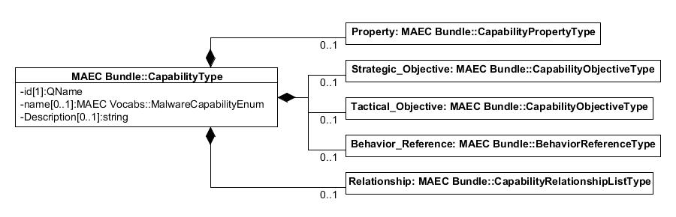

|  |  |  |  |
| --- | --- | --- | --- |
| **Field** | **Type** | **Multiplicity** | **Description** |
| **id** | QName | 1 | Specifies a unique ID for this Capability. The ID SHOULD follow the pattern defined in Section 1.4. |
| **name** | maecVocabs:  MalwareCapabilityEnum | 0..1 | Specifies the name of the Capability. It uses the ‘*MalwareCapabilityEnum-1.0*’ enumeration from the MAEC Vocabularies schema. |
| **Description** | string | 0..1 | Specifies a basic textual description of the Capability. |
| **Property** | CapabilityPropertyType | 0..* | Specifies a single property of the Capability as a key/value pair. More than one property can be specified via multiple occurrences of this field. |
| **Strategic_Objective** | CapabilityObjectiveType | 0..* | Specifies a single strategic objective that the Capability attempts to achieve. A Strategic_Objective is a more granular way of capturing the Capabilities present in the malware instance. More than one Strategic_Objective can be specified via multiple occurrences of this field. |
| **Tactical_Objective** | CapabilityObjectiveType | 0..* | Specifies a single tactical objective that the Capability attempts to achieve, typically in the context of a broader Strategic_Objective. A Tactical_Objective can be considered as a way of expounding upon strategic objectives to capture the Capabilities of the malware instance in more detail. More than one Tactical_Objective can be specified via multiple occurrences of this field. |
| **Behavior_Reference** | BehaviorReferenceType | 0..* | Specifies a reference to a Behavior that serves as an implementation of the Capability. For Behaviors that serve as implementations of specific strategic or tactical objectives, the Behavior_Reference field under the Strategic_Objective or Tactical_Objective fields should be used, respectively. More than one Behavior can be referenced via multiple occurrences of this field. |
| **Relationship** | CapabilityRelationshipType | 0..* | Specifies any relationships between this Capability and any other Capabilities. More than one Relationship can be specified via multiple occurrences of this field. |

### CapabilityPropertyType

The CapabilityPropertyType captures a single property of a Capability or Capability Objective.

|  |  |  |  |
| --- | --- | --- | --- |
| **Field** | **Type** | **Multiplicity** | **Description** |
| **Name** | cyboxCommon:  ControlledVocabularyStringType | 0..1 | Specifies the name of the property being captured. The default vocabulary type for a property of Capability *X* field is the MAEC ‘*XPropertiesVocab-1.0.*’ |
| **Value** | cyboxCommon:  StringObjectPropertyType | 0..1 | Specifies the value of the property being captured. |

### CapabilityObjectiveType

The CapabilityObjectiveType captures details of a Strategic_Objective or Tactical_Objective field that is associated with a Capability.

|  |  |  |  |
| --- | --- | --- | --- |
| **Field** | **Type** | **Multiplicity** | **Description** |
| **id** | QName | 1 | Specifies a unique ID for the Strategic_Objective or Tactical_Objective field. The ID SHOULD follow the pattern defined in Section 1.4. |
| **Name** | cyboxCommon:  ControlledVocabularyStringType | 0..1 | Specifies the name of the Capability objective. There are several default vocabularies for this use included in the MAEC Default Vocabularies schema. The default vocabulary type for use with a Strategic_Objective or Tactical_Objective field associated with Capability *X* is the MAEC ‘*XStrategicObjectivesVocab-1.0*’ or ‘*XTacticalObjectivesVocab-1.0*’, respectively. |
| **Description** | string | 0..1 | Specifies a basic textual description of the Capability objective. |
| **Property** | CapabilityPropertyType | 0..* | Permits the capture of a single property of the Capability objective, as a key/value pair. More than one property can be specified via multiple occurrences of this field. |
| **Behavior_Reference** | BehaviorReferenceType | 0..* | Specifies a reference to a Behavior that functions as an implementation of the Capability objective. More than one Behavior can be referenced via multiple occurrences of this field. |
| **Relationship** | CapabilityObjective  RelationshipType | 0..* | Specifies a relationship from the Capability objective to one or more other Capability objectives. More than one relationship can be specified via multiple occurrences of this field. |

### CapabilityObjectiveRelationshipType

The CapabilityObjectiveRelationshipType captures a relationship between a Capability objective (a Strategic_Objective or Tactical_Objective) and one or more other Capability objectives.

|  |  |  |  |
| --- | --- | --- | --- |
| **Field** | **Type** | **Multiplicity** | **Description** |
| **Relationship_Type** | cyboxCommon:  ControlledVocabularyStringType | 0..1 | Specifies the type of relationship being expressed between objectives (either strategic or tactical). The default vocabulary type for use in this field is the MAEC ‘*CapabilityObjectiveRelationshipTypeVocab-1.0.*’ |
| **Objective_Reference** | CapabilityObjectiveReferenceType | 1..* | References a single Capability objective (either strategic or tactical) in the relationship. More than one objective can be referenced via multiple occurrences of this field. |

### CapabilityRelationshipType

The CapabilityRelationshipType captures a relationship between a Capability and one or more other Capabilities.

|  |  |  |  |
| --- | --- | --- | --- |
| **Field** | **Type** | **Multiplicity** | **Description** |
| **Relationship_Type** | cyboxCommon:  ControlledVocabularyStringType | 0..1 | Specifies the type of relationship between Capabilities. A default vocabulary type has not yet been defined in v4.1. |
| **Capability_Reference** | CapabilityReferenceType | 1..* | Specifies a reference to a single Capability in the relationship. More than one Capability can be referenced via multiple occurrences of this field. |

## Behavior

The Behavior field of type BehaviorType can be thought of as capturing the intent behind groups of Action entities and is therefore used to represent distinct portions of higher-level malware functionality. Thus, while a malware instance may perform some multitude of actions, it is likely that these actions represent only a few distinct behaviors. Some examples include vulnerability exploitation, email address harvesting, the disabling of a security service, etc. Behavior entities can represent discrete components of malware functionality at a level that is useful for analysis, triage, and detection.

### BehaviorType

The BehaviorType is one of the foundational MAEC types and serves as a method for the characterization of malicious behaviors found or observed in malware.

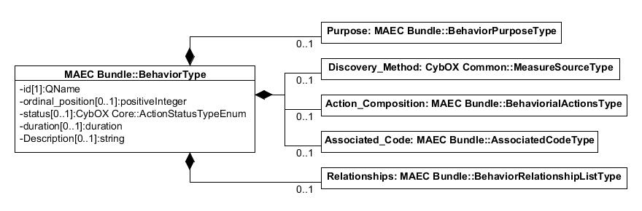

|  |  |  |  |
| --- | --- | --- | --- |
| **Field** | **Type** | **Multiplicity** | **Description** |
| **id** | QName | 1 | Specifies a unique ID for this Behavior. The ID SHOULD follow the pattern defined in Section 1.4. |
| **ordinal_position** | positiveInteger | 0..1 | Specifies the ordinal position of the Behavior with respect to the execution of the malware. |
| **status** | cybox:ActionStatusTypeEnum | 0..1 | Specifies the execution status of the Behavior being characterized. |
| **duration** | duration | 0..1 | Specifies the duration of the Behavior. One way to derive such a value may be to calculate the difference between the timestamps of the first and last Actions that compose the Behavior. |
| **Purpose** | BehaviorPurposeType | 0..1 | Specifies the intended purpose of the Behavior. Because a Behavior is not always successful, and may not be fully observed, this is meant as way to state the nature of the Behavior apart from its constituent Action entities. |
| **Description** | string | 0..1 | Specifies a prose textual description of the Behavior. |
| **Discovery_Method** | cyboxCommon:MeasureSourceType | 0..1 | Specifies the method used to discover the Behavior. |
| **Action_Composition** | BehavioralActionsType | 0..1 | Captures the Action entities that compose the Behavior. |
| **Associated_Code** | AssociatedCodeType | 0..1 | Specifies any code snippets that are associated, or are likely associated, with the Behavior. |
| **Relationships** | BehaviorRelationshipListType | 0..1 | Specifies any relationships between this Behavior and any other Behaviors. |

### BehaviorPurposeType

The BehaviorPurposeType captures the purpose behind a Behavior.

|  |  |  |  |
| --- | --- | --- | --- |
| **Field** | **Type** | **Multiplicity** | **Description** |
| **Description** | string | 0..1 | Contains a prose text description of the purpose of the Behavior, whether it was successful or not. |
| **Vulnerability_Exploit** | VulnerabilityExploitType | 0..1 | Characterizes any vulnerability (known or unknown) that a Behavior may have attempted to exploit. |

### BehavioralActionsType

The BehavioralActionsType is intended to capture the Action entities or Action_Collection entities that make up a Behavior.

|  |  |  |  |
| --- | --- | --- | --- |
| **Field** | **Type** | **Multiplicity** | **Description** |
| **Action_CollectionA** | ActionCollectionType | A(1)|  B(1)|  C(1)|  D(1) | Specifies an Action_Collection that is part of the behavioral composition. |
| **ActionB** | BehavioralActionType | Specifies a single Action that is part of the behavioral composition. |
| **Action_ReferenceC** | BehavioralActionReference  Type | Specifies a reference to a single Action that is part of the behavioral composition. |
| **Action_Equivalence_ReferenceD** | BehavioralActionEquivalenceReferenceType | Specifies a reference to a single Action equivalence that is part of the behavioral composition. |

### BehavioralActionType

The BehavioralActionType defines an Action field that can be used as part of a Behavior. It extends the MAEC MalwareActionType, which in turn extends the CybOX ActionType. The extended field is listed below.

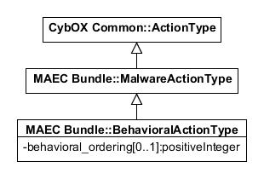

|  |  |  |  |
| --- | --- | --- | --- |
| **Field** | **Type** | **Multiplicity** | **Description** |
| **behavioral_ordering** | positiveInteger | 0..1 | Defines the ordering of the Action with respect to the other Actions that make up the Behavior. So an Action with a behavioral_ordering of ‘*1*‘ would come before an Action with a behavioral_ordering of ‘*2*’, etc. |

### BehaviorRelationshipType

The BehaviorRelationshipType serves to characterize relationships between Behavior entities.

|  |  |  |  |
| --- | --- | --- | --- |
| **Field** | **Type** | **Multiplicity** | **Description** |
| **type** | restriction of cyboxVocabs: ActionRelationshipTypeEnum-1.0 | 0..1 | Specifies the nature of the relationship between Behaviors that is being captured. The original enumeration is restricted to `*Preceded_By*’, `*Followed_By*’, `*Related_To*’, and ‘*Dependent_On*’. |
| **Behavior_Reference** | BehaviorReferenceType | 1..* | Specifies a reference to a single Behavior in the relationship. More than one Behavior can be referenced via multiple occurrences of this field. |

## Action

Action entities of type MalwareActionType can be thought of as system state changes and similar operations that represent the fundamental low-level functionality of malware. Some examples include the creation of a file, deletion of a registry key, and the sending of some data on a socket.

### MalwareActionType

The MalwareActionType is one of the foundational MAEC types and serves as a method for the characterization of Action entities found or observed in malware. The MalwareActionType extends the CybOX ActionType. The extended field is listed below. While the id and idref fields of the CybOX ActionType are OPTIONAL and have no required syntax, when The ActionType is used in MAEC, the id or idref field SHOULD always be used. The MAEC-recommended format for the id field is provided in Section 1.4.

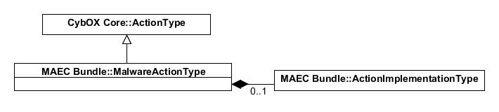

|  |  |  |  |
| --- | --- | --- | --- |
| **Field** | **Type** | **Multiplicity** | **Description** |
| **Implementation** | ActionImplementationType | 0..1 | Serves to capture fields that are relevant to how the Action is implemented in the malware, such as the specific API call that was used. |

### ActionImplementationType

The ActionImplementationType serves as a method for the characterization of action Implementation entities. Currently supported are implementations achieved through API function calls and abstractly defined code snippets.

|  |  |  |  |
| --- | --- | --- | --- |
| **Field** | **Type** | **Multiplicity** | **Description** |
| **id** | QName | 0..1 | Specifies a unique ID for this action Implementation. The ID SHOULD follow the pattern defined in Section 1.4. |
| **type** | ActionImplementationTypeEnum | 1 | Specifies the type of action Implementation being characterized in this field. |
| **Compatible_Platforms** | PlatformListType | 0..1 | Specifies the specific platform(s) that the Action is compatible with, or in other words, capable of being successfully executed on. |
| **API_CallA** | APICallType | A(0..1)|B(0..*) | Allows for the characterization of a system-level API call that was used to implement the Action. Software typically must make use of such calls to talk to hardware and perform system-specific functions. |
| **CodeB** | CodeObj:CodeObjectType | Contains any form of code that was used to implement the Action. |

### ActionImplementationTypeEnum

The ActionImplementationTypeEnum represents an enumeration of action Implementation types.

|  |  |
| --- | --- |
| **Enumeration Value** | **Description** |
| **api call** | Specifies that the action was implemented using some particular API call, details of which MAY be captured in the API_Call field. |
| **code** | Specifies that the Action was implemented using some particular code snippet, details of which MAY be captured in the Code field. |

## Object

An Object field captures the characteristics of a specific cyber-relevant entity (e.g., a file, a registry key, or a process). Note that a MAEC Object is of type cybox:ObjectType, which will not be defined here (see [CYBOX]), but MAEC-specific types related to Objects are defined in the Collections, Reference Types, and List Types sections below.

While the id and idref fields of the CybOX ObjectType are OPTIONAL and have no required syntax, when ObjectType is used in MAEC, the id field SHOULD always be used. Instead of using the idref field for referencing existing Object entities in the MAEC document, we recommend using the MAEC-specific ObjectReferenceType, defined in Section 2.12.7 below. The recommended format for the id field is given in Section 1.4.

## Candidate Indicator

A MAEC entity-based Candidate_Indicator field of type CandidateIndicatorType captures the particular components that may signify the presence of the malware instance on a host system or network.

### CandidateIndicatorType

The CandidateIndicatorType defines a MAEC entity-based Candidate_Indicator.

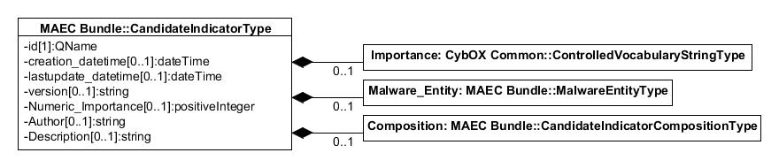

|  |  |  |  |
| --- | --- | --- | --- |
| **Field** | **Type** | **Multiplicity** | **Description** |
| **id** | QName | 1 | Specifies a unique ID for this Candidate_Indicator. The ID SHOULD follow the pattern defined in Section 1.4. |
| **creation_datetime** | dateTime | 0..1 | Specifies the date/time that the Candidate_Indicator was created. |
| **lastupdate_datetime** | dateTime | 0..1 | Specifies the last date/time that the Candidate_Indicator was updated. |
| **version** | string | 0..1 | Specifies the version of the Candidate_Indicator. |
| **Importance** | cyboxCommon:  ControlledVocabularyStringType | 0..1 | Specifies the relative importance of the Candidate_Indicator. The default vocabulary type is the MAEC *‘ImportanceTypeVocab-1.0*.’ |
| **Numeric_Importance** | positiveInteger | 0..1 | Specifies the specific numeric importance of the Candidate_Indicator. |
| **Author** | string | 0..1 | Specifies the author of the Candidate_Indicator. |
| **Description** | string | 0..1 | Provides a brief description of the Candidate_Indicator. |
| **Malware_Entity** | MalwareEntityType | 0..1 | Specifies the particular malware entity that the Candidate_Indicator is written against, whether it be a malware instance, family, etc. |
| **Composition** | CandidateIndicatorComposition  Type | 1 | Specifies the actual observables that the Candidate_Indicator is composed of, via a reference to one or more MAEC entities contained in the MAEC_Bundle. |

### CandidateIndicatorCompositionType

The CandidateIndicatorCompositionType captures the composition of a Candidate_Indicator, via references to any corresponding MAEC entities contained in the MAEC_Bundle.

|  |  |  |  |
| --- | --- | --- | --- |
| **Field** | **Type** | **Multiplicity** | **Description** |
| **operator** | cybox:OperatorTypeEnum | 0..1 | Specifies the boolean operator for this level of the Candidate_Indicator's composition. |
| **Behavior_ReferenceA** | BehaviorReferenceType | A(0..1)|  B(0..1)|  C(0..1) | Specifies a reference to a single Behavior in the MAEC_Bundle that is part of the Candidate_Indicator's composition. |
| **Action_ReferenceB** | cybox:ActionReferenceType | Specifies a reference to a single Action in the MAEC_Bundle that is part of the Candidate_Indicator's composition. |
| **Object_ReferenceC** | ObjectReferenceType | Specifies a reference to a single Object in the MAEC_Bundle that is part of the Candidate_Indicator's composition. |
| **Sub_Composition** | CandidateIndicatorCompositionType | 0..* | Captures any sub-compositions in this Candidate_Indicator, for expressing more complex Candidate_Indicators. |

## Collections

The Collections field of type CollectionsType contains the collection field types for Behavior, Action, Object, and Candidate_Indicator entities. Because the associated collection types are particular to being part of a collection, they are listed in this section, rather than in the functional groupings section (e.g., the BehaviorCollectionType is listed below instead of in the Behavior section (Section 2.6)).

### CollectionsType

The CollectionsType captures the various types of MAEC field collections. As shown in the UML, each of the different collection list types extend the MAEC Bundle BaseCollectionType.

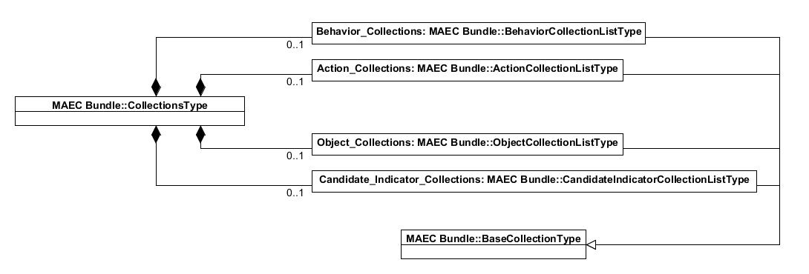

|  |  |  |  |
| --- | --- | --- | --- |
| **Field** | **Type** | **Multiplicity** | **Description** |
| **Behavior_Collections** | BehaviorCollectionListType | 0..1 | Captures any collections of MAEC Behaviors in the MAEC_Bundle. |
| **Action_Collections** | ActionCollectionListType | 0..1 | Captures any collections of MAEC Actions in the MAEC_Bundle. |
| **Object_Collections** | ObjectCollectionListType | 0..1 | Captures any collections of MAEC Objects in the MAEC_Bundle. |
| **Candidate_Indicator_Collections** | CandidateIndicatorCollectionListType | 0..1 | Captures any collections of MAEC Candidate_Indicators in the MAEC_Bundle. |

### BaseCollectionType

The BaseCollectionType is the base type for other MAEC collection types.

|  |  |  |  |
| --- | --- | --- | --- |
| **Field** | **Type** | **Multiplicity** | **Description** |
| **name** | string | 0..1 | Specifies the name of the Collection. |
| **Affinity_Type** | string | 0..1 | Provides an abstract way of characterizing how the Object entities in a Collection are related. |
| **Affinity_Degree** | string | 0..1 | Intended to provide an abstract way of characterizing the degree to which the Object entities in a Collection are related. |
| **Description** | string | 0..1 | Contains a textual description of the Collection. |

### BehaviorCollectionType

The BehaviorCollectionType provides a mechanism for characterizing collections of behaviors. It extends the MAEC Bundle BaseCollectionType (defined in Section 2.10.2). The BehaviorListType is defined in Section 2.13.6.

|  |  |  |  |
| --- | --- | --- | --- |
| **Field** | **Type** | **Multiplicity** | **Description** |
| **id** | QName | 1 | Specifies a unique ID for this Behavior_Collection. The ID SHOULD follow the pattern defined in Section 1.4. |
| **Purpose** | string | 0..1 | States the intended purpose of the collection of Behavior entities. Because Behaviors are not always successful, and may not be fully observed, this is meant as way of abstracting the nature of the collection of Behaviors away from its constituent Actions. |
| **Behavior_List** | BehaviorListType | 1 | Specifies a list of Behaviors that make up the collection. |

### ActionCollectionType

The ActionCollectionType provides a method for characterizing collections of Actions. This can be useful for organizing Action entities that may be related and where the exact relationship is unknown, as well as Actions whose associated Behavior has not yet been established. It extends the BaseCollectionType (defined in Section 2.10.2). The ActionListType is defined in Section 2.13.2.

|  |  |  |  |
| --- | --- | --- | --- |
| **Field** | **Type** | **Multiplicity** | **Description** |
| **id** | QName | 1 | Specifies a unique ID for this Action_Collection. The ID SHOULD follow the pattern defined in Section 1.4. |
| **Action_List** | ActionListType | 1 | Specifies a list of Actions that make up the collection. |

### ObjectCollectionType

The ObjectCollectionType provides a mechanism for characterizing collections of Objects. For instance, it can be used to group all of the Objects that are associated with a specific Behavior. It extends the MAEC Bundle BaseCollectionType (defined in Section 2.10.2). The ObjectListType is defined in Section 2.13.12.

|  |  |  |  |
| --- | --- | --- | --- |
| **Field** | **Type** | **Multiplicity** | **Description** |
| **id** | QName | 1 | Specifies a unique ID for this Object_Collection. The ID SHOULD follow the pattern defined in Section 1.4. |
| **Object_List** | ObjectListType | 1 | Specifies a list of Objects that make up the collection. |

### CandidateIndicatorCollectionType

The CandidateIndicatorCollectionType provides a mechanism for characterizing collections of Candidate_Indicators. It extends the MAEC Bundle BaseCollectionType (defined in Section 2.10.2). The CandidateIndicatorListType is defined in Section 2.13.9.

|  |  |  |  |
| --- | --- | --- | --- |
| **Field** | **Type** | **Multiplicity** | **Description** |
| **id** | QName | 1 | Specifies a unique ID for this Candidate_Indicator_Collection. The ID SHOULD follow the pattern defined in Section 1.4. |
| **Candidate_Indicator_List** | CandidateIndicatorListType | 1 | Specifies a list of Candidate_Indicators that make up the collection. |

## Shared Types

These types are used by a variety of fields. They are listed in alphabetical order. Note that some types in this section are currently used by only one particular field; however, they are included here because they could be used more generally.

### APICallType

The APICallType provides a method for the characterization of API calls, including functions and their parameters.

|  |  |  |  |
| --- | --- | --- | --- |
| **Field** | **Type** | **Multiplicity** | **Description** |
| **function_name** | string | 0..1 | Contains the exact name of the API function called, e.g., ‘*CreateFileEx*.’ |
| **normalized_function_name** | string | 0..1 | Contains the normalized name of the API function called, e.g., ‘*CreateFile*.’ |
| **Address** | hexBinary | 0..1 | Contains the code address of the API call in the binary. |
| **Return_Value** | string | 0..1 | Contains the return value of the API call. |
| **Parameters** | ParameterListType | 0..1 | Captures any name/value pairs of the parameters passed into the API call. |

### AssociatedCodeType

The AssociatedCodeType serves as generic way of specifying any code snippets associated with a MAEC field, such as a Behavior.

|  |  |  |  |
| --- | --- | --- | --- |
| **Field** | **Type** | **Multiplicity** | **Description** |
| **Code_Snippet** | CodeObj:CodeObjectType | 1..* | Captures a single snippet of code, via the CybOX CodeObjectType. |

### CVEVulnerabilityType

The CVEVulnerabilityType provides a way of referencing specific vulnerabilities that malware exploits or attempts to exploit via a Common Vulnerabilities and Exposures (CVE) identifier. For more information on CVE please see [CVE].

|  |  |  |  |
| --- | --- | --- | --- |
| **Field** | **Type** | **Multiplicity** | **Description** |
| **cve_id** | string | 1 | Contains the ID of the CVE that is being referenced, e.g., ‘*CVE-1999-0002*.’ |
| **Description** | string | 0..1 | Specifies the textual description of the vulnerability referenced by the cve_id. |

### MalwareEntityType

The MalwareEntityType provides a mechanism for characterizing the particular entity that an indicator or signature is written against, such as a particular malware instance, family, etc.

|  |  |  |  |
| --- | --- | --- | --- |
| **Field** | **Type** | **Multiplicity** | **Description** |
| **Type** | cyboxCommon:ControlledVocabularyStringType | 0..1 | Refers to the specific type of malware entity that the indicator or signature is written against. The default vocabulary type for use in this field is the MAEC *‘MalwareEntityTypeVocab-1.0*.’ |
| **Name** | string | 0..1 | Refers to the name of the malware instance, malware family, or malware class that the indicator or signature is written against. |
| **Description** | string | 0..1 | Intended to provide a brief description of the entity that the indicator or signature is written against. |

### ParameterType

The ParameterType characterizes function parameters.

|  |  |  |  |
| --- | --- | --- | --- |
| **Field** | **Type** | **Multiplicity** | **Description** |
| **ordinal_position** | positiveInteger | 0..1 | Refers to the ordinal position of the parameter with respect to the function where it is used. |
| **name** | string | 0..1 | Specifies the name of the parameter. |
| **value** | string | 0..1 | Specifies the actual value of the parameter. |

### VulnerabilityExploitType

The VulnerabilityExploitType characterizes any vulnerability that may be exploited by malware through a Behavior.

|  |  |  |  |
| --- | --- | --- | --- |
| **Field** | **Type** | **Multiplicity** | **Description** |
| **known_vulnerability** | boolean | 0..1 | Specifies whether the vulnerability that the malware is exploiting has been previously identified. If so, it SHOULD be referenced via a CVE ID in the CVE field. If not, the platform(s) targeted by the vulnerability exploitation behavior MAY be specified in the Targeted_Platforms field. |
| **CVE** | CVEVulnerabilityType | 0..1 | Specifies the CVE ID and description of the vulnerability targeted by the exploit, if available. |
| **Targeted_Platforms** | PlatformListType | 0..1 | Specifies the platforms(s) targeted by the vulnerability exploit. |

## Referential Types

This section defines the types of the MAEC Bundle data model whose sole purpose is to reference other types.

### BehavioralActionEquivalenceReferenceType

The BehavioralActionEquivalenceReferenceType defines an Action_Equivalence_Reference that can be used as part of a Behavior. Because Action_Equivalence_Reference equates two or more Actions, this can be thought of as specifying one of the aforementioned Actions as part of the composition of the Behavior.

|  |  |  |  |
| --- | --- | --- | --- |
| **Field** | **Type** | **Multiplicity** | **Description** |
| **action_equivalence_idref** | QName | 1 | Specifies the ID of an Action_Equivalence contained in the same MAEC document as the Behavior that utilizes it. The IDREF SHOULD follow the pattern defined in Section 1.4. |
| **behavioral_ordering** | positiveInteger | 0..1 | Defines the ordering of the Action with respect to the other Actions that make up the Behavior. For example, an Action with a behavioral_ordering of ‘*1*’ would come before an Action with a behavioral_ordering of ‘*2*’, etc. |

### BehavioralActionReferenceType

The BehavioralActionReferenceType defines an Action reference that can be used as part of a Behavior. It extends the CybOX ActionReferenceType.

|  |  |  |  |
| --- | --- | --- | --- |
| **Field** | **Type** | **Multiplicity** | **Description** |
| **behavioral_ordering** | positiveInteger | 0..1 | Defines the ordering of the Action with respect to the other Actions that make up the Behavior. So an Action with a behavioral_ordering of ‘*1*’ would come before an Action with a behavioral_ordering of ‘*2*’, etc. |

### BehaviorReferenceType

The BehaviorReferenceType serves as a method for referencing existing Behaviors contained in the MAEC_Bundle.

|  |  |  |  |
| --- | --- | --- | --- |
| **Field** | **Type** | **Multiplicity** | **Description** |
| **behavior_idref** | QName | 1 | Specifies the ID of the Behavior being referenced; this Behavior MUST be present in the current MAEC_Bundle. The IDREF SHOULD follow the pattern defined in Section 1.4. |

### BundleReferenceType

The BundleReferenceType serves as a method for linking to MAEC_Bundle entities embedded in other locations. It MAY be used in a MAEC_Package.

|  |  |  |  |
| --- | --- | --- | --- |
| **Field** | **Type** | **Multiplicity** | **Description** |
| **bundle_idref** | QName | 1 | References the ID of a MAEC_Bundle contained inside the current MAEC document. The IDREF SHOULD follow the pattern defined in Section 1.4. |

### CapabilityObjectiveReferenceType

The CapabilityObjectiveReferenceType serves as a method for referencing existing Capability objectives (Strategic_Objective or Tactical_Objective fields) contained in a MAEC document.

|  |  |  |  |
| --- | --- | --- | --- |
| **Field** | **Type** | **Multiplicity** | **Description** |
| **objective_idref** | QName | 1 | Specifies the ID of a Capability objective (either a Strategic_Objective or Tactical_Objective) contained inside the current MAEC document. The IDREF SHOULD follow the pattern defined in Section 1.4. |

### CapabilityReferenceType

The CapabilityReferenceType serves as a method for referencing existing Capability contained in a MAEC document.

|  |  |  |  |
| --- | --- | --- | --- |
| **Field** | **Type** | **Multiplicity** | **Description** |
| **capability_idref** | QName | 1 | Specifies the ID of a Capability contained inside the current MAEC document. The IDREF SHOULD follow the pattern defined in Section 1.4. |

### ObjectReferenceType

The ObjectReferenceType serves as a method for linking to CybOX Objects embedded in the MAEC_Bundle.

|  |  |  |  |
| --- | --- | --- | --- |
| **Field** | **Type** | **Multiplicity** | **Description** |
| **object_idref** | QName | 1 | Specifies the ID of a CybOX Object being referenced in the current MAEC_Bundle. The IDREF SHOULD follow the pattern defined in Section 1.4. |

## List Types

This section contains an alphabetical list of types that are lists of fields used in the MAEC Bundle data model.

### ActionCollectionListType

The ActionCollectionListType captures a list of Action_Collections.

|  |  |  |  |
| --- | --- | --- | --- |
| **Field** | **Type** | **Multiplicity** | **Description** |
| **Action_Collection** | ActionCollectionType | 1..* | Specifies a single collection of Actions in the MAEC_Bundle. |

### ActionListType

The ActionListType captures a list of Actions.

|  |  |  |  |
| --- | --- | --- | --- |
| **Field** | **Type** | **Multiplicity** | **Description** |
| **Action** | MalwareActionType | 1..* | Specifies a single Action in the list. |

### ActionReferenceListType

The ActionReferenceListType captures a list of Action_References.

|  |  |  |  |
| --- | --- | --- | --- |
| **Field** | **Type** | **Multiplicity** | **Description** |
| **Action_Reference** | cybox:ActionReferenceType | 1..* | Specifies a reference to a single Action. |

### AVClassificationsType

The AVClassificationsType captures a list of AV_Classifications.

|  |  |  |  |
| --- | --- | --- | --- |
| **Field** | **Type** | **Multiplicity** | **Description** |
| **AV_Classification** | AVClassificationType | 1..* | Captures a single AV_Classification of the malware instance. |

### BehaviorCollectionListType

The BehaviorCollectionListType captures a list of Behavior_Collections.

|  |  |  |  |
| --- | --- | --- | --- |
| **Field** | **Type** | **Multiplicity** | **Description** |
| **Behavior_Collection** | BehaviorCollectionType | 1..* | Specifies a single collection of MAEC Behaviors in the MAEC_Bundle. |

### BehaviorListType

The BehaviorListType captures a list of Behaviors.

|  |  |  |  |
| --- | --- | --- | --- |
| **Field** | **Type** | **Multiplicity** | **Description** |
| **Behavior** | BehaviorType | 1..* | Specifies a single MAEC Behavior in the list of Behaviors. |

### BehaviorRelationshipListType

The BehaviorRelationshipListType captures any relationships between a Behavior and other Behaviors.

|  |  |  |  |
| --- | --- | --- | --- |
| **Field** | **Type** | **Multiplicity** | **Description** |
| **Relationship** | BehaviorRelationshipType | 1..* | Specifies a single Relationship between a single Behavior and one or more other Behaviors. |

### CandidateIndicatorCollectionListType

The CandidateIndicatorCollectionListType captures a list of Candidate_Indicator_Collections.

|  |  |  |  |
| --- | --- | --- | --- |
| **Field** | **Type** | **Multiplicity** | **Description** |
| **Candidate_Indicator_Collection** | CandidateIndicatorCollectionType | 1..* | Specifies a single collection of Candidate_Indicators in the MAEC_Bundle. |

### CandidateIndicatorListType

The CandidateIndicatorListType captures a list of Candidate_Indicators.

|  |  |  |  |
| --- | --- | --- | --- |
| **Field** | **Type** | **Multiplicity** | **Description** |
| **Candidate_Indicator** | CandidateIndicatorType | 1..* | Specifies a single Candidate_Indicator in the list. |

### CapabilityListType

The CapabilityListType captures a list of Capabilities.

|  |  |  |  |
| --- | --- | --- | --- |
| **Field** | **Type** | **Multiplicity** | **Description** |
| **Capability** | CapabilityType | 1..* | Specifies a single Capability in the list and represents a single capability possessed by the malware instance. |
| **Capability_Reference** | CapabilityReferenceType | 1..* | References a single Capability defined elsewhere in the MAEC document. |

### ObjectCollectionListType

The ObjectCollectionListType captures a list of Object_Collections.

|  |  |  |  |
| --- | --- | --- | --- |
| **Field** | **Type** | **Multiplicity** | **Description** |
| **Object_Collection** | ObjectCollectionType | 1..* | Specifies a single collection of CybOX Objects in the MAEC_Bundle. |

### ObjectListType

The ObjectListType captures a list of CybOX Objects.

|  |  |  |  |
| --- | --- | --- | --- |
| **Field** | **Type** | **Multiplicity** | **Description** |
| **Object** | cybox:ObjectType | 1..* | Specifies a single CybOX Object in the list. For use in MAEC, the ID field at the top level of the Object MUST be utilized. |

### ObjectReferenceListType

The ObjectReferenceListType captures a list of references to CybOX Objects. Note that this type is not currently used inside of a MAEC_Bundle, but is used by a MAEC_Package field (maecPackage:ObjectEquivalenceType). It is listed in the MAEC Bundle data model section for consistency given that the ObjectReferenceType is also defined in this section (Section 2.12.7).

|  |  |  |  |
| --- | --- | --- | --- |
| **Field** | **Type** | **Multiplicity** | **Description** |
| **Object_Reference** | ObjectReferenceType | 1..* | Specifies a reference to a single CybOX Object. |

### ParameterListType

The ParametersType captures a list of function Parameter entities.

|  |  |  |  |
| --- | --- | --- | --- |
| **Field** | **Type** | **Multiplicity** | **Description** |
| **Parameter** | ParameterType | 1..* | Specifies a single function Parameter. |

### PlatformListType

The PlatformListType captures a list of software or hardware Platform entities.

|  |  |  |  |
| --- | --- | --- | --- |
| **Field** | **Type** | **Multiplicity** | **Description** |
| **Platform** | cyboxCommon:  PlatformSpecificationType | 1..* | Specifies a single Platform in the list via a common platform enumeration ID. Uses PlatformSpecificationType from the CybOX Common schema v2.0.1. |

# Appendix – References

References made in this document are listed below.

## MAEC Documents

[MAECO] MAEC Overview

<http://maec.mitre.org/about/docs/MAEC_Overview.pdf>

[MAECS] Characterizing Malware with MAEC and STIX

<http://maec.mitre.org/about/docs/Characterizing_Malware_MAEC_and_STIX_v1.0.pdf>

[SPECB] MAEC Bundle Specification

<http://maec.mitre.org/language/version4.1/MAEC_Bundle_Spec_v4_1.pdf>

[SPECP] MAEC Package Specification

<http://maec.mitre.org/language/version4.1/MAEC_Package_Spec_v2_1.pdf>

[SPECC] MAEC Container Specification

<http://maec.mitre.org/language/version4.1/MAEC_Container_Spec_v2_1.pdf>

[SPECV] MAEC Default Vocabularies Specification

<http://maec.mitre.org/language/version4.1/MAEC_Vocabs_Spec_v1_1.pdf>

[REQ] Requirements and Recommendations for MAEC Compatibiity

<http://maec.mitre.org/compatible/Requirements_for_MAEC_Compatibility_V1.1.pdf>

## MAEC Web Pages

[EXAMW] MAEC v4.1 Release Examples

[http://maec.mitre.org/language/version4.1/#samples](http://maec.mitre.org/language/version4.0.1/#samples)

[EXAMG] MAEC Examples (GitHub repository)

<https://github.com/MAECProject/schemas/tree/master/examples>

[MAEC] MAEC Web Site

<https://maec.mitre.org>

[MAECC] MAEC Community

<https://maec.mitre.org/community/index.html>

[MAECL] MAEC Discussion List Signup

<http://maec.mitre.org/community/discussionlist.html>

[MAECH] MAEC Handshake (send email to [maec@mitre.org](mailto:maec@mitre.org) for access)

<https://handshake.mitre.org/>

[REL4] MAEC v4.1 Release

[https://maec.mitre.org/language/version4.1/](https://maec.mitre.org/language/version4.0.1/)

[TERM] MAEC Terminology

<http://maec.mitre.org/about/terminology.html>

[TIES] Ties to Existing Standards

<http://maec.mitre.org/about/standards.html>

[FAQ] MAEC FAQ

<http://maec.mitre.org/about/faqs.html>

[TOU] MAEC Terms of Use

[https://maec.mitre.org/about/termsofuse.html](http://maec.mitre.org/about/termsofuse.html)

[VER] Versioning Policy

http://maec.mitre.org/language/versioning_policy.html

## MAEC Schema

[RELB] MAEC Bundle Model

[https://maec.mitre.org/language/version4.1/maec_bundle_schema.xsd](https://maec.mitre.org/language/version4.0/maec_bundle_schema.xsd)

[RELP] MAEC Package Model

[https://maec.mitre.org/language/version4.1/maec_package_schema.xsd](https://maec.mitre.org/language/version4.0/maec_package_schema.xsd)

[RELC] MAEC Container Model

[https://maec.mitre.org/language/version4.1/maec_container_schema.xsd](https://maec.mitre.org/language/version4.0/maec_container_schema.xsd)

[RELD] MAEC Default Vocabularies

[https://maec.mitre.org/language/version4.1/maec_default_vocabularies.xsd](https://maec.mitre.org/language/version4.0/maec_default_vocabularies.xsd)

## MAEC Development

[DEV] MAEC GitHub Repositories

<https://github.com/MAECProject/>

[DEVP] MAEC Python Library

<https://github.com/MAECProject/python-maec>

[DEVS] MAEC Schema Development

<https://github.com/MAECProject/schemas>

[DEVU] MAEC Utilities

<https://github.com/MAECProject/utils>

## Other References

[CPE] Common Platform Enumeration (CPE)

<http://nvd.nist.gov/cpe.cfm> (Official CPE Dictionary) <http://csrc.nist.gov/publications/PubsNISTIRs.html> (CPE Specifications)

[CUCKOO] Cuckoo Sandbox

<http://www.cuckoosandbox.org/>

[CVE] Common Vulnerabilities and Exposures (CVE)

<http://cve.mitre.org>

[CVSS] Common Vulnerability Scoring System

<http://www.first.org/cvss>

[CYBOX] Cyber Observable eXpression (CybOX)

<http://cybox.mitre.org>

[IOC] Open Indicators of Compromise (OpenIOC)

<http://openioc.org/>

[MMDEF] IEEE ICSG’s Malware Metadata Exchange Format

<http://standards.ieee.org/develop/indconn/icsg/mmdef.html>

[OVAL] Open Vulnerability and Assessment Language (OVAL)

<http://oval.mitre.org>

[RFC2119] RFC 2119 – Key words for use in RFCs to Indicate Requirement Levels

<http://www.ietf.org/rfc/rfc2119.txt>

[STIX] Structured Threat Information eXpression (STIX)

<http://stix.mitre.org>

[W3C0] W3C Namespaces in XML 1.0 (Third Edition)

<http://www.w3.org/TR/REC-xml-names/>

[W3C1] W3C Recommendation for Hex-Encoded Binary Data

<http://www.w3.org/TR/xmlSchema-2/#hexBinary>

[W3C2] W3C Recommendation for Boolean Data

<http://www.w3.org/TR/xmlSchema-2/#boolean>

[W3C3] W3C Recommendation for Double Data

<http://www.w3.org/TR/xmlschema-2/#double>

[W3C4] W3C Recommendation for Float Data

<http://www.w3.org/TR/xmlSchema-2/#float>

[W3C5] W3C Recommendation for Integer Data

<http://www.w3.org/TR/xmlSchema-2/#integer>

[W3C6] W3C Recommendation for XML Qualified Names

http://www.w3.org/TR/xmlSchema-2/#QName

[W3C7] W3C Recommendation for String Data

<http://www.w3.org/TR/xmlSchema-2/#string>

[W3C8] W3C Recommendation for unsigned int Data

<http://www.w3.org/TR/xmlschema-2/#unsignedInt>

[W3C9] W3C Recommendation for URI Data

<http://www.w3.org/TR/xmlschema-2/#anyURI>

1. For detailed information see [TOU].
2. For more information about the MAEC Language, please visit [MAEC].
3. Each data model and the default vocabularies are implemented in MAEC v4.1 via an XML schema. Other output formats, such as JSON, are being considered for future implementations.
4. As stated in footnote 3, each data model and the default vocabularies are implemented via an XML schema.
5. In MAEC v4.1, restrictions on ID syntax have been lifted in all IDs used in MAEC types so that all MAEC IDs are now compatible with the implementations used in CybOX and STIX. Consequently, the additional schematron and XSL files used in earlier MAEC versions primarily for ID syntax validation have been deprecated.
6. XML Schema Part 0: Primer Second Edition <http://www.w3.org/TR/xmlschema-0>
7. Namespaces (computer science): <http://en.wikipedia.org/wiki/Namespace_(computer_science)>
8. As stated in [MAECO], MAEC draws several components from the CybOX Language; consequently, the reader is referred to [CYBOX] for the definitions of these entities. In this specification, we do not define any types that are part of a non-MAEC data model. Instead we make note of the referenced data model’s specification and explicitly define only the extensions (i.e., new fields and types) that have been made as an extension of the base type.