Compare “do nothing more” (black) with “more of the same” [scale up EDAT and ITN] (red)

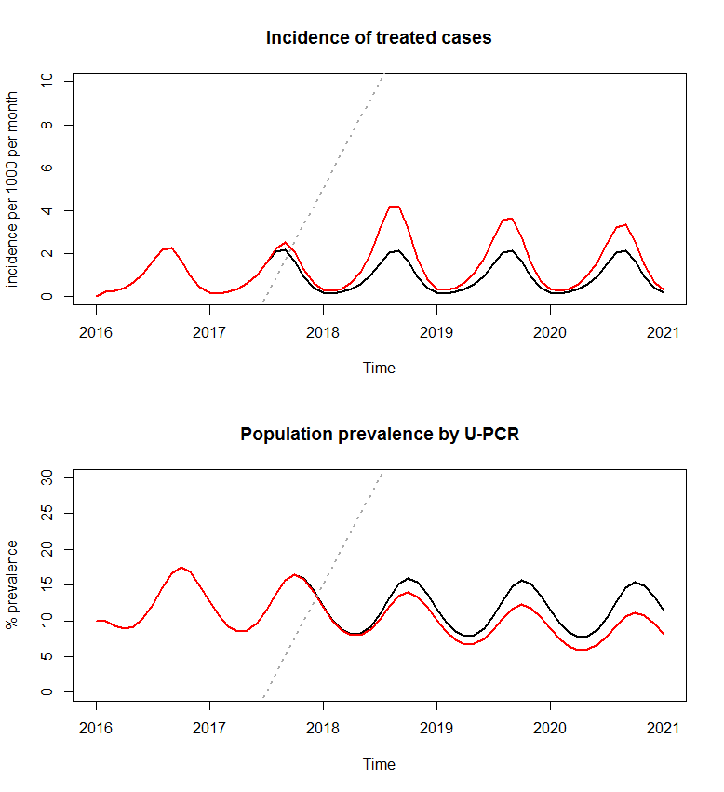

Compare do nothing more (black) with scale up EDAT and ITN and MDA+massRTS,S 3 rounds (red)

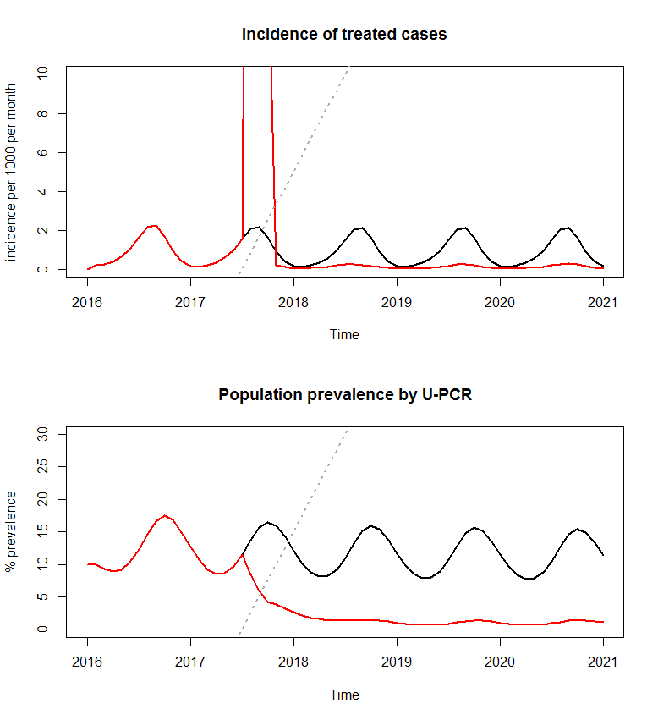

Compare do nothing more (black) with “kitchen sink” [scale-up and mass and RCD and improve VMW->CHW] (red)

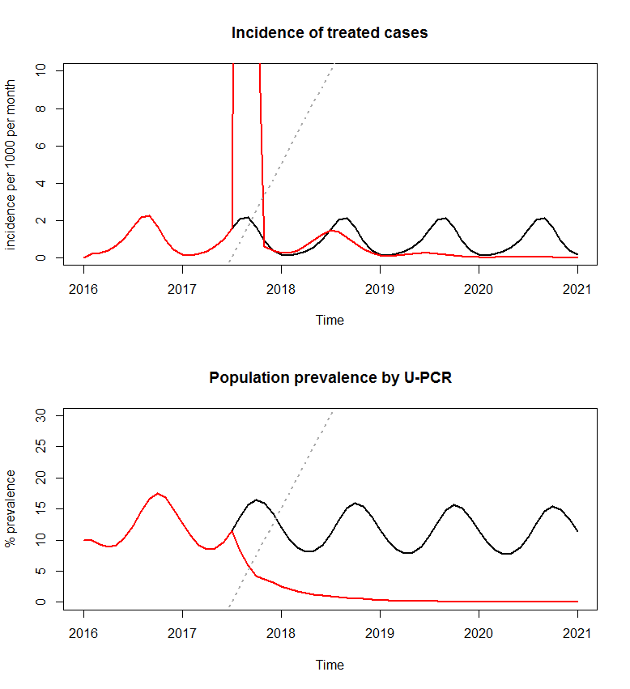

Compare “more of the same” (black) with “kitchen sink” (red)

