Ecosystem Simulation
Java-Based OOP Project Report — Final Report
University of Messina
Course: Data Analysis
Professor: Salvatore Distefano
Name: Yermek Aubayev
Matricula Number: 551098

Table of Contents
1. Introduction 4
1.1 Purpose of the Project 4
1.1.1 Build a Functional Discrete-Event Ecosystem Simulation 4
1.1.2 Demonstrate Object-Oriented Programming Principles 5
1.2 System Components and Architecture 5
1.2.1 World and Environment 5
1.2.2 Entity Hierarchy 5
1.2.3 Discrete-Event Engine 6
1.2.4 Rule DSL Pipeline 7
1.2.5 EntityFactory and SimulationConfig 10
1.2.6 GUI Layer 10
1.2.7 Statistics 11
2. OOP Principles Applied 12
2.1 Encapsulation 12
2.2 Information Hiding 13
2.3 Inheritance 15
2.4 Abstraction 15
2.5 Polymorphism 16
2.5.1 Polymorphism by Inclusion 16
2.5.2 Polymorphism by Overloading 17
2.5.3 Parametric Polymorphism (Generics) 18
2.5.4 Polymorphism by Coercion 18
2.5.5 Motivation for Polymorphism, Overall 19
2.6 Composition 19
2.7 Subtyping (Multityping with Interfaces) 20
2.8 Exception Handling 22
2.9 Discrete-Event Simulation Logic 24
2.10 Extensions and Customization: the Rule DSL 27
2.11 Extensibility (Open/Closed Principle) 29
2.12 Modularity 31
2.13 Hierarchy 32
2.14 Reuse 33
3. Testing 35
4. Known Limitations 35
5. Conclusion 35

1. Introduction
This project implements a customizable discrete-event ecosystem simulation in Java 21. Predators, herbivores, and plants interact directly and decentrally on a shared grid: predators hunt herbivores, herbivores graze on plants, and every species ages, consumes energy, and reproduces under rules a user can author and change while the simulation is running, without touching or recompiling any Java source.
The project was built to satisfy two requirements at once. First, a technically defensible discrete-event simulation (DES) engine, not a fixed-timestep loop that merely calls itself one. Second, a runtime rule-customization system built as a small domain-specific language (DSL), complete with its own lexer, parser, abstract syntax tree, and evaluator. Around these two pillars, the system also demonstrates every core Object-Oriented Programming principle with real, load-bearing examples rather than ones added purely to satisfy a checklist.

1.1 Purpose of the Project
The primary purpose of this project is twofold:

1.1.1 Build a Functional Discrete-Event Ecosystem Simulation
The engine supports all of the following:
- A future-event-list (FEL) driven simulation clock: the engine advances time by popping the single earliest-scheduled event and adopting that event’s own scheduled time, rather than incrementing time by a fixed step and polling every entity.
- Six distinct discrete-event types (EntityActivityEvent, EnvironmentRegenerationEvent, DeathEvent, PredationEvent, ReproductionEvent, MovementEvent), each with a single, well-defined owner of the state mutation it represents.
- A free-text rule language that lets a user compose entirely new ecosystem logic at runtime, rather than only tune numeric parameters or choose from a fixed set of presets.
- Two interchangeable front ends: a Swing GUI (MainWindow, with live statistics, an event log, and a rule editor) and a headless batch runner (HeadlessRunner), both driving the exact same SimulationEngine.

1.1.2 Demonstrate Object-Oriented Programming Principles
The project was designed so the required OOP concepts arise from real design pressure, not from decoration. For example:
- Abstraction is applied through the abstract Entity and SimulationEvent classes.
- Inheritance lets Predator, Herbivore, and Plant share energy, age, and position management through Organism and Entity.
- Inclusion polymorphism allows the engine to call entity.update() and event.execute(ctx) without ever asking “what kind is this?”.
- Encapsulation ensures a caller can never obtain a live, mutable reference to World’s internal entity list.
- Exception handling distinguishes a checked, recoverable RuleParseException (a malformed rule is expected, user-facing input) from an unchecked SimulationException (a programming-contract violation).
Each of these is expanded, with real code and an explanation of why the design went this way, in Section 2.

1.2 System Components and Architecture

1.2.1 World and Environment
World owns the authoritative list of all entities and a composed Environment object (food level, food regeneration rate, temperature). It exposes only spatial queries (getNeighbors, getEntitiesAt, countAliveByType) and controlled mutation (addEntity, removeEntity). It never hands out a live reference to its internal list:
// World.java
public List<Entity> getEntities() {
return new ArrayList<>(this.entities); // Return copy to preserve encapsulation
}

1.2.2 Entity Hierarchy
Entity (abstract)
└─ Organism (abstract) adds energy, age, maxEnergy
├─ Animal (abstract) adds speed, visionRange; implements Movable
│ ├─ Predator adds attackPower, fedCooldown; implements Reproducible
│ └─ Herbivore adds defensePower, grazeCooldown; implements Reproducible
└─ Plant adds growthRate; implements Reproducible
Movable and Reproducible are kept as two independent interfaces rather than folded into the abstract classes, so that Plant, which reproduces but never moves, is never forced to implement a move() method that would have no sensible body.

1.2.3 Discrete-Event Engine
SimulationEngine implements a narrow SchedulingContext interface and owns the future-event list, an EventQueue<SimulationEvent> backed by a java.util.PriorityQueue. SimulationEvent is the abstract base for all six event types; ties in scheduled time are broken deterministically by a monotonically increasing sequence number, because PriorityQueue does not guarantee FIFO order on its own:
// SimulationEngine.java
public void advanceTo(int targetTime) {
while (eventQueue.peek() != null && eventQueue.peek().getScheduledTime() <= targetTime) {
SimulationEvent event = eventQueue.dequeue();
clock = event.getScheduledTime();
event.execute(this);
}
if (clock < targetTime) {
clock = targetTime;
}
}
The full class relationships are shown below.
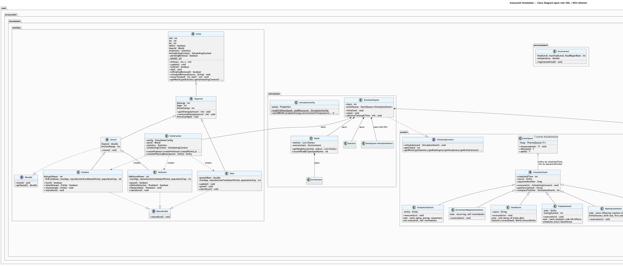
Ecosystem Simulation — Class Diagram (post rule-DSL / DES refactor)

1.2.4 Rule DSL Pipeline
Free text, typed into the RuleEditorPanel or hand-edited in config/rules.txt, flows through a small compiler pipeline: a hand-written Lexer, a recursive-descent Parser (no ANTLR or other generator), an immutable AST built from Java 21 sealed interfaces and records, static validation against a RuleVocabulary, and finally an Evaluator invoked once per entity, per tick. The full pipeline, from authoring through runtime evaluation, is shown below.
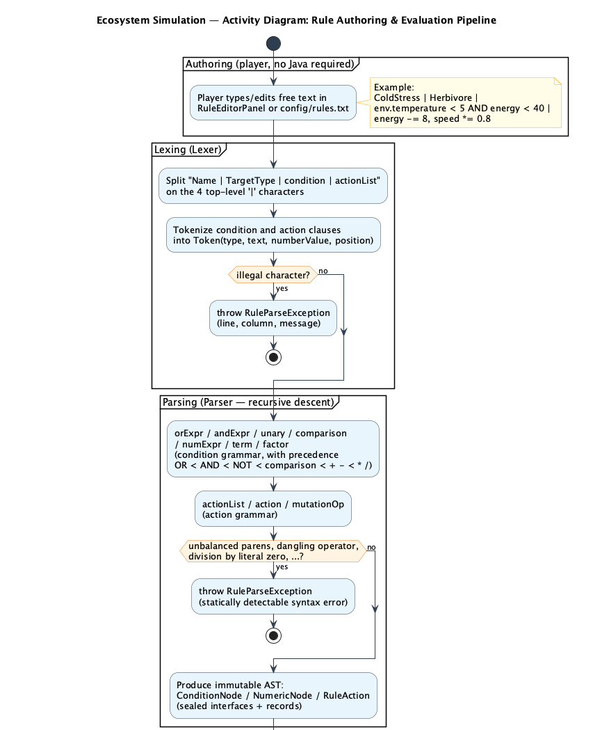
Ecosystem Simulation — Activity Diagram: Rule Authoring & Evaluation Pipeline (1 of 2 — authoring through AST construction)
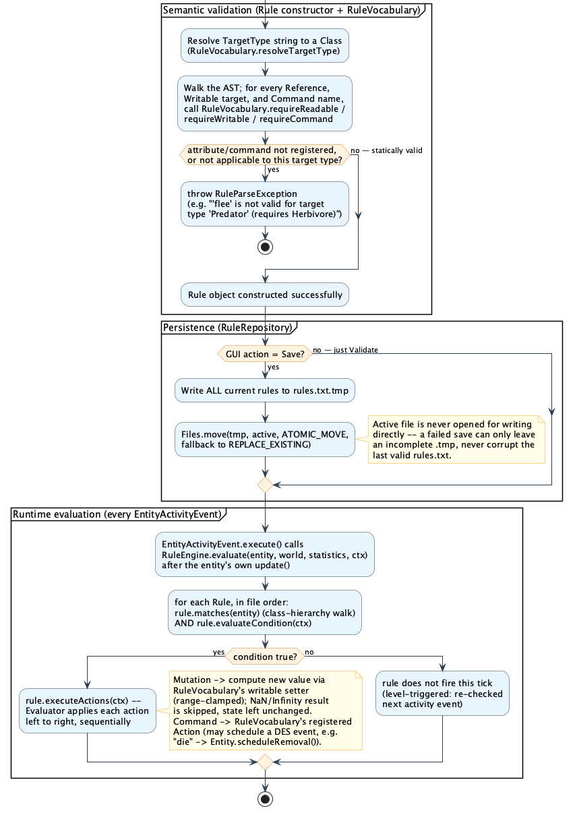
Ecosystem Simulation — Activity Diagram: Rule Authoring & Evaluation Pipeline (2 of 2 — semantic validation through runtime evaluation)

1.2.5 EntityFactory and SimulationConfig
Every entity, both the initial population and every reproduced offspring, is created through one place, EntityFactory, wired end to end from SimulationConfig (backed by config/simulation.properties):
// EntityFactory.java
public Predator createPredator(int x, int y) {
Predator p = new Predator(x, y, config.predatorEnergy(), config.predatorSpeed(), config.predatorAttackPower());
p.setVisionRange(config.predatorVisionRange());
p.setMaxAge(config.predatorMaxAge());
p.setReproductionCooldownPeriod(config.predatorReproductionCooldown());
p.setEnergyConsumptionPerTick(config.predatorEnergyConsumption());
p.setPopulationCap(config.predatorCap());
wire(p);
return p;
}
This eliminated a class of bugs from the earlier design, where the same species-default literals were hardcoded once in the GUI/headless entry points and again inside each species’ own reproduce() method.

1.2.6 GUI Layer
MainWindow composes independent Swing panels: ControlPanel, WorldPanel/ViewerPanel (spatial view), StatisticsPanel (live numeric counters), EventLogPanel (a scrolling log of rule triggers and discrete events), RuleEditorPanel, and ActiveRulesPanel. RuleEditorPanel itself holds no authoring surface; it offers three actions (build, reload from file, remove by name) and delegates composition to RuleBuilderDialog, a point-and-click composer whose target-type/attribute/command dropdowns are populated directly from RuleVocabulary.listReadables()/listWritables()/ listCommands() — nothing can be typed that does not already exist for the chosen type, and the only free-typed inputs are a rule’s name and its numeric thresholds. ControlPanel’s “Settings…” button similarly opens SettingsDialog, a tabbed, spinner-based editor for every value in config/simulation.properties, so no customization — rules or simulation parameters — requires hand-typing syntax or editing a file directly. None of these panels parses or interprets rule text itself; they all delegate to RuleRepository/RuleEngine, so validation behaves identically whether a rule comes from the builder dialog, a hand-edited file, or a unit test.

1.2.7 Statistics
Statistics tracks population by species, births and deaths (with per-species breakdown), successful/failed hunts, and plants consumed, behind a small, encapsulated interface (recordBirth, recordDeath, recordSuccessfulHunt, …).

2. OOP Principles Applied
Every principle below is demonstrated with a load-bearing example taken from the final implementation, not one manufactured solely to appear in this report. Where a design decision could reasonably have gone another way, the reasoning behind the choice actually made is included, since that reasoning is exactly what an oral examiner is likely to probe.

2.1 Encapsulation
Definition: Encapsulation bundles an object’s data together with the operations that act on it and controls how that data can be reached from outside — the object’s own methods are the only door in.
Code Snippet (World.java)
private List<Entity> entities;
...
public List<Entity> getEntities() {
return new ArrayList<>(this.entities); // Return copy to preserve encapsulation
}
public void addEntity(Entity entity) {
if (entity != null) {
this.entities.add(entity);
}
}
Description
World’s entity list is private, and the only way to read it is getEntities(). Critically, that method does not hand back the live list — it returns a defensive copy. A private field by itself only stops a caller from replacing World’s reference; without the copy, a caller could still obtain the live list through the getter and mutate it directly (add or remove entities behind World’s back), which would defeat the entire point of routing every mutation through addEntity/removeEntity.
Motivation
Without the defensive copy, Predator.hunt() iterating over world.getEntities() while World.addEntity()/removeEntity() run elsewhere in the very same tick (as they do, from ReproductionEvent and DeathEvent) could throw a ConcurrentModificationException or silently corrupt iteration. That is not a decorative detail; it is what makes the rest of the per-tick update loop safe to reason about at all.
Encapsulation versus information hiding, made explicit. This section is about access control on one object’s own state — World controlling what a caller can do with its entity list through the methods it exposes. §2.2 is a distinct concern: whether an attribute’s representation is free to change later without breaking other code, a property of the class hierarchy’s design, not of one method. The two examples below deliberately use different mechanisms so neither can be mistaken for a restatement of the other.

2.2 Information Hiding
Definition: Information hiding is the discipline of choosing, for every attribute, exactly the visibility, scope, and mutability it needs and nothing more, so that no code outside the declaring class can come to depend on details that might later change. This project applies the 3-step attribute-engineering method to every field: (1) always private, (2) instance-level or class-level, (3) constant or variable.
Applying the 3 steps to Entity/Organism
Attribute | 1. Private? | 2. Scope | 3. Constant or variable
Entity.id | Yes | Instance | Constant — final, assigned once in the constructor, never reassigned
Entity.nextId | Yes | Class (static) | Variable — increments on every new Entity(...)
Organism.energy | Yes | Instance | Variable — changes via gainEnergy/consumeEnergy
Code Snippet (Entity.java)
private final int id; // 1: private. 2: instance-level. 3: constant.
...
private static int nextId = 1; // 1: private. 2: class-level. 3: variable.
public Entity(int x, int y) {
...
this.id = nextId++;
}
public int getId() { return this.id; }
Description
Every field declared anywhere in the Entity → Organism → Animal → Predator/Herbivore hierarchy is private, including fields declared in the abstract base classes, which a looser design would leave protected so subclasses could “just reach in”. This project does not: Animal declares private double speed and private int visionRange, and Predator/Herbivore — its own subclasses — read and write them exclusively through getSpeed()/getVisionRange()/setVisionRange(...), never through the field directly. The same holds for Entity’s world, schedulingContext, statistics, and simulationEventListener: every one of Predator, Herbivore, and Plant reaches them only via getWorld()/getSchedulingContext()/getStatistics()/ getSimulationEventListener(), even though all four live in the same class hierarchy.
Motivation
Enforcing this strictly (private, not protected) is what actually delivers step 3 for Entity.id: because the field is both private and final, no code anywhere — not even a subclass — can reassign it after construction, so “constant” is a compiler-checked fact rather than a convention someone could accidentally break with a stray this.id = ... in a future subclass. Entity.nextId shows the opposite corner of the same table: private and static (one counter shared by every instance, not per-object), and deliberately mutable, since it must increment. Keeping every inherited field private rather than protected is also what keeps a superclass’s internal representation genuinely free to change later: a subclass that only ever calls getSpeed() does not, and structurally cannot, care whether speed is still a plain double field, a computed value, or something read from configuration.

2.3 Inheritance
Definition: Inheritance lets a subclass reuse and extend the state and behavior of a superclass, avoiding duplication and expressing genuine “is-a” relationships.
Code Snippet
public abstract class Organism extends Entity { ... } // Organism.java
public abstract class Animal extends Organism implements Movable { ... } // Animal.java
public class Predator extends Animal implements Reproducible { ... } // Predator.java
public class Plant extends Organism implements Reproducible { ... } // Plant.java
Description
Every level of the hierarchy in §1.2.2 adds genuinely new, non-redundant state: Organism adds energy/age/maxEnergy; Animal adds speed/visionRange; Predator adds attackPower; Herbivore adds defensePower; Plant adds growthRate. Nothing is re-declared at a lower level than where it is actually needed.
Motivation
Plant is placed directly under Organism, not under Animal, even though a plant is unambiguously a living organism. That was a conscious design check, not an oversight: Animal implements Movable, and a plant cannot move, so forcing Plant under Animal would have violated the Liskov Substitution Principle, since code holding an Animal reference could then legitimately call move() on what is really a stationary plant and expect a meaningful position change. Keeping Movable as a separate interface (§2.7) is what makes this inheritance tree honest.

2.4 Abstraction
Definition: Abstraction represents only the essential features an object must have, deferring how those features are implemented to concrete subclasses.
Code Snippet
// Entity.java
public abstract void update();
// SimulationEvent.java
public abstract void execute(SchedulingContext ctx);
public abstract String getDescription();
Description
Entity declares update() as abstract: it defines that every entity must be updatable once per tick, not how. SimulationEvent does the same for execute(SchedulingContext). Both are genuine abstractions because the base class cannot know the concrete behavior in advance: a Plant grows, a Predator hunts and may schedule a PredationEvent, a DeathEvent records exactly one death regardless of cause, and a MovementEvent has no side effect at all beyond narrating a position change that already happened inside EntityActivityEvent.
Motivation
Concentrating the contract in one abstract method per concern is what lets the engine and the FEL stay completely ignorant of concrete entity/event types. See §2.5.1 for how that abstraction is actually exercised at runtime, through inclusion polymorphism.

2.5 Polymorphism
Four distinct forms of polymorphism are used throughout the project: polymorphism by inclusion, by overloading, parametrically (generics), and by coercion.

2.5.1 Polymorphism by Inclusion
Code Snippet
// EntityActivityEvent.execute(), called through the FEL for every concrete event type
entity.update(); // static type here is Entity; the method that actually
// runs is chosen at runtime from {Predator, Herbivore, Plant}.update()
// SimulationEngine.advanceTo()
SimulationEvent event = eventQueue.dequeue();
clock = event.getScheduledTime();
event.execute(this); // dispatches to DeathEvent/PredationEvent/ReproductionEvent/
// MovementEvent/EntityActivityEvent/EnvironmentRegenerationEvent
Description
This is the real mechanism the entire simulation loop runs on. The engine never asks “what kind of event is this?” It simply calls execute() through the base SimulationEvent type and lets the JVM’s dynamic dispatch select the correct override, exactly as EntityActivityEvent does one level down by calling entity.update() through the base Entity type.
A deliberate non-example, stated for honesty: the rule AST’s sealed interfaces (ConditionNode, NumericNode, RuleAction) are evaluated in Evaluator through an exhaustive pattern-matching switch, not through virtual dispatch: there is no evaluate() method on each AST node. It is a deliberate, modern alternative to inclusion polymorphism, chosen because the AST’s node set is fixed and closed by the rule grammar (§2.10), so a compiler-checked exhaustive switch is the more type-safe tool here. It is cited only as a contrast, not claimed as an instance of §2.5.1, which is a subtlety worth being able to explain out loud.

2.5.2 Polymorphism by Overloading
Code Snippet
// Statistics.java
public void recordBirth(String entityType) { recordBirth(entityType, 1); } // overload 1
public void recordBirth(String entityType, int count) { ... } // overload 2
// Rule.java
public boolean evaluateCondition(Entity entity) { ... } // overload 1
public boolean evaluateCondition(EvaluationContext ctx) { ... } // overload 2
// SimulationException.java
public SimulationException(String message) { super(message); } // overload 1
public SimulationException(String message, Throwable cause) { super(message, cause); } // overload 2
public SimulationException(Code code) { super(buildMessage(code)); } // overload 3
Description
Each group shares a name but differs in parameter list, and the compiler selects the matching signature at compile time based on argument types.
Motivation
This contrasts with update()/execute() in §2.5.1, which are resolved at runtime from the object’s actual class. Being able to state that distinction precisely (compile-time signature resolution versus runtime dynamic dispatch) is a very common oral-exam probe.

2.5.3 Parametric Polymorphism (Generics)
Code Snippet
// EventQueue.java
public class EventQueue<T extends SimulationEvent> {
private final PriorityQueue<T> heap;
public void enqueue(T event) { ... }
public T dequeue() { ... }
}
Description
The bound T extends SimulationEvent is what makes this a meaningful generic rather than decoration: the compiler rejects enqueueing anything that is not a SimulationEvent at the call site, while EventQueue itself never needs to know which concrete event subtype it holds.
Motivation
Only EventQueue<SimulationEvent> is actually instantiated in this project, but the bound still does real compile-time work, and any future, more specific queue (for example one restricted to a narrower family of events) would work with this class completely unmodified.

2.5.4 Polymorphism by Coercion
Code Snippet
// Predator.java, attack()
double successChance = (double) this.attackPower / (this.attackPower + herbivore.getDefensePower());
Description
this.attackPower and herbivore.getDefensePower() are both int. The explicit cast on the left operand forces Java’s binary numeric promotion rule to widen the other, uncast int operand to double as well before the division executes; that implicit widening of the second operand is the coercion.
Motivation
This is intentionally not illustrated with something like Integer.parseInt(...) (used, for example, in SimulationConfig’s property-reading helpers). That is an explicit method call performing a conversion, not a language-level coercion, and conflating the two is a labeling mistake worth avoiding out loud in an oral exam.

2.5.5 Motivation for Polymorphism, Overall
Each form contributes a different, non-overlapping benefit. Inclusion polymorphism lets the engine treat all six event types, and all three entity types, uniformly through one reference type while still executing the correct concrete behavior, which is the entire reason the FEL loop in SimulationEngine.advanceTo() can be as short as it is. Overloading polymorphism gives Statistics, Rule, and SimulationException more ergonomic call sites without duplicating logic under different method names. Parametric polymorphism (generics) makes EventQueue reusable and type-safe without casting. Coercion polymorphism keeps arithmetic expressions like the attack-success formula concise without manual casts on every operand.

2.6 Composition
Code Snippet
// SimulationEngine.java
private final SimulationConfig config;
private final World world;
private final RuleVocabulary vocabulary;
private final RuleEngine ruleEngine;
private final Statistics statistics;
private final EntityFactory entityFactory;
private final EventQueue<SimulationEvent> eventQueue; // the future-event list
Description
SimulationEngine has-a World, RuleVocabulary, RuleEngine, Statistics, EntityFactory, and the FEL itself: every field is final and constructed once, inside SimulationEngine’s own constructor. World similarly has-a Environment, constructed inside World’s own constructor and never replaced.
Motivation
None of these composed objects is a kind of SimulationEngine, and none of them meaningfully outlives a running simulation, so composition (not inheritance, and not a looser aggregation where the parts could be shared or swapped from outside) is the structurally correct relationship. This also keeps the engine’s internals fully encapsulated: nothing outside SimulationEngine can reach RuleEngine or EntityFactory except through the narrow SchedulingContext interface it implements.

2.7 Subtyping (Multityping with Interfaces)
Code Snippet
public abstract class Animal extends Organism implements Movable { ... }
public class Predator extends Animal implements Reproducible { ... }
Description
A Predator object is simultaneously an Animal (by inheritance), a Movable (inherited transitively through Animal), and a Reproducible (declared directly). That is three independent types satisfied by one object, which is what multityping means in practice. Herbivore follows the same pattern; Plant implements Reproducible directly from Organism, without Movable.
The multityping is more than a static-typing exercise: the rule vocabulary itself depends on it, generically:
// RuleVocabulary.java
registerCommand("move", Movable.class, (entity, world) -> ((Movable) entity).move());
registerCommand("reproduce", Reproducible.class, (entity, world) -> ((Reproducible) entity).reproduce());
A rule’s move or reproduce command is validated and dispatched against whichever interface the rule’s target type happens to implement, not against a hardcoded list of concrete classes.
Client-code proof: the same object, five declared types
The type hierarchy above is a claim; the client program is where it is actually exercised. Main.demonstrateMultityping() creates exactly one Predator object and assigns that same reference to five variables of five different declared types, calling a type-specific method through each one:
// Main.java
Predator predator = new Predator(0, 0, 80, 2.0, 7);
Entity entityRef = predator; // by inheritance (Predator -> ... -> Entity)
Organism organismRef = predator; // by inheritance (Predator -> ... -> Organism)
Animal animalRef = predator; // by inheritance (Predator -> Animal)
Movable movableRef = predator; // by interface (Animal implements Movable)
Reproducible reproducibleRef = predator; // by interface (Predator implements Reproducible)
System.out.println("as Entity -> id=" + entityRef.getId() + ", alive=" + entityRef.isAlive());
System.out.println("as Organism -> energy=" + organismRef.getEnergy());
System.out.println("as Animal -> speed=" + animalRef.getSpeed());
System.out.println("as Movable -> getSpeed() via interface=" + movableRef.getSpeed());
System.out.println("as Reproducible -> " + reproducibleRef.getClass().getSimpleName() + " implements reproduce()");
System.out.println("identity check -> entityRef == animalRef: " + (entityRef == animalRef));
Running this (it executes at the start of every Main.main(), before the GUI opens) prints:
as Entity -> id=1, alive=true
as Organism -> energy=80
as Animal -> speed=2.0
as Movable -> getSpeed() via interface=2.0
as Reproducible -> Predator implements reproduce()
identity check -> entityRef == animalRef: true
The final line is the point: entityRef == animalRef is true because reference equality compares the underlying object, not the compile-time type of the variable — five variables, one object, five simultaneously valid types.
Motivation
The two interfaces are kept separate on purpose, following the Interface Segregation Principle: Plant is Reproducible but not Movable, so it is never forced to implement a move() method that would have no sensible body (see §2.3). Because RuleVocabulary checks interface membership rather than concrete type, a brand-new species that implements Movable automatically becomes a valid target for the move command with no change to the vocabulary itself.

2.8 Exception Handling
Definition: Exception handling means that code which can fail signals the failure through a well-defined exception type, and a caller that expects the failure catches it and takes a real recovery action — not merely defining an exception class and letting it propagate uncaught, and not merely catching it to print a message and continue as if nothing happened.
Two exception types, checked and unchecked, for different reasons
// RuleParseException.java — checked, recoverable: a malformed rule is
// expected, user-facing input, not a programming error.
public class RuleParseException extends Exception {
public RuleParseException(String message, int lineNumber, int column) {
super(message + " (line " + lineNumber + ", column " + column + ")");
this.lineNumber = lineNumber;
this.column = column;
}
}
// SimulationException.java — unchecked, a programming-contract violation.
public class SimulationException extends RuntimeException {
public SimulationException(Code code) { super(buildMessage(code)); }
}
RuleParseException is checked because callers are expected to catch it and recover. SimulationException is unchecked because its causes (for example negative world dimensions) indicate a bug in the caller, not a condition the program should routinely expect and recover from at runtime.
Case 1 — actually caught, with state-preserving recovery. RuleEditorPanel.doReload() re-reads config/rules.txt from disk. If that file has been hand-edited into something invalid since the program started, this is where it is genuinely handled, not merely defined:
// RuleEditorPanel.java
private void doReload() {
try {
repository.loadActive();
setStatus("Reloaded from " + repository.getActiveFile(), false);
fireChanged();
} catch (IOException ex) {
setStatus("Reload failed: " + ex.getMessage(), true);
} catch (RuleParseException ex) {
setStatus("Active file on disk is invalid, keeping previous in-memory rules: " + ex.getMessage(), true);
}
}
The recovery is concrete and independently verified, not just a status message: because RuleEngine.loadRules() parses into a local staging list and only assigns this.rules = staged on complete success (§1.2.4), RuleParseException being thrown partway through leaves the engine’s active rules exactly as they were — the corrupted file on disk never reaches the running simulation. RuleRepositoryTest.reloadingCorruptedFile_preservesLastValidRules asserts this directly, not merely that an exception was thrown.
Case 2 — recovering at startup, visibly, instead of only logging. An earlier version of this project’s startup path caught the same exceptions but only wrote to System.err — invisible in a packaged Swing application, and arguably not real handling at all, since nothing about the program’s behavior or the user’s knowledge of it actually changed. It now falls back to an explicit, defined state and tells the user, in the same on-screen event log the running simulation already uses for everything else:
// MainWindow.java
try {
ruleRepository.loadActive();
} catch (IOException | RuleParseException e) {
eventLogPanel.logEvent("Could not load config/rules.txt (" + e.getMessage()
+ ") -- starting with no active rules. Use the Rule Editor to add some.");
}
Motivation
Both catches do three things a bare throws declaration does not: they stop the exception from propagating into a crash, they leave the program in one specific, well-defined state (the last valid in-memory rules in case 1, an explicitly empty rule set in case 2), and they tell the user what happened and what to do about it. That combination — not the mere existence of a custom exception class — is what “handling” is intended to mean here.

2.9 Discrete-Event Simulation Logic
This section is the project’s central technical differentiator: the simulation is not a fixed-timestep loop that merely calls itself a “discrete-event simulation”; it satisfies the definition structurally.
What makes this genuinely discrete-event. SimulationEngine.advanceTo() (§1.2.3) pops only the single earliest-scheduled event from the future-event list, adopts that event’s own scheduledTime as the clock, and executes it, repeating until the FEL is empty or the next event’s time exceeds the requested boundary. The clock is never incremented on the engine’s own initiative. No entity is ever polled by an external loop: every living entity has exactly one pending EntityActivityEvent, which performs the entity’s behavior and reschedules its own successor, the standard DES idiom for a periodic recurring process. EnvironmentRegenerationEvent does the same for food regeneration.
One owner per mutation. Every state change in the simulation has exactly one event class responsible for it:
Mutation | Owner
Aging, energy consumption, growth, movement decision, rule evaluation | EntityActivityEvent.execute()
Predator-side kill effects (energy, satiation cooldown, hunt statistic) | PredationEvent.execute()
Offspring creation, birth statistic, first activity event | ReproductionEvent.execute()
alive flag, world removal, death statistic — for every cause | DeathEvent.execute() — the only call site of Entity.die()
Position-change record | MovementEvent — observational only; the move itself already happened inside EntityActivityEvent
Predator.attack() illustrates the pattern precisely: it only decides success or failure and schedules a PredationEvent; it never mutates energy, cooldown, or statistics itself:
// Predator.java
public boolean attack(Entity target) {
...
double successChance = (double) this.attackPower / (this.attackPower + herbivore.getDefensePower());
if (Math.random() < successChance) {
if (getSchedulingContext() != null) {
getSchedulingContext().schedule(new PredationEvent(getSchedulingContext().getClock(), this, herbivore, 45));
}
return true;
} else if (getStatistics() != null) {
getStatistics().recordFailedHunt();
}
...
}
Lazy invalidation. An entity can die between when an event referencing it was scheduled and when that event actually executes. Rather than actively searching and cancelling entries inside the FEL (PriorityQueue has no efficient arbitrary-removal operation), every event re-validates its own preconditions at the top of execute() and silently no-ops if stale. Entity.pendingRemoval is a single boolean guard, set synchronously the moment removal is requested:
// Entity.java
public void scheduleRemoval(String cause) {
if (!alive || pendingRemoval) {
return;
}
pendingRemoval = true;
if (schedulingContext != null) {
schedulingContext.schedule(new DeathEvent(schedulingContext.getClock(), this, cause));
} else {
die();
}
}
The diagram below traces the full lifecycle of one discrete-event step: a predator hunts, schedules a PredationEvent, which in turn schedules the prey’s DeathEvent.
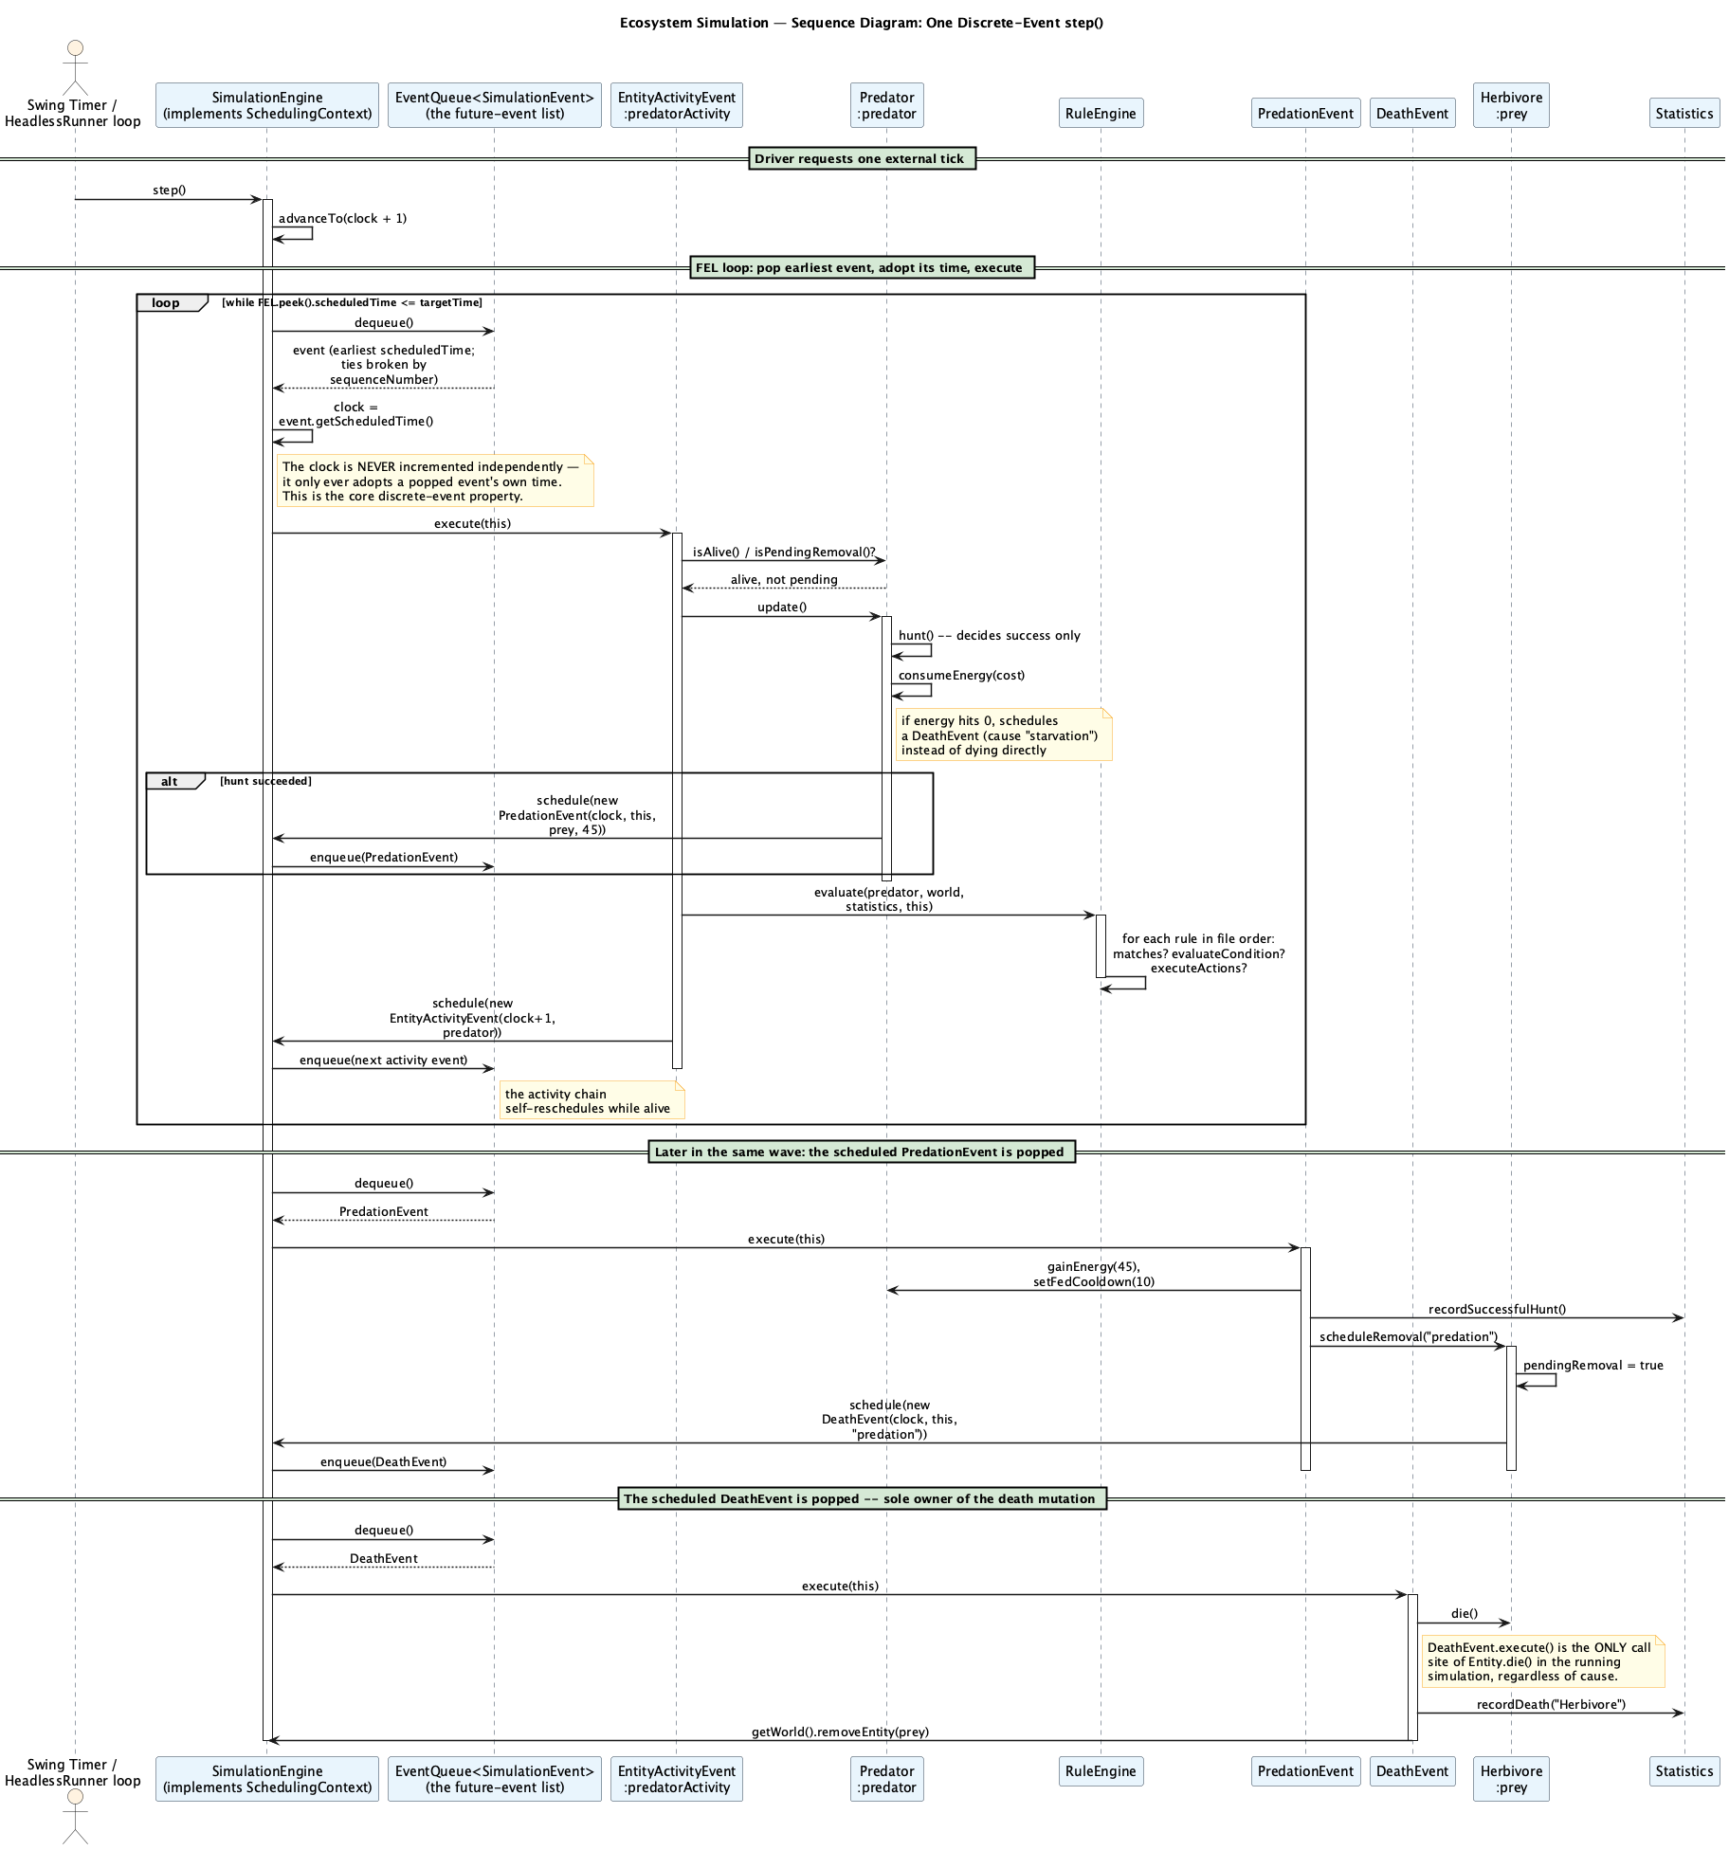
Ecosystem Simulation — Sequence Diagram: One Discrete-Event step()

2.10 Extensions and Customization: the Rule DSL
Beyond simple parameter tuning, the project exposes a small rule language that lets a user compose new ecosystem logic at runtime.
Grammar
rule ::= name "|" targetType "|" condition "|" actionList
condition ::= orExpr
orExpr ::= andExpr ( "OR" andExpr )*
andExpr ::= unary ( "AND" unary )*
unary ::= "NOT" unary | comparison | "(" orExpr ")"
comparison ::= numExpr compareOp numExpr
numExpr ::= term ( ("+"|"-") term )*
term ::= factor ( ("*"|"/") factor )*
factor ::= NUMBER | IDENTIFIER | "-" factor | "(" numExpr ")"
actionList ::= action ( "," action )*
action ::= IDENTIFIER ( mutationOp numExpr )?
Precedence, low to high: OR < AND < NOT < comparison < + - < * /.
Example rules, increasing in complexity
StarvingPredator | Predator | energy < 10 | die
ColdPenalty | Predator | age > 30 AND env.temperature < 10 | energy -= 5
ColdStress | Herbivore | env.temperature < 5 AND energy < 40 | energy -= 8, speed *= 0.8
CrowdedForest | Plant | stat.plantPopulation > 100 OR env.foodLevel < 20 | growthRate *= 0.5
CrowdedForest combines OR, a stat.* reference, and a non-energy attribute mutation; none of these could be expressed at all by the project’s earlier, dropdown-based rule builder.
Runtime semantics
- Evaluated once per entity, inside that entity’s own EntityActivityEvent, right after the entity’s own behavior runs.
- Level-triggered: a rule fires again on the next tick if its condition is still true — there is no per-rule “already fired” state to track.
- Rules fire in file/definition order; actions inside one rule execute left to right, sequentially, so a later action can observe an earlier action’s effect.
- Static rejection versus runtime no-op, one consistent principle: anything detectable without live simulation state (an unknown attribute, a target/command type mismatch, division by a literal zero) is a hard RuleParseException at load time. Anything only discoverable from changing runtime state (a stale scheduled reference, a dynamically-zero divisor) is a graceful, silent no-op, never a crash.
- Numeric safety: all rule arithmetic uses double; a runtime division by a dynamic zero yields NaN/Infinity, which Evaluator treats as a false condition or a skipped mutation, never as state that propagates into an entity.
- Range clamping: every writable attribute (energy, speed, attackPower, defensePower, growthRate) has a registered [min, max] range enforced inside its RuleVocabulary setter, so a repeated speed *= 1.1 cannot grow without bound.
Persistence. config/rules.txt is bootstrapped once from a read-only bundled default (src/main/resources/rules.txt) on first run. RuleRepository.loadActive() validates the entire file before it is allowed to replace the active rule set, so one bad line leaves the previous, still-valid rules untouched. Saving writes to a sibling .tmp file first, then attempts an ATOMIC_MOVE, falling back to a plain REPLACE_EXISTING move. The active file itself is never opened for writing directly, so a failed save can only ever leave an incomplete .tmp behind.
The honest customization boundary. Composing new rule logic from the attributes, operators, and commands already registered in RuleVocabulary needs zero Java changes or recompilation. Exposing a truly new attribute or command, one not already registered, needs one registerReadable/registerWritable/registerCommand call and a recompile. Both statements are true, and neither is hidden anywhere in this report or in the code’s own documentation.
Configuration. config/simulation.properties (the same bootstrap-from-seed pattern as the rule file) controls map size, initial populations, per-species stats, environment settings, and the headless run’s stopping condition — for example:
// SimulationConfig.java
public int worldWidth() { return getInt("world.width", 50); }
public int predatorAttackPower() { return getInt("predator.attackPower", 7); }
public double environmentTemperature() { return getDouble("environment.temperature", 20.0); }
public int maxSteps() { return getInt("simulation.maxSteps", 200); }
Every one of these values flows end to end through EntityFactory (§1.2.5) to both the initial population and every reproduced offspring.

2.11 Extensibility (Open/Closed Principle)
The architecture is designed so that new features can be added without modifying existing, already-tested classes — open for extension, closed for modification.
1. Extensible rule vocabulary. A new rule-language attribute or command needs exactly one call in RuleVocabulary, and nothing else changes:
// RuleVocabulary.java
registerReadable("attackPower", Predator.class, ctx -> ((Predator) ctx.entity()).getAttackPower());
registerWritable("attackPower", Predator.class, (ctx, newValue) ->
((Predator) ctx.entity()).setAttackPower((int) clamp(newValue, 1, 50)));
The RuleVocabularyValidationTest and ParserTest back this up directly: they add coverage against the existing registered vocabulary without ever touching Rule.java, RuleEngine.java, the Lexer, or the Parser, which is proof the extension point is real rather than aspirational.
2. Extensible event system. A new discrete-event type needs only to extend SimulationEvent and implement execute(SchedulingContext); the FEL, EventQueue, and SimulationEngine.advanceTo() require no change, since they interact with every event exclusively through the abstract base type (§2.5.1).
3. Extensible species. A new species extends Organism or Animal, implements Movable/Reproducible as applicable, and is wired through one new EntityFactory.createX(...) method plus matching SimulationConfig keys — the engine, the FEL, and the rule pipeline need no changes, since RuleVocabulary already dispatches by interface/superclass rather than by a hardcoded list of concrete types (§2.7).
4. Extensible GUI surface. Each Swing panel (StatisticsPanel, EventLogPanel, RuleEditorPanel, ActiveRulesPanel) is independent and composed inside MainWindow; a new panel only needs to be added to that composition and, if it needs live updates, registered against SimulationEventListener — the engine itself has no GUI dependency at all (HeadlessRunner proves this by driving the same engine with none of these panels present).
5. Extensible configuration. A new tunable parameter is one new SimulationConfig getter plus one new simulation.properties key, consumed by EntityFactory — no other class needs to change.
6. Dual entry points on one engine. MainWindow (interactive, Swing Timer-driven) and HeadlessRunner (batch, loop-driven) both call step() on the same SimulationEngine through the same SchedulingContext seam. A future third driver — for instance, a batch experiment harness sweeping a configuration parameter — could reuse SimulationEngine completely unmodified.
As a concrete illustration that this extensibility is real rather than aspirational, the diagram below traces Predator.hunt() in full, a substantial piece of species-specific behavior that lives entirely inside Predator, touching the engine only through the narrow SchedulingContext.schedule(...) seam.
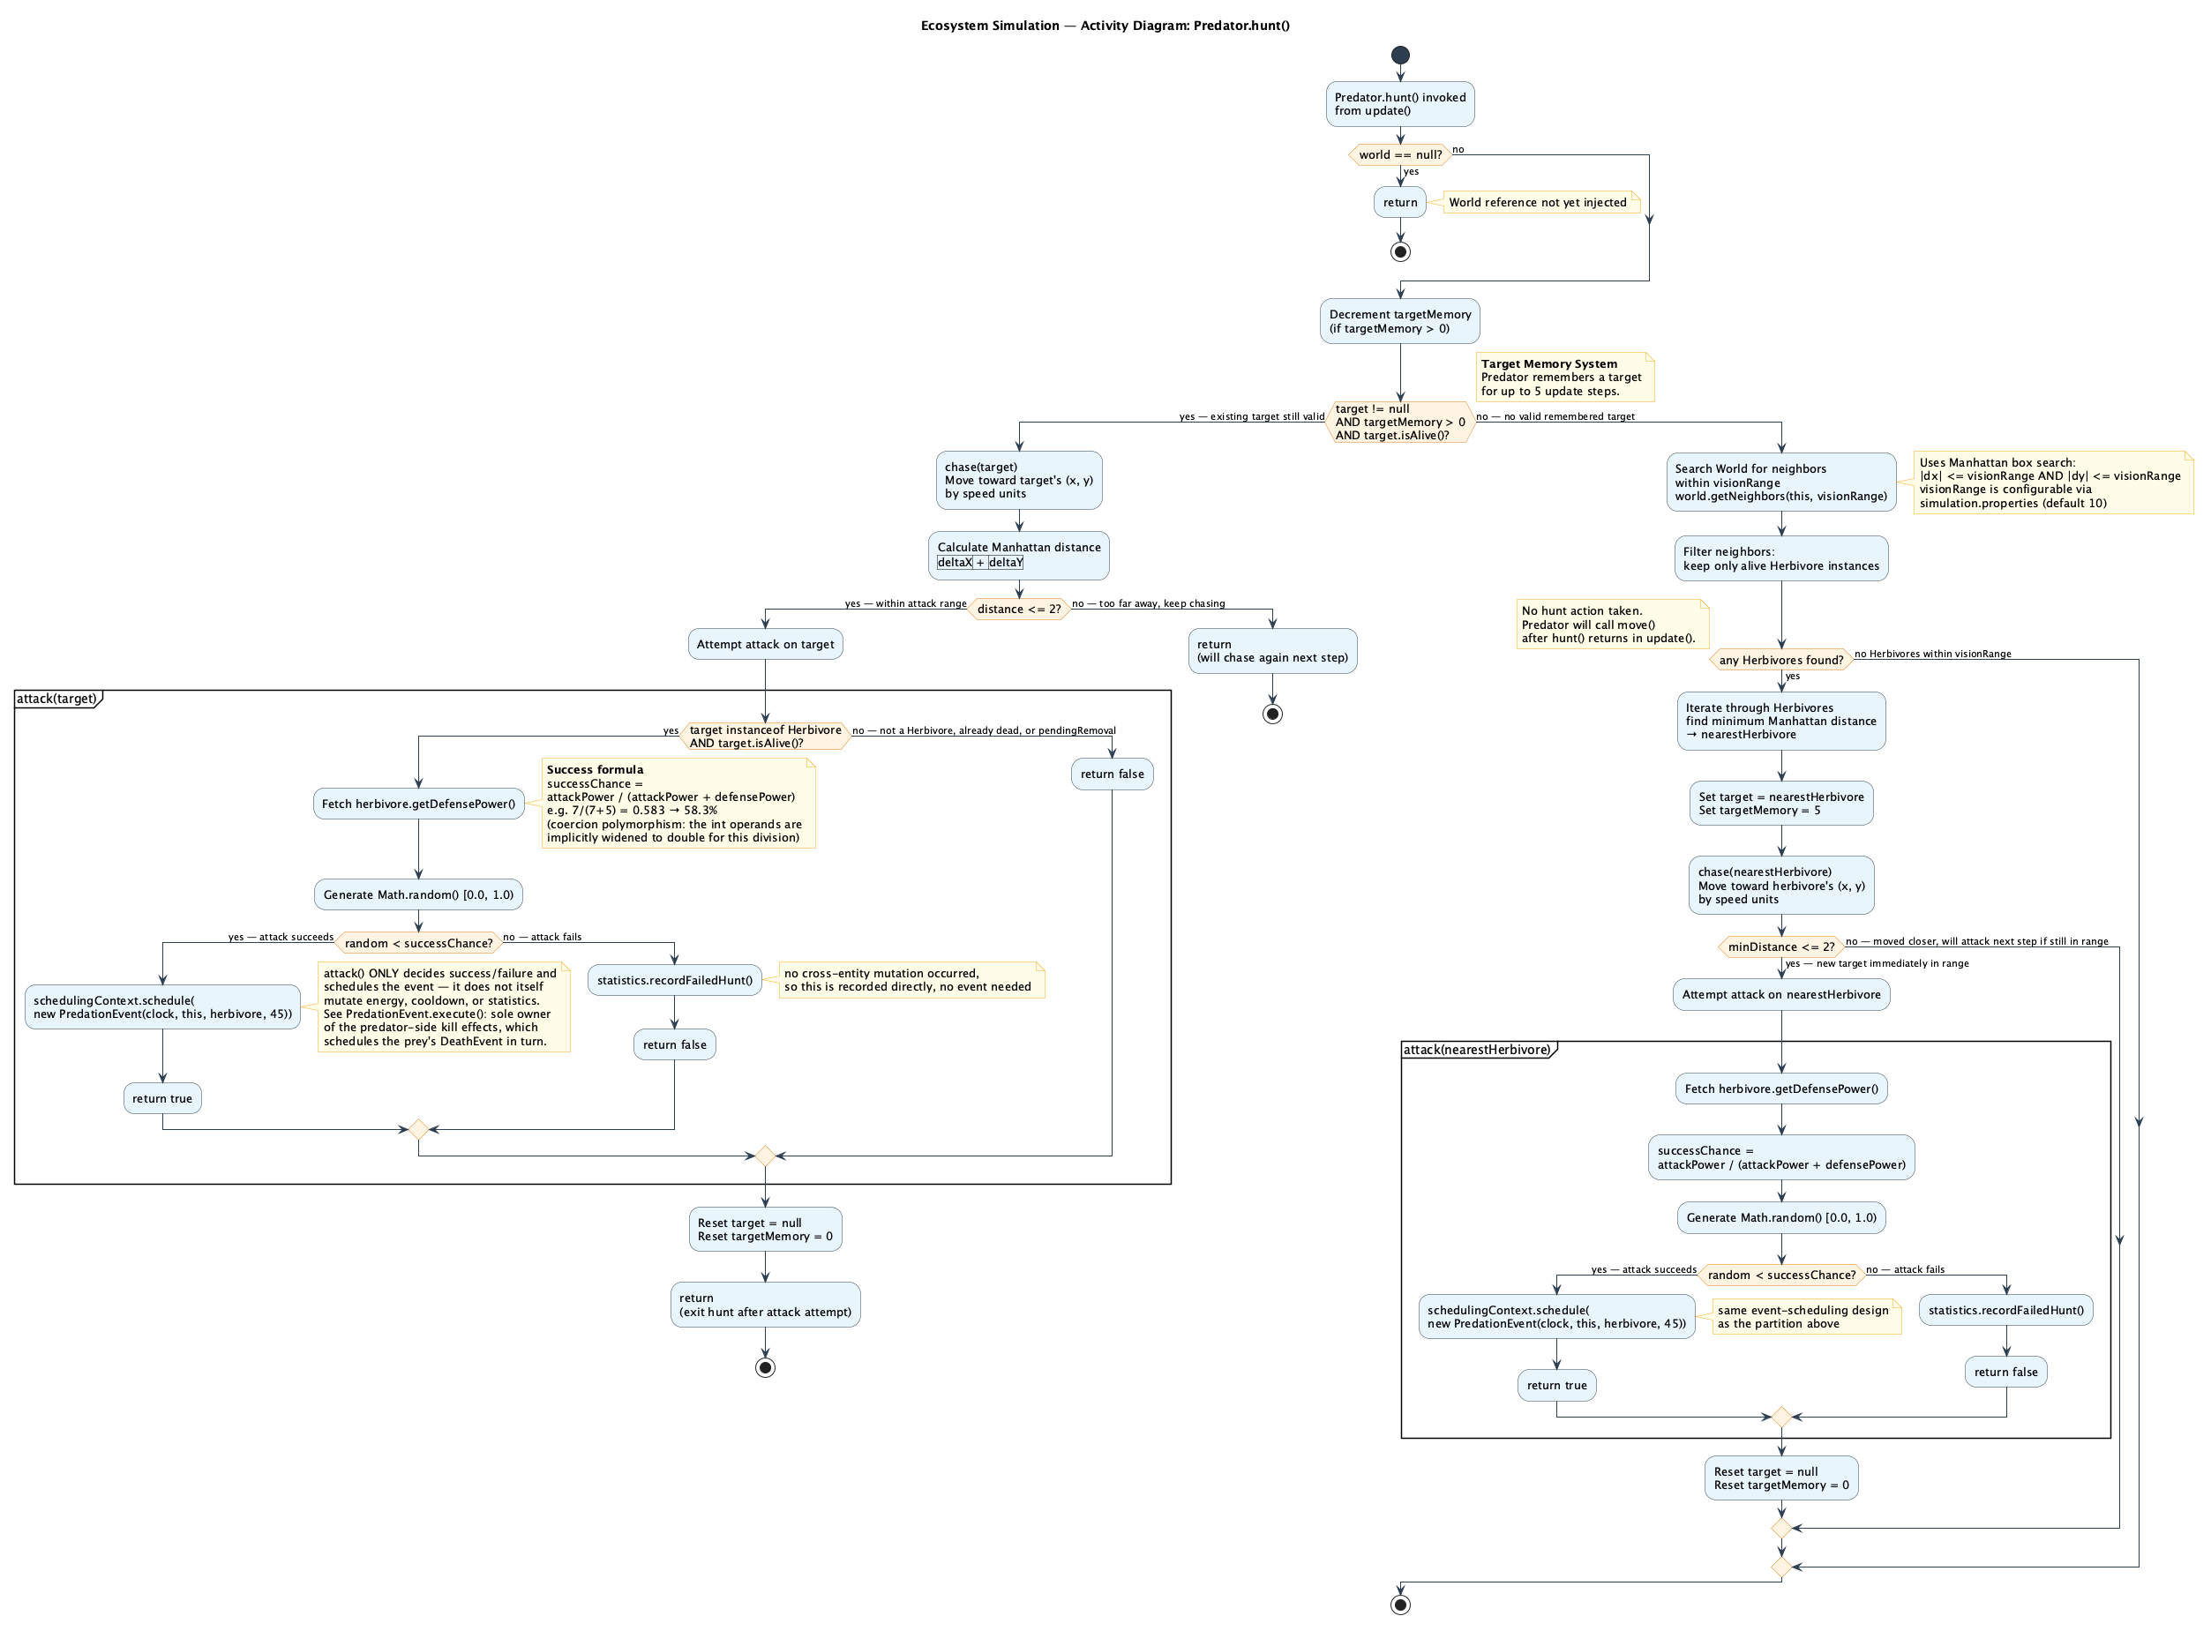
Ecosystem Simulation — Activity Diagram: Predator.hunt()

2.12 Modularity
Definition: Modularity means constructing software as an assembly of small, independent pieces, each responsible for one task and encompassing exactly the data and operations that task needs. In object-oriented design the module is the class, rather than the file, which is the module boundary in non-OO design.
Code Snippet — package structure
com.ecosystem.simulation
├── entities/ Entity hierarchy, EntityFactory, Movable/Reproducible
├── events/ SimulationEvent hierarchy, EventQueue, SchedulingContext
├── rules/ Rule DSL: Lexer, Parser, AST, RuleVocabulary, Evaluator
├── simulation/ SimulationEngine, World, SimulationConfig
├── statistics/ Statistics
└── gui/ MainWindow and every Swing panel
Description
Each package owns one concern and depends on the others only through narrow, explicit seams: entities never imports from gui; rules knows about entities only through the small Movable/Reproducible interfaces and the Entity base type, never through any concrete species. RuleVocabulary is the sharpest example inside a single class: every rule-language attribute and command is registered in exactly one place (§2.11), so a module that wants to add a capability edits one file, not several.
Motivation
Modular software is maintainable software, precisely because a change stays local: adding defensePower to the rule vocabulary touched only RuleVocabulary.java, never Lexer, Parser, Rule, or RuleEngine (§2.11 shows the test proof). Modularity is not, however, perfectly achieved everywhere in this project, and it is worth being honest about the one place it still slips: the set of concrete species (Predator, Herbivore, Plant) is independently spelled out in two places rather than one — Statistics’s private adjustSpeciesCounter helper and EntityFactory.createOffspringNear’s instanceof chain. This is narrower than it used to be: recordBirth and recordDeath each used to repeat their own three-case switch over the species name; both were rewritten to share one adjustSpeciesCounter switch instead, closing the duplication within Statistics. The remaining duplication, against EntityFactory, is left as a deliberate tradeoff rather than an oversight: removing it too would mean introducing a species-registry abstraction (entities registering their own constructor under a name, looked up generically) solely to delete one small instanceof chain — trading a few lines of duplicated but obvious knowledge for a more generic mechanism that is harder for a reader new to the codebase to follow. A fourth species would still require updating both remaining locations; that stays a known, stated limitation rather than a silently accepted one.

2.13 Hierarchy
Definition: Hierarchy is the organization of related concepts into classes arranged by specialization — deciding not just that two things are related, but which one is the more general case and which is the more specific one, and how many levels of specialization the domain actually needs.
Code Snippet
Entity (abstract)
└─ Organism (abstract) adds energy, age, maxEnergy
├─ Animal (abstract) adds speed, visionRange; implements Movable
│ ├─ Predator adds attackPower; implements Reproducible
│ └─ Herbivore adds defensePower; implements Reproducible
└─ Plant adds growthRate; implements Reproducible
Description
This is deliberately a strict tree, four levels deep, not a tangle: every class has exactly one superclass, and each level exists because it is the most general point at which some state or behavior is true for everything below it and nothing above it (age/energy sit at Organism, because a Plant ages and consumes energy just as an Animal does, but an abstract Entity in general does not have to; speed/visionRange sit at Animal, because a Plant has neither). §2.3 (Inheritance) covers the mechanism that makes this reuse work (extends); this section is about the shape of the tree itself — where each concept was deliberately placed, and why.
Motivation
The hierarchy is not just documentation — code depends on its exact shape. RuleVocabulary.requireReadable/requireWritable/requireCommand (§2.10, §2.11) validate a rule by walking this same tree with Class.isAssignableFrom, so a rule targeting Organism is automatically valid for every level below it without RuleVocabulary ever naming Predator, Herbivore, or Plant directly. Getting the hierarchy’s shape wrong — for instance placing Plant under Animal — would not just be a modeling mistake; it would make an invalid rule (Plant | move) pass validation, because the vocabulary trusts the hierarchy to tell the truth about what each type actually is.

2.14 Reuse
Definition: Reuse is applying existing, already-debugged code to a new need instead of writing it again. This project uses both mechanisms taught for it: class inheritance (a subclass reuses a superclass’s internals directly) and object composition (an object reuses another object’s behavior by holding a reference to it and calling its public methods).
Code Snippet
// Inheritance-based reuse: Predator and Herbivore both reuse
// Organism's energy/age management and Animal's movement state
// without re-implementing either.
public abstract class Animal extends Organism implements Movable { ... }
public class Predator extends Animal implements Reproducible { ... }
public class Herbivore extends Animal implements Reproducible { ... }
// Composition-based reuse: SimulationEngine reuses World, Statistics,
// EntityFactory, and RuleEngine as complete, independent collaborators.
private final World world;
private final Statistics statistics;
private final EntityFactory entityFactory;
private final RuleEngine ruleEngine;
Description
The two mechanisms are used for different reasons, matching the distinction the course draws between them. Inheritance is used where the relationship is genuinely “is-a” and the reuse is of internal state a subclass needs direct access to through its own accessors (a Predator really is an Organism with energy and age). Composition is used everywhere the relationship is “has-a” and reuse only needs the public behavior of the reused part — SimulationEngine reuses EntityFactory’s ability to build entities without needing, or being allowed, to reach into how EntityFactory does it.
Motivation
EntityFactory itself is a concrete instance of reuse paying off end to end (§1.2.5): before it existed, the same species-default construction logic was duplicated once for the initial population and again inside each species’ own reproduce() method, so a config change in one place silently failed to reach the other. Routing both the initial population and every reproduced offspring through the same EntityFactory.createPredator/createHerbivore/createPlant methods turned that duplication into a single reused implementation — exactly the maintainability benefit reuse is supposed to deliver, not just a definition satisfied on paper.

3. Testing
The project carries 107 automated tests across 13 test classes (unit and integration), covering: lexer tokenization; parser precedence, parentheses, and unary-minus handling; valid and invalid rule parsing; static target-type validation; writable-attribute range clamping; NaN/Infinity handling in rule arithmetic; external rule-file load/save/rollback with the atomic-move fallback; deterministic FEL ordering and sequence-number tie-breaking; lazy invalidation; duplicate-death prevention; offspring and activity-event scheduling; DES clock progression (adopting event time, never self-incrementing); rule evaluation happening inside activity events; a compound temperature rule’s measurable population effect; configuration propagation end to end, including to reproduced offspring; and full engine integration.

4. Known Limitations
Stated explicitly, since an oral examiner is likely to probe exactly these boundaries:
- Time is integer-tick-valued, and in this particular ecosystem model every entity needs an activity roughly every tick, so the simulation’s visible cadence resembles a fixed time-step. The load-bearing, architectural property is that the clock is FEL-driven (it always adopts a popped event’s own time) and that state only ever changes inside execute(), not that inter-event gaps happen to be large in this specific model.
- The rule DSL is intentionally not Turing-complete: no loops, no user-defined functions, no recursion. This is closed at the type level by the sealed AST, not just by convention.
- Math.random() is used directly rather than a shared, seeded Random, so exact run-to-run reproduction is not guaranteed; tests that depend on simulation outcomes use batch-averaged or structurally deterministic assertions instead of exact single-run values.
- Reproduced offspring use configured species defaults, not inherited/varied traits from the parent — no genetic algorithm or evolutionary pressure is modeled.

5. Conclusion
The project’s two central requirements, a structurally sound discrete-event engine and a real, runtime rule-authoring system, are both satisfied by mechanism, not by naming: the simulation clock only ever advances by adopting a popped event’s own scheduled time, and a user can compose new ecosystem behavior, including logic no earlier version of the project could express (CrowdedForest’s OR and stat.* reference, for example), without recompiling anything. Every required OOP principle is demonstrated by code the system actually depends on to function correctly, and the boundaries of the design, where it does not claim more than it delivers, are stated openly in Sections 2.10 and 4 rather than left for an examiner to discover.

