 | 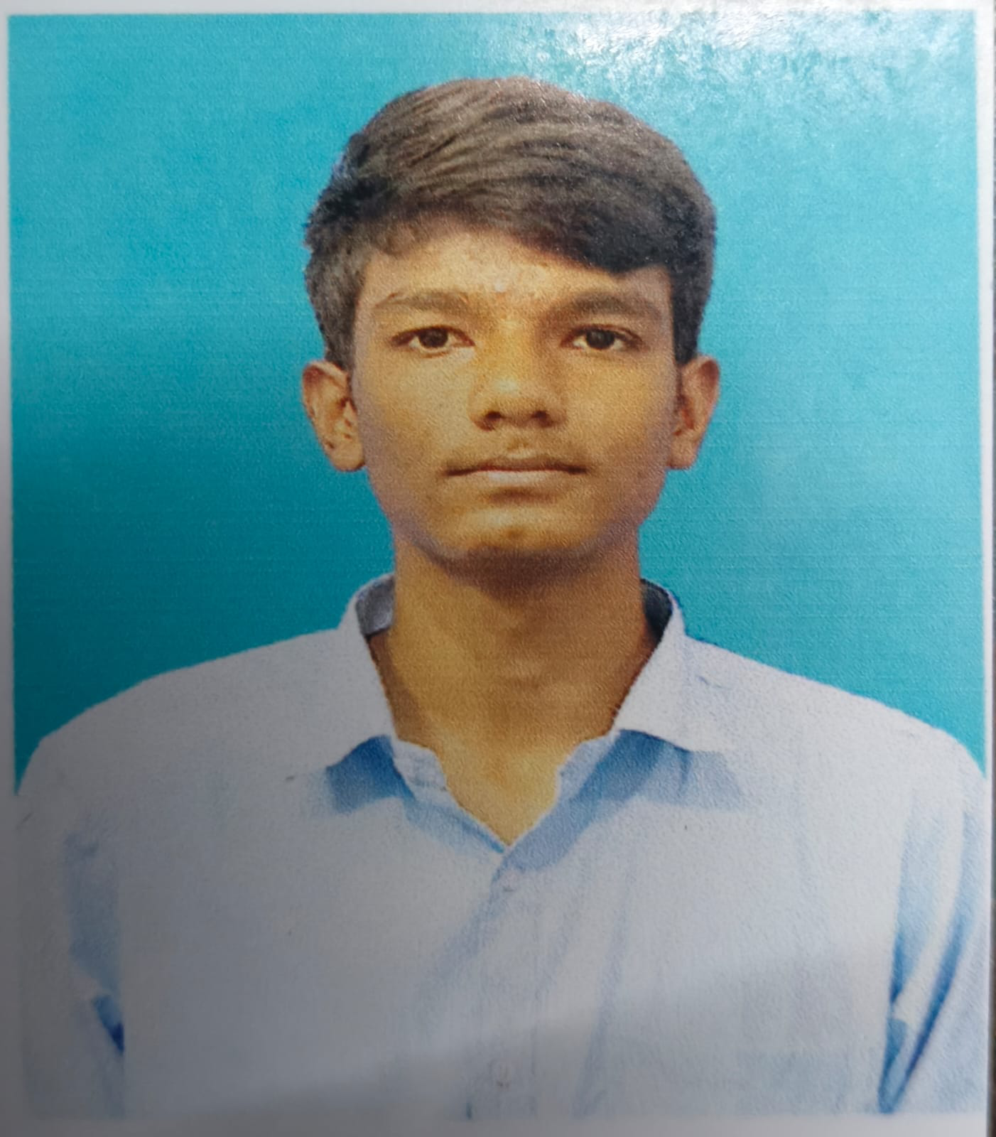
Candidate Information
Salutation | Mr. | Full Name | MUHAMMAD ASFAR T s
Candidate ID | SIC37756 | Email | asfar8667@gmail.com
Mobile Number | +918667376649 | Training Centre | Jamal Mohamed College
Course | Artificial Intelligence | Date of Birth | 2006-06-21
Age | 20 | Proof Of Identity | Aadhaar
Aadhaar Number | 254858958624 | Gender | Male
Father's Name | Syed musthafa t m | Mother's Name | Rasiya begam s r
Category | OBC | Highest Qualification | BCA
Specialization | BCA in Computer Science | Highest Qualification | BCA
Address Information
Address | Khajamian Hostel, Tiruchirappalli

Current Address
Is your current address same as | Yes
permanent address?
Career Goal Section
Explain what you would like to | Experience machine learning | How did you find out about SIC? | School/University
achieve through SIC? | tools and real-world problem | How did you find out about SIC? | School/University
solving with exciting curriculum

