Computational representation of social complexity for decision making: the case of climate change, migration, and social conflict

Jose Manuel Magallanes

Instituto de Anal´ıtica Social e Inteligencia Estrat´egica (PULSO PUCP) Pontificia Universidad Cat´olica del Peru´ - PUCP

Abstract

This chapter illustates how computer simulations can help us foresee critical situations in populations where climate change may cause wa- ter scarcity. In particular, we exemplify a city in the central Andes of Peru whose conditions related to deglatiation, urbanization, and pop- ulation growth, may bring water scarcity. The main technique used is agent-based modeling, which will combine quantitative and qualita- tive information. The results show possible scenarios of water scarcity leading to drastic migration and social conflict, a situation not yet evi- dent as a public problem. This work provides recommendations for this likely and undesired scenario.

*Keywords:* Social complexity, agent-based modeling

# Introduction

Social problems are mainly complex. That is, combine environmental, tech- nological, psychological, social, political, and cultural issues. This complicates policy and political decision making as one branch alone of the government can not solve public problems effectively, but involving several branches and multilevel decision makers will not make the discussion more efficient.

This chapter presents social simulations via agent-based modeling (ABM). As Macy and Willer (2002) propose, ABMs will allow the social scientists to change their modeling efforts to represent societies as interactions among variables into a different paradigm where social life can finally be represented as interactions among adaptive agents who influence one another in response to the influence they receive.

Jos´e Manuel Magallanes [](https://orcid.org/0000-0002-2593-0859) <https://orcid.org/0000-0002-2593-0859>

Correspondence concerning this article should be addressed to Jos´e Manuel Magallanes, PhD., Professor at Depart- mento de Ciencias Sociales, and Director of PULSO-PUCP, Pontificia Universidad Cat´olica del Peru´, Av. Universitaria 1801, San Miguel - Lima, Peru´. E-mail: [jmagallanes@pucp.edu.pe](mailto:jmagallanes@pucp.edu.pe)

This chapter exemplifies the use of ABMS to understand the interaction of climate change and population growth in a small-sized city. The ABM will allow us to envision possible futures as climate change trends affect water availability, the growth of the population urbanizes neighboring rural areas, and people need to decide in the future whether to stay or leave.

Water scarcity and droughts have an slow onset (Singh et al., 2021), so as time passes by, the majority of urban and rural settlers do not pay much attention to this issue. However, if we look into the future the absence of water may affect the decision of settlers in the urban and rural areas in different ways that need a preliminary answer:

* Is it possible that drastic migration patterns appear as people do not find water?
* Is it possible the emergence of social conflict in the area among the people that can not migrate and find themselves in a place with no water?

The purpose of an ABM is to serve as an input for anticipatory and participa- tory political decisions (D’Aquino et al., 2002). The presence of different actors with different goals and beliefs under stress due to the environmental conditions makes it challenging for mainstream modeling techniques based on variables are limited to provide the right guidance, so this work hopes to contribute methodologically in the coming discussion of the future of this city. There are certainly many computational modeling approaches—e.g. system dynamics or discrete systems simulations—that deal with organizational complexity. However, key concepts such as learning and emergence can only be modeled, arguably, through the use of ABMs (). As with all modeling techniques, ABMs need to capture the most basic variables and processes that could explain a particular phenomenon, while making all building assumptions explicit and transparent, and producing outcomes valid and of interest to the scientific and policy community. In contrast to other techniques, ABMs are virtual laboratories that allow their components to have different behaviors, reactions, and to be aware of only limited information. In particular, ABMs are useful in the social sciences when a particular social theory can be enacted through coding. You all can then see how the model behaves as the building parameters of the theory are manipulated (). Besides, ABM allows for the inclusion of complementary theories and models to carefully enrich the original theory, allowing the creation of different scenarios.

Climate change is a major social concern that needs profound reflection for

the future of humanity; particularly if it affects the availability of water (Robinson & Klobucista, 2023). But even if climate change were not a concern, population and city growth by themselves will challenge the best efforts in water management (Alfarra & Turton, 2018).

The application presented is based on the area that depend on the water from the Shullcas River in the central Andes of Peru. The Shullcas river is a proglacial river originated from the meltings of the Huaytallana tropical glacier, a the kind of

glacier more likely to disappear if global warming trends are unaltered (Willige, 2023). The area includes rural and urban settlers that make exclusive use of the water from that river. The area has a positive population growth, with a marked tendency to urbanize the rural area located on the Huaytapallana’s foot and skirt. Given this context, this example serves the current studies on computational representation of social complexity:

* First, the object of study is not one particular kind of population (as it is the case in most studies) but it studies simultaneously vulnerable but not marginal rural populations, and an urban population of the close metropolitan area; so the water issues will be of concern to two different kind of groups with different necessities on water, which may be the starting point for inter group conflict (Bar-Tal, 2011).
* Second, this ABM will include the effect of a glacier in the water supply for the social system, facilitating the analysis of similar systems by separating the precipitation (rainfall and snow melt).
* Third, the watershed under analysis may be a representative case for the whole Andes chain, as it is at the center, among the dry biggest cities on the west and the sparsely inhabited Amazon jungle to the east.
* Fourth, it integrates and harmonize current modeling efforts on the glacier melt- ing trend, the hydrology dynamics and the social behavior; making our work more challenging as these systems have never been integrated before bringing into question the validity of our results.
* Finally, and related to the previous point, the issue is not of particular concern neither to the majority of the population nor to the political authorities; it looks as though nobody wants to touch the situation as it may collide with the current way people live and benefit. This work also continued with the best practices in computational social science (CSS) research used by the previous studies, as it integrated the complex adaptive systems approach (Miller & Page, 2007), the CSS consolidated techniques (Cioffi-Revilla, 2014), and ethnographic work (Crate & Nuttall, 2009).

# Literature Review

Research interests dealing with modeling climate change are varied, but they tend to have a common interest in rural populations, especially vulnerable and located in developing countries. Ziervogel et al. (2005) focuses on modeling decision-making and forecasting of farmers in Lesotho, in an scenario where official forecasts, besides poorly done, are not diligently nor appropriately disseminated towards these end- users, making them more vulnerable as loses due to poor information endanger the

farmers’ survival. A similar research is found in Bharwani et al. (Bharwani et al., 2005) for smallholder farmers in a village in Vhembe district, Limpopo Province, South Africa.

Modeling using ABMs more comprehensive approaches are found in Kniveton et al. (Kniveton et al., 2011) and Hailegiorgis (Hailegiorgis, 2013). The former has Burkina Fasso as its case study, investigating the role of the environment in the de- cision to migrate using scenarios of future demographic, economic, social, political, and climate change in a dry land context. In that work, it is found that change to a drier environment produces the largest total and international migration fluxes when combined with changes to inclusive and connected social and political governance, while the lowest international migration flows are produced under a wetter climate with exclusive and diverse governance scenarios. And the latter focuses on the South Omo zone in southern Ethiopia, modeling how the current surge in large-scale land acquisition might affect rural livelihood. In this work, Hailegiorgis found that (i) the occurrence of drought affects their adaptive capacity and forces migration; (ii) increasing the magnitude of expansion of large-scale land acquisition aggravate dis- possession and increase migration of rural households; and (iii) capacity building and relief support in the time of extreme events minimizes migration.

As it is clear so far, climate change stresses the place where human activities are carried out, thus deteriorating the quality of the environment of these populations forcing them to make different decisions, which, as Hirschmann proposes (Hirschman, 1970), can be categorized as *e*xit, *v* oice and *l* oyalty. The previous cases speak of exit, as people emigrate looking for better conditions as the climate threatens their well-being; but, the confrontational and loyalty dimensions in social complexity is- sues also need to be analyzed under climate change effects. However, loyalty and voice seem to be less treated from the global computational social science commu- nity, which should be considered quite shocking as reports related to climate change and conflicts are abundant (). Related to conflict and climate change, Piontek (Pi- ontek, 2010) studies the Nile River, which serves 10 countries in Africa, seeking to understand, via computational modeling, how the interaction between humans and the environment may lead to conflict or cooperation. In this work, the author found that climate change can alter conditions for conflict and cooperation, but it might not the immediate cause for those issues. Nevertheless, the most outstanding work related to climate change and the emergence of conflicts can be found in the works produced at the Center for Social Complexity at George Mason University’ projects funded by the Multidisciplinary University Research Initiative (MURI) and Cyber- Enabled Discovery and Innovation (CDI) programs (). They focuse on the complex interaction of pastoral groups with their environment and other emerging external actors in east Africa finding that increased seasonal rainfall variability and droughts create tremendous stress on pastoral groups and challenges their long-term resilience and adaptive response mechanisms, thus concluding the population’s relation to the carrying capacity seems to be the major factor affecting cooperation and conflict

# Methodology

This ABMS is very abstract. It is built to capture the relationships that answer our questions and be useful for policy discussion. Thus, we have two sytems, the social and the natural one. The systems interact and the ABM will see if migration and conflict become more likely as time goes by. This is represented in Figure 1.

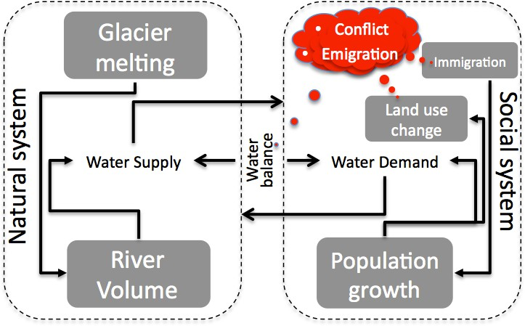

# Figure 1

*Basic model abstraction. The red elements represent the potential outcomes if the other elements keep the current trends*

As it can be seen in Figure 1, the natural system focuses on the water supply, as it is the key trigger factor for the social issues of interest in this chapter. The current studies of the area propose both a decreasing supply of rainfall, and forecast the complete retreat of the glacier, which will affect the balance negatively (). One obstacle for a more precise model is the lack of information on the snow melt supply; however, this value was bounded based on expert opinions1. On the other hand, water demand comes from the social system, which is represented by two subsystems, rural and urban. The basic process in both sub systems is population growth2, that is, eventually there will be not enough water supply for the population’s demand. We explore emigration as a particular response (other responses have not been considered at all): there are not many Andean cities having positive population growth but the area under study is one of them, so making a case for the opposite phenomenon is politically important. Other demographic information is fed into the model (working, educational and marital status).

1I thank Bryan Mark from Ohio State University for his input on this.

2The population growth parameter was simply computed from the census data available since 1981 at the Peruvian National Institute of Statistics (INEI) website.

# Hypothesis Operationalization

As this work proposes that the research questions have affirmative answers, we propose the following operationalization of variables in the hypothesis, as described in Figure 2:

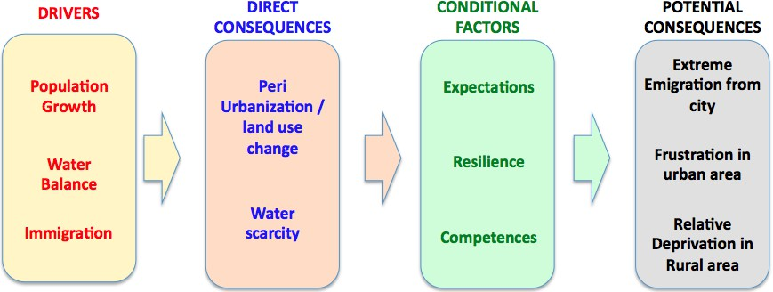

# Figure 2

*Operational Variables in Hypothesis*

The variables present a simple yet comprehensive process to study the potential for conflict and migration:

* The **potential outcomes** are chosen as the representation of our framework *exit, voice and loyalty* (Hirschman, 1970). In this case, *exit* is represented by **drastic migration**; *loyalty* by the permanence in the ara (not shown); and *voice* by expected reaction from the **frustration** felt by urban people, or the **relative deprivation** felt by rural people .
* The **drivers** clearly represent the current trends in the area, bith in the social and natural dimensions. These trends are not altered in the ABM. The assumption that the trends can be extended into the future are based on the historical population growth and immigration. The water balance trend represents the other important driver, which will be represented by water supply and demand. Water supply will be based on the contribution of the glacier Huaytapallana.
* The **direct consequences** are the clear results of the unaltered trends.The ABM includes the two most clear direct consequences supported by the literature and field work (). Water scarcity is a first expected outcome as the water balance and population growth trends remain unaltered. Water scarcity will become a major problem (as explained in (Carlos & Grijalva, 2012) and detailed in the next chapter) in the near future, which will combine with population growth and, particularly, immigration to exacerbate peri urbanization and land use change ().
* The **conditional factors** are processes that work at the individual level, and are the main sources of heterogeneity in the model. Every individual will need to find an particular response based on these factors. The factors have been se- lected from the classical work of Maslow (Maslow & Frager, 1987), and its appli- cation in agent based modeling to understand conflictive situations (Watkins et al., 2008). According to this individual level factors, we implemented a Bayesian mechanism to compute expectations, we carried out field work to uncover the local resilience, and made use of the census data to derive the competences of each individual. The competences reflect closely what determines the poten- tial outcomes (Watkins et al., 2008), that is, of water (physiological needs), work (safety needs), family (belonging needs) and education (for esteem and self-realization needs).

# Field work

We decided to organize an ad-hoc collection of information in situ as the ABM required some information for the agents not available neither on the literature nor the data. We needed to have a clearer idea on how the agents will react as water will become scarce in the rural and urban area. For that reason, we organized two research expeditions: One on the urban area and another in the rural area; Figure 3 show the area of study and the area cover for each expedition.

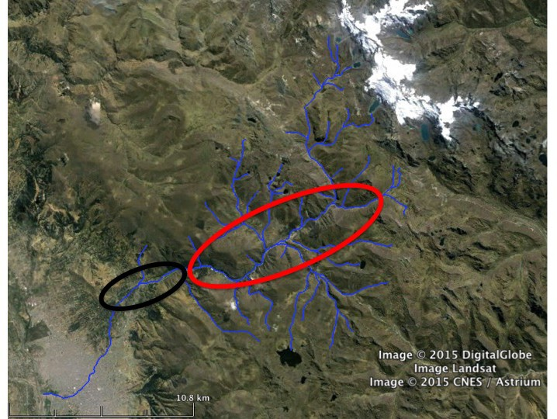

# Figure 3

*Map of Field work. The black oval is the area covered by the urban expedition and the red oval the area covered by the rural expedition*

The rural area has the longest extension of land, but is also the less populated. The team made unstructured interviews with the goal of this expedition was to find out about: (i) the awareness of the water scarcity in the future; (ii) their need to migrate in case water scarcity reached unbearable leves; (iii) the possibility of taking some political action. The main findings were (i) person after person affirmed that drastic migration is not an option for the rural; (ii) the increasing presence of im- migrants urbanizing the rural area represented an unappealing fact. The study also confirmed people were very aware of the progressive lack of water, but they believe this issue will be of more concern in the urban area. A couple of additional important facts were unveiled. First, they are sure that the urban needs of water will collide with the rural needs. They are not sure how much water will the growing city may need in the future. They are not confident local authorities will consider their opinion if the city needs more water. Second, they believe this generation of rural people will do their best effort to make a living in the rural area; but they are not very sure what would be the reaction of the future generations. They consider that the jungle represent an attractive destination for young unemployed people, but are afraid the attraction comes from easy-money and illegal activities.

The periurban expedition visited 65 families living in limit between the city and the rural area. A survey was designed and applied. The team designed a polietapic sampling design to include a representative sample of households of migranst and non-migrants in the urban settlements located along the peri urban area. The goal of this expedition was the same to the previous one. The information collected in the periurban area informed: (i) urban people have migration among their alternatives in case of lack of water; (ii) the urban settlers will look for a place nearby to move in (they may need to get land closer to the rural area). It is worth noticing that all who said they would never migrate are immigrants; (iii) all believe that they will feel frustrated if they have to stay in place with water scarcity. This expeditiom found that people in the periurban area did not start living in that zone but renting a place downtown, which was expensive, smaller and overcrowded, and, progressively, they moved (renting or buying) into the peri urban area as it represented a cheaper place to live. The strategy they followed to find a better place was a system of references, where family and friends were sharing their experience living outside the city center, even with lack of public utilities in the beginning. In case of searching for water, they say they will follow the same strategy (referencing system from relatives).

# Modeling building

The ABM simulates 50 years. Every time a complete cycle of the simulation is run, the history advances six months. So, this model will only run for 100 cycles. As each cycle represents six months, a cycle represents a season, which is either the *dry season* (that goes from May to September) or the *rainy season* (that goes from October to April). Figure 4 reflects the flow of the code each cycle or season, a figure that also represents the translation of the concepts represented in the scheme 1 on

page 5 into computer logic.

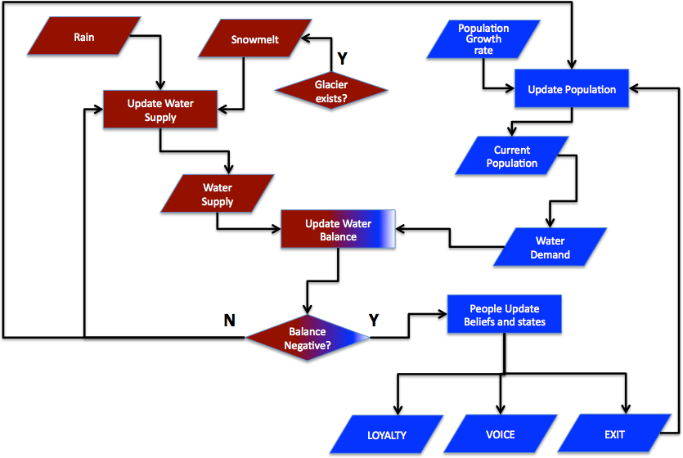

# Figure 4

*Process Overview. Color differentiates type of system (blue for* Social *and red for*

Natural*. A pass through this chart represents a six month* season*.*

Figure 5 is a flowchart representing the decision making of a rural agent. As it is shown in that figure, the decision flow starts when the agent detects scarcity. That detection is a particular computation following a Bayesian approach, which was the assumed as the mechanism to update beliefs. Once the agent detects scarcity, he will look for a place to move. As long as the agent detects scarcity where the agent is staying, the agent will move. The moving will end when the agent reaches the resilience limit. If the rural agent can migrate, the rural agent will migrate to the urban area. Agents that could not migrate are candidates to feel relatively deprived. Figure 6 is a flowchart representing the decision making of an urban agent.

Similar to the previous figure, the decision flow starts when the agent detects scarcity following a Bayesian approach. Once the agent detects scarcity, he will look for a place to move. As long as the agent detects scarcity where the agent is staying, the agent will move. The moving will end when the agent reaches the resilience limit. If the urban agent can migrate, the urban agent will migrate to the coast or the jungle, depending on the agent’s characteristics (employed, educated, marital status). Agents that could not migrate are candidates to feel frustrated. Once the agent is frustrated, the agent will try to connect to other agents in the same situation. These connections make a social network of frustrated or angry agents. A link is destroyed when a member of the network of frustrated agents migrates.

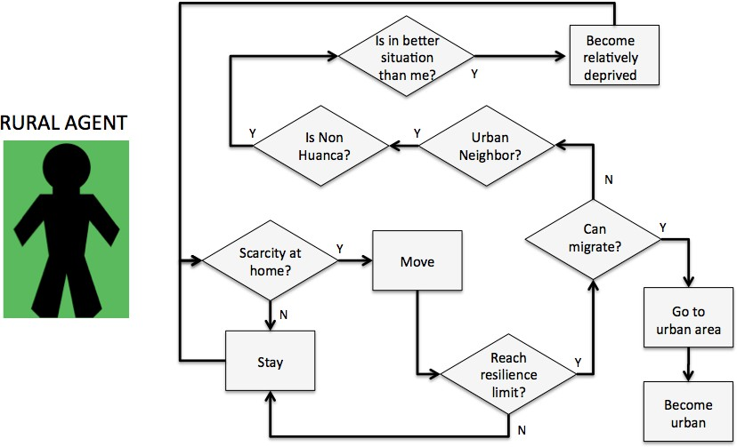

# Figure 5

*Decision making - rural agents*

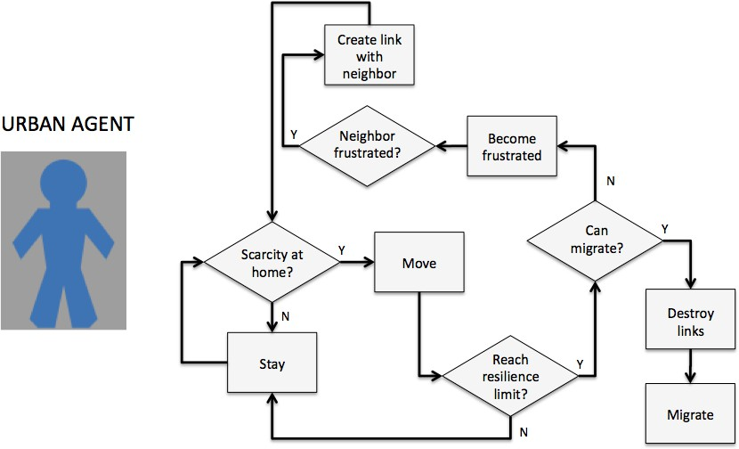

# Figure 6

*Decision making - urban agents*

# Analysis of Results

Rose (Rose, 1993) believes anticipation allows policymakers to forgo the nec- essary rigors of empirical evidence, as anticipation is not a scientific endeavor but in fact a *political tool* that can be used when facing uncertainty and novelty. This ABM results may halp anticipate a critical situation:

* **Take one**. The model has been verified and validated. All the population is situated in the *year zero* and the model is ready to run (after last census in 2017). The population count reflects a proportion of actual population. The areas are also proportional. The Glacier Huaytapallana area in in the year zero is represented by the zone in white, the rural settlers inhabit the green area and the urban agents are in the gray area. The water balance is not an issue yet, the water supply is enough for the population water needs. See Figure 7 (a).
* **Take two**. As time passes by, the glacier keeps melting following the identified trend. The pink patches near the white patches represent the zone retreated. Even though there are no water issues in this moment, people started slowly moving away from the more densely populated area (left gray area) into the periurban area. The main driving force for this is the population growth. See Figure 7 (b).
* **Take three**. The glacier has retreated almost completely, and the water balance for the urban area is now negative. The pink patches in the urban area are affected by the drought during the *dry season*. The drought is felt progressively from the highest risk zones (leftmost gray zone). If an agent is living in a patch that suffers drought, he may need to move away, depending on his beliefs of future scarcity. There are some urban agents that could not migrate when their resilience was reached. They are already organizing into a network. The peri urbanization process continues but no rural is feeling relatively deprived yet. See Figure 7 (c).
* **Take four**. The Huaytapallana has melted completely. This has made the situation even worse during the dry season. Urbans are populating more the periurban area, and the increasing presence of immigrants has started making rurals feel relatively deprived. The rural agents with a bigger size represent those rural agents. Even though the migration into the coast or the jungle has been massive, there are still many people feeling frustrated living in the area. Not every frustrated urbanite is connected to one another, but there are many network components and cliques every where in the city. The simulation is about to finish after representing 50 years. The potential for conflict and migration turn into a fact in the model. See Figure 7 (d).

Let’s try some answers to our initial questions.

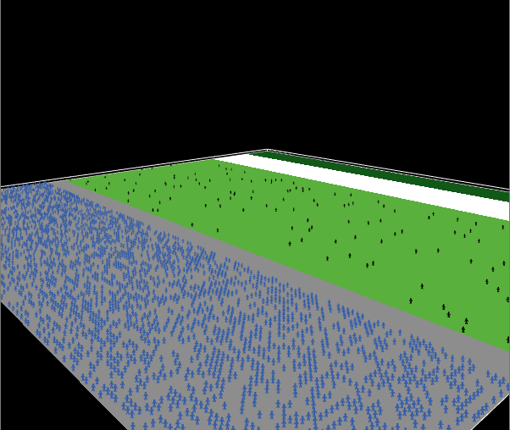 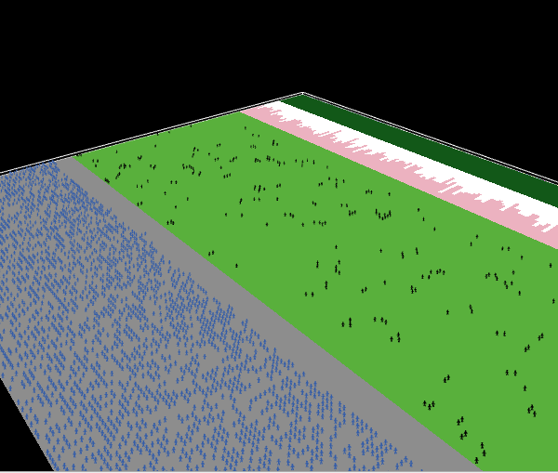

(a) (b)

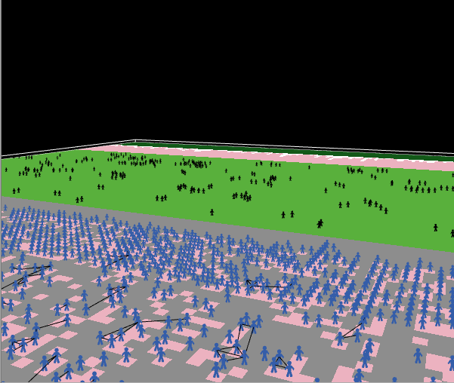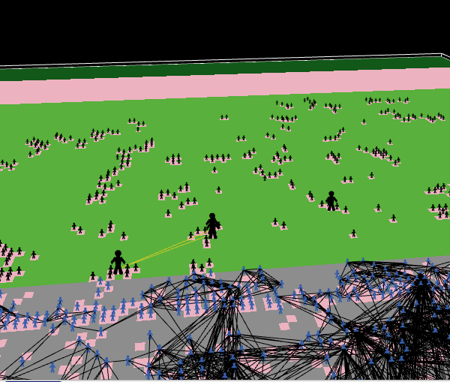

# Figure 7

(c) (d)

*(a) Take one (b) Take two (c) Take three (d) Take four*

# Is drastic migration possible?

Related to migration, Table 1 informs the final values obtained. There, one can see that, even though it is possible for rurals to migrate, the balance of water in the urban area the next years would not be an issue, so even though migration is allowed for rurals in the code, no immigration took place. Migration started at period 54 (year 27) and the most dramatic migration happened in moment 64, 10 periods later (year 32). If the demographic conditions held true, the migration to the jungle would be the most alarming.

# Is social conflict possible?

The Table 2 informs that the simulation ended with a immigrant population representing 72% of the total population, that is, after 100 periods (50 years), the immigrant population share doubled. It is also clear the share of rural people has

# Table 1

*Migration-related results*

|  |  |
| --- | --- |
| Variable | Value |
| People that moved to the Jungle | 2662 |
| People that moved to Lima | 356 |
| Rural people that moved to urban area | 0 |
| Moment Migration started | 54 |
| Max amount that emigrated in a year to the Jungle | 337 |
| Max amount that emigrated in a year to Lima | 54 |
| Max amount that emigrated in a year | 391 |
| Moment when Max amount that emigrated in a year was reached | 64 |
| Moment when Max amount that emigrated in a year to the Jungle was reached | 64 |
| Moment when Max amount that emigrated in a year to Lima was reached | 64 |

reached 16% (an increase of 12%). An important value to consider is that only 3 people felt relatively-deprived, however that may include their families in case of conflict.

# Table 2

*Conflict-related results*

|  |  |
| --- | --- |
| Variable | Value |
| Max amount of angry people reached | 2497.00 |
| Density of Angry Network when max amount of angry people reached | 0.01 |
| Average clustering coefficient of Angry Network when max amount of angry people reached | 0.41 |
| Number of network components when Max amount of angry people reached | 491.00 |
| Moment when Max amount of angry people reached | 96.00 |
| Rural population when max amount of angry people reached | 569.00 |
| Urban population when max amount of angry people reached | 3116.00 |
| Moment that first rural started feeling relatively deprived | 80.00 |

Table 2 also informs that the possibility of conflict in the rural area started around the period 80 (year 40). On the other hand, in the urban area the network of angry people does not get to reach high values, which means that even though there are many angry people, very few of them are connected. However, that result should need further reflection. These results could get the reader wrong if no other measure of connectivity had been obtained. Fortunately, we are aware that the low density does not mean a low potential for conflict, but that there are many components, some of them very tightly connected that could make and escalate conflict. A sample network in a moment of maximum angry people is shown in Figure 8, showing how unmanageable this situation could become.

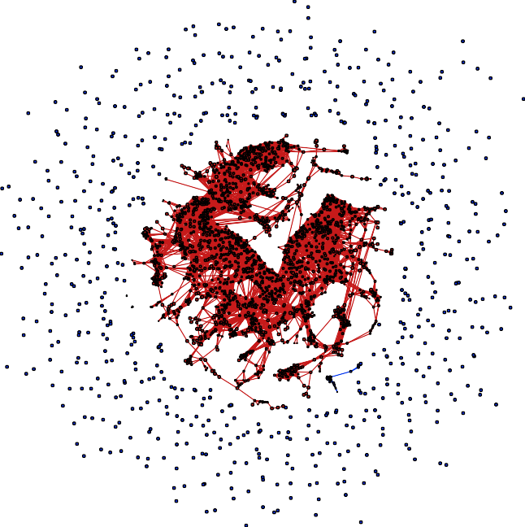

# Figure 8

*Network of Angry People. This is a network during the moment when the maximum amount of angry people was reached. You can see isolates and components. This network has an average clustering coefficient= 0.3635, 705 connected components and a density = 0.007*

# Discussion and Conclusions

The natural barrier to anticipation is a reactive mindset, which is very common in policy making (Torjman, 2005). For sure, one can not blame decision makers for being reactive as generally the political institutions are a set of rules that have been conceived based on what is known. There may be many examples of catastrophes that could have been avoided if the right anticipatory measure had been taken previously, but it is also true that the legal systems generally lack means to make decision makers liable for their lack of planing; and only electoral means are a way to express the general discontent for their lack of proactiveness. However, electing a new or better political leader does not undo the damage and suffering of the affected people. A reactive system of policies is not completely bad, and could even be considered an efficient way of spending public moneys. However, when combined with other factors, the whole situation can become catastrophic.

A first negative ingredient can be extremely centralized systems or weakly decentralized. A centralized system will react only after every institution beneath has considered that there is a need for anticipation, and a weekly centralized sys- tem gives the local institutions the illusion of decision making, when in reality there is a regulation that will force the local authority to deal with a complicated set of institutions. The Shullcas and the Huaytapallana may be clearly affected by this situation. Another negative ingredient to reactive policy-making is symbolic and superficial proactiveness. Particularly when dealing with this climate change issue, programs and organizations are created, technical documents are produced, presen- tations and dinners are offered, but at the end of the day there are no real measures beyond declarations of concern.

The level of economic development is also a key factor in understanding the ability to cope with water shortages, as more developed countries have more techno- logical and financial resources to deal with drastic environment issues. Poorer regions, countries, or localities have meager funds and often suffer through political instability that constrains implementation of effective and long-lasting policies. However, eco- nomic development has not stopped advance economies like the USA to be reactive in many cases in many different issues like the Challenger accident, the 9/11, Katrina hurricane, and so on (for more stories see (Bazerman, 2004)). Then, poor leadership affects enormously a reactive system of policies. A poor leader plays safe, and tends to leave difficult situations to *experts*, framing complex issues as *technical*. As explained by Heifetz and Linsky (Heifetz & Linsky, 2002), once leaders frame a complex prob- lem as technical instead of complex-adaptive the political system just does “routine management” instead of “change management”. This explains that the reports on the watershed appeared around 2010, and all of them were very technical; and since then, no more knowledge on this area has been produced from the government.

# Beyond the model What should be improved in the model?

Every model needs assumptions and facts, those facts can be qualitative or quanti- tative, and this agent-based model has dealt very well with facts and assumptions. However, the most urgent areas of improvement can be:

* Have a better sub model of what an agent could do when it predicts water scarcity is important. In our model, the agent looks for another sources of wa- ter, and when the agent finds a better place it abandons its home and moves to another place within the system, and keep doing that until his desire to stay in the system is surpassed. However, we would have preferred to have information on neighborhoods and its economic capacity, to implement an algorithm consid- ering that information, but that data does not exist. An important investment would be needed to produce that data.
* This model assumes thta the coas or jungle are the main destinations for the emigrants, but coast in fact represents “big cities in the coast” and the jungle represents “good places to go if you are a risk taker and your are not planing to bring your family”; although the answers from the interviews mentioned these two places it would be important to expand the model and see how the new arrivals are received and what new issues arise in those destinations. The answers also mentioned “foreign countries”, but that destination has not been included (but “coast” could represent it).
* It would be important to consider more strategies of the agent according to its economic capacity. The economic capacity is unknown at agent level, so further work on this should be done. It is important also to conduct a more detailed analysis on water regulation from the government to get the agents reduce consumption; since Peru is a country where no political authority wants to alter the price of water (water is very cheap in Peru), a different regulation mechanism should be thought following a participatory approach.
* A different programming platform could be important to consider. At this point, we have reached the capacity of the program NetLogo(Wilensky & Rand, 2015) but if this model becomes more computing-intensive, there is a clear need to migrate the model into more sophisticated platforms such as Mason (Luke et al., 2015), Repast (North et al., 2013), or Gamma (Taillandier et al., 2019). In fact, the code is ready to be sent to real maps, and see the simulation in a more realistic setting, but those other ABM platforms are needed to make the conversion useful.

# What measures should be taken?

This model, despite the real data that has been used to feed it, is still more a political tool than a engineering one. Its purpose is to show potential and not clear forecast of counts and moments, but a clear picture of what might happen and what to do to avoid it or gain time. This model’s ultimate goal is to raise enough awareness that triggers real political action. With that in mind, there are some recommendation on the next steps policy makers should follow:

* *Make sure people in rural area have enough rights and mechanisms to stay in their lands in good conditions.* The tendency of immigration may not diminish in the short run and rural people have no intention to leave Huancayo. To avoid relative deprivation emerge, policy makers from the central government need to assist rural populations to adapt their farming practices; regional planers need to determine buffers that separate urban from rural area as well as assure min- imal literacy conditions; while local governments need to stop giving building permits in the buffer area. The local University may also contribute to raise competitiveness of the local production.
* *Create mechanisms to ensure political participation of rural people.* Rural people are politically under represented. They only have local committees that regulate their internal activities in the community; but they have no real presence in the regional decision making. Local and regional governments should make sure that rural people have voice in every meeting held monthly where their participation will avoid future discrepancies. Policy makers have to keep in mind that the model is constantly recommending to increase the water reserve from the rainy season, which will need investment and the use of arable and/or herding land; in either case, rural communities will feel they are affected to favor exclusively the urban.
* *Improve participatory water governance.* The distribution of water between rural and urban area is currently a process that represents a constant debate. From the interviews, rural people believe that the city is taking more than water than they should from the Shullcas during the dry season and that the rural needs are relegated due to the pressure of the urban majority. Water management has many actors involved, including two Ministries from the central government (Agriculture and Environment), but the technical criteria adopted so far is biased toward the needs of the urban area.
* *Create and save the institutional memory.*This model has been done in the USA, but very distant from the modeling conditions we are familiar. Developed countries have long understand the importance of collecting, organizing and sharing data for the research community to find research problems and propose different solutions, or more importantly, to keep a memory of the events a community has experienced and help their local analysts do their job. Peru is the opposite.
* *Do not hide the crisis, but show a plan.* The dramatic situation has to be shared with the population, but in a message that shows the local governments have a plan that needs urban people to alter their inefficient use of water, or to learn routines that avoid unnecessary use of water. If the water demand decreases in the long run, make sure this process gets as slow as possible. For that, different campaigns should be promoted at elementary and high school level to be more efficient using water in the future generations of *Huancainos*; organize contests at college level to promote local inventions; and organize neighborhood contests to demonstrate how to achieve efficient practices in the use of water.
* *Seek collaboration from civil society, especially research institutions.* The high- lands of Peru have been always scenarios for NGOs to operate. Ideally, NGOs detect social problems and work with the community to empower their ac- tors; but this time the challenge is different, as it deals with the resilience and adaptive capacity of people facing high uncertainty of the future environmental

conditions and the reactions their neighbors themselves will have in those crit- ical moments. In this situation, the production of more knowledge is needed as well as interdisciplinary debate. The government has serious limitations to hire people permanently, but the local public University is the forgotten partner that could make all the difference. The local University has enough resources to fund important programs that can keep updating the social and natural sit- uation for more informed policy making and modeling, and which should create mechanisms for a two-way knowledge transfer, that is share scientific knowledge and collect traditional knowledge.

* *Be careful of easy solutions.* This work has suggested many times the saving of water. This is a decision that needs to be very well planned. To start, a huge reservoir for the area seems to be a good solution, but decision makers have to be aware of the Huaytapallana failure. This failure can cause any time a huge earthquake, and a huge reservoir represents a great potential for disaster. The saving of water will need a lot of work from the political class and the people themselves. From the top down, the infrastructure to save or become more efficient should be built; and the urban and rural settlers have the responsibility to be more efficient using water. Another important way to secure water will be a better management of the ground water, which currently is used without detailed knowledge of its quantity nor quality, and without any recharging policy.

.

# References

Macy, M. W., & Willer, R. (2002). From Factors to Actors: Computational Sociology and Agent-Based Modeling. *Annual Review of Sociology*, *28* (1), 143–166. [https:](https://doi.org/10.1146/annurev.soc.28.110601.141117)

[//doi.org/10.1146/annurev.soc.28.110601.141117](https://doi.org/10.1146/annurev.soc.28.110601.141117)

Singh, C., Jain, G., Sukhwani, V., & Shaw, R. (2021). Losses and damages associated with slow-onset events: Urban drought and water insecurity in Asia. *Current Opinion in Environmental Sustainability*, *50*, 72–86. [https://doi.org/10.1016/](https://doi.org/10.1016/j.cosust.2021.02.006) [j.cosust.2021.02.006](https://doi.org/10.1016/j.cosust.2021.02.006)

D’Aquino, P., Barreteau, O., Etienne, M., Boisseau, S., Aubert, S., Bousquet, F., Le Page, C., & Dar´e, W. The role playing games in an ABM participatory modeling process: Outcomes from five different experiments carried out in the last five years. In: In *Proceedings of the International Environmental Modelling and Software Society Conference*. International Environmental Modelling and Software Society Conference. Lugano, Switzerland: IEMSS, 2002, 275–280. Re- trieved May 17, 2024, from <https://agritrop.cirad.fr/544029/>

Cioffi-Revilla, C. A. (2014). *Introduction to computational social science: Principles and applications*. Springer.

Miller, J. H., & Page, S. E. (2007). *Complex adaptive systems: An introduction to computational models of social life*. Princeton University Press.

Gilbert, G. N., & Troitzsch, K. G. (2005). *Simulation for the social scientist* (2nd ed).

Open University Press.

Epstein, J. M., & 2050 Project. (1996). *Growing artificial societies: Social science* *from the bottom up*. Brookings Institution Press.

Robinson, K., & Klobucista, C. (2023, April 3). *Water Stress: A Global Problem That’s Getting Worse*. Council on Foreign Relations. Retrieved May 16, 2024, from [https://www.cfr.org/backgrounder/water-stress-global-problem-thats-](https://www.cfr.org/backgrounder/water-stress-global-problem-thats-getting-worse) [getting-worse](https://www.cfr.org/backgrounder/water-stress-global-problem-thats-getting-worse)

Alfarra, A., & Turton, A. NBS for Managing Water Availability. In: In *The United Nations world water development report 2018: Nature-based solutions for wa- ter*. UNESCO World Water Assessment Programme 2018. Paris: UNESCO, 2018, pp. 37–50. isbn: 978-92-3-100264-9.

Willige, A. (2023, October 26). *Explainer: What are tropical glaciers and why are they an indicator for climate change?* World Economic Forum. Retrieved May 18, 2024, from [https://www.weforum.org/agenda/2023/10/tropical-glacier-](https://www.weforum.org/agenda/2023/10/tropical-glacier-climate-change-elnino-indonesia/) [climate-change-elnino-indonesia/](https://www.weforum.org/agenda/2023/10/tropical-glacier-climate-change-elnino-indonesia/)

Bar-Tal, D. (Ed.). (2011). *Intergroup conflicts and their resolution: A social psycho-* *logical perspective*. Psychology Press.

Crate, S. A., & Nuttall, M. (2009). *Anthropology and climate change: From encounters* *to actions*. Left Coast Press.

Ziervogel, G., Bithell, M., Washington, R., & Downing, T. (2005). Agent-based social simulation: A method for assessing the impact of seasonal climate forecast applications among smallholder farmers. *Agricultural Systems*, *83* (1), 1–26. <https://doi.org/10.1016/j.agsy.2004.02.009>

Bharwani, S., Bithell, M., Downing, T. E., New, M., Washington, R., & Ziervogel,

G. (2005). Multi-agent modelling of climate outlooks and food security on a community garden scheme in Limpopo, South Africa. *Philosophical Transac- tions of the Royal Society B: Biological Sciences*, *360* (1463), 2183–2194. [https:](https://doi.org/10.1098/rstb.2005.1742)

[//doi.org/10.1098/rstb.2005.1742](https://doi.org/10.1098/rstb.2005.1742)

Kniveton, D., Smith, C., & Wood, S. (2011). Agent-based model simulations of future changes in migration flows for Burkina Faso. *Global Environmental Change*, *21*, S34–S40. <https://doi.org/10.1016/j.gloenvcha.2011.09.006>

Hailegiorgis, A. B. (2013). *Computational Modeling of Climate Change, Large-Scale Land Acquisition, and Household Dynamics in Southern Ethiopia* [Doctoral dissertation]. Ann Arbor, United States. Retrieved September 1, 2014, from <http://search.proquest.com/docview/1492669016/abstract?accountid=14541>

Hirschman, A. O. (1970). *Exit, voice, and loyalty: Responses to decline in firms, organizations, and states*. Harvard University Press.

Hendrix, C. S., & Salehyan, I. (2012). Climate change, rainfall, and social conflict in Africa. *Journal of Peace Research*, *49* (1), 35–50. [https://doi.org/10.1177/](https://doi.org/10.1177/0022343311426165) [0022343311426165](https://doi.org/10.1177/0022343311426165)

Hsiang, S. M., Burke, M., & Miguel, E. (2013). Quantifying the Influence of Climate on Human Conflict. *Science*, *341* (6151), 1235367–1235367. [https://doi.org/](https://doi.org/10.1126/science.1235367) [10.1126/science.1235367](https://doi.org/10.1126/science.1235367)

Steinbruner, J. D., Stern, P. C., & Husbands, J. L. (2013). *Climate and social stress:* *Implications for security analysis*. National Research Council (U.S.)

Piontek, F. (2010). *The Impact of Climate Change on Conflict and Cooperation in the Nile Basin* [Master’s thesis, Institute for Peace and Security Studies]. Ham- burg, Germany. Retrieved September 12, 2014, from [http://www.cairn.info/](http://www.cairn.info/resume.php?ID_ARTICLE=EUFOR_365_0099) [resume.php?IDARTICLE=EUFOR3650099](http://www.cairn.info/resume.php?ID_ARTICLE=EUFOR_365_0099)

Cioffi-Revilla, C. (2010). A Methodology for Complex Social Simulations. *Journal of Artificial Societies and Social Simulation*, *13* (1), 7. [http://jasss.soc.surrey.ac.](http://jasss.soc.surrey.ac.uk/13/1/7.html) [uk/13/1/7.html](http://jasss.soc.surrey.ac.uk/13/1/7.html)

Hailegiorgis, A. B., Kennedy, W. G., Balan, G. C., Bassett, J. K., & Gulden, T. An agent based model of climate change and conflict among pastoralists in east Africa. In: In *Proceedings of the 2010 International Congress on Environmental Modelling and Software*. 2010. Retrieved September 12, 2014, from [http://cs.](http://cs.gmu.edu/~eclab/projects/mason/publications/climate10.pdf) [gmu.edu/˜eclab/projects/mason/publications/climate10.pdf](http://cs.gmu.edu/~eclab/projects/mason/publications/climate10.pdf)

Kennedy, W. G., Hailegiorgis, A. B., Rouleau, M., Bassett, J. K., Coletti, M., Balan,

G. C., & Gulden, T. (2010, March 24). *An Agent-Based Model of Conflict in* *East Africa And the Effect of Watering Holes* (Conference). Charleston, SC.

Carlos, G., & Grijalva, R. (2012). Riesgos de Escasez de Agua en la Ciudad de Huan- cayo al 2030. *Apuntes de Ciencia & Sociedad, Universidad Continental*, *2* (1), 15–26.

L´opez-Moreno, J., Fontaneda, S., Bazo, J., Revuelto, J., Azorin-Molina, C., Valero- Garc´es, B., Mor´an-Tejeda, E., Vicente-Serrano, S., Zubieta, R., & Alejo- Cochach´ın, J. (2014). Recent glacier retreat and climate trends in Cordillera Huaytapallana, Peru. *Global and Planetary Change*, *112*, 1–11. [https://doi.](https://doi.org/10.1016/j.gloplacha.2013.10.010) [org/10.1016/j.gloplacha.2013.10.010](https://doi.org/10.1016/j.gloplacha.2013.10.010)

Haller, A., & Borsdorf, A. (2013). Huancayo Metropolitano. *Cities*, *31*, 553–562. [https:](https://doi.org/10.1016/j.cities.2012.04.004)

[//doi.org/10.1016/j.cities.2012.04.004](https://doi.org/10.1016/j.cities.2012.04.004)

Ho, R., & Milan, A. (2012). *“ Where the Rain Falls” Project. Results from Huan- cayo Province, Jun´ın Region.* (Case Study No. 5). United Nations University. Germany. Retrieved April 24, 2014, from <http://d-nb.info/102954221X/34>

Haller, A. (2012). Vivid valleys, pallid peaks? Hypsometric variations and rural–urban land change in the Central Peruvian Andes. *Applied Geography*, *35* (1-2), 439–

447. <https://doi.org/10.1016/j.apgeog.2012.09.009>

Maslow, A. H., & Frager, R. (1987). *Motivation and personality* (3rd ed). Harper and Row.

Watkins, J. H., MacKerrow, E. P., Patelli, P. G., Eberhard, A. S., & Stradling, S. G. (2008). *Understanding Islamist political violence through computational social simulation*. Los Alamos National Laboratory (LANL). Retrieved May 21, 2015, from [http://permalink.lanl.gov/object/tr?what=info:lanl-repo/lareport/LA-](http://permalink.lanl.gov/object/tr?what=info%3Alanl-repo/lareport/LA-UR-08-05107) [UR-08-05107](http://permalink.lanl.gov/object/tr?what=info%3Alanl-repo/lareport/LA-UR-08-05107)

Rose, R. (1993). *Lesson-drawing in public policy: A guide to learning across time and* *space*. Chatham House Publishers.

Torjman, S. (2005). *What is policy?* Caledon Institute of Social Policy. Retrieved June 11, 2015, from <http://www.deslibris.ca/ID/202308>

Bazerman, M. H. (2004). *Predictable surprises: The disasters you should have seen* *coming, and how to prevent them*. Harvard Business School Press.

Heifetz, R. A., & Linsky, M. (2002). *Leadership on the Line: Staying Alive Through the Dangers of Leading*. Harvard Business School Press. [http://books.google.](http://books.google.com/books?id=c3mYE7jNvn0C) [com/books?id=c3mYE7jNvn0C](http://books.google.com/books?id=c3mYE7jNvn0C)

Wilensky, U., & Rand, W. (2015). *Introduction to agent-based modeling: Modeling* *natural, social, and engineered complex systems with NetLogo*. The MIT Press.

Luke, S., Catalin, G., Sullivan, K., & Panait, L. (2015). *MASON - Multi Agent Sim- ulator Of Neighborhoods* (Version 19). [https://cs.gmu.edu/˜eclab/projects/](https://cs.gmu.edu/~eclab/projects/mason/) [mason/](https://cs.gmu.edu/~eclab/projects/mason/)

North, M. J., Collier, N. T., Ozik, J., Tatara, E. R., Macal, C. M., Bragen, M., & Sydelko, P. (2013). Complex adaptive systems modeling with Repast Sim- phony. *Complex Adaptive Systems Modeling*, *1* (1), 3. [https://doi.org/10.1186/](https://doi.org/10.1186/2194-3206-1-3)

[2194-3206-1-3](https://doi.org/10.1186/2194-3206-1-3)

Taillandier, P., Gaudou, B., Grignard, A., Huynh, Q.-N., Marilleau, N., Caillou, P., Philippon, D., & Drogoul, A. (2019). Building, composing and experimenting complex spatial models with the GAMA platform. *GeoInformatica*, *23* (2), 299–

322. <https://doi.org/10.1007/s10707-018-00339-6>