Mini Project Synopsis

Title of the Project
"AI-Powered Document Query System"

Mr. Dilip Magar
(125M1H055)

Dr. Anjana Arakerimath

DEPARTMENT OF MCA
PIMPRI CHINCHWAD COLLEGE OF ENGINEERING SECTOR NO. 26, PRADHIKARAN, NIGDI, PUNE - 44.
(2026 - 2027)

Index

1. Introduction
2. Problem Statement
3. Objectives of Proposed System
4. Scope of Proposed System
5. Methodology
6. Functional Requirements
7. Non-functional Requirements
8. Software & Hardware Requirements
9. Expected Outcomes
10. Conclusion

1. Introduction
Students and faculty regularly deal with large volumes of departmental PDFs — syllabi, regulations, lab manuals, and circulars. Finding specific information from hundreds of pages manually is time-consuming. Existing AI tools like ChatGPT cannot access private institutional documents and tend to hallucinate when asked about specific college policies.
The AI-Powered Document Query System is a full-stack web application that allows authorized college users to upload departmental PDFs and ask questions in plain English. It uses Retrieval-Augmented Generation (RAG) to search uploaded documents, find relevant paragraphs, and generate accurate answers with source citations (file name and page number). Access is restricted to verified @pccoepune.org Google accounts.
2. Problem Statement
Academic departments manage extensive documentation. When users need specific information, they must manually search through dozens of PDFs using keyword-based Ctrl+F search, which fails when different terminology is used. General-purpose LLMs cannot access private documents and hallucinate incorrect answers. There is no existing tool that combines private document understanding, hallucination prevention, source citations, and secure access control for academic use.
3. Objectives of Proposed System
- Build a RAG pipeline that answers questions strictly from uploaded departmental PDFs, preventing hallucination.
- Implement multi-stage retrieval using bi-encoder semantic search followed by Cross-Encoder reranking.
- Provide verifiable answers by citing the source document name and page number with every response.
- Secure the application with Google OAuth authentication restricted to @pccoepune.org users.
- Develop a full-stack web application with React frontend and Python FastAPI backend.
4. Scope of Proposed System
The proposed system covers the complete pipeline for document-based question answering within an academic institution. It enables uploading and processing of multiple PDF documents for text extraction and indexing, converting text chunks into vector embeddings using Sentence-BERT and storing them in ChromaDB for efficient retrieval. The system performs semantic search with Cross-Encoder reranking to accurately identify the most relevant document sections for any given user query. Answers are generated using the Groq LLM API with strict prompt guardrails to prevent hallucination, ensuring that the system responds only from the uploaded document content. Every answer is accompanied by source citations including the document name and page number for verifiability. Access to the system is restricted via Google OAuth 2.0 to users with a verified @pccoepune.org email address, ensuring that only authorized college users can interact with the application.
5. Methodology
The AI-Powered Document Query System follows a Retrieval-Augmented Generation (RAG) architecture — it first retrieves relevant sections from uploaded documents and then uses an AI model to generate answers based only on those sections. The complete system flow is illustrated in the diagram below.
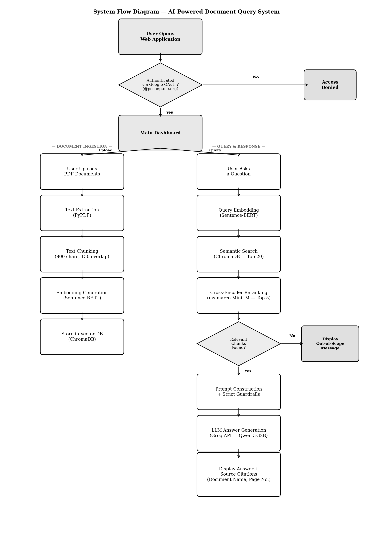
Fig 1: System Flow Diagram
6. Functional Requirements
- Allow upload of PDF files and automatic text extraction and embedding.
- Accept natural language questions via a chat interface.
- Retrieve relevant sections using semantic search and reranking.
- Generate LLM-based answers strictly from uploaded document context.
- Display source document name and page number with every answer.
- Require Google OAuth authentication; reject non @pccoepune.org emails.
7. Non-functional Requirements
Performance: Answer generation within 5–10 seconds.
Security: All data stored locally; no external cloud storage. Google OAuth with domain restriction.
Usability: Clean, intuitive chat interface similar to ChatGPT.
Scalability: New documents can be added without reprocessing existing ones.
8. Software & Hardware Requirements
Software Requirements:
Component | Technology
Frontend | React 18, Tailwind CSS v3, Vite
Backend | Python 3.10+, FastAPI
Embedding Model | SentenceTransformer (BAAI/bge-small-en-v1.5)
Reranker | CrossEncoder (ms-marco-MiniLM-L-6-v2)
Vector DB | ChromaDB
LLM API | Groq API (Qwen 3-32B)
Auth | Google OAuth 2.0
Browser | Chrome / Firefox (latest)
Hardware & OS Requirements:
Hardware: 8 GB RAM minimum, modern multi-core processor, 10 GB free disk space, stable internet connection.
OS: Windows 10/11, Linux (Ubuntu 20.04+), or macOS.
9. Expected Outcomes
- A functional web app where authorized users upload PDFs and ask questions in natural language.
- Accurate, hallucination-free answers generated strictly from uploaded document content.
- Source citations (document name, page number) displayed with every answer.
- Secure access restricted to verified @pccoepune.org email addresses.
10. Conclusion
The AI-Powered Document Query System solves a real problem faced by students and faculty — quickly finding specific information from departmental PDF collections. By combining semantic search (Sentence-BERT) with LLM-based answer generation (Groq API) in a RAG architecture, the system delivers accurate, source-verified answers without hallucination. Multi-stage retrieval with Cross-Encoder reranking ensures precision, and Google OAuth restricts access to authorized college users only.

STUDENT DETAILS

Name of Student: Dilip Magar
PRN: 125M1H055
Email: dilip.magar25@pccoepune.org
Contact No.: 9356331879

