Seminar Report
On
“Comparative Study of Transformer Models (BERT vs GPT)”

Submitted By
Mr. Dilip Magar

Under the Guidance of
Dr. Anjana Arakerimath



Department of Master of Computer Application
Pimpri Chinchwad Education Trust's
Pimpri Chinchwad College of Engineering
Pune -411044

CERTIFICATE

This is to certify that the seminar report entitled “Comparative Study of Transformer Models (BERT vs GPT)” being submitted by Dilip Magar (125M1H055) is a record of bonafide work carried out by him under the supervision and guidance of Dr. Anjana Arakerimath in partial fulfillment of the requirement for Master of Computer Application (MCA) course of Savitribai Phule Pune University, Pune in the academic year 2026-2027.

Date:16th October 2026

Place: Pune

Dr. Anjana Arakerimath Head of the Department

ABSTRACT
This seminar presents a comparative study of two widely used Transformer-based language models — BERT (Bidirectional Encoder Representations from Transformers) and GPT (Generative Pre-trained Transformer). Both models are built on the Transformer architecture proposed by Vaswani et al. in 2017, but they follow very different design philosophies. BERT uses an encoder-only structure and learns by predicting masked words in a sentence, which makes it good at understanding text meaning. GPT, on the other hand, uses a decoder-only structure and learns by predicting the next word, which makes it suitable for generating text. In this seminar, the internal architecture, training methods, and practical applications of both models are studied and compared across Natural Language Processing (NLP) tasks like text classification, question answering, and text generation. As a practical demonstration, this study also looks at how both model families can work together in a Retrieval-Augmented Generation (RAG) system, where BERT-based models handle document retrieval and reranking, while a GPT-based model generates the final answer. The expected outcome is to develop a clear understanding of which model type is better suited for which kind of NLP task.
Keywords: Transformer, BERT, GPT, Self-Attention, Natural Language Processing, Retrieval-Augmented Generation, Encoder-Decoder

ACKNOWLEDGEMENT
I would like to express my sincere gratitude to my seminar guide, Dr. Anjana Arakerimath, for her valuable guidance, constant encouragement, and support throughout the preparation of this seminar report. Her insights and feedback helped me understand the topic deeply and present it effectively.
I am also thankful to the Head of Department and all the faculty members of the Department of Master of Computer Application, Pimpri Chinchwad College of Engineering, for providing the necessary resources and a supportive learning environment.
I would also like to thank my classmates for their cooperation and useful discussions during the course of this work.
Finally, I am grateful to my family for their constant support and motivation.

TABLE OF CONTENTS
1. Introduction
2. Motivation / Need of the Study
3. Literature Survey
4. Problem Statement and Objectives
5. Details of Study
5.1 The Transformer Architecture
5.2 BERT: Bidirectional Encoder Representations
5.3 GPT: Generative Pre-trained Transformer
5.4 Comparative Analysis
5.5 Practical Demonstration: RAG Pipeline
6. Discussion on Results and Analysis
7. Conclusion
8. References

List of Figures
Figure 1: Transformer Architecture
Figure 2: BERT vs GPT Architecture Comparison
Figure 3: RAG Pipeline — BERT + GPT Working Together

List of Tables
Table 1: BERT vs GPT Feature Comparison
Table 2: Task-wise Performance Comparison

CHAPTER 1: INTRODUCTION
Natural Language Processing (NLP) is a branch of artificial intelligence that deals with enabling computers to understand, interpret, and generate human language. Over the past decade, NLP has evolved from simple rule-based systems to advanced deep learning models. Before 2017, Recurrent Neural Networks (RNNs) and LSTMs were dominant, but they processed text sequentially, making them slow and unable to capture long-range dependencies. In 2017, Vaswani et al. introduced the Transformer architecture in their paper "Attention Is All You Need," which replaced sequential processing with a self-attention mechanism that allows the model to look at all words simultaneously, making models faster and more accurate.
Following the Transformer's introduction, two major model families emerged. Google released BERT in 2018, which uses only the Encoder part and is designed to understand text by reading it in both directions. OpenAI released GPT in the same year, which uses only the Decoder part and generates text by predicting the next word. Today, both models power everything from Google Search to ChatGPT. I chose this topic because while working on my mini project — the AI-Powered Document Query System — I used BERT-based models for retrieval and a GPT-based model for answer generation, which made me curious about their differences.
This report is organized as follows: Chapter 2 discusses motivation. Chapter 3 presents the literature survey. Chapter 4 states the problem statement and objectives. Chapter 5 provides detailed study of the architectures. Chapter 6 discusses results and analysis. Chapter 7 concludes with key findings.
CHAPTER 2: MOTIVATION / NEED OF THE STUDY
Transformer-based models have become the backbone of modern AI applications. The two most discussed model families — BERT and GPT — are often presented as competitors, but this framing is misleading. BERT is an understanding model that reads text to extract meaning, while GPT is a generation model that produces new text. Most academic comparisons focus on benchmark scores and mathematical formulations, which can be difficult for students to follow. There is a need for a clear, practical comparison that explains differences in simple terms.
My personal motivation came from building the AI-Powered Document Query System as a mini project. In that system, I used Sentence-BERT for converting documents into searchable vectors and a GPT-family model through the Groq API to generate answers. Seeing both model types work together made me realize they are not competitors but complementary technologies. This seminar aims to formalize that understanding through a structured comparative study.
CHAPTER 3: LITERATURE SURVEY
The Transformer architecture was proposed by Vaswani et al. (2017) [1], introducing self-attention which allows models to process all positions simultaneously, removing the sequential bottleneck of recurrent networks. This became the foundation for all modern NLP models.
Devlin et al. (2019) introduced BERT [2], using only the encoder with bidirectional training via Masked Language Modeling (MLM) and Next Sentence Prediction (NSP). BERT-Base has 12 layers (110M parameters) and BERT-Large has 24 layers (340M). Radford et al. (2018) introduced GPT [3], using only the decoder with autoregressive training. GPT-2 [4] scaled to 1.5B parameters and GPT-3 [5] to 175B, demonstrating impressive few-shot learning. Liu et al. (2019) proposed RoBERTa [9], optimizing BERT's training by removing NSP and using dynamic masking. Raffel et al. (2020) introduced T5 [10], using the complete encoder-decoder Transformer.
Reimers and Gurevych (2019) introduced Sentence-BERT [7] for efficient semantic similarity using Siamese networks. Nogueira and Cho (2019) demonstrated BERT for passage re-ranking [8] using Cross-Encoders. Lewis et al. (2020) proposed the RAG framework [6], combining BERT-family retrieval with GPT-family generation, reducing hallucination and improving factual accuracy.
Most existing studies compare BERT and GPT independently on benchmarks like GLUE and SQuAD. This seminar fills the gap by studying both individually and demonstrating their combined usage in a practical RAG pipeline.
CHAPTER 4: PROBLEM STATEMENT AND OBJECTIVES
4.1 Problem Statement
BERT and GPT are both built on the Transformer architecture, yet they serve fundamentally different purposes — understanding versus generation. Most academic comparisons treat them as competing models, evaluating them on the same benchmarks without acknowledging their complementary nature. In real-world applications like chatbots, search engines, and document analysis tools, BERT and GPT often work together — BERT finds relevant information while GPT generates human-readable responses. Students and developers frequently struggle to decide which model to use for a given task, and there is a lack of practical, easy-to-understand comparisons.
This seminar addresses the need for a clear, structured comparison that highlights the architectural differences between BERT and GPT, identifies when to use each model, and demonstrates how they can complement each other in practical applications.
4.2 Objectives
- To study and understand the internal architecture of BERT (encoder-only) and GPT (decoder-only) Transformer models.
- To compare their pre-training strategies — Masked Language Modeling (MLM) in BERT versus autoregressive next-word prediction in GPT.
- To evaluate their strengths and weaknesses across different NLP tasks such as text classification, named entity recognition, question answering, and text generation.
- To demonstrate their complementary usage through a practical RAG-based case study (AI-Powered Document Query System) where BERT handles retrieval and GPT handles generation.
CHAPTER 5: DETAILS OF STUDY
5.1 The Transformer Architecture
The Transformer, proposed by Vaswani et al. in 2017, processes all tokens simultaneously using self-attention, unlike RNNs which process sequentially. For each token, it computes Query (Q), Key (K), and Value (V) vectors. Attention scores are calculated via scaled dot-product of Q and K, then applied as weights to V vectors. Multi-Head Attention runs this computation multiple times in parallel with different projections, capturing different relationship types.
As shown in Figure 1, the Transformer has two components. The Encoder reads the entire input and produces representations using stacked layers of Multi-Head Self-Attention and Feed-Forward Networks with residual connections. The Decoder generates output one token at a time using Masked Self-Attention (preventing attention to future tokens), Cross-Attention (attending to encoder output), and Feed-Forward Networks. Positional Encoding is added since self-attention has no inherent notion of token order.
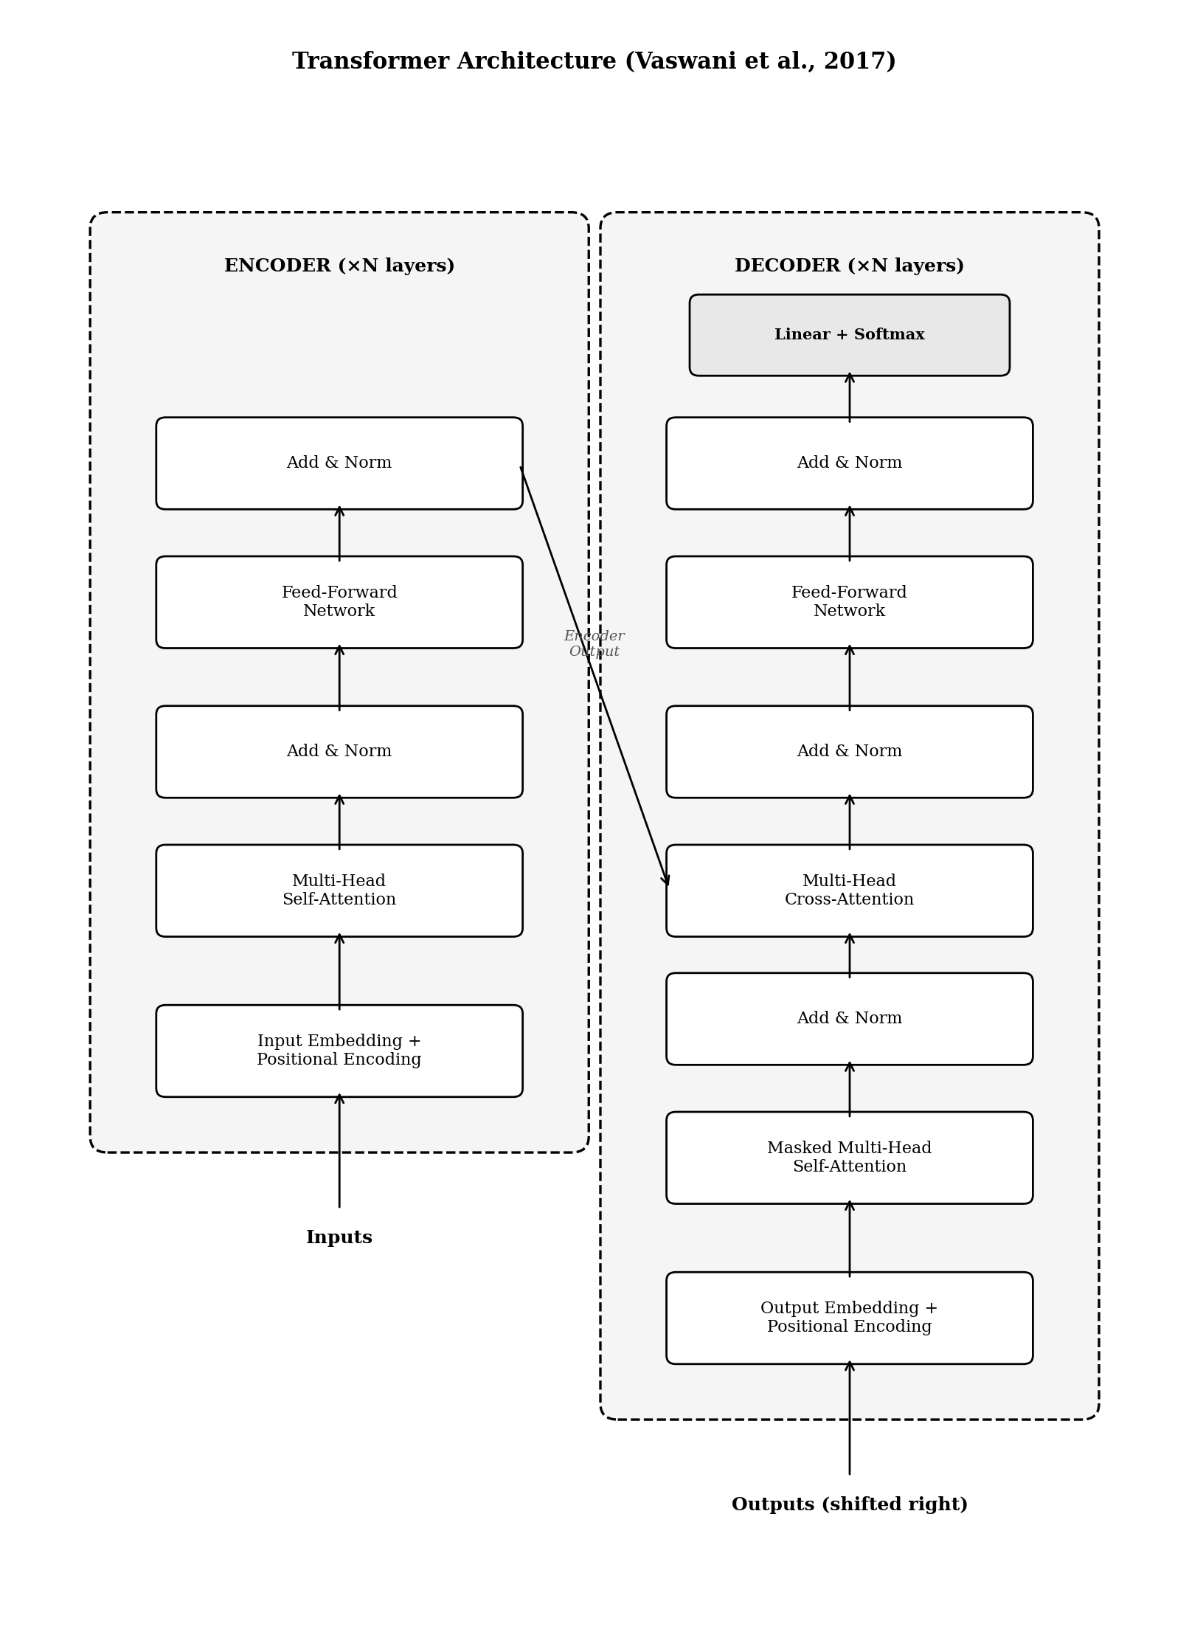
Figure 1: Transformer Architecture (Vaswani et al., 2017)
5.2 BERT: Bidirectional Encoder Representations
BERT, introduced by Devlin et al. in 2019, uses only the Encoder portion. Its key innovation is bidirectional training — each token attends to every other token regardless of position. BERT is pre-trained using Masked Language Modeling (MLM), where 15% of tokens are masked and the model predicts them from both-side context, and Next Sentence Prediction (NSP), where the model learns whether two sentences follow each other.
The input sums Token Embeddings (WordPiece), Segment Embeddings, and Position Embeddings. A [CLS] token is prepended for classification. After pre-training on BooksCorpus and Wikipedia (~3.3B words), BERT is fine-tuned by adding a simple output layer, making it effective for sentiment analysis, NER, extractive QA, and text classification.
5.3 GPT: Generative Pre-trained Transformer
GPT, introduced by Radford et al. in 2018, uses only the Decoder portion. It is unidirectional — each token attends only to previous tokens via masked (causal) self-attention. GPT is pre-trained using autoregressive language modeling: predicting the next token at each position, making it excellent at generating coherent text. The input uses Token Embeddings (Byte Pair Encoding) and learned Position Embeddings.
The GPT family's most remarkable aspect is scaling. GPT-1 (2018) had 117M parameters, GPT-2 (2019) scaled to 1.5B with zero-shot capabilities, and GPT-3 (2020) reached 175B parameters, introducing "in-context learning" — performing new tasks from just a few prompt examples. Figure 2 shows a side-by-side comparison of BERT and GPT.
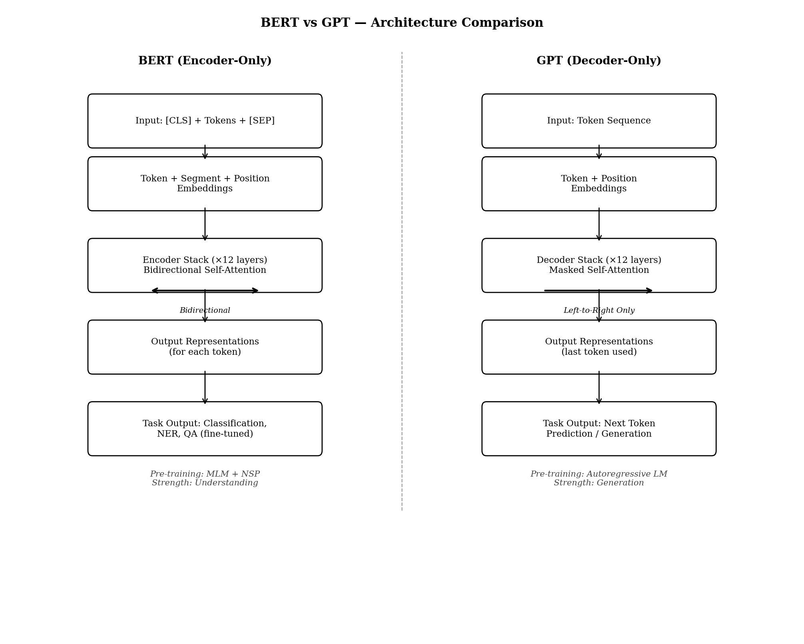
Figure 2: BERT vs GPT Architecture Comparison
5.4 Comparative Analysis
Table 1 presents a feature comparison. BERT uses full bidirectional attention while GPT uses causal attention. This determines their strengths: BERT excels at understanding tasks (classification, NER, QA) and GPT excels at generation tasks (text generation, dialogue, code). Their pre-training objectives reinforce these strengths — MLM captures deep semantics, autoregressive training produces fluency.
Table 1: BERT vs GPT Feature Comparison
Feature | BERT | GPT
Architecture | Encoder-only | Decoder-only
Attention Type | Bidirectional (full) | Unidirectional (causal)
Pre-training Task | MLM + NSP | Autoregressive LM
Reading Direction | Both directions | Left-to-right only
Primary Strength | Text understanding | Text generation
Fine-tuning | Task-specific output layer | Prompt-based / fine-tuning
Special Tokens | [CLS], [SEP], [MASK] | No special tokens
Best For | Classification, NER, QA | Generation, Dialogue, Code
Base Parameters | 110M (BERT-Base) | 117M (GPT-1)
Largest Version | 340M (BERT-Large) | 175B (GPT-3)

5.5 Practical Demonstration: RAG Pipeline
As a practical demonstration of how BERT and GPT complement each other, this study references the AI-Powered Document Query System — a mini project implementing a Retrieval-Augmented Generation (RAG) pipeline for answering questions from uploaded PDF documents.
In this system, BERT-family models handle retrieval. Sentence-BERT (BAAI/bge-small-en-v1.5) converts document chunks and user queries into vector embeddings stored in ChromaDB. When a user asks a question, the system finds semantically similar sections using cosine similarity. A Cross-Encoder (ms-marco-MiniLM-L-6-v2) then reranks the candidates by reading each query-document pair through BERT for precise relevance scoring.
A GPT-family model handles generation. The top-ranked sections are injected into a prompt with strict guardrails, and the model (Qwen 3-32B via Groq API) generates answers strictly from the provided context. If no relevant content is found, the system returns an out-of-scope message instead of hallucinating.
This RAG pipeline, illustrated in Figure 3, demonstrates that BERT and GPT are complementary technologies. BERT provides understanding needed to find relevant information, while GPT provides generative ability to synthesize coherent answers with source citations.
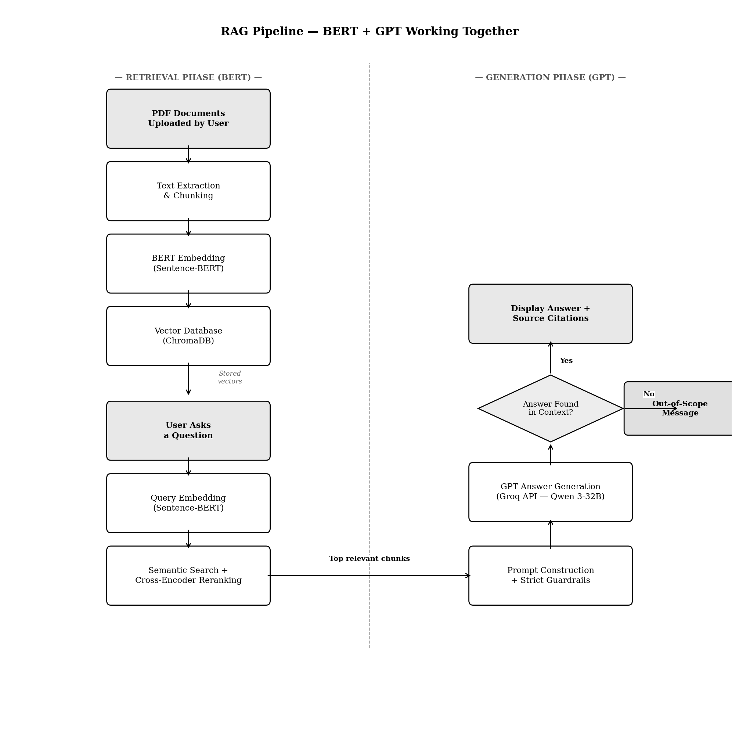
Figure 3: RAG Pipeline — BERT + GPT Working Together
CHAPTER 6: DISCUSSION ON RESULTS AND ANALYSIS
The comparative analysis reveals several key findings, summarized in Table 2. For understanding tasks (classification, NER, sentiment analysis), BERT consistently performs better due to bidirectional attention. For generation tasks (creative writing, dialogue, code), GPT is superior as its autoregressive training directly aligns with generation. For question answering, extractive QA favors BERT while generative QA favors GPT.
The RAG framework demonstrates the optimal combined use pattern. As shown with the AI-Powered Document Query System, BERT retrieves relevant document sections through semantic understanding, and GPT synthesizes them into readable answers — results neither model achieves alone. Scaling has had different effects: BERT improved through better training strategies (RoBERTa), while GPT improved through parameter scaling (117M to 175B), unlocking emergent few-shot learning capabilities.
Table 2: Task-wise Performance Comparison
NLP Task | Better Model | Reason
Text Classification | BERT | Bidirectional context captures full meaning
Named Entity Recognition | BERT | Understands entity context from both sides
Extractive QA | BERT | Identifies answer spans within given text
Sentiment Analysis | BERT | Full context understanding of opinion text
Text Generation | GPT | Autoregressive training produces fluent text
Dialogue / Chatbots | GPT | Natural conversational text generation
Code Generation | GPT | Sequential code generation capability
Summarization | Both | Extractive (BERT) or generative (GPT)
Semantic Search | BERT | Sentence-BERT embeddings for similarity
RAG Systems | Both | BERT retrieves, GPT generates

CHAPTER 7: CONCLUSION
This seminar presented a comparative study of BERT and GPT. BERT's bidirectional encoder is superior for understanding tasks (classification, NER, semantic search), while GPT's unidirectional decoder is superior for generation tasks (text generation, dialogue, code). The most important finding is that they are complementary — the RAG framework demonstrated through the AI-Powered Document Query System shows that combining BERT for retrieval with GPT for generation produces more accurate results than either model alone.
Future directions include exploring encoder-decoder models like T5, investigating model scaling versus architectural innovation, and studying newer techniques like mixture-of-experts for improved efficiency.
CHAPTER 8: REFERENCES
[1] A. Vaswani et al., "Attention Is All You Need," in Advances in Neural Information Processing Systems (NeurIPS), vol. 30, pp. 5998–6008, 2017.
[2] J. Devlin, M. W. Chang, K. Lee, and K. Toutanova, "BERT: Pre-training of Deep Bidirectional Transformers for Language Understanding," in Proceedings of NAACL-HLT, pp. 4171–4186, 2019.
[3] A. Radford, K. Narasimhan, T. Salimans, and I. Sutskever, "Improving Language Understanding by Generative Pre-Training," OpenAI Technical Report, 2018.
[4] A. Radford et al., "Language Models are Unsupervised Multitask Learners," OpenAI Technical Report, 2019.
[5] T. Brown et al., "Language Models are Few-Shot Learners," in Advances in Neural Information Processing Systems (NeurIPS), vol. 33, pp. 1877–1901, 2020.
[6] P. Lewis et al., "Retrieval-Augmented Generation for Knowledge-Intensive NLP Tasks," in Advances in Neural Information Processing Systems (NeurIPS), vol. 33, pp. 9459–9474, 2020.
[7] N. Reimers and I. Gurevych, "Sentence-BERT: Sentence Embeddings using Siamese BERT-Networks," in Proceedings of EMNLP, pp. 3982–3992, 2019.
[8] R. Nogueira and K. Cho, "Passage Re-ranking with BERT," arXiv preprint arXiv:1901.04085, 2019.
[9] Y. Liu et al., "RoBERTa: A Robustly Optimized BERT Pretraining Approach," arXiv preprint arXiv:1907.11692, 2019.
[10] C. Raffel et al., "Exploring the Limits of Transfer Learning with a Unified Text-to-Text Transformer," in Journal of Machine Learning Research, vol. 21, pp. 1–67, 2020.

