Age Calculator — Progress Report (FA-1)
Course: Advanced Web Technologies (AWT)
Department: MCA, Semester III (SYMCA)
Academic Year: 2026–27
College: Pimpri Chinchwad College of Engineering (PCCOE)
Field | Details
Student Name | Magar Dilip Balu
PRN | 125M1H055
Roll No. | 55
Project Title | Age Calculator
Course Coordinator | Dr. Avinash Chormale
Assessment | Formative Assessment-I (FA-1)

1. Problem Statement
People often need to know their exact age in years, months, and days for various purposes such as official document applications, visa processing, competitive exam eligibility, insurance calculations, and retirement planning. Manually computing age across leap years, varying month lengths, and calendar boundaries is error-prone and tedious.
- Proposed Solution: A modern, interactive Age Calculator web application built using React.js that allows users to input their date of birth and instantly view their exact age along with detailed breakdowns, birthday countdown, and fun birth-date facts.

2. Objectives
- Calculate and display exact age in years, months, and days from a given date of birth.
- Provide a detailed age breakdown in total months, weeks, days, hours, and minutes.
- Show a countdown to the user's next birthday.
- Display fun facts such as zodiac sign, birth day name, generation, and birth season.
- Maintain a session-based history of all calculations performed.
- Support dark and light themes with a responsive, mobile-friendly user interface.

3. Use Case Identification
- UC-1: Input Date of Birth: The user selects their date of birth using a date picker.
- UC-2: Calculate Age: The system calculates the exact age in years, months, and days based on the provided date of birth.
- UC-3: View Detailed Breakdown: The user views their age broken down into total months, weeks, days, hours, and minutes.
- UC-4: View Next Birthday: The user sees a countdown showing the exact number of days remaining until their next birthday.
- UC-5: View Fun Facts: The user discovers interesting facts about their birth date (e.g., Zodiac sign, birth season).
- UC-6: Manage History: The user views a history of their past age calculations and can clear the history.
- UC-7: Toggle Theme: The user switches between light and dark modes for a personalized viewing experience.

4. UI Design & Wireframe
The application follows a modern glassmorphism design aesthetic with:
- Dark mode as default theme (with light mode toggle)
- Purple-to-cyan gradient accents
- Inter font (Google Fonts) for clean typography
- Frosted glass card effects with subtle hover animations
- Fully responsive grid layout (2-column on desktop → single column on mobile)
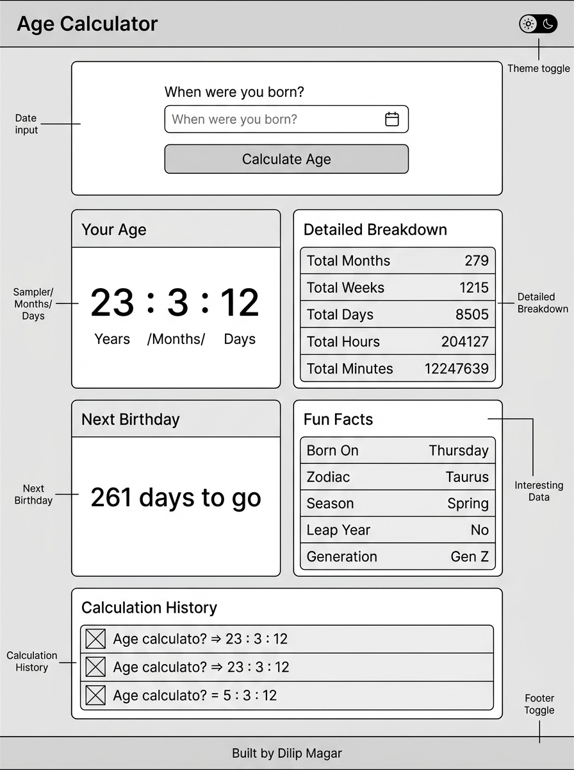
Figure 1: UI Wireframe Layout

5. Functional Requirements
ID | Requirement | Status
FR-1 | Date of birth input via native date picker | Implemented
FR-2 | Exact age calculation (Years / Months / Days) | Implemented
FR-3 | Detailed breakdown (total months, weeks, days, hours, minutes) | Implemented
FR-4 | Next birthday countdown with days remaining | Implemented
FR-5 | Calculation history with clear functionality | Implemented
FR-6 | Dark/Light theme toggle | Implemented
FR-7 | Responsive layout (mobile, tablet, desktop) | Implemented
FR-8 | Input validation with error messages | Implemented
FR-9 | Fun facts (zodiac sign, birth day, season, generation, leap year) | Implemented

6. Technology Stack
Technology | Purpose
React.js | Component-based UI development
JavaScript (ES6+) | Application logic, date calculations
Vite | Build tool and development server
HTML5 | Semantic page structure
CSS3 | Styling with custom properties, glassmorphism, responsive design
VS Code | Development environment

7. React Concepts Implemented
Concept | Components Using It
JSX | All 10 components
Functional Components | Header, DateInput, AgeResult, AgeBreakdown, BirthdayCountdown, FunFacts, HistoryItem, HistoryList, Footer
Props | Header, DateInput, AgeResult, AgeBreakdown, BirthdayCountdown, FunFacts, HistoryItem, HistoryList
useState | App (theme, result, breakdown, birthday, funFacts, history), DateInput (inputDate, error)
Event Handling | DateInput (onChange, onSubmit), Header (theme toggle), HistoryList (clear)
Conditional Rendering | Results section, Error messages, Birthday today, Empty history state, Theme icon
Lists & Keys | AgeBreakdown (stat items), FunFacts (facts list), HistoryList (history entries)

8. Project Structure
age-calculator/
├── public/
├── src/
│ ├── components/
│ │ ├── Header.jsx
│ │ ├── DateInput.jsx
│ │ ├── AgeResult.jsx
│ │ ├── AgeBreakdown.jsx
│ │ ├── BirthdayCountdown.jsx
│ │ ├── FunFacts.jsx
│ │ ├── HistoryItem.jsx
│ │ ├── HistoryList.jsx
│ │ └── Footer.jsx
│ ├── utils/
│ │ └── ageCalculator.js
│ ├── App.jsx
│ ├── App.css
│ └── main.jsx
├── index.html
├── package.json
└── vite.config.js

9. Screenshots

9.1 Initial State (Dark Theme)
The application loads with a dark theme by default, showing the date input card and empty calculation history.
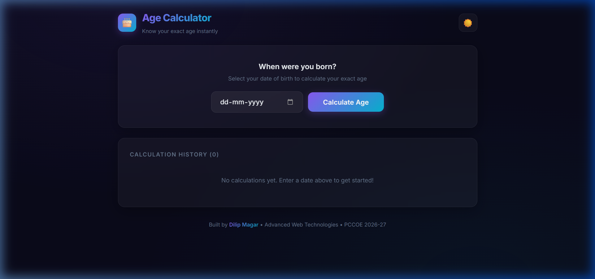

9.2 After Calculation
After entering a date of birth (May 15, 2003), the application displays:
- Age: 23 Years, 3 Months, 12 Days
- Detailed Breakdown: 279 months, 1,215 weeks, 8,505 days, 204,127 hours, 12,247,639 minutes
- Next Birthday: 261 days to go (Saturday, 15 May 2027)
- Fun Facts: Born on Thursday, Taurus ♉, Spring, Not a Leap Year baby, Gen Z
- History entry added
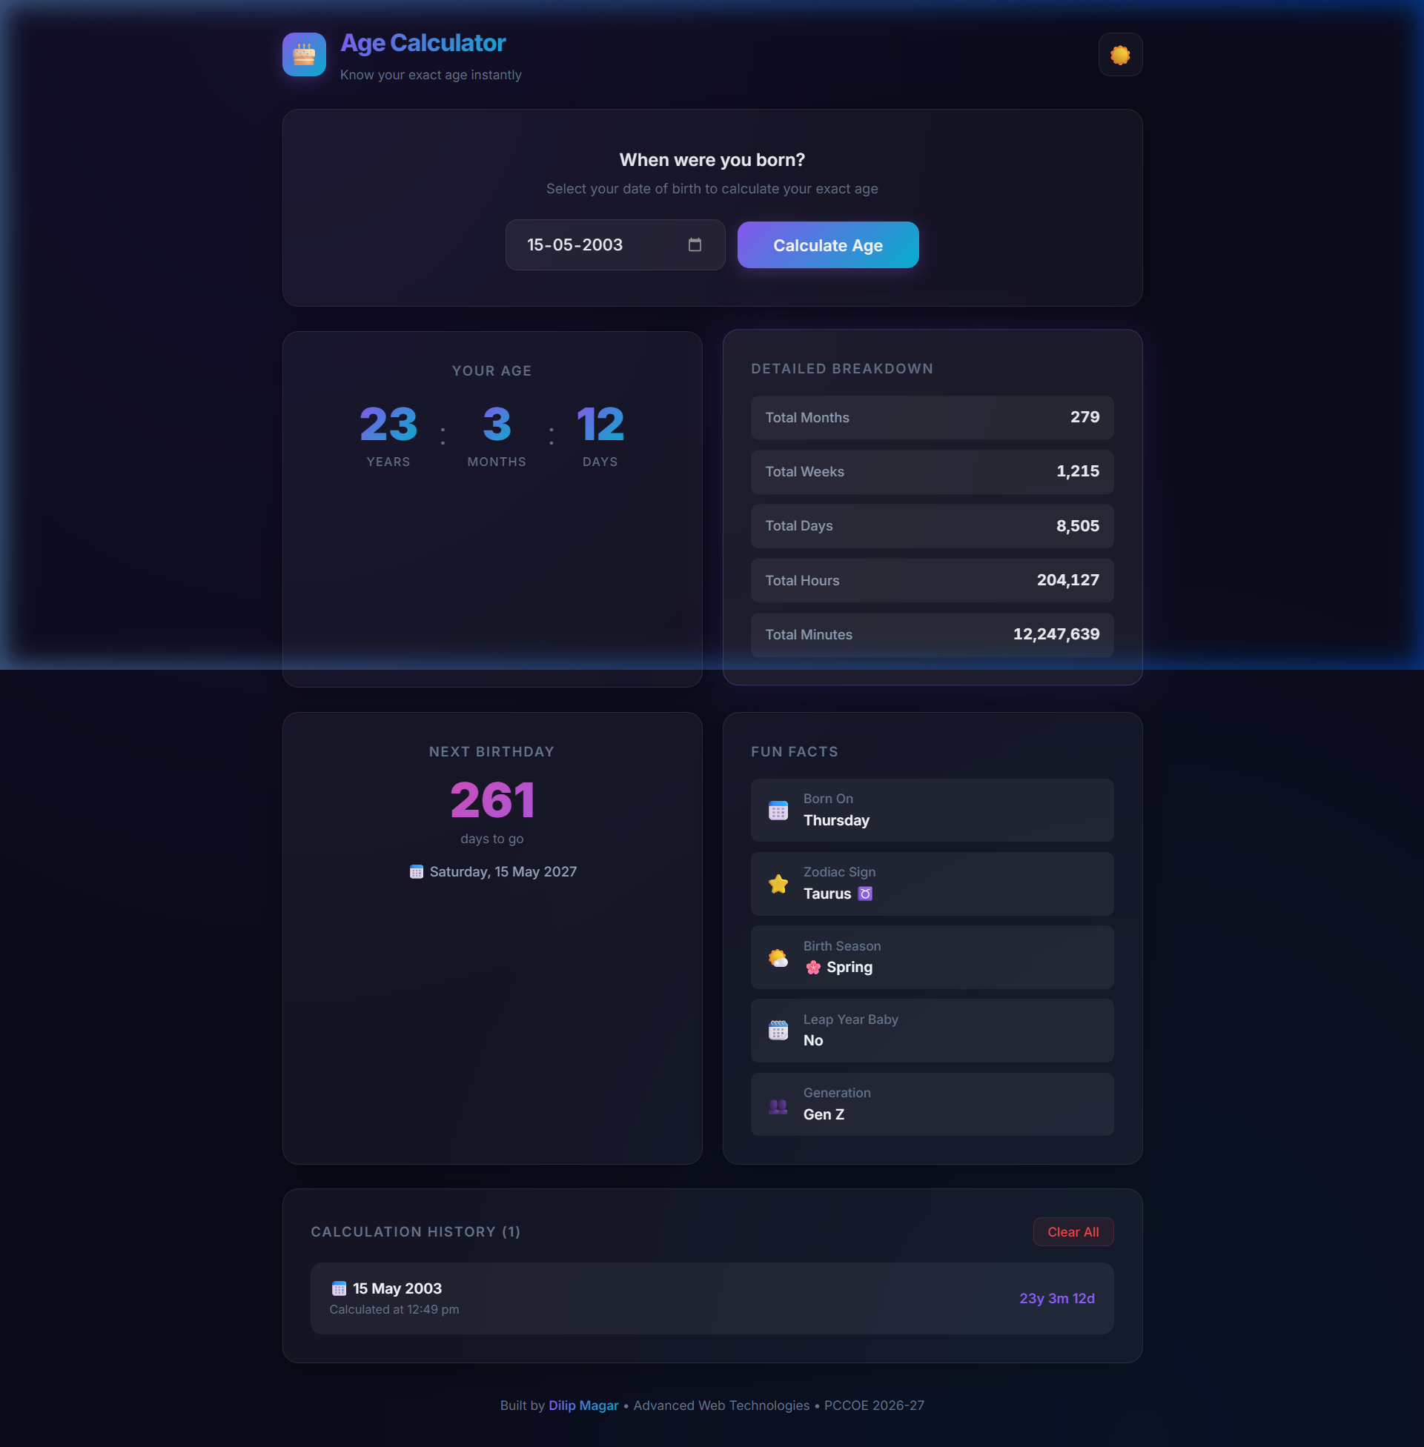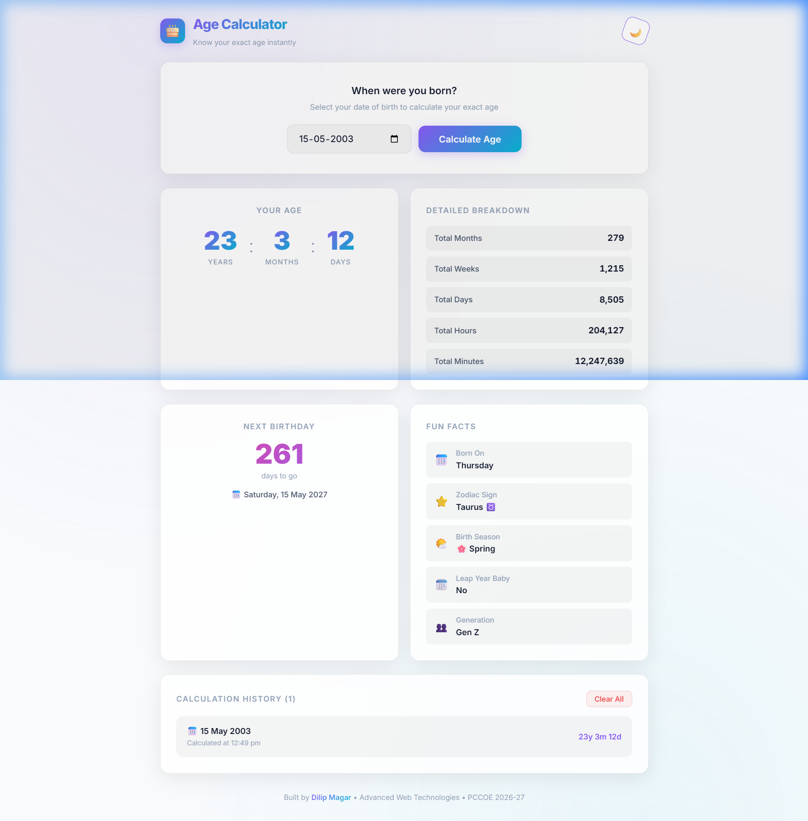

10. Conclusion
The Phase-I (FA-1) of the Age Calculator mini project has been successfully completed. All core React concepts — JSX, functional components, props, useState, event handling, conditional rendering, and lists & keys — have been implemented across 10 modular components. The application features a responsive, premium UI design with dark/light theme support, input validation, and comprehensive age calculation functionality.

