**Project-1**

1.solar panel power simulation

* Model pv panel under different irradiance&temperature.
* Input:solar irradiance,temperature.
* Output:I-v andp-v characteristics max power point.
* Libraries:numpy,matplotlib.
* Application:Renewable energy system design.

Program:

import matplotlib.pyplot as plt

import numpy as np

panel_area = 1.6

efficiency = 0.18

sunlight_hours = 6

hours = np.linspace(0, 24,59)

irradiance = np.piecewise(

    hours,

    [hours < 6, (hours >= 6) & (hours <= 18), hours > 18],

    [0, lambda h: 1000 * np.sin(np.pi * (h - 6) / 12), 0])

power_output = irradiance * panel_area * efficiency

energy_output = np.trapz(power_output, hours)

plt.figure(figsize=(7, 4))

plt.plot(hours, power_output, label='Power Output (W)', color='orange')

plt.fill_between(hours, power_output, alpha=0.3, color='orange')

plt.title(f"Solar Panel Power Output Simulation\nTotal Energy: {energy_output:.2f} Wh")

plt.xlabel('Hour of Day')

plt.ylabel('Power Output (W)')

plt.grid(True)

plt.legend()

plt.show()

**output**:

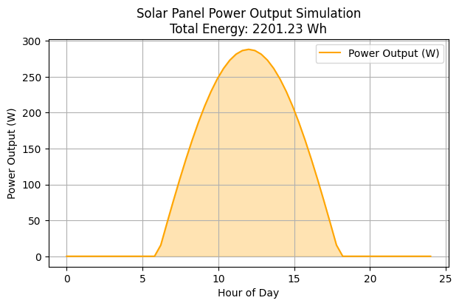

**conclusion:** The solar panel simulation effectively demonstrates how various factors—such as sunlight intensity, panel angle, and environmental conditions—impact the performance and energy output of solar panels. Through this simulation, we can better understand the optimal configurations and limitations of solar energy systems. It highlights the importance of proper installation and maintenance to maximize efficiency. Overall, the simulation serves as a valuable tool for predicting real-world solar panel behavior and guiding the design of more efficient and cost-effective solar energy solutions.