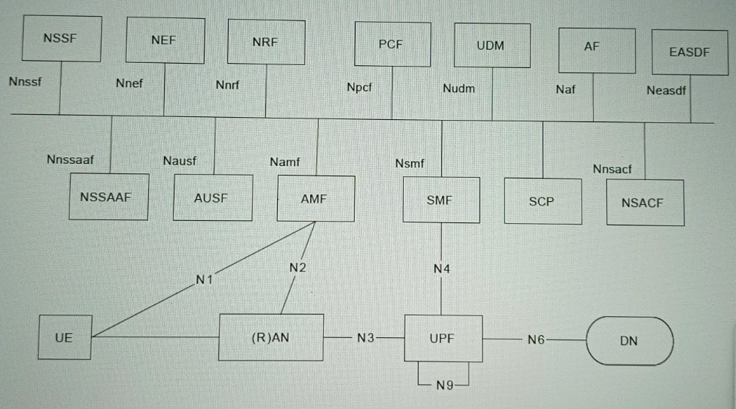

NSSF:

NSSF stands for “Network Slice Selection Function” in the context of 5G networks. It plays a crucial role in 5G by dynamically selecting and managing network slices based on the specific requirements of different services and applications. Network slicing allows operators to create multiple virtual networks that operate independently over a common physical infrastructure, enabling them to offer customized services with varying requirements for latency, bandwidth, and reliability. The NSSF determines which network slice is appropriate for a particular user or application based on policies, quality of service (QoS) parameters, and other criteria defined by the operator. This flexibility is a key feature of 5G networks, enabling a wide range of use cases from enhanced mobile broadband to mission-critical communications and massive IoT deployments.

NEF:

NEF stands for “Network Exposure Function”. It's a key component of the 5G core network architecture that enables third-party applications to request and access network services and resources. NEF manages the exposure of network capabilities and provides a secure interface for external entities to interact with the 5G network, facilitating innovative services and functionalities.

NRF:

NRF stands for "Network Repository Function”. It plays a crucial role in the 5G architecture by managing the registration and discovery of network functions and services within the network. Essentially, NRF helps orchestrate how different network functions communicate and interact, ensuring efficient routing and delivery of services across the 5G network infrastructure. This centralized function is key to enabling the dynamic and flexible nature of 5G networks, supporting capabilities like network slicing and service orchestration.

PCF:

PCF stands for "Policy Control Function." It's a critical component that manages and enforces policies related to quality of service (QoS), traffic prioritization, and network resource allocation. PCF ensures that various applications and services running on 5G networks receive the required network resources according to their specific needs and priorities. This capability is crucial for delivering a diverse range of services, from ultra-reliable low-latency communications (URLLC) to massive machine type communications (mMTC), all of which are fundamental to the promise of 5G technology.

UDM:

UDM stands for "Unified Data Management" in the context of 5G networks. It plays a crucial role in managing subscriber data and providing key functionalities such as authentication, authorization, and policy control in 5G networks. The UDM acts as a central repository for subscriber data, enabling seamless connectivity and services across various access networks within the 5G ecosystem. It ensures that subscribers can access services securely and efficiently, while also supporting the scalability and flexibility required for diverse 5G use cases.

AF:

AF stands for "Application Function." An Application Function is a network element responsible for providing specific services or functions within the 5G architecture. It manages and processes data related to applications, ensuring efficient delivery and performance across the network.

EASDF:

Edge Application Server Discovery Function (EAS-DF) plays a crucial role in optimizing the deployment and utilization of edge computing resources. Edge Application Server Discovery Function in 5G networks enhances the deployment flexibility, efficiency, and performance of edge computing applications, contributing to the realization of low-latency, high-bandwidth, and real-time services for various use cases including augmented reality (AR), virtual reality (VR), autonomous vehicles, and smart factories.

NSSAAF:

NSSAAF stands for Network Slice Specific Authentication and Authorization Function Handles authentication and authorization specific to network slices.

AUSF:

AUSF stands for Authentication Server Function Handles authentication for user equipment (UE) in the 5G network.

AMF:

AMF stands for Access and Mobility Management Function Manages user access and mobility, including registration, connection, and handover processes.

SMF:

SMF stands for Session Management Function Manages sessions and their lifecycle, including session establishment, modification, and release.

SCP:

SCP stands for Service Communication Proxy Acts as an intermediary to facilitate communication between network functions.

NSACF:

NSACF stands for Network Slice Admission Control Function Manages admission control for network slices.

UE:

UE stands for User Equipment Device used by the end-user to connect to the 5G network.

(R)AN:

(R)AN stands for Radio Access Network Provides the radio access connectivity between the UE and the core network.

UPF:

UPF stands for User Plane Function Manages the user plane data traffic, including packet routing and forwarding

DN:

DN stands for Data Network External data network where user data traffic is routed to and from

Interfaces:

1. N1: Interface between the UE and the AMF.

2. N2: Interface between the (R)AN and the AMF.

3. N3: Interface between the (R)AN and the UPF.

4. N4: Interface between the SMF and the UPF.

5. N6: Interface between the UPF and the DN.

6. N9: Interface between two UPFs.

Service-based Interfaces:

- Nnssf: Interface between NSSF and other network functions.

- Nnef: Interface between NEF and other network functions.

- Nnrf: Interface between NRF and other network functions.

- Npfc: Interface between PCF and other network functions.

- Nudm: Interface between UDM and other network functions.

- Naf: Interface between AF and other network functions.

- Neasdf: Interface between EASDF and other network functions.

- Nausf: Interface between AUSF and other network functions.

- Namf: Interface between AMF and other network functions.

- Nsmf: Interface between SMF and other network functions.

- Nnssaf: Interface between NSSAAF and other network functions.

- Nnsacf: Interface between NSACF and other network functions.