1. Perform multi-dimensional data model (Star schema) using SQL queries 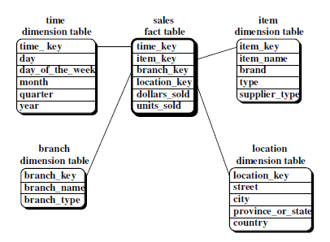

a. how many TV sets have been sold, for each brand and country, in 1997

b. In Which month Washing Machine has sold high in the year 2012

2. Perform multi-dimensional data model (Snowflake schema) using SQL queries

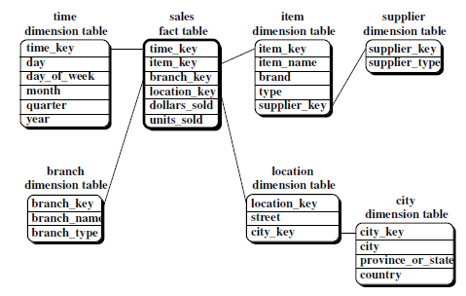

a. Find the total number of TV units sold by brand and by country for 2007.

b. Find the quarterly average sales of (Product) of the year 2005.