 | Pimpri-Chinchwad Education Trust’s  Pimpri-Chinchwad College of Engineering  (An Autonomous Institute)  Affiliated to Savitribai Phule Pune University (SPPU)  ISO 21001:2018 Certified by TUV

Assignment No 8

Name : Mahadev Suresh Jundale | Class : T.Y. IT - A
PRN No. : 125B2F007 | Subject : Design Analysis and Algorithm

Github Link: https://github.com/MAHADEVJUNDALE/DAA_ASSIGNMENT
1. Problem Statement
SwiftShip, a leading logistics company, delivers packages to many cities. To reduce fuel cost and delivery time, every truck must visit each assigned city exactly once and return to its starting city by the cheapest possible route. The task is to:
- Model the delivery network as an N × N cost matrix in which cost[i][j] is the fuel cost of driving from city i to city j, reflecting distance and road conditions.
- Design an exact algorithm based on LC (Least Cost) Branch and Bound that guarantees the least-cost tour, instead of checking all (N − 1)! permutations.
- Reduce unnecessary computation by computing lower bounds with matrix reduction and pruning every branch that cannot beat the best tour found so far.
- Respect the delivery time constraint by rejecting any partial route whose travel time already exceeds the allowed period.
The solution therefore combines a cost-matrix model with a best-first Branch and Bound search, so that SwiftShip obtains a provably optimal route for a moderate number of stops without paying the factorial cost of brute force.
2. Theory
2.1 Travelling Salesman Problem
Given n cities and a cost c(i, j) for travelling from city i to city j, the Travelling Salesman Problem (TSP) asks for a minimum-cost cycle that starts at a given city, visits every other city exactly once and returns to the start. TSP is NP-hard. A brute-force search must examine (n − 1)! tours: only 24 for five cities, but about 1.2 × 10¹⁷ for 20 cities.
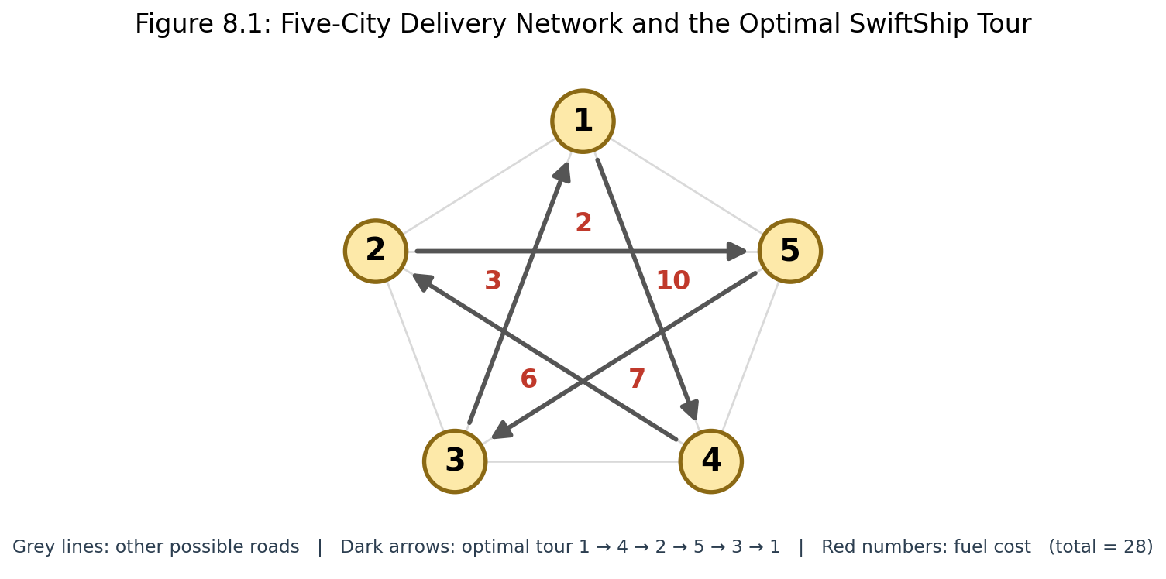
Figure 8.1: Five-city delivery network with the optimal tour highlighted
In Figure 8.1 the five cities are fully connected by roads. The dark arrows show the cheapest tour 1 → 4 → 2 → 5 → 3 → 1 with fuel costs 10 + 6 + 2 + 7 + 3 = 28. The network is described by the following cost matrix; the diagonal is ∞ because a city cannot travel to itself.
1 2 3 4 5
1 ∞ 20 30 10 11
2 15 ∞ 16 4 2
3 3 5 ∞ 2 4
4 19 6 18 ∞ 3
5 16 4 7 16 ∞

2.2 Branch and Bound with Matrix Reduction
Branch and Bound explores the solution space as a state-space tree. Every node is a partial route that starts at the start city, and its children extend that route by one more unvisited city. Each node stores the partial path, a reduced cost matrix, its level (the number of cities visited) and a lower bound lb on the cost of any complete tour that begins with that partial path.
- Branching — a node whose path ends at city u produces one child for every unvisited city v.
- Bounding — the lower bound of a child is computed from a reduced cost matrix (described below).
- Least-cost selection — a min-heap always returns the live node with the smallest lb, so the most promising branch is expanded first (best-first search).
- Pruning — a node whose lb is not smaller than the cost of the best complete tour found so far cannot lead to a better tour, so it is discarded with its whole subtree.
A matrix is reduced when every row and every column contains at least one 0 and no entry is negative. To reduce a matrix, subtract the minimum of each row from that row, then subtract the minimum of each column from that column, ignoring ∞ entries. The total amount subtracted is a valid lower bound, because every tour must leave each city once and enter each city once.
lb(root) = (sum of row minima) + (sum of column minima)
lb(child) = lb(parent) + M[u][v] + r
M = parent's reduced matrix, r = reduction cost of the child's matrix

To build the child matrix for the move u → v, row u and column v are set to ∞ because city u has been left and city v has been entered, and the cell [v][start] is set to ∞ so that the truck cannot return to the start before every city is visited. When the last city is added this cell is left alone, so the only finite entry that remains is the return edge, and the lb of that child becomes the exact cost of the complete tour.
2.3 Worked Example
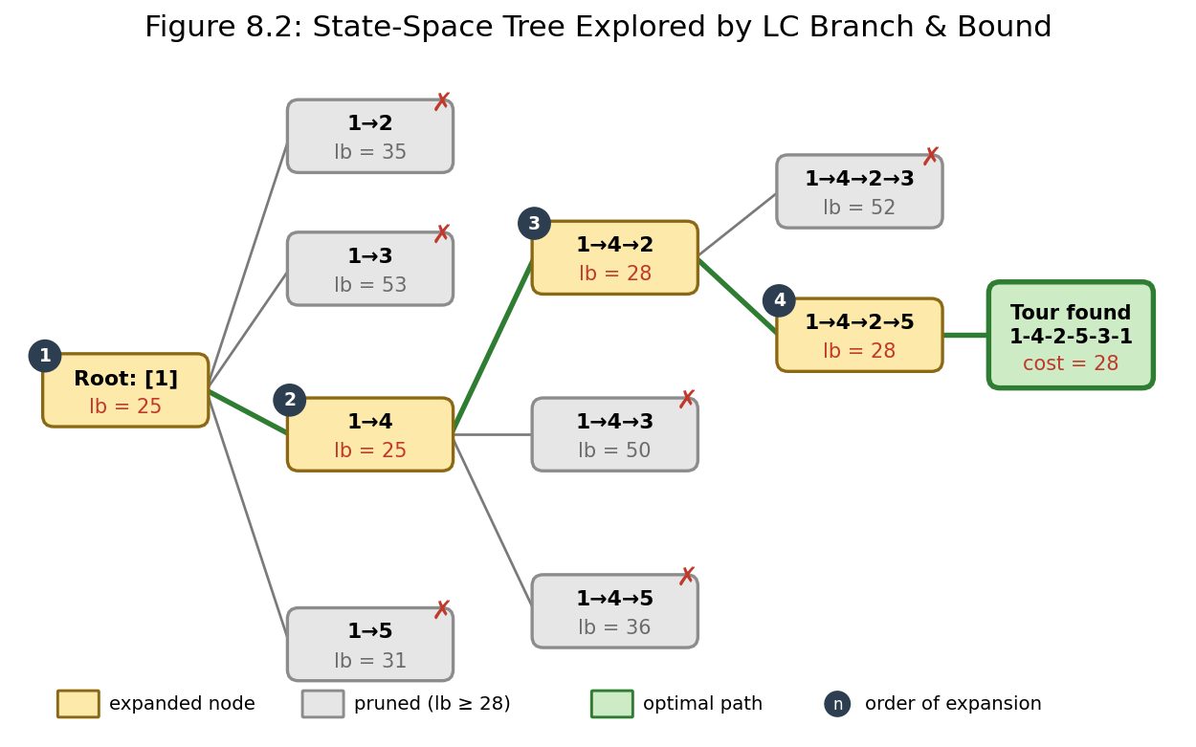
Figure 8.2: State-space tree for the five-city example (lb = lower bound)
Using the cost matrix of Section 2.1 with city 1 as the start city:
- Root: the row minima are 10, 2, 2, 3 and 4 (sum 21). After subtracting them, the column minima are 1, 0, 3, 0 and 0 (sum 4). The root bound is lb = 21 + 4 = 25.
- Level 1: the children of the root have lb = 35 for 1→2, 53 for 1→3, 25 for 1→4 and 31 for 1→5. The smallest, 1→4, is expanded next.
- Level 2: from 1→4 the children are 1→4→2 (lb = 28), 1→4→3 (lb = 50) and 1→4→5 (lb = 36). Node 1→4→2 is expanded next.
- Level 3: from 1→4→2 the children are 1→4→2→3 (lb = 52) and 1→4→2→5 (lb = 28). Node 1→4→2→5 is expanded next.
- Adding the last city 3 closes the tour 1 → 4 → 2 → 5 → 3 → 1 with exact cost 28, so bestCost = 28.
- Every node still waiting in the heap (lb = 31, 35, 36, 50, 52 and 53) is not smaller than 28 and is pruned without being expanded.
Only 4 nodes were expanded (11 nodes generated, 6 pruned) instead of examining all 24 possible tours. The result matches the program output in Section 8.
2.4 Handling the Time Constraint
SwiftShip deliveries must be completed within a given period. Along with the fuel cost matrix, the program reads a travel time matrix and a time limit. Every node remembers the elapsed time of its partial route, and a child is rejected as soon as its elapsed time (including the return leg when the last city is added) exceeds the limit. The lower bound is still based on fuel cost, so the algorithm returns the cheapest tour among all tours that meet the deadline.
2.5 Real-World Use Cases
- Logistics — planning delivery truck routes, as in SwiftShip.
- Electronics manufacturing — ordering the holes to be drilled on a circuit board to minimise tool movement.
- Warehouse automation — finding the shortest picking route for a robot or worker collecting items.
- Field services — planning meter-reading or inspection rounds that must end back at the depot.
- Tourism — planning a sightseeing trip that visits several cities once and returns home.
3. Complexity Analysis
Let n be the number of cities. Every node needs a copy and a reduction of an n × n matrix, so the bounding cost per node is O(n²). The total time depends on how many nodes survive pruning.
Case | Time Complexity | Reason
Best Case | O(n⁴) | Pruning is so strong that only one chain of about n nodes is expanded; each expansion creates up to n children at O(n²) each.
Average Case | Data dependent | The number of surviving nodes depends on how tight the bounds are; it is exponential in n but usually far below (n − 1)!.
Worst Case | O(n² · (n − 1)!) | No branch can be pruned, so the search tree has about (n − 1)! leaves and each node costs O(n²).
Space | O(n² per live node) | Every node in the heap stores its own n × n matrix; pruning keeps the heap small in practice.

4. Algorithm
- Read n, the fuel cost matrix, the travel time matrix, the time limit and the start city; set the diagonal of the cost matrix to ∞.
- Reduce the cost matrix to get the initial lower bound lb0, create the root node (path = [start], elapsed time = 0), insert it into a min-heap ordered by lb and set bestCost = ∞.
- Remove the node with the smallest lb from the heap; if its lb ≥ bestCost, discard it.
- For every unvisited city v, compute the elapsed time of extending the path to v (plus the return leg if v is the last city) and reject the child if it exceeds the time limit.
- Copy the parent matrix, set row u, column v and cell [v][start] to ∞ (the last cell is skipped for the last city), reduce it, and compute childLb = parent.lb + M[u][v] + reduction cost.
- If childLb ≥ bestCost, prune the child. If v was the last city, childLb is the exact tour cost, so update bestCost and bestPath; otherwise insert the child into the heap.
- Repeat until the heap is empty. bestPath and bestCost then hold the optimal route; if no tour was found, no route meets the time limit.
5. Flow Diagram
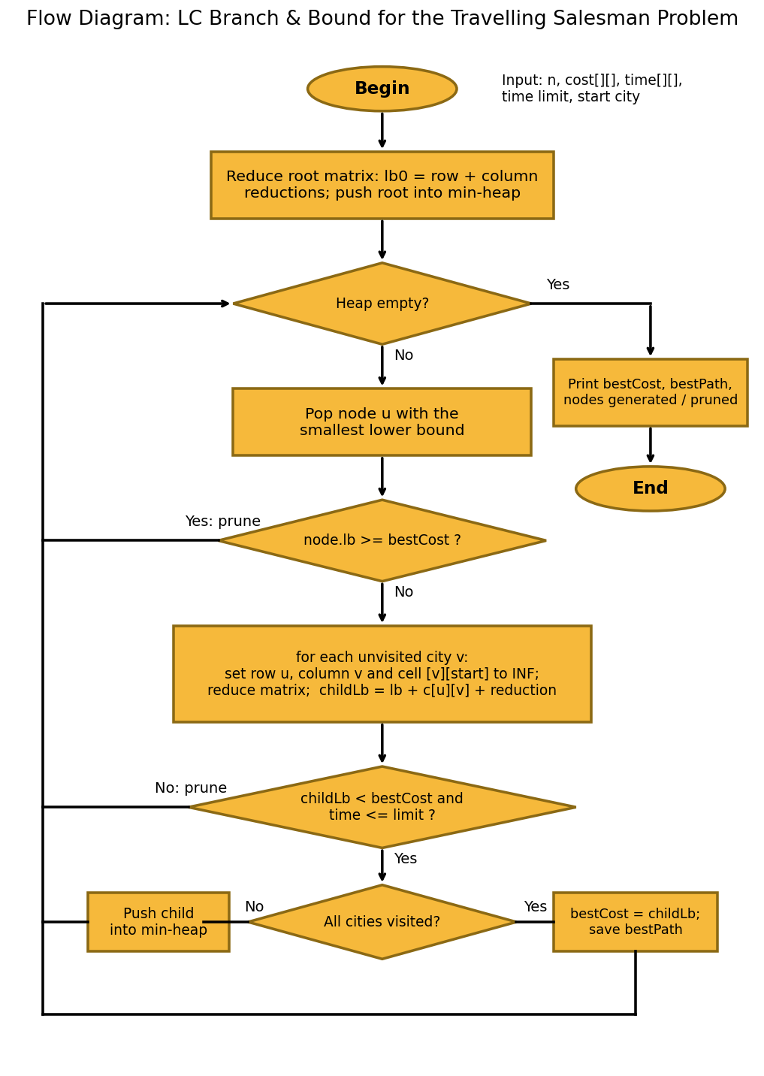
Figure 8.3: Flow diagram of the LC Branch and Bound procedure for TSP
6. Pseudo Code
// TSP - LEAST COST BRANCH AND BOUND
Algorithm TSP_LCBB(cost, time, limit, start)
set cost[i][i] ← ∞ for every city i
lb0 ← reduce(cost)
root ← Node(matrix = cost, lb = lb0, path = [start], level = 1, elapsed = 0)
bestCost ← ∞
bestPath ← null
PQ ← min-heap ordered by lb
PQ.insert(root)

while PQ is not empty do
node ← PQ.removeMin()
if node.lb ≥ bestCost then
continue // prune
end if
u ← last city of node.path
for each city v not in node.path do
last ← (node.level + 1 = N)
arrival ← node.elapsed + time[u][v]
if last then arrival ← arrival + time[v][start]
if arrival > limit then continue // time constraint
M ← copy of node.matrix
set row u and column v of M to ∞
if not last then M[v][start] ← ∞
childLb ← node.lb + node.matrix[u][v] + reduce(M)
if childLb ≥ bestCost then continue // prune
if last then
bestCost ← childLb
bestPath ← node.path + [v, start]
else
PQ.insert(Node(M, childLb, node.path + [v],
node.level + 1, node.elapsed + time[u][v]))
end if
end for
end while
return bestCost, bestPath
End Algorithm
7. JAVA Program:
import java.util.*;

public class TSPBranchAndBound {

static final int INF = 1_000_000;
static int n;
static int[][] cost, time;
static int timeLimit;
static long generated = 0, pruned = 0;

// A node of the search tree
static class Node implements Comparable<Node> {
int[][] matrix;
int lb, city, level, elapsed;
long id;
List<Integer> path;

public int compareTo(Node o) {
if (lb != o.lb) return Integer.compare(lb, o.lb);
if (level != o.level) return Integer.compare(o.level, level);
return Long.compare(id, o.id);
}
}

// Row and column reduction. Returns the total amount subtracted.
static int reduce(int[][] m) {
int total = 0;
for (int i = 0; i < n; i++) {
int min = INF;
for (int j = 0; j < n; j++) min = Math.min(min, m[i][j]);
if (min != INF && min > 0) {
for (int j = 0; j < n; j++) if (m[i][j] != INF) m[i][j] -= min;
total += min;
}
}
for (int j = 0; j < n; j++) {
int min = INF;
for (int i = 0; i < n; i++) min = Math.min(min, m[i][j]);
if (min != INF && min > 0) {
for (int i = 0; i < n; i++) if (m[i][j] != INF) m[i][j] -= min;
total += min;
}
}
return total;
}

static int[][] copy(int[][] m) {
int[][] c = new int[n][];
for (int i = 0; i < n; i++) c[i] = m[i].clone();
return c;
}

static void solve(int start) {
int bestCost = INF;
List<Integer> bestPath = null;
long seq = 0;

int[][] rootMatrix = copy(cost);
for (int i = 0; i < n; i++) rootMatrix[i][i] = INF;

Node root = new Node();
root.matrix = rootMatrix;
root.lb = reduce(rootMatrix);
root.city = start;
root.level = 1;
root.elapsed = 0;
root.id = seq++;
root.path = new ArrayList<>(List.of(start));
generated++;

PriorityQueue<Node> pq = new PriorityQueue<>();
pq.add(root);

while (!pq.isEmpty()) {
Node node = pq.poll();
if (node.lb >= bestCost) { pruned++; continue; }

int u = node.city;
for (int v = 0; v < n; v++) {
if (node.path.contains(v)) continue;

int arrival = node.elapsed + time[u][v];
boolean last = (node.level + 1 == n);
if (last) arrival += time[v][start];
generated++;
if (arrival > timeLimit) { pruned++; continue; }

int[][] m = copy(node.matrix);
int edge = node.matrix[u][v];
for (int k = 0; k < n; k++) { m[u][k] = INF; m[k][v] = INF; }
if (!last) m[v][start] = INF;
int childLb = node.lb + edge + reduce(m);

if (childLb >= bestCost) { pruned++; continue; }

if (last) {
bestCost = childLb;
bestPath = new ArrayList<>(node.path);
bestPath.add(v);
bestPath.add(start);
continue;
}

Node child = new Node();
child.matrix = m;
child.lb = childLb;
child.city = v;
child.level = node.level + 1;
child.elapsed = node.elapsed + time[u][v];
child.id = seq++;
child.path = new ArrayList<>(node.path);
child.path.add(v);
pq.add(child);
}
}

if (bestPath == null) {
System.out.println("No feasible route exists within the time limit.");
return;
}
int totalTime = 0;
StringBuilder route = new StringBuilder();
for (int i = 0; i < bestPath.size(); i++) {
route.append(bestPath.get(i) + 1);
if (i + 1 < bestPath.size()) {
route.append(" -> ");
totalTime += time[bestPath.get(i)][bestPath.get(i + 1)];
}
}
System.out.println();
System.out.println("Minimum Fuel Cost: " + bestCost);
System.out.println("Optimal Delivery Route: " + route);
System.out.println("Total Travel Time: " + totalTime + " hours");
System.out.println("Nodes generated: " + generated
+ ", Nodes pruned: " + pruned);
}

public static void main(String[] args) {
Scanner sc = new Scanner(System.in);
System.out.print("Enter number of cities: ");
n = sc.nextInt();

cost = new int[n][n];
time = new int[n][n];
System.out.println("Enter fuel cost matrix (" + n + " x " + n
+ "), use 0 on the diagonal:");
for (int i = 0; i < n; i++)
for (int j = 0; j < n; j++) cost[i][j] = sc.nextInt();

System.out.println("Enter travel time matrix in hours ("
+ n + " x " + n + "):");
for (int i = 0; i < n; i++)
for (int j = 0; j < n; j++) time[i][j] = sc.nextInt();

System.out.print("Enter maximum allowed time (hours): ");
timeLimit = sc.nextInt();
System.out.print("Enter starting city (1-" + n + "): ");
int start = sc.nextInt() - 1;

solve(start);
sc.close();
}
}
8. Sample Input and Output
Sample 1 – Input:
Enter number of cities: 5
Enter fuel cost matrix (5 x 5), use 0 on the diagonal:
0 20 30 10 11
15 0 16 4 2
3 5 0 2 4
19 6 18 0 3
16 4 7 16 0
Enter travel time matrix in hours (5 x 5):
0 4 6 2 3
4 0 5 1 2
6 5 0 2 3
2 1 2 0 1
3 2 3 1 0
Enter maximum allowed time (hours): 40
Enter starting city (1-5): 1
Output:
Minimum Fuel Cost: 28
Optimal Delivery Route: 1 -> 4 -> 2 -> 5 -> 3 -> 1
Total Travel Time: 14 hours
Nodes generated: 11, Nodes pruned: 6

Sample 2 – Input (same matrices, time limit reduced to 13 hours):
Enter maximum allowed time (hours): 13
Enter starting city (1-5): 1
Output:
Minimum Fuel Cost: 41
Optimal Delivery Route: 1 -> 5 -> 3 -> 4 -> 2 -> 1
Total Travel Time: 13 hours
Nodes generated: 30, Nodes pruned: 14

In Sample 2 the cheapest tour of Sample 1 needs 14 hours, so it is rejected by the time constraint and the program returns the cheapest tour that fits within 13 hours.
9. Comparison with Other Design Strategies
The Travelling Salesman Problem can also be solved by brute force or by Dynamic Programming (the Held–Karp method). The table compares them with LC Branch and Bound.
Aspect | Brute Force | Dynamic Programming (Held–Karp) | LC Branch and Bound
Approach | Generates and costs every one of the (n − 1)! tours | Stores the best cost for every (subset of cities, last city) state | Best-first search with lower bounds; prunes branches that cannot win
Optimality | Guaranteed optimal | Guaranteed optimal | Guaranteed optimal
Time Complexity | O(n!) | O(n² · 2ⁿ), with O(n · 2ⁿ) memory | O(n²·(n − 1)!) worst case, usually far less
Suitability | Only for very small n | Good for moderate n, but memory grows as 2ⁿ | Comfortable for about 12–16 cities; time limits are easy to add

For SwiftShip, where the number of stops per route is moderate, exact optimality is required and a delivery deadline must be honoured, LC Branch and Bound is a good fit: it keeps the optimality of brute force, avoids most of its work through pruning, and handles the time limit with one extra check per node. Greedy heuristics such as nearest neighbour are faster but give no guarantee that the route is optimal.
10. Advantages of the Branch and Bound Approach
- Guarantees the least-cost tour, unlike greedy or other heuristic methods.
- Matrix-reduction bounds prune large parts of the search tree, so far fewer than (n − 1)! tours are examined.
- Best-first selection tends to reach a good complete tour early, which gives a tight bestCost for pruning the rest.
- Works with asymmetric costs (cost[i][j] may differ from cost[j][i]), as on real roads with varying fuel consumption.
- The time constraint is added with one simple check on every partial route.
11. Limitations
- The worst-case time is still factorial, so the method does not scale to large instances (for example 20 or more cities) unless pruning is very effective.
- Every live node stores an n × n matrix, so the memory used by the priority queue can grow very large.
- For very large route sets or real-time routing, heuristics such as 2-opt or metaheuristics are more practical than an exact method.
12. Result
The Travelling Salesman Problem was implemented in Java using LC Branch and Bound with matrix reduction. For the five-city sample, the program found the minimum fuel cost of 28 with the route 1 → 4 → 2 → 5 → 3 → 1 after generating 11 nodes and pruning 6, which matches the worked example in Section 2.3. With the time limit reduced to 13 hours it returned the cheapest feasible route, which costs 41, and it reports when no route satisfies the limit.
13. Conclusion
LC Branch and Bound with a reduced cost matrix gives an exact algorithm for the Travelling Salesman Problem that explores far fewer routes than naive permutation enumeration, because strong lower bounds and best-first expansion let it discard hopeless branches early. It suits SwiftShip when the number of stops per route is moderate and exact optimality is required, for example for high-cost deliveries or deadline-bound routes. For larger route sets or real-time routing, exact Branch and Bound can be used for the critical sub-routes while heuristics provide scalability.
14. Program Execution Screenshot
The following screenshot shows the Java program being compiled and executed in the terminal, using Sample 1 from Section 8.
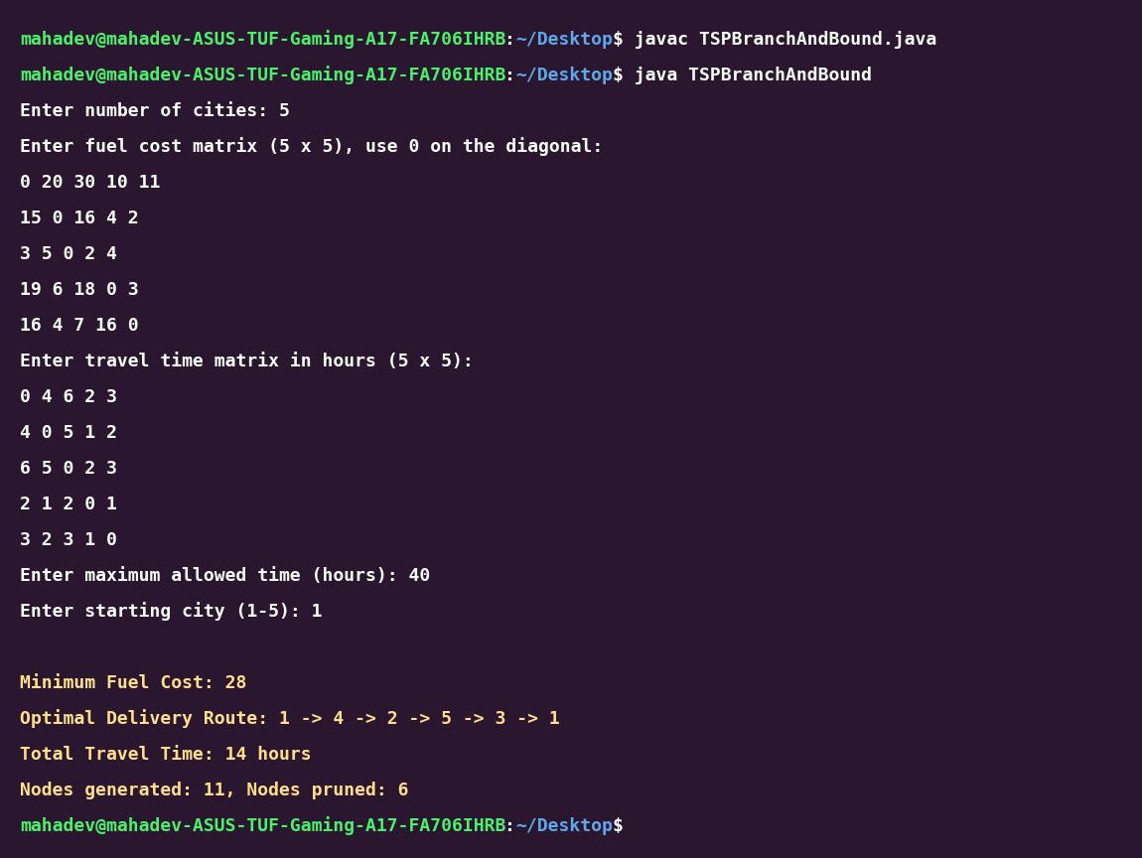
Figure 8.4: Terminal screenshot showing compilation and execution of TSPBranchAndBound.java
15. Explanation of the Program
- Data structures: cost[][] and time[][] store the fuel cost and travel time between cities. The Node class holds the reduced matrix, lower bound, current city, level, elapsed time and path, and a PriorityQueue<Node> ordered by lb (ties go to the deeper node, then to the older one) works as the min-heap.
- reduce(): subtracts the minimum of every row and then of every column from the matrix (ignoring ∞), changes the matrix in place and returns the total subtracted, which is the reduction cost.
- solve(): builds the root node, then repeatedly takes the node with the smallest lb, prunes it if lb ≥ bestCost, and creates one child for every unvisited city.
- Child creation: the matrix is copied, row u, column v and cell [v][start] are set to ∞, and childLb = parent.lb + edge cost + reduction cost. Children that break the time limit or cannot beat bestCost are pruned.
- Closing the tour: when the last city is added, the return edge is the only finite entry left, so childLb is the exact tour cost and bestCost and bestPath are updated.
- Output: the program prints the minimum fuel cost, the route, the total travel time and the number of nodes generated and pruned; if no tour fits within the time limit it prints a message saying that no feasible route exists.

