 | Pimpri-Chinchwad Education Trust's  Pimpri-Chinchwad College of Engineering  (An Autonomous Institute)  Affiliated to Savitribai Phule Pune University  (SPPU) ISO 21001:2018 Certified by TUV
Assignment No 4: Dijkstra's Algorithm using Greedy Technique

Name : Mahadev Suresh Jundale | PRN : 125B2F007
Subject: Design and Analysis of Algorithms | Batch: TY- A4

Github Link

1. Problem Statement:
A smart city is implementing an intelligent traffic management system to assist ambulances in reaching hospitals as quickly as possible. The city’s road network is represented as a graph, where intersections or junctions are represented as nodes and roads are represented as edges. Each road has a weight representing its travel time in minutes, considering current traffic congestion.
An ambulance is currently at Source (S) and needs to reach the nearest hospital (Destination D) in the shortest possible time. Since traffic conditions can change dynamically, the weight of road segments may increase or decrease in real time. The system must therefore calculate efficient routes and update the route when traffic conditions change.

2. Goals:
- Implement Dijkstra’s algorithm to find the shortest path from the ambulance’s current location (S) to all possible hospitals.
- Account for dynamic traffic conditions by updating road weights and recalculating the shortest path when traffic changes.
- Optimize the system to work efficiently for a large city containing thousands of intersections and roads.
- Provide a visual representation of the optimal path so that the ambulance can follow the quickest route to the hospital.
- Minimize emergency response time by continuously selecting the route with the lowest estimated travel time.

3. Course Objectives:
- To understand the basics of computational complexity of various algorithms.
- To select appropriate algorithm design strategies to solve real-world shortest-path problems.
- To apply graph-based algorithms to practical transportation and navigation problems.

4. Course Outcomes:
After learning the course, students will be able to:
- Analyze the asymptotic performance of algorithms.
- Solve computational problems by applying suitable algorithmic paradigms.
- Apply graph algorithms such as Dijkstra’s algorithm to real-world shortest-path problems.

5. Theory
The Smart Traffic Management problem can be modeled using a weighted graph. In this graph, intersections are represented as vertices and roads connecting intersections are represented as edges. The weight of each edge represents the estimated travel time in minutes. The objective is to find the shortest travel-time path from the ambulance’s source node S to hospital destinations.

Dijkstra’s Algorithm
Dijkstra’s algorithm is a greedy shortest-path algorithm used to find the minimum distance from a source vertex to all other vertices in a weighted graph with non-negative edge weights. In this scenario, the edge weights represent travel times, which are non-negative.

Working of Dijkstra’s Algorithm
- Initialize the distance of the source S to 0 and all other vertices to infinity.
- Use a priority queue to select the unvisited vertex having the smallest current distance.
- For each neighboring vertex, calculate a new possible distance through the selected vertex.
- If the new distance is smaller than the currently recorded distance, update the distance and predecessor.
- Repeat the process until all reachable vertices are processed or the required hospital destinations are determined.
- Use predecessor information to reconstruct the shortest route from S to the selected hospital.

Dynamic Traffic Weight Updates
In a real smart-city system, traffic conditions may change while the ambulance is travelling. Therefore, the weight of a road may be updated according to congestion, accidents, road closures, or other traffic events.
When an important edge weight changes, Dijkstra’s algorithm can be run again from the ambulance’s current location to obtain an updated shortest path.
- Receive updated travel-time information for affected roads.
- Update the corresponding edge weights in the graph.
- Recalculate the shortest distances from the ambulance’s current location when required.
- Compare the newly calculated route with the current route.
- Switch to the new route if it provides a lower estimated travel time.

Working of the Algorithm
- Represent the city road network as a weighted graph.
- Store roads using an adjacency list for efficient processing of large graphs.
- Set the ambulance location S as the source vertex.
- Initialize distance[S] = 0 and all other distances to infinity.
- Select the vertex with the minimum distance using a min-priority queue.
- Relax all outgoing edges from the selected vertex.
- Store the predecessor of every updated vertex to reconstruct the path.
- Continue until all required hospital vertices have their shortest distances.
- Select the hospital with the minimum travel time.
- When traffic weights change, update the affected edges and recompute the route.
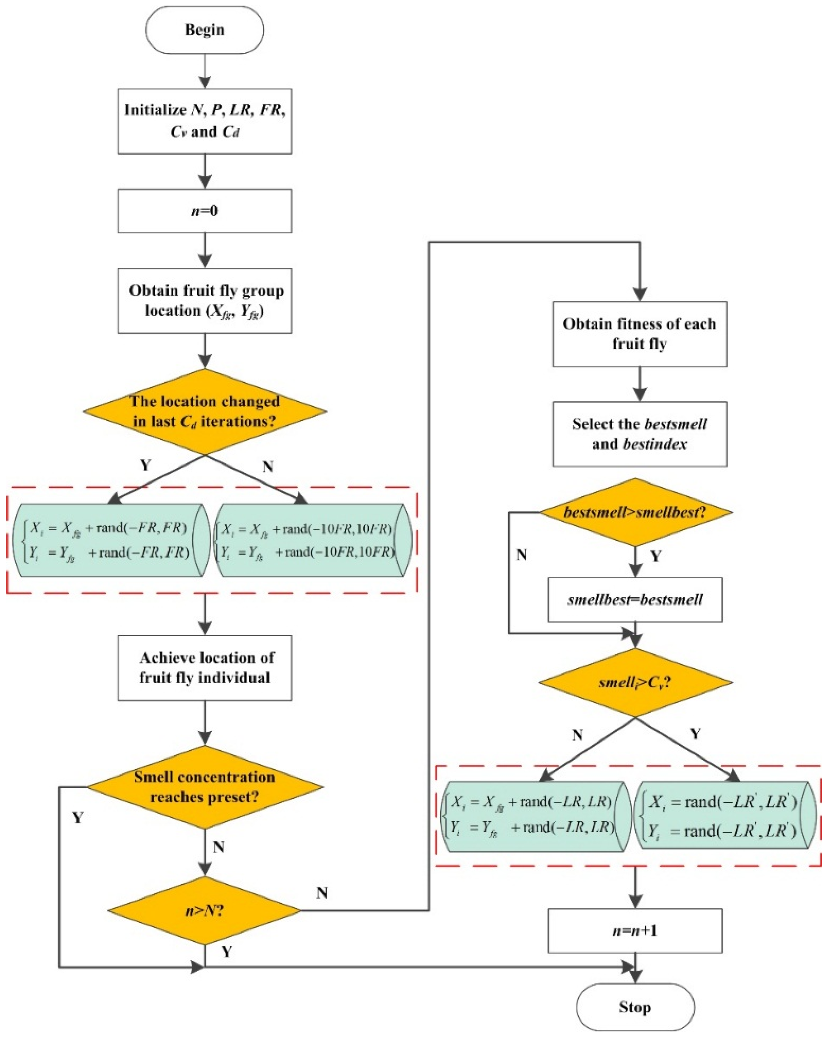

6. Time and Space Complexity
- Graph representation using adjacency list: O(V + E) space.
- Dijkstra’s algorithm using a binary min-heap: O((V + E) log V).
- Distance and predecessor arrays: O(V) space.
- Total auxiliary space: O(V + E).
- When traffic conditions change, the shortest path may need to be recalculated from the ambulance’s current location.
Where:
- V = Number of intersections/vertices
- E = Number of roads/edges

7. Pseudo code
ALGORITHM FindNearestHospital(Graph, S, Hospitals)

Input:
Graph = weighted road network
S = ambulance source location
Hospitals = list of hospital nodes

Output:
Nearest hospital and minimum travel time

1. V ← number of vertices in Graph

2. for each vertex v in Graph do
3. dist[v] ← ∞
4. end for

5. dist[S] ← 0

6. Create an empty min-priority queue PQ

7. Insert (0, S) into PQ

8. while PQ is not empty do

9. (d, u) ← extract minimum from PQ

10. if d > dist[u] then
11. continue
12. end if

13. for each edge (u, v, w) in Graph[u] do

14. newDistance ← dist[u] + w

15. if newDistance < dist[v] then
16. dist[v] ← newDistance
17. Insert (dist[v], v) into PQ
18. end if

19. end for

20. end while

21. minTime ← ∞
22. nearestHospital ← -1

23. for each hospital h in Hospitals do

24. if dist[h] < minTime then
25. minTime ← dist[h]
26. nearestHospital ← h
27. end if

28. end for

29. if nearestHospital = -1 OR minTime = ∞ then
30. Display "No hospital reachable"
31. else
32. Display nearestHospital and minTime
33. end if

END ALGORITHM

6. Example:
Consider the following road network:
Source (S) = A
Hospital destinations = D and F
Road | Travel Time (min) | Status
A → B | 4 | Open
A → C | 2 | Open
B → D | 5 | Open
C → B | 1 | Open
C → E | 8 | Open
E → F | 2 | Open
D → F | 3 | Open

Step 1: Initial Shortest-Path Calculation
- From A, the direct travel time to B is 4 minutes and to C is 2 minutes.
- The route A → C → B has travel time 2 + 1 = 3 minutes, which is shorter than A → B.
- The route A → C → B → D has travel time 2 + 1 + 5 = 8 minutes.
- The route A → C → B → D → F has travel time 8 + 3 = 11 minutes.
- The route A → C → E → F has travel time 2 + 8 + 2 = 12 minutes.

Therefore:
Shortest path to Hospital D:
A → C → B → D
Minimum travel time = 8 minutes
Shortest path to Hospital F:
A → C → B → D → F
Minimum travel time = 11 minutes
Hence, Hospital D is the nearest hospital with a travel time of 8 minutes.

Step 2: Dynamic Traffic Update
Suppose heavy traffic increases the travel time of road B → D from 5 minutes to 10 minutes.
The previous route becomes:
A → C → B → D
Travel time:
2 + 1 + 10 = 13 minutes
The alternative route is:
A → C → E → F
Travel time:
2 + 8 + 2 = 12 minutes
Therefore, after updating the road weight and recalculating the shortest path, the system can select the faster alternative route:
Updated route to Hospital F:
A → C → E → F
Updated travel time = 12 minutes

7. Output:
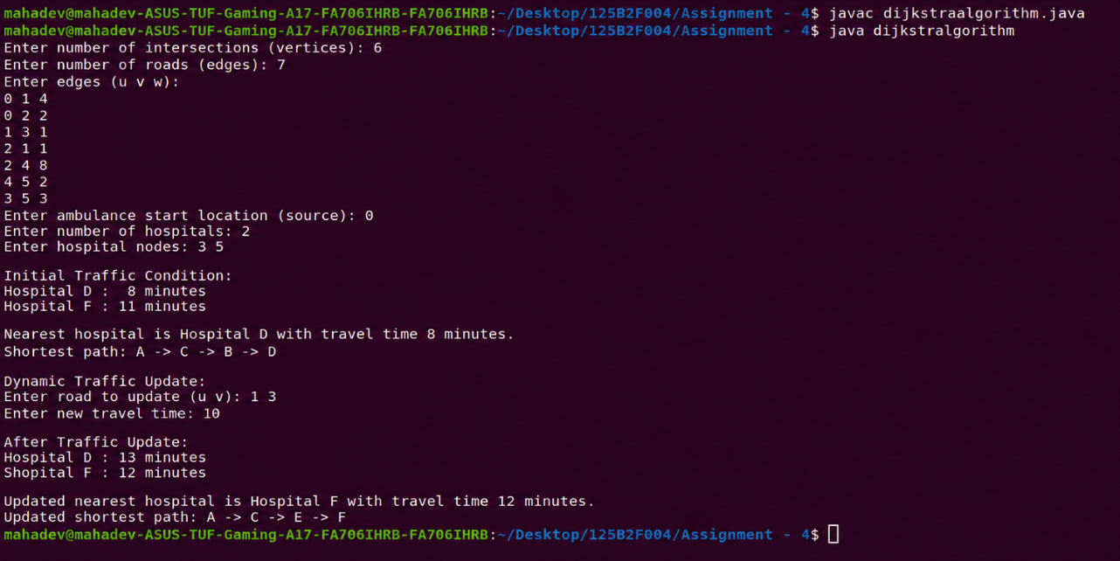

8. Conclusion:
Dijkstra’s algorithm provides an efficient method for finding the shortest travel-time routes in a smart traffic management system when road weights are non-negative. By modeling intersections as vertices and roads as weighted edges, the system can identify the quickest route from an ambulance to multiple hospitals.
Dynamic traffic updates can be incorporated by modifying affected edge weights and recalculating the shortest path. Using an adjacency list and priority queue makes the approach suitable for large city road networks. A visual route representation further helps ambulance drivers follow the optimal path and reduces emergency response time.

