 | Pimpri-Chinchwad Education Trust’s  Pimpri-Chinchwad College of Engineering  (An Autonomous Institute)  Affiliated to Savitribai Phule Pune University (SPPU)  ISO 21001:2018 Certified by TUV

Assignment No 5

Name : Mahadev Suresh Jundale | Class : T.Y. IT - A
PRN No. : 125B2F007 | Subject : Design Analysis and Algorithm

Github Link: https://github.com/MAHADEVJUNDALE/DAA_ASSIGNMENT/tree/main/Assignment5
1. Problem Statement
SwiftCargo, a logistics company, delivers packages across multiple cities through a network of warehouses, transit hubs and final delivery points. To optimise its deliveries, the transportation network is organised into a sequence of stages, and every package must travel from the source stage to the destination stage by passing through exactly one node in each intermediate stage. The task is to:
- Model the transportation network as a directed, weighted multistage graph with several intermediate stages.
- Design an efficient algorithm, based on Dynamic Programming, that finds the minimum-cost delivery route from the source to the destination.
- Ensure the approach scales to large networks containing thousands of cities and routes.
- Allow the route selection to be re-evaluated when real-time factors such as traffic, weather delays or fuel efficiency change the edge costs.
The solution should therefore combine a clear graph model with a provably optimal, bottom-up Dynamic Programming procedure that is fast enough for large-scale, real-time logistics planning.
2. Theory
2.1 Multistage Graph
A multistage graph is a directed graph G = (V, E) in which the vertex set V is partitioned into k disjoint stages V₁, V₂, …, Vₖ, such that every edge connects a vertex of some stage Vᵢ only to a vertex of the immediately following stage Vᵢ₊₁. The first stage contains a single source vertex and the last stage contains a single sink (destination) vertex. Each edge carries a non-negative weight representing the cost, time or distance of moving between the two vertices it joins.
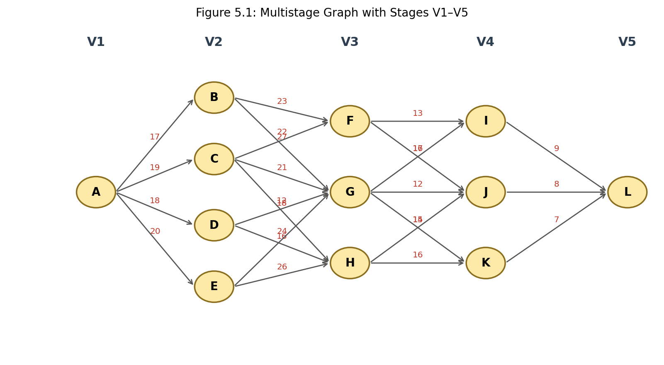
Figure 5.1: A multistage graph partitioned into five disjoint stages (V1 – V5)
In the graph above, stage V1 = {A} is the single source, V2 = {B, C, D, E}, V3 = {F, G, H}, V4 = {I, J, K}, and V5 = {L} is the single sink. Every directed edge moves a package from a city in one stage to a city in the next stage, and the number on the edge is the cost of using that route. A complete delivery route is therefore a path A → … → L that touches exactly one vertex of every intermediate stage — this stage-by-stage structure is what makes the graph “multistage”.
The objective is to find the minimum-cost path from the source to the sink. Because the graph is acyclic and every path from source to sink has optimal substructure (the best route to the sink through a given node depends only on the best routes available from that node onward), this problem is a classic application of Dynamic Programming.
2.2 Dynamic Programming Formulation
Dynamic Programming (DP) solves a problem by breaking it into smaller, overlapping sub-problems, solving each sub-problem exactly once, and reusing the stored result whenever the same sub-problem reappears. Two properties make the multistage shortest-path problem well suited to DP:
- Optimal substructure — the cheapest route from any vertex v to the sink is built from the cheapest routes available from v's successors.
- Overlapping sub-problems — the same intermediate vertex is often reachable from several predecessors, so its minimum cost to the sink would otherwise be recomputed many times.
Working backward from the sink avoids this recomputation entirely. If cost(v) denotes the minimum cost of travelling from vertex v to the sink L, then:
cost(L) = 0
cost(v) = min over every edge (v, j) of { weight(v, j) + cost(j) }
Processing the stages from the last one back to the first guarantees that cost(j) is already known whenever cost(v) is being computed, so each vertex is evaluated only once. A companion array next[v] records which successor produced the minimum, which lets the optimal path be reconstructed by walking forward from the source once the backward pass is complete.
2.3 Worked Example
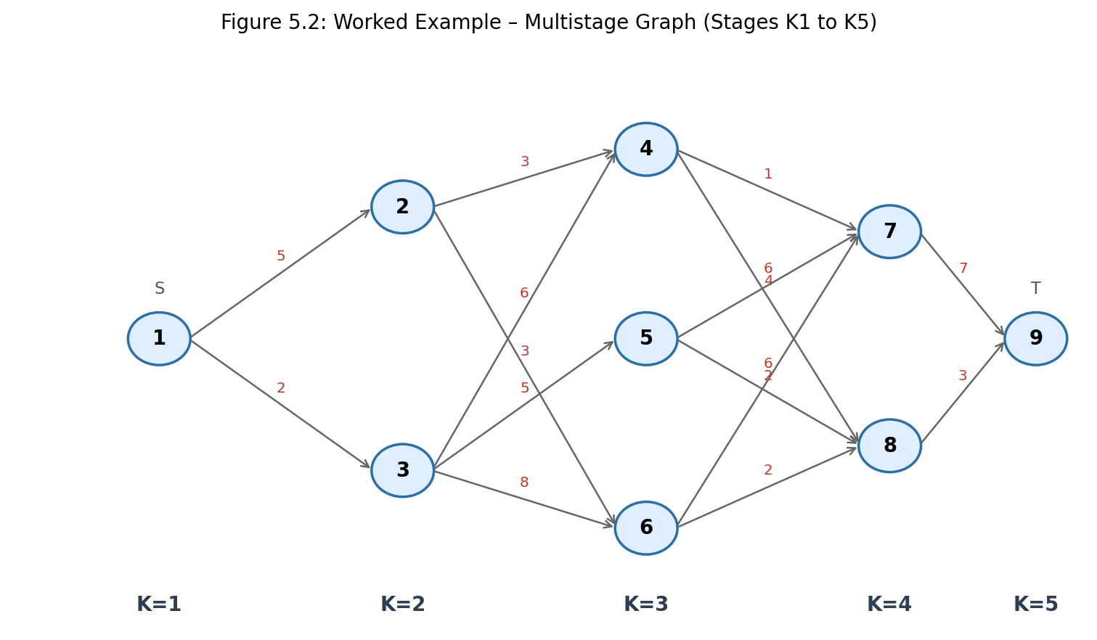
Figure 5.2: Worked example – nodes 1–9 arranged in stages K1 to K5
Applying the backward recurrence stage by stage:
- Stage K−3 → K−2: cost(4) = min{1+7, 4+3} = 7, cost(5) = min{6+7, 2+3} = 5, cost(6) = min{6+7, 2+3} = 5
- Stage K−4 → K−3: cost(2) = min{3+7, 3+5} = 8, cost(3) = min{6+7, 5+5, 8+5} = 10
- Stage K−5 → K−4: cost(1) = min{5+8, 2+10} = 12
Tracing next[] forward from node 1 gives the minimum-cost route 1 → 3 → 5 → 8 → 9 with a total cost of 12, which matches the sample program output in Section 8.
2.4 Real-World Use Cases
- Logistics — routing parcels through warehouses and transit hubs, as in SwiftCargo.
- Manufacturing — sequencing stage-wise production steps to minimise cost or time.
- Network routing — forwarding data packets through layered network protocols.
- Speech and language processing — choosing the most likely word sequence stage by stage.
- Finance — planning investment decisions across successive time periods.
3. Complexity Analysis
Let the graph contain n vertices and e edges, arranged in k stages. The backward DP pass visits every vertex once and relaxes every outgoing edge of that vertex exactly once, so the total work is proportional to the number of edges plus the number of vertices.
Case | Time Complexity | Reason
Best Case | O(n + e) | Every vertex and edge is still examined once, even on a sparse graph.
Average Case | O(n + e) | Each edge contributes exactly one relaxation during the backward pass.
Worst Case | O(n + e) | A dense multistage graph still performs one pass over all vertices and edges.
Space | O(n) | Arrays cost[] and next[] each store one entry per vertex.

4. Algorithm
- Read the graph as a list of directed, weighted edges and group the vertices into their stages.
- Initialise cost[sink] = 0 and next[sink] = − 1 (no successor).
- Process the remaining vertices in reverse stage order, from the stage just before the sink back to the source.
- For every vertex v in the current stage, examine each outgoing edge (v, j) and set cost[v] = min( weight(v, j) + cost[j] ), recording the minimising j in next[v].
- After every vertex has been processed, cost[source] holds the minimum total cost.
- Reconstruct the optimal route by following next[] forward from the source until the sink is reached.
5. Flow Diagram
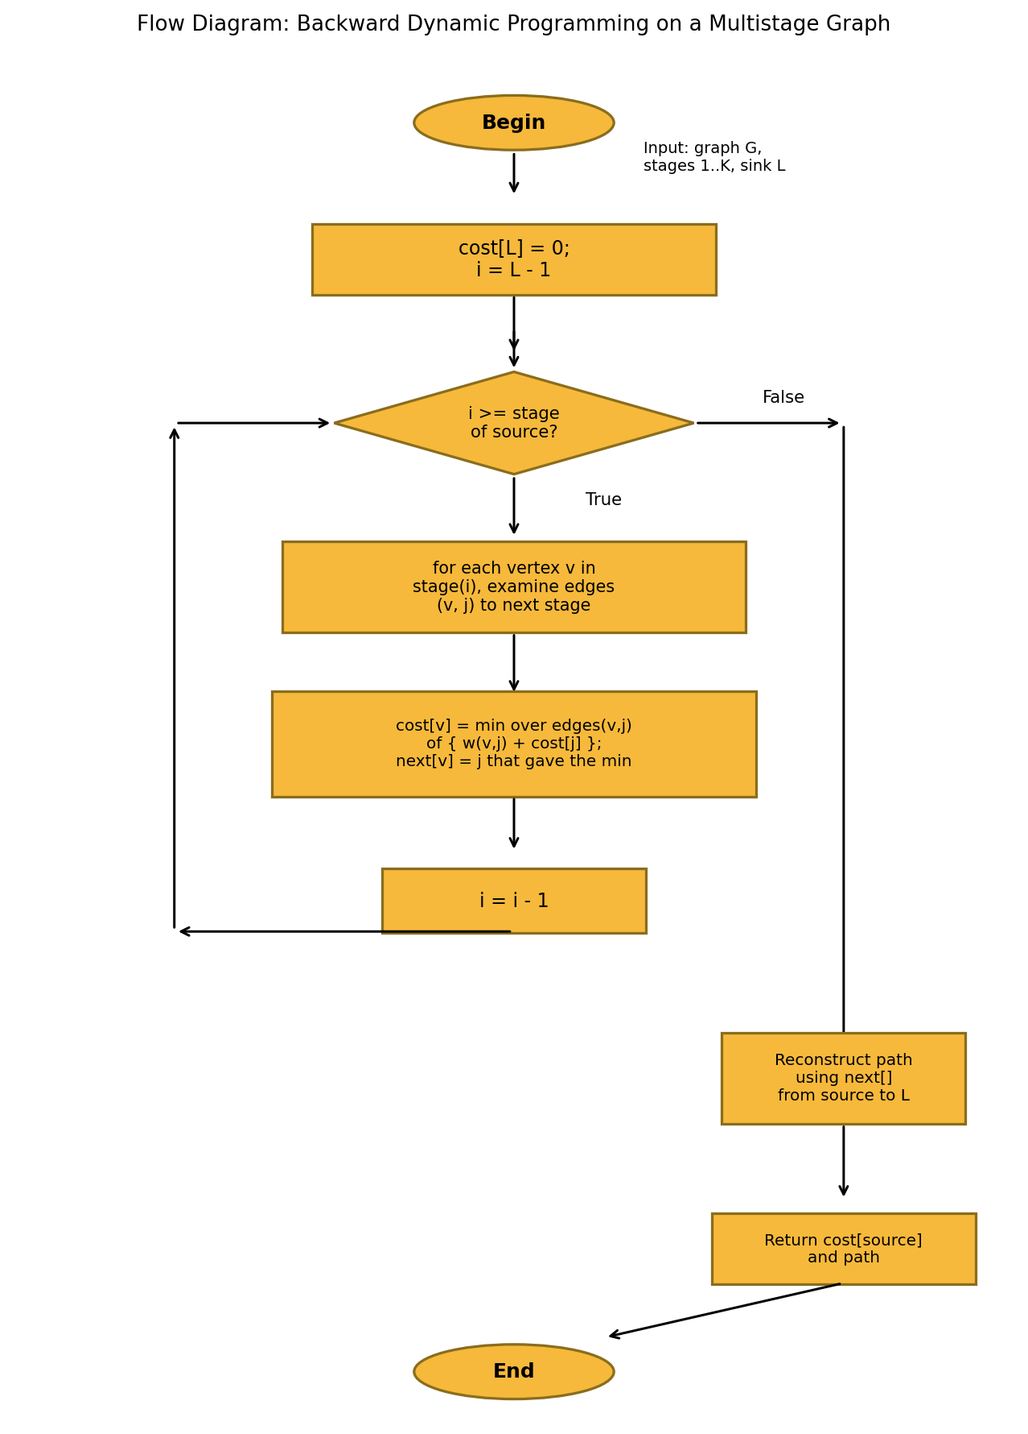
Figure 5.3: Flow diagram of the backward Dynamic Programming procedure
6. Pseudo Code
// MULTISTAGE GRAPH - SHORTEST ROUTE (BACKWARD DP)
Algorithm MultistageGraph(graph, stages, source, sink)

cost[sink] ← 0
next[sink] ← -1

for i ← (stage of sink) - 1 down to (stage of source) do
for each vertex v in stage i do
cost[v] ← ∞
for each edge (v, j, weight) in graph do
if weight + cost[j] < cost[v] then
cost[v] ← weight + cost[j]
next[v] ← j
end if
end for
end for
end for

// Reconstruct path
path ← [source]
v ← source
while v ≠ sink do
v ← next[v]
append v to path
end while

return cost[source], path
End Algorithm
7. JAVA Program:
import java.util.*;

public class MultistageGraph {

// Compute minimum cost from source to sink using backward DP
static int solve(int n, List<int[]>[] adj, int source, int sink,
long[] cost, int[] next) {
Arrays.fill(cost, Long.MAX_VALUE);
cost[sink] = 0;

for (int v = sink - 1; v >= source; v--) {
for (int[] edge : adj[v]) {
int to = edge[0];
int weight = edge[1];
if (cost[to] != Long.MAX_VALUE && weight + cost[to] < cost[v]) {
cost[v] = weight + cost[to];
next[v] = to;
}
}
}
return 0;
}

public static void main(String[] args) {
Scanner sc = new Scanner(System.in);

System.out.print("Enter number of stages: ");
int stages = sc.nextInt();

System.out.print("Enter total number of vertices: ");
int n = sc.nextInt();

System.out.print("Enter total number of edges: ");
int m = sc.nextInt();

List<int[]>[] adj = new List[n + 1];
for (int i = 1; i <= n; i++) adj[i] = new ArrayList<>();

System.out.println("Enter edges (u v weight):");
for (int i = 0; i < m; i++) {
int u = sc.nextInt(), v = sc.nextInt(), w = sc.nextInt();
adj[u].add(new int[]{v, w});
}

System.out.print("Enter source vertex: ");
int source = sc.nextInt();
System.out.print("Enter sink vertex: ");
int sink = sc.nextInt();

long[] cost = new long[n + 1];
int[] next = new int[n + 1];
Arrays.fill(next, -1);

solve(n, adj, source, sink, cost, next);

System.out.println();
System.out.println("Minimum Delivery Cost: " + cost[source]);
System.out.print("Optimal Delivery Route: ");
int v = source;
StringBuilder route = new StringBuilder();
while (v != -1) {
route.append(v);
if (v != sink) route.append(" -> ");
v = next[v];
}
System.out.println(route);
sc.close();
}
}
8. Sample Input and Output
Input:
Enter number of stages: 5
Enter total number of vertices: 9
Enter total number of edges: 15
Enter edges (u v weight):
1 2 5
1 3 2
2 4 3
2 6 3
3 4 6
3 5 5
3 6 8
4 7 1
4 8 4
5 7 6
5 8 2
6 7 6
6 8 2
7 9 7
8 9 3
Enter source vertex: 1
Enter sink vertex: 9
Output:
Minimum Delivery Cost: 12
Optimal Delivery Route: 1 -> 3 -> 5 -> 8 -> 9
9. Comparison with Other Design Strategies
The same shortest-route problem can, in principle, be approached with a Greedy method or with Backtracking. The table below compares the three strategies for a multistage graph.
Aspect | Greedy | Backtracking | Dynamic Programming
Decision making | Picks the locally cheapest edge at each stage | Explores every possible route and discards invalid/costly ones | Builds the solution from previously computed optimal sub-results
Optimality | Not guaranteed optimal | Optimal, but explores many redundant paths | Guaranteed optimal for this problem
Time Complexity | O(n) (fast but unreliable) | Exponential in the worst case | O(n + e)
Suitability | Unsuitable — a locally cheap edge can lead to an expensive stage later | Unsuitable for large graphs | Well suited — scales to thousands of nodes

For a logistics network with thousands of cities and routes, Dynamic Programming is the clear choice: it guarantees the minimum-cost route and still runs in time proportional to the size of the network, unlike Backtracking, and unlike Greedy it never sacrifices optimality for a short-sighted local choice.
10. Advantages of the Dynamic Programming Approach
- Guarantees the minimum-cost route across the entire multistage network.
- Runs in time proportional to the number of vertices and edges — scales to thousands of cities and routes.
- Avoids recomputation by solving each sub-problem exactly once (no overlapping work, unlike plain recursion).
- The next[] array lets the full optimal path be reconstructed, not just its cost.
- Easy to re-run when edge weights change due to traffic, weather or fuel-cost updates.
11. Limitations
- Requires the full graph (or at least the relevant stages) to be known before the backward pass can start.
- Needs O(n) extra memory for the cost[] and next[] arrays.
- Assumes the graph is acyclic and cleanly divided into stages; a graph that does not fit this structure needs a general shortest-path algorithm instead.
12. Result
The multistage graph shortest-route problem was implemented in Java using backward Dynamic Programming. The program reads the stage-wise directed graph, computes the minimum delivery cost from the source to the sink, and reconstructs the optimal delivery route, matching the worked example in Section 2.3.
13. Conclusion
Multistage graphs offer a natural way to model logistics networks that progress through well-defined stages such as warehouses, transit hubs and delivery points. Dynamic Programming solves the associated shortest-route problem efficiently by computing each vertex’s minimum cost to the sink exactly once, working backward from the destination. Compared with Greedy and Backtracking strategies, this approach is both optimal and scalable, making it well suited to SwiftCargo’s goal of minimising delivery cost and time across thousands of routes, even as real-time conditions such as traffic and weather change.
14. Program Execution Screenshot
The following screenshot shows the Java program being compiled and executed in the terminal, using the sample dataset from Section 8.
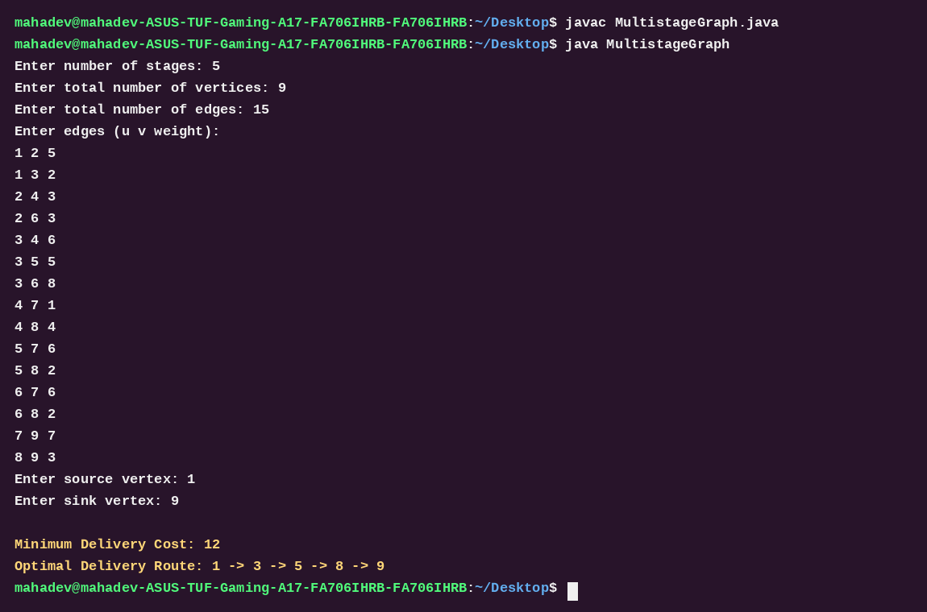
Figure 5.4: Terminal screenshot showing compilation and execution of MultistageGraph.java
15. Explanation of the Program
- Graph representation: Each vertex keeps an adjacency list of outgoing edges (destination, weight), built from the (u, v, weight) triples entered by the user.
- Backward pass: The solve() method walks vertices from sink − 1 down to source, relaxing every outgoing edge so that cost[v] is finalised using already-finalised successor costs.
- Path tracking: The next[] array records, for each vertex, which successor produced its minimum cost, so the route can be printed without a second search.
- Output: After the backward pass, the program prints the minimum delivery cost from the source and the full optimal route from source to sink.

