 | Pimpri-Chinchwad Education Trust’s  Pimpri-Chinchwad College of Engineering  (An Autonomous Institute)  Affiliated to Savitribai Phule Pune University (SPPU)  ISO 21001:2018 Certified by TUV

Assignment No 6

Name : Mahadev Suresh Jundale | Class : T.Y. IT - A
PRN No. : 125B2F007 | Subject : Design Analysis and Algorithm

Github Link: https://github.com/MAHADEVJUNDALE/DAA_ASSIGNMENT/tree/main/Assignment6
1. Problem Statement
A powerful earthquake has struck a remote region, and a relief organisation must rush essential supplies to the affected area using a single relief truck of limited carrying capacity W kg. N different kinds of relief items are available, each with its own weight and a utility value that reflects how important it is for saving lives and meeting urgent needs. Because the truck cannot carry everything, the coordinator must choose which items to load so that the total utility carried is as large as possible without the combined weight exceeding W. As the logistics coordinator, the task is to:
- Model the problem as a 0/1 Knapsack, where every item is either loaded onto the truck (1) or left behind (0) — no item can be split.
- Design an algorithm that finds the set of items giving the maximum total utility within the weight limit W.
- Compare the Brute-Force, Dynamic Programming and Greedy strategies for solving the problem efficiently.
- Extend the model for real-world needs — giving priority to perishable items such as medicines and food, and considering multiple trucks or real-time re-planning as conditions change.
The goal is therefore a model and an algorithm that reliably picks the most valuable combination of relief supplies the truck can carry.
2. Theory
2.1 The 0/1 Knapsack Problem
In the 0/1 Knapsack Problem, every item i has a weight wᵢ and a value vᵢ, and the truck (knapsack) has a maximum capacity W. The goal is to choose a subset of items that maximises the total value while keeping the total weight within W. Formally, with xᵢ ∈ {0, 1} indicating whether item i is chosen:
Maximize sum( value[i] * x[i] )
subject to sum( weight[i] * x[i] ) <= W, x[i] in {0, 1}
Because each item can only be taken whole or left out (unlike the Fractional Knapsack, where items can be split), the problem is called “0/1”.
2.2 Brute-Force Approach
- Generate every possible subset of the N items (2ⁿ subsets in total).
- For each subset, add up its weight and value.
- Keep the subset with the highest value whose weight does not exceed W.
- Time Complexity: O(2ⁿ) — only practical for a very small number of items.
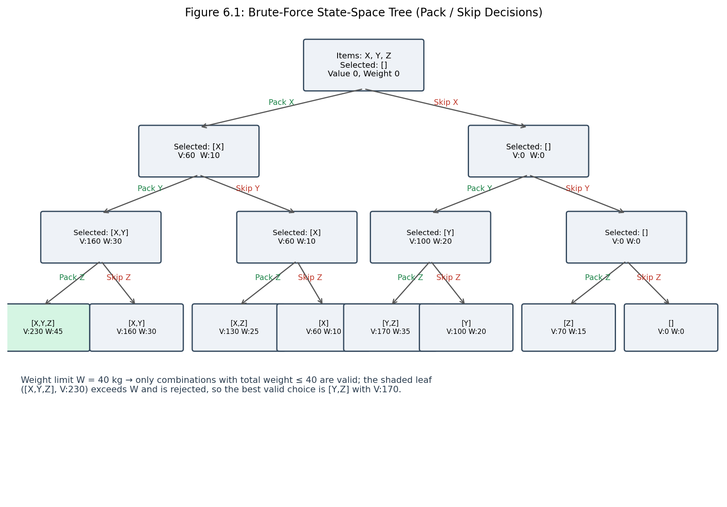
Figure 6.1: Brute-force state-space tree showing pack/skip decisions for 3 items
2.3 Dynamic Programming Approach
The 0/1 Knapsack problem has both optimal substructure and overlapping sub-problems, so it can be solved bottom-up with a DP table dp[i][w], defined as the maximum value obtainable using only the first i items with capacity w:
if weight[i-1] <= w:
dp[i][w] = max( value[i-1] + dp[i-1][w - weight[i-1]], dp[i-1][w] )
else:
dp[i][w] = dp[i-1][w]
- Time Complexity: O(N × W)
- Space Complexity: O(N × W)
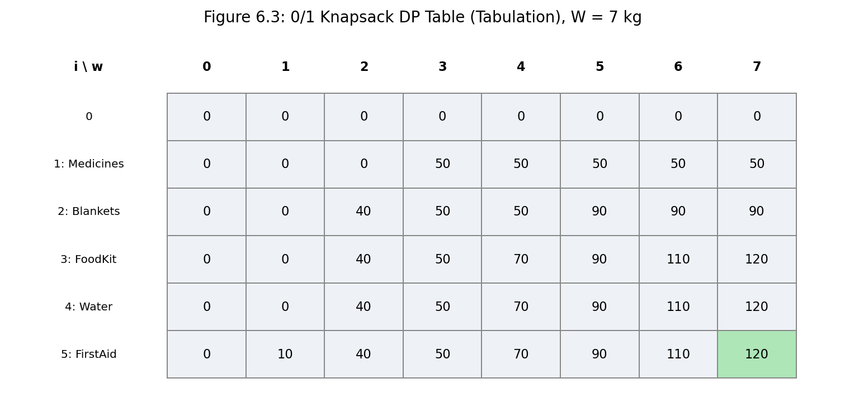
Figure 6.3: 0/1 Knapsack DP table filled bottom-up for a 5-item example (W = 7 kg)
Reading dp[N][W] after the table is filled gives the maximum achievable utility, and tracing back through the table (moving to dp[i-1][w] whenever dp[i][w] equals dp[i-1][w], otherwise including item i and reducing w by weight[i-1]) recovers the actual items chosen.
2.4 Greedy Approach (Fractional Knapsack)
- Sort all items by their value-to-weight ratio in descending order.
- Fill the truck with the highest-ratio items first, taking a fraction of an item only if it is the one that overflows the capacity.
The Greedy method gives the optimal answer for the Fractional Knapsack, where items can be split, but it is not guaranteed to be optimal for the 0/1 Knapsack, since an item cannot actually be split in the disaster-relief scenario — a half a medicine box is of no real use.
2.5 Real-World Extensions
- Priority weighting: perishable or life-critical items (medicines, infant food) can have their utility value boosted before running the DP, so they are favoured in the optimal set.
- Multiple trucks: the problem extends to a Multiple Knapsack, where items are distributed across several trucks to maximise total utility carried.
- Real-time re-planning: as roads close or new supplies arrive, the DP table can be recomputed quickly since N and W usually stay modest for a single relief convoy.
3. Complexity Analysis
Approach | Time Complexity | Space Complexity
Brute Force | O(2ⁿ) | O(N) (recursion stack)
Dynamic Programming | O(N × W) | O(N × W)
Greedy (fractional only) | O(N log N) (sorting) | O(1) extra

For the disaster-relief scenario, N (the number of relief item types) and W (the truck capacity) are both modest, so the O(N × W) Dynamic Programming approach comfortably finds the exact optimum in well under a second, unlike Brute Force, whose cost explodes exponentially as more item types are added.
4. Algorithm
- Read N relief items, each with a weight and a utility value, and the truck capacity W.
- Create a DP table dp[N+1][W+1] and initialise every entry to 0.
- For each item i from 1 to N, and each capacity w from 1 to W: if weight[i-1] ≤ w, set dp[i][w] = max( value[i-1] + dp[i-1][w - weight[i-1]], dp[i-1][w] ); otherwise set dp[i][w] = dp[i-1][w].
- The maximum achievable utility is dp[N][W].
- Trace back from dp[N][W]: for i from N down to 1, if dp[i][w] ≠ dp[i-1][w], item i was included — record it and reduce w by weight[i-1].
- Optionally raise the utility value of perishable or life-critical items before running the DP so they are prioritised.
5. Flow Diagram
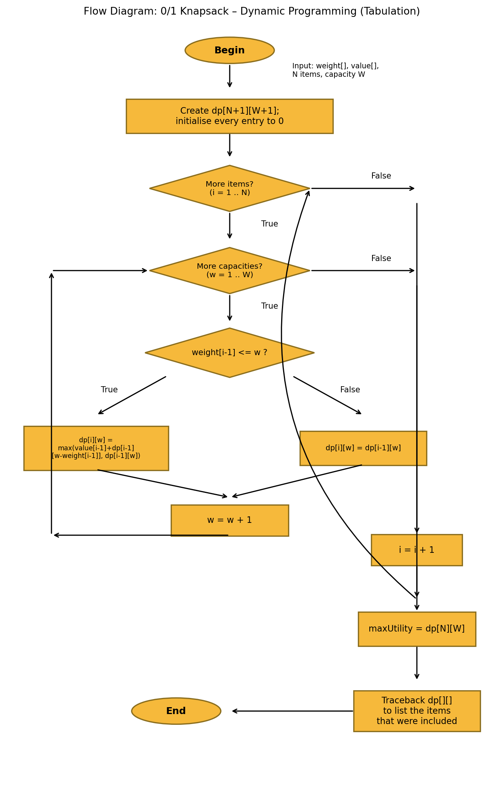
Figure 6.2: Flow diagram of the 0/1 Knapsack Dynamic Programming (tabulation) procedure
6. Pseudo Code
// 0/1 KNAPSACK FOR DISASTER RELIEF
Algorithm Knapsack(weight[], value[], N, W)

create dp[N+1][W+1] and initialise all entries to 0

for i <- 1 to N do
for w <- 1 to W do
if weight[i-1] <= w then
dp[i][w] <- max( value[i-1] + dp[i-1][w - weight[i-1]], dp[i-1][w] )
else
dp[i][w] <- dp[i-1][w]
end if
end for
end for

maxUtility <- dp[N][W]

// Traceback to find included items
w <- W
includedItems <- []
for i <- N down to 1 do
if dp[i][w] != dp[i-1][w] then
append i to includedItems
w <- w - weight[i-1]
end if
end for

return maxUtility, includedItems
End Algorithm
7. JAVA Program:
import java.util.*;

public class DisasterReliefKnapsack {

static class Item {
String name;
int weight;
int value;
Item(String name, int weight, int value) {
this.name = name;
this.weight = weight;
this.value = value;
}
}

public static void main(String[] args) {
Scanner sc = new Scanner(System.in);

System.out.print("Enter number of relief items: ");
int n = sc.nextInt();

System.out.print("Enter truck capacity (kg): ");
int W = sc.nextInt();

Item[] items = new Item[n];
System.out.println("Enter each item's name, weight, and utility value:");
for (int i = 0; i < n; i++) {
String name = sc.next();
int wt = sc.nextInt();
int val = sc.nextInt();
items[i] = new Item(name, wt, val);
}

int[][] dp = new int[n + 1][W + 1];
for (int i = 1; i <= n; i++) {
int wt = items[i - 1].weight;
int val = items[i - 1].value;
for (int w = 1; w <= W; w++) {
if (wt <= w) {
dp[i][w] = Math.max(val + dp[i - 1][w - wt], dp[i - 1][w]);
} else {
dp[i][w] = dp[i - 1][w];
}
}
}

int maxUtility = dp[n][W];
System.out.println();
System.out.println("Maximum Relief Utility: " + maxUtility);

List<String> selectedItems = new ArrayList<>();
int totalWeight = 0;
int currW = W;
for (int i = n; i >= 1; i--) {
if (dp[i][currW] != dp[i - 1][currW]) {
selectedItems.add(items[i - 1].name);
totalWeight += items[i - 1].weight;
currW -= items[i - 1].weight;
}
}
Collections.reverse(selectedItems);

System.out.println("Total Weight Carried: " + totalWeight + " kg");
System.out.println("Selected Relief Supplies:");
for (String itemName : selectedItems) {
System.out.println("- " + itemName);
}
sc.close();
}
}
8. Sample Input and Output
Input:
Enter number of relief items: 5
Enter truck capacity (kg): 50
Enter each item's name, weight, and utility value:
Medicines 10 60
FoodPackets 20 100
DrinkingWater 15 70
FirstAidKits 10 50
InfantNutrition 5 40
Output:
Maximum Relief Utility: 270
Total Weight Carried: 50 kg
Selected Relief Supplies:
- Medicines
- FoodPackets
- DrinkingWater
- InfantNutrition
9. Comparison of the Three Approaches
Aspect | Brute Force | Greedy | Dynamic Programming
Decision making | Tries every possible subset of items | Picks the best ratio item first, greedily | Builds the solution from optimal sub-results
Optimality for 0/1 Knapsack | Optimal, but impractical for large N | Not guaranteed optimal | Guaranteed optimal
Time Complexity | O(2ⁿ) | O(N log N) | O(N × W)
Suitability | Only tiny item counts | Works only for the fractional version | Well suited to real relief-truck sizes

For SwiftCargo-style relief operations, Dynamic Programming is the practical choice: it guarantees the best combination of supplies and runs quickly for realistic values of N and W, whereas Brute Force becomes infeasible as the number of item types grows and Greedy can give a sub-optimal answer whenever items must be taken whole.
10. Advantages of the Dynamic Programming Approach
- Always finds the truly optimal combination of relief items for a given truck capacity.
- Polynomial time O(N × W), far faster than the exponential Brute-Force search.
- The DP table makes it easy to trace back and recover exactly which items were chosen, not just the best value.
- Easily adapted to give priority to life-critical items by adjusting their value before solving.
- Can be re-run quickly whenever supplies, weights or the truck's capacity change.
11. Limitations
- Time and memory grow with N × W, so a very large capacity W (e.g. weight measured in grams for a huge truck) can make the table large.
- Assumes item weights and the capacity are integers; real-valued weights need scaling or a different technique.
- Does not natively support multiple trucks — that needs an extension to a multiple-knapsack formulation.
12. Result
The disaster-relief resource allocation problem was modelled as a 0/1 Knapsack and solved in Java using bottom-up Dynamic Programming. The program reads the relief items and truck capacity, builds the DP table, and reports both the maximum achievable utility and the exact set of items to load, as shown in Section 8.
13. Conclusion
The 0/1 Knapsack model captures the disaster-relief loading problem naturally: each relief item is either carried or left behind, and the truck's weight limit is a hard constraint. Dynamic Programming solves this exactly and efficiently by building the solution from smaller sub-problems, avoiding the exponential blow-up of Brute Force while remaining more reliable than a Greedy heuristic. This makes it well suited to SwiftCargo-style operations, where the right choice of supplies can directly affect how many lives are saved, and where the model can be extended to prioritise critical items or scale across multiple trucks.
14. Program Execution Screenshot
The following screenshot shows the Java program being compiled and executed in the terminal, using the sample dataset from Section 8.
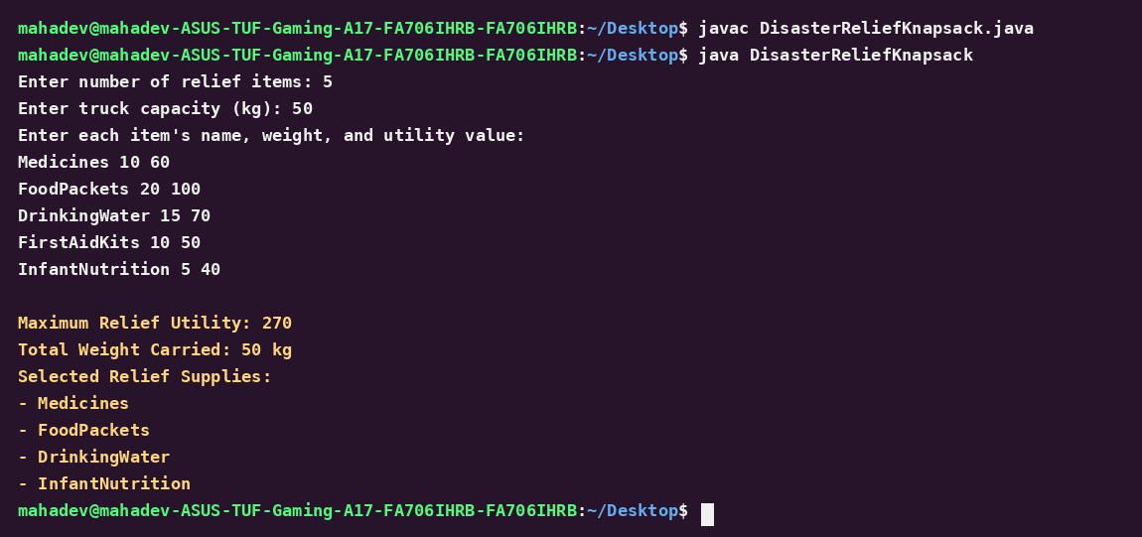
Figure 6.4: Terminal screenshot showing compilation and execution of DisasterReliefKnapsack.java
15. Explanation of the Program
- Item representation: Each relief item is stored as an Item object holding its name, weight and utility value, read directly from user input.
- DP table construction: The nested loop fills dp[i][w] for every item count i and every capacity w from 1 to W, using the standard 0/1 Knapsack recurrence.
- Reading the answer: dp[n][W] after the loops finish is the maximum utility the truck can carry.
- Traceback: Starting from dp[n][W], the program walks backward through the table, adding an item to the selected list whenever dp[i][currW] differs from dp[i-1][currW], then reducing the remaining capacity by that item's weight.
- Output: The program prints the maximum utility, the total weight actually carried, and the list of relief supplies selected for the truck.

