 | Pimpri-Chinchwad Education Trust’s  Pimpri-Chinchwad College of Engineering  (An Autonomous Institute)  Affiliated to Savitribai Phule Pune University (SPPU)  ISO 21001:2018 Certified by TUV

Assignment No 7

Name : Mahadev Suresh Jundale | Class : T.Y. IT - A
PRN No. : 125B2F007 | Subject : Design Analysis and Algorithm

Github Link: https://github.com/MAHADEVJUNDALE/DAA_ASSIGNMENT
1. Problem Statement
A university has to schedule its end-semester exams, but many students are enrolled in several courses, so two exams that share a student cannot be held in the same time slot. The timetable must avoid all such clashes while using as few exam slots as possible. Each exam also needs a classroom large enough for the students who sit it. The task is to:
- Model the course-student enrolments as a graph and implement a graph colouring algorithm (Greedy, Welsh-Powell or DSATUR).
- Minimise the number of colours, which correspond to exam time slots, while keeping the schedule conflict-free.
- Handle large datasets with thousands of courses and students efficiently.
- Compare Greedy, DSATUR and Welsh-Powell, and extend the solution with room allocation so that exams in the same slot fit into available classrooms.
The goal is therefore a conflict-free exam timetable with the fewest possible slots, where every exam is also given a suitable room.
2. Theory
2.1 Graph Model of the Conflicts
A graph G = (V, E) consists of vertices V and edges E. Here each vertex is a course, and an edge joins two courses when at least one student is enrolled in both. Two courses that share a student must not be in the same slot, so this relationship is captured exactly by an edge. The conflict graph is undirected and unweighted, because a clash between two courses is mutual and carries no cost.
Figure 7.1 shows the sample data. Students S1, S2 and S3 create the three edges C1–C2, C2–C3 and C1–C3, so these three courses form a triangle. Course C4 is taken only by student S4, so it has no edges and can share a slot with any other course.
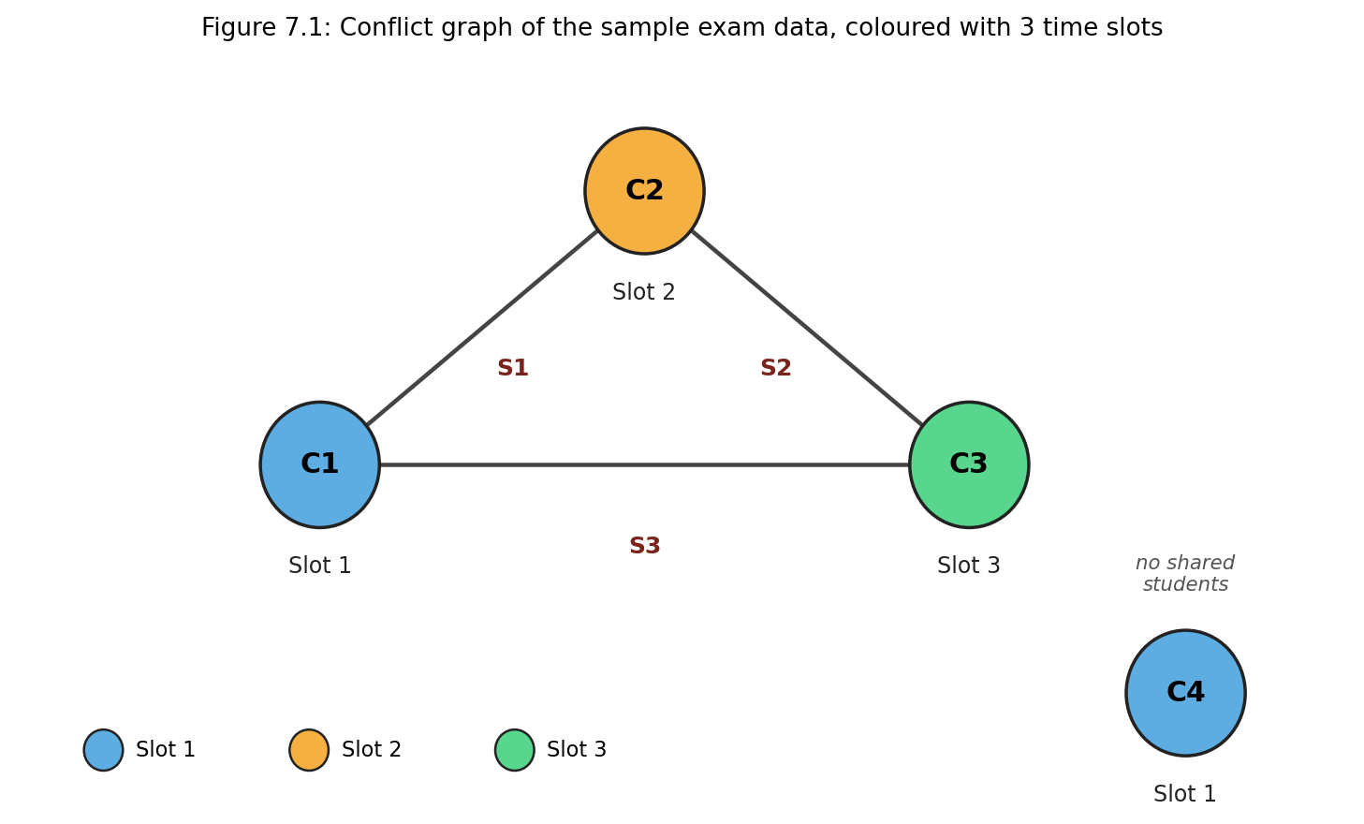
Figure 7.1: Conflict graph of the sample data, coloured with three time slots
2.2 Graph Colouring and Chromatic Number
A proper colouring assigns a colour to each vertex so that no two adjacent vertices share a colour. Each colour is one exam time slot. The smallest number of colours that gives a proper colouring is the chromatic number χ(G). For the sample data, the triangle C1, C2, C3 needs three different slots, so χ(G) = 3, and the timetable uses exactly three slots. Two simple bounds apply in general: χ(G) is at least the size of the largest clique (a set of courses that all conflict with each other), and a greedy colouring never needs more than Δ + 1 colours, where Δ is the largest number of conflicts any single course has.
2.3 Colouring Algorithms
- Greedy colouring: the courses are taken in a fixed order, and each one receives the smallest slot not already used by a conflicting course that has been scheduled. It is simple and fast, but the number of slots depends heavily on the order.
- Welsh-Powell: the courses are first sorted by degree (number of conflicts) in descending order, and then the greedy rule is applied. Courses with many conflicts are placed first, while the choices are still flexible, which usually reduces the number of slots.
- DSATUR (Degree of Saturation): the saturation of a course is the number of different slots already used by its conflicting courses. At each step the uncoloured course with the highest saturation is chosen (ties are broken by degree), and it receives the smallest free slot. DSATUR is one of the strongest practical heuristics and is optimal on bipartite graphs.
Exact methods such as backtracking can find the true minimum, but their running time grows exponentially with the number of courses. For a university with thousands of courses, heuristics are therefore used in practice.
2.4 Room Allocation Constraint
Once every course has a slot, rooms are assigned slot by slot. Within one slot, the courses are taken in order of decreasing number of students, and each course receives the smallest free room whose capacity is at least its number of students. The rules are: a room can host only one exam in a given slot, and a room must be large enough for the course. Choosing the smallest adequate room leaves the larger rooms free for the bigger exams that come later. If no free room is large enough, the course is reported as unplaced rather than silently given a room that is too small.
2.5 Complexity Class of the Problem
Deciding whether a graph can be coloured with k colours is an NP-complete problem for every k ≥ 3 (it appears among the 21 problems shown NP-complete by Karp in 1972). Finding the chromatic number is therefore NP-hard, and no polynomial-time algorithm is known that always gives the optimum. This is why the exam timetable is solved with polynomial-time heuristics (Greedy, Welsh-Powell and DSATUR), which give good but not always optimal slot counts, and why exact backtracking is avoided for large inputs.
2.6 Handling Large Datasets
- Adjacency lists (one set of neighbours per course) use memory proportional to V + E, instead of the V×V matrix needed for an adjacency matrix.
- A hash map from course code to index gives constant-time lookup while the enrolments are read.
- DSATUR keeps each course's set of neighbouring slots up to date incrementally, so the saturation of a course is read in constant time instead of being recomputed from scratch at every step.
3. Complexity Analysis
Let V be the number of courses, E the number of conflict edges, C the number of courses and R the number of rooms. The table gives the cost of each stage of the program as it is implemented.
Stage | Time Complexity | Space Complexity
Build conflict graph | O(Σ kₛ²), where kₛ = courses taken by student s | O(V + E)
Greedy colouring | O(V + E) | O(V)
Welsh-Powell colouring | O(V log V + E) | O(V)
DSATUR colouring | O(V² + E) | O(V + E)
Room allocation | O(C · R + C log C) | O(C + R)
Overall | Dominated by DSATUR: O(V² + E) | O(V + E)

Greedy and Welsh-Powell are linear in the size of the graph (apart from the sort in Welsh-Powell). DSATUR is the most expensive of the three, because each of its V steps scans every uncoloured course to find the one with the highest saturation. This is still far faster than exhaustive search, and it is affordable for thousands of courses.
4. Algorithm
- Read the courses, the student enrolments and the list of rooms with their capacities. Map every course code to an index.
- For each student, add a conflict edge between every pair of courses that the student takes. Count the number of students in each course.
- Colour the conflict graph with Greedy, Welsh-Powell and DSATUR, and count the slots used by each.
- Keep the colouring that uses the fewest slots.
- For each slot, sort its courses by number of students (largest first). Give each course the smallest free room whose capacity is at least its number of students. If no such room exists, mark the course as 'No room'.
- Print every course with its time slot, room and number of students.
5. Flow Diagram
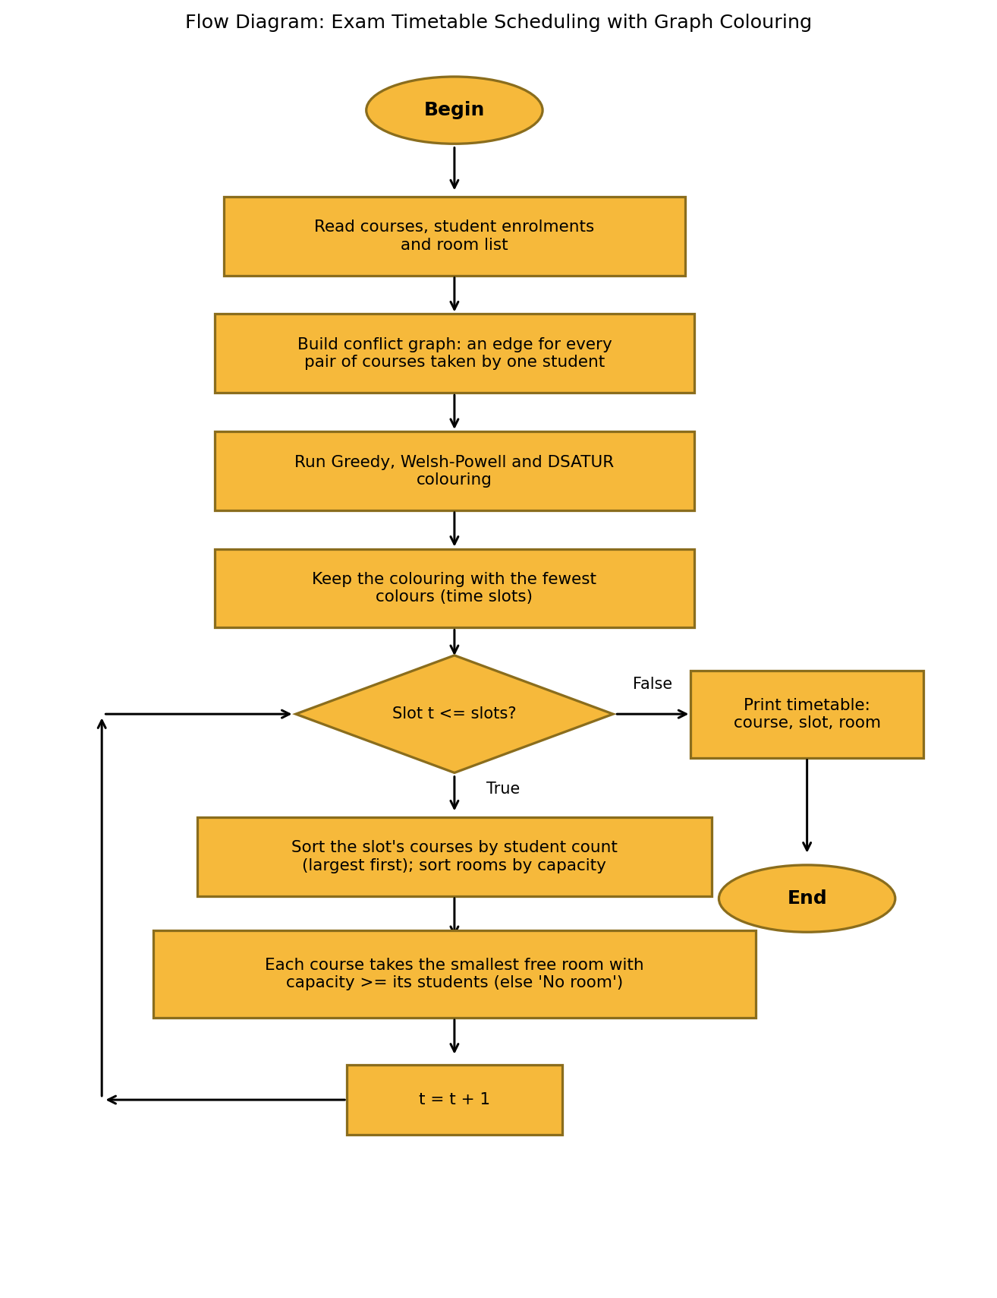
Figure 7.2: Flow diagram of the exam timetable scheduling procedure
6. Pseudo Code
// EXAM TIMETABLE USING GRAPH COLOURING
Algorithm ExamTimetable(courses, students, rooms)

// Step 1: Build the conflict graph
for each course c do adj[c] <- empty set, count[c] <- 0
for each student s do
for each course c taken by s do count[c] <- count[c] + 1
for each pair (c1, c2) taken by s, c1 != c2 do
add c2 to adj[c1] and c1 to adj[c2]
end for
end for

// Step 2: Colour the graph with three heuristics
colourG <- Greedy(courses in input order)
colourW <- WelshPowell(courses sorted by degree, descending)
colourD <- DSATUR()

// Step 3: Keep the colouring with the fewest slots
colour <- colouring with minimum number of colours
slots <- number of colours used by colour

// Step 4: Room allocation slot by slot
for t <- 0 to slots - 1 do
Q <- courses c with colour[c] = t, sorted by count[c] descending
for each course c in Q do
room <- smallest free room r with capacity(r) >= count[c]
if room exists then assign room to c and mark it occupied
else assign 'No room' to c
end for
end for

// Step 5: Output
print each course with its slot colour[c] + 1, its room and count[c]
End Algorithm
7. JAVA Program:
import java.util.*;

public class ExamTimetable {

static class Room {
String name;
int capacity;
Room(String name, int capacity) {
this.name = name;
this.capacity = capacity;
}
}

static int n; // number of courses (vertices)
static List<Set<Integer>> adj; // adjacency lists of the conflict graph

// Smallest colour not used by any already-coloured neighbour of u
static int smallestFreeColour(int u, int[] color) {
Set<Integer> used = new HashSet<>();
for (int v : adj.get(u)) {
if (color[v] != -1) used.add(color[v]);
}
int c = 0;
while (used.contains(c)) c++;
return c;
}

// Greedy colouring: colour vertices in the given order
static int[] greedy(List<Integer> order) {
int[] color = new int[n];
Arrays.fill(color, -1);
for (int u : order) {
color[u] = smallestFreeColour(u, color);
}
return color;
}

// Welsh-Powell: greedy colouring after sorting by degree (descending)
static int[] welshPowell() {
List<Integer> order = range(n);
order.sort((a, b) -> adj.get(b).size() - adj.get(a).size());
return greedy(order);
}

// DSATUR: always colour the uncoloured vertex with the highest saturation
// (number of distinct colours among its neighbours); ties broken by degree
static int[] dsatur() {
int[] color = new int[n];
Arrays.fill(color, -1);
// satSet[u] = distinct colours already used by neighbours of u (kept up to date)
List<Set<Integer>> satSet = new ArrayList<>();
for (int i = 0; i < n; i++) satSet.add(new HashSet<>());
for (int step = 0; step < n; step++) {
int best = -1, bestSat = -1, bestDeg = -1;
for (int u = 0; u < n; u++) {
if (color[u] != -1) continue;
int s = satSet.get(u).size();
int d = adj.get(u).size();
if (s > bestSat || (s == bestSat && d > bestDeg)) {
best = u;
bestSat = s;
bestDeg = d;
}
}
color[best] = smallestFreeColour(best, color);
for (int v : adj.get(best)) satSet.get(v).add(color[best]);
}
return color;
}

// Number of colours (time slots) used
static int countSlots(int[] color) {
int max = -1;
for (int c : color) max = Math.max(max, c);
return max + 1;
}

static List<Integer> range(int size) {
List<Integer> list = new ArrayList<>();
for (int i = 0; i < size; i++) list.add(i);
return list;
}

public static void main(String[] args) {
Scanner sc = new Scanner(System.in);

System.out.print("Enter number of courses: ");
n = sc.nextInt();
String[] courses = new String[n];
Map<String, Integer> index = new HashMap<>();
System.out.println("Enter course codes:");
for (int i = 0; i < n; i++) {
courses[i] = sc.next();
index.put(courses[i], i);
}

adj = new ArrayList<>();
for (int i = 0; i < n; i++) adj.add(new HashSet<>());
int[] studentCount = new int[n];

System.out.print("Enter number of students: ");
int m = sc.nextInt();
System.out.println("Enter student enrollments (student_id count course1 course2 ...):");
for (int s = 0; s < m; s++) {
sc.next(); // student id (not needed for colouring)
int k = sc.nextInt();
List<Integer> enrolled = new ArrayList<>();
for (int j = 0; j < k; j++) {
Integer idx = index.get(sc.next());
if (idx != null) {
enrolled.add(idx);
studentCount[idx]++;
}
}
// Every pair of courses taken by this student gets an edge (conflict)
for (int a = 0; a < enrolled.size(); a++) {
for (int b = a + 1; b < enrolled.size(); b++) {
int u = enrolled.get(a), v = enrolled.get(b);
if (u != v) {
adj.get(u).add(v);
adj.get(v).add(u);
}
}
}
}

System.out.print("Enter number of available classrooms: ");
int r = sc.nextInt();
Room[] rooms = new Room[r];
System.out.println("Enter room name and capacity:");
for (int i = 0; i < r; i++) {
rooms[i] = new Room(sc.next(), sc.nextInt());
}

// Run the three colouring algorithms and compare
int[] gColor = greedy(range(n));
int[] wColor = welshPowell();
int[] dColor = dsatur();
int gS = countSlots(gColor), wS = countSlots(wColor), dS = countSlots(dColor);

System.out.println("\nColouring comparison (number of time slots):");
System.out.println("Greedy : " + gS);
System.out.println("Welsh-Powell : " + wS);
System.out.println("DSATUR : " + dS);

// Use the colouring that needs the fewest slots
int[] color = gColor;
int slots = gS;
if (wS < slots) { color = wColor; slots = wS; }
if (dS < slots) { color = dColor; slots = dS; }

// Room allocation: within each slot, biggest classes first,
// each takes the smallest free room that is large enough
String[] assignedRoom = new String[n];
Arrays.fill(assignedRoom, "No room");
for (int slot = 0; slot < slots; slot++) {
List<Integer> slotCourses = new ArrayList<>();
for (int i = 0; i < n; i++) {
if (color[i] == slot) slotCourses.add(i);
}
slotCourses.sort((a, b) -> studentCount[b] - studentCount[a]);

boolean[] occupied = new boolean[r];
for (int c : slotCourses) {
int best = -1;
for (int j = 0; j < r; j++) {
if (!occupied[j] && rooms[j].capacity >= studentCount[c]) {
if (best == -1 || rooms[j].capacity < rooms[best].capacity) {
best = j;
}
}
}
if (best != -1) {
occupied[best] = true;
assignedRoom[c] = rooms[best].name;
}
}
}

System.out.println("\nExam Timetable Schedule:");
System.out.println("Total Time Slots Required: " + slots);
System.out.println();
System.out.printf("%-8s %-10s %-8s %-8s%n", "Course", "Time Slot", "Room", "Students");
for (int i = 0; i < n; i++) {
System.out.printf("%-8s %-10s %-8s %-8d%n",
courses[i], "Slot " + (color[i] + 1), assignedRoom[i], studentCount[i]);
}
sc.close();
}
}
8. Sample Input and Output
Input:
java ExamTimetable.java
Enter number of courses: 4
Enter course codes:
C1 C2 C3 C4
Enter number of students: 4
Enter student enrollments (student_id count course1 course2 ...):
S1 2 C1 C2
S2 2 C2 C3
S3 2 C1 C3
S4 1 C4
Enter number of available classrooms: 3
Enter room name and capacity:
R1 100
R2 80
R3 50
Output:
Colouring comparison (number of time slots):
Greedy : 3
Welsh-Powell : 3
DSATUR : 3

Exam Timetable Schedule:
Total Time Slots Required: 3

Course Time Slot Room Students
C1 Slot 1 R3 2
C2 Slot 2 R3 2
C3 Slot 3 R3 2
C4 Slot 1 R2 1
The room assigned to C1 is R3, the smallest room that holds its two students. The sample table in the question lists different rooms; that is also valid, because any free room with enough capacity is acceptable. This program always picks the smallest adequate room.
9. Comparison of Greedy, Welsh-Powell and DSATUR
The three heuristics were run on the sample data and on a generated stress-test dataset of 2,000 courses and 50,000 students, with each student taking 4 to 6 courses and 40 rooms available. The results are shown below.
Algorithm | Vertex order | Time complexity | Slots (sample) | Slots (2,000 courses)
Greedy | Input order | O(V + E) | 3 | 105
Welsh-Powell | Degree, descending | O(V log V + E) | 3 | 97
DSATUR | Dynamic (saturation) | O(V² + E) | 3 | 91

On the sample data all three heuristics reach the optimum of three slots, because the only real constraint is the triangle. On the larger dataset, the ordering matters: Welsh-Powell saves eight slots over plain Greedy, and DSATUR saves a further six. DSATUR gives the fewest slots because it adapts its order to the colours already used, instead of fixing the order in advance.
10. Advantages
- Guarantees that no student has two exams at the same time, because every conflict is an edge that the colouring must respect.
- Uses far fewer slots than a naive one-exam-per-slot schedule, and DSATUR gives the best slot count of the three heuristics tested.
- Scales to thousands of courses and students: the stress test with 2,000 courses and 50,000 students completed in about 4 seconds.
- The room allocation keeps the best-fit rooms free for larger exams and reports any course that cannot be placed.
11. Limitations
- The heuristics do not guarantee the minimum number of slots. Finding the true optimum is NP-hard, so the result may be one or more slots above the chromatic number.
- Room allocation is greedy and checks only the number of students against capacity. On the stress test, 975 of the 2,000 courses could not be placed, because no free room in their slot was large enough. A real system would have to add slots, rooms or split large exams.
- The model assumes every exam lasts one slot and that rooms are available in every slot. It ignores invigilators, exam lengths and room equipment.
- The stress-test data is synthetic. Real enrolment data would have different course sizes and conflict patterns.
12. Result
The exam timetable was modelled as a graph colouring problem and implemented in Java. On the sample data the program found a conflict-free timetable with three slots, which equals the chromatic number, and assigned every course a room. On the stress-test dataset of 2,000 courses and 50,000 students, DSATUR used 91 slots, Welsh-Powell 97 and Greedy 105. An independent check of the output confirmed that no student has two exams in the same slot and that no room is booked twice in one slot or assigned to an exam larger than its capacity.
13. Conclusion
Modelling exam conflicts as a graph turns the scheduling problem into graph colouring, and each colour becomes a time slot. Greedy, Welsh-Powell and DSATUR give conflict-free timetables that are fast enough for large universities, with DSATUR giving the fewest slots in the tests. Adding room allocation by best fit makes the timetable usable in practice and shows clearly where room capacity is the real bottleneck. Because graph colouring is NP-hard, these heuristics are the practical choice, and exact backtracking is reserved for small instances.
14. Program Execution Screenshot
The following screenshot shows the program run on the sample dataset from Section 8, with the inputs typed in and the output produced by the program.
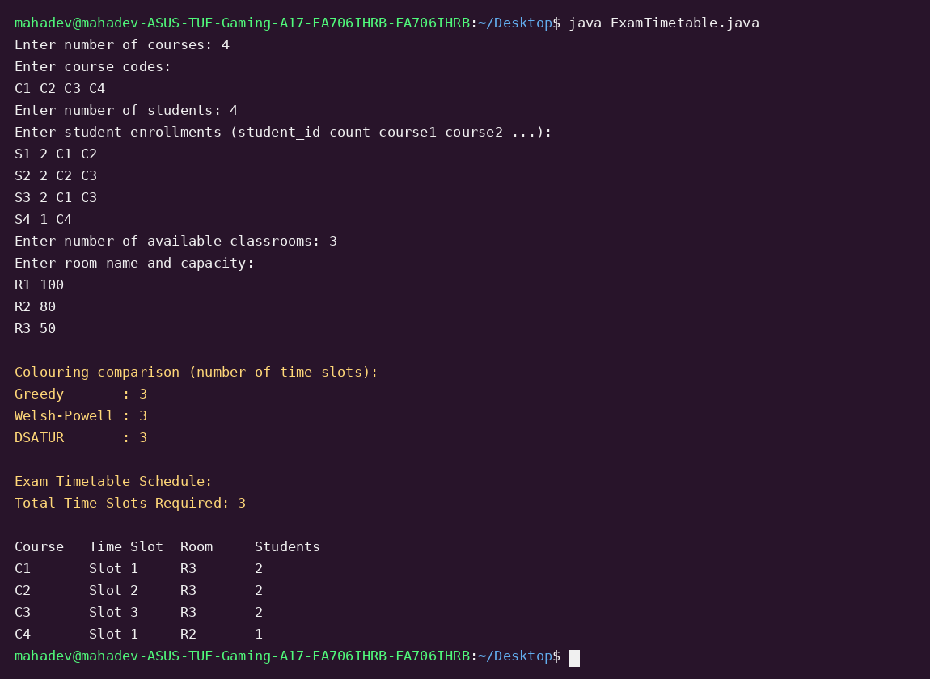
Figure 7.3: Terminal screenshot of the exam timetable program on the sample dataset
15. Explanation of the Program
- Conflict graph: adj is a list of sets. Each student's courses are read and an edge is added between every pair, so the sets never contain duplicates.
- Greedy: greedy() visits the courses in the given order and gives each one the smallest colour not used by its neighbours.
- Welsh-Powell: welshPowell() sorts the courses by the size of their adjacency set, in descending order, and then calls greedy().
- DSATUR: dsatur() keeps a set of neighbouring colours for each course. At every step it picks the uncoloured course with the largest set (ties broken by degree) and colours it.
- Choice of colouring: the program keeps whichever of the three colourings uses the fewest slots.
- Room allocation: within each slot, courses are sorted by number of students, and each takes the smallest free room that is large enough.
- Output: the table lists each course with its slot, room and number of students.

