 | Pimpri Chinchwad Education Trust’s Pimpri Chinchwad College of Engineering
Assignment No. 4
Course: Computer Networks Technology Laboratory (BIT24PC02)
Name: Mahadev Suresh Jundale
PRN: 125B2F007

Aim: Develop a software solution to manage error identification and rectification for 7/8 bit ASCII sequences utilizing Hamming Codes or CRC.

Theory:

What is error detection and error correction? Illustrate the need for it.

Error Detection

Error detection is the functional mechanism used to find if data bits were altered during the move from source to destination. As information moves via a link, it is susceptible to corruption from electronic noise, signal clashing, or device failures. These validation methods allow the receiving side to verify if the incoming packet is intact or has been modified. This process involves appending specific extra bits, known as parity or redundant bits, to the message before it is sent. The destination hardware then analyzes these bits to confirm whether a bit-flip or data corruption event took place.

Example:
Imagine a transmitter sends the string 101101 and includes a single parity bit to facilitate the detection of errors. If external noise causes a bit to flip during transit, the receiver identifies the error by seeing the parity mismatch.

Common Error Detection Techniques
- Parity Check
- Checksum
- Cyclic Redundancy Check (CRC)

Error Correction

Error correction is the advanced capability to find faults in received packets and fix them without requesting a new copy. Under this approach, sufficient redundant information is added so the system can pinpoint the exact bit that changed. This is vital for communication links where waiting for retransmission is not feasible, like deep-space or live broadcasts.

Example:

In a Hamming Code system, extra check bits are interleaved with data so that any single-bit flip can be localized .Common Error Correction Techniques
- Hamming Code
- Reed-Solomon Code
- Forward Error Correction (FEC)

Need for Error Detection and Error Correction
These protocols are fundamental to networking because physical transmission media are inherently prone to distortion and noise.

Reasons why they are needed:
- Guarantees Data Integrity: They ensure the message read by the receiver is the exact same as the one sent.
- Boosts System Reliability: By managing errors, the overall communication network becomes much more dependable and stable.
- Minimizes Data Loss: Correction allows the recovery of information without the overhead of sending the same packet again.
- Vital for Modern Tech: Mobile networks, satellite links, and fiber optics rely on these for high-speed, accurate transfers.
- Protects High-Stakes Data: Financial transfers and medical records require 100% accuracy, which these algorithms provide.

List and explain different error detection and correction methods
During the transit of digital signals, various factors like interference or hardware glitches can induce data errors. To guarantee that the destination receives the correct content, multiple detection and correction schemes are implemented. These strategies work by adding helper bits to the payload to facilitate the verification of the bitstream.

Error Detection Methods
- Parity Check
- his stands as the most basic approach used to find errors in a block of binary information. An additional bit, the parity bit, is calculated and attached to the data string before it leaves the sender. Two standard forms exist: Even Parity (even number of 1s) and Odd Parity (odd number of 1s).

Example:
If the data is 1011, it contains three 1s. To make even parity, a 1 is added as the parity bit so that the total number of 1s becomes four.

Limitation:
It can detect single-bit errors but may fail to detect multiple-bit errors.

Checksum
Checksums are a standard feature in many networking protocols to verify the integrity of transmitted segments. The sender splits the data into fixed chunks, sums them up, and sends this sum as a footer. The receiver repeats the summation and compares its result with the footer to see if they match.

Example:
Checksum is used in TCP/IP communication to detect errors during data transmission.

Cyclic Redundancy Check (CRC)
CRC is a highly reliable detection method frequently used in storage devices and high-speed network interfaces. The data is treated like a large polynomial and is divided by a specific generator key using binary math. The resulting remainder is the CRC value, which is sent along with the original message to the receiver.
Example:
CRC is used in Ethernet networks, hard disks, and digital communication systems.

Error Correction Methods
- Hamming Code
Hamming Code is an error correction technique that can detect and correct single-bit errors in transmitted data.
In this method, extra bits called Hamming bits are inserted at specific positions in the data. These bits help identify the exact location of the error so that it can be corrected automatically.

Example:
If one bit changes during transmission, the receiver can determine the incorrect bit and fix it using the Hamming code.

Reed–Solomon Code
Reed–Solomon is a powerful error correction algorithm used for correcting multiple errors in data.
It works by adding redundant data symbols to the original message so that even if some parts of the data are lost or corrupted, the original data can still be reconstructed.

Example:
Reed–Solomon codes are used in:
  - CDs and DVDs
  - QR codes
  - Satellite communication
  - Digital television

Forward Error Correction (FEC)
Forward Error Correction allows the receiver to detect and correct errors without requesting retransmission.
In this technique, the sender adds redundant information to the data so the receiver can recover the original message even if some bits are corrupted.

Example:
FEC is widely used in:
  - Satellite communication
  - Mobile networks
  - Video streaming
  - Wireless communication

Explain error detection using hamming codes
Hamming code is an error-correcting code used to ensure data accuracy during transmission or storage. Hamming code detects and corrects the errors that can occur when the data is moved or stored from the sender to the receiver. This simple and effective method helps improve the reliability of communication systems and digital storage. It adds extra bits to the original data, allowing the system to detect and correct single-bit errors.

What are Redundant Bits?
Redundant bits are extra binary bits that are generated and added to the information-carrying bits of data transfer to ensure that no bits are lost during the data transfer. The number of redundant bits can be calculated using the following formula:
2^{r} ≥ m + r + 1 where,
  - m is the number of bits in input data
  - r is the number of redundant bits.
Suppose the number of data bits is 7, then the number of redundant bits can be calculated as
= 2⁴ ≥ 7 + 4 + 1
Thus, the number of redundant bits is 4.

Types of Parity Bits
A parity bit is a bit appended to a data of binary bits to ensure that the total number of 1’s in the data is even or odd. Parity bits are used for error detection. There are two types of parity bits:
  - Even Parity Bit: In the case of even parity, for a given set of bits, the number of 1’s are counted. If that count is odd, the parity bit value is set to 1, making the total count of occurrences of 1’s an even number. If the total number of 1’s in a given set of bits is already even, the parity bit's value is 0.
  - Odd Parity Bit: In the case of odd parity, for a given set of bits, the number of 1’s are counted. If that count is even, the parity bit value is set to 1, making the total count of occurrences of 1’s an odd number. If the total number of 1’s in a given set of bits is already odd, the parity bit's value is 0.
Algorithm of Hamming Code
Hamming Code is simply the use of extra parity bits to allow the identification of an error. Step 1: Write the bit positions starting from 1 in binary form (1, 10, 11, 100, etc).
Step 2: All the bit positions that are a power of 2 are marked as parity bits (1, 2, 4, 8, etc). Step 3: All the other bit positions are marked as data bits.
Step 4: Each data bit is included in a unique set of parity bits, as determined its bit position in binary form:

  - Parity bit 1 covers all the bits positions whose binary representation includes a 1 in the least significant position (1, 3, 5, 7, 9, 11, etc).
  - Parity bit 2 covers all the bits positions whose binary representation includes a 1 in the second position from the least significant bit (2, 3, 6, 7, 10, 11, etc).
  - Parity bit 4 covers all the bits positions whose binary representation includes a 1 in the third position from the least significant bit (4–7, 12–15, 20–23, etc).
  - Parity bit 8 covers all the bits positions whose binary representation includes a 1 in the fourth position from the least significant bit bits (8–15, 24–31, 40–47, etc).
  - In general, each parity bit covers all bits where the bitwise AND of the parity position and the bit position is non-zero.
Step 5: Since we check for even parity set a parity bit to 1 if the total number of ones in the positions it checks is odd. Set a parity bit to 0 if the total number of ones in the positions it checks is even.
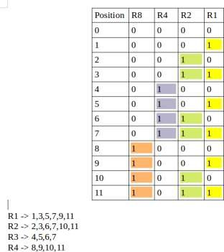

Determining The Position of Redundant Bits
A redundancy bits are placed at positions that correspond to the power of 2. As in the above example:
  - The number of data bits = 7
  - The number of redundant bits = 4
  - The total number of bits = 7+4=11

  - The redundant bits are placed at positions corresponding to power of 2 that is 1, 2, 4, and 8
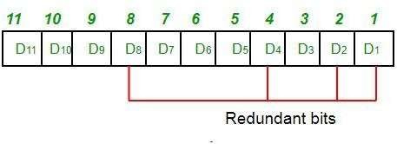
  - Suppose the data to be transmitted is 1011001 from sender to receiver, the bits will be placed as follows:
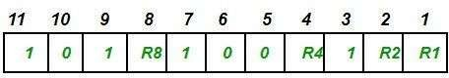

Determining The Parity Bits According to Even Parity
  - R1 bit is calculated using parity check at all the bits positions whose binary representation includes a 1 in the least significant position. R1: bits 1, 3, 5, 7, 9, 11
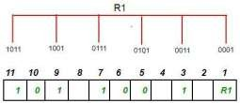

  - To find the redundant bit R1, we check for even parity. Since the total number of 1’s in all the bit positions corresponding to R1 is an even number. So, the value of R1 (parity bit’s value) = 0.
  - R2 bit is calculated using parity check at all the bits positions whose binary representation includes a 1 in the second position from the least significant bit. R2: bits 2,3,6,7,10,11
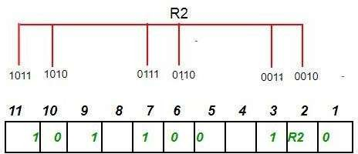

  - To find the redundant bit R2, we check for even parity. Since the total number of 1’s in all the bit positions corresponding to R2 is odd the value of R2(parity bit’s value)=1

  - R4 bit is calculated using parity check at all the bits positions whose binary representation includes a 1 in the third position from the least significant bit. R4: bits 4, 5, 6, 7

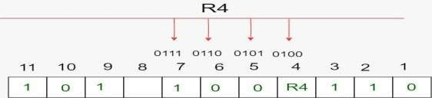

  - To find the redundant bit R4, we check for even parity. Since the total number of 1’s in all the bit positions corresponding to R4 is odd so the value of R4(parity bit’s value) = 1
  - R8 bit is calculated using parity check at all the bits positions whose binary representation includes a 1 in the fourth position from the least significant bit. R8: bit 8,9,10,11
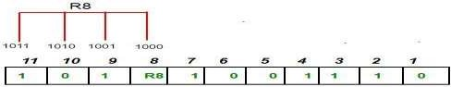

  - To find the redundant bit R8, we check for even parity. Since the total number of 1’s in all the bit positions corresponding to R8 is an even number the value of R8(parity bit’s value)=0. Thus, the data transferred is:

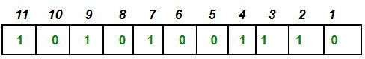

Error Detection and Correction
Suppose in the above example the 6th bit is changed from 0 to 1 during data transmission, then it gives new parity values in the binary number:

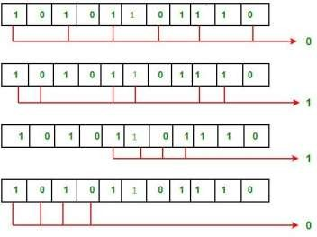

For all the parity bits we will check the number of 1's in their respective bit positions.
  - For R1: bits 1, 3, 5, 7, 9, 11. We can see that the number of 1's in these bit positions are 4 and that's even so we get a 0 for this.
  - For R2: bits 2,3,6,7,10,11 . We can see that the number of 1's in these bit positions are 5 and that's odd so we get a 1 for this.
  - For R4: bits 4, 5, 6, 7 . We can see that the number of 1's in these bit positions are 3 and that's odd so we get a 1 for this.
  - For R8: bit 8,9,10,11 . We can see that the number of 1's in these bit positions are 2 and that's even so we get a 0 for this.
  - The bits give the binary number 0110 whose decimal representation is 6. Thus, bit 6 contains an error. To correct the error the 6th bit is changed from 1 to 0.

Explain error detection using Cyclic Redundancy Check along with an example
Cyclic Redundancy Check or CRC is a method of detecting accidental changes/errors in the communication channel. CRC uses Generator Polynomial which is available on both sender and receiver side.
An example generator polynomial is of the form like x³ + x + 1. This generator polynomial represents key 1011. Another example is x² + 1 that represents key 101.
There are two primary variables in CRC:
  - n: Number of bits in data to be sent from sender side
  - k: Number of bits in the key obtained from generator polynomial.

Encoded Data Generation from Generator Polynomial (Sender Side)
  - The binary data is first augmented by adding k-1 zeros in the end of the data.

  - Then, modulo - 2 binary division is used to divide binary data by the key and remainder of division is stored.
  - At last the the remainder is appended at the end of the data to form the encoded data which is later sent.

Checking Error in Transmission (Receiver Side)
  - After receiving the data, to check if the data is error free, perform the modulo-2 division again.
  - If the remainder is 0, then there are not errors, otherwise, the data is faulty and contain transmission errors.

Modulo 2 Division
The process of modulo-2 binary division is the same as the familiar division process we use for decimal numbers. Just that instead of subtraction, we use XOR here.
  - In each step, a copy of the divisor (or data) is XORed with the k bits of the dividend (or key).
  - The result of the XOR operation (remainder) is (k-1) bits, which is used for the next step after 1 extra bit is pulled down to make it k bits long.
  - When there are no bits left to pull down, we have a result. The (k-1) bit remainder which is appended at the sender side.

Examples:
Case 1: No error in transmission
Data = 100100, Generator Polynomial (Key) = x³ + x² + 1 (1101)
Sender Side

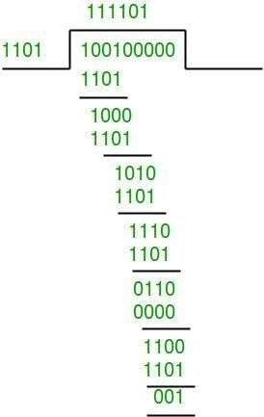

Generating Remainder
The remainder is 001. Thus the data sent is 100100001.

Receiver Side
Code word received at the receiver side 100100001

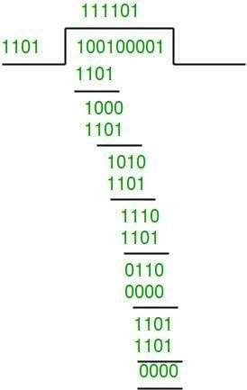

Checking the Remainder
The remainder is 0, hence the data received has no errors. CRC Implementation - O(n) Time and O(n) Space

Case 2: Error in Transmission
Data = 100100, Generator Polynomial (Key) = x³ + x² + 1 (1101)

Sender Side

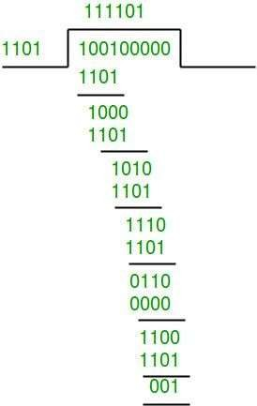

The remainder is 001. Thus the data sent is 100100001.

Receiver Side
Let there be an error and code word received at the receiver side 100000001.
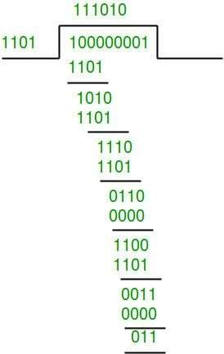
As the remainder is not 0, hence there is some error detected in the receiver side.

Conclusion
From this assignment, I gained a clear understanding of how errors can occur during data transmission and why error detection and error correction techniques are essential in communication systems. I learned about different methods used to identify and correct errors, such as Parity Check, Checksum, Cyclic Redundancy Check (CRC), and Hamming Codes. These techniques help ensure that the data received is accurate and reliable.
The study of Hamming Codes helped me understand how single-bit errors can be detected and corrected by adding redundant bits at specific positions in the data. Similarly, Cyclic Redundancy Check (CRC) demonstrated an effective method for detecting errors using polynomial division. Through the implementation of these techniques for 7/8-bit ASCII codes, I understood how theoretical concepts are applied in practical programming.
Overall, this assignment improved my knowledge of data communication reliability, error handling techniques, and their practical implementation, which are essential for maintaining accurate and secure data transmission in computer networks and digital systems.

Implementation

Source Code:
#include <iostream> using namespace std;

int main()
{
int d[4]; int code[8];
int p1, p2, p4, parity; int s1, s2, s4, errPos;

cout<<"Enter 4 data bits:\n"; for(int i=0;i<4;i++)
cin>>d[i];

cout<<"\nPlacing data bits into Hamming code positions\n"; cout<<"Positions: 1=P1 2=P2 3=D1 4=P4 5=D2 6=D3 7=D4\n";

code[2]=d[0];
code[4]=d[1];
code[5]=d[2];
code[6]=d[3];

cout<<"\nData bits placed:\n";

cout<<"D1="<<code[2]<<" D2="<<code[4]<<" D3="<<code[5]<<"
D4="<<code[6]<<endl; cout<<"\nCalculating parity bits\n";
p1 = code[2]^code[4]^code[6]; p2 = code[2]^code[5]^code[6]; p4 = code[4]^code[5]^code[6];

code[0]=p1; code[1]=p2; code[3]=p4;

cout<<"P1 = "<<p1<<endl; cout<<"P2 = "<<p2<<endl; cout<<"P4 = "<<p4<<endl;

cout<<"\nGenerated 7-bit Hamming Code:\n"; for(int i=0;i<7;i++)
cout<<code[i]<<" "; cout<<"\n";
parity = 0;
for(int i=0;i<7;i++) parity ^= code[i];

code[7] = parity;

cout<<"\nOverall parity bit = "<<parity<<endl;

cout<<"\nFinal 8-bit Hamming Code:\n"; for(int i=0;i<8;i++)
cout<<code[i]<<" "; cout<<"\n";
cout<<"\nEnter received 8-bit code:\n"; for(int i=0;i<8;i++)
cin>>code[i]; cout<<"\nChecking for errors...\n";
s1 = code[0]^code[2]^code[4]^code[6]; s2 = code[1]^code[2]^code[5]^code[6]; s4 = code[3]^code[4]^code[5]^code[6];

errPos = s1*1 + s2*2 + s4*4;

parity = 0;
for(int i=0;i<8;i++) parity ^= code[i];

cout<<"S1="<<s1<<" S2="<<s2<<" S4="<<s4<<endl;

if(errPos==0 && parity==0) cout<<"\nNo error found\n";

else if(errPos!=0 && parity==1)
{
cout<<"\nSingle bit error at position "<<errPos<<endl; code[errPos-1] ^= 1;
cout<<"Corrected code:\n"; for(int i=0;i<8;i++)
cout<<code[i]<<" ";
}

else if(errPos==0 && parity==1)
{
cout<<"\nError in overall parity bit\n";

code[7] ^= 1;

cout<<"Corrected code:\n"; for(int i=0;i<8;i++)
cout<<code[i]<<" ";
}

else
cout<<"\nDouble bit error detected. Correction not possible.\n";

return 0;
}

Output:
