 | Pimpri Chinchwad Education Trust’s Pimpri Chinchwad College of Engineering
Assignment No. 3
Course: Computer Networks Technology Laboratory (BIT24PC02)
Name: Mahadev Suresh Jundale
PRN: 125B2F007

Aim
To design and implement a WAN consisting of both wired and wireless LANs using Packet Tracer and to demonstrate the transmission of data from LAN 1 (wired) to LAN 2 (wireless).

Theory:

Theory about Wireless LAN, wireless protocols and wireless devices

Wireless LAN (WLAN):
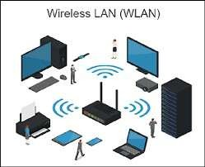

A Wireless Local Area Network (WLAN) is a type of network that enables devices to communicate without using physical cables. Instead of wires, it uses radio signals for communication between devices such as laptops, smartphones, printers, and routers.
WLANs are widely used in homes, offices, educational institutions, and public areas because they provide flexibility and ease of connection. Devices connect through a central device known as an Access Point (AP), which helps in communication and also connects the network to the internet.
The most commonly used WLAN technology is Wi-Fi, which follows IEEE 802.11 standards.

Features of Wireless LAN
- Mobility: Users can move freely within the coverage area while staying connected.
- Easy Setup: Installation is simple as it does not require extensive wiring.
- Flexibility: Devices can easily join or disconnect from the network.
- Scalability: New devices can be added without major changes in infrastructure.

Advantages

Minimizes the use of cables

Supports mobile and portable devices

Useful in places where wiring is difficult

Cost-efficient for network expansion

Disadvantages
- Security issues if not properly configured
- Interference from obstacles and other devices
- May offer lower speed compared to wired networks

Wireless Protocols

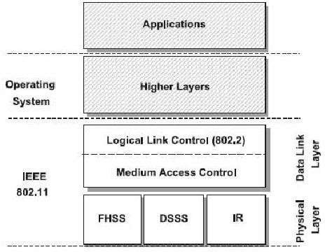

- IEEE 802.11 (Wi-Fi)
Wi-Fi is the most popular wireless communication standard used in WLANs. It is based on IEEE 802.11 and is developed for wireless connectivity.
It allows devices like laptops, smartphones, tablets, and smart TVs to connect to the internet via a wireless router or access point.

Key Characteristics

Works mainly on 2.4 GHz and 5 GHz bands

Suitable for homes, offices, and public hotspots

Uses radio waves for communicationCommon Wi-Fi Standards

Common Wi-Fi Standards:

Standard | Frequency | Maximum Speed |  |  | Features
802.11a | 5 GHz | 54 Mbps |  |  | Less interference but shorter range
802.11b | 2.4 GHz | 11 Mbps |  |  | Longer range but slower
802.11g | 2.4 GHz | 54 Mbps |  |  | Improved speed compatibility | with | wider
802.11n | 2.4 / 5 GHz | Up to 600 Mbps |  |  | Uses MIMO technology for better performance
802.11ac | 5 GHz | Up Gbps | to | several | Faster speeds and better streaming
802.11ax (Wi-Fi  6) | 2.4 / 5 GHz | Very high speeds |  |  | Improved efficiency many devices | and | supports

Advantages
  - Provides high-speed wireless connectivity
  - Compatible with most modern devices
  - Easy to install and expand.

Limitations

- Affected by interference
- Security concerns if encryption is weak

Bluetooth

Bluetooth is a wireless technology used for short-distance communication between devices.

Key Characteristics
- Range of around 10–100 meters
- Low power usage
- Supports multiple device connections.

Common Uses
  - Wireless headphones and speakers
  - Keyboard and mouse connectivity
  - File transfer between smartphones
  - Smartwatches and wearable devices
  - Car infotainment system

Advantages
  - Low energy consumption.
  - Easy pairing between devices.
  - No internet connection required.

Limitations
  - Limited range compared to Wi-Fi.
  - Slower data transfer speed.

ZigBee
ZigBee is a wireless protocol designed for low-power and low-data-rate communication. It is mainly used in Internet of Things (IoT) applications and smart home devices.
ZigBee is based on the IEEE 802.15.4 standard and supports mesh networking, where devices can relay data to each other.

Key Characteristics
  - Operates mainly in 2.4 GHz frequency band.
  - Designed for long battery life (months or even years).
  - Supports large networks with many connected devices.

Common Uses
  - Smart home automation systems
  - Smart lighting systems
  - Industrial monitoring systems
  - Sensor networks
  - Smart energy meters

Advantages
  - Very low power consumption.
  - Supports large networks.
  - Reliable communication through mesh networking.

Limitations
  - Low data transfer rate compared to Wi-Fi.
  - Mainly used for small data transmissions.

NFC (Near Field Communication)
Near Field Communication (NFC) is a very short-range wireless communication protocol that allows devices to exchange data when placed very close to each other (within about 4 cm).
It is commonly used for contactless transactions and authentication systems. Key Characteristics
  - Extremely short communication range (a few centimeters).
  - Fast and secure data exchange.
  - Works by simply bringing devices close together.

Common Uses
  - Contactless payments (mobile wallets).
  - Access control systems.
  - Public transport ticketing.
  - Smart cards and ID cards.

Advantages
  - Highly secure due to very short range.
  - Very simple to use (tap-based interaction).
  - Quick data exchange.

Limitations
  - Very limited range.
  - Supports only small data transfers.

Cellular Wireless Protocols (3G, 4G, 5G)
Cellular wireless protocols provide wide-area wireless communication using mobile network towers. These protocols allow smartphones and other devices to connect to the internet over large geographic areas.

Major Cellular Generations 3G (Third Generation)
  - Introduced mobile internet access.
  - Supports video calls and multimedia services.

4G LTE (Fourth Generation)
  - Provides high-speed internet access.
  - Supports HD video streaming, gaming, and fast downloads.

5G (Fifth Generation)
  - Very high speed and extremely low latency.
  - Supports advanced technologies such as smart cities, autonomous vehicles, and IoT networks.

Advantages
  - Wide coverage area.
  - High-speed mobile internet access.
  - Supports millions of connected devices.

Limitations
  - Requires network infrastructure such as cellular towers.
  - Higher power consumption compared to short-range protocols.

Configuration of components (screenshots with information)

PC Configuration
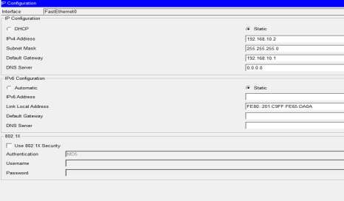
Each PC was configured with:
  - IP Address
  - Subnet Mask
  - Default Gateway

Steps:
- Click on PC
- Go to Desktop
- Select IP Configuration
- Enter:

Purpose:
o IP Address (e.g., 192.168.10.2)
o Subnet Mask (255.255.255.0)
- Default Gateway (192.168.10.1)

  - IP address identifies the device.
  - Subnet mask defines the network.
  - Default gateway allows communication with other networks.

Switch Configuration
Switches connect multiple devices within a LAN. Normally, basic switches work without configuration, but for management we assign an IP address.

Steps:
- Click on Switch
- Go to CLI
- Enter: enable
configure terminal interface vlan 1
ip address 192.168.10.10 255.255.255.0
no shutdown exit

Purpose:
  - Assigns IP for switch management.
  - Activates VLAN 1 interface.

Router Configuration

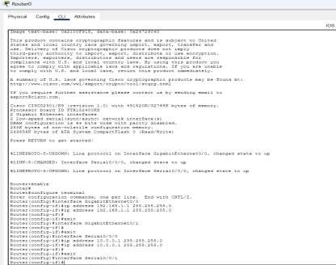
Routers connect different networks and route data between them.

Steps:
- Click on Router
- Go to CLI
- Enter: enable
configure terminal interface fastethernet 0/0
ip address 192.168.10.1 255.255.255.0
no shutdown exit

interface fastethernet 0/1
ip address 192.168.20.1 255.255.255.0
no shutdown exit

If serial interface is used: interface serial 0/0/0

ip address 10.0.0.1 255.255.255.252
clock rate 64000 no shutdown

Purpose:
- Assigns IP addresses to router interfaces.
- Enables communication between multiple networks.

Testing the Network
After configuration:
  - Use ping command from PC to another PC.
  - Check if connections show green lights.
  - Use show ip interface brief in router. Example:
ping 192.168.20.2
If reply is received, configuration is successful.

Output (include screenshots and addressing table)
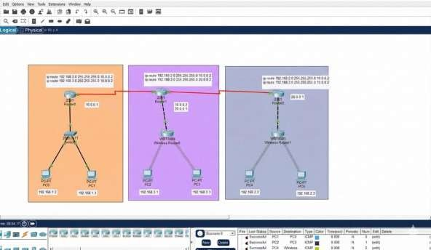

Device Name | IP address | Subnet mask | Default Gateway | Interface | Ip route
PC0 | 192.168.1.2 | 255.255.255. | 192.168.1.1 | FastEthernet | No
 |  | 0 |  | 0
PC1 | 192.168.1.3 | 255.255.255. | 192.168.1.1 | FastEthernet | No
 |  | 0 |  | 0
PC2 | 192.168.3.2 | 255.255.255.  0 | 192.168.3.1 | WIRELESS | No
PC3 | 192.168.3.3 | 255.255.255.  0 | 192.168.3.1 | WIRELESS | No
PC4 | 192.168.2.2 | 255.255.255.  0 | 192.168.2.1 | WIRELESS | No
PC5 | 192.168.2.3 | 255.255.255.  0 | 192.168.2.1 | WIRELESS | No
Wireless | 192.168.3.1 | 255.255.255. | Not required | -- | No
router0 |  | 0
Wireless | 192.168.2.1 | 255.255.255. | Not required | -- | No
router1 |  | 0
Router0 | 10.0.0.1 | 255.255.255. |  | SerialPort0/0 | ip route 192.168.3.0
 |  | 0 |  | /0 | 255.255.255.0 10.0.0.2
 |  |  |  |  | ip route 192.168.2.0
 |  |  |  |  | 255.255.255.0 10.0.0.2
Router1 | 10.0.0.2  20.0.0.1 | 255.255.255.  0 |  | SerialPort0/0  /0 | ip route 192.168.2.0  255.255.255.0 10.0.0.2
 |  |  |  | SerialPort0/0  /1 | ip route 192.168.3.0  255.255.255.0 20.0.0.
Router3 | 20.0.0.2 | 255.255.255. |  | SerialPort0/0 | ip route 192.168.2.0
 |  | 0 |  | /0 | 255.255.255.0 20.0.0.2
 |  |  |  |  | ip route 192.168.3.0
 |  |  |  |  | 255.255.255.0 20.0.0.2

- Conclusion
In this assignment, a network was designed connecting different departments using both wired and wireless communication. Each department was assigned a separate subnet to improve management and security.
Routers were used to connect different networks, while switches connected devices within the same network. Proper IP addressing ensured smooth communication.
This design allows efficient sharing of data and services across departments, ensuring reliable and secure communication.

