Logistics and supply chain management system

Database name : Logistics_and_supply_chain_management_system

Creating Tables:

1.CREATE TABLE Shipment(
shipment_id INT PRIMARY KEY,
destination VARCHAR(250),
weight VARCHAR(250),
content_description VARCHAR(500),
shipment_date DATE
);

DESCRIPTION:
Creating a Shipment Table columns are shipment_id data type INT(Primary key), destination data type varchar, weight data type varchar, content_description varchar, shipment_date data type date.

2. CREATE TABLE Warehouse(
warehouse_id INT PRIMARY KEY,
location VARCHAR(300),
capacity VARCHAR(250),
shipment_id INT,
FOREIGN KEY (shipment_id) REFERENCES Shipment(shipment_id)
);

DESCRIPTION:
Creating a Warehouse Table columns are warehouse_id data type INT(Primary key), location data type varchar, capacity data type varchar, shipment_id data type Int(Foreign key).

3. CREATE TABLE Carriers(
carrier_id INT PRIMARY KEY,
name VARCHAR(250),
type VARCHAR(250),
contact BIGINT
);

DESCRIPTION:
Creating a Carriers Table columns are carrier_id data type INT(Primary key), name data type varchar, type data type varchar, contact data type BIGINT.

4.CREATE TABLE Clients(
client_id INT PRIMARY KEY,
name VARCHAR(250),
address VARCHAR(300),
shipment_id INT,
FOREIGN KEY (shipment_id) REFERENCES Shipment(shipment_id)
);

DESCRIPTION:
Creating a Clients Table columns are client _id data type INT(Primary key), name data type varchar, address data type varchar, shipment_id data type INT(Foreign key).

5. CREATE TABLE Employees(
employee_id INT PRIMARY KEY,
name VARCHAR(250),
warehouse_id INT,
carrier_id INT,
rolee VARCHAR(250),
FOREIGN KEY (warehouse_id) REFERENCES Warehouse(warehouse_id),
FOREIGN KEY (carrier_id) REFERENCES Carriers(carrier_id)
);

DESCRIPTION:
Creating a Employees Table columns are employee_id data type INT(Primary key), name data type varchar, warehouse_id data type INT(Foreign key) , carrier_id data type INT(Foreign key), rolee data type varchar.

6. CREATE TABLE Address(
shipment_id INT,
carrier_id INT,
client_id INT,
city VARCHAR(250),
village VARCHAR(250),
FOREIGN KEY (shipment_id) REFERENCES Shipment(shipment_id),
FOREIGN KEY (carrier_id) REFERENCES Carriers(carrier_id),
FOREIGN KEY (client_id) REFERENCES Clients(client_id)
);

DESCRIPTION:
Creating a Address Table columns are shipment_id data type INT(Foreign key), city data type varchar, carrier_id data type INT(Foreign key) , client_id data type INT(Foreign key), village data type varchar.

Inserting data into Tables:

1.INSERT INTO Shipment (shipment_id, destination, weight, content_description, shipment_date) VALUES
(1, 'Delhi', '120kg', 'Electronics items', '2025-06-01'),
(2, 'Mumbai', '250kg', 'Furniture', '2025-06-05'),
(3, 'Bangalore', '180kg', 'Pharmaceuticals', '2025-06-07');

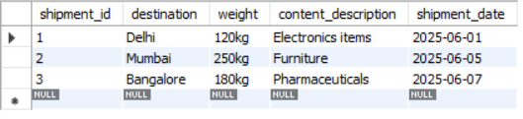

2. INSERT INTO Warehouse (warehouse_id, location, capacity, shipment_id) VALUES
(101, 'Delhi Industrial Zone', '500kg', 1),
(102, 'Mumbai Dockyard', '1000kg', 2),
(103, 'Bangalore Tech Park', '700kg', 3);

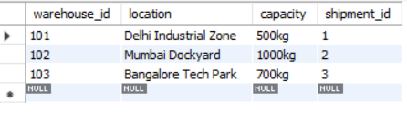

3.INSERT INTO Carriers (carrier_id, name, type, contact) VALUES
(201, 'Blue Dart', 'Air', 9876543210),
(202, 'GATI Ltd.', 'Road', 9123456780),
(203, 'DHL Express', 'Rail', 9988776655);

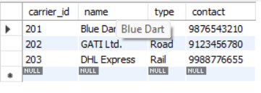

4.INSERT INTO Clients (client_id, name, address, shipment_id) VALUES
(301, 'Reliance Retail', 'Mumbai Central', 2),
(302, 'Apollo Hospitals', 'Bangalore North', 3),
(303, 'Flipkart India', 'Delhi NCR', 1);

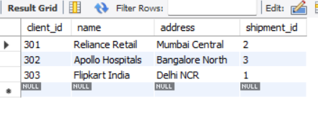

5.INSERT INTO Employees (employee_id, name, warehouse_id, carrier_id, rolee) VALUES
(401, 'Ravi Kumar', 101, 201, 'Warehouse Manager'),
(402, 'Sneha Roy', 102, 202, 'Transport Supervisor'),
(403, 'Ajay Mehta', 103, 203, 'Logistics Coordinator');

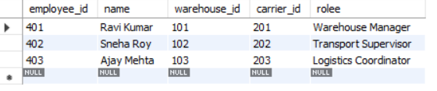

6.INSERT INTO Address (shipment_id, carrier_id, client_id, city, village) VALUES
(1, 201, 303, 'Delhi', 'Kalkaji'),
(2, 202, 301, 'Mumbai', 'Wadala'),
(3, 203, 302, 'Bangalore', 'Whitefield');

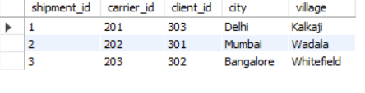

  - ER DIAGRAM:

