.

Hotel Management Database Documentation

1. Table: Employee
Stores employee details, including managers and staff.

CREATE TABLE Employee (
employee_id INT PRIMARY KEY,
name VARCHAR(100),
role VARCHAR(50),
hotel_code INT,
shift_details VARCHAR(100),
FOREIGN KEY (hotel_code) REFERENCES Hotel(hotel_code)
);

Foreign Key:
- hotel_code references Hotel(hotel_code)

DESCRIPTION:
Creating a Employee Table and the columns are employee_id data type int (Primary key), name data type varchar, role data type varchar, hotel_code data type Int shift_details data type varchar.

2. Table: Hotel
Stores hotel information.

CREATE TABLE Hotel (
hotel_code INT PRIMARY KEY,
name VARCHAR(100),
city VARCHAR(100),
manager_id INT,
num_rooms INT,
star_rating INT,
FOREIGN KEY (manager_id) REFERENCES Employee(employee_id)
);

Foreign Key:
- manager_id references Employee(employee_id);

DESCRIPTION:
Creating Hotel table and the colums are hotel_code int (primary key), name data type varchar, city data type varchar, manager_id data type int
Num_rooms data type int, star_rating int.

3. Table: Room
Represents individual rooms in a hotel.
CREATE TABLE Room (
room_number INT,
hotel_code INT,
type VARCHAR(50),
price_per_night DECIMAL(10,2),
availability_status VARCHAR(20),
PRIMARY KEY (room_number, hotel_code),
FOREIGN KEY (hotel_code) REFERENCES Hotel(hotel_code)
);
Foreign Key:
- hotel_code references Hotel(hotel_code)

DESCRIPTION:
Create a Room table and the colums are room_number data type is int(primary key), hotel_code data type int(primary key), type varchar, price_per_night data type DECIMAL(10,2), availability_status data type varchar.

4. Table: Guest
Stores guest information.

CREATE TABLE Guest (
guest_id INT PRIMARY KEY,
name VARCHAR(100),
loyalty_level VARCHAR(50)
);
Foreign Keys:
- guest_id references Guest(guest_id)
- hotel_code references Hotel(hotel_code)
- (Optional FK on room_number, depending on normalization strategy)

DESCRIPTION:
Create a Guest table and the columns are guest_id data type int(primary key), name data type varchar, loyalty_level data type varchar.

6. Table: Feedback
Stores guest feedback after a stay.

CREATE TABLE Feedback (
feedback_id INT PRIMARY KEY,
booking_id INT,
guest_id INT,
rating INT,
comments VARCHAR(255),
FOREIGN KEY (booking_id) REFERENCES Booking(booking_id),
FOREIGN KEY (guest_id) REFERENCES Guest(guest_id)
);
Foreign Keys:
- booking_id references Booking(booking_id)
- guest_id references Guest(guest_id)
DESCRIPTION:
Create a Feedback table and the columns are feedback_id data type int(primary key), booking_id data type int, guest_id int, comments data type varchar.

7. Table : Booking
Strong guest booking after a stay

CREATE TABLE Booking (
booking_id INT PRIMARY KEY,
guest_id INT,
hotel_code INT,
room_number INT,
check_in_date DATE,
check_out_date DATE,
total_bill DECIMAL(10,2),
FOREIGN KEY (guest_id) REFERENCES Guest(guest_id),
FOREIGN KEY (hotel_code, room_number) REFERENCES Room(hotel_code, room_number)
);

Foreign key :
. FOREIGN KEY (guest_id) REFERENCES Guest(guest_id),
. FOREIGN KEY (hotel_code, room_number) REFERENCES Room(hotel_code, room_number);

DESCRIPTION:
Create a Booking table and the columns are booking_id data type int(primary key), guest_id data type int, hotel_code data type int, room_number data type int,
Check_in_date data type DATE, Check_out_date data type DATE, total_bill data type DECIMAL(10,2).

INSERTING DATA

NSERT INTO Employee VALUES (101, 'Amit Rao', 'Manager', 1, 'Day');
INSERT INTO Employee VALUES (102, 'Priya Singh', 'Receptionist', 1, 'Night');
INSERT INTO Employee VALUES (103, 'Rahul Verma', 'Manager', 2, 'Day');
INSERT INTO Employee VALUES (104, 'Neha Kapoor', 'Housekeeping', 2, 'Day');

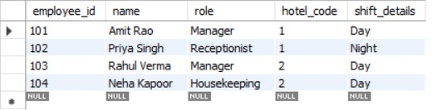

INSERT INTO Hotel VALUES (1, 'Grand Palace', 'Delhi', 101, 50, 5);
INSERT INTO Hotel VALUES (2, 'Seaside Resort', 'Mumbai', 103, 30, 4);

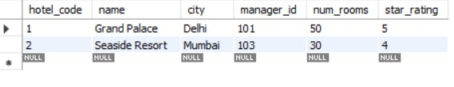

INSERT INTO Room VALUES (101, 1, 'Deluxe', 3500.00, 'Available');
INSERT INTO Room VALUES (102, 1, 'Suite', 5000.00, 'Occupied');
INSERT INTO Room VALUES (201, 2, 'Standard', 2500.00, 'Available');
INSERT INTO Room VALUES (202, 2, 'Deluxe', 3200.00, 'Available');

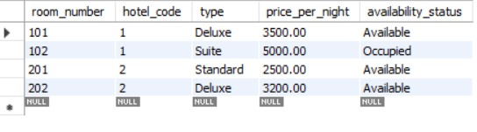

INSERT INTO Guest VALUES (1001, 'Karan Mehta', 'Silver');
INSERT INTO Guest VALUES (1002, 'Sneha Reddy', 'Gold');

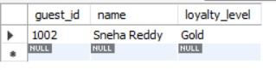

INSERT INTO Booking VALUES (501, 1001, 1, 102, '2025-06-10', '2025-06-13', 15000.00);
INSERT INTO Booking VALUES (502, 1002, 2, 201, '2025-06-12', '2025-06-14', 5000.00);

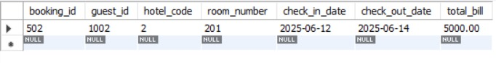

INSERT INTO Feedback VALUES (301, 501, 1001, 4, 'Great experience!');
INSERT INTO Feedback VALUES (302, 502, 1002, 5, 'Loved the hospitality!');

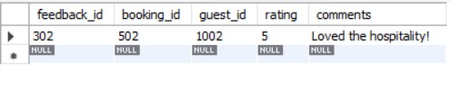

  - ER DIAGRAM:

