Kubernets

apiVersion: apps/v1
kind: Deployment
metadata:
name: ipl-deployment
namespace: mahi-ns
spec:
replicas: 6
selector:
matchLabels:
app: redis
template:
metadata:
labels:
app: ipl
spec:
containers:
- name: ipl-container
image: ipl: latest
ports:
- containerPort: 6379

Step-1 Create a namespace
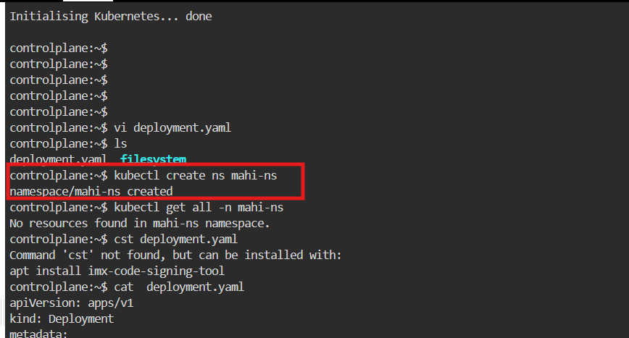
Step 2: Create a deployment yaml file inside a namespace
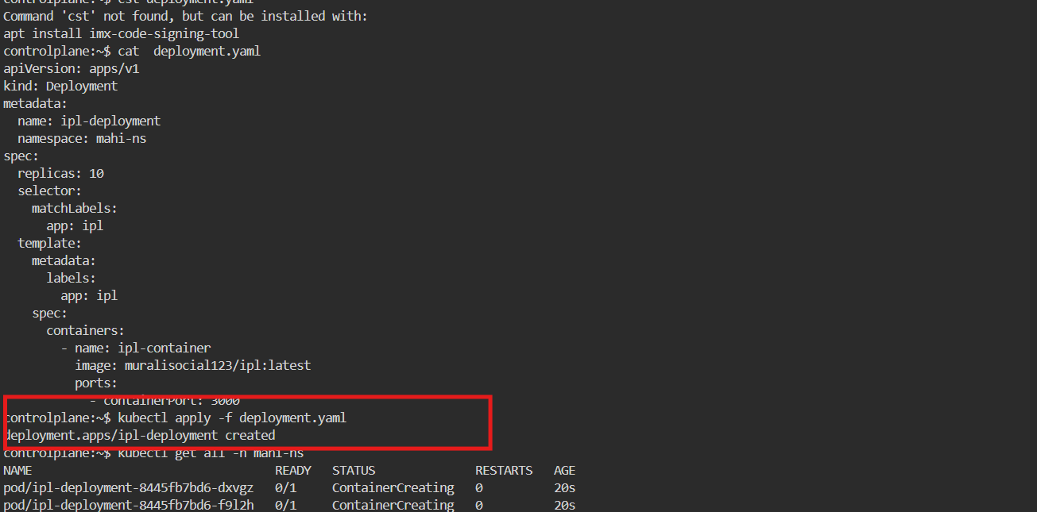

Step 3: After creating YAML file u need to check pods and replicas and deployments
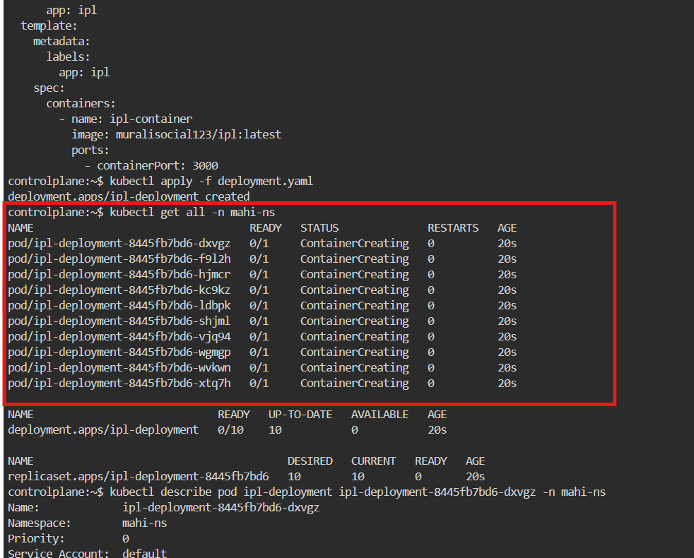
Step 4: After checking pods we need to describe the pod
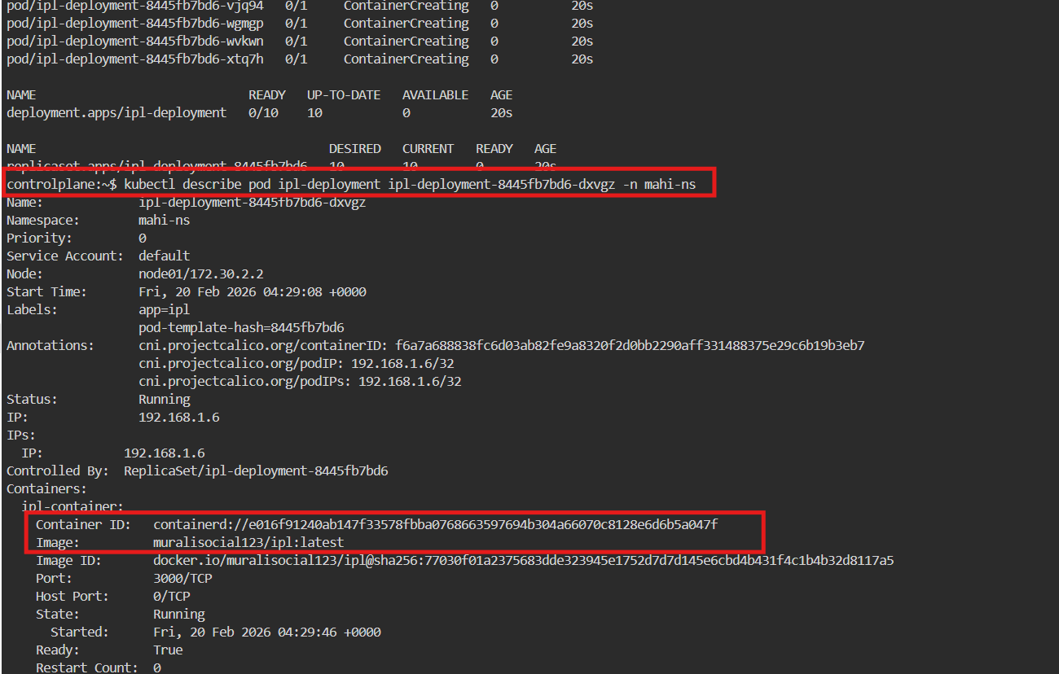

Step 5: Again, u have to upgrade the version by changing the image name in the yaml file
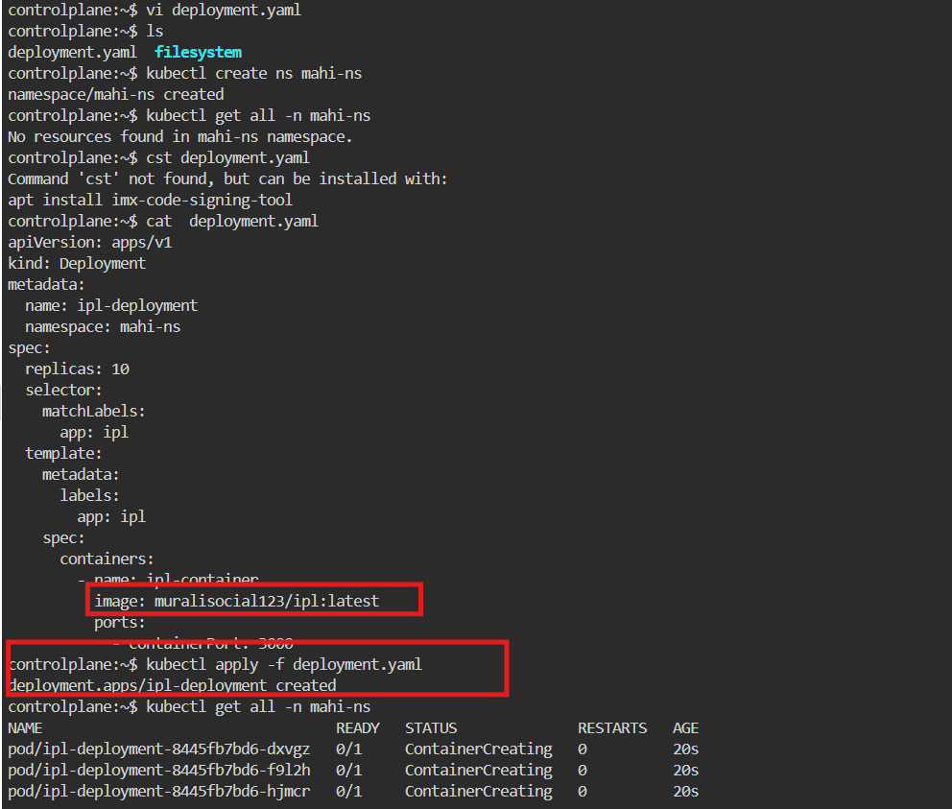
Step 6: After change the image name in the yaml file. To check the pods and replica set and deployment.
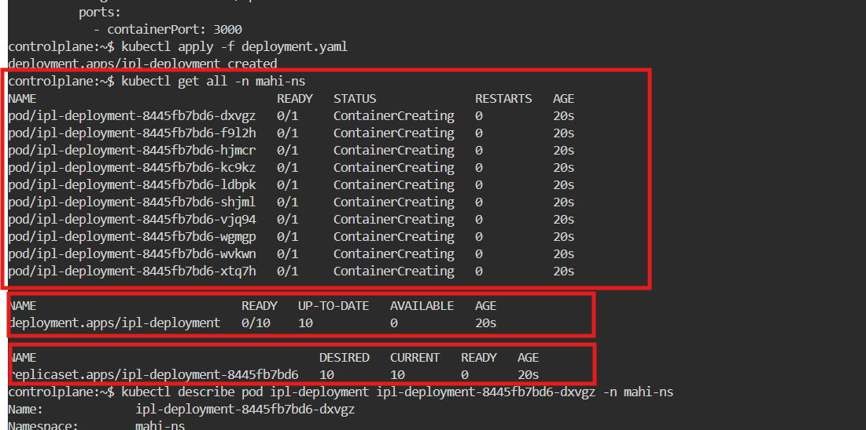

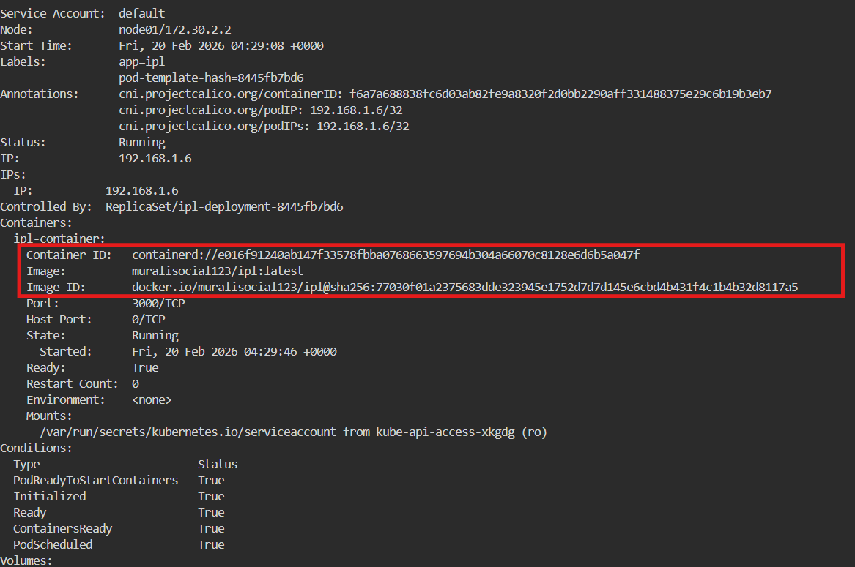
Step 7: To roll back the image name using command and check the history of deployment
