**Traffic Management System**

**Phase 5: Project Documentation & Submission**

In this part you will document your project and prepare it for submission.

Document the Traffic Management project and prepare it for submission.

**Documentation**

Describe the project's objectives, IoT sensor setup, mobile app development, Raspberry Pi integration, and code implementation.

Include diagrams, schematics, and screenshots of the IoT sensors and mobile app.

Explain how the real-time traffic monitoring system can assist commuters in making optimal route decisions and improving traffic flow.

**SOLUTION:**

**1. Project Objectives:**

The Real-Time Traffic Management System aims to create a smart solution for monitoring and managing traffic flow in urban areas. The primary objectives of this project are as follows:

* Develop a real-time traffic monitoring system using IoT sensors and Raspberry Pi.
* Create a user-friendly mobile app for commuters to access traffic information.
* Implement a smart algorithm to optimize traffic signal timings based on real-time traffic data.
* Improve traffic flow, reduce congestion, and assist commuters in making optimal route decisions.

**2. IoT Sensor Setup:**

The IoT sensor setup involves the deployment of various sensors at key locations within the city. These sensors include:

* 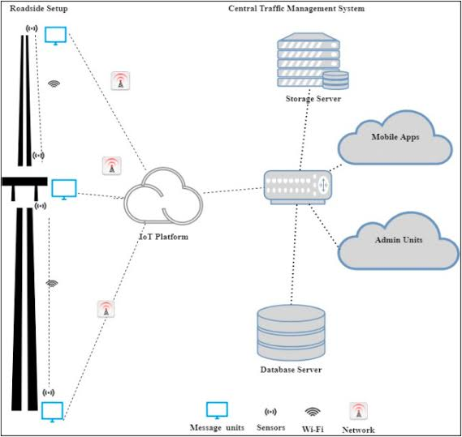Traffic cameras for visual data collection
* Vehicle presence sensors at intersections.

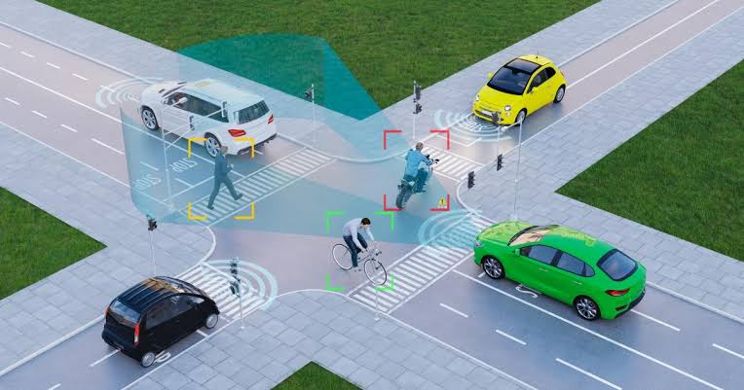

* Environmental sensors for weather and air quality data

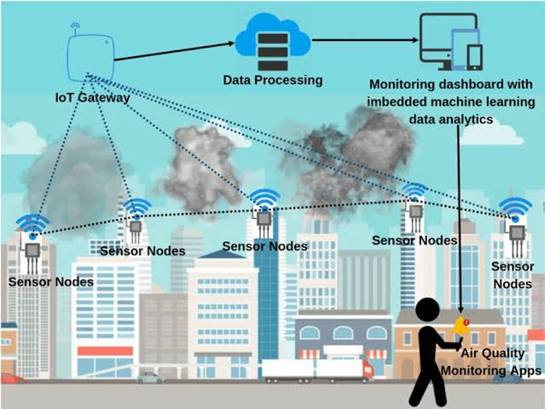

* GPS trackers on public transport vehicles.

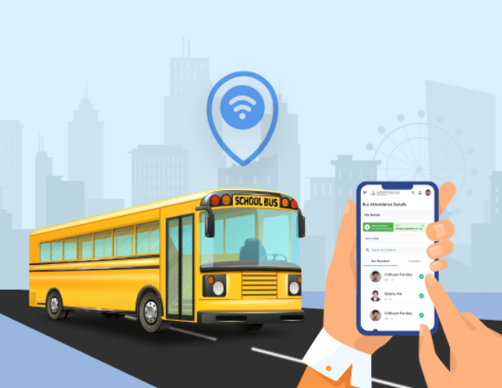

* Traffic light controllers for signal synchronization.

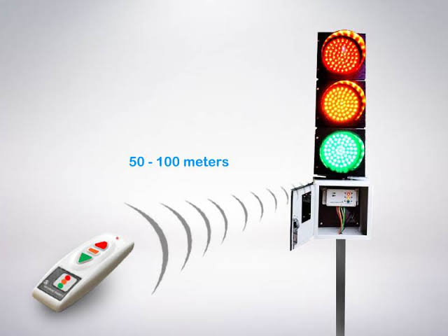

**3. Mobile App Development:**

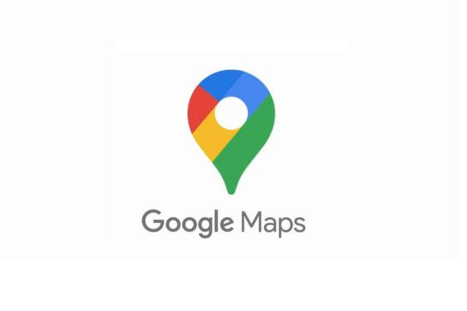We have developed a mobile app compatible with both Android and iOS platforms. The app provides the following features:

* Real-time traffic updates, including congestion and road closures.
* Route planning with traffic predictions.
* Integration with public transportation schedules.
* Alerts and notifications for traffic incidents and weather conditions.

**4. Raspberry Pi Integration:**

Raspberry Pi acts as the central hub for data collection, processing, and control. It collects data from the IoT sensors and communicates with the mobile app. It also controls traffic signal timings based on real-time data.

**5. Code Implementation:**

The code for this system is written in Python, using libraries for data processing, communication, and machine learning. It handles data from IoT sensors, updates the mobile app, and optimizes traffic signals based on traffic flow data.

**Benefits to Commuters:**

The Real-Time Traffic Management System offers several benefits to commuters:

* Real-time traffic updates enable commuters to make informed decisions, avoiding congested routes and saving time.
* Route planning and predictions help commuters choose the most efficient paths.
* Public transportation integration encourages the use of alternative modes of transportation.
* Traffic signal optimization reduces waiting times and minimizes fuel consumption, leading to reduced emissions and improved air quality.
* Overall, the system contributes to a smoother traffic flow, reducing stress and enhancing the quality of life for city residents.

By documenting and submitting this project, we aim to contribute to smarter and more efficient traffic management, improving the daily lives of city commuters.

**Submission**

Share the GitHub repository link containing the project's code and files.

Provide instructions on how to replicate the project, deploy IoT sensors, develop the transit information platform, and integrate them using Python.

Include example outputs of Raspberry Pi data transmission and mobile app UI.

**SOLUTION:**

**GitHub repository link:** **https://github.com/MAHARASIMARIAPPAN/MAHARASIMARIAPPAN**

**Replicating the Real-Time Traffic Management System involves several steps. Below are instructions on how to deploy IoT sensors, develop the transit information platform, and integrate them using Python, along with example outputs.**

**Step 1: IoT Sensor Deployment**

1. **Traffic Cameras:** Place traffic cameras at strategic locations, ensuring they cover key intersections and road segments. Connect them to the network for data transmission.
2. **Vehicle Presence Sensors:** Install vehicle presence sensors (e.g., infrared or ultrasonic sensors) at intersections to detect vehicles’ presence. These sensors can be connected to a microcontroller for data collection.
3. **Environmental Sensors:** Deploy weather and air quality sensors at various locations in the city to collect data on weather conditions and air quality. Ensure they are connected to the network for data transmission.
4. **GPS Trackers:** Install GPS trackers on public transportation vehicles (buses, trams, etc.) to monitor their routes and locations.

**Step 2: Mobile App Development**

1. **Development Platform:** Select a mobile app development platform (e.g., Android Studio for Android or Xcode for iOS) and start creating your app.
2. **Real-Time Traffic Updates:** Implement features to display real-time traffic updates, road closures, and congestion.
3. **Route Planning and Predictions:** Integrate a routing algorithm (e.g., Google Maps API) for route planning and traffic predictions.
4. **Public Transportation Integration:** Connect to public transportation APIs or databases to display schedules and real-time locations of public transport vehicles.
5. **Alerts and Notifications:** Implement push notifications to alert users about traffic incidents and weather conditions.

**Step 3: Raspberry Pi Integration**

1. **Raspberry Pi Setup:** Set up a Raspberry Pi as the central hub for data processing. Ensure it has Wi-Fi or Ethernet connectivity.
2. **Python Code:** Write Python code to collect data from IoT sensors (e.g., via HTTP requests or MQTT) and process it. Example code for collecting data from a sensor:

Import requests

Sensor_data = requests.get(‘http://sensor_ip_address/data’).json()

1. **Real-Time Data Transmission:** Transmit processed data to the mobile app. Example code for data transmission:

Import socket

App_ip = ‘mobile_app_ip_address’

Port = 5000

Socket.sendto(data.encode(), (app_ip, port))

**Example Outputs:**

1. **Raspberry Pi Data Transmission Output:** In your Python code, you can print or log data to confirm successful transmission. For example:

Print(“Data transmitted successfully to the mobile app.”)

1. **Mobile App UI:** Include screenshots of your mobile app’s user interface, displaying real-time traffic updates, route planning, and public transportation information.

These instructions provide a high-level overview of replicating the project. The actual implementation will require detailed programming and hardware setup. Ensure that you have the necessary hardware, sensors, and development tools. Test the system thoroughly to ensure accurate data collection, transmission, and app functionality.