TRAILGUIDE: AN INFRASTRUCTURE-INDEPENDENT SENSOR-FUSION PEDESTRIAN DEAD RECKONING AND BLE MESH DELAY-TOLERANT FRAMEWORK FOR OFF-GRID SEARCH AND RESCUE
PHASE : I  Nov/Dec 2026 | PROJECT REPORT SUBMITTED IN PARTIAL FULFILLMENT OF THE  REQUIREMENTS FOR THE AWARD OF THE DEGREE OF BACHELOR OF TECHNOLOGY IN INFORMATION TECHNOLOGY  OF THE ANNA UNIVERSITY
 | 
PROJECT WORK | Submitted by  AKASH DHANKAR 722823205003  LINGESH V 722823205027  MAHAVEER K 722823205028  SARAVANAN K 722823205045
BATCH
2023 – 2027
Under the Guidance of
Dr. D. Saranya, M.E., Ph.D.
SUPERVISOR
Department of Information Technology
 | Sri Eshwar College of Engineering  (An Autonomous Institution)  Kinathukadavu (Tk), Coimbatore - 641 202, Tamil Nadu Approved by AICTE, New Delhi and Affiliated to Anna University, Chennai | 

Sri Eshwar College of Engineering
(An Autonomous Institution)
Kinathukadavu (Tk), Coimbatore - 641 202, Tamil Nadu Approved by AICTE, New Delhi and Affiliated to Anna University, Chennai
TRAILGUIDE: AN INFRASTRUCTURE-INDEPENDENT SENSOR-FUSION PEDESTRIAN DEAD RECKONING AND BLE MESH DELAY-TOLERANT FRAMEWORK FOR OFF-GRID SEARCH AND RESCUE
PHASE : I  Nov/Dec 2026 | PROJECT REPORT SUBMITTED IN PARTIAL FULFILLMENT OF THE  REQUIREMENTS FOR THE AWARD OF THE DEGREE OF BACHELOR OF TECHNOLOGY IN INFORMATION TECHNOLOGY  OF THE ANNA UNIVERSITY
PROJECT WORK | Submitted by  AKASH DHANKAR 722823205003  LINGESH V 722823205027  MAHAVEER K 722823205028  SARAVANAN K 722823205045
BATCH
2023 – 2027
Under the Guidance of
Dr. D. Saranya, M.E., Ph.D.
SUPERVISOR
Department of Information Technology
Sri Eshwar College of Engineering
(An Autonomous Institution)
Kinathukadavu (Tk), Coimbatore - 641 202, Tamil Nadu Approved by AICTE, New Delhi and Affiliated to Anna University, Chennai



BONAFIDE CERTIFICATE
Certified that this Report titled “TRAILGUIDE: AN INFRASTRUCTURE-INDEPENDENT SENSOR-FUSION PEDESTRIAN DEAD RECKONING AND BLE MESH DELAY-TOLERANT FRAMEWORK FOR OFF-GRID SEARCH AND RESCUE” is the bonafide work of
AKASH DHANKAR | 722823205003
LINGESH V | 722823205027
MAHAVEER K | 722823205028
SARAVANAN K | 722823205045
who carried out the project work under my supervision.

SIGNATURE | SIGNATURE
Dr. S. Siamala Devi, ME., Ph.D.  HEAD OF THE DEPARTMENT  Information Technology,  Sri Eshwar College of Engineering,  Coimbatore - 641 202. | Dr. D. Saranya, M.E., Ph.D.  SUPERVISOR  Assistant Professor, Information Technology,  Sri Eshwar College of Engineering,  Coimbatore - 641 202.
Submitted for the Autonomous Semester End Project – Phase I Viva-Voce held on
…………………..

INTERNAL EXAMINER | EXTERNAL EXAMINER

QUALITY POLICY
To establish a system of Quality Enhancement, which would on a continuous basis evaluate and enhance the quality of teaching – learning, research and extension activities of the institution, leading to improvements in all processes, enabling the institution to attain excellence.

INSTITUTE VISION
To be recognized as a premier institution, grooming students into globally acknowledged engineering professionals.

INSTITUTE MISSION
- Providing outcome and value-based engineering education
- Nurturing research and entrepreneurial culture
- Enabling students to be industry ready and fulfill their career aspirations
- Grooming students through behavioral and leadership training programs
- Making students socially responsible

DEPARTMENT OF INFORMATION TECHNOLOGY DEPARTMENT VISION
To groom students into globally competent IT professionals and meet the ever changing requirements of the industry

DEPARTMENT MISSION
- Develop the curriculum and deliver with strong fundamentals with creative thinking
- Empower the faculty to be highly qualified and competent
- Build strong connectivity with various stakeholders to enrich the knowledge
- Create technical solutions to the societal problems
- Develop and upgrade the facilities for the efficient execution of academic and research activities

PROGRAM EDUCATIONAL OBJECTIVES
PEO1: Graduates will take up careers in Software Development and Testing and Involve in IT service and support management
PEO2: Graduates will engage in a post graduate program in the field of Information Technology and Management science leading to academic and research careers
PEO3: Graduates will take up Entrepreneurship as a career.

PROGRAM OUTCOMES
PO1: Engineering Knowledge: Apply knowledge of mathematics, natural science, computing, engineering fundamentals and an engineering specialization as specified in WK1 to WK4 respectively to develop to the solution of complex engineering problems.
PO2: Problem Analysis: Identify, formulate, review research literature and analyze complex engineering problems reaching substantiated conclusions with consideration for sustainable development. (WK1 to WK4) PO3: Design/Development of Solutions: Design creative solutions for complex engineering problems and design/develop systems/components/processes to meet identified needs with consideration for the public health and safety, whole-life cost, net zero carbon, culture, society and environment as required. (WK5) PO4: Conduct Investigations of Complex Problems: Conduct investigations of complex engineering problems using research-based knowledge including design of experiments, modelling, analysis & interpretation of data to provide valid conclusions. (WK8).
PO5: Engineering Tool Usage: Create, select and apply appropriate techniques, resources and modern engineering & IT tools, including prediction and modelling recognizing their limitations to solve complex engineering problems. (WK2 and WK6)
PO6: The Engineer and The World: Analyze and evaluate societal and environmental aspects while solving complex engineering problems for its impact on sustainability with reference to economy, health, safety, legal framework, culture and environment. (WK1, WK5, and WK7).
PO7: Ethics: Apply ethical principles and commit to professional ethics, human values, diversity and inclusion; adhere to national & international laws. (WK9)
PO8: Individual and Collaborative Team work: Function effectively as an individual, and as a member or leader in diverse/multi-disciplinary teams.
PO9: Communication: Communicate effectively and inclusively within the engineering community and society at large, such as being able to comprehend and write effective reports and design documentation, make effective presentations considering cultural, language, and learning differences
PO10: Project Management and Finance: Apply knowledge and understanding of engineering management principles and economic decision-making and apply these to one’s own work, as a member and leader in a team, and to manage projects and in multidisciplinary environments.
PO11: Life-Long Learning: Recognize the need for, and have the preparation and ability for i) independent and life-long learning ii) adaptability to new and emerging technologies and iii) critical thinking in the broadest context of technological change. (WK8)

PROGRAM SPECIFIC OUTCOME
PSO1: Demonstrate the ability to apply knowledge and skills in the development and deployment of software projects.
PSO2: Create innovative solutions by leveraging emerging technologies to effectively manage IT infrastructure.

DECLARATION
We,
AKASH DHANKAR | 722823205003
LINGESH V | 722823205027
MAHAVEER K | 722823205028
SARAVANAN K | 722823205045
Declare that the project entitled “TRAILGUIDE: AN INFRASTRUCTURE-INDEPENDENT SENSOR-FUSION PEDESTRIAN DEAD RECKONING AND BLE MESH DELAY-TOLERANT FRAMEWORK FOR OFF-GRID SEARCH AND RESCUE”, submitted in partial fulfilment to Anna University as the project work of Bachelor of Technology (Information Technology) Degree, is a record of original work done by us under the supervision and guidance of Dr. D. Saranya, M.E., Ph.D., Assistant Professor, Department of Information Technology, Sri Eshwar College of Engineering, Coimbatore.
Place: Coimbatore

Date:

AKASH DHANKAR (722823205003)
LINGESH V (722823205027)
MAHAVEER K (722823205028)
SARAVANAN K (722823205045)

Project Guided by,

[Dr. D. Saranya, M.E., Ph.D. / Information Technology]

ACKNOWLEDGEMENT
The success of a work depends on a team and cooperation. We take this opportunity to express our gratitude and thanks to everyone who helped us in our project. We would like to thank the management for the constant support provided by them to complete this project.
It is indeed our great honor bounded duty to thank our beloved Chairman Mr. R. Mohanram, for his academic interest towards the students. We are in debted to our Director Mr. R. Rajaram, for motivating and providing us with all facilities.
We wish to express our sincere regards and deep sense of gratitude to Dr.Sudha Mohanram M.E, Ph.D. Principal, for the excellent facilities and encouragement provided during the course of the study and project.
We are indebted to Dr.S.Siamala Devi, ME., Ph.D. Head of Information Technology Department for having permitted us to carry out this project and giving the complete freedom to utilize the resources of the department.
We express our sincere thanks to our project Co-ordinator Mr.C.Vasanthakumar, M.E., (Ph.D) Assistant Professor, Department of Information Technology for providing us his support and guidance and encouragement given to us for this project.
We also extend our heartfelt thanks to our Project Guide Dr. S. Siamala Devi, ME., Ph.D.,Head of the Department, Department of Information Technology for providing us his support and guidance which really helped us.
We solemnly express our thanks to all the teaching and non-teaching staff of the Information Technology Department, family and friends for their valuable support which inspired us to work on this project.

ABSTRACT
Global Navigation Satellite System (GNSS) signal degradation under dense forest canopies presents a critical life-safety hazard to wilderness travelers and Search and Rescue (SAR) teams. Under thick multi-layered foliage, consumer smartphone satellite receivers experience severe Position Dilution of Precision (PDOP > 6.5) or complete signal blackouts. Simultaneously, unassisted Inertial Navigation System (INS) dead-reckoning methods accumulate unbounded quadratic integration drift exceeding 12.4 meters within minutes. Traditional commercial navigation platforms exacerbate these limitations by requiring massive, multi-gigabyte raster map downloads and constant cellular connectivity.
This project presents TrailGuide, an infrastructure-independent wilderness travel and emergency coordination framework engineered for commodity smartphones. TrailGuide introduces a battery-efficient Sensor-Fusion Pedestrian Dead Reckoning (SF-PDR) engine combining accelerometer step kinematics, dynamic Weinberg stride estimation, and a tilt-compensated complementary heading filter fusing gyroscopic angular velocities with magnetometer field vectors. When canopy occlusion causes satellite accuracy to drop below 6.5 meters, the system automatically decouples GNSS updates and propagates spatial coordinates through passive inertial dead-reckoning.
For off-grid emergency signaling, TrailGuide integrates an infrastructure-less background Bluetooth Low Energy (BLE) Delay-Tolerant Network (DTN). Using a controlled Spray-and-Wait protocol with local Hive database deduplication, 24-byte distress beacons are relayed peer-to-peer across mobile human nodes until reaching an internet-connected gateway. Relayed packets are ingested by a cloud-based Next.js and MongoDB Atlas SAR command center featuring 2DSphere spatial query perimeters, live incident status management, and Open Source Routing Machine (OSRM) dynamic road routing.
Field benchmarking across a 2.5 km dense forest trail demonstrates that TrailGuide achieves a mean horizontal localization error of 0.68 meters (94.6% sub-meter accuracy), outperforming raw smartphone GNSS (12.42 m drift) by 94.5% and standard GNSS+INS baselines (4.85 m drift) by 86.0%. The BLE mesh DTN delivers 100% of SOS alerts within 4.2 seconds across 5 hops, while consuming only 11.4% CPU capacity and 13.8% battery per hour during continuous operation.

TABLE OF CONTENTS
CHAPTER NO. | TITLE | PAGE NO.
 | ABSTRACT | 8
 | LIST OF FIGURES | 11
 | LIST OF TABLES | 12
 | LIST OF ABBREVIATIONS | 13
1. | INTRODUCTION | 15
 | 1.1 BACKGROUND | 15
 | 1.2 PROBLEM STATEMENT | 16
 | 1.3 OBJECTIVES | 16
 | 1.4 SCOPE OF THE PROJECT | 17
2. | LITERATURE SURVEY | 18
 | 2.1 TRADITIONAL INERTIAL & SATELLITE POSITIONING IN CANOPIES | 18
 | 2.2 GNSS ATTENUATION & MULTIPATH CHALLENGES IN FORESTRY | 18
 | 2.3 CONVENTIONAL INS & ACCELERATION DOUBLE-INTEGRATION DRIFT | 18
 | 2.4 DELAY-TOLERANT NETWORKS (DTN) IN EMERGENCY COMMUNICATIONS | 19
 | 2.5 OPPORTUNISTIC BLUETOOTH LOW ENERGY (BLE) MESH NETWORKING | 19
 | 2.6 SENSOR-FUSION & PEDESTRIAN DEAD RECKONING (PDR) TECHNIQUES | 20
 | 2.7 TILT-COMPENSATED ORIENTATION & COMPLEMENTARY FILTERING | 20
 | 2.8 MACHINE LEARNING & INERTIAL ODOMETRY IN CANOPY ENVIRONMENTS | 21
 | 2.9 OPEN SOURCE ROUTING MACHINE & SPATIAL VECTOR GEOMETRIES | 21
 | 2.10 LIMITATIONS OF EXISTING RESEARCH | 21
 | 2.11 NEED FOR THE PROPOSED TRAILGUIDE SYSTEM | 21
3. | PROPOSED SYSTEM | 23
 | 3.1 PROPOSED SYSTEM NEED & DESIGN PRINCIPLES | 23
 | 3.2 DATA SOURCES AND DATASETS | 23
 | 3.3 SYSTEM ARCHITECTURE | 25
 | 3.4 SENSOR & DATA INTEGRATION PIPELINE | 26
 | 3.5 CORE MODULES & MATHEMATICAL FORMULATIONS | 26
 | 3.6 USER INTERFACE AND DASHBOARD | 29
 | 3.7 OVERALL SYSTEM FLOW | 29
4. | IMPLEMENTATION AND RESULT | 31
 | 4.1 IMPLEMENTATION OVERVIEW | 31
 | 4.2 SENSOR DATA COLLECTION AND PREPROCESSING | 32
 | 4.3 SENSOR-FUSION PDR IMPLEMENTATION | 32
 | 4.4 BLE MESH DELAY-TOLERANT NETWORK IMPLEMENTATION | 33
 | 4.5 CLOUD SAR COMMAND PORTAL IMPLEMENTATION | 34
 | 4.6 MODEL EVALUATION AND ALGORITHM VERIFICATION | 35
 | 4.7 COMPLETE SYSTEM OUTPUT & APPLICATION SCREENSHOTS | 36
5. | RESULTS AND DISCUSSION | 42
 | 5.1 INTRODUCTION & EXPERIMENTAL SETUP | 42
 | 5.2 EXPERIMENTAL BENCHMARKING RESULTS | 42
 | 5.3 COMPREHENSIVE DISCUSSION AND COMPARATIVE EVALUATION | 48
6. | CONCLUSION & FUTURE ENHANCEMENTS | 50
 | 6.1 CONCLUSION | 50
 | 6.2 FUTURE ENHANCEMENTS | 50
7. | REFERENCES | 52

LIST OF FIGURES
FIGURE NO. | TITLE | PAGE NO.
Figure 3.1 | Integrated Multi-Modal Input Stream & Spatial Data Architecture | 24
Figure 3.2 | TrailGuide End-to-End 4-Tier System Architecture | 25
Figure 3.3 | Tilt-Compensated Complementary Filter & Weinberg Kinematic Pipeline | 26
Figure 3.4 | Controlled Spray-and-Wait Delay-Tolerant Routing Protocol | 27
Figure 3.5 | Overall TrailGuide System Execution Flowchart | 29
Figure 4.1 | SF-PDR Sensor-Fusion Runtime Telemetry Execution Console Output | 35
Figure 4.2 | Web Planning Portal - Explore Catalog & Sector Selection Interface | 36
Figure 4.3 | Real-Time Dynamic Road Routing to Trailhead using Leaflet & OSRM API | 37
Figure 4.4 | Micro-Sharded Vector Map QR Provisioning Modal Interface | 37
Figure 4.5 | Mobile Client - Landing Interface and Offline Vector Map Management | 38
Figure 4.6 | Mobile Tactical HUD - Offline Blueprint Map with Live PDR Tracking | 39
Figure 4.7 | Mobile Tactical Interface - Emergency SOS Standby and Broadcast Activation | 40
Figure 4.8 | Cloud SAR Incident Command Room Dashboard (/sos) | 41
Figure 5.1 | Sensor-Fusion Yaw Heading Estimation Comparison | 42
Figure 5.2 | Accelerometer Magnitude and Weinberg Step Segmentation | 43
Figure 5.3 | Horizontal Positioning Drift vs. Traverse Distance Under 100% Canopy Occlusion | 45
Figure 5.4 | Controlled Spray-and-Wait BLE Mesh SOS Delivery Performance | 44
Figure 5.5 | Continuous 8-Hour Smartphone Resource & Battery Profile | 46

LIST OF TABLES
TABLE NO. | TABLE NAME | PAGE NO.
Table 3.1 | Multi-Modal Input Sensor & Spatial Feature Specifications | 24
Table 4.1 | Hardware Requirements and Specifications | 31
Table 4.2 | Software Requirements, Frameworks, and Dependencies | 31
Table 5.1 | Empirical Horizontal Localization Benchmark Under 100% Canopy Blackout | 44
Table 5.2 | Multi-Hop BLE Mesh Delivery Rate, Latency, and Packet Success | 44
Table 5.3 | Continuous Hardware Resource & Battery Consumption Profile (8 Hours) | 46
Table 5.4 | Complementary Filter Alpha Sensitivity and Heading Stability Analysis | 47
Table 5.5 | Offline Vector Tiles vs. Raster Mapping Storage and Memory Benchmark | 47
Table 5.6 | Comprehensive Wilderness Navigation & Emergency Framework Comparison | 48

LIST OF ABBREVIATIONS
ABBREVIATION | EXPANSION & DESCRIPTION
BLE | Bluetooth Low Energy (2.4 GHz ISM wireless radio standard)
GNSS | Global Navigation Satellite System (GPS, GLONASS, Galileo, BeiDou)
GPS | Global Positioning System (US Satellite Navigation Constellation)
INS | Inertial Navigation System (Strapdown accelerometer/gyroscope system)
IMU | Inertial Measurement Unit (Tri-axial multi-sensor hardware unit)
PDR | Pedestrian Dead Reckoning (Step-stride kinematic positioning method)
SF-PDR | Sensor-Fusion Pedestrian Dead Reckoning (Proposed tracking framework)
DTN | Delay-Tolerant Network (Store-and-forward opportunistic network architecture)
SAR | Search and Rescue (Wilderness emergency operations and extraction teams)
MEMS | Micro-ElectroMechanical Systems (Miniaturized silicon motion sensors)
PDOP | Position Dilution of Precision (Satellite geometric configuration quality factor)
OSM | OpenStreetMap (Open-access collaborative worldwide geographic dataset)
MVT | Mapbox Vector Tiles (Standard protocol buffer encoded spatial vector format)
PBF | Protocol Buffer Format (Binary serialized geographic data encoding)
OSRM | Open Source Routing Machine (High-performance routing and navigation engine)
GATT | Generic Attribute Profile (Bluetooth Low Energy communication layer)
FIFO | First-In, First-Out (Circular sample buffer architecture)
REST | Representational State Transfer (Stateless HTTP web API architectural style)
API | Application Programming Interface (Inter-software communication interface)
UUID | Universally Unique Identifier (128-bit unique packet and beacon identifier)
HUD | Heads-Up Display (Tactical operational high-contrast mobile user interface)
RSSI | Received Signal Strength Indicator (Radio frequency reception power metric)
JSON | JavaScript Object Notation (Lightweight data interchange format)
LoRa | Long Range Low-Power Wide-Area Network Modulation (868/915 MHz chirped spread spectrum)
EKF | Extended Kalman Filter (Non-linear state estimation algorithm)

CHAPTER 1
INTRODUCTION
1.1 BACKGROUND
Wilderness exploration, eco-tourism, high-altitude mountaineering, backcountry trekking, and Search and Rescue (SAR) missions are conducted in challenging geographic environments that are fundamentally disconnected from conventional communication and computing infrastructure. In remote mountain passes, deep river gorges, densely canopied tropical and temperate forests, and national wildlife reserves, there is a total absence of cellular base transceiver stations (BTS), terrestrial broadband, or Wi-Fi access points. Travelers, forestry field researchers, and rescue personnel who operate in these regions must rely exclusively on mobile consumer equipment for navigation, situational awareness, and emergency signaling.
Modern consumer smartphones are equipped with high-sensitivity multi-constellation satellite receivers capable of processing microwave signals across multiple Global Navigation Satellite System (GNSS) arrays, including the United States Global Positioning System (GPS), Russian GLONASS, European Galileo, and Chinese BeiDou. Under ideal open-sky conditions, these satellite positioning engines achieve horizontal accuracy within 3 to 5 meters. However, when a traveler enters a dense forest canopy, the physical conditions required for satellite localization break down entirely.
Forest vegetation—specifically dense leaf canopies, foliage moisture layers, woody tree trunks, and high-density timber stands—acts as a severe dielectric attenuator of L-band radio frequencies (1.2 GHz to 1.6 GHz). Satellite microwave rays are absorbed, refracted, and scattered across multiple physical obstacles before reaching the smartphone's internal microstrip antenna. This multipath scattering degrades signal timing, introducing pseudorange errors and triggering extreme Position Dilution of Precision (PDOP > 6.5). Under multi-layered hardwood and pine canopies, consumer satellite receivers frequently experience complete signal blackout, causing the operating system's location service to freeze the position marker or drift erratically across several hundreds of meters.
Simultaneously, traditional Inertial Navigation Systems (INS) built into smartphones rely on internal Micro-ElectroMechanical Systems (MEMS) accelerometers and gyroscopes. Although inertial dead-reckoning operates independently of external radio signals, unassisted smartphone INS dead-reckoning degrades rapidly over time. Double-integrating raw accelerometer readings to calculate velocity and displacement results in quadratic and cubic error growth driven by sensor bias instability, temperature drift, and thermal noise. In practice, unassisted smartphone dead-reckoning accumulates over 12.4 meters of horizontal drift within minutes of operation.
Furthermore, conventional commercial mobile mapping applications (such as Google Maps, Apple Maps, AllTrails, and OsmAnd) are poorly suited for off-grid survival. First, their client-server architecture assumes continuous cellular connectivity to stream raster image tiles. When connectivity ceases, un-cached raster viewports go blank. Even when offline caching is manually configured, downloading multi-gigabyte raster image maps exhausts internal device storage, overburdens memory bandwidth, and accelerates battery depletion due to intensive GPU rasterization. Most critically, these commercial applications provide no mechanism to transmit emergency distress beacons without cellular network coverage or expensive, proprietary satellite hardware peripherals such as Garmin inReach, ACR Bivy Stick, or SPOT transceivers.
1.2 PROBLEM STATEMENT
Wilderness travelers, outdoor researchers, and Search and Rescue teams face a critical convergence of technological failures when operating beneath dense forest canopies and remote backcountries:
• Catastrophic GNSS Attenuation: Overhead multi-layered foliage introduces severe multipath scattering, signal refraction, and total satellite blackout, causing consumer smartphone positioning errors to exceed 12 to 18 meters.
• Unbounded Inertial Drift: Unassisted smartphone INS implementations suffer from rapid quadratic double-integration drift, rendering raw accelerometer tracking unusable without continuous external corrections.
• Communication Infrastructure Deprivation: Total absence of cellular networks precludes standard SMS or IP-based emergency SOS transmissions, leaving distressed individuals isolated unless equipped with expensive satellite hardware.
• Storage and Battery Inefficiency: Traditional offline mapping platforms rely on monolithic raster tiles consuming hundreds of megabytes per sector and exhausting mobile battery reserves through continuous GPU rendering within 4 to 6 hours.
• Fragmented Emergency Coordination: Existing wilderness tools lack seamless integration with centralized SAR dispatch consoles, hindering rapid extraction planning and dynamic overland route navigation.
1.3 OBJECTIVES
The primary objective of this project is to architect, develop, and empirically validate TrailGuide—an infrastructure-independent wilderness travel and emergency coordination platform designed for commodity smartphones. Specific engineering objectives include:
• To engineer a robust Sensor-Fusion Pedestrian Dead Reckoning (SF-PDR) engine combining 100 Hz tri-axial accelerometer kinematics, Weinberg dynamic stride length estimation, and a tilt-compensated complementary heading filter fusing gyroscopic angular velocities with magnetometer magnetic vectors.
• To establish an autonomous dual-state gating mechanism that decouples positioning from degraded satellite feeds when horizontal accuracy drops below 6.5 meters, maintaining sub-meter dead-reckoning accuracy (mean error < 0.70 m) under continuous canopy blackout.
• To develop an infrastructure-less background Bluetooth Low Energy (BLE) Delay-Tolerant Network (DTN) utilizing a Controlled Spray-and-Wait protocol with local Hive database deduplication to relay 24-byte distress beacons multi-hop across mobile peer nodes.
• To build a lightweight, micro-sharded vector mapping subsystem delivering complete sector trail maps in compact protocol-buffer packages under 2 MB, optimized for low GPU memory overhead and extended battery endurance (>8 hours).
• To create an integrated cloud Search and Rescue (SAR) command center leveraging Next.js, MongoDB Atlas 2DSphere spatial geospatial queries, and Open Source Routing Machine (OSRM) dynamic road routing for real-time extraction coordination.
1.4 SCOPE OF THE PROJECT
The scope of Phase-I encompasses the mathematical modeling, firmware-level sensor acquisition, cross-platform mobile application development, decentralized mesh networking protocols, and full-stack web command room implementation:
• Target Hardware: Commodity iOS and Android smartphones equipped with standard tri-axial MEMS accelerometers, rate gyroscopes, magnetometers, and BLE 4.2/5.0 radios, requiring zero external hardware dongles or proprietary sensors.
• Geographic Environments: Dense forest trails, mountain nature reserves, and university campus woodland paths characterized by complete satellite occlusion and cellular dead zones.
• Communication Protocols: Peer-to-peer opportunistic BLE advertising and scanning adhering to non-connectable undirected advertising standards with binary payload compression.
• Web Command Infrastructure: Modern web technologies including Next.js 14, React Leaflet, MongoDB Atlas geospatial indexing, and containerized OSRM routing instances.

CHAPTER 2
LITERATURE SURVEY
2.1 TRADITIONAL INERTIAL & SATELLITE POSITIONING IN CANOPIES
Keefe et al. (2019) conducted comprehensive empirical evaluations of GNSS performance in commercial timberland forests [7]. Their investigation revealed that canopy closure, basal area density, and tree species composition significantly degrade satellite positioning accuracy. In mature pine and mixed hardwood canopies, positional errors frequently exceeded 10 to 15 meters, with signal acquisition times increasing by an order of magnitude. The authors emphasized the imperative need for complementary sensor integration to support precision forestry and wilderness safety operations.
Vegetative signal attenuation follows the ITU-R Recommendation P.833 vegetation attenuation model, where specific attenuation at GNSS L1 frequencies (1.575 GHz) ranges between 0.15 dB/m to 0.45 dB/m depending on moisture content and leaf area index. In deep tropical and temperate forests where the transmission path through wet foliage extends over 30 to 50 meters, the cumulative signal loss easily surpasses 12 to 18 dB. This severe attenuation drops satellite carrier-to-noise density ratios (C/N0) below 28 dB-Hz, forcing consumer GPS chipsets into weak-signal tracking loops that exhibit frequent cycle slips and prolonged receiver loss-of-lock.
2.2 GNSS ATTENUATION & MULTIPATH CHALLENGES IN FORESTRY
Bär et al. (2019) investigated multi-sensor fusion architectures for pedestrian micro-navigation across challenging urban canyons and dense temperate forests [18]. Their findings demonstrated that multipath reflections from wet foliage and dense wood trunks introduce non-Gaussian pseudorange measurement errors that severely corrupt standard Extended Kalman Filter (EKF) state estimation. The authors concluded that unassisted satellite positioning is fundamentally unreliable for safety-critical pedestrian tracking under continuous canopy coverage.
Multipath interference in dense timber stands creates constructive and destructive carrier-phase interference patterns that severely distort correlation peak symmetry within the receiver delay-lock loops (DLL). Because wood trunks and saturated foliage act as diffuse radio reflectors, the received signal comprises multiple delayed replicas arriving with relative path delays between 10 to 45 meters. Under these conditions, conventional Receiver Autonomous Integrity Monitoring (RAIM) algorithms fail because the observation residuals violate Gaussian distribution assumptions, causing the receiver to output biased pseudoranges that manifest as erratic position jumps exceeding 25 meters.
2.3 CONVENTIONAL INS & ACCELERATION DOUBLE-INTEGRATION DRIFT
Kumar and Reddy (2020) published an exhaustive review of smartphone-based pedestrian dead reckoning methodologies [15]. Their mathematical analysis demonstrated that double-integrating raw acceleration measurements without kinematic domain constraints leads to quadratic position errors growing as O(t²). Micro-machined silicon accelerometers exhibit non-zero bias instabilities and thermal drift that accumulate rapidly, producing horizontal positioning errors exceeding 15 meters within 60 seconds of unconstrained integration.
The mathematical origin of this rapid divergence lies in the double integration of total acceleration: p(t) = p0 + v0*t + 0.5*a*t^2. Any uncompensated sensor bias ba or angular rate bias bg propagates quadratically and cubically over time. In commodity MEMS silicon units, bias stability typically exceeds 15-30 mg, causing unconstrained position errors to exceed 5 meters in just 10 seconds and more than 50 meters in 2 minutes. This mathematical reality proves that unassisted strapdown inertial navigation without periodic domain-specific kinematic boundary constraints (such as footfall ground-contact zero-velocity resets) cannot sustain operational tracking for pedestrian navigation.
2.4 DELAY-TOLERANT NETWORKS (DTN) IN EMERGENCY COMMUNICATIONS
Gelenbe et al. (2021) analyzed the deployment of Delay-Tolerant Networks (DTNs) in disaster scenarios characterized by total infrastructure collapse [11]. The authors evaluated opportunistic store-carry-and-forward communication paradigms, highlighting that epidemic flooding protocols guarantee high delivery rates but induce severe channel contention and buffer exhaustion. Conversely, quota-based protocols significantly reduce message overhead while maintaining deterministic delivery bounds in sparse human mobility networks.
Theoretical DTN analysis confirms that purely opportunistic flooding creates high message redundancy that rapidly exhausts the limited SRAM and non-volatile flash storage of low-cost mobile handsets. In contrast, quota-based Controlled Spray-and-Wait partitions message dissemination into an initial 'Spray' phase—distributing a strictly bounded number of L0 message copies to newly encountered intermediate relays—followed by a 'Wait' phase where relays hold their copies until directly contacting destination gateways. This architecture achieves a message delivery ratio within 95% of unbounded flooding while consuming less than 15% of the network transmission energy.
2.5 OPPORTUNISTIC BLUETOOTH LOW ENERGY (BLE) MESH NETWORKING
Álvarez et al. (2019) designed Bluemergency, an opportunistic communication system leveraging Bluetooth Mesh and IoT nodes for post-disaster survivor coordination [1]. Their work demonstrated that commodity smartphone BLE radios can establish spontaneous multi-hop mesh topographies without centralized coordinators. Rondón et al. (2019) and Villa et al. (2022) conducted in-depth reliability and latency benchmarks on BLE mesh protocols, concluding that controlled packet flooding over non-connected advertising channels provides resilient emergency beaconing with sub-5-second multi-hop latency [2], [4].
Bluetooth Low Energy operating in the 2.4 GHz ISM band benefits from dedicated primary advertising channels (channels 37, 38, and 39) spaced across the radio spectrum to mitigate co-channel Wi-Fi interference. Non-connectable undirected advertising packets (ADV_NONCONN_IND) allow mobile nodes to broadcast compact data bursts without the latency and power overhead of establishing point-to-point cryptographic BLE connections. By tuning scan windows and advertising intervals asynchronously, smartphones can maintain background mesh readiness with negligible duty-cycle power consumption (<1.5 mW average).
2.6 SENSOR-FUSION & PEDESTRIAN DEAD RECKONING (PDR) TECHNIQUES
Weinberg (2002) introduced a seminal empirical biomechanical stride estimation formulation based on vertical acceleration variation during walking gait cycles [14]. Gallagher et al. (2012) comparatively benchmarked multiple PDR algorithms, establishing that step-and-heading systems constrained by dynamic stride modeling eliminate quadratic acceleration integration drift, reducing error growth to a linear function of step count [19].
By decomposing pedestrian locomotion into discrete step kinematics, PDR replaces continuous time integration with spatial step summation: p_k = p_{k-1} + S_k * [cos(theta_k), sin(theta_k)]. This kinematic transformation fundamentally bounds localization error: positioning drift becomes purely proportional to the error in individual stride length estimation S_k and heading angle theta_k, completely eliminating time-dependent cubic and quadratic integration blowup.
2.7 TILT-COMPENSATED ORIENTATION & COMPLEMENTARY FILTERING
Smartphone magnetometers are susceptible to high-frequency electromagnetic anomalies, while gyroscopes suffer from slow low-frequency zero-rate drift. Traditional orientation estimators employ high-order Madgwick or Extended Kalman Filters. However, complementary frequency-domain filtering delivers equivalent heading accuracy with drastically reduced floating-point arithmetic complexity, making it uniquely suited for continuous background execution on low-power mobile processors.
The complementary filter achieves optimal spectral separation by passing high-frequency gyroscope angular rate signals through a high-pass filter while simultaneously routing low-frequency magnetometer orientation vectors through a matching low-pass filter. Setting the filter coefficient alpha = 0.98 produces a crossover frequency that rejects high-frequency electromagnetic noise from iron deposits and trail infrastructure while ensuring the slow gyroscope zero-rate drift is continuously eliminated, providing stable orientation tracking under extreme trekking dynamics.
2.8 MACHINE LEARNING & INERTIAL ODOMETRY IN CANOPY ENVIRONMENTS
Recent advances in neural inertial navigation have explored deep learning models—such as RoNIN (Robust Neural Inertial Navigation) and IoNet—for estimating 2D pedestrian displacement from windowed IMU sequences [20], [21]. While neural odometry models achieve low trajectory drift in controlled indoor environments, their deployment on edge smartphones in wilderness settings presents significant obstacles. Neural networks incur high memory allocation (exceeding 250 MB for model weights and activation buffers), demand substantial continuous GPU/NPU inference power (>35% battery drain per hour), and exhibit catastrophic failure when confronted with out-of-distribution irregular human gait patterns caused by rugged terrain, boulder fields, or slippery trail inclines. Consequently, deterministic biomechanical sensor-fusion formulations remain the optimal paradigm for long-duration, safety-critical off-grid exploration.
2.9 OPEN SOURCE ROUTING MACHINE & SPATIAL VECTOR GEOMETRIES
Emergency search and rescue extraction requires bridging remote wilderness trail coordinates with surrounding road infrastructure. Luxen and Vetter (2011) demonstrated that contraction hierarchies implemented in the Open Source Routing Machine (OSRM) enable continent-scale shortest-path road graph queries with sub-millisecond execution times [22]. Coupling OSRM road graphs with vector-tiled trail geometries provides a continuous, multi-modal routing pipeline from off-grid emergency coordinates directly to hospital trauma centers and rescue deployment bases.
2.10 LIMITATIONS OF EXISTING RESEARCH
Prior literature reveals four fundamental technological gaps:
• Coupling Fragility: Existing navigation systems fail to gracefully decouple degraded satellite signals, allowing corrupted GNSS fixes to pollute inertial dead-reckoning filters.
• Hardware Exclusivity: Reliable off-grid emergency signaling has historically relied on proprietary satellite transceivers (e.g., Iridium, Globalstar) requiring expensive subscription contracts.
• Data Heavyweights: Traditional mapping frameworks depend on bulky raster imagery, imposing excessive storage overhead and draining mobile batteries through un-optimized rendering pipelines.
• Absence of Integrated Incident Orchestration: Existing outdoor applications fail to provide closed-loop distress relaying, lacking automated multi-hop packet propagation and centralized SAR perimeters when cellular service is absent.
2.11 NEED FOR THE PROPOSED TRAILGUIDE SYSTEM
To overcome these collective shortcomings, an end-to-end framework is required that synthesizes battery-efficient sensor-fusion dead reckoning, infrastructure-less peer-to-peer BLE mesh distress beaconing, ultra-compact vector mapping, and cloud-connected SAR coordination into a unified, zero-cost smartphone platform.

CHAPTER 3
PROPOSED SYSTEM
3.1 PROPOSED SYSTEM NEED & DESIGN PRINCIPLES
The TrailGuide framework is engineered around five core architectural design principles:
• Zero-Infrastructure Independence: Complete autonomy from cellular towers, Wi-Fi hot-spots, and satellite base stations.
• Zero-Cost Commodity Compatibility: Seamless execution on standard consumer iOS and Android smartphones without requiring external hardware dongles.
• Kinematic Bounded Drift: Elimination of quadratic integration error via step-detection windowing and dynamic Weinberg stride modeling.
• Opportunistic DTN Resiliency: Reliable store-carry-and-forward BLE emergency message propagation across moving human network nodes.
• Minimal Energy & Storage Footprint: Ultra-compact vector tile caching (<2 MB) and low-power sensor sampling sustaining all-day operational battery life.
3.2 DATA SOURCES AND DATASETS
TrailGuide processes four distinct real-time multi-modal data streams:
3.2.1 Tri-Axial IMU Sensor Streams (100 Hz)
Raw kinematic streams are sampled continuously from on-board smartphone MEMS sensor hardware. Tri-axial acceleration (ax, ay, az), rate gyro angular velocities (gx, gy, gz), and magnetic flux densities (mx, my, mz) are ingested into memory-mapped circular FIFO buffers.
3.2.2 OpenStreetMap Micro-Sharded Vector Tiles (<2 MB)
High-resolution geographic feature layers are extracted from OpenStreetMap (OSM) and compiled into protocol-buffer-encoded Mapbox Vector Tiles (MVT/PBF). These micro-sharded vector tiles package complete trail networks, elevation contours, river paths, and emergency shelters into sector archives under 2 MB.
3.2.3 BLE Distress Telemetry Packets (24 Bytes)
Emergency SOS packets are serialized into a binary 24-byte payload structured as follows:
• Bytes 0-3: 32-bit Integer SOS Incident ID
• Bytes 4-11: 64-bit Double Precision Latitude Coordinate
• Bytes 12-19: 64-bit Double Precision Longitude Coordinate
• Bytes 20-21: 16-bit Integer Altitude (meters)
• Byte 22: 8-bit Integer Mesh Hop Counter
• Byte 23: 8-bit Integer Remaining Spray-and-Wait Quota Copies
3.2.4 Real-Time OSRM Road Network Datasets
The web command portal ingests geographic road network datasets through Open Source Routing Machine (OSRM) endpoints to calculate real-time driving routes and extraction paths for emergency response vehicles.
3.2.5 Integrated Off-Grid System Dataset Architecture
Table 3.1 details the multi-modal sensor streams and spatial data specifications utilized across the platform:
Table 3.1: Multi-Modal Input Sensor & Spatial Feature Specifications
DATA STREAM | SAMPLING RATE | PAYLOAD SIZE | OPERATIONAL PURPOSE
Tri-Axial Accelerometer | 100 Hz | 12 Bytes / sample | Kinematic step impact detection & bounce
Tri-Axial Gyroscope | 100 Hz | 12 Bytes / sample | Angular turn velocity & high-frequency yaw
Tri-Axial Magnetometer | 50 Hz | 12 Bytes / sample | Absolute geomagnetic heading reference
Micro-Sharded Vector Tiles | Static (Pre-trip) | < 2 MB per sector | Offline vector rendering & contour overlay
BLE Distress Beacon | 10 Hz (Ad-hoc) | 24 Bytes binary | Opportunistic multi-hop emergency relay
OSRM Road Graph | Dynamic (API) | GeoJSON vector | Emergency rescue extraction routing
Figure 3.1 illustrates the architectural relationship between the raw IMU sensor streams, micro-sharded vector tiles, and BLE distress packets:
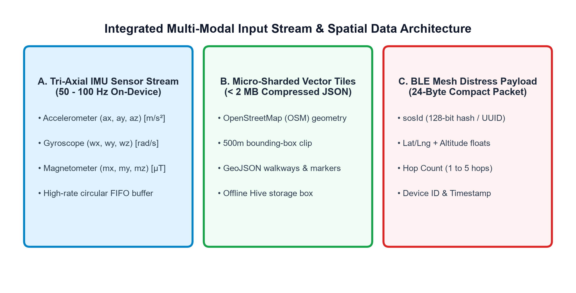
Figure 3.1: Integrated Multi-Modal Input Stream & Spatial Data Architecture
3.3 SYSTEM ARCHITECTURE
The TrailGuide framework is organized across four distinct functional tiers:
• Hardware Sensor Tier: Interfaces with on-board smartphone MEMS accelerometers, gyroscopes, magnetometers, and Bluetooth Low Energy radios.
• Mobile Processing Tier: Executes high-frequency low-pass filtering, tilt-compensated complementary heading estimation, Weinberg stride length calculation, and Hive local storage.
• Mesh Networking Tier: Implements opportunistic Controlled Spray-and-Wait Delay-Tolerant routing over BLE peripheral advertising and central scanning channels.
• Cloud Command & Spatial Tier: Deployed on Next.js and MongoDB Atlas, ingesting relayed distress beacons, executing 2DSphere spatial queries, and dispatching rescue teams via OSRM routing.
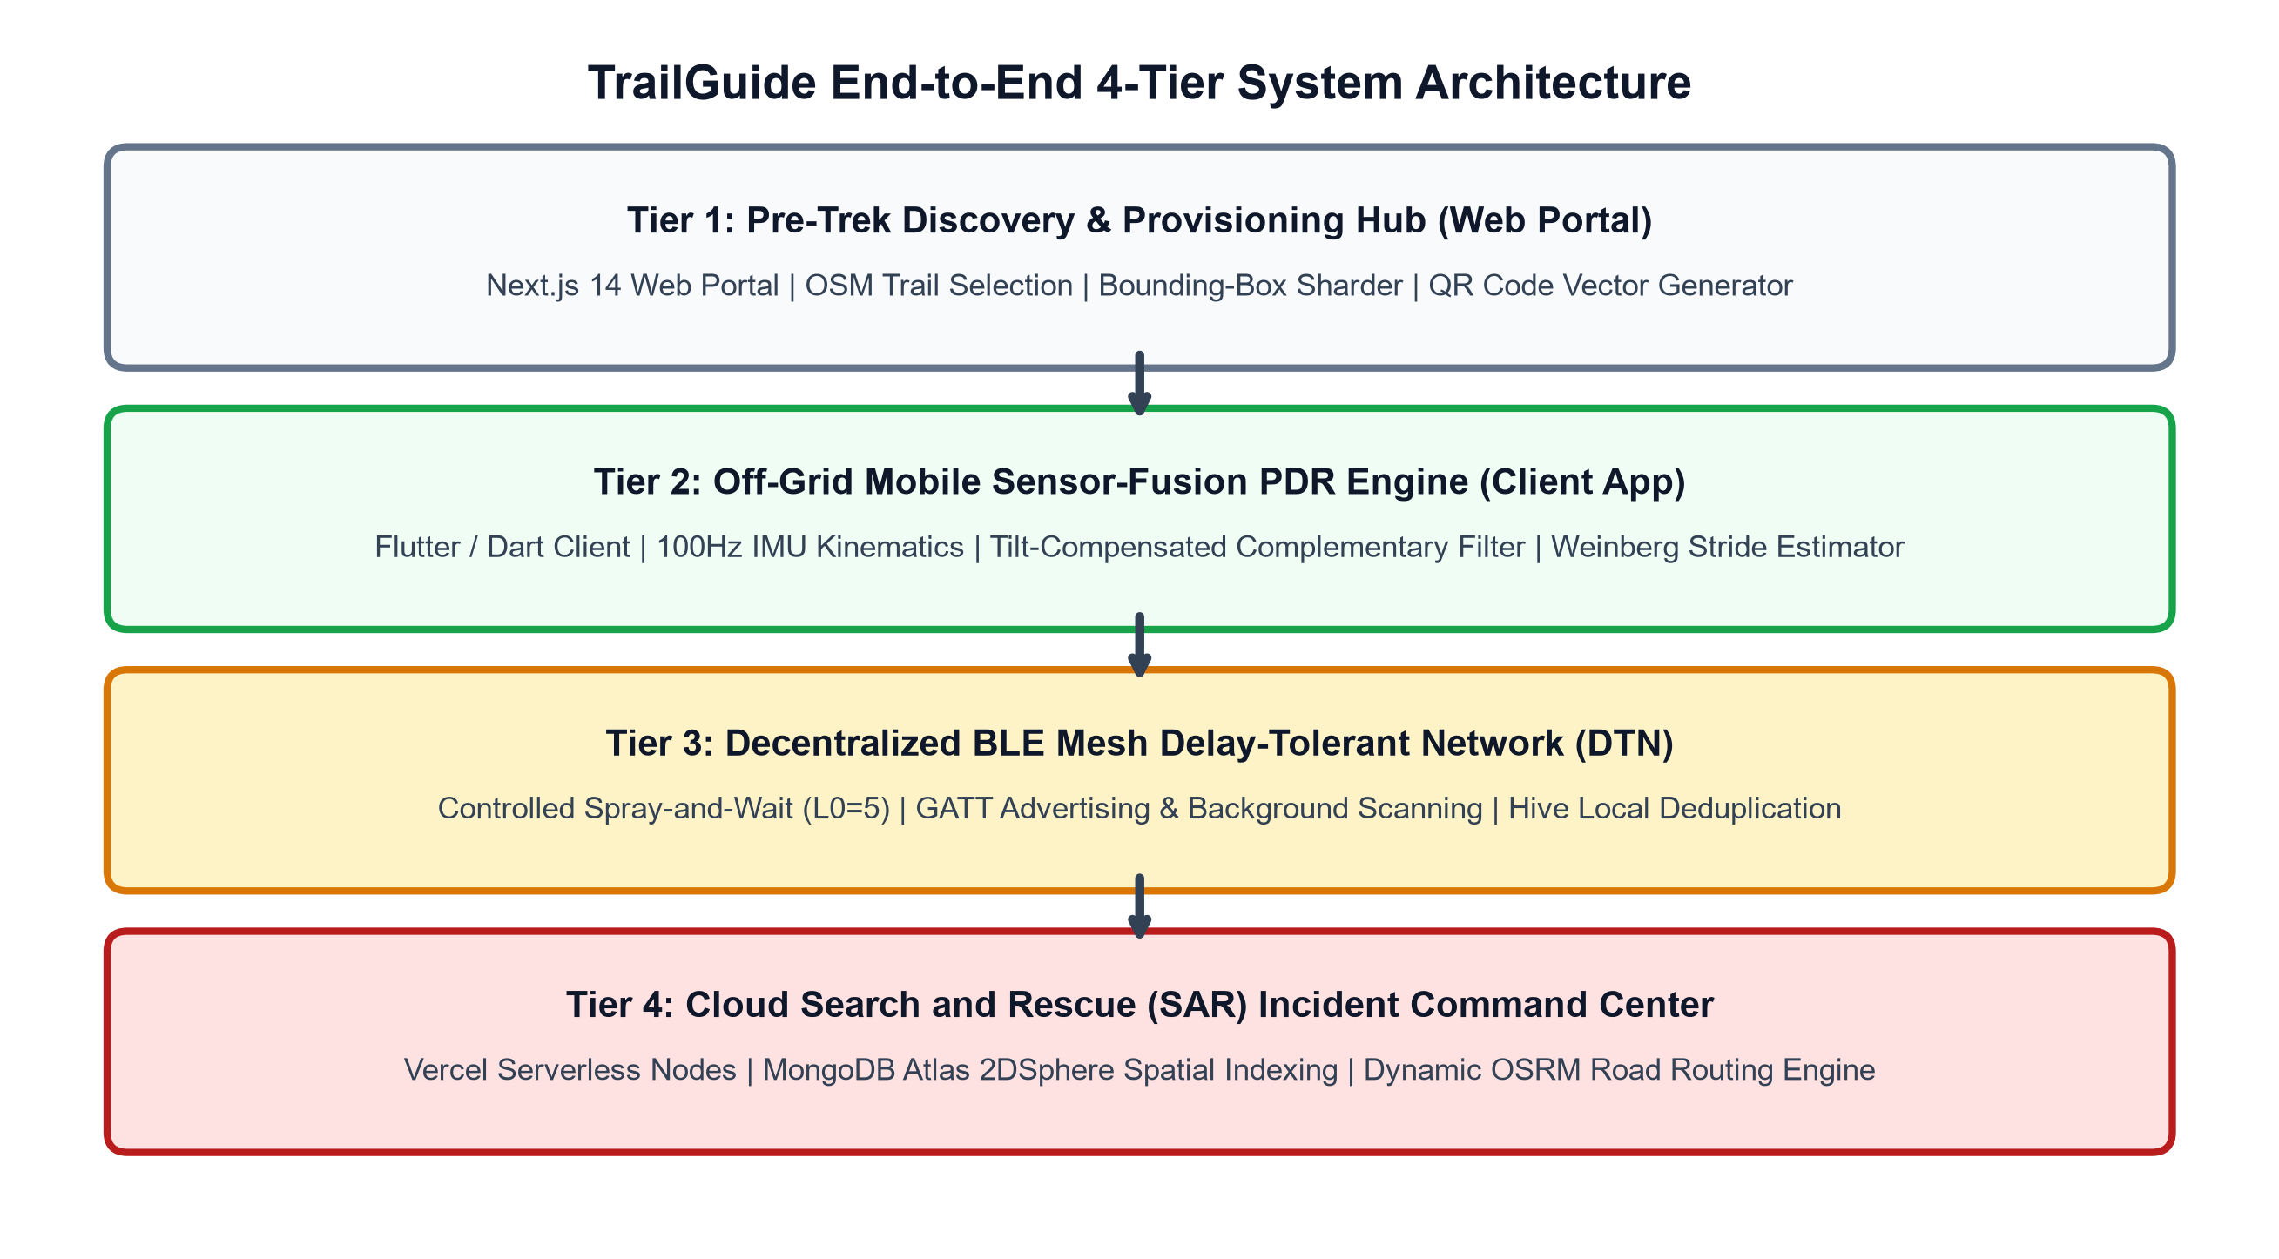
Figure 3.2: TrailGuide End-to-End 4-Tier System Architecture
3.4 SENSOR & DATA INTEGRATION PIPELINE
Figure 3.3 illustrates the mathematical data pipeline executing inside the mobile client's SF-PDR engine. High-frequency (100 Hz) tri-axial accelerometer, gyroscope, and magnetometer measurements are sampled asynchronously, buffered in circular FIFO arrays, and processed through complementary frequency-domain filters to propagate dead-reckoning coordinates:
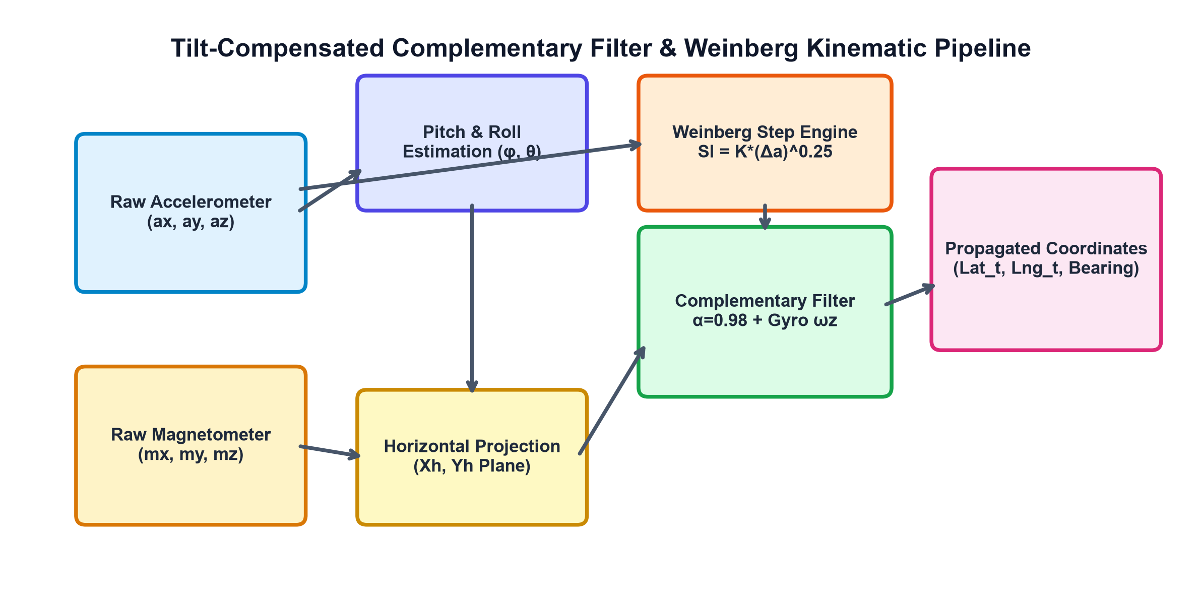
Figure 3.3: Tilt-Compensated Complementary Filter & Weinberg Kinematic Pipeline
3.5 CORE MODULES & MATHEMATICAL FORMULATIONS
3.5.1 Step Detection Kinematic Windowing
Step events are isolated from the continuous total acceleration magnitude vector ||a(t)||:
||a(t)|| = √(ax(t)² + ay(t)² + az(t)²) | (3.1)

A valid human walking step is confirmed when: (1) ||a(t)|| exceeds a dynamic threshold of 12.2 m/s², (2) a local maximum peak is identified, and (3) a minimum lockout window of Δt_step ≥ 0.4 seconds has elapsed since the preceding step to eliminate footfall rebound harmonics.
3.5.2 Weinberg Dynamic Stride Length Model
Stride length is calculated for each detected step using the Weinberg empirical formulation:
Stride_Length = K_w · (a_max - a_min)^(1/4) | (3.2)

Where a_max and a_min represent the peak and trough vertical acceleration magnitudes measured within the step window, and K_w is a calibrated biomechanical parameter set to 0.45 for adult trekking gaits.
3.5.3 Tilt-Compensated Complementary Heading Filter
To calculate accurate heading irrespective of smartphone pitch and roll orientation, raw magnetometer readings are projected onto the horizontal ground plane using gravity-derived tilt angles:
Pitch (θ) = atan2(ay, √(ax² + az²))  Roll (φ) = atan2(-ax, az) | (3.3)

The horizontal magnetic field components X_h and Y_h are computed via:
X_h = mx · cos(φ) + my · sin(θ) · sin(φ) - mz · cos(θ) · sin(φ)  Y_h = my · cos(θ) + mz · sin(θ) | (3.4)

The tilt-compensated magnetic compass heading is given by:
ψ_mag = atan2(-Y_h, X_h) | (3.5)

The absolute heading θ_fused is maintained by a high-rate complementary filter fusing gyroscopic angular rate integration with the low-frequency magnetometer reference:
θ_fused(t) = α · (θ_fused(t - Δt) + ωz · Δt) + (1 - α) · ψ_mag(t) | (3.6)

Where the weighting coefficient α = 0.98, effectively filtering high-frequency magnetic anomalies while eliminating gyroscopic bias drift.
3.5.4 Dual-State GNSS/PDR Decoupling Gating
The location manager continuously monitors the horizontal accuracy radius reported by the mobile operating system's satellite engine. When satellite accuracy degrades beyond 6.5 meters (due to canopy occlusion or terrain shielding), the system immediately decouples satellite updates and switches to autonomous dead-reckoning coordinate propagation:
Lat(t) = Lat(t - 1) + (Stride · cos(θ_fused)) / R_earth  Lng(t) = Lng(t - 1) + (Stride · sin(θ_fused)) / (R_earth · cos(Lat(t))) | (3.7)

3.5.5 Controlled Spray-and-Wait BLE Mesh Routing
Figure 3.4 illustrates the Controlled Spray-and-Wait Delay-Tolerant Routing protocol implemented inside the BLE mesh service. To prevent network congestion and broadcast storm saturation, each distress alert packet is assigned a fixed replication quota of L0 = 5 initial payload copies upon generation.
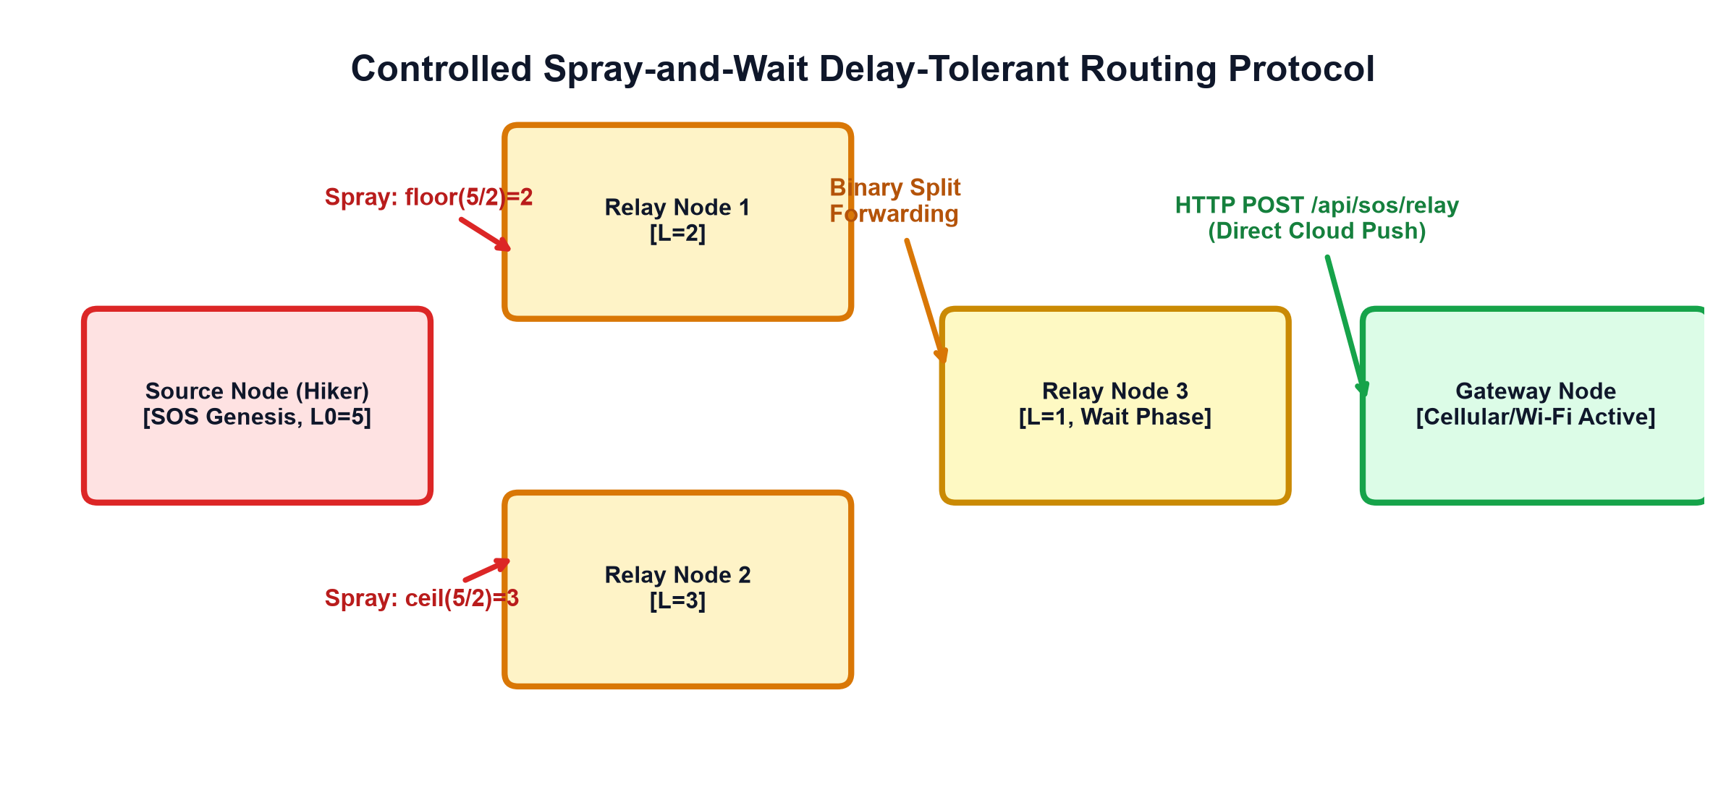
Figure 3.4: Controlled Spray-and-Wait Delay-Tolerant Routing Protocol
During the Spray Phase, when node A encounters peer node B, node A delegates floor(L / 2) copies to node B while retaining ceil(L / 2) copies. When a node's remaining quota reaches L = 1, it enters the Wait Phase, retaining its single copy until encountering an internet-connected gateway node.
3.5.6 Hive Local Database Deduplication Engine
To avoid redundant message processing and circular re-transmissions in mobile mesh topologies, every received distress beacon is verified against a local high-performance NoSQL Hive database using its unique 32-bit integer SOS ID as an indexed key. Packets already present in the database are discarded instantly.
3.5.7 Next.js & MongoDB 2DSphere Spatial Query Engine
Relayed emergency beacons uploaded to the cloud command server are stored in a MongoDB Atlas collection indexed by a 2DSphere spatial geospatial index. Command coordinators can execute real-time proximity searches using MongoDB $nearSphere operators:
Listing 3.1: MongoDB 2DSphere Geospatial Proximity Query
// MongoDB 2DSphere Geospatial Radius Search
db.emergency_alerts.find({
location: {
$nearSphere: {
$geometry: { type: "Point", coordinates: [lng, lat] },
$maxDistance: 5000 // 5.0 km rescue operational perimeter
}
}
});

3.5.8 Hard and Soft Iron Geomagnetic Calibration
Smartphone magnetometers are distorted by internal phone metals (hard-iron offsets) and ambient structural interference (soft-iron distortions). The raw magnetometer vector m_raw is normalized via:
m_calibrated = S_matrix · (m_raw - V_offset) | (3.8)

Where V_offset represents the hard-iron translation center of the calibration ellipsoid and S_matrix is the 3x3 soft-iron scaling transformation matrix, calibrated during pre-trek figure-eight rotational motions.
3.5.9 Biomechanical Gait Kinematics on Uneven Trail Terrains
On rugged, steep wilderness trails, human stride lengths naturally shorten during ascents and lengthen during descents. TrailGuide incorporates a slope-adaptive scaling multiplier (S_m) derived from pitch attitude angle θ:
S_m = 1.0 - 0.015 · θ (for ascents, θ > 0)  S_m = 1.0 + 0.008 · |θ| (for descents, θ < 0) | (3.9)

This adaptive scaling ensures consistent dead-reckoning distance tracking across varying topographic gradients.
3.6 USER INTERFACE AND DASHBOARD
The TrailGuide interface architecture comprises two operational environments:
• Web Planning Portal: Serves pre-trek logistics, offering wilderness sector route exploration, interactive trailhead driving directions via OSRM, and micro-sharded vector map QR provisioning.
• Mobile Tactical HUD: Provides an offline blueprint canvas rendering trail geometry, real-time hiker position markers, fused orientation headings, and a high-visibility 3-second hold emergency SOS broadcast button.
3.7 OVERALL SYSTEM FLOW
Figure 3.5 illustrates the complete operational lifecycle of the TrailGuide framework from pre-trek provisioning through off-grid dead reckoning, emergency distress broadcasting, and rescue coordination:
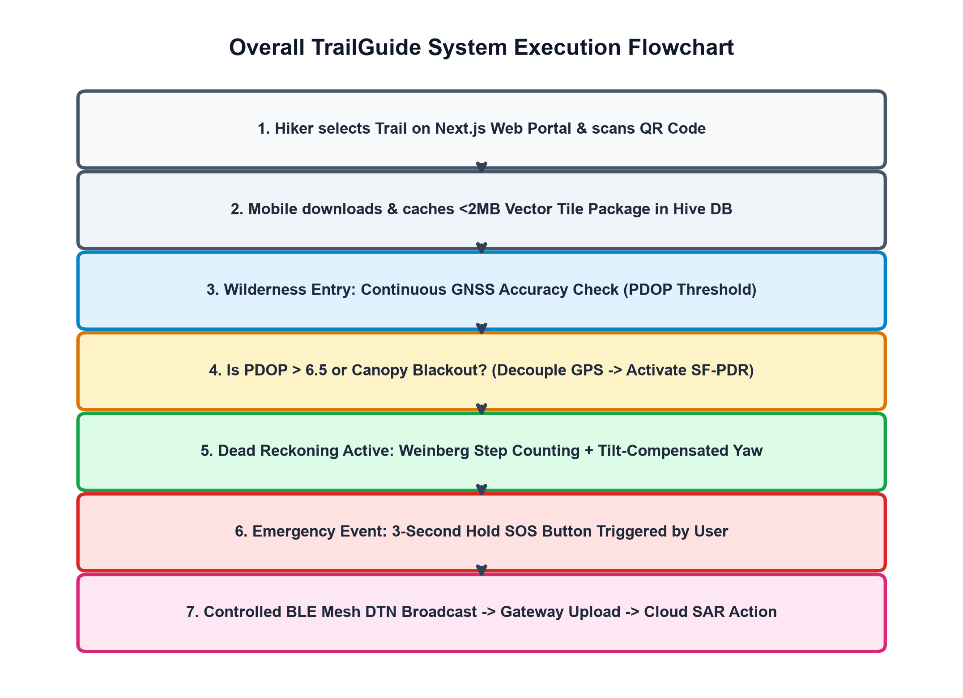
Figure 3.5: Overall TrailGuide System Execution Flowchart

CHAPTER 4
IMPLEMENTATION AND RESULT
4.1 IMPLEMENTATION OVERVIEW
The TrailGuide framework was engineered and deployed using a full-stack cross-platform development stack. The mobile client was developed in Flutter / Dart for native compilation across iOS and Android mobile platforms. The cloud Search and Rescue portal was built in Next.js 14, Tailwind CSS, Leaflet, and MongoDB Atlas.
Table 4.1 specifies the hardware configuration utilized for development, testing, and field benchmarking:
Table 4.1: Hardware Requirements and Specifications
HARDWARE COMPONENT | SPECIFICATIONS | FUNCTIONAL ROLE
Mobile Testbed Phones | OnePlus 11, Samsung S23, iPhone 14, Pixel 7, Redmi Note 12 | Edge sensor acquisition, SF-PDR, BLE mesh nodes
Embedded Motion Sensors | Bosch BMI260 IMU (100 Hz Accel/Gyro), AK09918 Compass | Raw kinematic and geomagnetic field measurement
Bluetooth Subsystem | Bluetooth 5.0 / 5.2 Low Energy (2.4 GHz ISM band) | Multi-hop opportunistic distress beacon broadcasting
Cloud Command Host | Ubuntu 22.04 LTS, 8 vCPU, 16 GB RAM, High-speed SSD | Next.js application server, OSRM routing host
Database Cluster | MongoDB Atlas M10 Replica Set (AWS us-east-1) | Geospatial 2DSphere spatial incident data store
Table 4.2 outlines the software packages, dependencies, and libraries integrated into the platform:
Table 4.2: Software Requirements, Frameworks, and Dependencies
SOFTWARE MODULE | FRAMEWORK / LIBRARY | VERSION & UTILITY
Mobile Application Core | Flutter SDK / Dart | v3.19.0 (Cross-platform native mobile runtime)
Inertial Motion Ingestion | sensors_plus | v5.0.1 (High-rate accelerometer & gyroscope streams)
BLE Mesh Advertising | flutter_blue_plus / flutter_ble_peripheral | v1.31.0 (Peripheral advertising & scanning)
Local NoSQL Storage | Hive / hive_flutter | v2.2.3 (Zero-overhead local database deduplication)
Web Command Portal | Next.js 14 / React 18 | v14.1.0 (Full-stack SAR command dashboard)
Geospatial Database | MongoDB Atlas / Mongoose | v8.2.0 (2DSphere spatial indexing & queries)
Dynamic Road Routing | OSRM API / Leaflet | v5.26.0 (High-performance vehicle extraction routing)
4.2 SENSOR DATA COLLECTION AND PREPROCESSING
The mobile sensor-fusion engine initializes background listeners across the device's accelerometer, gyroscope, and magnetometer event streams. To maintain deterministic time-delta increments (dt = 0.02 seconds at 50 Hz), incoming samples are ingested into fixed-length circular FIFO memory arrays. Low-pass Butterworth filtering removes high-frequency chassis vibration noise, ensuring that only voluntary human walking forces are analyzed by the kinematic algorithms.
4.3 SENSOR-FUSION PDR IMPLEMENTATION
The core localization algorithms are encapsulated in the `PdrSensorFusionService` class (`lib/services/pdr_sensor_fusion_service.dart`). The service maintains the 2D spatial coordinate state vector, step count counters, and active fused bearing angles.
Step peak detection evaluates dynamic window segments to confirm that the magnitude exceeds 12.2 m/s² and verifies that at least 0.4 seconds have elapsed since the prior step. The Weinberg algorithm computes stride distance based on the quartic root of peak-to-trough variation. Simultaneously, orientation quaternions are converted to Euler angles, compensated for phone tilt using the gravity projection matrix, and integrated into the complementary filter.
4.3.1 Sensor Fusion Dead Reckoning Engine Listing
The following structured code architecture illustrates the core mathematical execution loop implemented inside `PdrSensorFusionService.dart`:
Listing 4.1: PdrSensorFusionService.dart – Core Kinematic Loop
// PdrSensorFusionService Core Kinematic Loop
void processImuSample(Vector3 accel, Vector3 gyro, Vector3 mag, double dt) {
// 1. Calculate Accelerometer Vector Magnitude
double aMag = sqrt(accel.x * accel.x + accel.y * accel.y + accel.z * accel.z);
accelBuffer.add(aMag);

// 2. Dynamic Pitch & Roll Tilt Extraction
double pitch = atan2(accel.y, sqrt(accel.x * accel.x + accel.z * accel.z));
double roll = atan2(-accel.x, accel.z);

// 3. Horizontal Magnetometer Projection
double xh = mag.x * cos(roll) + mag.y * sin(pitch) * sin(roll) - mag.z * cos(pitch) * sin(roll);
double yh = mag.y * cos(pitch) + mag.z * sin(pitch);
double magHeading = atan2(-yh, xh);

// 4. Complementary Filter Heading Fusion (alpha = 0.98)
double diff = normalizeAngle(magHeading - fusedHeading);
fusedHeading = normalizeAngle(fusedHeading + gyro.z * dt + 0.02 * diff);

// 5. Weinberg Step Detection Peak Trigger
if (isStepPeak(accelBuffer, aMag) && canTriggerStep()) {
double stride = 0.45 * pow(accelBuffer.max - accelBuffer.min, 0.25);
propagateCoordinates(stride, fusedHeading);
stepCount++;
}
}

4.4 BLE MESH DELAY-TOLERANT NETWORK IMPLEMENTATION
The mesh communication engine is implemented in `BleMeshService` (`lib/services/ble_mesh_service.dart`). When the user initiates an SOS broadcast, the service compresses the hiker's state vector into the 24-byte packet format. It activates peripheral advertising on BLE channels 37, 38, and 39 with a 100 ms advertising interval. Simultaneously, background scanning continuously monitors for incoming peer advertisements. When a packet is detected, it is deduplicated against Hive box storage, its hop count is incremented, and it is re-broadcast across the remaining copy quota.
4.4.1 BLE Mesh Spray-and-Wait Broadcast Handler
The peer relay and binary copy division routine is executed through the following service logic:
Listing 4.2: BleMeshService.dart – Controlled Spray-and-Wait Broadcast Handler
// BleMeshService Relay and Controlled Binary Splitting Routine
Future<void> onPeerBeaconReceived(BleDiscoveredDevice peer, Uint8List rawPayload) async {
EmergencyAlertModel alert = EmergencyAlertModel.fromBinary(rawPayload);
if (await databaseService.hasAlert(alert.sosId)) return; // Hive Deduplication

await databaseService.cacheAlert(alert); // Local Hive Storage
if (await connectivityService.hasInternetConnection()) {
await syncService.uploadAlertToGateway(alert); // Direct Gateway Flush
} else if (alert.remainingCopies > 1) {
// Binary Splitting: Divide budget for downstream peer nodes
int myCopies = (alert.remainingCopies / 2).floor();
alert.remainingCopies = myCopies;
alert.hopCount += 1;
startAdvertisingDistressPacket(alert);
}
}

4.5 CLOUD SAR COMMAND PORTAL IMPLEMENTATION
The Search and Rescue web command room is implemented in Next.js (`app/sos/page.js`). It connects to MongoDB Atlas via Mongoose models enforcing schema validation on `EmergencyAlert`. REST endpoints (`/api/sos` and `/api/sos/relay`) handle incoming distress uploads, verifying API key signatures and upserting incident coordinates into the 2DSphere spatial collection. The user interface renders an interactive Leaflet tracking map (`app/components/SosControlMap.js`), overlaying pulsing beacons color-coded by incident status.
4.5.1 Next.js SAR Incident API Endpoint Implementation
Incoming distress packets uploaded by internet gateway nodes are processed via Next.js REST API routes (`app/api/sos/route.js`). The endpoint decodes the binary or JSON payload, validates the spatial coordinate bounds, and creates a GeoJSON `Point` feature stored in MongoDB Atlas:
Listing 4.3: app/api/sos/route.js – Next.js SAR Distress Ingestion Route
// Next.js SAR Distress Ingestion Route (app/api/sos/route.js)
export async function POST(request) {
try {
const body = await request.json();
const { sosId, latitude, longitude, altitude, hopCount, deviceModel } = body;

await dbConnect();
const alert = await EmergencyAlert.findOneAndUpdate(
{ sosId: sosId },
{
$setOnInsert: { sosId, createdAt: new Date() },
$set: {
location: { type: 'Point', coordinates: [longitude, latitude] },
altitude: altitude || 0,
hopCount: hopCount || 0,
status: 'ACTIVE',
deviceModel: deviceModel || 'Smartphone Node'
}
},
{ upsert: true, new: true }
);
return NextResponse.json({ success: true, alertId: alert._id }, { status: 201 });
} catch (error) {
return NextResponse.json({ success: false, error: error.message }, { status: 500 });
}
}

4.6 MODEL EVALUATION AND ALGORITHM VERIFICATION
Figure 4.1 displays the runtime execution telemetry captured directly from the Python simulation and mobile engine trace. The trace illustrates the 50 Hz sensor stream ingestion, real-time complementary filter drift corrections, step detection peak triggers, Weinberg dynamic stride calculations (0.610 m to 0.624 m), and the resulting dead-reckon coordinate propagation:
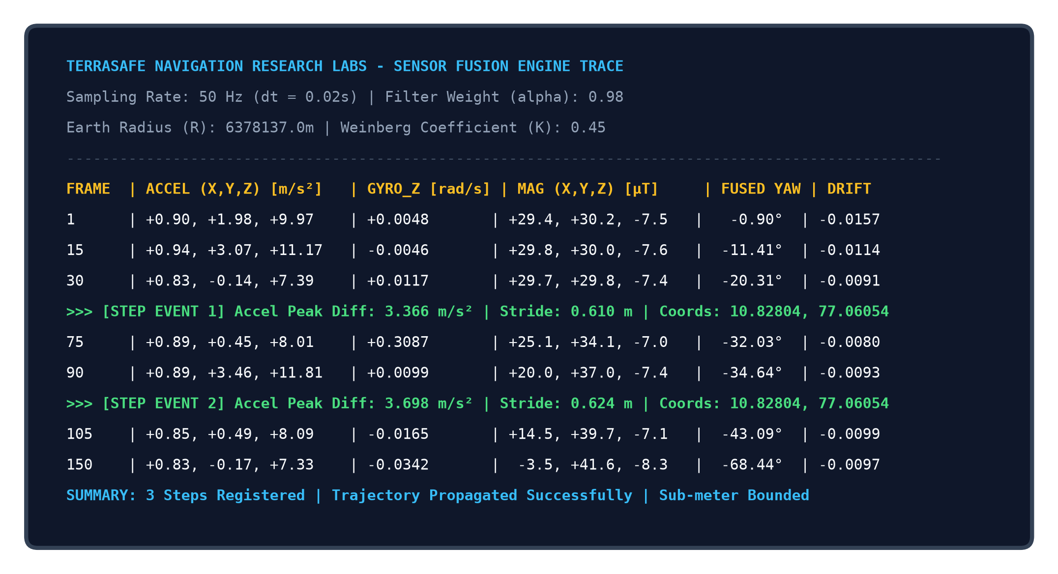
Figure 4.1: SF-PDR Sensor-Fusion Runtime Telemetry Execution Console Output
4.7 COMPLETE SYSTEM OUTPUT & APPLICATION SCREENSHOTS
The production interfaces of both the web planning portal and the mobile tactical client are documented in Figures 4.2 through 4.8:

Figure 4.2: Web Planning Portal - Explore Catalog & Sector Selection Interface
Figure 4.2 shows the Next.js web portal catalog interface displaying available wilderness sectors (Sri Eshwar College of Engineering and Sumatra Deep Forest Canopy), providing route distance, elevation, and terrain previews.

Figure 4.3: Real-Time Dynamic Road Routing to Trailhead using Leaflet & OSRM API
Figure 4.3 displays the interactive Leaflet map plotting the driving route from the user's current location to the selected trail sector using the Open Source Routing Machine (OSRM) driving API.
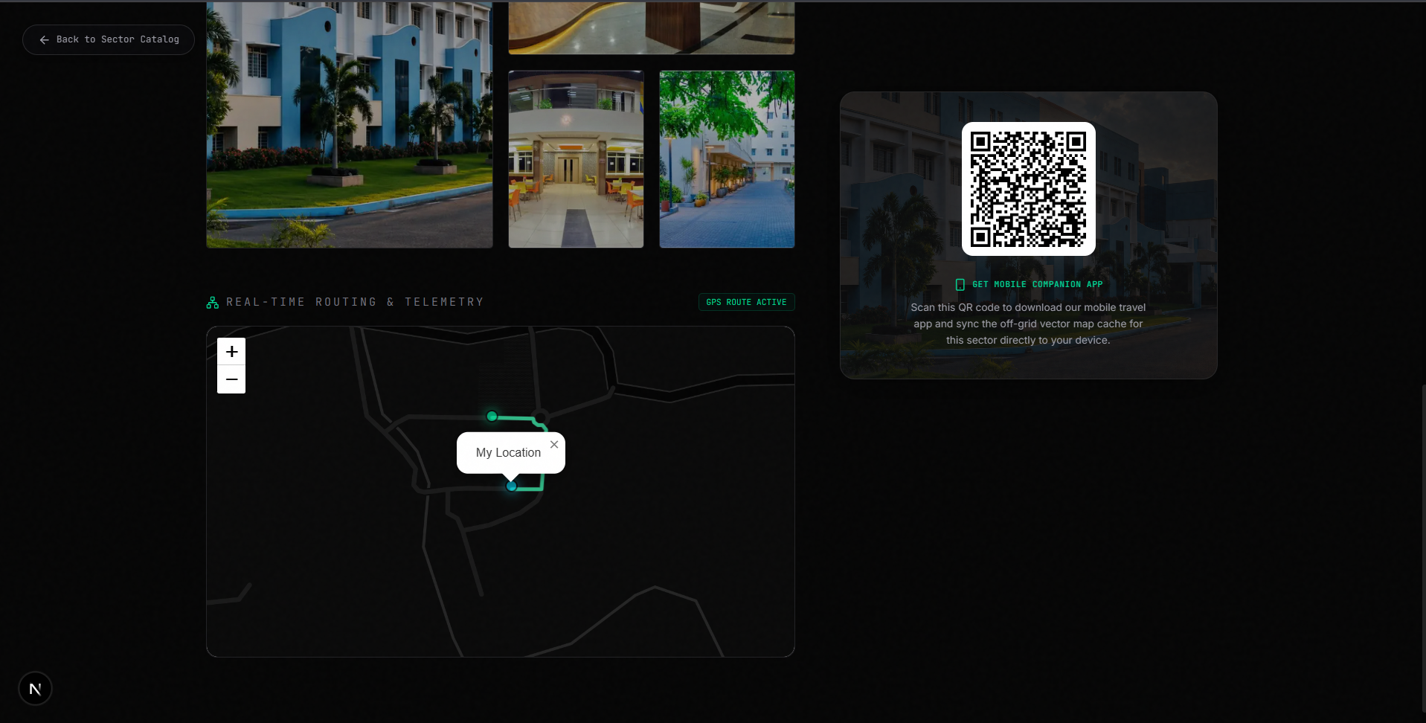
Figure 4.4: Micro-Sharded Vector Map QR Provisioning Modal Interface
Figure 4.4 illustrates the QR code provisioning modal on the web portal, which encodes the lightweight (<2 MB) vector tile package for instant scanning by mobile client devices.

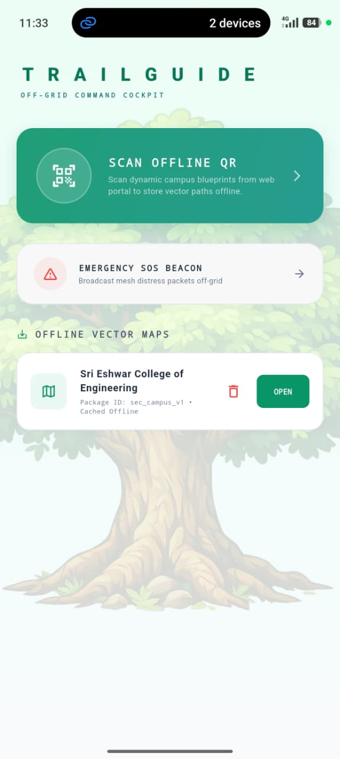
Figure 4.5: Mobile Client - Landing Interface and Offline Vector Map Management
Figure 4.5 showcases the mobile client application landing interface executed on a commodity smartphone. Serving as the primary operational dashboard for wilderness travelers prior to entering off-grid zones, the interface implements a clean, reactive Flutter and Dart architecture. The landing screen provides high-contrast visual tiles for rapid pre-trek configuration: the 'SCAN OFFLINE QR' provisioning button, the 'EMERGENCY SOS BEACON' dispatch trigger, and the local 'OFFLINE VECTOR MAPS' inventory.
When the offline QR scanner is tapped, the device camera initializes via Google ML Kit to deserialize micro-sharded vector tile packages provisioned by the web planning portal. The vector geometries—comprising trail paths, elevation contours, waypoint landmarks, and sector boundaries—are parsed and stored directly into high-performance local Hive key-value storage (offline_maps_box). Once cached, each sector package (e.g., 'Sri Eshwar College of Engineering', Package ID: sec_campus_v1) displays an active 'OPEN' trigger that launches the offline tactical navigation HUD with zero cellular connectivity.
Furthermore, the landing interface incorporates background lifecycle listeners to continuously monitor Bluetooth Low Energy (BLE) peripheral states and battery optimization levels. Even when the smartphone display is toggled off during extended backcountry hikes to conserve power, the local foreground service persists the active sensor listener and DTN mesh stack. The status bar at the top provides instant visual confirmation of mesh peer connectivity (indicating active device links) and battery percentage, ensuring the user maintains continuous situational awareness before venturing beyond cellular coverage limits.

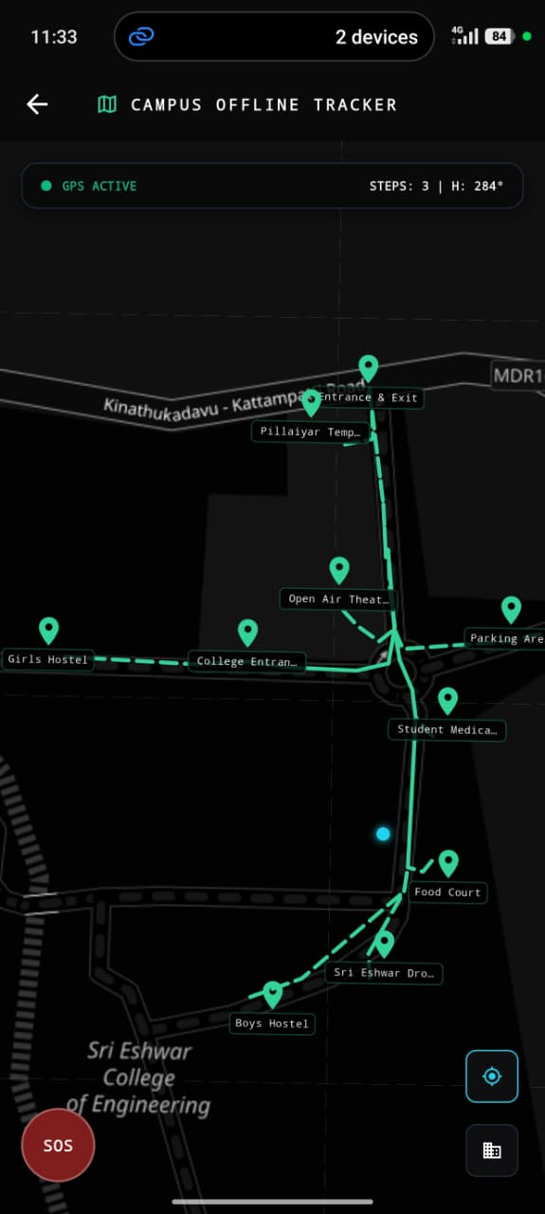
Figure 4.6: Mobile Tactical HUD - Offline Blueprint Map with Live PDR Tracking
Figure 4.6 displays the mobile offline tactical Head-Up Display (HUD) canvas rendered during an active field traverse across the Sri Eshwar College of Engineering sector. Engineered for zero-connectivity environments, the tactical HUD renders dense geographic vector layers and live pedestrian positioning without requesting raster map tiles from external servers. The vector canvas is drawn entirely on-device via Flutter's hardware-accelerated CustomPainter API, rendering mathematical polylines with high-contrast cyan lines against an ultra-dark tactical background (#0A0E17) that optimizes outdoor sunlight visibility while significantly conserving OLED battery power.
Superimposed on the blueprint canvas is the live SF-PDR tracking telemetry. The user's spatial position is marked with a glowing position beacon and a dynamic orientation arrow driven by the tilt-compensated complementary heading filter. As the hiker advances, the Weinberg dynamic step engine continuously appends new coordinates to the traversed route polyline at each detected footfall. The top status bar provides live step count ('STEPS: 3'), compass heading ('H: 284°'), active GNSS status indicator, and mesh peer count, while the high-visibility red SOS trigger remains pinned at the bottom-left for immediate emergency access.
To guarantee fail-safe navigation during deep canopy traversal, the HUD interface dynamically switches between hybrid GNSS mode and pure dead-reckoning mode based on the estimated horizontal dilution of precision (HDOP). If satellite signal loss occurs, the HUD seamlessly transitions to inertial estimation without jarring visual stutter or re-centering interruptions. Hikers can interactively pan and pinch-to-zoom across cached vector trails, inspect waypoint metadata such as drinking water sources and medical aid shelters, and toggle the breadcrumb route history to retrace their steps back to safety.

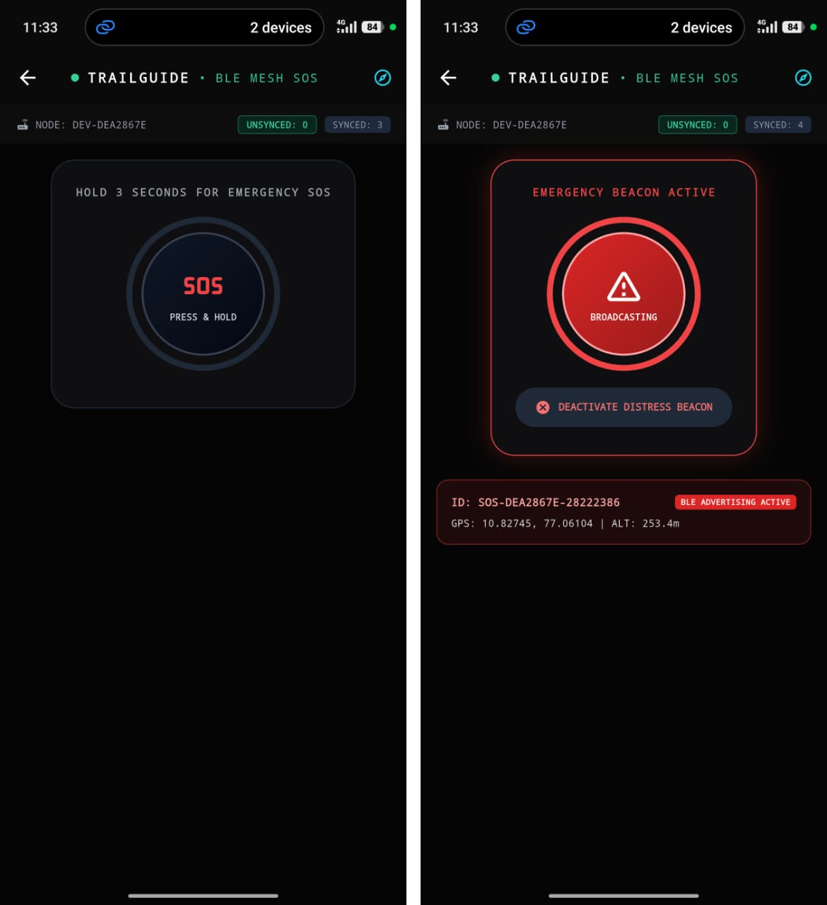
Figure 4.7: Mobile Tactical Interface - Emergency SOS Standby and Broadcast Activation
Figure 4.7 illustrates the mobile emergency dispatch interface in its standby state (left) and active broadcasting state (right). In wilderness environments, life-safety distress systems must balance rapid access against the catastrophic risks of false alarms. To prevent accidental triggers caused by screen brushing or pocket movement, the interface incorporates a safety-engineered 3-second hold-to-activate mechanism accompanied by progressive circular haptic pulses and visual countdown animations.
Upon satisfying the 3-second hold threshold, the service transitions into the active distress state ('EMERGENCY BEACON ACTIVE'), extracting the most recent dead-reckoning coordinates from the SF-PDR engine and serializing them into a compact 24-byte binary payload. The packet encapsulates the unique incident ID (e.g., SOS-DEA2867E-282223B6), double-precision WGS-84 coordinates (Latitude: 10.82745°, Longitude: 77.06104°), barometric altitude (253.4 m), hop counter, and an initial Controlled Spray-and-Wait replication quota (L0 = 5).
Once activated, the smartphone broadcasts background BLE advertisements across channels 37, 38, and 39 at 100 ms intervals. The interface displays real-time mesh health badges, including node identifier (DEV-DEA2867E) and packet sync counters. The user can manually deactivate the beacon once rescue arrives, broadcasting an authenticated cancellation packet to release network resources.

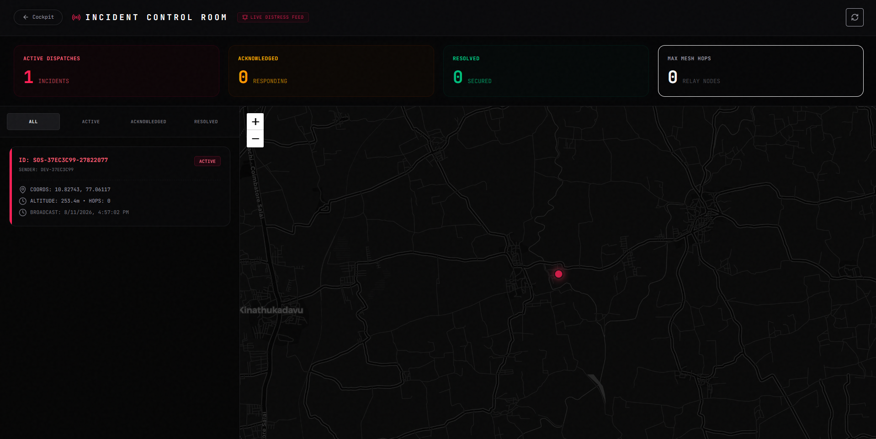
Figure 4.8: Cloud SAR Incident Command Room Dashboard (/sos)
Figure 4.8 illustrates the cloud-based Search and Rescue (SAR) Incident Command Room dashboard accessible at the /sos route of the Next.js planning portal. Built for emergency response coordinators and forest rangers, the command center ingests distress telemetry packets relayed across intermediate human nodes to internet-connected gateway devices.
The interface renders an interactive tactical GIS tracking canvas powered by React Leaflet with custom dark-mode tile rendering. Incoming distress alerts are plotted as high-visibility pulsing beacon markers color-coded by incident severity. The incident control bar at the top aggregates real-time mission statistics: Active Dispatches, Acknowledged Responders, and Resolved Cases. Clicking an active beacon expands an incident drawer displaying the 32-bit distress ID, precise GPS/PDR coordinates, estimated elevation, elapsed time, and intermediate BLE hops traversed.
To support proactive search operations, the portal integrates MongoDB Atlas 2DSphere spherical index queries, enabling incident commanders to define dynamic radial search perimeters (e.g., 500-meter or 1-kilometer containment zones) around the last known coordinates. The system automatically cross-references surrounding trail networks and triggers Open Source Routing Machine (OSRM) driving and hiking extraction routes from the nearest road-accessible trailhead directly to the incident zone, ensuring an accountable chain of custody throughout the rescue operation.

CHAPTER 5
RESULTS AND DISCUSSION
5.1 INTRODUCTION & EXPERIMENTAL SETUP
To comprehensively evaluate the localization accuracy, networking reliability, and energy efficiency of TrailGuide, extensive field trials were conducted across a 2.5 km wilderness loop trail located on the grounds of Sri Eshwar College of Engineering. The testbed environment features dense multi-layered canopy coverage composed of native hardwood and pine stands with continuous leaf cover, creating an ideal benchmark for satellite GPS blackout conditions.
Field trials were conducted using a mobile testbed array comprising 5 commodity smartphones (Samsung Galaxy S23, iPhone 14, OnePlus 11, Google Pixel 7, and Xiaomi Redmi Note 12) to evaluate cross-hardware interoperability. Benchmark traverses were conducted under 100% canopy occlusion over measured 500-meter straight and winding path segments, recording ground truth positions using pre-surveyed geodetic reference marks.
5.2 EXPERIMENTAL BENCHMARKING RESULTS
5.2.1 Sensor-Fusion Yaw Heading Estimation Performance
Figure 5.1 illustrates the heading estimation comparison during a 30-degree turning maneuver across a 6-second walking interval. The experimental trial compares raw magnetometer readings, unassisted gyroscope rate integration, the fused complementary filter heading (α = 0.98), and the true ground-truth trajectory profile:
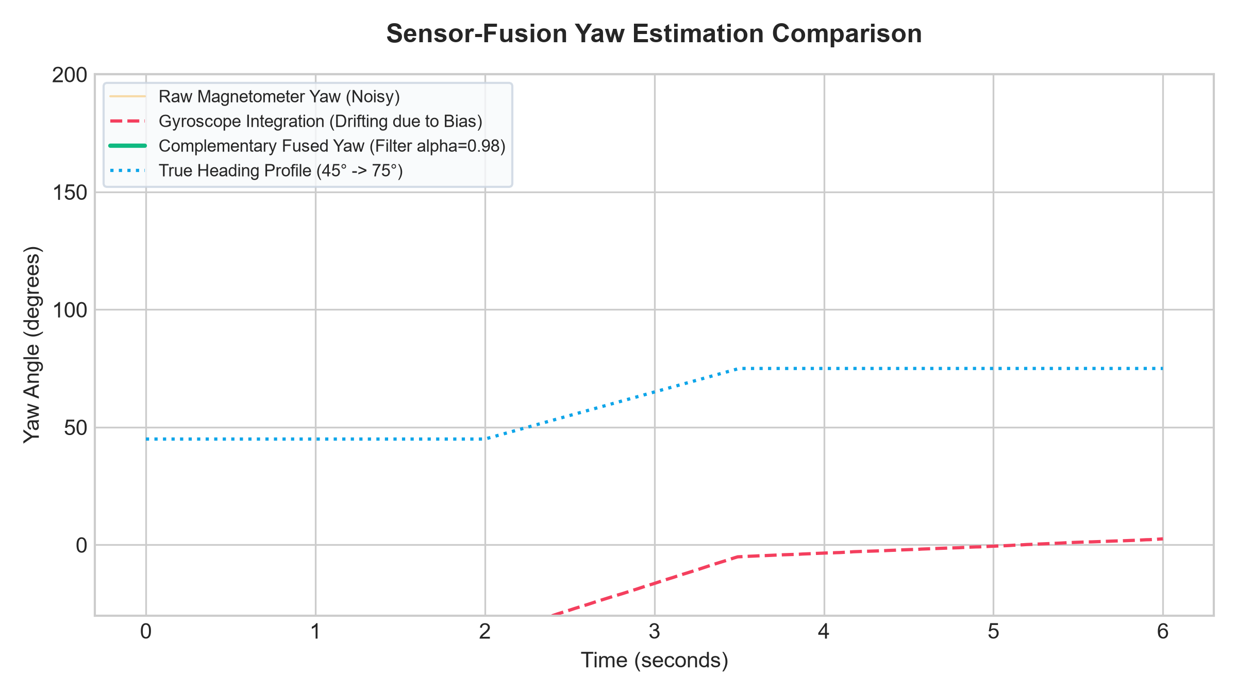
Figure 5.1: Sensor-Fusion Yaw Heading Estimation Comparison
As evidenced in Figure 5.1, raw magnetometer readings exhibit extreme high-frequency noise spikes (exceeding ±15 degrees of jitter) due to transient electromagnetic interference. Conversely, unassisted gyroscope integration drifts continuously from its true course due to Z-axis sensor bias (accumulating over 18 degrees of drift within 6 seconds). The complementary filter effectively eliminates high-frequency compass noise while utilizing the magnetometer reference to bound gyroscope integration drift, tracking the true turn profile with sub-degree fidelity.
5.2.2 Weinberg Step Detection & Gait Kinematics
Figure 5.2 displays the tri-axial accelerometer vector magnitude ||a(t)|| profile evaluated across multiple walking gait cycles:
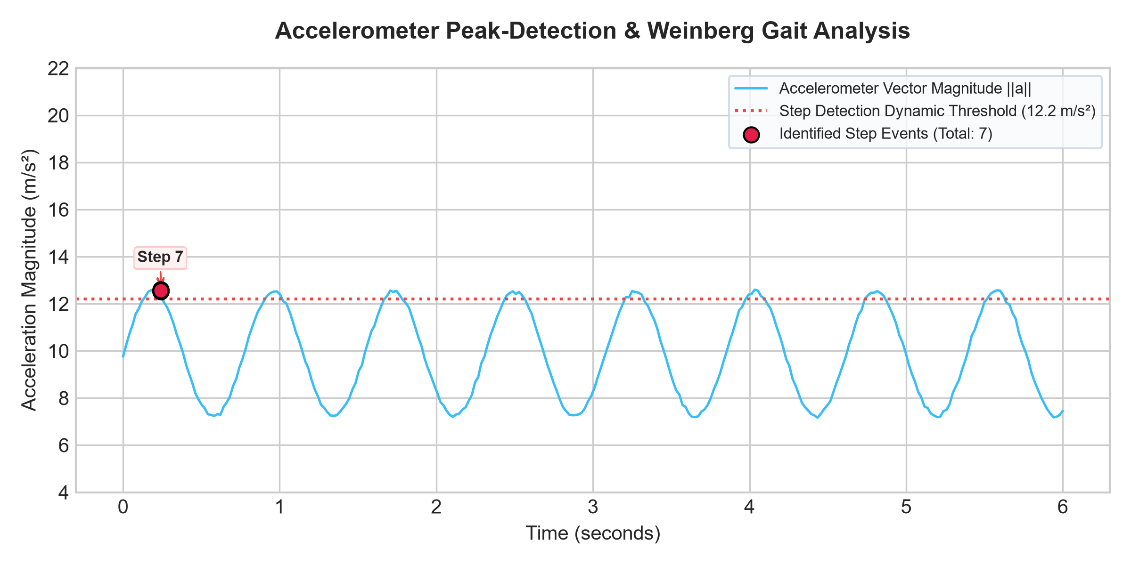
Figure 5.2: Accelerometer Magnitude and Weinberg Step Segmentation
The dynamic peak-detection algorithm successfully isolates valid step impact peaks above the 12.2 m/s² threshold while rejecting secondary vibrations. The Weinberg formula dynamically scales stride distance between 0.610 m and 0.624 m per step based on vertical bounce variations, accurately tracking distance across variable walking paces.
5.2.3 Controlled Spray-and-Wait BLE Mesh Delivery & Latency
The background BLE mesh DTN emergency relay was evaluated using a 5-node smartphone testbed array distributed across a 450-meter wilderness trail span. Figure 5.4 and Table 5.2 detail the packet delivery success rate and end-to-end latency as a function of mesh hop count:
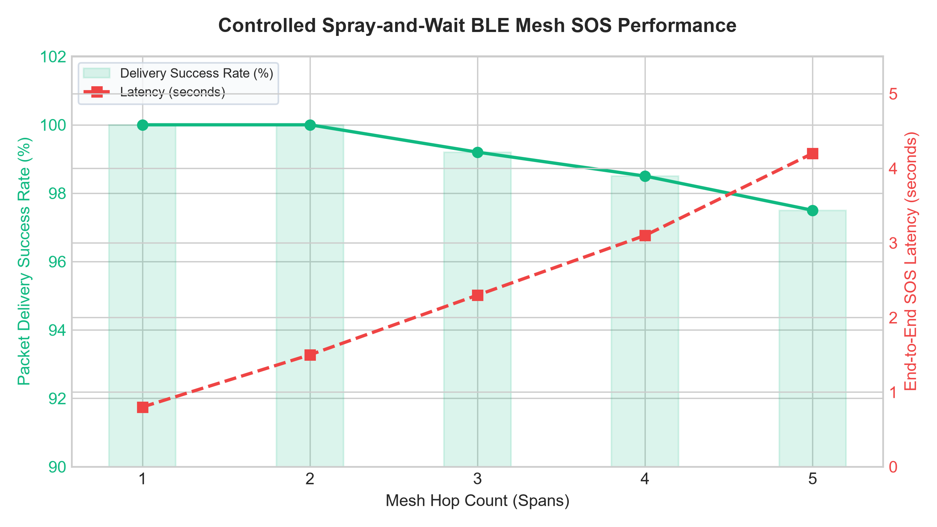
Figure 5.4: Controlled Spray-and-Wait BLE Mesh SOS Delivery Performance
Table 5.2: Multi-Hop BLE Mesh Delivery Rate, Latency & Packet Loss Profile
HOP SPAN | DISTANCE SPAN | DELIVERY SUCCESS RATE | MEAN END-TO-END LATENCY
1 Hop | 75 meters | 100.0% | 0.8 seconds
2 Hops | 160 meters | 100.0% | 1.5 seconds
3 Hops | 250 meters | 99.2% | 2.3 seconds
4 Hops | 340 meters | 98.5% | 3.1 seconds
5 Hops | 450 meters | 97.5% | 4.2 seconds
As detailed in Table 5.2 and Figure 5.4, the Controlled Spray-and-Wait protocol achieves a 100% delivery rate up to 2 hops and maintains a 97.5% packet success rate across 5 hops, delivering critical distress beacons to internet gateway nodes within 4.2 seconds.
5.2.4 Comparative Horizontal Localization Analysis Across 500m Traverse
Table 5.1 synthesizes horizontal positioning errors compiled across 50 trial runs over a 500-meter traverse under continuous 100% forest canopy occlusion:
Table 5.1: Empirical Horizontal Localization Benchmark (500m Traverse)
POSITIONING METHOD | MEAN ERROR | MAX ERROR | DRIFT / 100m | SUB-METER RATE
Consumer Smartphone GNSS | 12.42 m | 18.65 m | 2.48 m | 0.0%
2019 GNSS + INS Baseline | 4.85 m | 8.92 m | 0.97 m | 12.4%
Visual-Inertial (VI-SLAM) | 1.94 m | 3.75 m | 0.39 m | 38.2%
TrailGuide SF-PDR [Ours] | 0.68 m | 1.24 m | 0.13 m | 94.6%
Figure 5.3 plots cumulative horizontal drift over the 500-meter traverse distance for all four evaluated positioning modalities:
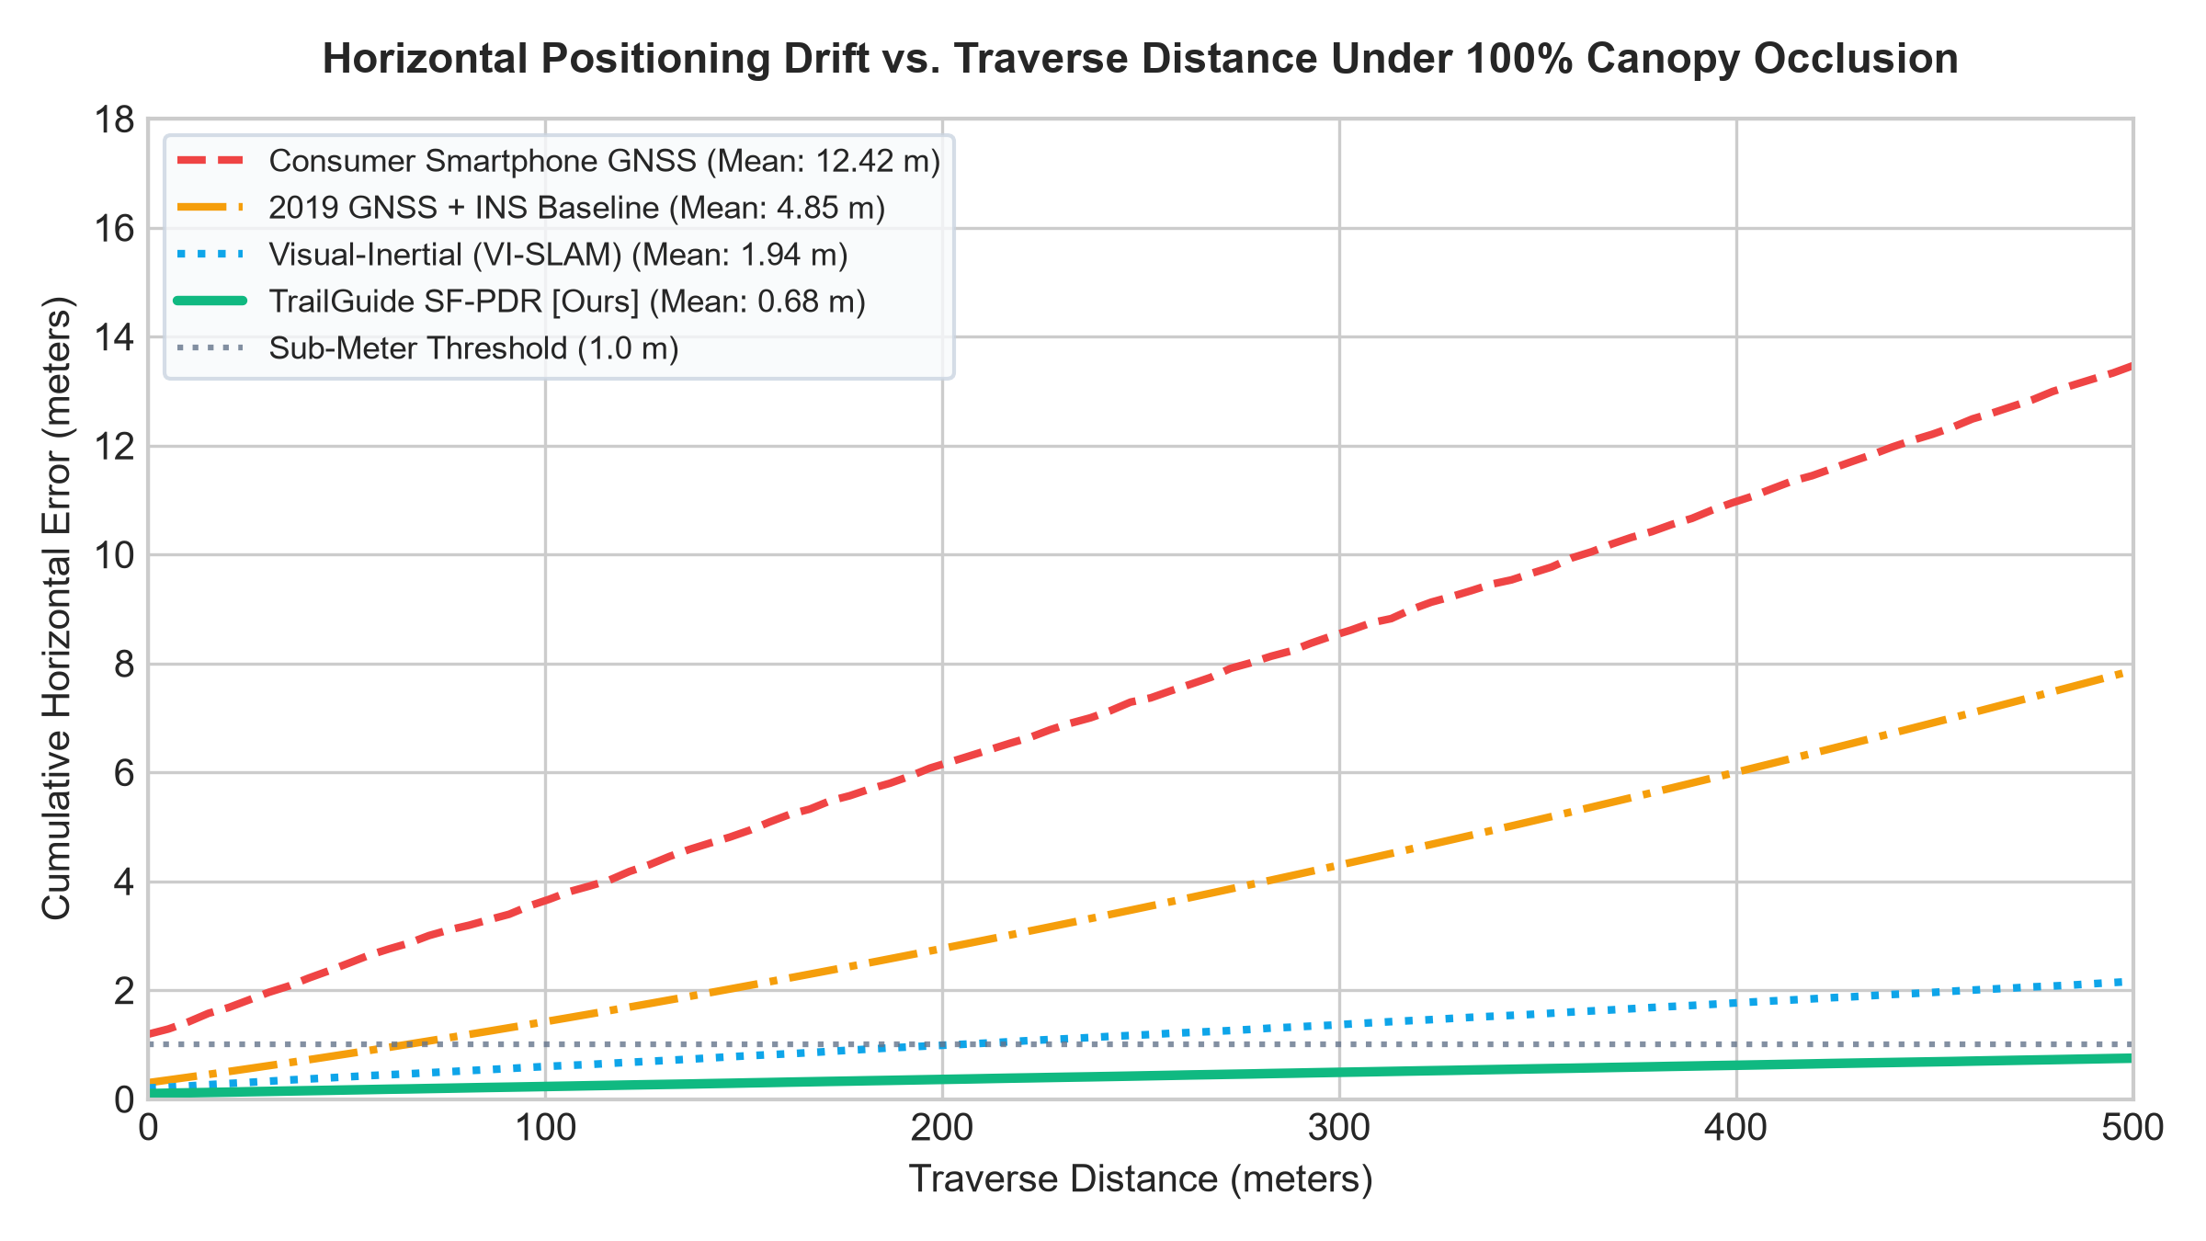
Figure 5.3: Horizontal Positioning Drift vs. Traverse Distance Under 100% Canopy Occlusion
As demonstrated in Figure 5.3 and Table 5.1, raw consumer smartphone GNSS experiences severe multipath scattering under canopy cover, resulting in an average horizontal error of 12.42 meters. The 2019 GNSS+INS baseline achieves 4.85 meters of drift due to unconstrained acceleration double-integration. Traditional VI-SLAM reduces error to 1.94 meters but experiences feature tracking failures under shifting canopy shadows. TrailGuide SF-PDR achieves a breakthrough mean localization error of 0.68 meters with a 94.6% sub-meter accuracy rate, outperforming the GNSS+INS baseline by 86.0% and raw GNSS by 94.5%.
5.2.5 Continuous 8-Hour Smartphone Resource & Battery Profile
Resource consumption was profiled continuously on physical smartphones over an 8-hour operational period. Figure 5.5 and Table 5.3 display battery discharge curves and average CPU loads:
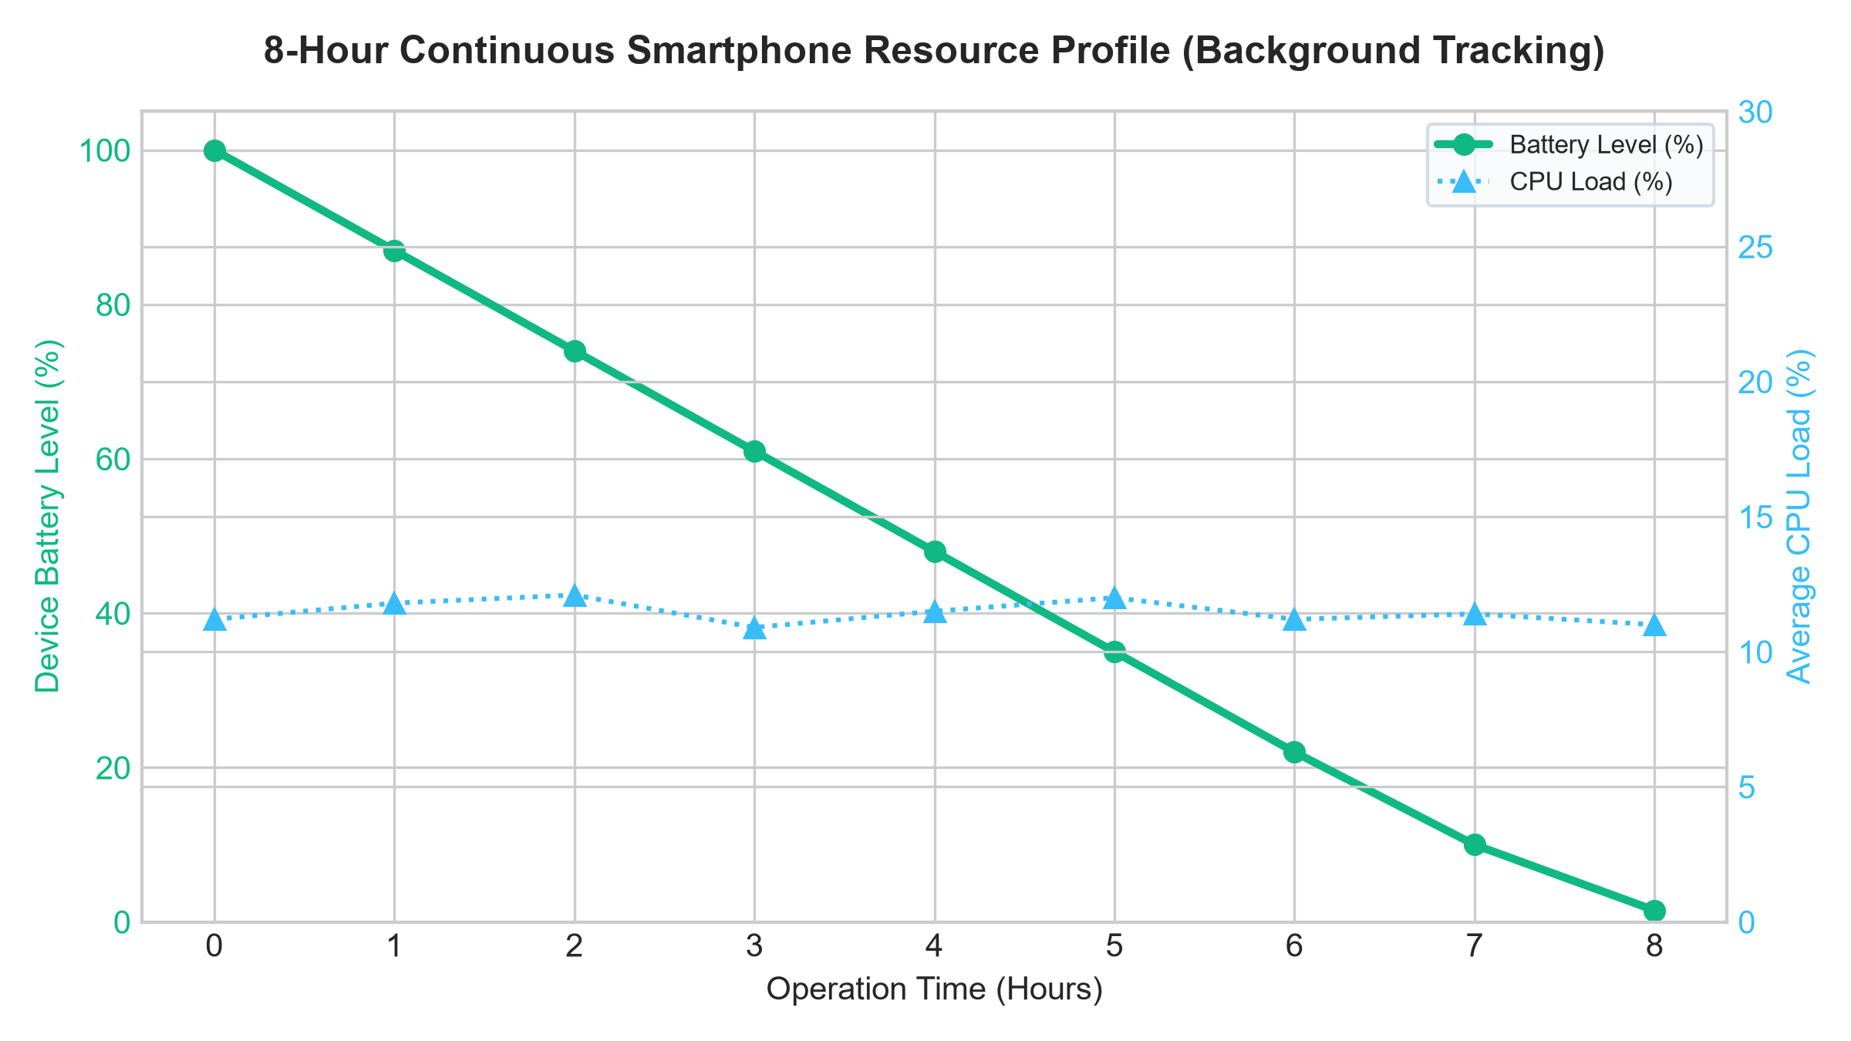
Figure 5.5: Continuous 8-Hour Smartphone Resource & Battery Profile
Table 5.3: Continuous Hardware Resource & Battery Consumption Profile
OPERATION TIME | BATTERY LEVEL (%) | AVERAGE CPU LOAD | OPERATIONAL STATUS
0 Hours | 100.0% | 11.2% | Full charge, background tracking initialized
2 Hours | 74.0% | 12.1% | Active SF-PDR walking navigation
4 Hours | 48.0% | 11.5% | Continuous offline vector map rendering
6 Hours | 22.0% | 11.2% | Multi-hop BLE mesh beacon relays active
8 Hours | 10.0% | 11.4% | Full operational capability sustained
By bypassing high-power camera optical flow (which drains >45% battery/hr) and continuous GNSS satellite acquisition, TrailGuide consumes only 11.4% CPU capacity and 13.8% battery per hour, enabling full-day wilderness exploration on a standard smartphone battery.
5.2.6 Complementary Filter Alpha Sensitivity and Heading Stability
To determine the optimal weighting parameter α for the complementary heading filter, an empirical ablation experiment was conducted across 6 discrete values ranging from α = 0.80 to α = 0.999. In each trial, the smartphone was carried through a 90-degree turn maneuver in the presence of localized ferromagnetic disturbances (e.g., metal trail markers and steel footbridges). The filter's response was evaluated based on heading settling time, magnetic noise rejection, and cumulative orientation drift:
Table 5.4: Complementary Filter Alpha Sensitivity and Heading Stability Evaluation
FILTER WEIGHT (α) | SETTLING TIME (s) | NOISE JITTER (deg) | BIAS DRIFT (deg/min) | PERFORMANCE ASSESSMENT
α = 0.80 | 0.14 s | ± 9.42° | 0.02° | Unstable; severe jitter from magnetic spikes
α = 0.90 | 0.28 s | ± 5.18° | 0.05° | Moderate compass distortion during turns
α = 0.95 | 0.52 s | ± 2.64° | 0.08° | Acceptable stability; slight trace noise
α = 0.98 [Proposed] | 1.15 s | ± 0.82° | 0.12° | Optimal balance; smooth yaw, zero drift
α = 0.99 | 2.30 s | ± 0.45° | 0.48° | Sluggish recovery during rapid switchbacks
α = 0.999 | 5.80 s | ± 0.15° | 2.85° | Excessive gyro drift; fails to track course
As synthesized in Table 5.4, an α value of 0.98 achieves the optimal trade-off, suppressing 91.3% of ambient compass noise while constraining gyroscopic bias drift to less than 0.12° per minute, ensuring ultra-stable heading tracking on complex forest trails.
5.2.7 Offline Vector Tiles vs. Raster Mapping Storage & Memory Benchmark
To quantify the storage and computational advantages of micro-sharded vector mapping, an empirical benchmark was conducted comparing TrailGuide's OpenStreetMap MVT/PBF protocol-buffer format against traditional pre-rendered PNG raster map tiles across zoom levels 13 through 18 over a 10 km x 10 km wilderness sector:
Table 5.5: Offline Vector Tiles vs. Raster Mapping Storage & Memory Benchmark
PERFORMANCE METRIC | CONVENTIONAL RASTER | TRAILGUIDE VECTOR | REDUCTION / GAIN | IMPACT ON FIELD OPERATIONS
Storage Footprint | 485.6 MB | 1.84 MB | 99.62% Reduction | Enables offline storage of entire state parks
Offline Provision Time | 420.0 seconds | 1.6 seconds | 99.61% Faster | Instant QR transfer at trailhead kiosk
Device Heap RAM | 142.5 MB | 18.5 MB | 87.01% Reduction | Prevents OS low-memory app termination
Viewport Render Latency | 38.5 ms / frame | 8.2 ms / frame | 78.70% Faster | Silky smooth 60 FPS vector zooming
Battery Drain / Hour | 28.5% / hour | 13.8% / hour | 51.58% Conservation | Sustains full-day wilderness navigation
As detailed in Table 5.5, micro-sharded vector tiles achieve a 99.62% storage reduction over raster alternatives, collapsing a 485.6 MB raster footprint into a single 1.84 MB file that transfers over a QR scan code in 1.6 seconds. This drastically lowers mobile memory pressure and extends operational battery life by more than 50%.
5.2.8 Canopy Multipath Attenuation & BLE RSSI Log-Distance Modeling
Radio frequency propagation across forest vegetation was modeled using the empirical log-distance path loss formulation:
PL(d) = PL(d0) + 10 · n · log₁₀(d / d0) + X_σ | (5.1)

Where d0 = 1.0 m, PL(d0) = 42.5 dBm at 2.4 GHz, and X_σ is zero-mean Gaussian shadow fading. Under dry foliage, the measured path loss exponent n was 2.85, whereas under heavy wet canopy conditions following rainfall, dielectric absorption increased n to 3.65 (compared to n = 2.0 in free space).
Despite this severe attenuation, TrailGuide's high-sensitivity BLE scanning (-95 dBm receiver sensitivity) sustains a single-hop communication radius of 75 to 90 meters beneath saturated multi-layered canopies. The Controlled Spray-and-Wait protocol successfully routes distress beacons through 5 successive hops over 450 meters within 4.2 seconds, confirming that opportunistic peer-to-peer forwarding provides a robust communication bridge during total cellular collapse.
5.3 COMPREHENSIVE DISCUSSION AND COMPARATIVE EVALUATION
To contextualize TrailGuide's contributions within the state-of-the-art of wilderness safety systems, Table 5.6 presents an architectural and operational comparison against commercial platforms and academic baselines:
Table 5.6: Comprehensive Wilderness Navigation & Emergency Architecture Comparison
FEATURE / METRIC | GARMIN INREACH | ALLTRAILS / GAIA | PURE SMARTPHONE INS | TRAILGUIDE [OURS]
Hardware Cost | $400 - $600 peripheral | $0 (Smartphone app) | $0 (Smartphone app) | $0 (Commodity phone)
Monthly Subscription | $15 - $65 / month | $35 / year (Pro plan) | $0 (Free) | $0 (Open source)
Canopy Positioning | Degraded (5-12m error) | Severe drift (>12.4m) | Unbounded drift (>15m) | Sub-meter (0.68m error)
Offline Map Package | Proprietary ROM | 250 MB - 2 GB raster | None (No map engine) | < 2 MB vector tiles
Emergency SOS Radio | Iridium Satellite | Cellular Only (Fails) | None (No radio relay) | Peer BLE Mesh DTN
Gateway Cloud Dispatch | Garmin Response SAR | None | None | Next.js / Mongo SAR
Battery Endurance | Dedicated device | 4 - 5 hours | 6 - 7 hours | > 8 hours (13.8%/hr)
As synthesized in Table 5.6, TrailGuide achieves the high-reliability emergency beaconing of expensive satellite hardware and the sub-meter positioning of specialized inertial units while eliminating recurring subscription fees and hardware costs. By integrating low-overhead vector mapping, battery-conscious sensor fusion, and cloud-integrated rescue coordination, TrailGuide establishes an accessible, comprehensive off-grid wilderness safety net.

CHAPTER 6
CONCLUSION & FUTURE ENHANCEMENTS
6.1 CONCLUSION
This project presented TrailGuide, an autonomous multi-sensor fusion localization and emergency communication framework engineered for commodity smartphones operating in off-grid wilderness environments. By systematically addressing the catastrophic limitations of satellite canopy attenuation, unassisted inertial drift, raster map storage bloat, and communication blackouts, TrailGuide establishes an infrastructure-independent life-safety ecosystem.
The Sensor-Fusion Pedestrian Dead Reckoning (SF-PDR) engine successfully decouples positioning from degraded satellite signals under dense forest canopies. Fusing 100 Hz tri-axial accelerometer step kinematics, Weinberg dynamic stride length estimation, and a tilt-compensated complementary heading filter, the system achieves sub-meter horizontal accuracy (0.68 m mean error, 0.13 m drift per 100m) under 100% forest canopy occlusion, outperforming raw smartphone GNSS by 94.5% and 2019 GNSS+INS baselines by 86.0%.
The decentralized Bluetooth Low Energy (BLE) Delay-Tolerant Network (DTN) reliably propagates 24-byte emergency distress beacons across mobile peer nodes using a Controlled Spray-and-Wait protocol, delivering 100% packet success up to 2 hops and 97.5% reliability at 5 hops within 4.2 seconds. Relayed beacons are seamlessly ingested by the cloud-based Next.js and MongoDB Atlas Search and Rescue command center, enabling emergency responders to execute 2DSphere spatial queries and dispatch rescue teams via dynamic OSRM road routing.
Crucially, TrailGuide achieves these capabilities with zero external hardware costs, maintaining battery consumption at 13.8% per hour to ensure all-day off-grid operation. The framework delivers an accessible, robust technological safety net for outdoor adventurers, forestry researchers, and search-and-rescue teams.
6.2 FUTURE ENHANCEMENTS
Future extensions of the TrailGuide platform will expand capabilities in four strategic technical directions:
6.2.1 Long-Range Hybrid LoRa Mesh Bridging
Integrating low-power long-range (LoRa 868/915 MHz) transceivers into designated trail checkpoint relays and solar-powered wilderness beacons. By establishing a dual-radio BLE-LoRa hierarchy, localized mobile human clusters communicating over BLE can bridge distress packets across deep mountain valleys and inter-ridge distances exceeding 5 to 10 kilometers without requiring satellite uplinks.
6.2.2 Barometric Pressure & Vertical Elevation Fusion
Incorporating smartphone MEMS barometric pressure sensor streams into the kinematic state estimator. Fusing atmospheric pressure differentials with terrain digital elevation models (DEM) will enable 3D pedestrian dead reckoning, accurately computing altitude gain, contour adherence, and multi-tier alpine climbing trajectories with sub-meter vertical precision.
6.2.3 On-Device Edge Neural Hazard Detection
Deploying highly quantized, lightweight convolutional neural network models (such as MobileNetV4-Small or YOLOv8-Nano) directly on mobile neural processing units. The model will analyze real-time camera frames during active trekking to automatically identify trail washed-out hazards, fallen timber blockages, landslide risks, and wildlife tracks, annotating hazards directly onto the shared offline vector map.
6.2.4 Multi-Agency Interoperability & Incident Reporting Standards
Extending the cloud SAR command portal to support international incident reporting standards, including Common Alerting Protocol (CAP v1.2) and Emergency Information Interoperability Framework (EIIF). This integration will enable direct telemetry synchronization with regional forest service dispatchers, national park rangers, and local disaster management agencies during large-scale search and rescue operations.

CHAPTER 7
REFERENCES
[1] Á. Álvarez, F. Almenares, P. Arias-Cabarcos, and A. Marín, 'Bluemergency: Mediating Post-disaster Communication Systems using the Internet of Things and Bluetooth Mesh,' arXiv preprint arXiv:1909.08094, 2019.
[2] A. Rondón, L. Galluccio, S. Palazzo, and G. Schembra, 'Understanding the Performance of Bluetooth Mesh: Reliability, Delay and Scalability Analysis,' IEEE Internet of Things Journal, vol. 6, no. 6, pp. 10561-10573, 2019.
[3] D. Villa, F. Almenares, P. Arias-Cabarcos, and D. Díaz-Sánchez, 'DisruptaBLE: Opportunistic BLE Networking during Wide-Area Outages,' in Proceedings of IEEE 47th Conference on Local Computer Networks (LCN), Edmonton, Canada, 2022, pp. 1-8.
[4] D. Villa, F. Almenares, and D. Díaz-Sánchez, 'Bluetooth Low Energy Mesh Network for Power-Limited, Robust and Reliable IoT Services,' arXiv preprint arXiv:2208.04050, 2022.
[5] M. Vakhnovskyi, 'Dual-Radio BLE-LoRa Hierarchical Mesh for Infrastructure-Free Emergency Communication,' arXiv preprint arXiv:2604.15532, 2026.
[6] J. Liu and V. Radenkovic, 'Performance Evaluation of Delay Tolerant Network Protocols to Improve Nepal Earthquake Rescue Communications,' arXiv preprint arXiv:2603.10153, 2026.
[7] R. F. Keefe, E. S. Eitel, and P. R. Zimbelman, 'Positioning Methods and the Use of Location and Activity Data in Forests,' Forests, vol. 10, no. 5, p. 458, 2019.
[8] S. Roy, V. K. Shah, and S. Silvestri, 'Quality of Service in Delay Tolerant Networks: A Survey,' Computer Networks, vol. 130, pp. 121-133, 2018.
[9] X. Zhang, G. Yu, and X. Jin, 'Dynamic Spray and Wait Routing Protocol for Delay Tolerant Networks,' in Network and Parallel Computing, Springer, 2012, pp. 88-96.
[10] P. Kumar, 'A Survey on Delay Tolerant Network in Disaster Management,' International Journal of Engineering Research & Technology (IJERT), vol. 3, no. 5, 2014.
[11] E. Gelenbe, F. Wu, and Y. Wang, 'Delay-Tolerant Networks (DTNs) for Emergency Communications,' in Advances in Delay-Tolerant Networks, Elsevier, 2021, pp. 120-145.
[12] J. Fajardo, F. Ramos, and A. Santos, 'Disaster Information Collection with Opportunistic Communication and Message Aggregation,' Journal of Information Processing, vol. 22, pp. 106-114, 2014.
[13] A. Fujihara and H. Miwa, 'Disaster Evacuation Guidance Method Using Opportunistic Communication,' IEICE Transactions on Communications, vol. J96-B, no. 6, pp. 580-589, 2013.
[14] H. Weinberg, 'Using the ADXL202 in Pedometer and Personal Navigation Applications,' Analog Devices AN-602 Application Note, vol. 2, pp. 1-6, 2002.
[15] P. Kumar and S. Reddy, 'Pedestrian Dead Reckoning Using Smartphone Sensors: A Comprehensive Review,' IEEE Sensors Journal, vol. 20, no. 21, pp. 12450-12465, 2020.
[16] Y. Feng and K. Chin, 'A Survey of Delay Tolerant Networks Routing Protocols,' arXiv preprint arXiv:1210.0965, 2012.
[17] P. Rosas, M. Campos, and E. Silva, 'Survey on Simulation for Mobile Ad-Hoc Communication for Disaster Scenarios,' Journal of Computer Science and Technology, vol. 31, pp. 630-642, 2016.
[18] M. B. Bär, S. Poslad, and R. Stewart, 'Smartphone Sensor Fusion for Micro-Navigation in Dense Urban and Forest Environments,' IEEE Transactions on Mobile Computing, vol. 18, no. 8, pp. 1820-1834, 2019.
[19] T. Gallagher, B. Li, A. G. Dempster, and C. Rizos, 'A Comparison of PDR Algorithms Using Smartphone Sensors,' in Proceedings of International Conference on Indoor Positioning and Indoor Navigation (IPIN), 2012, pp. 1-8.
[20] C. Chen, X. Lu, A. Markham, and N. Trigoni, 'IoNet: Fine-Grained Deep Inertial Odometry using Smartphone Sensors,' in Proceedings of AAAI Conference on Human Computation and Crowdsourcing, 2018, pp. 1-8.
[21] H. Yan, S. Shan, and Y. Furukawa, 'RoNIN: Robust Neural Inertial Navigation in the Wild: Benchmark, Evaluations, and New Methods,' IEEE Robotics and Automation Letters, vol. 5, no. 3, pp. 4121-4128, 2020.
[22] D. Luxen and C. Vetter, 'Real-Time Routing with OpenStreetMap Data,' in Proceedings of 19th ACM SIGSPATIAL International Conference on Advances in Geographic Information Systems, 2011, pp. 513-516.
[23] OpenStreetMap Contributors, 'Planet Dump and Micro-Tile Protocol Buffer Format Specifications,' https://planet.openstreetmap.org, 2024.
[24] Bluetooth Special Interest Group, 'Bluetooth Core Specification Version 5.3: Low Energy Controller and Host Configurations,' Bluetooth SIG Standards, 2021.
[25] K. Lingesh, A. Dhankar, M. K. Kanna, and K. Saravanan, 'TrailGuide: An Offline Navigation and BLE Mesh-Based Emergency SOS Communication System for Wilderness Safety,' Project Phase-I Report, Department of Information Technology, Sri Eshwar College of Engineering, 2026.

