The HUGETracker  
manual

introduction

Hi, this is the manual to hUGETracker. I wrote this program because there wasn’t a music editing tool for the Gameboy which fulfilled the following requirements:

* Produces small output
* Tracker interface
* Usable for homebrew titles
* Open source

But now there is!

I’d like to acknowledge

1. Christian Hackbart for creating UGE, which serves as hUGETracker’s emulation core
2. Rusty Wagner for writing the sound code which was adapted for UGE
3. Lior “LIJI32” Halphion for SameBoy, a super-accurate emulator which I used for debugging and copied the LFSR code from
4. Declan “Dooskington” Hopkins for GameLad, which I yanked the timing code from
5. Eldred “ISSOtm” Habert, who helped me navigate the Gameboy’s peculiarities and for writing an alternative sound driver for the tracker
6. Evelyn “Eevee” Woods, whose article on the Gameboy sound system was valuable in writing the music driver.
7. Richard “RichardULZ” Ziegler for help with testing and GBT import functionality.
8. B00daW, for invaluable testing and debugging support on Linux.
9. The folks who created RGBDS, the assembler used for building ROMs from songs.

I hope you enjoy composing in hUGETracker, and if you make any cool songs, I’d love to hear from you and potentially include them as demo tunes that come with the tracker.

E-mail me at [yux50000@hotmail.com](mailto:yux50000@hotmail.com) and get in touch!

-Nick “[SuperDisk](http://nickfa.ro)” Faro

Contents

Prerelease information 4

Glossary 5

Interface 8

VU Meters and Oscilloscopes 9

Tracker Grid 9

Order editor 12

Song components 13

Toolbar 14

General 15

Instruments 16

Waves 18

Comments 19

Effect editor 20

Effect reference 21

Hotkeys 23

Routines 24

Miscellaneous 25

The clipboard 25

File format 26

# Prerelease information

This is a prerelease version of hUGETracker. Most features are implemented, and most bugs are gone, but of course it’s not completely done. Also, hUGETracker doesn’t have a super-cool scene logo to show in the help -> about section, so if you have art skills and want to help out, get in contact ;)

There aren’t many good example songs yet as well, so send your songs in and they might be included with the next release!

Also, be sure to save often in case there’s a crash. There shouldn’t be anything that can crash the tracker, but better safe than sorry.

This manual isn’t complete, but the effect and hotkey reference are here, so that’s the most important part.

Have fun!

-Nick

# Glossary

|  |  |
| --- | --- |
| Term | definition |
| Cell | A note value, an instrument value, and an effect value. This is a single row in a **pattern**. Also known simply as a note. |
| Channel | One of the Gameboy’s 4 voices for producing sound. There are 2 duty channels, one wave channel, and one noise channel. |
| Duty | The waveform of a pulse wave. A pulse wave has two states, either on or off, and duty specifies what percentage of the time it’s on. A pulse wave with 50% duty would be a square wave. |
| Effect | Consists of an **effect code** and **effect params.** Used for a variety of reasons, including changing the way a specific note sounds, changing global settings such as master volume, affecting song tempo, or calling into your own custom code. |
| Effect code | A hexadecimal number which specifies which **effect** to use |
| Effect params | Two hexadecimal numbers which the **effect** can use. |
| Instrument | A bunch of parameters which change the way a **channel** produces sound. Each **cell** must include an instrument number. |
| Octave offset | When entering **note values** into the **tracker grid**, the value of the note is increased by 12*(octave offset), to allow for more natural entry of higher notes. |
| Order | Four numbers which correspond to **patterns**. An **order** is how you arrange the building blocks of **patterns** into a structured **song**. |
| Order table | A table which contains multiple **orders**, representing the structure of the **song**. |
| Pattern | A list of 64 **cells**, used to represent 2 measures of music. This is the basic building block of your **song**. |
| Render | Export a **song** as a .WAV file or .MP3 file so anybody can listen to them without hUGETracker or an emulator on their system. |
| Routine | A custom **effect** written in GBZ80 assembly language. An advanced feature that would typically be used when integrating hUGETracker into a homebrew game, or perhaps for making custom effects. |
| Song | The whole track, which includes **patterns**, **orders**, **instruments**, **waves**, and **routines**. |
| Sweep | A change of pitch over time. The Gameboy sound hardware provides the ability for the first duty **channel** to perform a sweep as specified by some parameters in an **instrument**. |
| Tick | During playback, each row in a **pattern** has its **effect** called a certain number of times, at a certain rate. Each time the **effect** is performed, it’s called a **tick**. Ticks happen at a rate of ~60hz. |
| Ticks (tempo) | The tempo of a **song** specifies how many **ticks** have to elapse before a row is complete. The greater the number of ticks, the slower the song is. |
| Wave | A waveform which changes the timbre of the wave channel when selected. You can draw these in the wave tab. Must be associated to an instrument in the instruments tab. |

# Interface

The hUGETracker interface is styled similarly to conventional trackers such as ModPlug Tracker or ProTracker. If you’re comfortable composing in a tracker interface, then you’ll feel right at home.

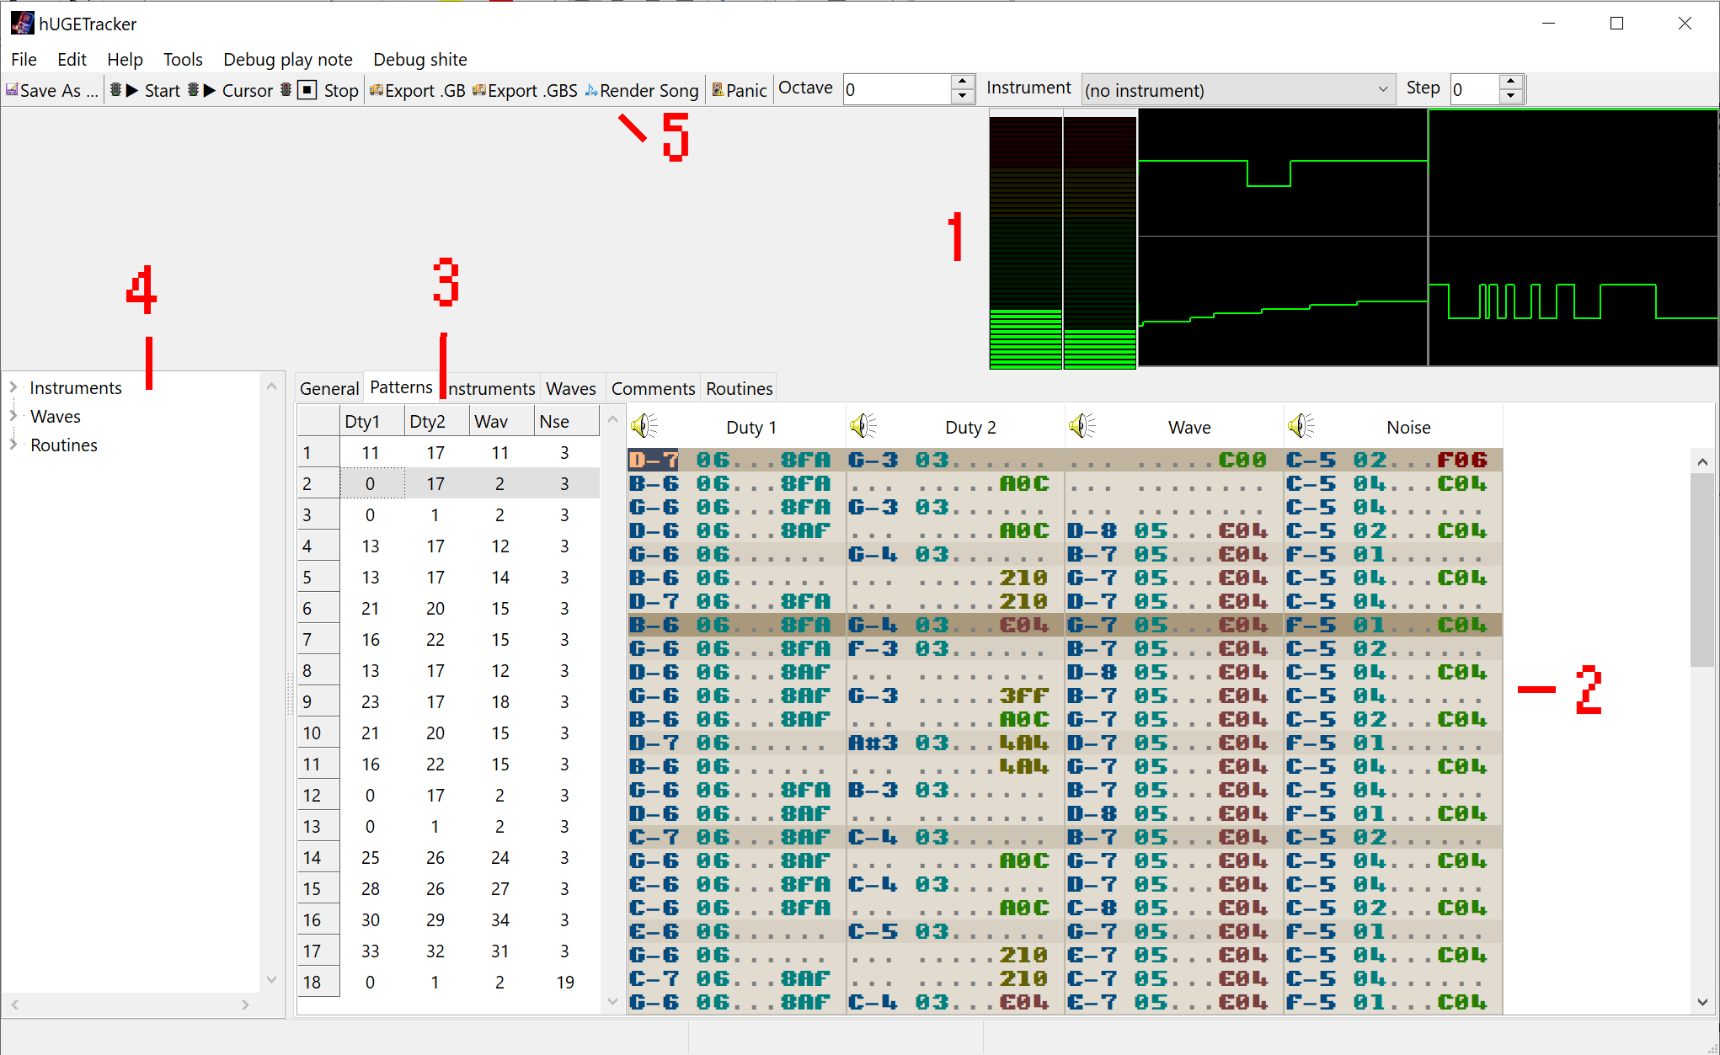

1. VU Meters and Oscilloscopes
2. Tracker Grid
3. Order Editor
4. Song components
5. Toolbar

## VU Meters and Oscilloscopes

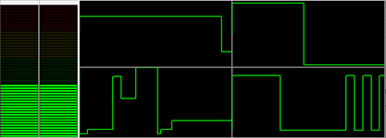

The **VU meters** show the volume level for the left and right speakers. When volume gets too loud, they display as yellow/red. The oscilloscopes show the waveforms generated by the four Gameboy channels, duty 1, duty 2, wave, and noise. You can click an oscilloscope to mute that channel during playback.

## Tracker Grid

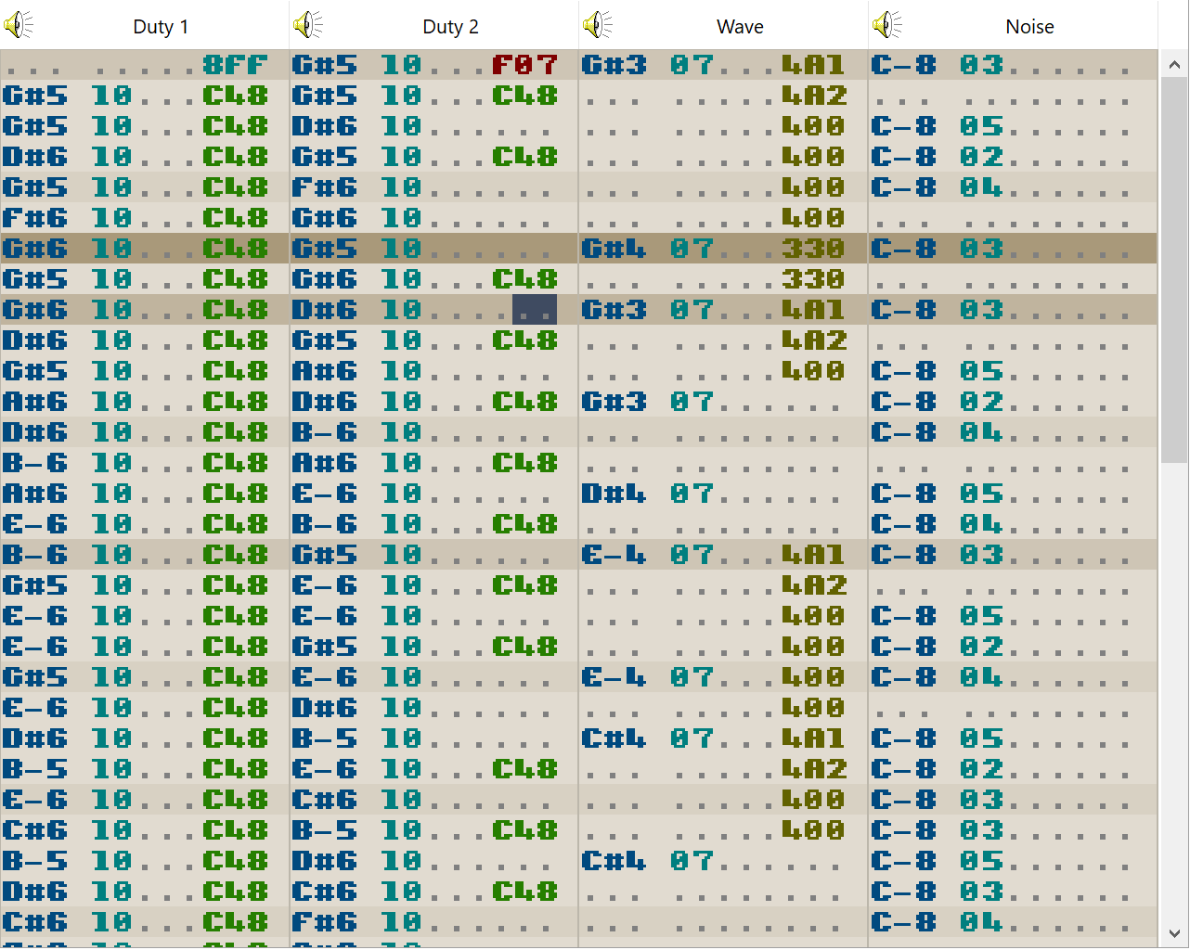

The **tracker grid** displays four patterns together. This represents one position in the **order table.** This is the component used to compose a song. When a different order is selected in the **order table**, the patterns in the **tracker grid** are updated to reflect their contents.

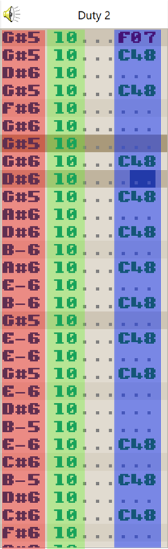In a given pattern, there are 64 rows of cells. Each cell is divided into three parts, the **note**, the **instrument**, and the **effect**. A note is a value ranging from C-3 to B-8, and is the pitch of the tone that will play on that cell. An instrument is a value from 01 to 15, which specifies which instrument parameters will be applied to the playing note. An effect is a pair of **effect code** (a value from 0 to F hexadecimal) and **effect parameter** (a value from 00 to FF hexadecimal). See the effect reference section for more details. You can also use the Effect Editor to create the effect values for you if you’re not comfortable entering hexadecimal directly.

The keyboard is used to enter values into the three cell parts—The keys Q through \, A through ‘, and Z through / each represent an octave with which to enter notes. The **octave offset** can be modified in the toolbar to allow for higher or lower note values.

The numeric keys can enter values into the instrument column.

The numeric keys, and keys A through F enter values into the effect column.

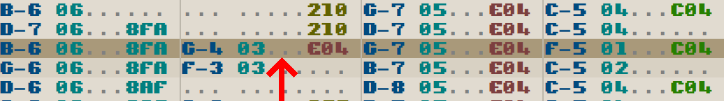

When a song is played, the highlighted row moves downward on the patterns, representing the currently played row. The tempo of your song (speed at which the highlighted row) moves can be adjusted in the General tab.

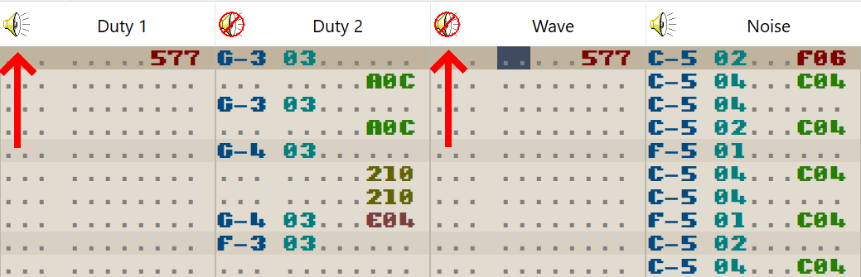

The **headers** of these channels are clickable, and will mute/unmute the playback of a specific channel when playing a song. You can also toggle playback of channels by clicking the oscilloscopes.

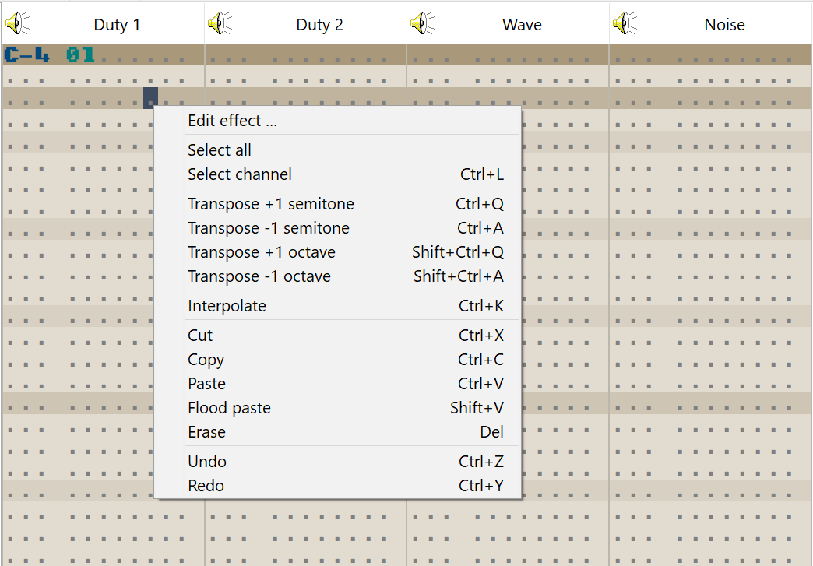

The tracker grid also features a right-click menu for opening the effect editor, and performing various editing tasks. These all can be accomplished by using the hotkeys as well.

## Order editor

The **order editor** is where you arrange the structure of your song. Since most music tends to be fairly repetitive (a single drum pattern is often enough for the majority of a song, for instance), you can define any number of patterns and arrange them here. Each column corresponds to a channel in the tracker grid. Much like the tracker grid, the order editor’s highlighted row moves downward each time a new **order** is reached. The song loops back to the first order when the last order is finished playing.

An order is a row in this table.

Right click to open the popup menu, where you can:

* **Insert new row** – Inserts a row with all brand-new pattern numbers.
* **Insert empty row** – Inserts a row with all zeros in it.
* **Duplicate row** – Inserts a row which has the same pattern numbers as the one highlighted.
* **Replicate row** – Inserts a row with all brand-new pattern numbers, and these new patterns contain a copy of the data in the highlighted row.

## Song components

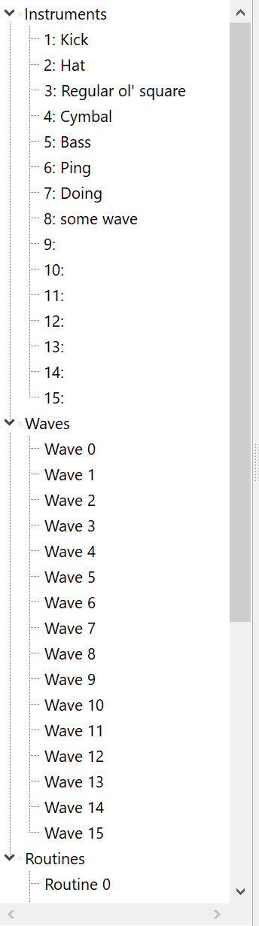The components of a hUGETracker song are shown here. Listed are instruments along with their names, waves numbered from 0 to 15, and routines numbered from 0 to 15.

Double clicking on any of these will lead you to the tab for editing them.

## Toolbar



The toolbar contains various functions that are useful when writing music.

* Save as – Saves your song to a file
* Start – Plays your song from the beginning
* Cursor – Plays your song starting from the current cursor position. Useful when editing a specific pattern
* Stop – Halts playback
* Export .GB – Assembles your song into a standalone .GB file for playback on an emulator, or real Nintendo GameBoy.
* Export .GBS – Assembles your song into a standalong .GBS file for playback in a program such as Bleep!
* Render Song – Exports your song in either .WAV or .MP3 format
* Panic – Silences channel playback immediately. Useful for when something has happened and a tone is playing which you want to make stop.
* Octave – Selects the octave offset for the tracker grid.
* Instrument – Selects the instrument with which to input new notes in the tracker grid. Any new note entered will be accompanied by this instrument number, and a preview note will play with this instrument.
* Step – Selects the **step** for the tracker grid. After inputting a new note, the cursor will move down by this amount, useful for inputting drum tracks or arpeggios.

## General

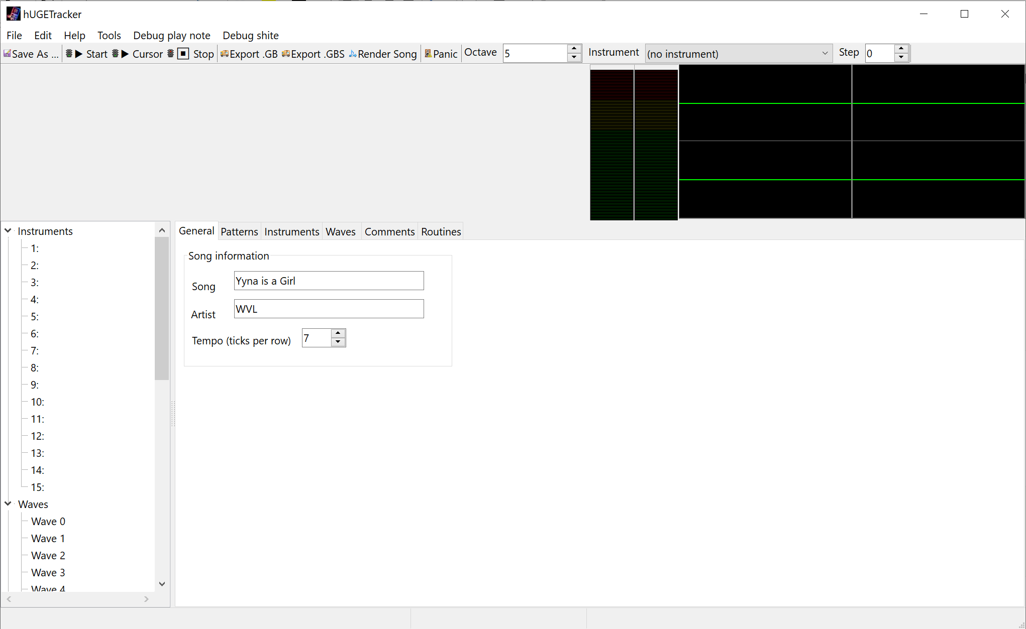

The **general** tab specifies the name, artist, and tempo of your song. Name and artist are limited to 255 characters. Tempo is limited to a value between 0 and 20.

Tempo is actually an inverse relationship to the speed of the song—a higher value results in a slower song.

## Instruments

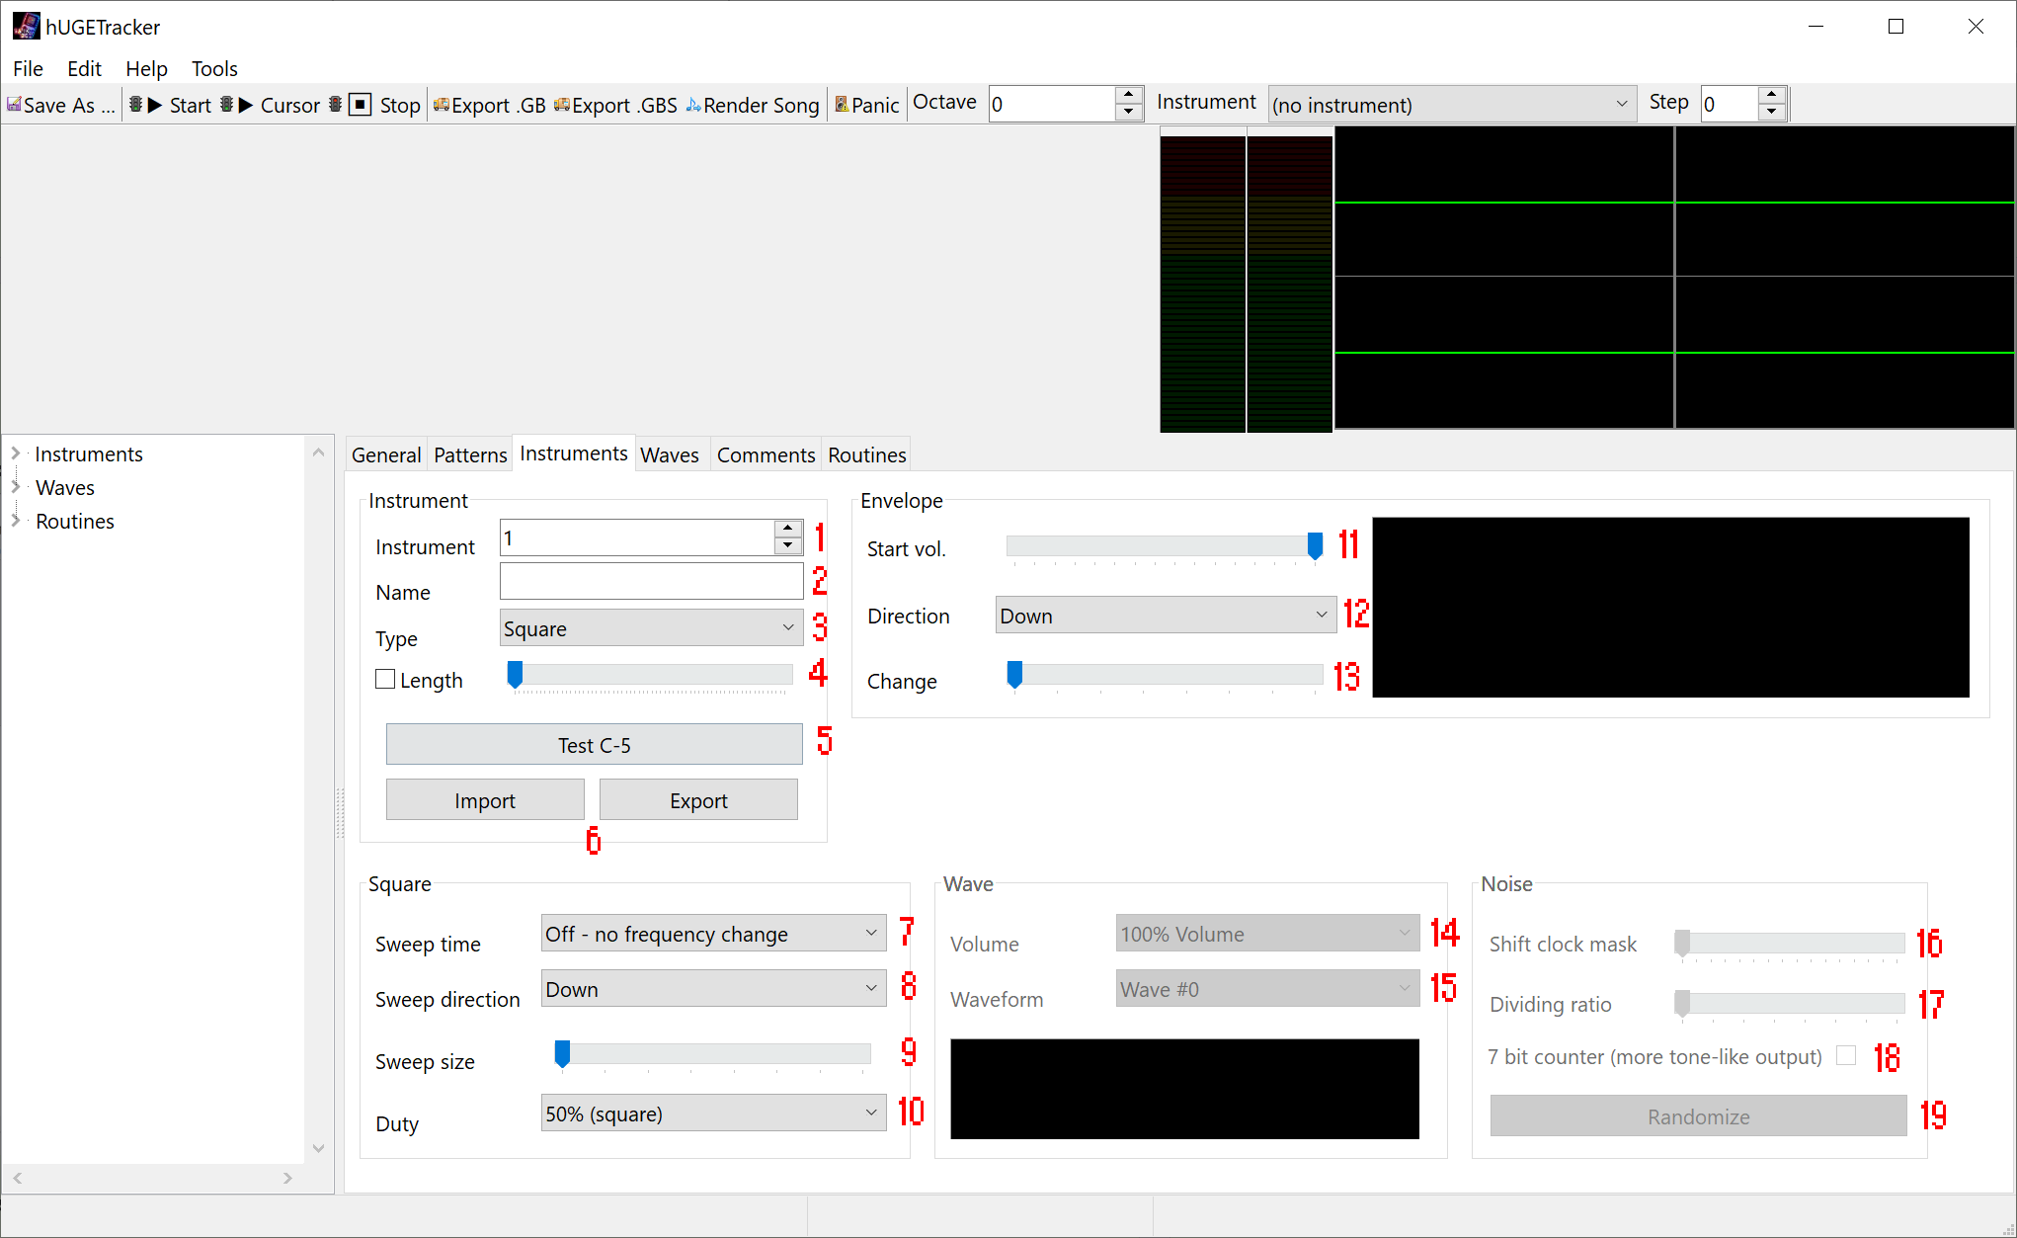

1. Instrument number – This selects which instrument to edit. Ranges from 1-15.
2. Instrument name – This is the name for the instrument. It is shown in the instrument combobox in the toolbar and the song components.
3. Instrument type – Selects which “type” of instrument this instrument is. Can be **square**, for instruments to be played on the duty channels, **wave**, for instruments to be played on the wave channel, and **noise**, for instruments to be played on the noise channel.
4. Length – When enabled, a playing note will be cut off immediately at a specific length.
5. Test C-5 – Plays a test note for a few seconds to test what the instruments will sound like.
6. Import/Export buttons – Used to import or export an instrument’s settings to/from a file
7. Sweep time – Selects the “sweep time” for the note to take. The greater the value, the slower the sweep.
8. Sweep direction – Selects the direction of sweep for the note to take. Up portamentos the note up, down portamentos it down.
9. Sweep size – Selects the magnitude of sweep for the note to take per “tick” as specified by sweep time.
10. Duty – Selects the timbre of note to play. Each one sounds different, and they are useful when you don’t want both of the duty channels to clash with one another.
11. Start vol – Selects the starting volume for the envelope. When there’s no change on the envelope, this functions simply as the volume for the note unless overridden by a volume effect command.
12. Direction – This specifies which direction for the envelope to go. Upward and volume will increase with time, downward and volume will decrease with time.
13. Change – This specifies how steep the envelope will be. The higher the value, the quicker the note will fade in or out.
14. Wave volume – Specifies at what volume a wave instrument shall play unless overridden by a volume effect command. There are only 3 possible values here, as the wave channel’s volume interface is more limited than the other channels.
15. Waveform – Specifies which waveform should play as part of this instrument. See waves.
16. Shift clock mask – A component of the noise generation algorithm. Tweak it however you want.
17. Dividing ratio – A component of the noise generation algorithm. Tweak it however you want.
18. 7-bit counter – When checked, the instrument will sound more like a musical tone rather than noise.
19. Randomize – Rather than manually tweaking the sliders, you can click this button until you hear something you like. Plays a random configuration of sliders, with a random length, at a random pitch.

## Waves

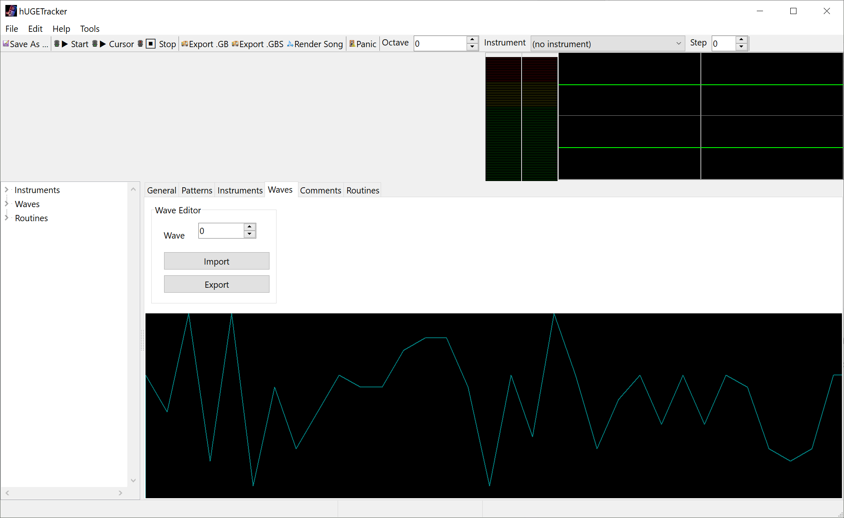

The **waves** tab allows you to edit **waveforms** for use by instruments. Use the spinner to select which wave you want to edit, and draw manually with the mouse in the displayed waveform viewer. Waves can also be imported and exported to files.

## Comments

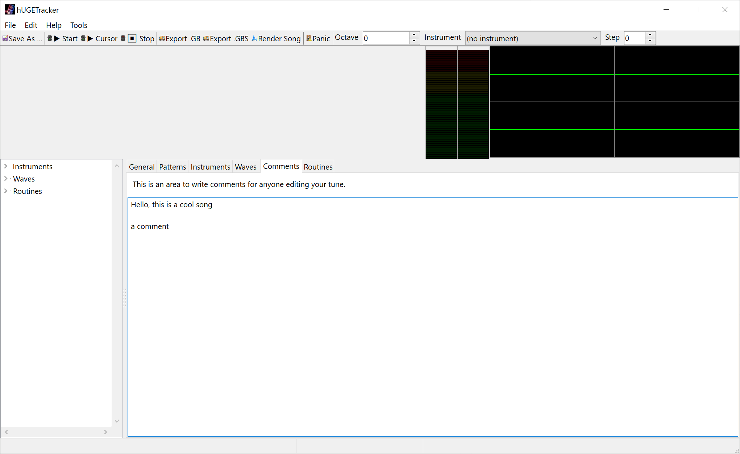

The **comments** tab allows you to include a comment section with your song, allow for acknowledgements, contact information, or anything you want, limited to 255 characters.

## Effect editor

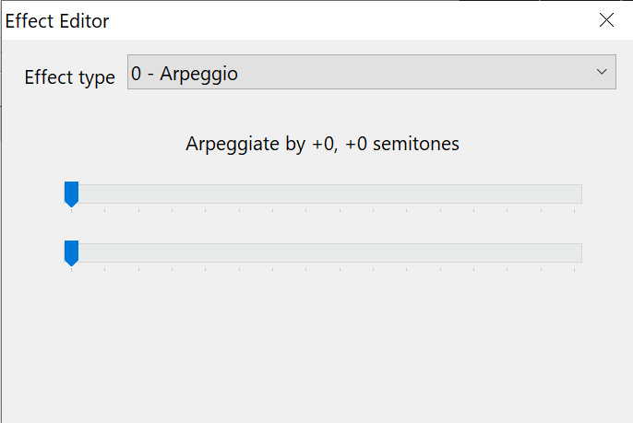 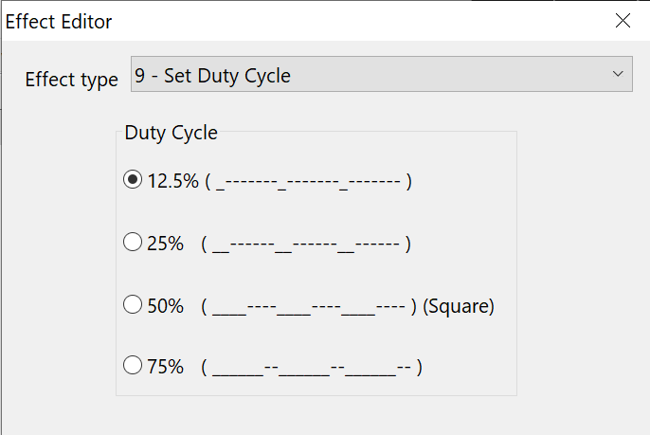

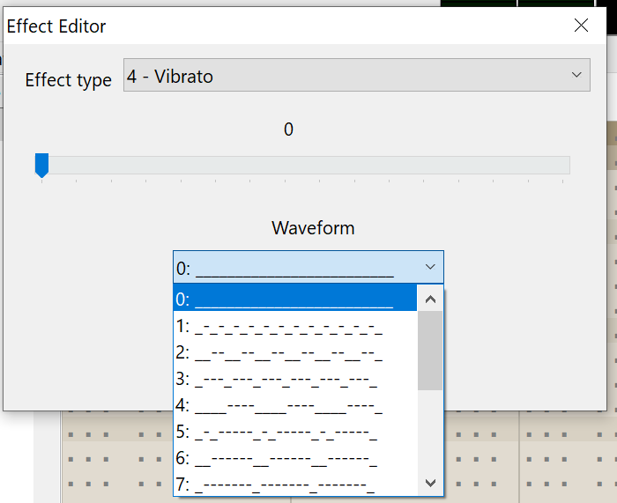 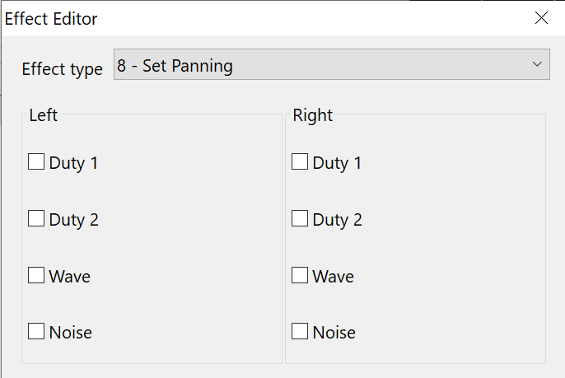

The effect editor is a tool for creating effect values in the tracker grid. This is especially useful for things like panning, or master volume, which operate on a bit level and are infeasible to enter from the top of your head. Open the editor by double clicking in the tracker grid, or with the right click menu.

# Effect reference

The hUGETracker effect codes are intentionally similar to ProTracker or FastTracker’s. If you know them, then many of these effects will look familiar to you.

|  |  |  |
| --- | --- | --- |
| Effect | Name | Description |
| 0xy | Arpeggio | On every tick, switch between the playing note, note + x, and note + y, where `x` and `y` are values in semitones. Can be used to create “chords” or a strum effect. |
| 1xx | Portamento up | Slide the pitch up by `xx` units every tick. |
| 2xx | Portamento down | Slide the pitch down by `xx` units every tick. |
| 3xx | Tone Portamento | Slide the pitch towards the specified note value by `xx` units every tick. Stops when it reaches the specified note value. **This effect cannot be used in a cell with an instrument value**. |
| 4xy | Vibrato | Rapidly switch between the specified note value and note + y, at the rate of `x`, where `y` is a value in units. Valid values for `x` are 0, 1, 3, 7, and F. This is similar to arpeggio, except you can control the frequency, and the amount is specified in units rather than semitones. |
| 5xx | Set Master Volume | Sets the master volume control of the Gameboy for the left and right speakers. Use the effect editor to create one of these effects. Note that a volume of zero is not completely silent. |
| 6xx | Call Routine | Call a user-defined routine. See the section Routines. Will crash the song if an invalid routine is specified. |
| 7xx | Note Delay | Wait `xx` ticks before playing the note in this cell. |
| 8xx | Set Panning | Sets which channels play on which speakers. Use the effect editor to create one of these effects. Can also be used as a mute for a channel by setting it to output on neither left nor right. |
| 9xx | Set Duty Cycle | Select duty cycle for either channel 1 or channel 2. If this effect appears on the noise or wave channels, it will affect channel 2. Valid values for xx are 00, 40, 80, C0. Under the hood, the `xx` value is loaded directly into ch1 or ch2’s length register, so you could theoretically achieve other effects than just duty cycle changing. |
| Axy | Volume Slide | Slide the note’s volume up by `x` units, and then down by `y` units. This effect actually retriggers the note on each tick, which might not be noticeable for instruments without length/envelope, but could potentially sound bad if those are present. Recommended to use either instrument envelopes, or the `C` command instead if you can. **This effect does not work in the same cell as a note/instrument!** |
| Bxx | Position Jump | Jump to order `xx`. |
| Cxx | Set Volume | Set the volume of the channel to `xx`. **Must be accompanied by a note and instrument to work (except on channel 3).** Valid values range from 00-0F. |
| Dxx | Pattern Break | Jump to the next order, and start on row `xx`. |
| Exx | Note Cut | Cut the note short after `xx` ticks. |
| Fxx | Set Speed | Set the number of ticks per row to `xx`. Can be used in an alternating fashion to create a swing beat. |

# Hotkeys

The keyboard interface to hUGETracker is intentionally designed to be similar to ModPlug’s. If you’re familiar with it, then most of these keybindings will look familiar.

|  |  |  |
| --- | --- | --- |
| Hotkey | Action | Remarks |
| Ctrl-C | Copy | Copies the selected pattern data into the clipboard |
| Ctrl-X | Cut | Copies the selected pattern data into the clipboard, then erases the selected pattern data |
| Ctrl-V | Paste | Pastes any stored pattern data in the clipboard |
| Shift-V | Flood paste | Continually pastes stored pattern data one after the other until reaching the bottom of the pattern. Useful for repeating beats/phrases/swing tempos. |
| Ctrl-Q | Semitone up | Transposes the selected notes one semitone up |
| Ctrl-A | Semitone down | Transposes the selected notes one semitone down |
| Ctrl-Shift-Q | Octave up | Transposes the selected notes one octave up |
| Ctrl-Shift-A | Octave down | Transposes the selected notes one octave down |
| Ctrl-L | Select channel | Selects the entire pattern that the cursor is located in |
| Del | Erase | Erases the selected note data |
| Ctrl-Z | Undo | Undoes the previous action. |
| Ctrl-Y | Redo | Redoes the action last undone. |

# Routines

Routines allow you to implement your own effects. The feature is currently not documented here, and is subject to change soon. If you’re *really* interested, check out the hUGEDriver/driverLite.z80 file.

# Miscellaneous

Here are some random things about hUGETracker.

## The clipboard

The clipboard format for hUGETracker is compatible with ModPlug/OpenMPT! This means that you can convert your existing .mod, .xm, .s3m, or .it chiptunes into Gameboy tunes very quickly by just copying and pasting your patterns into hUGETracker. Note that the effects are not converted when pasted, so you’ll need to adjust the effects to work in hT.

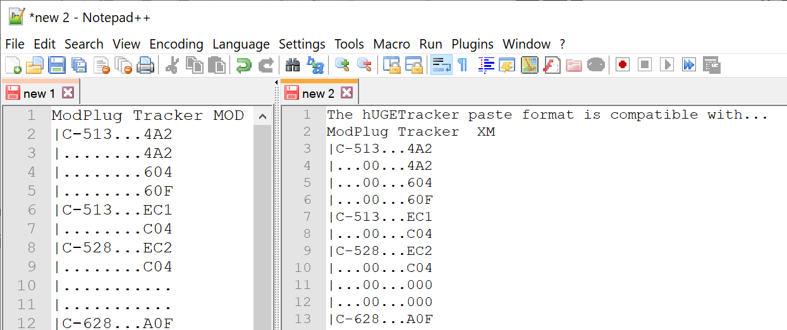

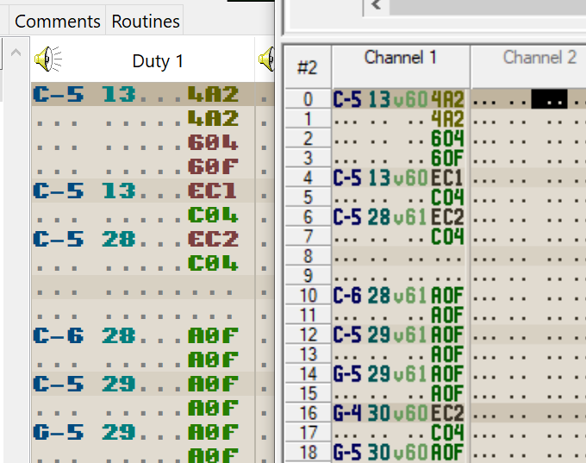

## File format

The hUGETracker file format is very simple and the reading/writing code can be found here: <https://github.com/SuperDisk/UGE/blob/hUGETracker/song.pas>

The file format might change to an NBT, JSON or XML based format in the future.