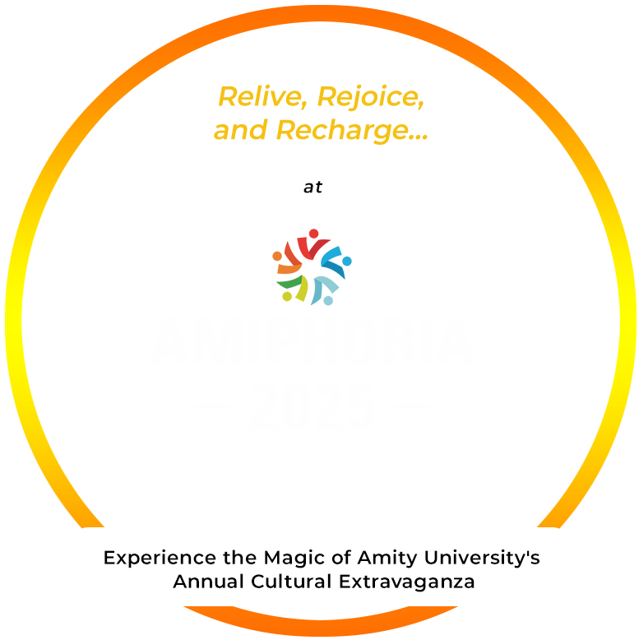

1. Event Title - **XUBERANCE** - Ms. & Mr. Amity, 2025

Registration amount is Rs 100

**2. Event Overview**

The search is for someone who is representative of Amity’s core values Modernity blends with traditions. Someone who not only oozes charm but also is intellectual, cultured, and a source of inspiration to Amitians.

**3. Organizers-** Amity Business School

**4. Eligibility Criteria -**AMITY STUDENT WITH 6 CGPA AND NO DISCIPLINARY ACTION

**5. Event Dates** (TENTATIVE)

o Finale: March 05, 2025  
First Round: February 06, 2025  
Second Round: February 12, 2025

**6. Registration Process-** The final participants will register for the event.

**7. Competition Format-** 3 ROUNDS in which participants will be shortlisted as per the criteria for becoming the face of amity. In each round elimination will be done as per the judging criteria of the Judges in each round.

**First round** criteria are :

Ramp walk

Introduction 1 min – one line that describes you

Fluency in English

Attire and poise

**Round 2: students will be shortlisted for the final round on the basis of:**

Grooming

Composure/ elegance

Question and answer

Communication skills

**Final round** will be held on March 05, 2025

**8. Judging Criteria**- Already Mentioned

**9. Prizes & Awards**- Titles and Awards will be given approximately Rs. 50,000/-.

Certificates for all Participants and Volunteers

**10. Rules & Regulations-** Mentioned in eligibility Criteria

**12. Contact Information-**

* Dr Rekha Khosla, [rkhosla@lko.amity.edu](mailto:rkhosla@lko.amity.edu), Mob: 9919990980
* Dr. Richa Raghuvanshi, [rraghuvanshi@lko.amity.edu](mailto:rraghuvanshi@lko.amity.edu), 9956401219
* Dr. Snigdha Singh, [ssingh7@lko.amity.edu](mailto:ssingh7@lko.amity.edu), 9919164322
* Mr. Samarth Pande, [spande2@lko.amity.edu](mailto:spande2@lko.amity.edu), 9919603896