Diabetes Prediction Project - Complete Documentation
This document provides full technical documentation for the diabetes prediction project, including dataset details, preprocessing techniques, model training process, evaluation metrics, and image-based analysis.

1. Dataset Description
The project primarily uses an augmented diabetes dataset and also supports custom CSV input or a fallback sklearn dataset.
Dataset File | Available | Rows | Columns
Diabetes_Final_Data_V2.csv | Yes | 5437 | 15
Diabetes_Final_Data_Augmented.csv | Yes | 5437 | 17
diabetes_dataset.csv | Yes | 442 | 11
Target variable used for training: diabetes (binary 0/1).
If source data contains diabetic values as Yes/No, it is converted to diabetes (Yes=1, No=0).
Columns in augmented dataset: age, gender, pulse_rate, systolic_bp, diastolic_bp, glucose, height, weight, bmi, family_diabetes, hypertensive, family_hypertension, cardiovascular_disease, stroke, diabetic, cholesterol, physical_activity_level

2. Preprocessing Techniques
Preprocessing pipeline steps applied in sequence:
1) Stratified train-test split (80/20) with random_state=42.
2) Missing value imputation using median strategy.
3) Feature scaling using StandardScaler.
4) Class imbalance handling using SMOTE if minority/majority ratio is below 0.5.
5) Feature subset selection: age, bmi, glucose, cholesterol, systolic_bp, physical_activity_level
SMOTE applied in saved run: Yes

3. Model Training and Results
Models trained with hyperparameter search:
- Logistic Regression (GridSearchCV, scoring=ROC-AUC, cv=2)
- Random Forest (RandomizedSearchCV, scoring=ROC-AUC, cv=2)
- XGBoost (RandomizedSearchCV, scoring=ROC-AUC, cv=2)
Best selected model: Logistic Regression
Best hyperparameters from latest training artifacts:
- Logistic Regression: {'C': 1, 'penalty': 'l2', 'solver': 'lbfgs'}
- Random Forest: {'n_estimators': 150, 'min_samples_split': 5, 'min_samples_leaf': 2, 'max_depth': 10, 'class_weight': None}
- XGBoost: {'subsample': 1.0, 'n_estimators': 150, 'max_depth': 5, 'learning_rate': 0.2, 'colsample_bytree': 0.85}

4. Evaluation Metrics
The following metrics are used for evaluation: Accuracy, Precision, Recall, F1-score, ROC-AUC, Confusion Matrix, and ROC Curve.
Model | Accuracy | Precision | Recall | F1-score | ROC-AUC
Logistic Regression | 0.7564 | 0.1597 | 0.6667 | 0.2577 | 0.7957
Random Forest | 0.8539 | 0.2289 | 0.5507 | 0.3234 | 0.7768
XGBoost | 0.9210 | 0.3607 | 0.3188 | 0.3385 | 0.7743
Best model summary (Logistic Regression): accuracy=0.7564, precision=0.1597, recall=0.6667, f1=0.2577, roc_auc=0.7957.
Confusion matrix values for best model: TN=777, FP=242, FN=23, TP=46.

5. Visual Analysis and Image Explanations

5.1 Correlation Heatmap
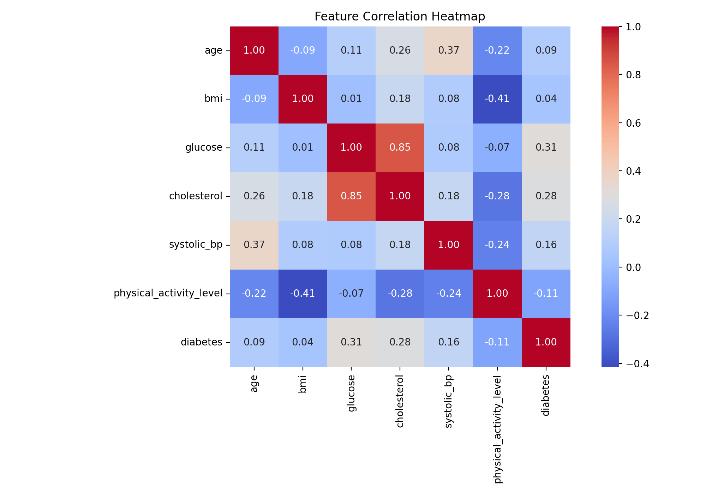
This heatmap shows pairwise linear relationships among numeric features and the target. Stronger positive or negative colors indicate stronger correlation. It helps identify relevant features and potential multicollinearity before model training.

5.2 Mutual Information Ranking
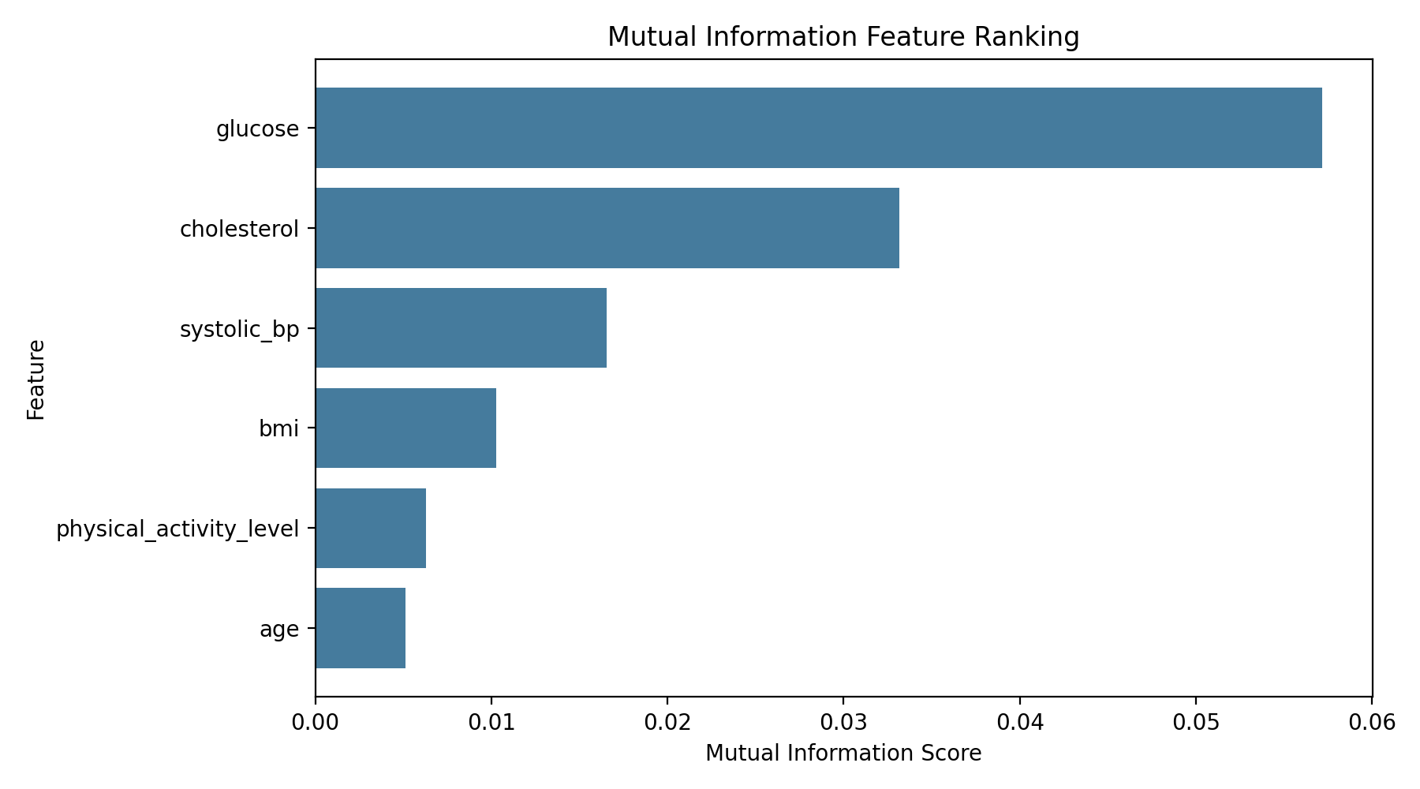
This chart ranks features by mutual information with the diabetes target. Higher values indicate stronger nonlinear association with the outcome, supporting feature relevance decisions in preprocessing.

5.3 Feature Importance (Best Model)
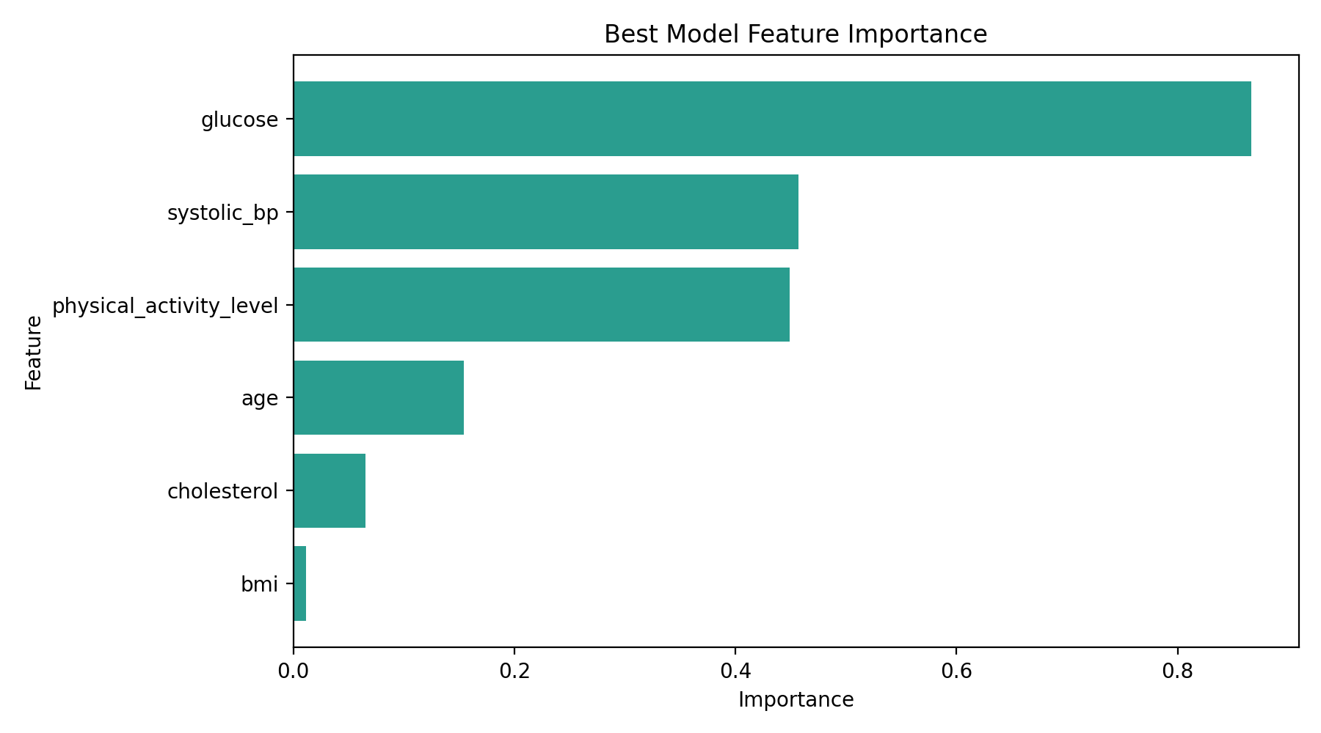
This plot shows feature contribution magnitude for the selected best model. Higher bars indicate stronger influence on model predictions for diabetes risk.

5.4 Model Comparison Across Metrics
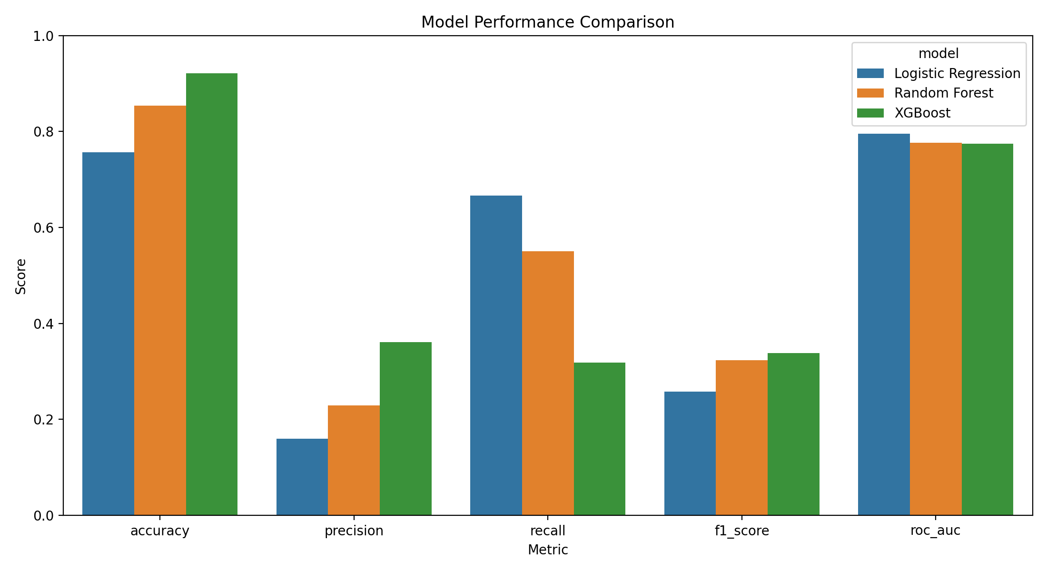
This grouped bar chart compares Logistic Regression, Random Forest, and XGBoost across five metrics. It visually highlights trade-offs between overall accuracy and clinical sensitivity (recall).

5.5 ROC Curve of Best Model
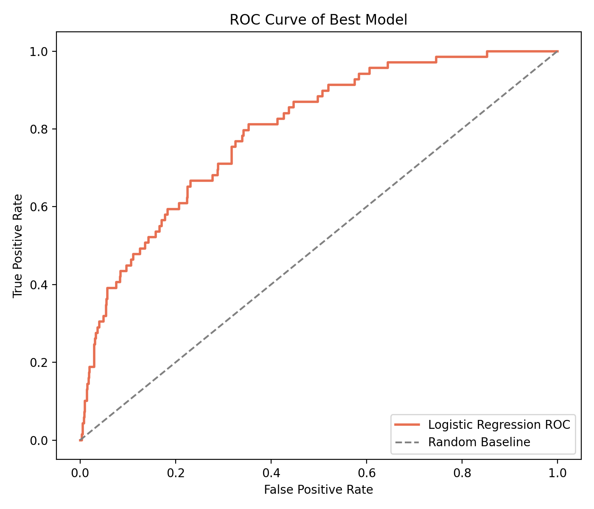
The ROC curve plots true positive rate against false positive rate at different thresholds. A curve farther from the diagonal baseline indicates better discrimination. The area under this curve (ROC-AUC) is used for model selection in this project.

5.6 Confusion Matrix of Best Model
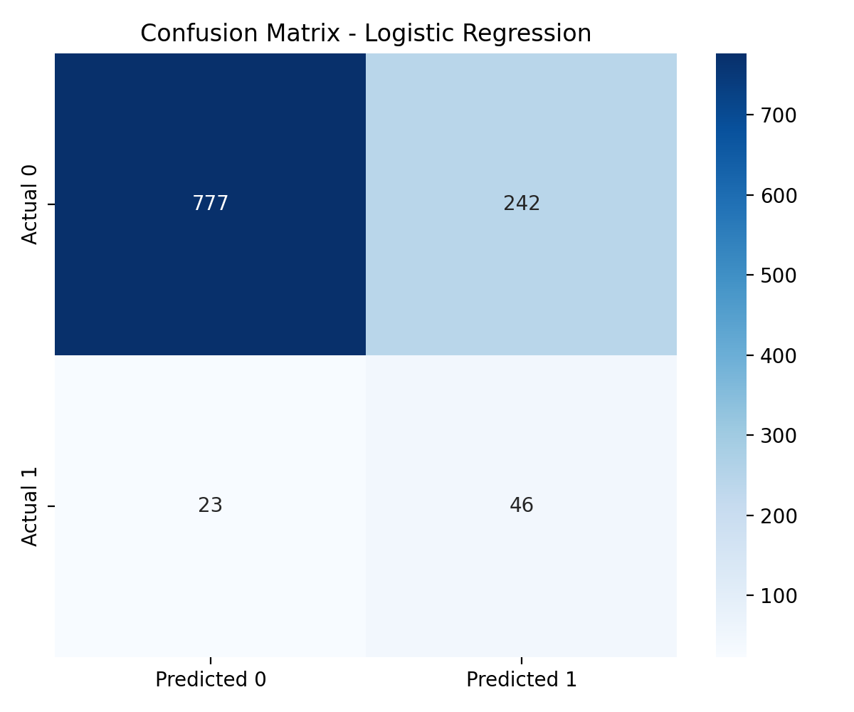
The confusion matrix breaks predictions into TN, FP, FN, and TP categories. It gives direct insight into screening behavior, especially false negatives (missed diabetic cases) and false positives (over-alerted cases).

6. End-to-End Pipeline Summary
1) Load dataset from CSV path, augmented dataset, or sklearn fallback.
2) Construct binary target diabetes and select fixed feature set.
3) Split, impute, scale, and optionally balance using SMOTE.
4) Train and tune three candidate models.
5) Evaluate models on holdout test data and select best by ROC-AUC.
6) Save model, preprocessors, and evaluation artifacts for app inference.

7. Conclusion
The project demonstrates a complete and reproducible machine learning workflow for diabetes prediction. The selected model is Logistic Regression based on ROC-AUC from the current training run. This documentation includes full methodological details and visual evidence for transparent reporting.

