Diabetes Prediction Project - Complete Documentation
This report documents the full diabetes prediction workflow, including datasets, preprocessing, training, evaluation, and visual analysis.

1. Dataset Description
The project uses an augmented diabetes dataset by default and also supports a custom CSV or a sklearn fallback dataset.
Dataset File | Available | Rows | Columns
Diabetes_Final_Data_V2.csv | Yes | 5437 | 15
Diabetes_Final_Data_Augmented.csv | Yes | 5437 | 17
diabetes_dataset.csv | Yes | 442 | 11
Target variable: diabetes (0/1).
Augmented dataset columns: age, gender, pulse_rate, systolic_bp, diastolic_bp, glucose, height, weight, bmi, family_diabetes, hypertensive, family_hypertension, cardiovascular_disease, stroke, diabetic, cholesterol, physical_activity_level

2. Preprocessing Techniques
1) Stratified 80/20 train-test split with random_state=42
2) Median imputation for missing values
3) StandardScaler for feature scaling
4) SMOTE for class balancing when needed
5) Selected features: age, bmi, glucose, cholesterol, systolic_bp, physical_activity_level
SMOTE used in this trained run: Yes

3. Model Training and Results
Trained models: Logistic Regression, Random Forest, XGBoost
Model selection metric: ROC-AUC
Best model: Logistic Regression
Best hyperparameters:
- Logistic Regression: {'C': 1, 'penalty': 'l2', 'solver': 'lbfgs'}
- Random Forest: {'n_estimators': 150, 'min_samples_split': 5, 'min_samples_leaf': 2, 'max_depth': 10, 'class_weight': None}
- XGBoost: {'subsample': 1.0, 'n_estimators': 150, 'max_depth': 5, 'learning_rate': 0.2, 'colsample_bytree': 0.85}

4. Evaluation Metrics
Reported metrics: Accuracy, Precision, Recall, F1-score, ROC-AUC, Confusion Matrix, ROC Curve
Model | Accuracy | Precision | Recall | F1-score | ROC-AUC
Logistic Regression | 0.7564 | 0.1597 | 0.6667 | 0.2577 | 0.7957
Random Forest | 0.8539 | 0.2289 | 0.5507 | 0.3234 | 0.7768
XGBoost | 0.9210 | 0.3607 | 0.3188 | 0.3385 | 0.7743
Best model scores: accuracy=0.7564, precision=0.1597, recall=0.6667, f1=0.2577, roc_auc=0.7957.
Confusion matrix (Logistic Regression): TN=777, FP=242, FN=23, TP=46.

5. Visual Analysis and Image Explanations

5.1 Correlation Heatmap
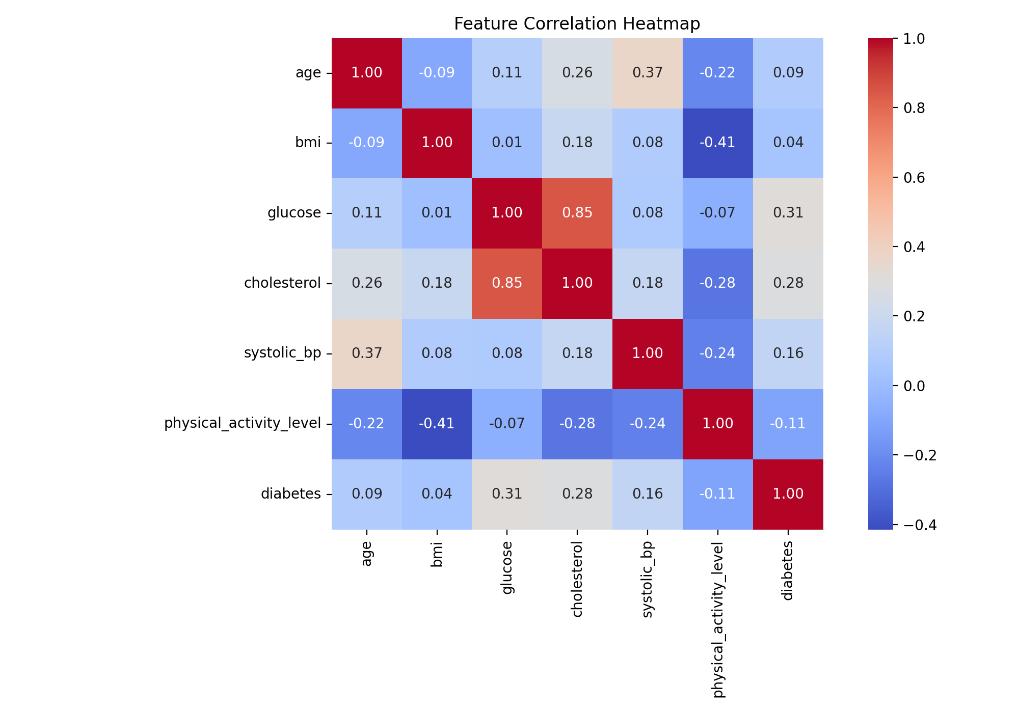
The heatmap shows linear relationships between numeric features and the target, helping identify strong associations and possible multicollinearity.

5.2 Mutual Information Ranking
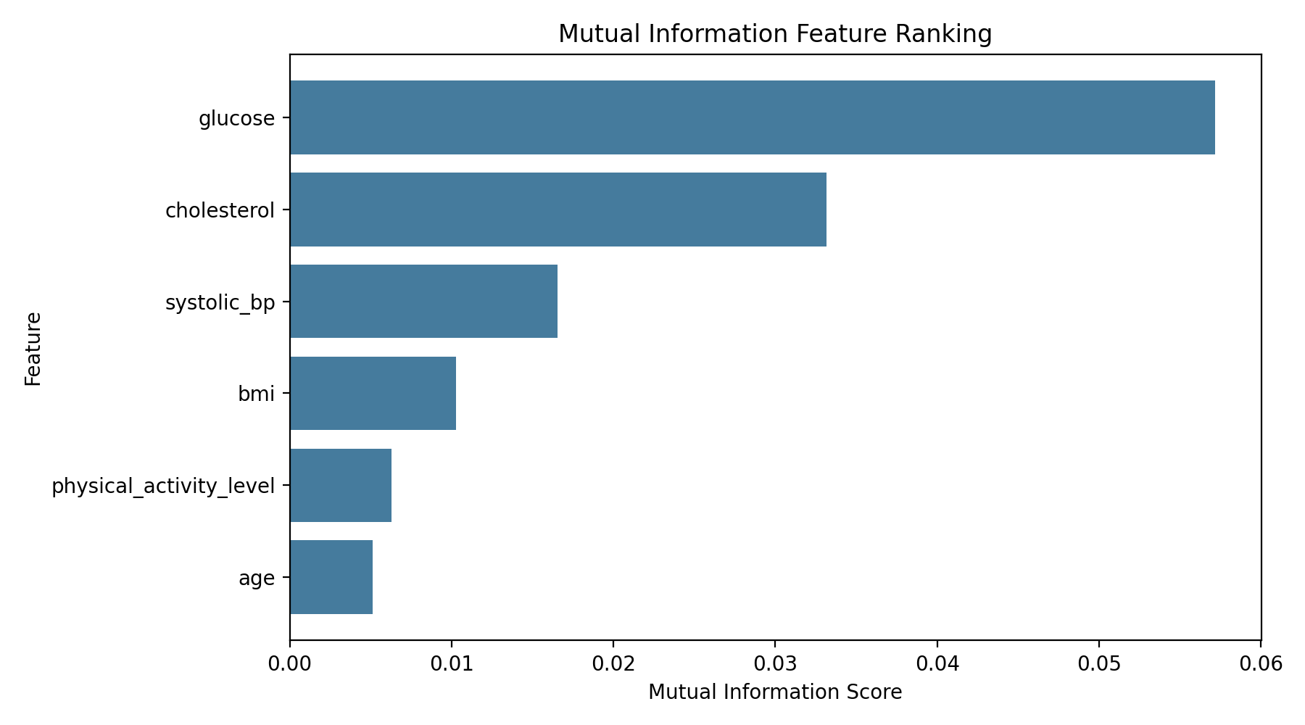
This chart ranks features by mutual information with the target, indicating how informative each feature is for classification.

5.3 Feature Importance (Best Model)
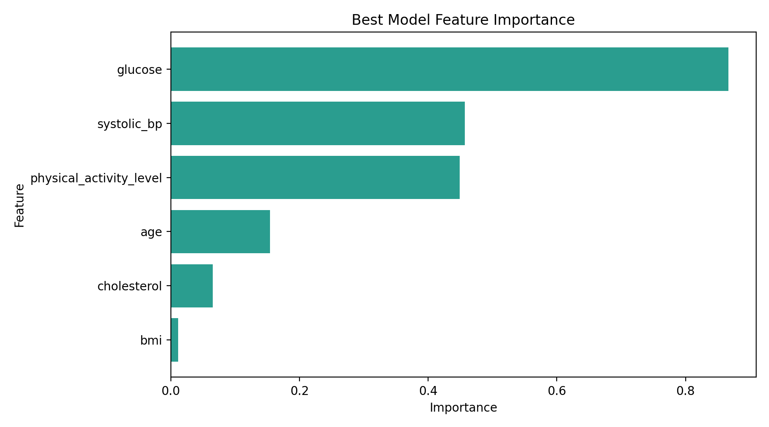
The bar plot shows which features contribute most to the best model predictions.

5.4 Model Comparison Across Metrics
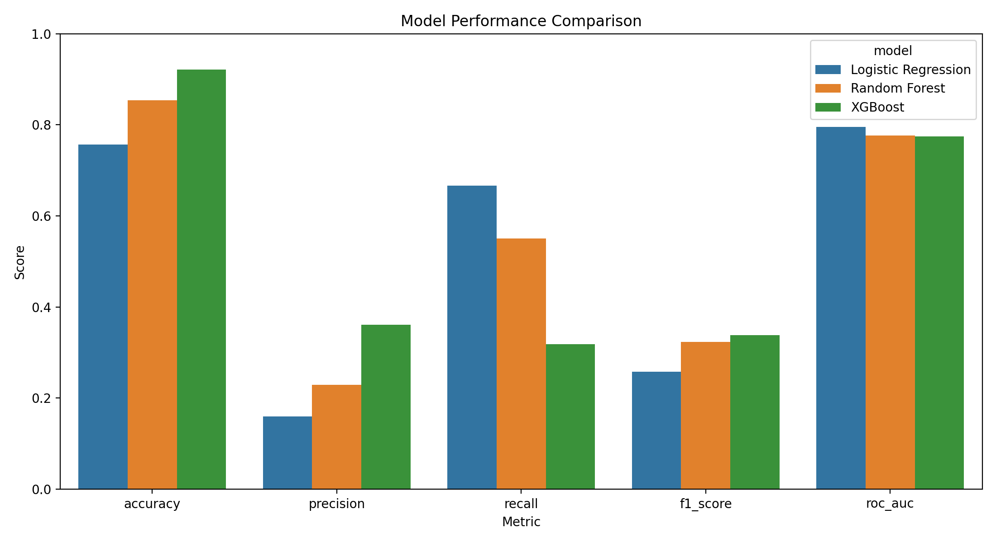
This chart compares all trained models across major evaluation metrics and highlights performance trade-offs.

5.5 ROC Curve of Best Model
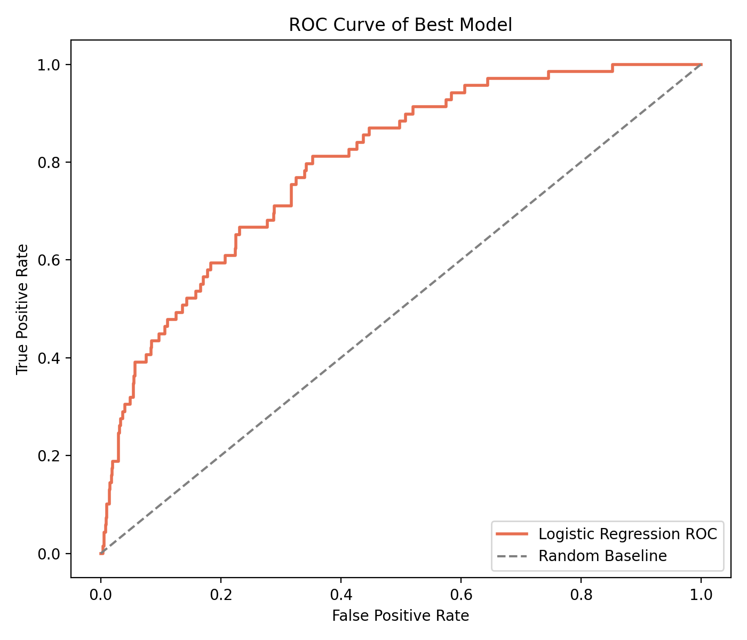
The ROC curve visualizes threshold behavior of the best model. A curve farther from the diagonal baseline indicates stronger class discrimination.

5.6 Confusion Matrix of Best Model
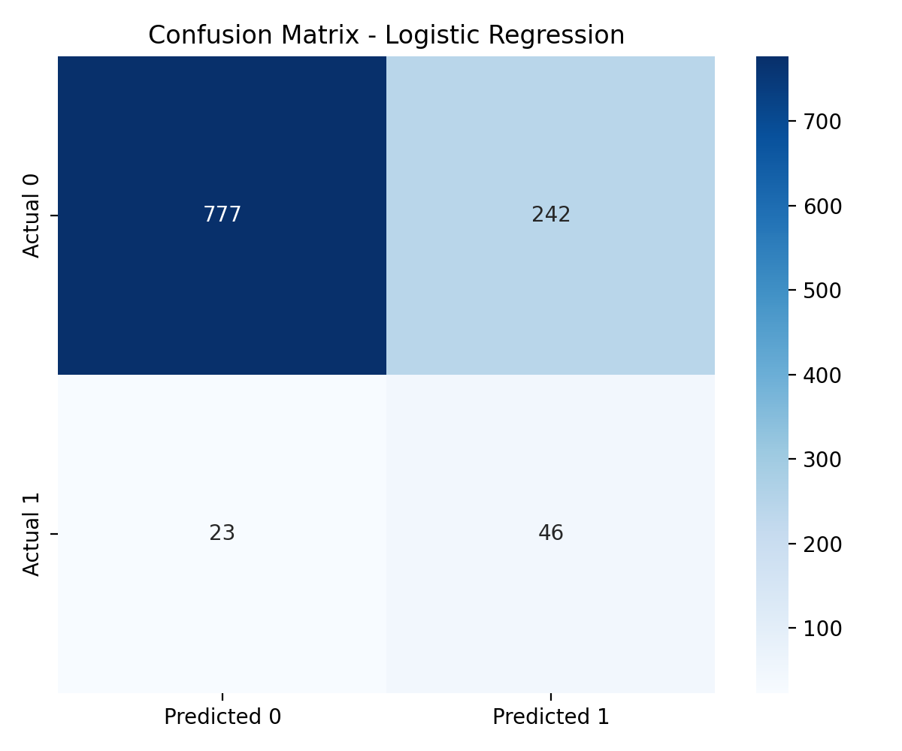
The confusion matrix shows exact prediction outcomes as TN, FP, FN, and TP, making false positive and false negative behavior explicit.

6. Pipeline Summary
1) Load data
2) Build target and select features
3) Split, impute, scale, and balance
4) Train and tune models
5) Evaluate and select best model
6) Save model and artifacts

7. Conclusion
This project delivers a full machine learning pipeline for diabetes prediction with reproducible artifacts and clear visual evidence of model behavior.

