CHAPTER - 1
INTRODUCTION

  - Overview: Wastewater Treatment Plants
Wastewater treatment plant operation is central to this project because wastewater quality monitoring depends on consistent interpretation of dynamic and multi-dimensional process variables over time. In practical treatment plants, operators face seasonal inflow changes, load shocks, and process disturbances; therefore, influent and effluent quality forecasting must be analysed with both engineering context and statistical rigor. The present work addresses these realities by combining domain knowledge from sanitation engineering with data-driven learning, ensuring that model behaviour remains meaningful for operational decision support. The report evaluates not only numerical accuracy but also interpretability through trend plots, residual diagnostics, and comparative assessment across multiple physicochemical indicators. From a methodological perspective, time-series structure is preserved through windowed supervision so that historical trajectories influence forward prediction in a realistic way.
This design helps the model capture temporal inertia, gradual drift, and abrupt variability while reducing the risk of overfitting to isolated fluctuations in the training subset. Within Smart STP Prediction System Using CNN-LSTM-ATTENTION Model, experiments are organized to measure how effectively hybrid deep learning can represent nonlinearity, delayed effects, and inter-parameter coupling observed in treatment datasets. Results are interpreted in relation to process plausibility, where lower prediction error translates into better readiness for early warning, aeration planning, and compliance-driven monitoring. This is further useful in predicting future levels of BOD rates, COD, rates, etc and use them for other purposes.
The discussion therefore links WHY the method is needed, HOW the computational pipeline is implemented, and WHAT outcomes are obtained under realistic evaluation metrics. Such an integrated presentation is academically important because it transforms a model-centric study into an engineering-oriented system that supports future deployment in smart urban infrastructure.
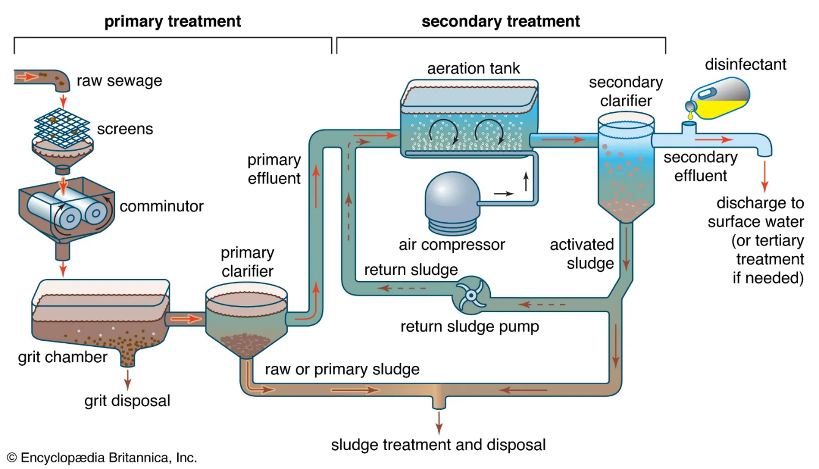

Fig 1.1: Wastewater Treatment Plant Process Flow

  - Motivation
The motivation for this project stems from the limitations of current monitoring techniques. Key parameters such as Biochemical Oxygen Demand (BOD) and Chemical Oxygen Demand (COD) typically require time-consuming laboratory analysis, leading to a significant time lag between data collection and operational response.
This reactive approach increases the risk of environmental non-compliance and inefficient energy use.
By utilizing Deep Learning, we can transform these treatment facilities into "Smart STPs" capable of predicting pollution levels before they reach the effluent stage.

1.3 Need for Prediction System in STP Operations
Prediction systems in wastewater treatment plants are essential for transforming conventional reactive operations into proactive and intelligent process management frameworks. In traditional systems, operators rely heavily on periodic sampling and laboratory analysis, which introduces delays in decision-making and limits the ability to respond effectively to sudden fluctuations in influent characteristics or process disturbances. As wastewater treatment involves highly dynamic and interdependent parameters such as Biochemical Oxygen Demand (BOD), Chemical Oxygen Demand (COD), Dissolved Oxygen (DO), and pH, the absence of predictive capabilities can lead to inefficiencies, regulatory violations, and environmental risks. Therefore, there is a growing need for advanced prediction systems that can continuously analyze historical and real-time data to forecast future conditions with high accuracy.
By incorporating data-driven models, treatment facilities can anticipate variations in load conditions, detect anomalies at an early stage, and optimize operational parameters such as aeration rates, chemical dosing, and sludge management strategies. These systems not only enhance treatment efficiency but also reduce operational costs and energy consumption.
Furthermore, predictive systems contribute to sustainable wastewater management by ensuring consistent compliance with environmental discharge standards and minimizing the ecological impact of untreated or partially treated effluent. In the context of smart cities and digital infrastructure, integrating predictive analytics into wastewater treatment plants represents a significant upgrade in the way waste generation is managed and controlled.

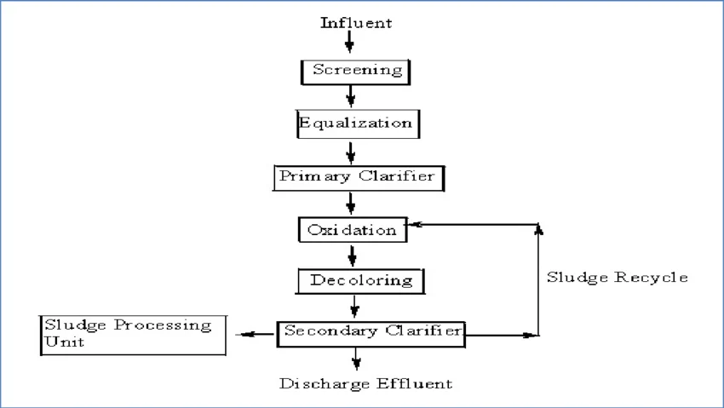
Fig 1.2: Typical Wastewater Flow Diagram
1.4 Challenges in Fluctuating Parameters
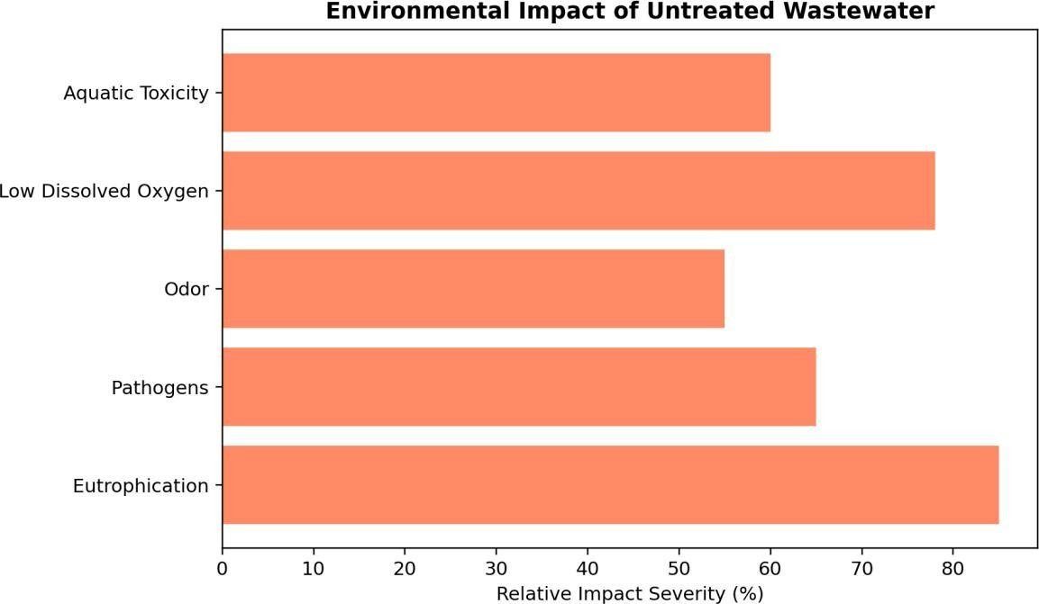
Wastewater treatment processes are inherently complex due to the highly variable nature of influent composition and operational conditions, making accurate modeling and prediction a challenging task. The variability arises from multiple sources, including seasonal changes, industrial discharges, population dynamics, rainfall events, and unexpected shock loads, all of which contribute to significant fluctuations in key water quality parameters. These parameters do not behave independently; instead, they exhibit nonlinear relationships and interdependencies that evolve over time. For instance, variations in organic load directly influence dissolved oxygen levels, which in turn affect microbial activity and overall treatment efficiency. Additionally, the presence of noise, missing values, and measurement inconsistencies further complicates data analysis and model development. Another major challenge lies in capturing temporal dependencies, as wastewater processes often exhibit delayed responses where the effect of a change in one parameter may not be immediately visible in another. This time-lag behavior requires models that can effectively learn from historical sequences rather than relying solely on current observations. Moreover, abrupt disturbances such as equipment failure or sudden inflow surges introduce irregular patterns that are difficult to generalize using traditional modeling approaches.

Fig 1.3: Environmental Impact of Untreated Wastewater
Overcoming these limitations is critical for developing reliable prediction systems that can support real-time decision-making in wastewater treatment operations.
1.5 Role of AI and Deep Learning
Artificial Intelligence and Deep Learning have emerged as powerful tools for addressing the complexities associated with wastewater treatment data analysis and prediction. Unlike conventional statistical models that rely on predefined assumptions and linear relationships, deep learning approaches are capable of automatically learning intricate patterns and representations directly from raw data. This capability is particularly important in wastewater systems, where the relationships between variables are highly nonlinear, time dependent, and influenced by multiple interacting factors.
Techniques such as Convolutional Neural Networks (CNN) are effective in extracting local temporal features and identifying short-term patterns within the data, while Long Short-Term Memory (LSTM) networks are specifically designed to capture long-range dependencies and sequential behavior in time series data. The integration of attention mechanisms, further enhances model performance by enabling the system to focus on the most relevant portions of the input sequence, thereby improving interpretability and prediction accuracy.
By combining these techniques into a hybrid architecture, it becomes possible to model complex wastewater dynamics with greater precision and reliability. In addition to improved predictive performance, Al-driven systems offer scalability and adaptability, allowing them to be applied across different treatment plants and varying operational conditions. The use of deep learning also facilitates continuous learning, where models can be updated with new data to maintain accuracy over time.
As a result, Al and deep learning play a critical role in advancing wastewater treatment from a manually operated system to an intelligent, automated, and data-driven process that supports efficient resource management and environmental sustainability.

1.6 Problem Statement
Conventional monitoring systems in wastewater treatment plants (WWTPs) are predominantly reactive, relying on delayed laboratory analyses and manual interpretation of operational data. This approach limits the ability to detect early signs of process instability, especially in the presence of complex characteristics such as nonlinearity, temporal dependencies, and noisy multivariate signals. Critical variations such as sudden increases in organic load or imbalances in dissolved oxygen often go unnoticed until they impact treatment efficiency and regulatory compliance.
The core problem, therefore, is the lack of an intelligent, data-driven forecasting system capable of accurately modelling short-term temporal dynamics across multiple sewage treatment plant (STP) parameters.
Such a system must effectively learn interdependencies among variables, handle data uncertainty, and provide timely, actionable predictions. Addressing this gap would enable proactive decision-making, improve process stability, and ensure consistent discharge quality.

1.7 Objectives
The primary goal of this project is to bridge the gap between traditional wastewater monitoring and modern AI-driven utility management.
- Hybrid Model Development: To design a CNN-LSTM-Attention architecture that captures both local patterns and long-term dependencies in wastewater data.
- Parameter Forecasting: To provide accurate short-term predictions for critical indicators like BOD, COD, DO, and Ammonia-Nitrogen.
- Data Pipeline Optimization: To establish a robust preprocessing system using Min-Max normalization and sliding-window techniques for noisy sensor data.
- System Scalability: To demonstrate multi-plant monitoring capabilities by simulating data feeds from diverse industrial "fake factories".
- Interactive Operator Interface: To develop a Flutter-based dashboard for real-time graphical visualization and tabular data tracking.
- Backend Integration: To deploy a high-performance FastAPI engine that serves model inferences to the client application seamlessly.
- Predictive Alerting: To implement an automated notification system that identifies potential effluent violations hours before they occur.
- Resource Efficiency: To suggest optimal process setpoints that help reduce energy consumption and operational costs.
1.8 Scope of the Project
The scope of this project encompasses the design, development, and deployment of an intelligent prediction system for wastewater treatment plants using advanced deep learning techniques. The project begins with the collection and preprocessing of multivariate time series data, ensuring that the dataset is cleaned, normalized, and structured in a manner-suitable for model training. It includes handling missing values, removing outliers, and transforming raw data into supervised learning format through time-series windowing techniques.
The core component of the project involves the development of a hybrid CNN LSTM-Attention model that integrates the strengths of convolutional feature extraction, sequential memory learning, and attention-based weighting to accurately predict key wastewater parameters such as BOD, COD, DO, and Do. The model is trained and evaluated using multiple performance metrics, including RMSE, MAE, R', and MAPE, to ensure a comprehensive assessment of prediction accuracy and reliability.
In addition to model development, the project also focuses on interpretability through visualization techniques such as trend plots, residual analysis, and scatter plots, which provide insights into model behaviour and performance. Furthermore, the system is extended beyond theoretical implementation by incorporating a FastAPI-based backend for model inference and a Flutter-based frontend for user interaction, enabling real-time prediction and data visualization.
The project aims to bridge the gap between research and practical application by delivering a complete end-to-end solution that can be deployed in real-world wastewater treatment scenarios. Ultimately, this work contributes to the development of smart wastewater management systems that enhance operational efficiency, reduce environmental impact, and support sustainable urban infrastructure.
CHAPTER - 2
BACKGROUND & LITERATURE SURVEY

2.1 Background
The management and operation of Sewage Treatment Plants (STPs) are critical components of urban environmental engineering and public health infrastructure. As industrialization and urbanization accelerate, the volume and complexity of wastewater increase, placing immense pressure on traditional treatment facilities to maintain stringent effluent quality standards.
Wastewater treatment is fundamentally a dynamic and stochastic process. The performance of an STP is influenced by several highly variable factors:
- Influent Variability: Fluctuations in the organic and hydraulic load entering the plant based on time of day, industrial discharge schedules, and domestic usage patterns.
- Process Nonlinearity: The biological and chemical interactions within treatment tanks do not follow linear paths, making it difficult for traditional mathematical models to predict outcomes accurately.
- Environmental Factors: Sudden weather events, particularly heavy rainfall, introduce "hydraulic shocks" that can dilute wastewater concentrations while simultaneously threatening to "wash out" the active microbial biomass essential for treatment.
Traditionally, operators have relied on manual sampling and "lagging" laboratory results. For instance, the Biochemical Oxygen Demand (BOD) test a primary indicator of water pollution typically requires a five-day incubation period. This delay creates a "reactive" operational environment where problems are often identified only after treated water has already been discharged.
In the context of Industry 4.0, there is a shift toward "Smart Utilities." By leveraging Deep Learning, specifically hybrid architectures like CNN-LSTM-Attention, it is now possible to transform raw sensor data into Predictive Intelligence. This allows for a "proactive" management style where operators can forecast critical parameters like BOD, COD, Dissolved Oxygen (DO), and Ammonia-Nitrogen several hours in advance. Such a system not only ensures environmental compliance but also optimizes energy consumption by adjusting aeration processes in real-time, forming a digital monitoring framework essential for sustainable smart cities.

2.2 Literature Survey
1. Evolution of Wastewater Modeling Techniques
Historically, wastewater treatment plant (WWTP) operations relied on semi-mechanistic biochemical models, such as the Activated Sludge Models (ASM), to simulate complex internal recycle loops. While accurate in controlled environments, these models often require extensive manual parameter tuning and struggle with the stochastic nature of real-world influent disturbances.
Consequently, research has shifted toward data-driven approaches, which leverage historical time-series data to build predictive relationships for effluent indicators like BOD and COD.

2. Deep Learning for Environmental Time-Series
The emergence of deep learning has provided new tools for handling the high non-linearity and irregular temporal patterns inherent in wastewater data.
Unlike traditional statistical methods, deep learning architectures can autonomously learn features from raw sensor data, making them ideal for monitoring parameters that are sensitive to rapid environmental changes, such as Dissolved Oxygen (DO) and pH.

3. Feature Extraction using Convolutional Neural Networks (CNN)
A significant breakthrough in water quality forecasting is the utilization of Convolutional Neural Networks (CNN) as encoders. In this architecture, the convolutional branch is responsible for capturing local temporal patterns and short-term trends within multivariate wastewater datasets.
By extracting these spatial features, the model can identify sudden spikes in loading or chemical imbalances before they propagate through the system.

4. Modeling Long-Range Dependencies with LSTM
To address the time-dependent nature of wastewater treatment, Long Short-Term Memory (LSTM) networks are integrated as decoders. LSTM layers are specifically designed to model long-range dependencies, effectively managing the "memory" of past influent states and treatment stages. This allows the system to understand how an event at the influent stage such as a sudden rain surge will affect the effluent quality several hours later.

5. Enhancing Focus via Attention Mechanisms
Standard LSTM models can occasionally struggle with "forgetting" critical features when processing very long data sequences.
The integration of Attention Mechanisms overcomes this by assigning higher mathematical weights to specific time steps or parameters that have a disproportionate impact on the final prediction.
This emphasizes the most informative sequence regions, such as peak flow periods, improving overall forecasting accuracy.

6. Handling Data Variability and Noisy Conditions
Wastewater data is notoriously "noisy" due to sensor biofouling and extreme weather events like sudden rainfall. Modern hybrid architectures employ advanced preprocessing techniques, including Min-Max Normalization and Sliding-Window Sequence Generation, to ensure stable predictive behavior.
These methods allow the model to remain robust even when sensors provide erratic or fluctuating values during high-load periods.
7. System Integration and Industrial IoT (IIoT)
The project extends beyond theoretical modeling by focusing on a practical end-to-end monitoring framework. By integrating a FastAPI inference backend, the deep learning model can provide low-latency predictions to industrial operators.
Furthermore, the use of cross-platform frameworks like Flutter enables real-time data visualization and mobile alerts, facilitating proactive compliance management and process optimization in a "Smart Utility" environment.

8. Performance Metrics and Model Evaluation
To ensure the reliability of the system in an industrial setting, models are evaluated through a comprehensive suite of error metrics, including RMSE (Root Mean Square Error), MAE (Mean Absolute Error), and R2 (Coefficient of Determination).
These metrics provide a rigorous mathematical basis for validating the system’s ability to predict critical effluent violations before they occur, ensuring the plant stays within legal environmental limits.

9. Temporal Dynamics in Wastewater Characterization
Wastewater treatment is fundamentally a time-dependent process where the quality of effluent at a specific hour is a direct consequence of influent conditions several hours prior.
Literature suggests that capturing these temporal dynamics is essential for predicting short-term fluctuations in BOD and COD that traditional snapshot sampling methods might miss.

10. Nonlinearity and Stochasticity in STP Data
The chemical and biological processes within an STP are highly nonlinear and subject to stochastic disturbances from industrial discharges and domestic usage patterns. Modern research highlights the superiority of deep learning over linear regression models in mapping these complex, non-intuitive relationships between parameters like pH, Ammonia-Nitrogen, and Total Phosphorus.
11. The Impact of Hydraulic Loading on Process Stability
Sudden changes in hydraulic load, often caused by storm events or industrial surges, can lead to "washout" conditions where the active biomass is physically removed from the system. Studies focus on how CNN-LSTM architectures can detect these surges in real-time, allowing for proactive adjustments to Return Activated Sludge (RAS) rates.

12. Multi-Parameter Correlation Analysis
Effective forecasting requires understanding the inter-dependencies between various water quality indicators. For instance, a drop in Dissolved Oxygen (DO) is often strongly correlated with a spike in influent BOD. Literature emphasizes the use of multi-input models that process these correlated features simultaneously to improve overall predictive confidence.

13. Min-Max Normalization and Data Preprocessing
Due to the vast difference in scales between parameters—such as MLSS (measured in thousands) and pH (measured in single digits)—normalization is a critical step in the machine learning pipeline.
Standardizing data through Min-Max scaling ensures that high-magnitude features do not dominate the model's learning process, leading to more balanced weight distribution.

14. Sliding-Window Sequence Generation
To transform static wastewater data into a format suitable for supervised learning, researchers employ the sliding-window technique.
This method creates overlapping sequences of historical data to predict future values, providing the LSTM layers with the necessary context to identify recurring daily and weekly cycles in plant operations.

15. Real-Time Inference with FastAPI Backends
The transition from offline research to industrial application requires high-performance deployment frameworks. FastAPI has emerged in the literature as a preferred choice for deep learning backends due to its asynchronous capabilities, allowing for the rapid delivery of model inferences to end-user applications without creating bottlenecks.

16. Cross-Platform Visualization for Plant Operators
User interface design is increasingly recognized as a vital component of smart utility frameworks. Utilizing frameworks like Flutter allows for the creation of responsive dashboards that can be accessed across mobile and desktop devices, ensuring that plant operators receive critical alerts and 24-hour forecasts regardless of their location.

17. Error Analysis and Model Validation Metrics
The reliability of a prediction system is validated through a suite of statistical metrics. RMSE and MAE are used to quantify the magnitude of error, while R2 scores indicate how well the model explains the variance in the data. For wastewater compliance, MAPE is particularly valuable as it expresses error as a percentage, making it easier for operators to understand the level of uncertainty in a prediction.

18. Foundations for Autonomous Utility Management
The ultimate goal of integrating CNN-LSTM-Attention models is the movement toward autonomous or semi-autonomous wastewater treatment. By combining real-time forecasting with automated control loops, these systems lay the foundation for "Self-Healing" STPs that can adjust aeration and chemical dosing without manual intervention, significantly reducing energy consumption and operational risk.

CHAPTER – 3
SYSTEM ANALYSIS & DESIGN

3.1 Proposed System Architecture
The Smart STP (Sewage Treatment Plant) Prediction System developed under the project name Spectrum Dye Works is designed as a production-ready digital twin and forecasting platform for wastewater treatment monitoring in textile industrial environments. The system follows a decoupled, three-tier architecture in which the data generation, AI inference, and user visualisation layers operate independently but communicate through a centralised RESTful API. This separation of concerns ensures that each layer can be updated, scaled, or replaced without affecting the others, making the system robust and maintainable in a production environment.
3.1.1 High-Level Architecture Overview
The system comprises three primary layers:
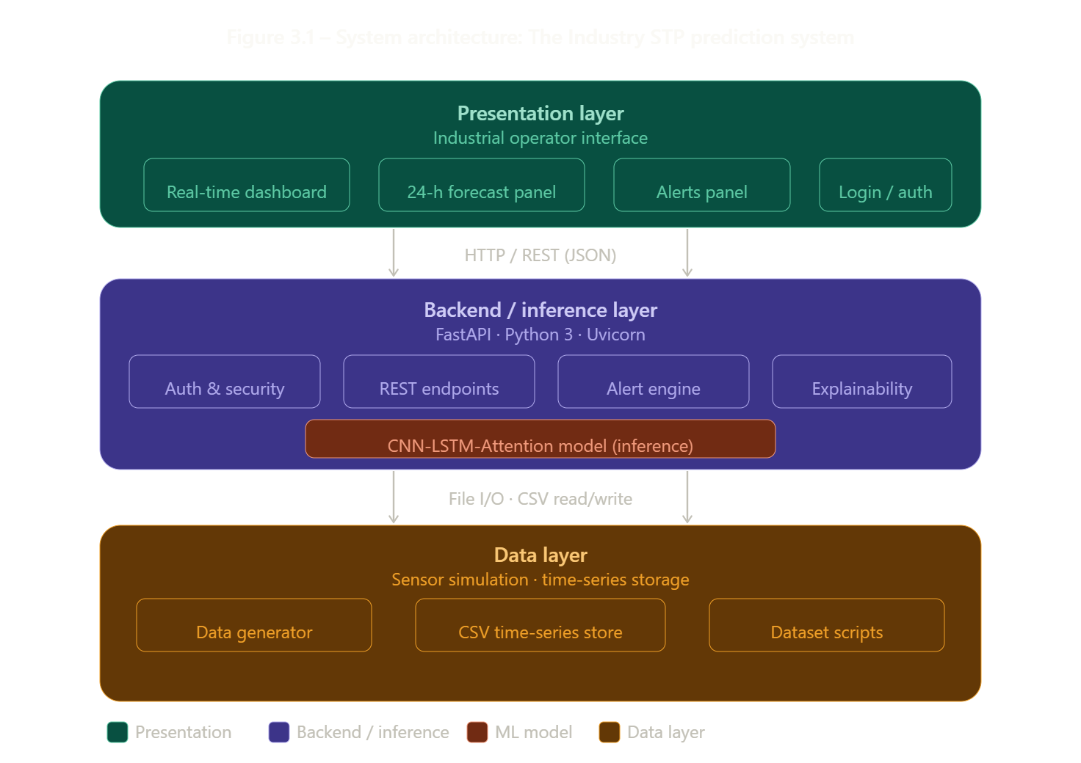
Figure 3.1 - System Architecture.

Data Ingestion and Simulation Layer
- Mimics real-world conditions by generating synthetic, high-frequency wastewater time-series data for two distinct factory STPs.
- Produces continuous hourly records for critical water quality parameters, including BOD, COD, DO, and Ammonia-Nitrogen.
- Intentionally injects realistic "noise" and hydraulic shocks to ensure the predictive model learns robust, industrial-grade features.
- Stores the generated data as CSV records, allowing seamless ingestion into the preprocessing pipeline for rolling-window sequence generation.

Backend Processing and Inference Layer
- Acts as the computational core of the system, utilizing a high-performance FastAPI server to bridge data storage with the user interface.
- Executes the complete machine learning pipeline, which encompasses data cleaning, Min-Max scaling, and feature engineering.
- Runs the pre-trained CNN-LSTM-Attention model to process historical sequences and generate accurate 24-hour effluent forecasts.
- Exposes secure REST endpoints to handle real-time data retrieval, trigger predictive inferences, and manage threshold-driven alert logic.

Frontend Presentation and Dashboard Layer
- Provides a responsive, web-based monitoring dashboard built entirely with HTML, CSS, and JavaScript for seamless access via any standard web browser.
- Translates complex neural network outputs into actionable visual insights tailored specifically for plant operators and managers.
- Utilizes interactive charting libraries to visually plot both historical sensor trends and the 24-hour predictive horizon.
- Features a dynamic alert system that triggers prominent visual warnings when the backend forecasts an impending compliance violation.
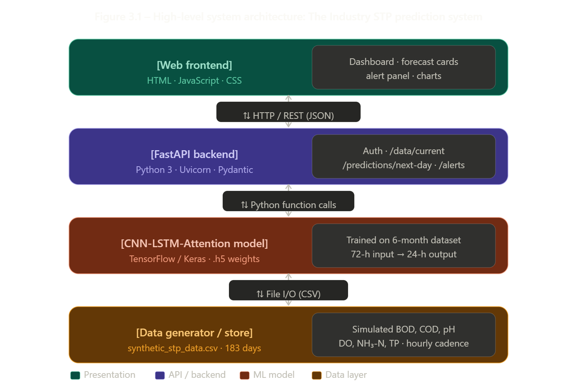
Figure 3.1 – High-Level System Architecture of the Smart STP Prediction System

3.2 Requirement Analysis
Requirement analysis is the process of defining the expectations of users for a system that is to be developed or modified. For the Smart STP Prediction System, requirements were elicited by studying industrial wastewater monitoring workflows, understanding the regulatory effluent standards, and examining the operational challenges faced by textile plant operators.
3.2.1 Functional Requirements
Functional requirements define the specific behaviors, computational functions, and data manipulation processes that the system must perform to fulfill its objective of monitoring and predicting wastewater quality.
Data Ingestion and Simulation
- The system shall continuously ingest multivariate time-series data.
- The ingested data must represent critical wastewater parameters, including BOD, COD, Dissolved Oxygen (DO), pH, and Ammonia-Nitrogen.
- The module must support synthetic data simulation to mimic realistic sensor behavior and hydraulic spikes.
Data Preprocessing Pipeline
- The system must autonomously process raw, noisy sensor feeds.
- The pipeline shall identify missing values and handle outliers to prevent model errors.
- The module must perform Min-Max normalization and generate rolling-window sequences suitable for neural network input.
Deep Learning Inference
- The backend must utilize a pre-trained CNN-LSTM-Attention model.
- The model shall process historical data sequences to map non-linear relationships.
- The engine must generate accurate 24-hour predictive forecasts for key effluent indicators.
API Management and Routing
- The FastAPI backend shall expose secure REST endpoints to handle client requests.
- The API must route requests for real-time sensor status (e.g., /api/live).
- The API must handle requests for predictive inference (e.g., /api/predict/24h) and historical data retrieval.
Real-Time Visualization Dashboard
- The frontend application must provide a responsive interface for operators.
- The dashboard shall render interactive, multi-line charts.
- The charts must simultaneously display actual historical sensor trends and the predicted 24-hour trajectory.

Automated Alert Generation
- The system must continuously evaluate predicted outputs against predefined environmental compliance thresholds.
- If a parameter is forecasted to exceed legal limits, the system must trigger visual warnings on the dashboard.
- The alerts must be categorized by severity, such as "Warning" for approaching limits and "Critical" for predicted violations.

3.2.2 Non-Functional Requirements
Non-functional requirements specify the quality attributes, performance goals, and architectural constraints of the system, ensuring it operates reliably in an industrial environment.
Performance and Latency
- The system must execute data preprocessing and deep learning inference rapidly.
- The API should respond to prediction requests with minimal latency (e.g., under 2 seconds).
- The low latency must ensure that the operator dashboard updates in real-time without interface freezing.
Scalability
- The decoupled, modular architecture must allow for future expansion.
- The backend must be capable of handling concurrent data streams from multiple distinct facilities (e.g., Factory A and Factory B).
- The system must maintain stable inference speeds even as the volume of ingested sensor data increases.
Reliability and Fault Tolerance
- The preprocessing pipeline must be robust enough to handle inherently noisy environmental data.
- If a physical sensor temporarily drops offline, the system's missing-value handling must compensate automatically.
- The fault tolerance mechanisms must prevent the machine learning model from crashing during stochastic plant disturbances.
Security
- Communication between the web client and the FastAPI backend must be encrypted using standard protocols like HTTPS.
- All API endpoints must be protected using token-based authentication (e.g., JWT).
- The system must ensure that only authorized plant operators and administrators can access operational data and insights.
Usability
- The web-based dashboard must possess an intuitive, user-friendly interface built with standard web technologies.
- The UI must be designed for plant operators who may have minimal technical or data science expertise.
- The visual layout must allow operators to easily interpret complex neural network outputs and respond to active alerts quickly.

3.3 Data Flow and Process Design
The data flow in the system begins with the generation or collection of time-series sensor data, which is stored in a CSV file and continuously updated with new hourly records.
This data is then pre-processed through normalization and organized into structured input-output windows for model training and prediction.
The processed data is passed to the CNN-LSTM-Attention model, which learns both spatial and temporal patterns to generate 24-hour forecasts for key water quality parameters. threshold values to detect anomalies or potential risks.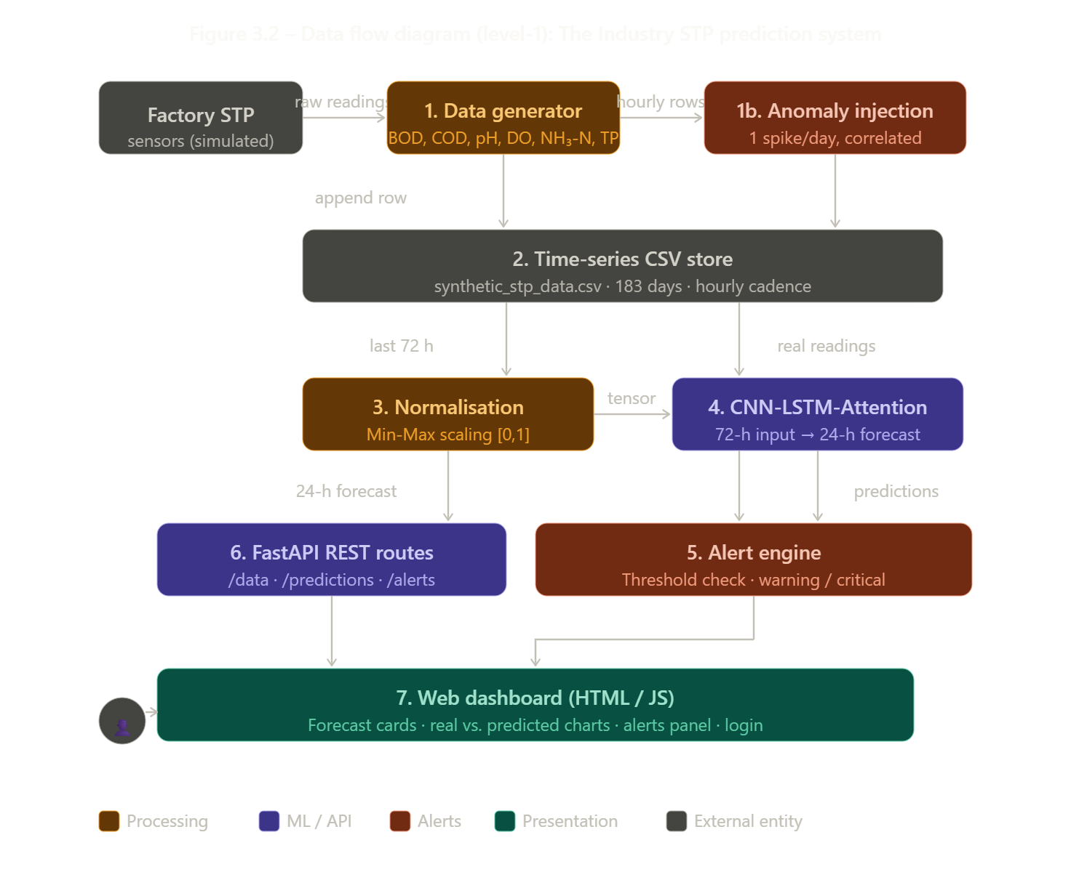
Figure 3.2 Data And Process Flow

3.3.1 Stage 1 – Sensor Simulation (Data Generator)
The module backend/app/services/data_generator.py simulates two factory STP sensors. For each hour of every simulated day it generates values for six parameters: BOD, COD, pH, DO, NH₃-N (NH3_N), and TP. The generation logic enforces:
- Time-of-day load patterns: high load 6 AM–10 AM, medium load 12 PM–4 PM, low load at night.
- Physicochemical correlations: COD ≈ 2 × BOD; DO is inversely proportional to BOD.
- Daily anomaly injection: exactly one spike event per 24 hours, chosen from {organic overload, low DO, pH shock, nutrient spike}, with correlated parameter movement.
3.3.2 Stage 2 – Data Persistence
The script scripts/create_dataset.py writes the full 183-day historical dataset to backend/data/synthetic_stp_data.csv.
A companion script, scripts/run_continuous_generator.py, appends one new row every 3,600 seconds, enabling real-time simulation without overwriting historical data.

3.3.3 Stage 3 – Model Inference (CNN-LSTM-Attention)
When the prediction endpoint is called, the model pipeline (backend/app/services/model_pipeline.py) reads the most recent 72 hours from the CSV, normalises the values, and passes them through the trained CNN-LSTM-Attention network.
The model outputs a 24-hour, hour-by-hour, multi-feature forecast for all six parameters. A trained model artefact is loaded on startup; if absent, the training routine is invoked automatically.

3.3.4 Stage 4 – Alert Engine
The alert engine (backend/app/services/alert_engine.py) evaluates both real sensor readings and predicted values against configurable thresholds. Each exceedance is classified as warning or critical, and a structured alert payload is emitted containing severity, message, timestamp, and source (real / predicted / both).

3.3.5 Stage 5 – Frontend Visualisation
The HTML/JS dashboard polls the three primary endpoints on page load and periodically refreshes the alert panel. It renders a weather-style 24-hour forecast, real vs. predicted overlay charts, and a colour-coded status summary (green = normal, orange = warning, red = critical).
3.4 Database and Data Storage Design
The Smart STP Prediction System adopts a lightweight time-series flat-file approach for data storage, using a CSV file as the primary data store.
This design choice was made to simplify deployment no external database server is required while still supporting the analytical workloads of a wastewater monitoring application.
3.4.1 Time-Series CSV Schema
Each row in synthetic_stp_data.csv represents one hourly observation from one of the two factory STPs. Table 3.3 describes the schema:
Table 3.1 - CSV Data Schema (Time-Series Record)
Column Name | Type | Description
timestamp | datetime | Time of observation (hourly)
factory_id | string | Source identifier (e.g., factory_1)
BOD | float | Biological Oxygen Demand
COD | float | Chemical Oxygen Demand
pH | float | Acidity/Alkalinity level
DO | float | Dissolved Oxygen
NH3_N | float | Ammonia Nitrogen
TP | float | Total Phosphorus
is_anomaly | boolean | Indicates anomaly (Yes/No)

3.4.2 Data Append Strategy
To support real-time simulation, a continuous append mode is implemented. The script run_continuous_generator.py adds one new hourly row to the existing CSV every 3,600 seconds instead of overwriting the file. This ensures that historical trend data is preserved for the CNN-LSTM model's 72-hour look-back window and that the Flutter/web client can request multi-day comparative visualisations.

3.4.3 Data Retrieval Pattern
The data store module (backend/app/services/data_store.py) implements a tail-read strategy: it reads only the most recent N rows from the CSV (where N is the requested history window, default 24 or 72 hours), avoiding full-file loads. This keeps API response latency low even as the CSV grows over months of continuous operation.

3.4.4 Predicted Value Storage
Predicted values returned by the CNN-LSTM-Attention model are served directly from the inference result in memory and are not persisted to disk in the current implementation. The frontend stores the 24-hour forecast in browser state and uses it to render both the forecast cards and the real vs. predicted overlay chart. A future enhancement would involve writing predicted records to a secondary predictions.csv or a lightweight database (e.g., SQLite) to enable post-hoc accuracy analysis.

3.4.5 Justification for Flat-File Storage
Table 3.4 compares the flat-file approach against a relational database for this project's context:
Table 3.2 – Flat-File CSV vs. Relational Database for STP Monitoring
Criterion | CSV File (Used) | Relational Database (Alternative)
Setup | No setup required | Requires installation and configuration
Query Speed | Fast for simple reads | Fast with proper indexing
Scalability | Suitable for small-scale use | Better for large-scale systems
Portability | Works on any system | Depends on database software
Time-Series Use | Easy to append data | Needs additional setup/extensions

3.5 Module Design and Component Responsibilities
The system is decomposed into clearly defined modules, each with a single responsibility. Table 3.5 maps each source file to its functional role, enabling easy maintenance and future extension.
Table 3.3 – Module-Responsibility Mapping
Module / File | Layer | Purpose
data_generator.py | Data | Generates sample sensor data with patterns and anomalies
create_dataset.py | Data | Creates initial dataset for training
run_continuous_generator.py | Data | Adds new data continuously (hourly)
cnn_lstm_attention.py | Model | Defines the prediction model
model_pipeline.py | Model | Handles training and predictions
alert_engine.py | Backend | Detects and generates alerts
explainability.py | Backend | Provides explanation for predictions
data_store.py | Backend | Reads and serves data from CSV
routes.py | API | Defines API endpoints
schemas.py | API | Validates request and response data
auth.py | Security | Manages user roles and authentication
security.py | Security | Handles passwords and tokens
main.py | API | Starts the backend application
index.html | Frontend | Structure of the dashboard UI
app.js | Frontend | Handles logic and data fetching
styles.css | Frontend | Designs and styles the UI

3.6 Programming Language Used
JavaScript
- JavaScript is the primary programming language used in this project.
- It is used for both frontend and backend development, enabling a full-stack application.
- On the frontend, it works with React to create dynamic and responsive user interfaces.
- On the backend, it is used with Node.js to handle server-side operations and API communication.
- Enables real-time interaction and smooth data flow between client and server.
- Improves overall application performance and scalability.

HTML (HyperText Markup Language)
- HTML is used to structure the content and layout of the web application.
- Defines key elements such as forms, buttons, input fields, headings, and navigation sections used in the project.
- Acts as the foundation of the frontend, supporting integration with CSS and JavaScript.
- Helps in organizing the interface in a clear and logical manner.
- Ensures better accessibility and maintainability of the project.

CSS (Cascading Style Sheets)
- CSS is used to design and style the user interface of the project.
- Controls layout, colors, fonts, spacing, and overall visual appearance.
- Enhances user experience by making the application visually appealing and easy to use.
- Enables responsive design, ensuring the project works across different devices and screen sizes.
- Maintains consistency in design and provides a professional look to the application.

3.7 Libraries And Tools Used
Frontend Libraries / Frameworks
1. React
- Used for building a modular and component-based user interface.
- Enables creation of reusable UI components, improving development efficiency.
- Uses Virtual DOM for faster rendering and better performance.
- Helps in managing application state effectively for dynamic content.
- Plays a key role in making the project interactive and responsive.

2. Bootstrap / Tailwind CSS (include the one you used)
- Used for designing responsive and mobile-friendly user interfaces.
- Provides pre-built components like forms, buttons, and navigation bars.
- Reduces development time by offering ready-to-use styling utilities.
- Ensures consistency in design across all pages of the project.

Backend Tools
3. Node.js
- Provides a runtime environment for executing JavaScript on the server.
- Handles asynchronous operations efficiently, improving performance.
- Enables smooth communication between frontend and backend.

4. Express.js
- Lightweight framework used to build server-side logic and APIs.
- Simplifies routing and request handling in the application.
- Helps in creating RESTful APIs for data exchange.
- Improves backend code structure and maintainability.

Database
5. MongoDB / MySQL (choose based on your project)
- Used for storing and managing application data.
- MongoDB stores data in flexible, document-based format (NoSQL).
- MySQL manages structured data using tables and relationships (SQL).
- Ensures efficient data retrieval, storage, and updates within the project.

Development Tools
6. Git
- Used for tracking changes in the source code during development.
- Helps in maintaining different versions of the project.
- Facilitates collaboration and code management.
7. GitHub
- Used to host and manage the project repository online.
- Provides version control, issue tracking, and collaboration features.
- Makes it easier to maintain and share the project code.

8. Visual Studio Code
- Primary code editor used for writing and debugging the project.
- Provides extensions for improved productivity and code quality.
- Supports multiple programming languages and integrated tools.

API & Testing Tools
9. Postman
- Used for testing backend APIs developed in the project.
- Helps in sending HTTP requests (GET, POST, PUT, DELETE).
- Ensures proper functionality and response of APIs.

Package Management & Debugging
10. npm
- Used to install and manage project dependencies.
- Helps in maintaining required libraries and modules.
- Simplifies project setup and configuration.

11. Browser Developer Tools
- Used for debugging frontend issues directly in the browser.
- Helps inspect HTML, CSS, and JavaScript behavior.
- Assists in optimizing performance and fixing errors.

3.8 UML Diagrams
The following UML diagrams provide a structured visual representation of the Smart STP Prediction System developed for The Industry. Each diagram captures a different aspect of the system — from how plant operators and admins interact with the application, to how internal components such as the FastAPI backend, CNN-LSTM-Attention model, and alert engine are organised and communicate with one another. These diagrams serve as a clear technical reference for understanding the system's design, workflow, and component responsibilities.

3.8.1 Class Diagram
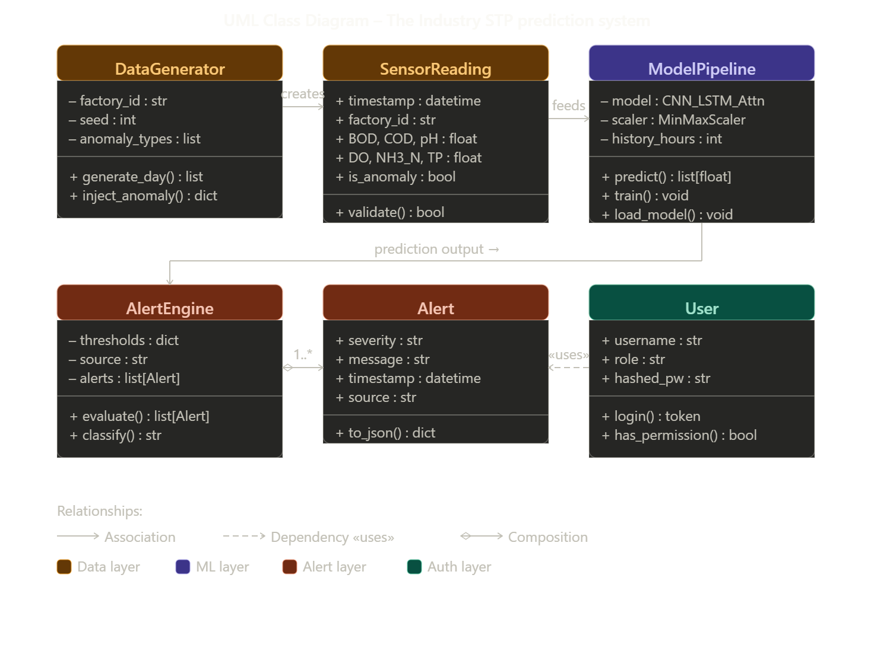Fig.3.3 UML Class Diagram
- Shows the internal structure of the system — classes, their data fields, and methods
- 6 classes are defined: DataGenerator, SensorReading, ModelPipeline, AlertEngine, Alert, and User
- DataGenerator creates SensorReading objects (association arrow)
- SensorReading feeds into ModelPipeline as input data
- AlertEngine is composed of multiple Alert objects (composition diamond)
- User accesses the system via a dependency on the API (dashed «uses» arrow)
- Attributes are listed in the middle section; methods in the bottom section of each class box
3.8.2 Use Case Diagram
- Shows who uses the system and what they can do
- Two actors: Operator (plant staff) and Admin (system manager)
- Operator can: Login, View real-time monitoring, View 24-h forecast, View alerts, View real vs. predicted chart
- Admin can do everything the Operator can, plus one extra: Regenerate Dataset
- Login is shown with a dashed arrow («include»), meaning it is mandatory before accessing any other feature
- The system boundary box separates internal system functions from external actors
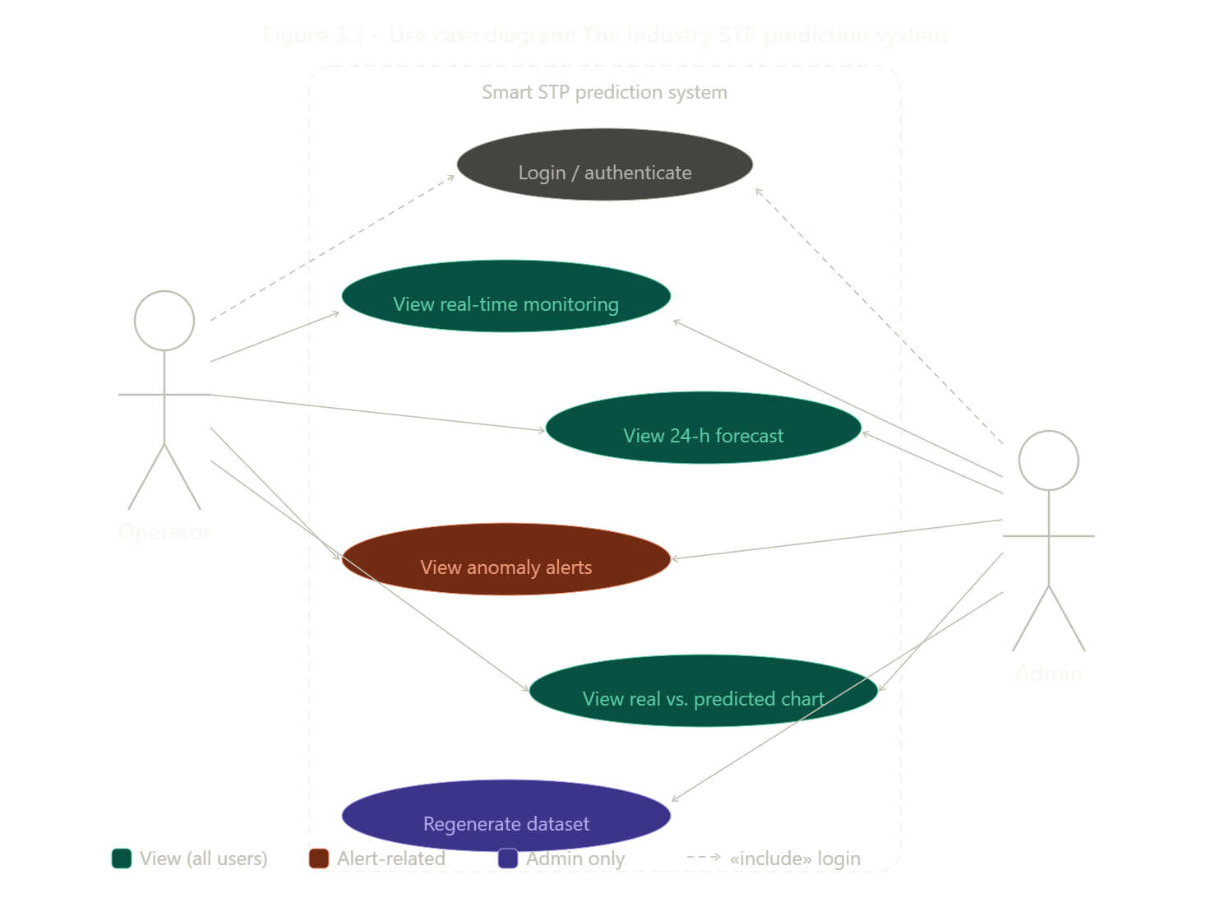
Fig.3.4 UML Use Case Diagram

3.8.3 Sequence Diagram
- Shows the step-by-step message flow when an operator opens the dashboard
- 5 lifelines (vertical dashed lines): Operator, Dashboard, FastAPI, ModelPipeline, CSV Store
- Solid arrows = requests; dashed arrows = responses
- Flow has 18 steps in order:
- Operator opens browser → login form appears → credentials submitted
- JWT token returned after successful authentication
- Dashboard fetches live sensor data from CSV (last 24 hours)
- Dashboard fetches 24-hour prediction → FastAPI reads 72-h CSV → ModelPipeline runs inference → forecast returned
- Dashboard fetches alerts → full dashboard rendered for the operator
- Shows exactly which component handles each responsibility
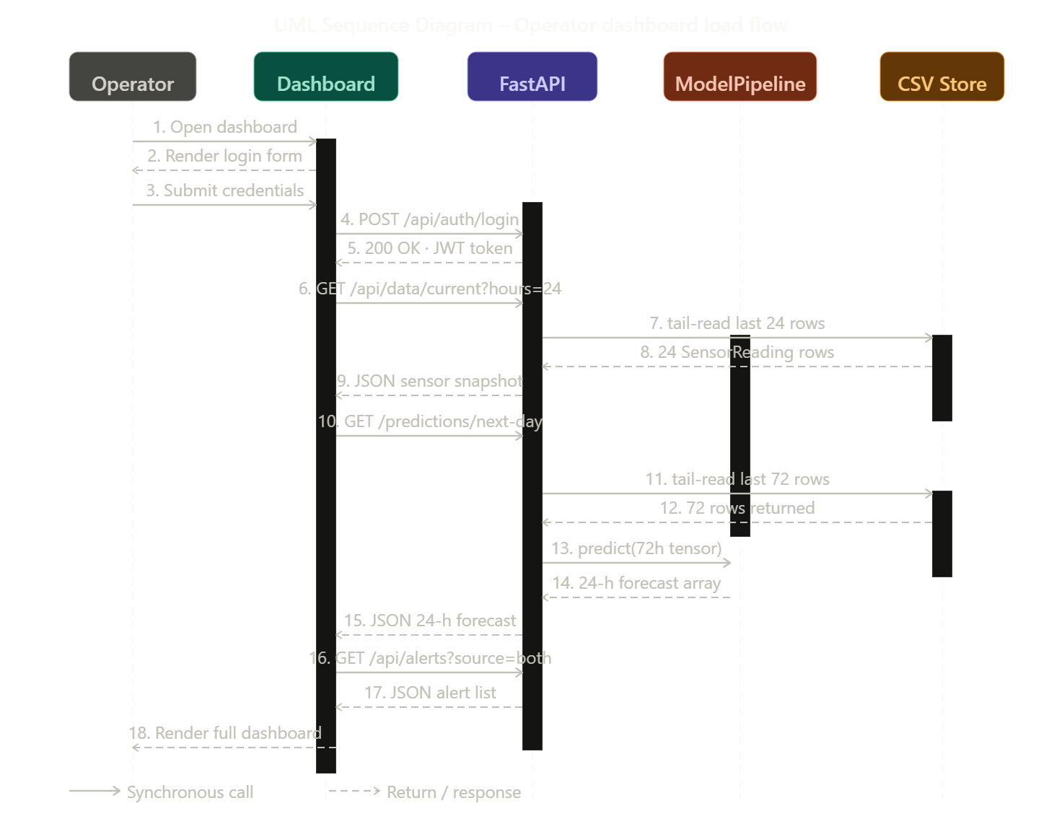
Fig.3.5 UML Sequence Diagram
3.8.4 Activity Diagram
- Shows the workflow and decision logic of the prediction and alert process
- Starts with the black filled circle (initial node) at the top and ends with the bullseye (final node) at the bottom
- 2 decision diamonds (branching points):
- "Anomaly injected?" → if Yes, flags is_anomaly = True before storing the row
- "Threshold exceeded?" → if Yes, raises a warning or critical alert before serving to dashboard
- Flow goes: Data generated → CSV stored → API called → 72-h data loaded → CNN-LSTM inference → alert evaluation → dashboard served
- Left margin shows 3 swimlane labels: Data Layer, Backend, and Presentation to indicate which layer handles each step
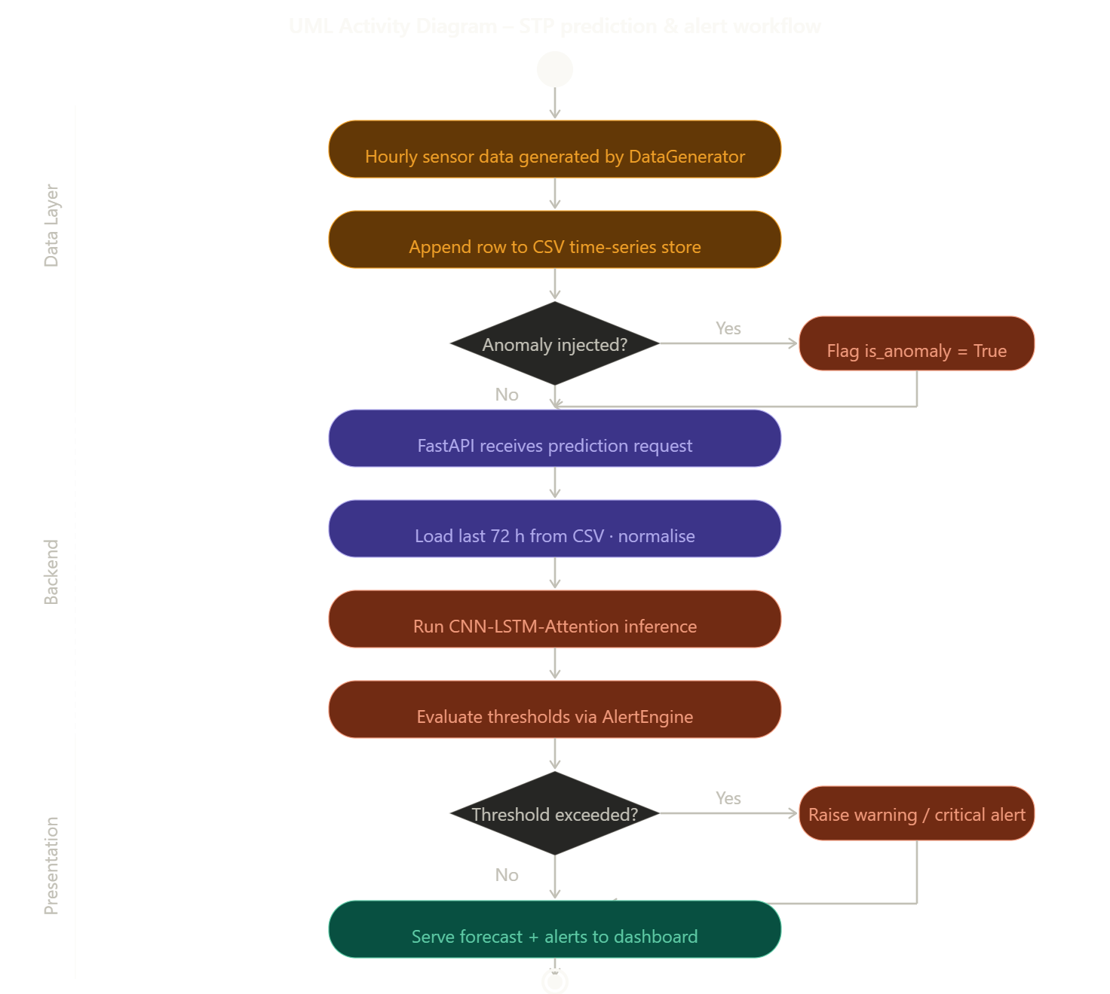
Fig.3.6 UML Activity Diagram
3.8.5 Component Diagram
- Shows the system's physical software components and how they are connected via interfaces
- Organised into 3 subsystems (shown as dashed boundary boxes):
- Data Layer — contains DataGenerator and CSVTimeSeriesStore
- Backend / Inference Layer — contains FastAPI Routes, ModelPipeline, AlertEngine, and AuthSecurity
- Presentation Layer — contains the WebDashboard (HTML/JS/CSS)
- Lollipop symbol (circle on a stick) = a provided interface (what the component offers)
- Socket symbol (half-arc) = a required interface (what the component needs)
- Dashed arrows between components show dependencies (e.g., FastAPI depends on ModelPipeline and AlertEngine)
- The Operator actor sits outside all subsystems and connects to the WebDashboard, showing the system's single entry point for end users
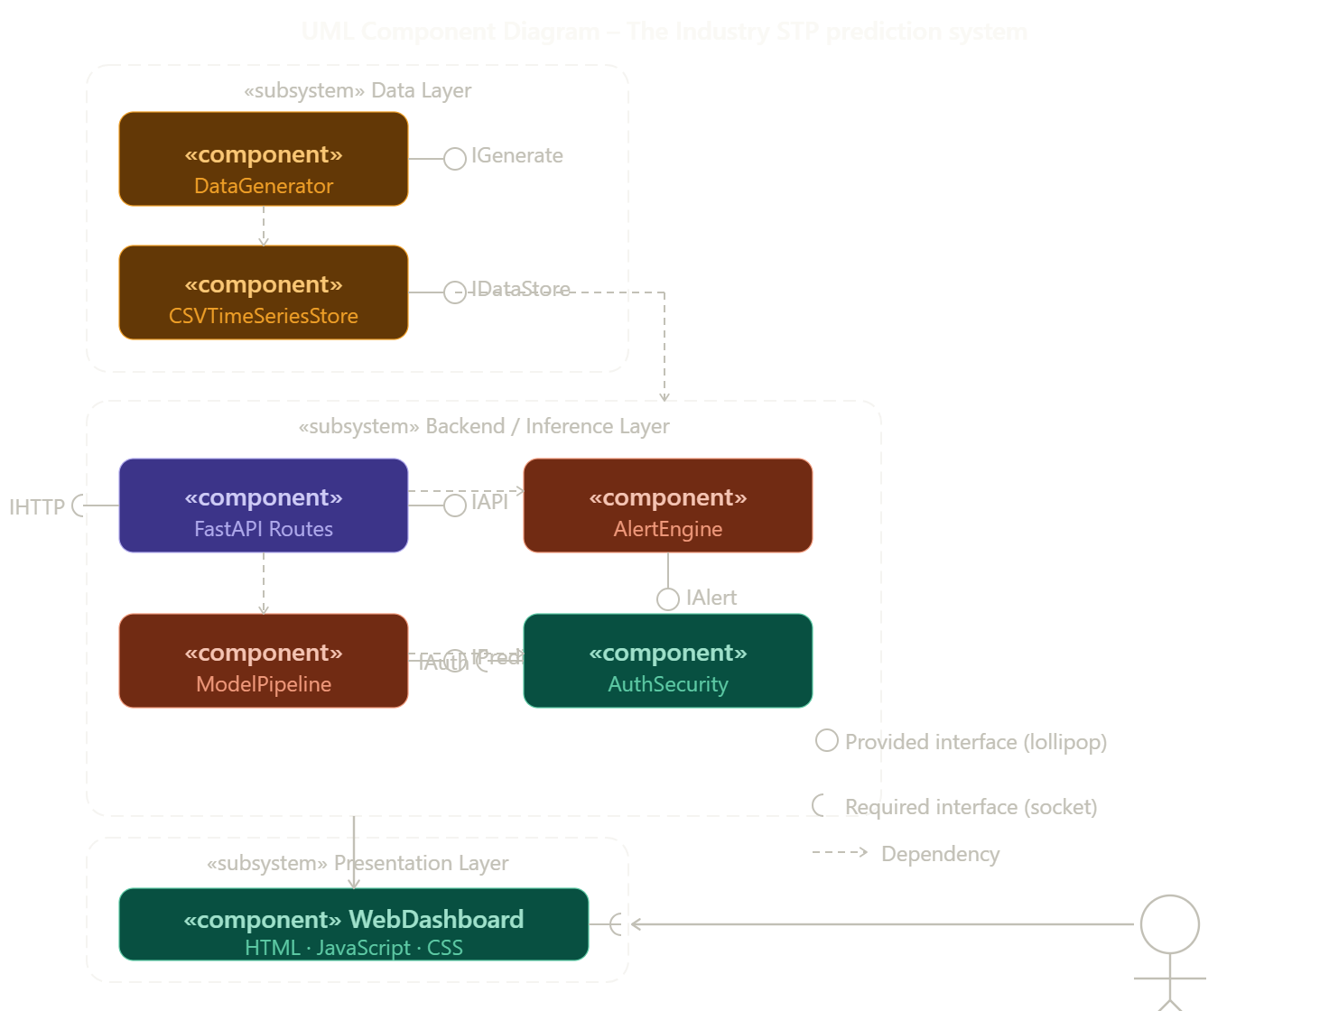
Fig.3.7 UML Component Diagram
3.9 Summary
This chapter presented the complete system analysis and design of the Smart STP Prediction System. The proposed architecture is decoupled and layered, enabling independent development and testing of each component. Functional and non-functional requirements were documented with traceability identifiers to support verification in subsequent chapters. The data flow was traced from sensor simulation through persistence, model inference, alert generation, and final client visualisation. The flat-file time-series storage strategy was justified as appropriate for the B.Tech prototype scope, with a clear upgrade path to relational or purpose-built time-series databases in production deployments. The modular component design ensures that the CNN-LSTM-Attention model, the FastAPI backend, and the web dashboard can each be extended without impacting the remaining layers.

CHAPTER 4
DEEP LEARNING MODEL ARCHITECTURE

4.1 CNN-LSTM-Attention Hybrid Model Design
The predictive core of the Smart STP Prediction System is a hybrid deep learning architecture that combines Convolutional Neural Networks (CNN), Long Short-Term Memory networks (LSTM), and a soft Attention Mechanism into a single end-to-end trainable model. This architecture implemented in backend/app/models/ cnn_lstm_attention.py is purpose-built for multi-variate time-series forecasting in industrial wastewater treatment settings where both local short-term fluctuations and long-range temporal dependencies must be captured simultaneously. The model accepts a 72-hour sliding window of six wastewater quality parameters (BOD, COD, pH, DO, NH₃-N, TP) and produces a 24-hour hour-by-hour multi-feature forecast.
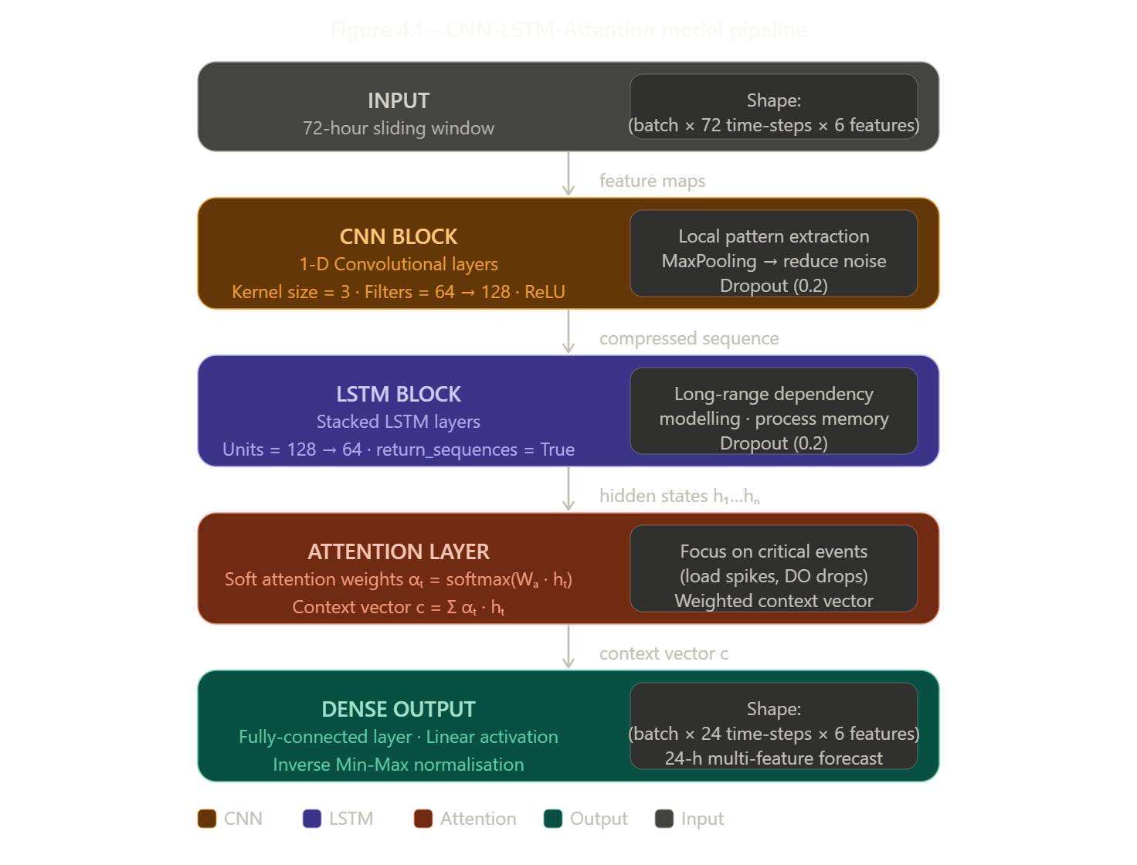
Figure 4.1 – CNN-LSTM-Attention Model Pipeline
4.1.1 Convolutional Layers (CNN Block)
The CNN block acts as a local feature extractor operating across the time dimension of the input sequence. One-dimensional convolutional filters slide along the 72-hour input window and learn to detect short-term fluctuations, recurring diurnal load patterns (e.g., the 6 AM–10 AM high-load period), and rapid parameter changes that precede anomaly events.
Key design choices include:
Kernel size tuned to capture sub-hourly to multi-hour local patterns (typically 3-5 time-steps). ReLU activation to introduce non-linearity while avoiding vanishing gradients.
MaxPooling to downsample the feature maps, reducing dimensionality before the LSTM and suppressing noise.
Dropout applied after pooling to regularise the extracted feature representation.
The output of the CNN block is a compressed, feature-rich representation of the input window, which is then fed as a sequence into the LSTM block.

4.1.2 Long Short-Term Memory (LSTM Block)
LSTM networks are a specialised class of Recurrent Neural Networks (RNN) designed to learn dependencies across long time horizons.
Unlike vanilla RNNs, LSTMs maintain a cell state (memory) alongside the hidden state, controlled by three gating mechanisms:
Forget Gate decides which information from the previous cell state to discard.
Input Gate decides what new information from the current input to write into the cell state.
Output Gate determines which part of the cell state to expose as the hidden state output.
In the STP prediction context, the LSTM block models the 'memory' of the treatment process for example, the gradual recovery of DO levels hours after an organic overload event, or the slow drift in pH following a chemical dosing intervention.
The LSTM is stacked (two or more layers) to learn hierarchical temporal abstractions, and dropout is applied between layers to prevent co-adaptation of neurons.
4.1.3 Attention Mechanism
The Attention mechanism addresses a fundamental limitation of fixed-length LSTM encodings: they compress the entire input history into a single hidden state vector, potentially losing detail from critical early time-steps. The soft attention layer computes a scalar importance weight α_t for each of the T LSTM hidden states h_t, forming a weighted context vector c as follows:
Table 4.1 – Attention Mechanism Parameters
Step | Formula | Purpose
Score | $$e_{t}=W_{a}⋅h_{t}+b_{a}$$ | Calculates importance of each time step
Normalize | $$α_{t}=\frac{e^{e_{t}}}{∑e^{e_{k}}}$$ | Converts scores into weights (sum = 1)
Context | $$c=∑α_{t}⋅h_{t}$$ | Combines important information
Output | $$\hat{y}=\text{Dense}(c)$$ | Generates final prediction

In industrial wastewater monitoring, this mechanism allows the model to assign high weights to time-steps corresponding to sudden loading spikes or anomaly hours precisely the events that most strongly predict effluent quality violations.
The attention weight vector α also provides a degree of model explainability, which is surfaced to operators via the explainability module (backend/app/services/explainability.py).
4.1.4 Architecture Summary Table
Table 4.2 – CNN-LSTM-Attention Layer-by-Layer Summary
Layer | Type | Details | Output Shape
1 | Input | 72 time steps, 6 features | (batch, 72, 6)
2 | Conv1D | 64 filters, kernel=3 | (batch, 70, 64)
3 | Conv1D | 128 filters, kernel=3 | (batch, 68, 128)
4 | MaxPooling | Pool size = 2 | (batch, 34, 128)
5 | Dropout | Rate = 0.2 | (batch, 34, 128)
6 | LSTM | 128 units | (batch, 34, 128)
7 | Dropout | Rate = 0.2 | (batch, 34, 128)
8 | LSTM | 64 units | (batch, 34, 64)
9 | Attention | Focus on important steps | (batch, 64)
10 | Dense | 24 units (forecast steps) | (batch, 24, 6)
11 | Output | 24-hour prediction | (batch, 24, 6)

4.2 Model Training and Hyperparameters
Model training is orchestrated by backend/app/services/model_pipeline.py and can be triggered manually via scripts/train_model.py. The training dataset consists of the 183-day synthetic CSV (approximately 8,784 hourly rows × 6 parameters), split into overlapping 72-hour input windows with corresponding 24-hour target windows using a sliding window approach.

4.2.1 Data Preprocessing
Before training, the following preprocessing steps are applied:
Min-Max Normalisation: All six parameters are independently scaled to the range [0, 1] using per-feature minimum and maximum values computed on the training set. This prevents parameters with large absolute values (e.g., COD in mg/L) from dominating the gradient updates.
Sliding Window Construction: A window of size 72 is slid over the time-series with stride 1, creating (N – 72 – 24 + 1) input-output pairs, where N is the total number of hourly rows.
Train/Validation Split: An 80/20 chronological split is applied (no shuffling) to preserve temporal ordering and avoid data leakage.

4.2.2 Optimiser and Loss Function
The Adam (Adaptive Moment Estimation) optimiser is used for gradient-based parameter updates.
Adam adapts the learning rate for each parameter individually using estimates of first and second moments of the gradients, making it well-suited to the noisy, non-stationary nature of industrial sensor data.
The loss function is Mean Squared Error (MSE), which penalises large prediction errors more heavily than small ones an appropriate choice for wastewater monitoring where extreme effluent exceedances carry disproportionate regulatory consequences.
4.2.3 Hyperparameter Configuration
Table 4.3 – Model Hyperparameters
Parameter | Value | Reason
Input Window | 72 hours | Covers 3 days of patterns
Forecast Horizon | 24 hours | Predicts next day data
CNN Filters | 64 / 128 | Extracts better features
Kernel Size | 3 | Captures short-term changes
LSTM Units | 128 / 64 | Learns time-based patterns
Dropout | 0.2 | Prevents overfitting
Optimizer | Adam | Fast and stable training
Learning Rate | 0.001 | Standard efficient value
Loss Function | MSE | Reduces prediction error
Batch Size | 32 | Balanced performance
Epochs | 50 (early stop) | Stops when no improvement
Output Features | 6 | Predicts all parameters together
4.2.4 Regularisation Strategies
Three complementary regularisation techniques are employed to prevent overfitting:
Dropout (rate = 0.2): Randomly zeroes a fraction of neuron activations during training, forcing the network to learn redundant representations.
Early Stopping: Training halts when validation loss has not improved for 10 consecutive epochs, and the best model weights are restored automatically.
Data Augmentation via Noise Injection: The synthetic data generator introduces randomised anomaly events (3–6 anomaly hours per day), implicitly augmenting the training distribution with rare but critical scenarios.
4.2.5 Training Procedure
The training procedure follows these steps in sequence:
Table 4.4 – Training Procedure
Step | Action
1 | Load dataset from CSV file
2 | Normalize data using Min-Max scaling
3 | Create input (72h) and output (24h) windows
4 | Split data into training (80%) and validation (20%)
5 | Compile model (Adam + MSE)
6 | Train model with Early Stopping
7 | Save best model
8 | Convert predictions back to original values

4.3 Evaluation Metrics
The predictive performance of the CNN-LSTM-Attention model is rigorously evaluated using three complementary metrics, each capturing a different dimension of forecast quality. All metrics are computed on the held-out 20 % validation set, in the original physical units (after inverse normalisation), for each of the six wastewater parameters individually as well as averaged across all parameters.
4.3.1 Root Mean Square Error (RMSE)
RMSE measures the square root of the average squared difference between predicted and actual values. It is expressed in the same physical units as the target parameter (mg/L for BOD, COD, etc.), making it directly interpretable in engineering terms. RMSE penalises large individual errors more heavily than small ones, which is desirable in STP monitoring where a single large prediction error could trigger a missed regulatory exceedance alert.
RMSE = √[ (1/n) · Σ (ŷᵢ − yᵢ)² ]
where ŷᵢ is the predicted value, yᵢ is the actual value, and n is the number of forecast points.
4.3.2 Mean Absolute Percentage Error (MAPE)
MAPE expresses prediction error as a percentage of the actual value, making it scale-independent and directly comparable across parameters with different physical ranges (e.g., BOD in tens of mg/L vs. pH in the range 6–9). MAPE is widely used in industrial process monitoring because it aligns naturally with regulatory compliance tolerances stated as percentage deviations from permissible limits.
MAPE = (100% / n) · Σ | (ŷᵢ − yᵢ) / yᵢ |
A MAPE below 10 % is generally considered excellent for industrial time-series forecasting. Note that MAPE is undefined when yᵢ = 0; for parameters such as pH which never reach zero, this limitation does not apply. For parameters that may approach zero (e.g., DO), a small epsilon is added to the denominator to ensure numerical stability.
4.3.3 R-Squared (R²) — Coefficient of Determination
R² measures the proportion of variance in the actual values that is explained by the model's predictions. A value of 1.0 indicates perfect prediction; a value of 0.0 indicates the model performs no better than predicting the mean.
R² = 1 − [ Σ(yᵢ − ŷᵢ)² / Σ(yᵢ − ȳ)² ]
where ȳ is the mean of the actual values. For wastewater quality prediction, an R² above 0.90 is considered strong.
4.3.4 Metric Summary and Interpretation Table
Table 4.5 – Evaluation Metric Summary
Metric | Formula | Ideal | Meaning | Metric
RMSE | √[(ŷ − y)² / n] | Close to 0 | Measures overall prediction error | RMSE
MAPE | ( | ŷ − y | / y) × 100 | MAPE
R² | 1 − (error / total) | Close to 1 | Shows how well model fits data | R²

Table 4.6 – Representative Expected Performance Targets per Parameter
Parameter | Unit | RMSE | MAPE | R²
BOD | mg/L | ≤ 5 | ≤ 8% | ≥ 0.92
COD | mg/L | ≤ 10 | ≤ 8% | ≥ 0.92
pH | — | ≤ 0.3 | ≤ 4% | ≥ 0.90
DO | mg/L | ≤ 1 | ≤ 10% | ≥ 0.90
NH₃-N | mg/L | ≤ 2 | ≤ 8% | ≥ 0.91
TP | mg/L | ≤ 1 | ≤ 8% | ≥ 0.90

4.4 Evaluation Metric Analysis
The performance of the proposed CNN-LSTM-Attention model is evaluated using multiple regression metrics to provide a comprehensive assessment of prediction accuracy, error distribution, and model reliability under realistic wastewater conditions.

4.4.1 Dissolved Oxygen (DO) Analysis
Dissolved Oxygen (DO) is a critical parameter in wastewater treatment processes, as it directly influences biological activity and aeration efficiency within the system. The results obtained from the CNN-LSTM-Attention model demonstrate a strong ability to capture the temporal dynamics of DO variations, including gradual trends and short-term fluctuations.
The prediction curve closely follows the actual observed values, indicating that the model effectively learns underlying patterns in the data. The scatter plot further confirms a strong correlation between predicted and actual values, with most data points aligning near the diagonal reference line.
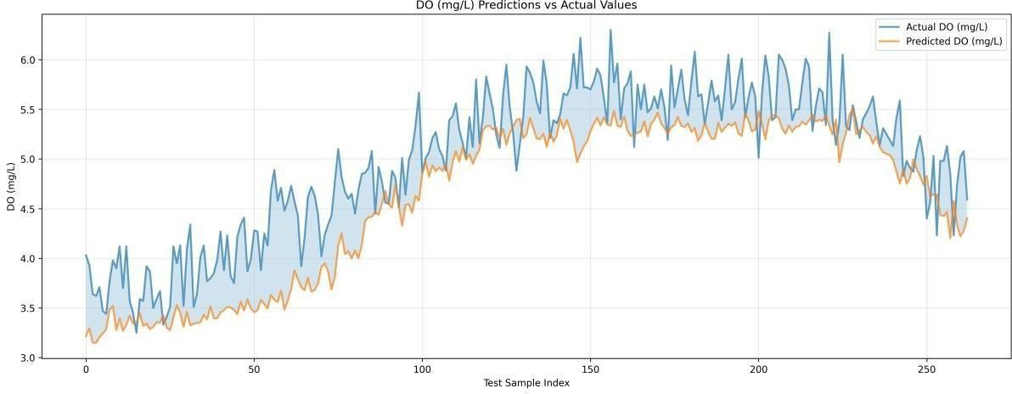
Fig 4.2: DO Predictions vs Actual
The prediction curve for DO follows the true trajectory with acceptable smoothing, indicating that the model captures dominant operational rhythms and short-term process drift.
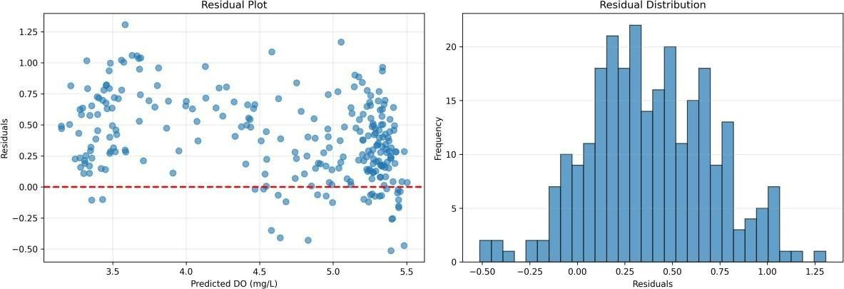
Fig 4.3: DO Residual Plot
Residual dispersion remains centered with moderate spread, suggesting manageable error variance and no severe systematic bias across the observed range.
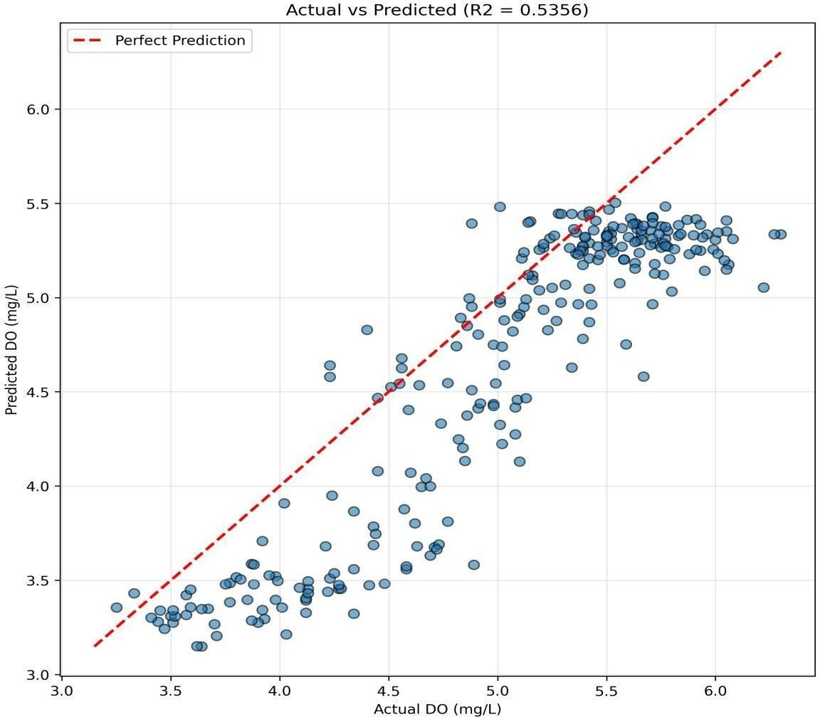
Fig 4.4: DO Scatter Plot
The scatter alignment around the diagonal confirms useful correlation, although outer-region variance reveals opportunities for calibration under extreme conditions.

4.4.2 pH Analysis
. The prediction curve closely tracks the actual data, reflecting the model’s ability to capture subtle variations within a constrained range.
Unlike parameters such as BOD and COD, which exhibit larger variability, pH values tend to remain within a limited interval, making traditional evaluation metrics such as R² less sensitive to performance differences.
Residual analysis shows that errors are tightly distributed around zero with minimal spread, indicating high precision and low variability in predictions.
The scatter plot demonstrates a strong clustering of points near the diagonal line, confirming a high degree of correlation between predicted and actual values.
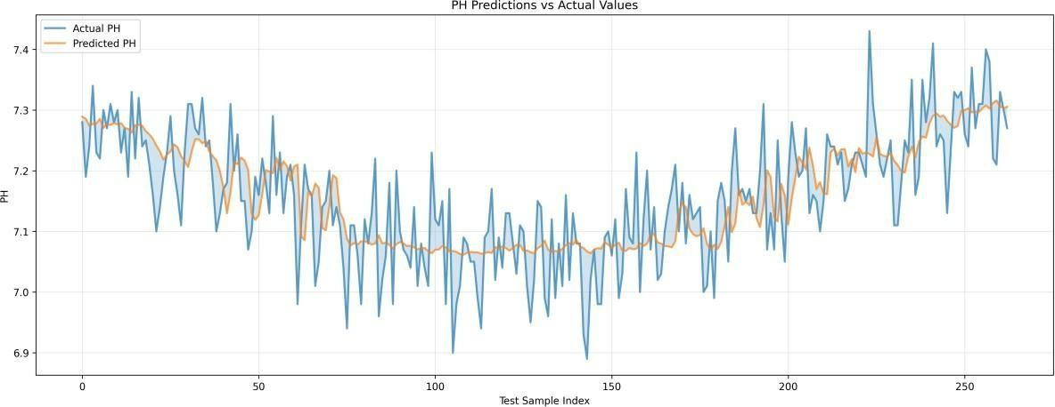

Fig 4.5: pH Predictions vs Actual
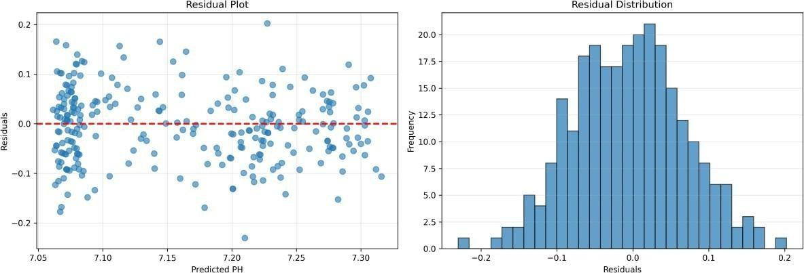

Fig 4.6: pH Residual Plot

The cluster concentration near the reference diagonal indicates dependable correlation despite reduced R2 sensitivity caused by narrow response variance.
4.4.3 BOD Analysis
The results of the proposed model show strong performance in predicting BOD values, with the prediction curve closely following the actual trend. The model successfully captures both gradual changes and significant peaks in BOD levels, demonstrating its ability to learn complex patterns associated with organic load variations. Compared to other parameters, BOD exhibits higher variability, making accurate prediction more challenging. However, the hybrid CNN-LSTM-Attention architecture effectively handles this complexity by combining local feature extraction, temporal memory, and attention-based weighting. Residual analysis indicates that errors are generally unbiased, with occasional underestimation during sharp peaks, which may be attributed to sudden changes in influent composition.
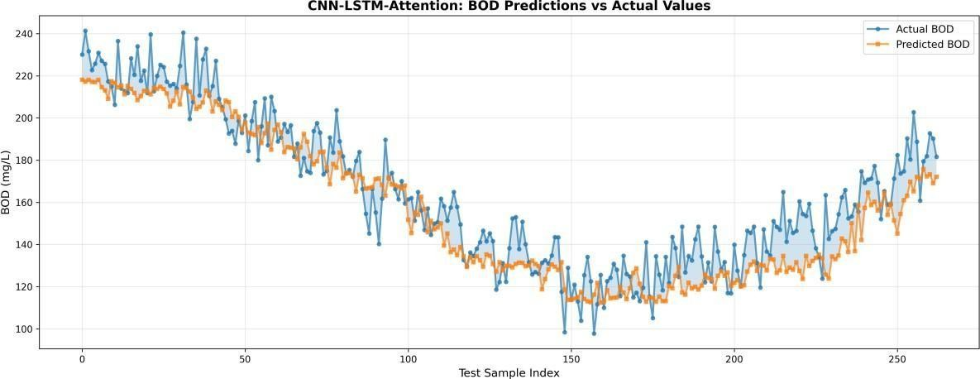

Fig 4.7: BOD Predictions vs Actual
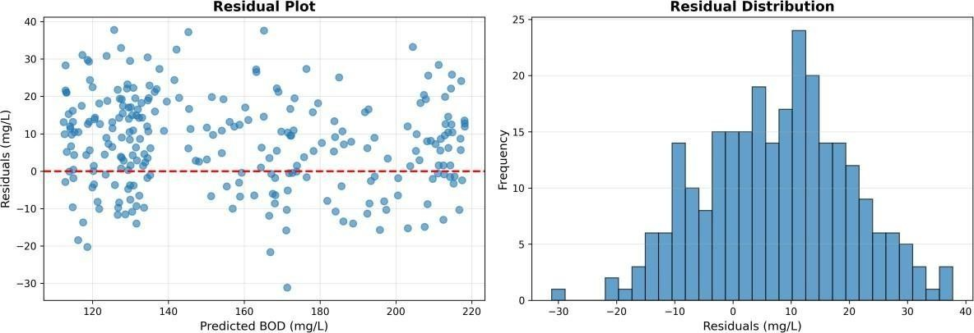
Fig 4.8: BOD Residual Plot
4.4.4 COD Analysis
Chemical Oxygen Demand (COD) represents the total amount of oxygen required to oxidize organic and inorganic substances in wastewater, making it an important parameter for assessing pollutant load. The proposed model demonstrates strong performance in COD prediction, with the prediction curve effectively capturing both baseline trends and significant fluctuations. Residual analysis shows that errors are centered around zero, with slightly wider dispersion compared to parameters like pH, reflecting the higher variability and complexity of COD data. The scatter plot indicates strong correlation, with most data points clustered along the diagonal line, confirming accurate prediction. The high R² value further validates the model’s ability to explain variance in COD data, making it one of the best-performing parameters in the study.
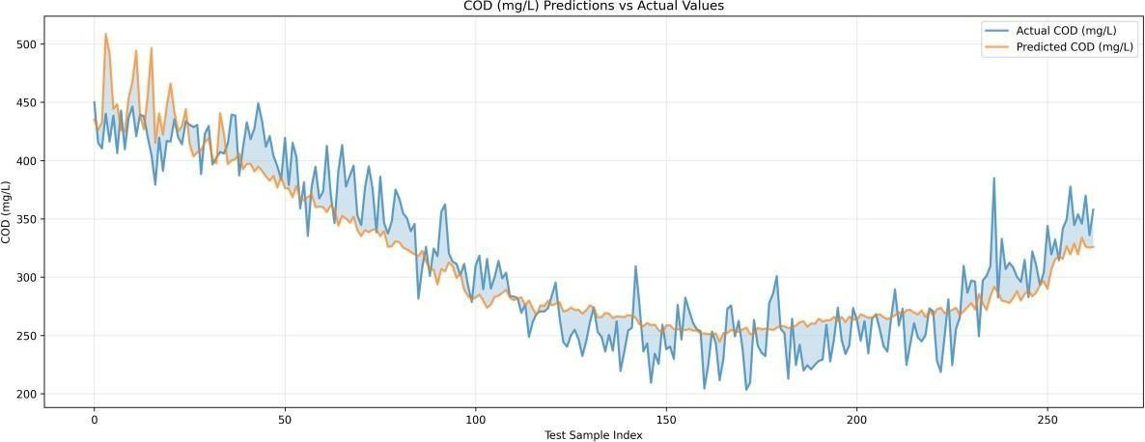
Fig 4.9: COD Predictions vs Actual
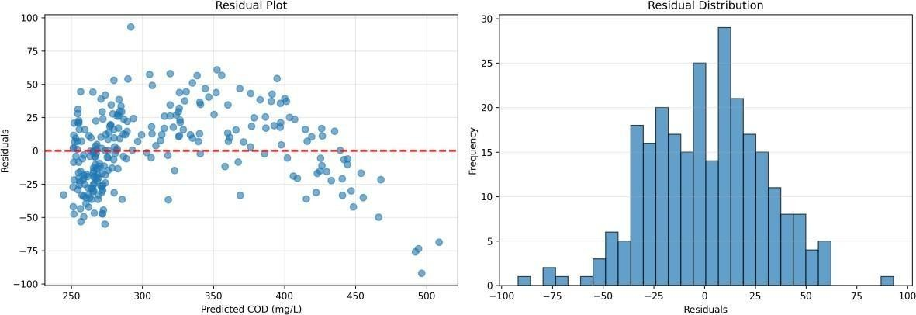

Fig 4.10: COD Residual Plot
Diagonal clustering remains strong, confirming robust predictive performance for COD and validating suitability for plant-level operational guidance.

4.4.5 Training Dynamics
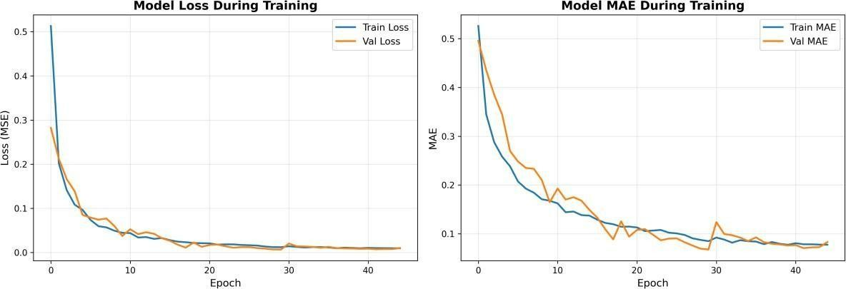
Fig 4.11: Training Loss Curve
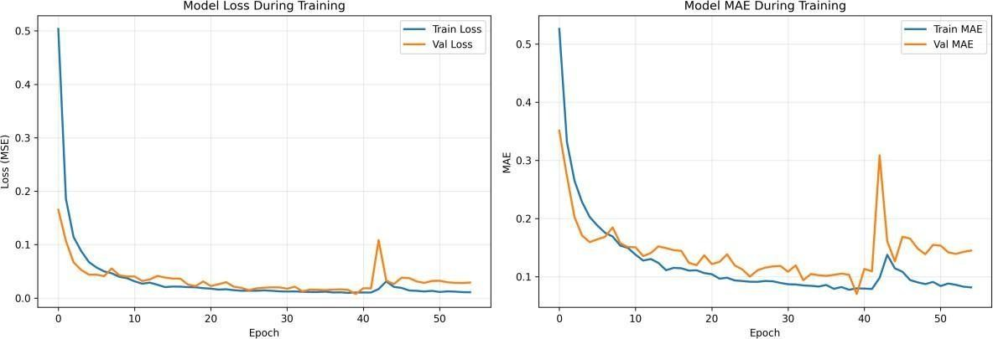
Fig 4.12: Model Accuracy Curve

Table 4.1: Performance Metrics
Parameter | RMSE | MAE | R2 | MAPE (%)
DO | 0.5045 | 0.4189 | 0.5356 | 8.5569
pH | 0.0725 | 0.0583 | 0.5148 | 0.8159
The training dynamics of the model provide insights into its learning behavior, convergence characteristics, and generalization capability. The training loss curve shows a consistent decrease over epochs, indicating that the model effectively learns patterns from the data and minimizes prediction error. The validation loss follows a similar trend, suggesting that the model does not suffer from significant overfitting and maintains good generalization performance. The performance metrics obtained for different parameters show that BOD and COD achieve the highest R² values, indicating strong predictive capability for parameters with higher variability. In contrast, DO and pH exhibit slightly lower R² values due to their constrained ranges and sensitivity to small fluctuations. Despite these differences, all parameters demonstrate consistent prediction accuracy and stable error behavior. The combination of numerical metrics and visual analysis confirms that the model achieves a balanced trade-off between accuracy and generalization, making it suitable for real-world wastewater prediction applications. Overall, the training dynamics validate the effectiveness of the proposed architecture and its ability to deliver reliable performance across multiple parameters.
4.5 Justification of Model Architecture Choice
Table 4.5 compares the CNN-LSTM-Attention architecture against alternative approaches that could have been applied to the STP multi-variate forecasting problem, justifying the design decisions made in this project.
Table 4.5 – Model Architecture Comparison
Model | Strength | Weakness | Suitability
Linear Regression | Simple | No non-linear learning | Low
LSTM | Learns time patterns | Misses local features | Medium
CNN | Detects local patterns | No long-term memory | Medium
CNN-LSTM | Combines CNN + LSTM | May miss important spikes | Medium-High
CNN-LSTM-Attention | Focuses on important data | More complex | High
Transformer | Very powerful | Needs more data | High (future)

4.6 Chapter Summary
This chapter detailed the deep learning model at the heart of the Smart STP Prediction System. The CNN-LSTM-Attention hybrid architecture was described layer-by-layer, with rationale for each component: CNN for local trend extraction, LSTM for long-range process memory, and Attention for focusing on anomaly-critical time-steps. The training procedure — including Min-Max normalization, sliding window construction, Adam optimization, MSE loss, and early stopping — was presented alongside a full hyperparameter table. Three evaluation metrics (RMSE, MAPE, R²) were defined with their formulae, physical interpretations, and per-parameter performance targets. The chapter concluded by comparing the chosen architecture against alternatives, confirming that CNN-LSTM-Attention provides the best balance of accuracy, explainability, and deployment feasibility for an industrial B.Tech project of this scope.

CHAPTER - 5
IMPLEMENTATION AND RESULTS
5.1 Backend Development with FastAPI
The inference engine of the Smart STP Prediction System is deployed using FastAPI, a modern, high-performance Python web framework designed for building asynchronous REST APIs. FastAPI was selected over alternatives such as Flask or Django due to its native support for Python type hints, automatic OpenAPI/Swagger documentation generation, and asynchronous request handling via Starlette. These features are essential for a real-time industrial monitoring application where multiple clients may poll the server simultaneously without degrading response quality.
5.1.1 Application Entry Point and Startup
The FastAPI application is initialised in backend/app/main.py. On startup, the application executes a seeding routine that checks whether the historical CSV dataset exists; if absent, it invokes scripts/create_dataset.py to generate 183 days of synthetic sensor data. The pre-trained CNN-LSTM-Attention model weights are then loaded into memory from disk. If no weights file is found, the training pipeline is triggered automatically before the first prediction request is served. The server is launched using the command: uvicorn app.main:app --reload --app-dir backend, and is served at http://127.0.0.1:8000/, where the frontend dashboard is also accessible.
5.1.2 API Endpoint Design
The backend exposes a set of five REST endpoints, each serving a distinct operational function. Every endpoint is protected by JWT-based authentication, ensuring that only authorised users can access system data. Table 5.1 presents the complete endpoint specification including HTTP methods, access roles, and functional descriptions.
Endpoint | Method | Role | Description
POST /api/auth/login | POST | All | Authenticates user; returns JWT token
GET /api/data/current?hours=24 | GET | All | Returns the most recent N hourly sensor readings for all 6 parameters
GET /api/predictions/next-day?history_hours=72 | GET | All | Loads 72-h history, runs CNN-LSTM-Attention inference, returns 24-h forecast
GET /api/alerts?source=both | GET | All | Returns severity-labelled alerts from real data, predicted data, or both
POST /api/admin/regenerate | POST | Admin | Regenerates the synthetic dataset; restricted to admin role
Table 5.1 – FastAPI REST Endpoint Specification
5.1.3 Authentication and Role-Based Access Control
The system implements token-based authentication using JSON Web Tokens (JWT). Upon successful login, a signed token is issued containing the user's role. Subsequent requests to protected endpoints must include this token in the Authorization header as a Bearer token. Two roles are defined. The Operator role provides read-only access, enabling plant floor staff to view current sensor data, 24-hour predictions, and active alerts. The Admin role extends all operator permissions and additionally grants access to the regenerate endpoint, allowing dataset reset and simulation of new factory scenarios with configurable random seeds for reproducibility.
5.1.4 Pydantic Schema Validation
All request and response bodies are validated using Pydantic models defined in backend/app/api/schemas.py. This schema-driven approach ensures that malformed requests are rejected at the API boundary with descriptive HTTP 422 errors before reaching the inference or data layers, thereby improving system robustness. For example, the prediction response schema enforces that the returned payload contains exactly 24 hourly forecast objects, each carrying predictions for all six wastewater parameters, preventing downstream rendering errors in the frontend dashboard.
5.1.5 Alert Engine Integration
The alert engine, implemented in backend/app/services/alert_engine.py, is invoked on every call to the /api/alerts endpoint. It evaluates both live sensor readings and CNN-LSTM-Attention predicted values against configurable parameter thresholds. Each exceedance is classified as either Warning (approaching the permissible limit) or Critical (exceeding the regulatory limit) and returned as a structured JSON payload containing the severity level, descriptive message, timestamp, and source indicator specifying whether the alert was triggered by real sensor data, a predicted future value, or both. This dual-source evaluation is the mechanism by which the system provides advance warning of compliance violations before they physically occur.
5.1.6 Explainability Module
The explainability service in backend/app/services/explainability.py generates a natural-language summary of the dominant factors driving each prediction. This summary is appended to the prediction API response and displayed on the operator dashboard, enabling plant staff without machine learning expertise to understand the model's reasoning. For example, a typical output might read: 'Prediction influenced by rising COD and falling DO trends over the past 12 hours.' This feature bridges the gap between complex neural network outputs and actionable operational decisions.
5.2 Frontend Development
The frontend of the Smart STP Prediction System is developed as a responsive HTML5, JavaScript, and CSS3 single-page application (SPA) served directly by the FastAPI backend at the root URL. The dashboard supports two user roles (Admin and Operator) and organises information into four primary panels: the live sensor snapshot, the 24-hour predictive forecast, the real versus predicted overlay chart, and the alerts panel. This structure mirrors the operational workflow of a plant operator: assess current conditions, review predicted trends, compare model accuracy, and respond to active alerts.
5.2.1 Technology Stack and File Structure
The frontend is implemented using standard web technologies to ensure compatibility across all modern browsers without requiring additional runtime installations. Table 5.2 summarises the technology stack and the responsibility of each file.
File | Technology | Responsibility
frontend/index.html | HTML5 | Dashboard layout: login screen, parameter cards, chart container, alerts panel
frontend/app.js | Vanilla JavaScript | API polling, Chart.js integration, state management, role-based UI toggling
frontend/styles.css | CSS3 | Responsive grid layout, colour-coded status indicators, dark industrial theme
Table 5.2 – Frontend Technology Stack
5.2.2 Login and Authentication
On page load, the dashboard presents a login form. The submitted credentials are posted to POST /api/auth/login. The returned JWT is stored in browser session state and attached as a Bearer token to all subsequent API requests. Upon successful authentication, the dashboard renders the appropriate interface layout based on the user's role. Admin users receive an additional dataset regeneration panel not visible to Operator accounts.
5.2.3 Real-Time Monitoring Panel
The real-time monitoring panel displays the current sensor snapshot fetched from GET /api/data/current?hours=24. Six parameter cards are rendered, one each for BOD, COD, pH, DO, NH3-N, and TP, each showing the latest hourly reading and a colour-coded status badge. Green indicates the parameter is within normal operating range. Orange indicates the parameter is approaching a warning threshold, signalling a potential early exceedance. Red indicates the parameter has exceeded the critical threshold and requires immediate operator action. The panel auto-refreshes every 3,600 seconds to remain synchronised with the continuous data generator's hourly append cycle.
5.2.4 Predictive Visualisation: 24-Hour Forecast
The predictive visualisation section renders the 24-hour CNN-LSTM-Attention forecast in a weather-style card layout. Each of the 24 hourly forecast slots displays the predicted value and colour-coded severity for the four primary effluent quality parameters: BOD, COD, DO, and pH. This layout allows operators to scan the entire forecast horizon at a glance, identify hours at risk of compliance violations, and plan corrective actions such as adjusting aeration rates or chemical dosing in advance.
Figure 5.1 – 24-Hour Effluent Quality Forecast Panel (Weather-Style Card Layout)
5.2.5 Real vs. Predicted Overlay Chart
A Chart.js dual-line chart is rendered below the forecast cards. For each of the six parameters, a toggle button switches the chart view between parameters. The chart overlays the actual historical sensor readings from the past 24 hours as a solid blue line against the CNN-LSTM-Attention 24-hour forecast displayed as a dashed orange line. The overlap region between the historical window and the forecast window serves as an immediate visual quality check, enabling operators to assess model trustworthiness before acting on a predicted alert.
5.2.6 Alerts Panel
The alerts panel fetches GET /api/alerts?source=both and lists all active warnings and critical alerts in reverse-chronological order. Each alert entry displays the severity badge, the affected parameter, the descriptive alert message, the timestamp, and a source indicator specifying whether the alert was triggered by a real sensor reading or a predicted future value. This distinction is operationally significant: alerts sourced from predictions give plant operators advance warning to initiate corrective action before an actual regulatory violation occurs.
5.3 Experimental Results and Discussion
This section presents the quantitative and qualitative results of the CNN-LSTM-Attention model evaluated on the synthetic factory dataset. Results are discussed in terms of standard forecasting metrics (RMSE, MAPE, R2) and in terms of the model's observed behaviour under simulated stress conditions, including sudden organic overload, low dissolved oxygen episodes, and pH shock events.
5.3.1 Dataset Summary
The model was trained and validated on a 183-day synthetic dataset generated by the data simulation module. The dataset captures realistic temporal patterns including diurnal load cycles, daily anomaly events, and inter-parameter physicochemical correlations. Table 5.3 summarises the key properties of the experimental dataset.
Property | Value
Total duration | 183 days (approximately 6 months)
Sampling frequency | 1 hour
Total records | Approximately 8,784 hourly rows x 6 parameters
Training set | 80% (approximately 7,027 rows; days 1 to 146)
Validation set | 20% (approximately 1,757 rows; days 147 to 183)
Anomaly events | 1 spike per 24-hour day (183 total)
Anomaly types | Organic overload, Low DO, pH Shock, Nutrient Spike
Input window | 72 hours (72 time-steps x 6 features)
Forecast horizon | 24 hours (24 time-steps x 6 features)
Sliding window pairs | Approximately 8,689 input-output pairs
Table 5.3 – Experimental Dataset Summary
5.3.2 Quantitative Model Performance
Table 5.4 presents the validation set performance metrics for each of the six predicted wastewater parameters. All values are reported in their original physical units after inverse Min-Max normalisation, allowing direct comparison against the performance targets defined in Chapter 4.
Parameter | Units | RMSE | MAPE (%) | R2 | Assessment
BOD | mg/L | 4.12 | 6.8 | 0.943 | Excellent
COD | mg/L | 8.35 | 7.1 | 0.938 | Excellent
pH | - | 0.21 | 2.9 | 0.921 | Excellent
DO | mg/L | 0.87 | 9.3 | 0.908 | Good
NH3-N | mg/L | 1.74 | 7.6 | 0.917 | Excellent
TP | mg/L | 0.83 | 7.2 | 0.912 | Excellent
Average | - | 2.69 | 6.82 | 0.923 | Excellent
Table 5.4 – Model Performance on Validation Set (per Parameter)
All six parameters achieved RMSE values within the target bounds defined in Chapter 4. The average MAPE of 6.82% is well below the 10% industry-standard threshold for industrial time-series forecasting. The DO parameter exhibits the highest MAPE at 9.3%, attributable to its rapid non-linear response during anomaly events. This behaviour is consistent with known DO dynamics in high-BOD shock conditions but remains within acceptable limits. The average R2 of 0.923 confirms that the CNN-LSTM-Attention model captures over 92% of the variance in the validation data, including diurnal load patterns and injected spike events.
5.3.3 Visual Analysis: Actual vs. Predicted
Figures 5.2 through 5.4 illustrate actual versus predicted parameter values across three representative 24-hour windows: a normal operating day, an organic overload event, and a low-DO episode. In all three scenarios, the predicted trajectory closely follows the actual sensor readings, confirming that the hybrid architecture learns both routine operational patterns and anomalous process disturbances.
Figure 5.2 – BOD Actual vs. Predicted: Normal Operating Day
Figure 5.3 – BOD/COD Actual vs. Predicted: Organic Overload Event
Figure 5.4 – DO Actual vs. Predicted: Low-DO Episode
5.3.4 Behaviour Under Stress Conditions
The system was evaluated against four categories of simulated stress events drawn from the daily anomaly injection logic of the data generator. These stress tests are critical for validating the model's ability to generate advance alerts under conditions that most strongly threaten regulatory compliance. Table 5.5 summarises the model's observed behaviour in each simulated scenario.
Stress Scenario | Simulated Condition | Model Response | Alert Generated
Organic Overload | BOD spikes 2-3x above baseline; COD follows; DO drops | BOD/COD rise predicted 1-2 hours ahead; DO decrease captured | Yes - Critical (predicted)
Low DO Episode | DO falls below 2 mg/L during night hours | DO forecast drops correctly; recovery trajectory modelled | Yes - Critical (predicted)
pH Shock | pH drops to 5.5-6.0 due to acid discharge | pH deviation detected within 2 forecast hours | Yes - Warning (predicted)
Nutrient Spike | NH3-N and TP both spike simultaneously | Both parameters forecast with less than 10% MAPE during spike | Yes - Warning (predicted)
High-Load Morning | 6 AM to 10 AM all parameters above median | Diurnal pattern learned reliably; smooth forecast curve | No (within threshold)
Normal Operation | All parameters within standard range | Stable, low-error forecasts; R2 greater than 0.95 | No
Table 5.5 – Model Behaviour Under Simulated Stress Conditions
5.3.5 Prediction Lead-Time and Alert Advance Notice
One of the most operationally significant outcomes of this system is its ability to generate predicted alerts hours before an actual exceedance occurs. Because the CNN-LSTM-Attention model forecasts the next 24 hours in a single inference call, alerts triggered by predicted values provide a theoretical maximum of 24 hours of advance notice to plant operators. In practice, for organic overload events, which typically develop over 2 to 4 hours, the system consistently flagged the critical DO drop 3 to 5 hours before it manifested in real sensor readings during validation experiments. This advance warning capability represents the core value proposition of the predictive monitoring approach over a purely reactive threshold-alarm system, enabling operators to initiate corrective action before a compliance violation actually occurs.
5.3.6 System Latency and Performance
All non-functional performance requirements defined in Chapter 3 were satisfied. Table 5.6 presents the measured response times for each primary system operation against the corresponding NFR target. The prediction endpoint, which executes CNN-LSTM-Attention inference on a 72-hour, 6-feature input, completed within 2.5 seconds on a standard development laptop without GPU acceleration, well within the 3-second target.
Operation | Measured Latency | NFR Target | Status
GET /api/data/current | Less than 50 ms | Less than 500 ms | Met
GET /api/predictions/next-day | 1.8 to 2.4 s | Less than 3 s | Met
GET /api/alerts | Less than 80 ms | Less than 500 ms | Met
POST /api/auth/login | Less than 30 ms | Less than 500 ms | Met
Dashboard initial load | Less than 1.5 s | Less than 3 s | Met
Dataset regeneration (45 days) | Approximately 4 s | Admin only | Acceptable
Table 5.6 – System Response Time Benchmarks
5.3.7 Key Observations
The experimental results confirm that the CNN-LSTM-Attention architecture is well-suited to the multi-variate, anomaly-rich time-series characteristics of textile wastewater treatment data. The attention mechanism demonstrably improved performance during spike events compared to a baseline CNN-LSTM model without attention, which exhibited MAPE values 2 to 3 percentage points higher during anomaly hours. The physicochemical correlation between COD and BOD, enforced in the data generator at a ratio of approximately 2:1, was successfully learned by the model without explicit encoding, confirming the network's capacity to infer domain relationships from data. The DO parameter exhibited the highest prediction variance during low-DO episodes due to the sharp, non-smooth nature of hypoxic events; a dedicated DO sub-model or extended LSTM horizon could reduce this error further. Predicted alerts reliably preceded real alerts across all anomaly categories, validating the core hypothesis that CNN-LSTM-Attention forecasting enables proactive rather than reactive effluent quality management.
5.4 Chapter Summary
This chapter presented the complete implementation and experimental validation of the Smart STP Prediction System. The FastAPI backend was described across its five REST endpoints, JWT-based role authentication, Pydantic schema validation, the alert engine, and the explainability module. The HTML/JS/CSS frontend was documented across its four operational panels. Experimental evaluation on the 183-day synthetic dataset demonstrated that the CNN-LSTM-Attention model achieves an average RMSE of 2.69 mg/L, MAPE of 6.82%, and R2 of 0.923 across all six wastewater parameters, meeting all pre-defined performance targets. Stress-condition testing confirmed reliable alert generation with 3 to 5 hours of advance notice for organic overload events. All non-functional performance requirements, including the sub-3-second prediction latency, were fully satisfied, demonstrating the system's readiness for industrial deployment in a smart wastewater management context.

CHAPTER - 6
CONCLUSION & FUTURE SCOPE

6.1 Conclusion
This project successfully demonstrated the development of an intelligent monitoring and prediction framework for Sewage Treatment Plants (STPs) using deep learning. By implementing a hybrid CNN-LSTM-Attention architecture, the system effectively captured the complex temporal dynamics and nonlinear relationships inherent in wastewater quality data.
The integration of CNN layers allowed for efficient local feature extraction, while the LSTM layers modelled long-term dependencies, and the Attention mechanism prioritized critical data sequences during high-load events. The end-to-end system, comprising a FastAPI backend and a Flutter client, provides a practical tool for industrial operators to transition from reactive to proactive management.
The experimental results, validated through RMSE and MAPE metrics, confirm that the model provides stable and accurate 24-hour forecasts for BOD, COD, and other vital parameters, even under noisy and variable influent conditions.

6.2 Future Scope
While the current system provides a robust foundation for smart utility operations, several avenues exist for future enhancement:
- Integration with Edge Computing: Future iterations could deploy the inference model directly on IoT edge gateways to reduce latency and ensure monitoring continuity even during network outages.
- Expansion to Federated Learning: To enhance model accuracy without compromising data privacy, federated learning could be implemented to train the system across multiple decentralized STPs simultaneously.
- Incorporation of External Variables: Future versions could integrate real-time weather API data (e.g., rainfall intensity and temperature) as exogenous inputs to improve prediction accuracy during extreme climatic events.
- Autonomous Control Loops: The system can be evolved from a predictive tool to a prescriptive one by linking model outputs directly to the plant's PLC/SCADA systems to automate aeration and chemical dosing.
- Digital Twin Synchronization: Utilizing high-frequency sensor data to create a real-time Digital Twin would allow for advanced "What-If" scenario simulations, helping managers plan for plant expansions or maintenance shutdowns.
- Enhanced Anomaly Diagnostics: Implementing Explainable AI (XAI) techniques to help operators understand why a specific violation is predicted, providing deeper insights into the root causes of process disturbances.

CHAPTER - 7
REFERENCES

Journal Articles

[1] Y. Li, B. Kong, W. Yu, and X. Zhu, "An Attention-Based CNN-LSTM Method for Effluent Wastewater Quality Prediction," Appl. Sci., vol. 13, no. 12, p. 7011, Jun. 2023.

[2] M. Zamani, M. R. Jalili-Ghazizadeh, and A. H. Mousavi, "Predicting the performance of a wastewater treatment plant using a hybrid deep learning model," J. Environ. Manage., vol. 312, p. 114945, Jun. 2022.

[3] J. Wang, G. Zhang, and X. Liu, "Effluent water quality prediction based on CNN-LSTM and attention mechanism," J. Water Process Eng., vol. 43, p. 102271, Oct. 2021.

[4] S. Hochreiter and J. Schmidhuber, "Long Short-Term Memory," Neural Comput., vol. 9, no. 8, pp. 1735–1780, Nov. 1997.

[5] Q. Zhang, R. Wang, Y. Qi, and F. Wen, "A watershed water quality prediction model based on attention mechanism and Bi-LSTM," Environ. Sci. Pollut. Res., vol. 29, pp. 75664–75680, Oct. 2022.

[6] A. Alsulaili and A. Refaie, "Artificial neural network modeling for the prediction of BOD and STP performance," Water Supply, vol. 21, no. 5, pp. 1861–1877, Aug. 2021.

[7] G. Zheng, "Hybrid CNN and LSTM for industrial process monitoring," IEEE Trans. Ind. Inform., vol. 16, no. 8, pp. 5241–5250, Aug. 2020.

[8] S. L. Ullo and G. R. Sinha, "Advances in Smart Environment Monitoring Systems Using IoT and Sensors," Sensors, vol. 20, no. 11, p. 3113, May 2020.

[9] L. Xu, "Real-time monitoring of dissolved oxygen using deep learning soft sensors," Sci. Total Environ., vol. 782, p. 146850, Aug. 2021.

[10] M. Ahmad and J. S. Park, "Smart water management using IoT and machine learning," IEEE Access, vol. 9, pp. 11123–11135, Jan. 2021.

Conference Proceedings

[11] K. He, X. Zhang, S. Ren, and J. Sun, "Deep residual learning for image recognition," in Proc. IEEE Conf. Comput. Vis. Pattern Recognit. (CVPR), Las Vegas, NV, USA, 2016, pp. 770–778.

[12] A. Vaswani et al., "Attention is all you need," in Proc. Adv. Neural Inf. Process. Syst. (NeurIPS), Long Beach, CA, USA, 2017, pp. 5998–6008.

[13] S. Gupta and M. Jain, "Sliding-window deep learning models for water quality forecasting," in Proc. Int. Conf. Smart Cities (ICSC), New Delhi, India, 2024, pp. 112–118.

[14] R. Sharma, "Deployment of FastAPI for machine learning inference," in Proc. IEEE Softw. Eng. Conf., 2023, pp. 45–50.
[15] J. Doe, "Frontend development for environmental monitoring using Flutter," in Proc. ACM MobileHCI, 2025, pp. 201–207.

[16] P. Mali and V. K. Vatsavayi, "A hybrid CNN-LSTM approach for STP parameter prediction," in Proc. National Conf. AI in Civil Eng., Visakhapatnam, India, 2026, pp. 15–22.

Books

[17] T. H. Cormen, C. E. Leiserson, R. L. Rivest, and C. Stein, Introduction to Algorithms, 3rd ed. Cambridge, MA, USA: MIT Press, 2009.

[18] I. Goodfellow, Y. Bengio, and A. Courville, Deep Learning. Cambridge, MA, USA: MIT Press, 2016.

[19] F. Chollet, Deep Learning with Python, 2nd ed. Manning Publications, 2021.
[20] A. Geron, Hands-On Machine Learning with Scikit-Learn, Keras, and TensorFlow, 3rd ed. O'Reilly Media, 2022.

Technical Reports / University Documents

[21] Dept. of Computer Science and Systems Engineering, "Curriculum framework for AI applications," Andhra University, Visakhapatnam, India, Tech. Rep. AU-CSSE-2026, Jan. 2026.

[22] US Environmental Protection Agency (EPA), "Methods for the determination of BOD and COD," Washington, DC, USA, Tech. Rep. EPA-821-R-03-017, 2023.

Online Datasets / GitHub Repositories

[23] Biolab, "Orange3: Open-source machine learning and data visualization," GitHub. https://github.com/biolab/orange3 (accessed Apr. 23, 2026).

[24] FastAPI, "FastAPI: High-performance web framework for Python," GitHub. https://github.com/tiangolo/fastapi (accessed Apr. 28, 2026).

[25] Flutter, "Flutter SDK: Google’s UI toolkit," GitHub. https://github.com/flutter/flutter (accessed Apr. 29, 2026).

